Caitlynne Johnson

WEB-335 Introduction to NoSQL

Professor Krasso

19th March 2023

Assignment 1.4 – Business Rules

User has one birthdate:

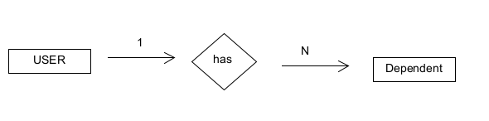

User has many roles: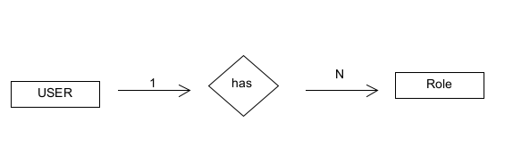

User has many dependencies:

