Caitlynne Johnson

WEB-420 RESTFul APIs

Professor Krasso

24thh March 2023

Assignment 2.2 – Composer API Interface

**Part 1**

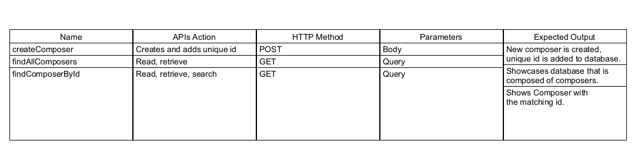

**Part 2**



