<Name of project>

TECHNICAL DESIGN DOCUMENT

|  |  |
| --- | --- |
| **Author** | *Caitlynne Johnson* |
| **Last Updated** | 7/9/2023 4:51 PM |
| **Version Number** | *0.1.0* |

**Version History**

|  |  |  |  |
| --- | --- | --- | --- |
| Name | Date | Reason for Change | Version |
| *Johnson, Caitlynne* | *7/9/23* | *New document format* | *0.1.0* |
|  |  |  |  |
|  |  |  |  |
|  |  |  |  |
|  |  |  |  |
|  |  |  |  |
|  |  |  |  |
|  |  |  |  |
|  |  |  |  |
|  |  |  |  |

Table of Contents

SECTION 1: INTRODUCTION 3

1.1. Purpose 3

1.2. Terminology 3

1.3. User Personas 3

1.4. User Stories 3

1.5. Time Estimations 3

SECTION 2: PROCESS DESIGN 4

2.1. Prototypes 4

2.2. ORD (Object Relational Diagram(s) 4

2.3. NoSQL Document Diagram 4

2.4. NoSQL Data Structure 4

SECTION 3: QA TESTING 4

3.1. QA Test Plan 4

3.2. Unit Tests 4

SECTION 4: REFERENCES 5

# SECTION 1: INTRODUCTION

## Purpose

*The purpose of this website is to allow customers the ability to view their monthly payment and interest of their loan.*

## Terminology

|  |  |
| --- | --- |
| **Name** | **Comments** |
| *MEAN Stack* | *MongoDB, Express, Angular, and Node.js* |
| *VS Code* | *Development IDE* |
| *SoapUI* | *API testing tool* |
| *MongoDB Compass* | *Database development IDE* |
| *Angular Material* | [*https://material.angular.io/*](https://material.angular.io/) |
| *Flex-layout* | [*https://github.com/angular/flex-layout*](https://github.com/angular/flex-layout) |

## User Personas

**Name:** Sarah  
**Role:** Customer  
**Characteristics:** Young, enjoys simplicity  
**Features commonly used:** The loan calculator  
**Features not commonly used:** About page  
**Needs:** would like to see how much a loan for a business would be

**Name:** Rick  
**Role:** Loan Officer   
**Characteristics:** Older, smart, patient   
**Features commonly used:** Loan calculator, contact page  
**Features not likely used:** About  
**Needs:** Loan calculator to work and information of who to contact

**Name:** Riley  
**Role:** Customer  
**Characteristics:** Young, shy  
**Features commonly used:** Loan calculator, contact page  
**Features not likely used:** About  
**Needs:** Loan calculator, ways to get in contact with someone (email preferably)

## User Stories

**User Story 1:**

* As a user I would like an easy, simple tool to use so that I can calculate my loan payment.
* As a user, it would be nice to have a contact page so that I can contact a loan officer.
* As a user, having a site that is easy to use and not difficult to understand would be great.

**User Story 2:**

* As a user, it would be great to have a contact page so that my information can be displayed to future customers who would like to use me for their loan information.
* As a user, the loan calculator being simple and easy to understand is important to me so that customers can see an estimate of what their loan and interest payment may look like before speaking with me.
* As a user, it is also important that the loan calculator be easy for me to understand as well. No extra steps.

**User Story 3:**

* As a user I would like an easy, simple tool to use so that I can calculate my loan payment.
* As a user, I am young and shy, so I don’t like talking on the phone much. It would be great if there was an option to email the loan officer instead of having to conversate with them on the phone.
* As a user, the about page would be a great feature so I can see who I am working with.

## Time Estimations

|  |  |  |  |
| --- | --- | --- | --- |
| User Story | Importance | Story Points | Time Est |
| 1A | 1 | 5 | 4 |
| 2A | 3 | 3 | 2 |
| 3A | 2 | 1 | 2 |
| 1B | 3 | 5 | 4 |
| 2B | 1 | 1 | 2 |
| 3B | 2 | 3 | 2 |
| 1C | 1 | 3 | 1 |
| 2C | 2 | 1 | 3 |
| 3C | 3 | 5 | 2 |

# SECTION 2: PROCESS DESIGN

## 2.1. Prototypes

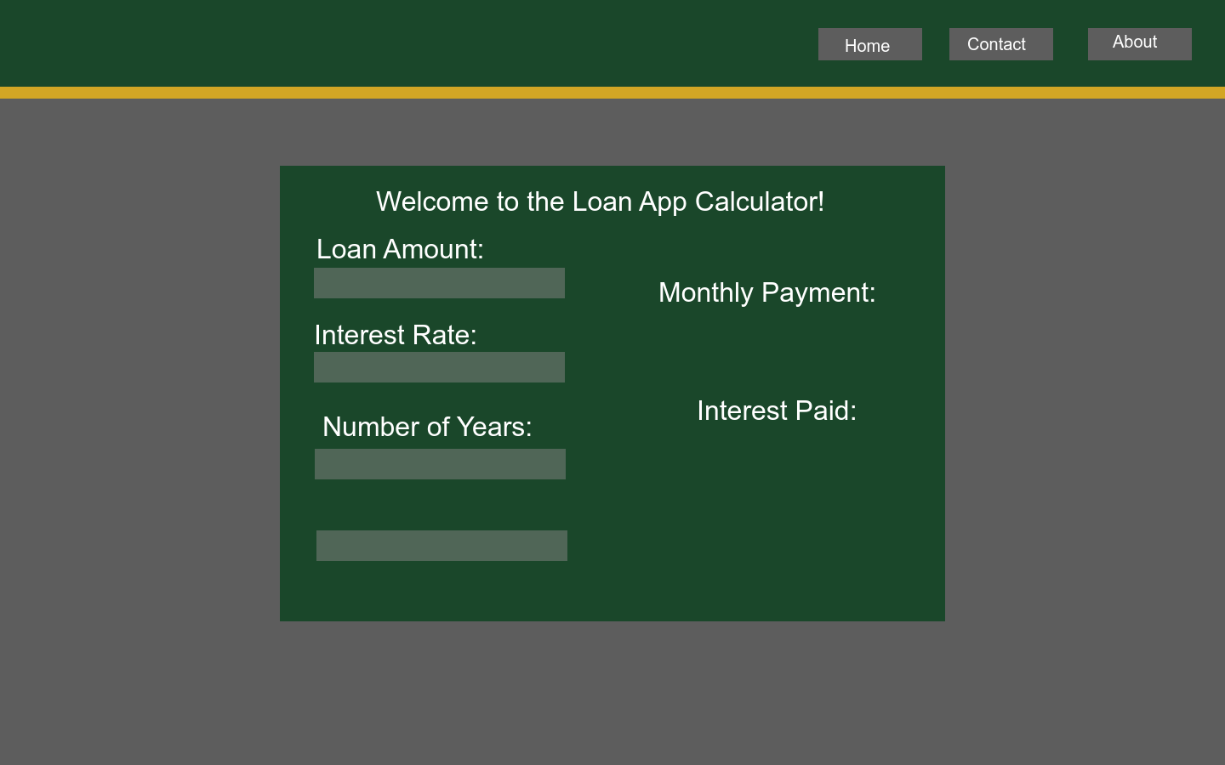

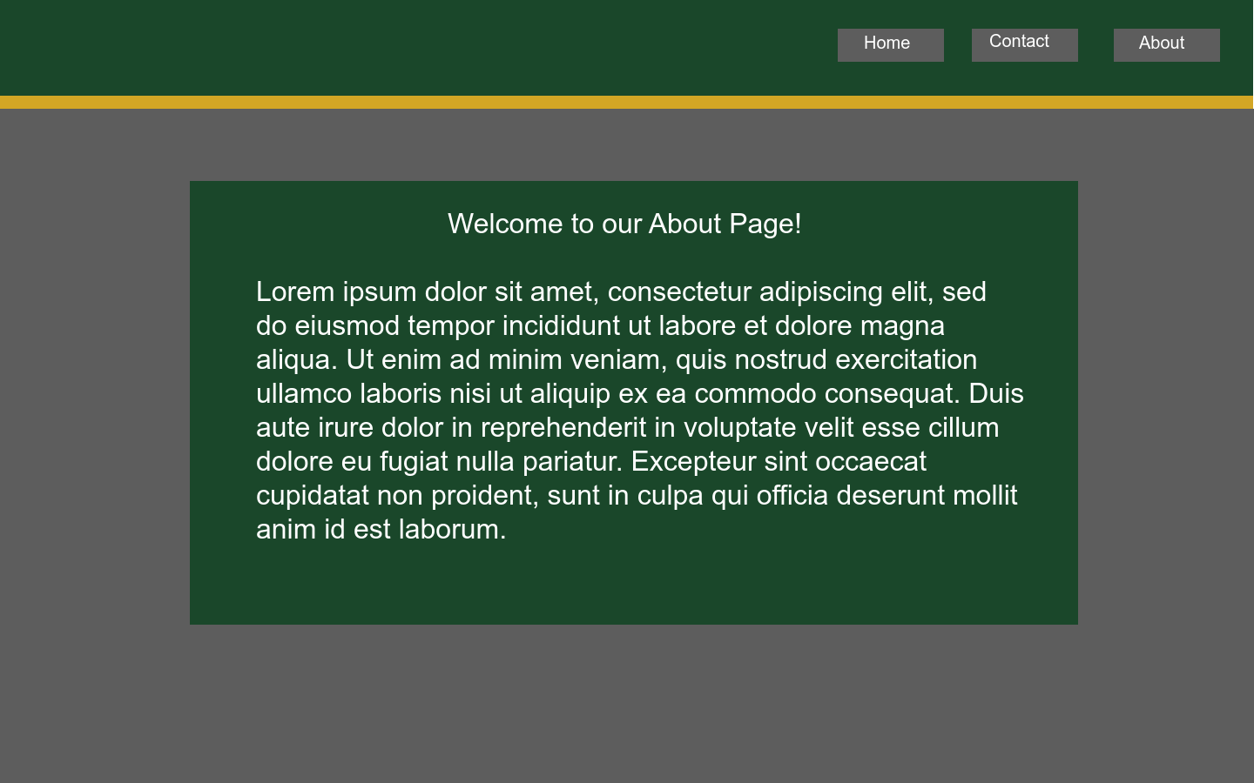

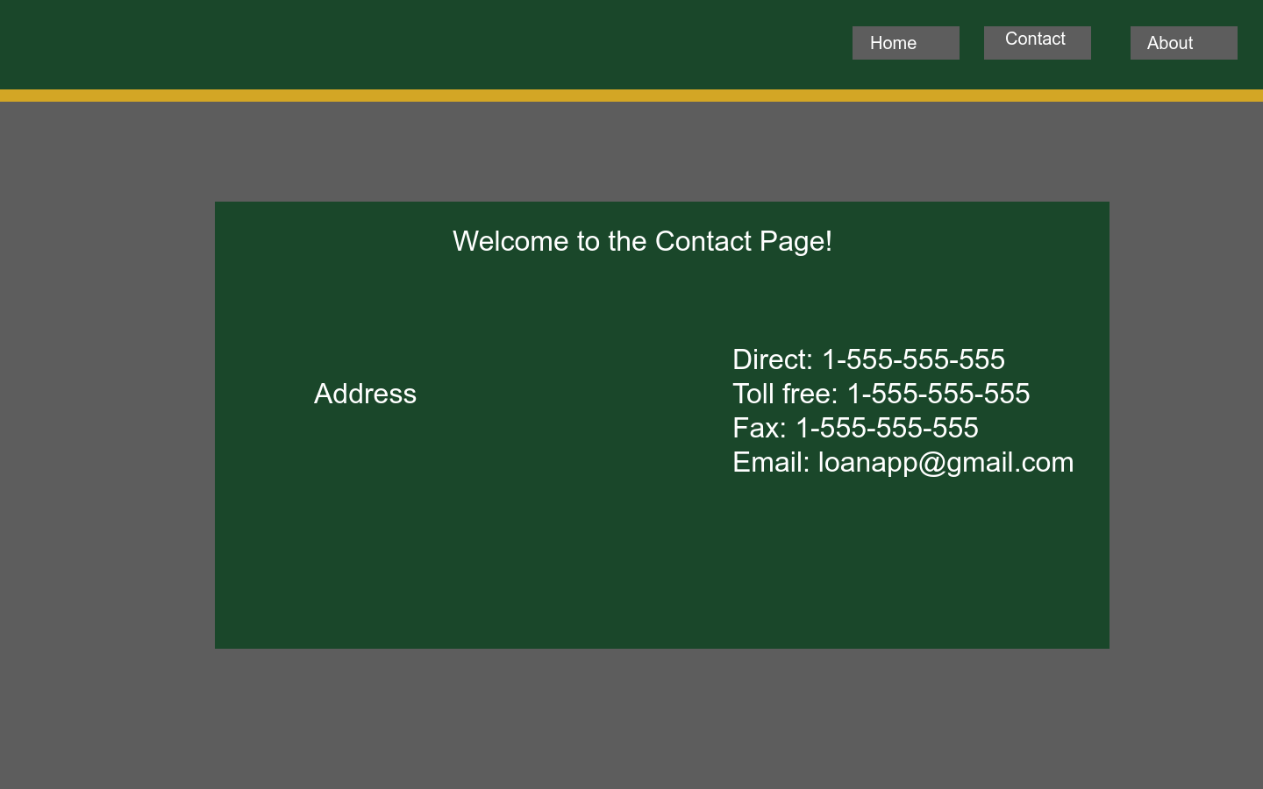

## 2.2. ORD (Object Relational Diagram(s)

## 2.3. NoSQL Document Diagram

*[Covert the above ORD into a NoSQL Document Diagram]*

## 2.4. NoSQL Data Structure

*[Covert the above NoSQL Document Diagram into a NoSQL Data Structure (JSON data)]*

# SECTION 3: QA TESTING

## 3.1. QA Test Plan

*[Weekly Test Cases]*

## 3.2. Unit Tests

*[Images of SoapUI Unit Tests]*

# SECTION 4: REFERENCES

*Hogwarts house colors: The hidden meaning and symbolism in Harry Potter*. Color Meanings. (2023, March 8). https://www.color-meanings.com/harry-potter-house-colors-meaning-hogwarts/