Example of running run_mini_project_1.py:

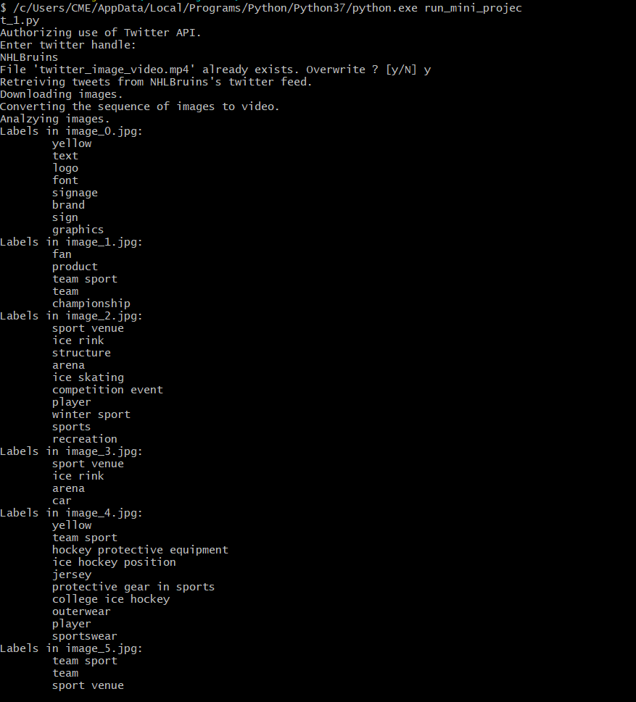

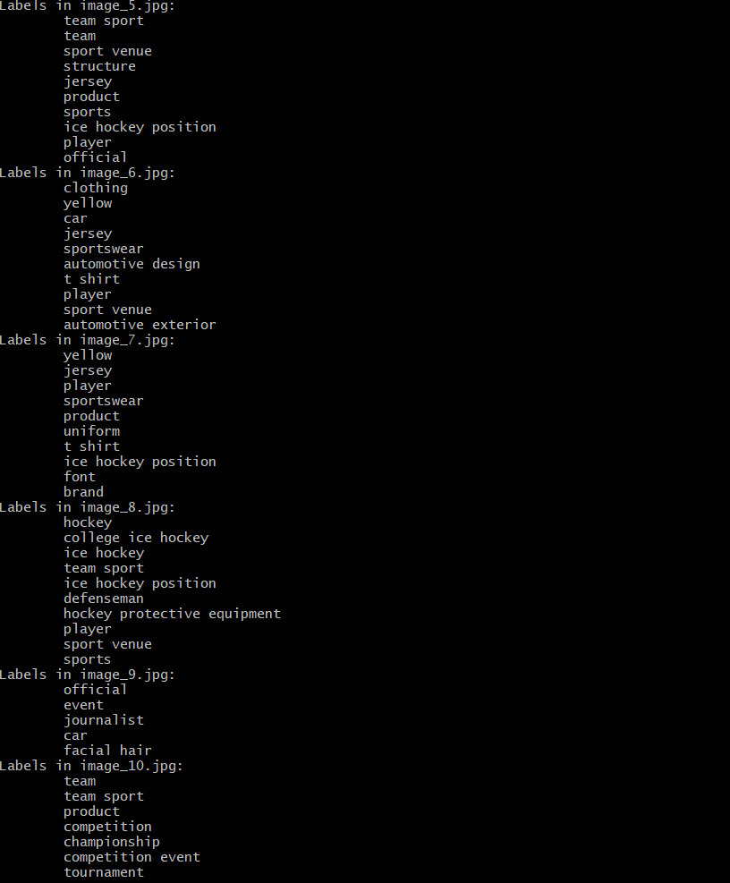

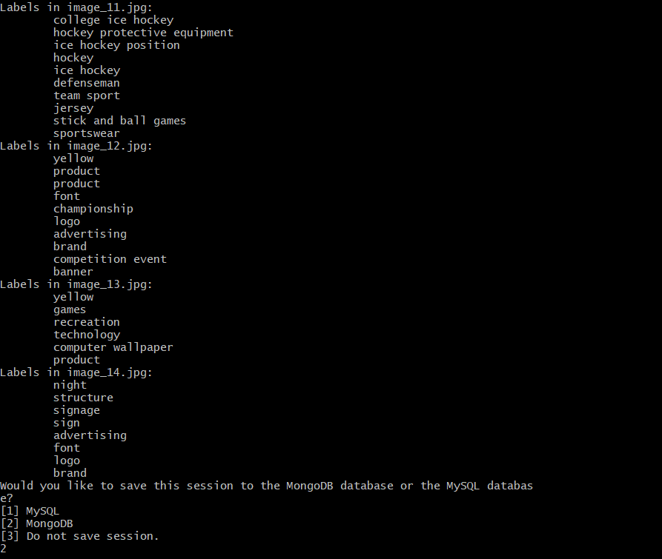

Example of running search_for_descriptors.py:

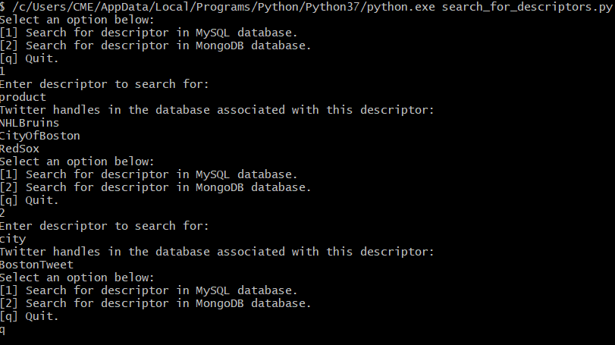

Example of MySQL database created by running run_mini_project_1.py and saving to MySQL database:

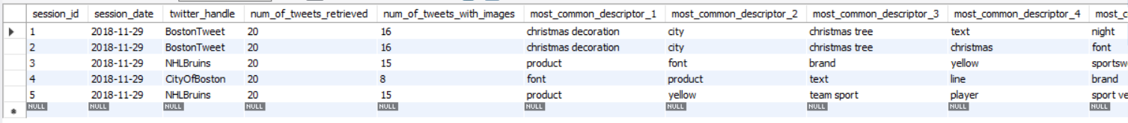

Example of MongoDB database created by running run_mini_project_1.py and saving to MongoDB database:

