Local Semantic Cache and RAG Pipeline
for an Offline, CPU-Only LLM Deployment
Monthly Progress Report
Extending the System to Electrical Engineering Documents
Prepared by: Mustafa Emre Cekmis
Advisor: Tony Wu
August 31, 2026
Covers the project from the beginning to the end of August. July work is summarized; August work is given in detail.

1. Objectives
The goals set at the start of the project were:
- Avoid asking the local LLM the same or a very similar question twice.
- Use RAG so answers come from real stored documents.
- Focus on one topic area, so the system can be tested deeply.
- Pre-fill the cache during quiet hours, since this system has no real user traffic.
- Keep everything on CPU, with no GPU and no cloud services.
- Make the similarity search a matrix operation instead of a loop.
Two goals were added this month:
- Move the system from oversea education advising to Electrical Engineering documents, keeping the existing design.
- Measure the system properly - speed and answer accuracy - instead of judging it from a few example runs.
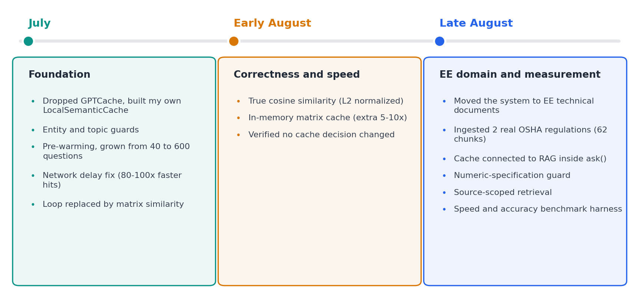
Figure 1. Project milestones.

2. Background and Introduction
Running a local LLM is slow. Even for a short question, the model needs several seconds of CPU work. If the same question is asked twice, or asked in different words, that cost is paid again for nothing.
A semantic cache avoids this. Each question is turned into a vector (an embedding), and meanings are compared instead of exact text. If a new question is close enough to an earlier one, the stored answer is returned and the LLM is never called.
RAG solves a different problem. The model only knows what it saw during training, so it cannot know the content of a specific standard or manual. With RAG, documents are split into small pieces, and the most relevant pieces are put into the prompt with an instruction to answer only from them.

2.1 Setup
Everything runs on one computer, offline. Two local servers are started with llama-server:
- Chat model: Phi-3-mini-4k-instruct (Q4), port 8000.
- Embedding model: all-MiniLM-L6-v2 (Q8_0), port 8001.
The machine is an AMD Ryzen AI 9 HX 370 with 64 GB RAM. It has an integrated GPU, but one project rule was fixed at the start: CPU only. The code is one Python script plus a SQLite file with two tables, cache and documents.

2.2 Why the Project Moved to Electrical Engineering
There were three reasons. Electrical Engineering is my own field of study, so I can judge whether an answer is correct instead of only checking whether it matches a document. My university's internship committee also considers this topic a better fit for the internship. And it is a more concrete and deeper subject than the previous one: the questions have exact answers written in standards, rather than general advice.
It is also a harder test for the system. Technical documents are full of numbers, units and tables, and these broke several assumptions in my code - as Sections 4.3 and 5.5 show.
The decision was to adapt the system, not rewrite it. Every part built in July is still in use.

3. Related Work
I first tried GPTCache, an existing semantic cache library. I stopped using it because it did not match my installed library versions, it needed online access to Hugging Face Hub, and it produced internal errors I could not fix without editing the library.
So I wrote my own cache, LocalSemanticCache, on top of SQLite. This gave me control over the similarity method and the matching rules, which mattered more than expected: most problems this month were in the matching rules, not in the storage.
For large-scale vector search there are dedicated tools such as FAISS or Redis. Mine is much simpler, but it is enough at the size this project works with - the cache holds up to 1000 entries - and it keeps the system fully offline. RAG itself is a standard method; what is less standard here is putting the cache in front of it, so a repeated question skips both retrieval and generation.

4. My Solution

4.1 How One Question Flows Through the System
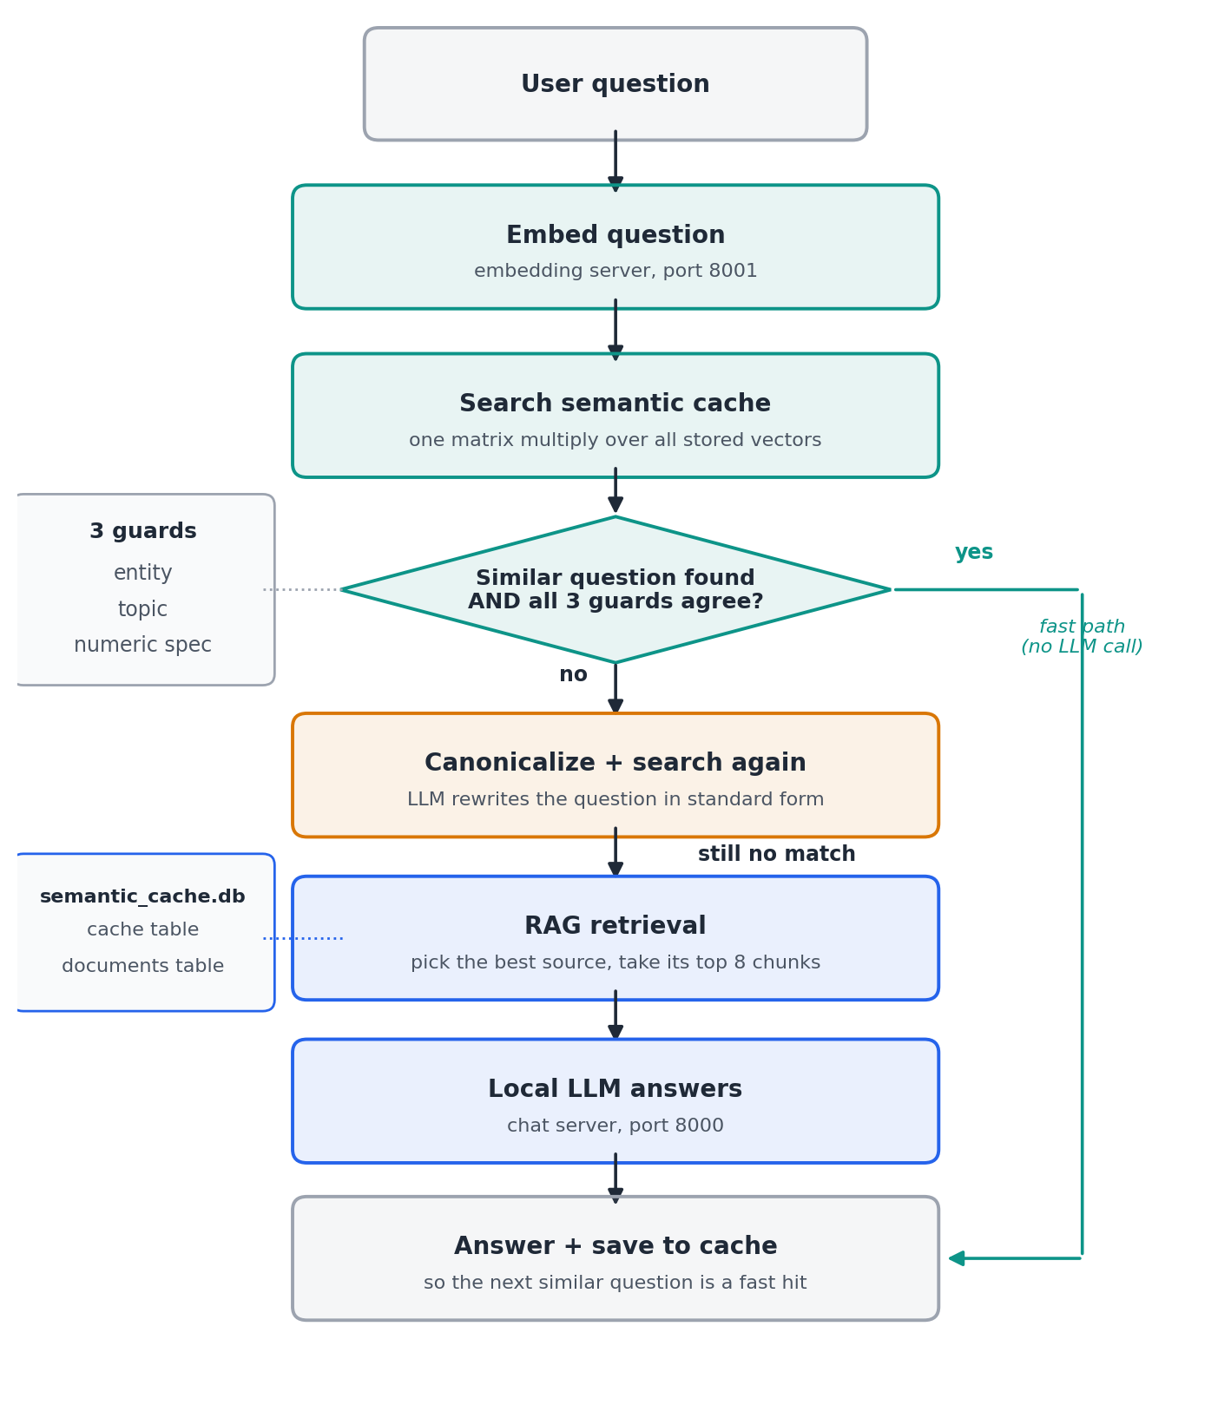
Figure 2. The path of one question. The fast path on the right never calls the LLM.
There are three possible endings:
- Fast hit: a similar question is found and the three guards agree. The stored answer is returned in about 0.2 seconds, with no LLM call.
- Canonical hit: no match at first, so a quick LLM call rewrites the question into a standard form and the cache is searched again. Two phrasings of the same question become much more similar after rewriting.
- Miss: RAG retrieves the most relevant document chunks, the LLM answers from them, and the answer is saved so the next similar question is fast.

4.2 The Semantic Cache
Each entry stores the canonical question, the original question as typed, the answer, and the embedding. Unused entries are removed with an LRU rule so the cache does not grow forever.
Two details came directly from bugs. The fast path exists because the first version always called the LLM to canonicalize, even on a hit, which made hits almost as slow as misses. The original question is kept because the guards need to compare what the user actually wrote - canonicalization sometimes removes the very detail that makes two questions different.

4.3 Three Guards Against Wrong Cache Hits
High similarity does not mean two questions have the same answer. Before returning a cached answer, three checks must agree.
The entity guard and the topic guard were built in July. The first compares named things, mostly country names in the old domain; the second compares topic keywords, so a question about tuition fees does not match one about scholarships.

Numeric-specification guard (new this month)
In Electrical Engineering the thing that separates two similar questions is usually a number. "What is the maximum load on a 15 A receptacle" and "...on a 30 A receptacle" are almost the same sentence, but the answers are 12 amperes and 24 amperes.
I added this guard only after proving the problem was real. I put a trap question in the benchmark - a 30 A question whose 15 A version was already cached - and the cache returned the wrong answer at 58% similarity (Section 5.3).
The guard extracts every number followed by a known unit and compares them, so "15A", "15 amperes" and "15-ampere" all match each other. A number without a unit is ignored, which keeps section numbers like "Section 4.3.2" out of the comparison. Unlike the other two guards, it only requires one shared value rather than a proportional overlap, because a cached question often covers several values at once.

4.4 RAG for Technical Documents
Documents are plain text. Each is split into overlapping chunks, embedded, and stored with its source file name. Two things had to change for technical documents.
Chunk size. The first real regulation crashed the embedding server: a 500-word chunk became 802 tokens, over the server's 512-token limit. Technical text tokenizes much heavier than ordinary prose because of numbers, units and citations like "1910.304(g)(6)(i)(B)". I now use 120-word chunks for these documents.
Source separation. Once more than one document was loaded, a question about one could pull chunks from another. I saw this happen: a question about overcurrent protection retrieved three correct chunks from the OSHA regulation and a fourth, weaker one from an unrelated motor manual. Retrieval now finds the single best-matching chunk first, then searches only inside that chunk's source file. Nothing has to tell the system which document a question is about.

4.5 Documents Used
Document | Type | Chunks
OSHA 29 CFR 1910.304 - Wiring Design and Protection | Real regulation | 32
OSHA 29 CFR 1910.303 - General | Real regulation | 30
ACME Industrial Electrical Installation Manual | Written by me | 3
The third document is invented on purpose. Its rules exist nowhere else, so if the system answers a question about it correctly, the answer can only have come from retrieval. Real regulations cannot prove this as cleanly, because the model may have seen similar text during training.

4.6 Similarity Search and Performance
The similarity search improved in three steps. First, the loop over stored vectors was replaced by a single matrix multiplication. Second, explicit L2 normalization was added, so the result is a true cosine similarity instead of a raw dot product that only works if all vectors happen to have length 1. Third, I found that 80-90% of a search was spent re-reading the database and rebuilding the matrix, so the matrix is now kept in memory and rebuilt only when something changes.
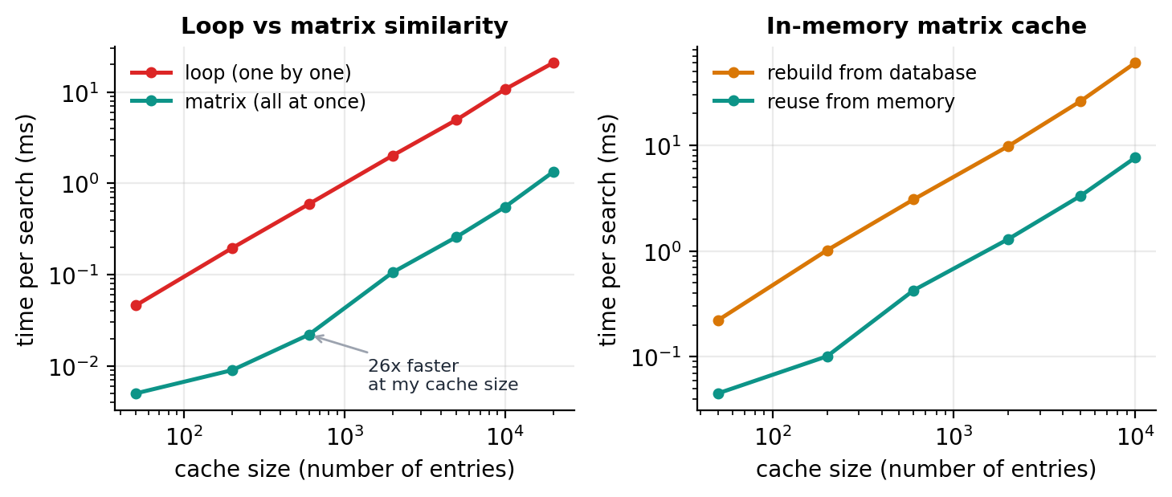
Figure 3. Left: loop versus matrix similarity. Right: rebuilding the matrix each time versus keeping it in memory.
The largest speed gain of the whole project, however, had nothing to do with algorithms. The code connected to the servers using "localhost", which on this machine sometimes tried IPv6 first, waited, then fell back to IPv4. Using "127.0.0.1" removed the delay and made cache hits 80-100 times faster after any idle period.

4.7 Pre-warming
Since the system has no real users, I generate realistic questions from templates and answer them during quiet hours. In the education domain this grew from 40 to 600 questions. It has not been adapted to Electrical Engineering yet: the old version was built around a clean pattern (one template, one country slot) and this domain has no equally natural equivalent. It is listed as an open decision in Section 6.

4.8 Measurement Harness
Until this month I judged the system from example runs. That is not enough: LLM answer time varies a lot between runs, and the model does not always answer the same question the same way. The harness works as follows:
- 15 fixed questions, each stored with its correct answer as accepted phrases. Trap questions also store phrases that must not appear.
- Every question runs through the normal system path, and timings are split by stage: embedding, cache search, canonicalization, retrieval, LLM inference.
- Answers are graded automatically and stored in full, so grading can be checked by hand.
- The set can be repeated several times, with per-question consistency reported. "Correct 3 times out of 5" is a very different finding from "always correct".
- Every row is appended to a CSV file, so results accumulate and configurations can be compared later.
Grading by string matching has a real weakness: an answer that states the correct rule and then draws the wrong conclusion can still score as correct. This is why full answers are saved. Checking by hand once caught the opposite error too - the system correctly refused an impossible question, but my list of accepted refusal phrases was incomplete, so it was marked wrong.

5. Experimental Study
All numbers below come from the current system: 3 documents, 65 chunks, 15 questions, 5 repeats (75 measured answers). The cache is cleared between repeats, so each repeat starts cold.

5.1 Overall Results
Measurement | Result
Cache hit response time | 0.201 s
Cache miss response time | 8.006 s
Speed-up, hit vs miss | about 40x
Semantic search inside the cache | 0.0051 s
RAG retrieval | 0.0007 s
LLM inference (share of a miss) | 90%
Cache hit rate | 26.7%
Answer accuracy | 74.7% (56/75)
Wrong answers served from cache | 5

5.2 Where the Time Actually Goes
This is the most useful result of the month, and not what I expected before measuring.
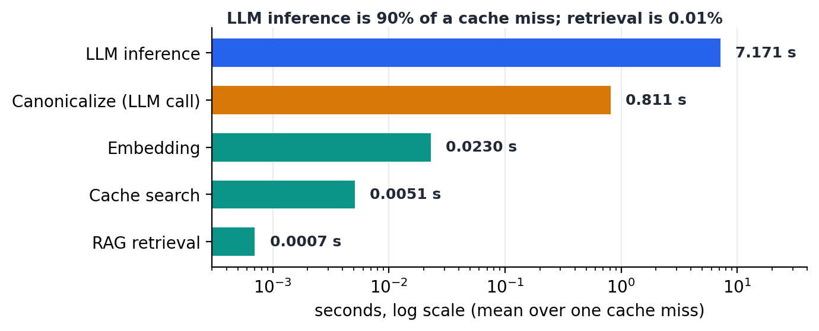
Figure 4. Time spent in each stage of a cache miss. Note the log scale.
Retrieval takes 0.0007 seconds and cache search 0.005 seconds - both are effectively free. LLM inference takes 7.2 seconds, or 90% of the total.
This changes how the cache should be described. It is not valuable because searching is fast; it is valuable because a hit means the model is never called. It also means further optimization of retrieval has nothing left to win.

5.3 The Numeric Guard
Without the guard, the 30 A trap question matched the cached 15 A question at 58.13% similarity and returned its answer: 12 amperes instead of 24. One detail was unexpected - it missed on the fast path and only matched after canonicalization, meaning the rewriting step had blurred the number that made the two questions different. That is a good argument for a separate, deterministic check. Appendix A.1 shows both runs.
When the guard was added, the cache hit rate fell from 41.7% to 33.3% (on the 12-question set in use at that time). This is an improvement, not a regression: the hit that disappeared was a wrong answer. It is a clear example of why hit rate alone is misleading, and why accuracy is measured next to it.

5.4 A Guard That Was Silently Blocking Correct Hits
The benchmark also found the opposite error. The entity guard treated any capitalized word as a named thing, so sentence-opening words like "For" and "What's" became entities, and "15A" contributed the letter "A". Two questions then had entity sets like {"what's", "a"} and {"for"}, which do not overlap, so a correct match at 63% similarity was thrown away.
After fixing the extraction, the hit rate went from 30% to 40% (on the 10-question set in use at that time) with no wrong hits added. This bug had been in the system for weeks; it only became visible once accuracy and hit rate were measured together.

5.5 Diagnosing Wrong Answers
Three questions were answered wrongly every time. Instead of guessing why, I built two tools: one reports where the chunk containing the correct answer ranks for a question (with no LLM call, so it separates retrieval failures from model failures), and one runs the same question many times under different settings.

Case 1 - a retrieval failure, now fixed
A question about minimum working-space width was answered with a real number from the correct document, but from the paragraph for equipment above 600 V, when the question asked about 600 V or less. The model even copied the surrounding wording, which made the wrong answer look convincing - worse than an invented answer, because it is harder to notice.
The rank tool showed the chunk with the correct rule ranked 5th, while only the top 4 were retrieved. It had missed by one place. Raising the retrieved count to 8 fixed the question completely.

Case 2 - a table row that is never retrieved
A question about one row of a clearance table still fails. The chunk holding that row ranks 13th out of 30, with a similarity of only 0.43. Table rows like "9001 V-25 kV -> Condition A: 1.5 m ..." do not embed well, because they are not sentences. Retrieving 13 chunks for every question would be expensive, so the fix has to be structural (Section 6).
The behaviour is at least honest: instead of inventing a value, the system answered that the provided information does not cover that voltage range.

Case 3 - a result I cannot explain
One question about motor breaker types is wrong every time under the current settings, but correct 9 times out of 10 when one unrelated chunk from a different document is added to its context. I ran 10 trials per setting across two independent runs, so this is not random variation. I have no sensible mechanism for why irrelevant text would fix an answer, and I did not undo the source-separation change because of it: that change fixes a problem I understand, and this one I do not. Appendix A.3 shows the experiment.
Two of my earlier explanations for this failure were wrong. I first assumed the model could not compare 7 kW against a 5 kW threshold; then I concluded retrieval was incomplete. The experiment ruled out both. This is why I now try to measure a cause before acting on it.

5.6 More Context Is Not Simply Better
Raising the retrieved-chunk count from 4 to 8 fixed the question in Case 1, but it was not free.
Configuration | Accuracy | Miss time | LLM time
Top 4 chunks (135 answers) | 72.6% | 5.25 s | 4.44 s
Top 8 chunks (75 answers) | 74.7% | 8.01 s | 7.17 s
One correction belongs with this table. The top-4 rows were collected before I widened the accepted phrases for one question, so one correct answer there is recorded as wrong. The real top-4 accuracy is 73.3%, and the true gain is about 1.4 points rather than 2.1.
So accuracy rose by roughly one point while a miss became about 50% slower. The per-question view explains why the gain is so small: one question was fixed, but another got worse. The question whose answer is in none of the documents refused correctly in all nine top-4 measurements, but only 1 time out of 5 in the final run with 8 chunks.
The reason makes sense. With more text in front of the model, there is a higher chance something mentions a percentage or a voltage that can be shaped into a plausible answer. More context helps the model find facts and makes it worse at admitting a fact is missing.
I kept the higher setting, because the question it fixed is understood and reproducible. Two warnings about these numbers: the speed-up rising from 27x to 40x is not an improvement (hit time barely moved, from 0.196 s to 0.201 s - the ratio grew only because misses got slower), and timings move between runs on their own. Three runs of the identical top-4 configuration gave mean inference times of 4.90 s, 4.29 s and 4.13 s, a spread of about 19%, so part of the slowdown above may be machine variation rather than the setting.

5.7 Per-Question Results
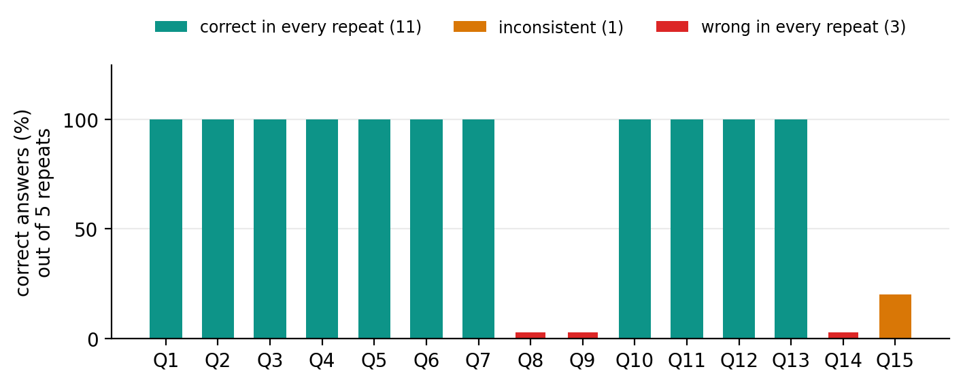
Figure 5. Result for each benchmark question over 5 repeats.
Eleven of fifteen questions are correct in every repeat. The failures are the three cases above, plus one inconsistent question.
Two of the three failures are the same underlying question - one asked directly, one a paraphrase that hits the cache. This shows something easy to miss: the cache does not make the system more correct, it makes it faster. A wrong answer, once stored, is served instantly to every later paraphrase. The benchmark counts these separately as wrong cache hits.

5.8 Checking That Answers Come From the Documents
The benchmark includes questions whose answers exist only in my documents, and one whose answer exists nowhere. The off-topic control question ("what is the best programming language for web development") is refused correctly in every repeat, and the invented manual's rules are answered exactly as written. Appendix A.2 shows the refusal.

6. Summary and Conclusion

6.1 What Works Now
- A complete offline pipeline: question, cache, RAG, local LLM, answer, saved back to the cache.
- A repeated question is answered about 40 times faster than the full pipeline.
- Three guards protect the cache from returning a confidently wrong answer, including a new numeric guard for this domain.
- Retrieval keeps documents separate, so a question about one regulation is answered from that regulation.
- A measurement harness records speed and accuracy together and accumulates results across runs.

6.2 What I Learned
- Retrieval is free and the LLM is everything: 90% of a miss is model inference. The value of the cache is skipping the model, not searching faster.
- Cache hit rate alone is misleading. It went down when I fixed a correctness bug, because the removed hits were wrong answers.
- A cache multiplies whatever accuracy the system already has, in both directions.
- The most dangerous wrong answers are not invented ones. The worst case used a real number from the right document but the wrong paragraph, and read perfectly.
- Measuring before fixing matters. Two of my explanations for one failure were wrong, and only a controlled experiment showed it.

6.3 Limitations
- Table data does not work well. A question needing one specific table row still fails, because table rows do not embed like sentences.
- One failure has no explanation: adding an unrelated chunk reliably fixes a question that otherwise always fails.
- Automatic grading uses string matching, so failing cases still need to be read by hand.
- The benchmark is small - 15 questions from 3 documents. Large enough to find real bugs, not large enough for precise accuracy numbers.
- Timing varies between runs, so single-run numbers should not be trusted.
- Pre-warming and the topic keyword list are still the education-domain versions.

6.4 Next Steps
- Table-aware chunking: store tables as their own chunks, or attach the table header to every row, so a table row can be retrieved. This is the root cause of the remaining failure.
- Measure the refusal loss directly. The top-4 and top-8 figures above come from different runs, and the refusal question was only measured 5 times at the larger setting, which is too few to be sure of the size of the effect.
- Settle the scope of the well-known benchmark test with my advisor. Two points need a decision: whether it should measure speed or answer accuracy, and whether it should run on our own documents or on the benchmark's own dataset. Most standard benchmarks bring their own documents, which would move away from the offline Electrical Engineering setup, so this is worth agreeing before spending time on it.
- Decide on the leftover parts from the previous domain - the topic keyword list and pre-warming - and either adapt them or explain why they were left out.
- Add more real documents, so retrieval is tested at a more realistic scale than 65 chunks.
The plan is to stop adding features around the middle of September and keep the final week for a full measurement run and the final report.

Appendix: Output From Test Runs
Two kinds of output appear below. Lines marked as console output are printed by the program during a run. Answer text is not printed to the console - it is written to the results file - so answers are shown separately and labelled.

A.1 - Numeric Guard (Section 5.3)
Console output before the guard existed. The 30 A question matched the cached 15 A question:
[DEBUG-ENTITY] sim=58.13% | raw_query='What's the max load on a 30A receptacle when
multiple receptacles share the circuit?' | cached='For a 15-ampere receptacle on a
15- or 20-ampere branch circuit supplying two or more receptacles, what is the
maximum cord- and plug-connected load allowed?' (raw_prompt found)
| q_ent=set() | c_ent=set() | entity_ok=True
| q_topic=set() | c_topic=set() | topic_ok=True | agree=True
[11] HIT (canonical_hit) total= 0.860s
The answer recorded for that question was the cached 15 A answer, ending: "...the maximum cord-and-plug-connected load allowed is 12 amperes." The correct answer is 24 amperes.
Console output after the guard was added. The same question is now rejected:
[DEBUG-ENTITY] sim=58.13% | q_ent=set() | c_ent=set() | entity_ok=True
| q_topic=set() | c_topic=set() | topic_ok=True
| q_spec={'30a'} | c_spec={'15a', '20a'} | specs_ok=False | agree=False
[11] MISS (RAG) total= 5.276s
The answer recorded after the fix: "The max load on a 30A receptacle when multiple receptacles share the circuit, according to Table S-5 - Receptacle Ratings, is 24 amperes." The value is correct. The table reference is not - the 24 A figure comes from Table S-4 - which is an example of the kind of small error that value-based grading does not catch.

A.2 - Refusing an Off-Topic Question (Section 5.8)
Recorded answer for the control question "What's the best programming language for web development?":
I'm sorry, but the information provided does not cover the question about the
best programming language for web development. This topic falls outside my
domain of expertise in electrical engineering technical knowledge.

A.3 - Rank Diagnostic and the Unexplained Effect (Section 5.5)
Console output showing where the answer chunk ranks for the two table questions, and what happens when more chunks are retrieved:
[CHUNK RANK] Looking for the chunk containing '762 mm'
Found at rank 5/30 (score=0.6523, source=osha_1910_303_general.txt)
-> OUTSIDE default top_k=4 - recall problem

[A/B EXPERIMENT] 3 trials per variant
scoped top_k=4 (current default) 0/3 correct
scoped top_k=8 3/3 correct
scoped top_k=12 2/3 correct

[CHUNK RANK] Looking for the chunk containing '9001 V-25 kV'
Found at rank 13/30 (score=0.4345, source=osha_1910_303_general.txt)
-> OUTSIDE default top_k=4 - recall problem
Console output for the result I cannot explain. The only difference between the first two lines is one extra chunk from an unrelated document:
[A/B EXPERIMENT] 5 trials per variant
Question: What type of circuit breaker curve should be used for a 7 kW induction...
scoped top_k=4 (current default) 0/5 correct chunks=3 sources={acme_manual}
pooled top_k=4 (previous default) 5/5 correct chunks=4 sources={acme_manual,
osha_1910_304}
scoped top_k=3 (all ACME chunks) 0/5 correct chunks=3 sources={acme_manual}
-> Large, consistent gap between variants: the setting looks causal.
A second run of the same experiment gave 0/5, 4/5 and 0/5, so across both runs the scoped setting was correct 0 times out of 10 and the pooled setting 9 times out of 10.

