Local Semantic Cache and RAG Pipeline
for an Offline, CPU-Only LLM Deployment
Monthly Progress Report — Oversea Education Advising Domain
Prepared by: Mustafa Emre Cekmis | Advisor: Tony Wu | July 31, 2026

1. Objectives
This project builds an offline cache for a local LLM. The main goal is to answer questions faster and with less computing cost, by reusing past answers when possible. In detail:
- Avoid asking the LLM the same or a very similar question twice.
- Add a RAG step, so the assistant can use real stored facts, not only its own memory.
- Focus on one topic area (oversea education advising), so I can test the system deeply.
- Pre-fill the cache during quiet hours, since this system has no real live traffic.
- Make the local servers faster, using CPU only.
- Turn the similarity search into a real matrix operation, instead of a loop.

2. Background and Introduction
Calling a local LLM takes time and CPU power, even on good hardware. A common fix is a “semantic cache”: compare the meaning of a new question (via embeddings) to old ones, and reuse the old answer if a close enough match exists.
This project runs fully offline, on one computer, with no cloud APIs. I use two local servers, both run with llama-server: a chat model (Phi-3-mini-4k-instruct, Q4) and an embedding model (all-MiniLM-L6-v2, Q8_0).
One rule was set at the start: CPU power only, no GPU. The development computer (AMD Ryzen AI 9 HX 370, Radeon 890M integrated GPU, 64GB RAM) has a GPU, but it is not allowed for this project.

3. Related Work
I first tried GPTCache, an existing open-source library. I stopped using it for three reasons: it did not match my library versions, it needed online access to Hugging Face Hub, and it had internal errors I could not fix without changing the library itself.
So I built my own small cache instead, called LocalSemanticCache, with full control over storage (SQLite), the similarity method, and the matching rules. This is close to tools like FAISS or Redis with vector search. RAG is also a known method for grounding answers in real stored text, not only training data.

4. Solution

4.1 System Architecture
The system has three parts:
- Two local servers: the main LLM (port 8000) and the embedding model (port 8001).
- One Python script that runs the cache, RAG, pre-warming, and a simple chat mode.
- One SQLite file (semantic_cache.db) with two tables: cache (for questions and answers) and documents (for RAG).
The diagram below shows the main steps for one question, from start to a cached or a fresh answer:
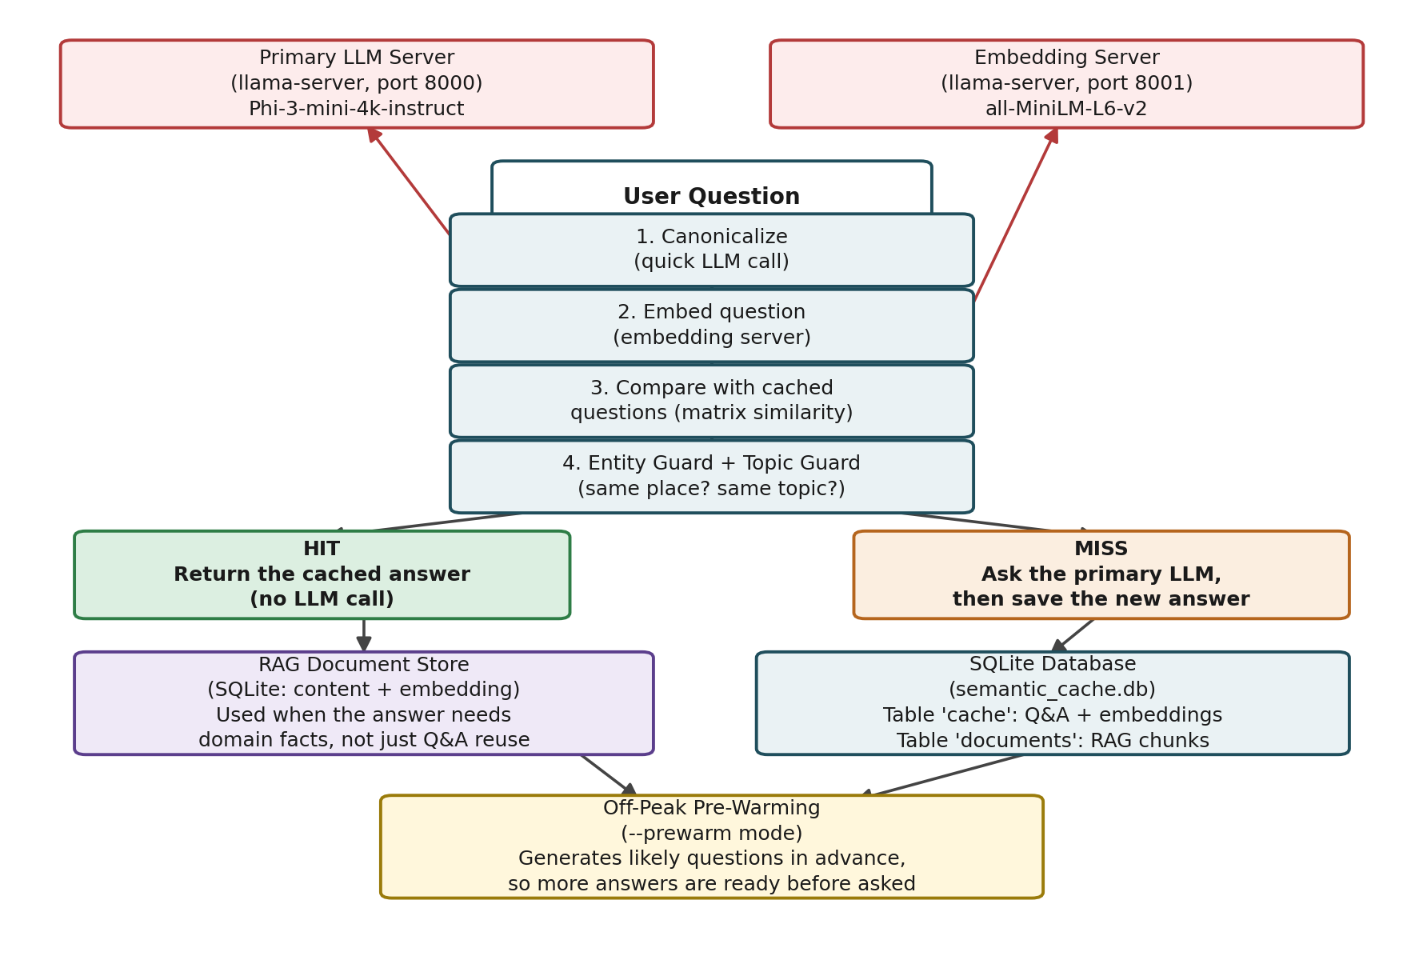
Figure 1. Main steps for answering one question, and how the two servers and the database are used.
In short: the question is standardized, turned into a vector, and compared to old questions. If it passes both checks (entity and topic), I reuse the old answer. If not, I ask the LLM and save the new answer.

4.2 Reactive Semantic Cache
Before asking the LLM, I turn the question into a vector (embedding) and compare it to old questions already in the cache, using cosine similarity (as a dot product). If the score is high enough, I reuse the old answer.
The question is also “canonicalized” first — a quick LLM call rewrites it in a standard form, so two phrasings of the same question end up as similar vectors.
Old, unused cache entries are removed with LRU (least recently used), so the cache does not grow without limit.
Problem found during testing: similarity alone is not enough. Two questions can look almost the same but ask about two different things — for example, the same question about two different countries.

4.3 Entity and Topic Guards
To fix this, I added two extra checks.
Entity guard: Compares country names and other key entities in both questions. If they do not match, the cached answer is not reused, even when similarity is high. A small dictionary also maps terms like “American” and “US” to “America” to handle cases the LLM may miss.
Topic guard: Questions about the same country can still be about different topics, such as tuition fees and scholarships. This separate check compares topic keywords like “fee”, “scholarship”, and “visa”. It remains independent from the entity check to avoid overlooking country mismatches.
Both checks must pass before the cache returns an old answer.

4.4 RAG Pipeline
Real facts are stored in a documents table (text, embedding, and source file). Long text is split into overlapping chunks, so I can search smaller pieces instead of whole documents.
For a question, I retrieve the most similar chunks and put them in the prompt, telling the model to answer using only that information.
To test this, I added a fake university rule to the documents table. The model reproduced it exactly, proving the answer came from stored text, not its training.

4.5 Domain Focus
I was asked to focus on one topic area, and chose “oversea education advising” (help for students studying abroad) — a topic with many named things (countries, exams, visas), which is a good test for the entity and topic guards.
I also changed the system prompt, so the model answers only questions in this topic, and declines questions outside it.

4.6 Proactive / Off-Peak Caching
This system will never have real users, so I cannot wait for real traffic to know what to pre-cache. Instead, I build a large set of realistic questions myself, and answer them all in advance, during quiet hours.
Four steps:
- Question templates with a country slot, such as “What is the minimum IELTS score in {country}?”
- All template + country combinations — the full list of possible questions.
- A priority score for each question. This is a heuristic guess for now, since I have no real traffic data.
- A `--prewarm` mode that answers questions in priority order, skipping any that are already covered.
This question list grew during the month: from 40, to 160, to 600 questions.

4.7 Chatbot Interface
A `--chat` mode: type one question, get an answer.
It checks the cache in two steps: first a fast check using only the embedding (no LLM call); if that fails, it tries again after canonicalizing the question (this step does use the LLM). Only if both fail does it ask the LLM for a new answer.
I added this after finding a bug: the first version always called the LLM to canonicalize, even on a cache hit — making a “hit” almost as slow as asking the LLM directly.

4.8 Vectorized (Matrix-Based) Similarity
The original search checked each cached question one at a time, in a loop. I changed this to one matrix operation over all stored vectors at once — same result, but faster and more scalable as the cache grows.
Tested: the new method gives the exact same results as the old loop method, on both test data and the real code.

4.9 Performance Optimization (CPU-Only)
All performance work here uses CPU only, per the project rules — no GPU, even though the development machine has one.
I found and fixed a big, confusing slowdown: the code used “localhost” instead of “127.0.0.1”. On this machine, “localhost” sometimes tried an IPv6 connection first, waited, and then fell back to IPv4 — adding a real, repeatable delay after any idle time. Switching to “127.0.0.1” fixed it completely.
I also tried CPU settings such as thread count and batch size. After the fix above, these gave no clear extra speed-up at the current scale.

5. Experimental Study

5.1 Entity and Topic Guard Validation
These test cases check whether the guards can tell a real match from a similar-looking but wrong one:
Test Case | Cosine Similarity | Expected | Guard Outcome
UK / IELTS paraphrase | 89.6% | HIT | HIT (correct)
Germany / IELTS (different country) | 86.9% | MISS | MISS (correct)
US / American visa paraphrase | 92.5% | HIT | HIT (correct)
Canada / visa (different country) | 81.7% | MISS | MISS (correct)
Tuition fee vs. scholarship, same country | ~70-76% | MISS | HIT → bug found, then fixed

Both wrong matches (different country, and different topic) scored above my 0.55 similarity threshold. This shows the guards are doing real, needed work — similarity alone is not enough. See Appendix A.1 for the real console output of the topic-guard case.

5.2 Cache Growth Over the Month
Milestone | Templates × Countries | Question Set Size
Initial domain test set | — | 6 questions, written by hand
First proactive pre-warm | 5 × 8 | 40 questions
First expansion | 10 × 16 | 160 questions
Current | 30 × 20 | 600 questions

The latest full run (600 questions) worked well: 583 new answers were added, and 17 were already cached. No unexpected overlaps were found across all pairs among the 30 templates and 20 countries. See Appendix A.2 for the real console output.

5.3 Latency Improvements
Scenario | Before Network Fix | After Network Fix
Cache hit (fast path) | ~2.0 – 2.5 s | ~0.02 – 0.03 s
Cache miss (LLM call needed) | ~5 s | ~5 s (unchanged — not yet targeted)

The fix (using “127.0.0.1” instead of “localhost”) made cache hits about 80–100 times faster, no matter how long the system had been idle. See Appendix A.3 for the real console output, before and after.

5.4 RAG Grounding Verification
I tested RAG with a made-up, specific rule (a fake university's exam-score exception, with an exact document name and score not found anywhere else). The model's answer matched this rule exactly. This proves the answer came from my stored documents, not the model's own training. See Appendix A.4 for the real console output.

6. Summary and Conclusion

Achievements
- Replaced a broken third-party library with my own offline cache and RAG pipeline.
- Found and fixed two kinds of wrong cache matches: wrong country, and wrong topic.
- Focused the system on one topic area, and proved RAG answers are grounded in real stored text.
- Built and tested a 4-step pre-warming pipeline, grown from 40 to 600 questions.
- Found and fixed a network delay bug.
- Changed the similarity search to a matrix operation, tested to give the same results as before.

Limitations
- The entity and topic guards use hand-made word lists, not a learned method. They work well for my current questions, but any new template should be checked again for overlap.
- The similarity score uses raw dot products, not fully normalized cosine similarity. This has been stable so far, but it is not a guaranteed property.
- Priority scores in the pre-warming step are heuristic guesses, since I have no real usage data yet.
- I have optimized the embedding server and the network layer, but not yet the main LLM server's answer time — this is the main cost on a cache miss.

Next Steps
- Apply the same CPU performance work to the main LLM server.
- Consider adding true vector normalization, for an exact cosine similarity.
- Keep growing the question set if more topic coverage is needed.
- Update the priority scores if real usage data ever becomes available.

Appendix: Real Console Output
This appendix has real, unedited console output from testing this month. Each item is linked to a section above.

A.1 — Supports Section 5.1 (Topic Guard)
Real output showing the topic guard correctly rejecting a same-country, different-topic match (tuition fee vs. scholarship):
[DEBUG-ENTITY] sim=69.75% | q_ent={'britain'} | c_ent={'britain'} | entity_ok=True
| q_topic={'scholarship'} | c_topic={'fee', 'tuition'} | topic_ok=False | agree=False

A.2 — Supports Section 5.2 (Cache Growth, 600-question run)
Real output at the end of the largest pre-warm run:
[PREWARM] Done: {'attempted': 600, 'already_cached': 17, 'newly_cached': 583}
Cache stats: {'records': 583, 'max_records': 1000}

A.3 — Supports Section 5.3 (Latency, Before/After Network Fix)
Real timing output, before the fix (idle for 10+ seconds before asking):
[TIMING] embed=2.30s | search=0.01s | total=2.31s
Real timing output, after the fix (using 127.0.0.1):
[TIMING] embed=0.03s | search=0.01s | total=0.03s
[TIMING] embed=0.02s | search=0.01s | total=0.03s

A.4 — Supports Section 5.4 (RAG Grounding)
Real output showing the model's answer matched my made-up test rule exactly:
[RAG CHECK] LLM answer: Exchange-track applicants for XYZ University's Fall 2026
program need a minimum IELTS score of 6.5. They must submit a 'Statement of
Academic Purpose' (SOAP) no later than 45 days before the semester starts.

