An Offline Semantic Cache and RAG System
for Electrical Engineering Documents
Final Internship Report
6 July - 18 September 2026
Mustafa Emre Cekmis
Electrical Engineering, Istanbul Technical University
Advisor: Tony Wu
Youtune Technology Co. Ltd., Ningbo

Contents
1. Objectives
2. Background and Introduction
why a cache, why RAG, the setup, and why the topic changed
3. Related Work
GPTCache, vector search libraries, RAG, and how such systems are evaluated
4. My Solution
the cache, the three guards, retrieval, document handling, performance work
5. Experimental Study
how it was measured, the results, three levels of benchmark, and the failures
6. Summary and Conclusion
what was built, what I learned, limitations, next steps
Appendix A
how to run the system
Appendix B
output from test runs

1. Objectives
The goal was to build a question-answering assistant that runs entirely offline on an ordinary CPU, answers from real technical documents, and does not pay the cost of the language model twice for the same question.
The objectives set at the start of the internship:
- Avoid asking the local model the same or a very similar question twice.
- Answer from stored documents rather than from what the model happens to remember.
- Keep everything offline: no GPU, no cloud service, no internet at run time.
- Make the similarity search a matrix operation rather than a loop.
- Fill the cache in advance during idle hours, since the system has no real user traffic to learn from.
- Work within one topic area, so the system can be tested deeply instead of shallowly.
In late August the topic area moved from oversea education advising to Electrical Engineering, and two objectives were added:
- Move the system to Electrical Engineering standards and manuals without rewriting it.
- Measure it properly - speed and answer accuracy - instead of judging it from example runs.
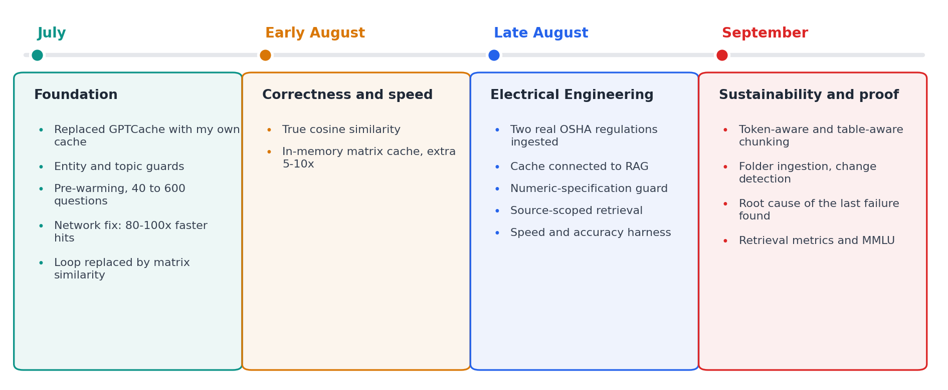
Figure 1. The project from the first week to the last.

2. Background and Introduction
A local language model is slow. On this machine one answer costs several seconds of CPU work. If the same question is asked twice, or asked in different words, that cost is paid again for nothing.
A semantic cache avoids this. Each question is converted into a vector, and meanings are compared instead of exact text, so a question that has been answered before is recognised even when it is worded differently. This is the difference between a normal cache and a semantic one: a normal cache would only match identical text, which almost never happens with questions people actually type.
RAG - retrieval-augmented generation - solves a different problem. The model only knows what it saw during training, so it cannot know the content of a particular standard or company manual. With RAG the documents are split into passages, and the passages most relevant to a question are placed in the prompt with an instruction to answer only from them.
Putting the two together is the design of this project. The cache sits in front of retrieval, so a repeated question skips both retrieval and generation, while a new question is answered from the documents.

2.1 Hardware and software
Two local servers run with llama-server, and nothing leaves the machine:
- Chat model: Phi-3-mini-4k-instruct, 4-bit quantized, port 8000, 12 threads, 4096-token context.
- Embedding model: all-MiniLM-L6-v2, 8-bit quantized, port 8001, mean pooling.
The machine is an AMD Ryzen AI 9 HX 370 with 64 GB of RAM. It has an integrated GPU, but a rule set at the start of the project was CPU only, and it was kept throughout. The system is one Python script plus a SQLite file with three tables: cached answers, document passages, and a record of which version of each document was loaded.

2.2 Why the topic area changed
The first two months used oversea education advising as the topic area. It worked well for building and testing the cache, but in late August the project moved to Electrical Engineering for three reasons. It is my own field of study, so I can judge whether an answer is correct instead of only whether it matches a document. My university's internship committee considers it a better fit for the internship. And it is a more concrete subject: the questions have exact answers written down in standards, rather than general advice.
It is also a harder test. Technical documents are full of numbers, units and tables, and these broke several assumptions that had held up fine in the previous topic area. Sections 4 and 5 describe what broke and how it was fixed.
The decision was to adapt the system rather than rewrite it. Everything built in July and early August is still in the final system.

3. Related Work
I began with GPTCache, an existing open-source semantic cache. I stopped using it for three reasons: it did not work with my installed library versions, it required online access to Hugging Face Hub, which breaks the offline rule, and it produced internal errors I could not fix without editing the library itself.
So I wrote my own cache on top of SQLite. In hindsight this was the more useful path: almost every interesting problem in this project turned out to be in the rules that decide whether a cached answer may be reused, not in how answers are stored, and those rules are exactly what a library hides.
For vector search at scale there are dedicated tools such as FAISS or Redis with vector support. Mine is far simpler. The cache holds at most 1000 entries and the document corpus is 68 passages, so a single matrix multiplication over all stored vectors is fast enough, and avoiding the dependency keeps the system genuinely offline.
RAG itself is standard practice now, and the usual pipeline - split documents, embed the pieces, retrieve the closest ones, put them in the prompt - is what I follow. What is less standard is the ordering: placing the cache in front of retrieval so that a repeated question costs neither.

4. My Solution

4.1 How a question is answered
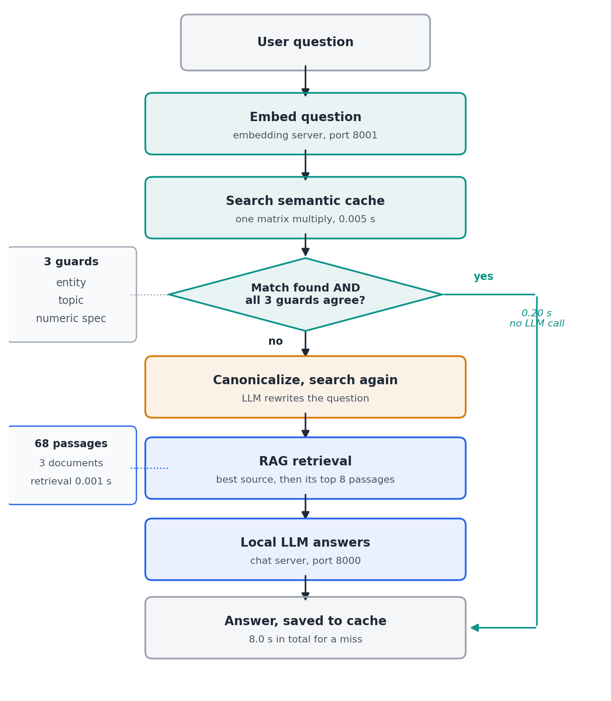
Figure 2. The path of one question, with measured timings.
There are three possible endings:
- Fast hit: a similar question is found and the three guards agree. The stored answer is returned in about 0.2 seconds with no model call at all.
- Canonical hit: nothing matches at first, so a short model call rewrites the question into a standard form and the cache is searched again. Two different phrasings of the same question become much more similar after rewriting, so this catches matches the first search misses.
- Miss: retrieval finds the most relevant passages, the model answers from them, and the answer is saved so the next similar question is fast.
The fast path exists because of a mistake in the first version. That version always called the model to rewrite the question, even when the answer was already cached, which made a hit almost as slow as a miss and defeated the point of having a cache.

4.2 The semantic cache
Each entry stores the canonical question, the original question as the user typed it, the answer, the embedding vector, when it was last used, and which documents the answer came from. Entries that are not used are removed with a least-recently-used rule, so the cache does not grow without limit.
Keeping the original question alongside the canonical one matters more than it looks. The guards in the next section need to compare what the user actually wrote, because rewriting sometimes removes the very detail that makes two questions different - Section 4.3 gives a real example.

4.3 Three guards against wrong cache hits
High similarity between two questions does not mean they have the same answer. This was the single most persistent source of bugs in the project. Before a cached answer is reused, three checks must all agree.

Entity guard
This came from a real failure in the first topic area. Two questions about student visas for different countries scored above the similarity threshold and matched each other, so the system answered a question about one country with the answer for another. The guard compares the named things in the two questions, and a small dictionary maps forms like "American" and "US" to the same entity. I used a dictionary rather than asking the model to normalise, because the model did it inconsistently.

Topic guard
Pre-warming the cache with hundreds of questions exposed a second kind of collision: two questions about the same country but different subjects, such as tuition fees and scholarships, matching at 70 to 76%. The entity guard cannot catch these because the entity is identical. This guard compares topic keywords and is kept deliberately independent of the entity check.

Numeric-specification guard
This one was built for Electrical Engineering, where the thing that separates two otherwise identical questions is usually a number. "What is the maximum load on a 15 A receptacle" and "...on a 30 A receptacle" are almost the same sentence, but the correct answers are 12 amperes and 24 amperes.
I added it only after proving the problem was real rather than assuming it. I put a trap question into the benchmark - a 30 A question whose 15 A version was already cached - and the cache returned the wrong answer at 58% similarity. One detail was instructive: the trap missed on the fast path and only matched after the rewriting step, meaning canonicalization had blurred the number that made the two questions different. That is a good argument for a separate deterministic check rather than trusting the embedding or the rewriting.
The guard extracts every number followed by a known unit, so "15A", "15 amperes" and "15-ampere" all match each other. A number with no unit is ignored, which keeps section numbers such as "1910.304(b)(4)" out of the comparison. Unlike the other two guards it requires only one shared value rather than proportional overlap, because a cached question often legitimately covers several values at once - the 15 A question also mentions the 20 A circuit it sits on.

4.4 Pre-warming
The system has no real users, so there is no traffic to learn from. Instead I generate realistic questions from templates and answer them during idle time, so that a later question has something to match against. In the education topic area this grew from 40 combinations to 600.
This part was not carried over to Electrical Engineering, and that was a deliberate decision rather than an omission. The education version was built around a clean pattern - one question template with a country slot - and Electrical Engineering has no equally natural equivalent. Section 6.3 lists it as a limitation.

4.5 Making the search fast
Three separate improvements were made to the similarity search, each measured rather than assumed.
First, the loop was replaced by a matrix operation. The original code compared the query to each stored vector one at a time; now all comparisons happen in a single matrix multiplication.
Second, the calculation was made mathematically correct. The old code used a raw dot product, which only equals cosine similarity when every vector already has length one. That was an assumption my code never enforced. I added explicit normalization to both sides. On real embeddings the numerical difference was about 0.000000015, far too small to change any cache decision, but the result is now a true cosine similarity by construction rather than by luck.
Third, I measured where the time was actually going and found a second bottleneck. The matrix multiplication was fast, but the full search was not: 80 to 90% of it was spent reading every row out of SQLite and rebuilding the matrix from scratch, on every single search. The matrix is now kept in memory and rebuilt only when something changes - a save, an eviction, or a clear.
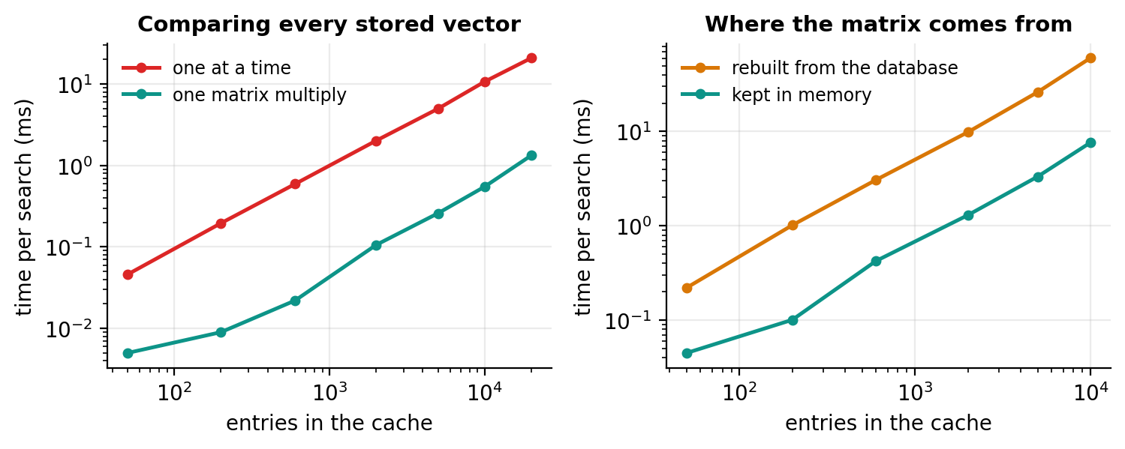
Figure 3. Left: comparing vectors one at a time against one matrix multiplication. Right: rebuilding the matrix from the database against keeping it in memory.
At the cache size I was working with, the matrix operation is about 26 times faster than the loop, and keeping the matrix in memory adds a further 5 to 10 times for repeated searches. Both gains hold across the range tested, up to 20,000 entries.
The largest single speed gain of the entire project, however, had nothing to do with algorithms. The code connected to the local servers using the name "localhost", which on this machine sometimes attempted an IPv6 connection first, waited for it to fail, and then fell back to IPv4. Using the numeric address instead removed the delay completely and made cache hits 80 to 100 times faster after any idle period. I would not have found it by reading the code; it only appeared once I measured the same operation twice and got very different times.

4.6 Retrieval for technical documents
Documents are plain text files. Each is split into overlapping passages, each passage is embedded, and each is stored with the name of the file it came from. Three things had to change for technical documents specifically.

Passage size measured in tokens, not words
The first real regulation crashed the embedding server. A 500-word passage became 802 tokens, over the server's limit. Technical text costs far more tokens per word than ordinary prose - I measured 1.6 against roughly 1.3 - because the wording is long and citations split into many pieces.
The first fix was a hand-tuned constant found by trial and error on that one file, which had no reason to transfer to another document. The system now measures the token cost of each document from a sample of its own text, derives a passage size from a token budget, and then checks the longest passage against the model's real limit and shrinks if needed. When I ran it, the automatic method independently chose a size within a few words of the constant I had found by hand, which was a good sign that the method was sound.

Tables kept apart from prose
Tables were being split by the same word-counting window as ordinary text. A table row could land in a passage that began with an unrelated sentence, and rows could be separated from the heading that gives their numbers meaning - a row reading "9001 V-25 kV, Condition A: 1.5 m" says nothing on its own about what is being measured.
Each table is now chunked on its own, and its heading is repeated at the top of every passage the table produces. Prose chunking is untouched, and a document with no tables is chunked exactly as it was before. Section 5.7 shows what this was worth.

One document at a time
Once more than one document was loaded, a question about one could pull passages from another. I saw this happen: a question about overcurrent protection retrieved three correct passages from the regulation and then a fourth, weaker one from an unrelated motor manual. Retrieval now finds the single best-matching passage first and then searches only within that passage's document, so nothing has to tell the system which document a question belongs to. The previous behaviour is still available as an option, which is how the two were compared.

4.7 Documents used
Document | Type | Passages
OSHA 29 CFR 1910.304 - Wiring Design and Protection | Real regulation | 34
OSHA 29 CFR 1910.303 - General | Real regulation | 32
ACME Industrial Electrical Installation Manual | Written by me | 2
The two OSHA regulations are real and in the public domain. The third document is invented deliberately: its rules exist nowhere else, so a correct answer about it can only have come from retrieval. Real regulations cannot prove this as cleanly, because the model may have seen similar text during training. Section 5.9 shows that this choice mattered more than I expected - and also caused a problem I did not foresee.

4.8 Managing the documents
Adding a document is a file copy. Every text file in the documents folder is loaded automatically, and files already stored are skipped. Before this, each document was written into the main script with its own path and settings, which meant a code change for every new file.
Editing a document is handled too, and this was the last genuine bug in the system rather than a limitation. Before the fix, an edited document left its old passages in the database and, worse, answers cached from the old version kept being served instantly and confidently, with no way for a user to notice. The system now stores a fingerprint of each file; when a file changes, its old passages and the cached answers built from it are removed and the file is reloaded. Answers from other documents are left alone.
There is also an interactive mode, so the assistant can be used rather than only benchmarked. Each answer is labelled with where it came from - the cache, with the similarity and the time, or a named document - which makes the cache visible in use. Appendix A shows a session.

5. Experimental Study

5.1 Choosing how to measure
Finding the right benchmark took some thought. The obvious option is to take an established one off the shelf, but the well-known benchmarks for this kind of system come with their own document collections. Running one would measure a different system on different documents, which is exactly what this project is not: an offline assistant answering from a specific set of electrical standards.
Rather than force a single benchmark to do a job it was not built for, I measured at three levels, each answering a different question:
What is measured | How | What it answers
The whole system | my own 15-question benchmark | is the answer right, and how fast
Retrieval alone | Recall@k and MRR, standard IR metrics | is the right passage found
The model alone | MMLU electrical engineering | how much does the model know by itself
The separation turned out to matter more than I expected. For weeks I could see that certain questions were answered wrongly, but not whether the wrong passage was being retrieved or the right passage was being misread. Measuring retrieval on its own settled that in minutes, and measuring the model on its own explained the one failure neither of the other two could.

5.2 My own benchmark: how the system is measured
A benchmark of 15 questions runs through the normal path. Each question stores its correct answer as a list of accepted phrases; trap questions also store phrases that must not appear. Timings are recorded stage by stage, answers are graded automatically and stored in full, and the whole set is repeated five times, because both the wording of answers and the speed of the model vary between runs. Every result row is appended to a file, so configurations measured on different days can still be compared.
The set covers four kinds of question on purpose: direct lookups, paraphrases of an earlier question (which should hit the cache), numeric traps that differ from a cached question only by a number, and two questions with no answer in any document - one off-topic, one plausible but absent - which test whether the system declines instead of inventing.
Automatic grading by string matching has a real weakness: an answer that states the correct rule and then draws the opposite conclusion can still score as correct. This is why full answers are kept and failing cases are read by hand. Doing that once caught the opposite error - the system correctly refused an impossible question, but my list of accepted refusal phrases was incomplete, so a correct refusal was marked wrong.

5.3 Results of the final system
Measurement | Result
Answer accuracy | 84.0% (63 of 75)
Cache hit response | 0.202 s
Cache miss response | 7.925 s
Speed-up, hit against miss | about 39x
Semantic search inside the cache | 0.0054 s
RAG retrieval | 0.0010 s
LLM inference, share of a miss | 90%
Cache hit rate | 26.7%
Wrong answers served from cache | 5
These figures come from the code exactly as submitted, over 15 questions repeated 5 times. Twelve of the fifteen questions are answered correctly in every repeat.

5.4 Where the time goes
This is the most useful single result of the project, and it was not what I expected before measuring.
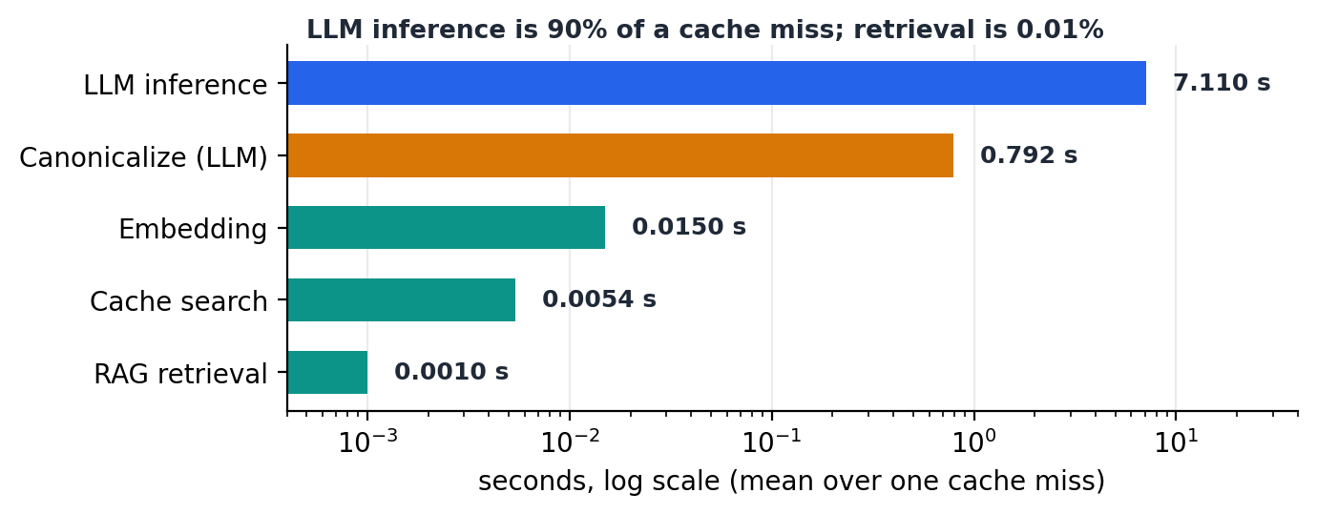
Figure 4. Time spent in each stage of a cache miss. Note the logarithmic scale.
Retrieval takes one thousandth of a second and searching the cache five thousandths. Both are effectively free. Model inference takes 7.1 seconds, which is 90% of the total.
This changes how the cache should be described. It is not valuable because searching is fast - searching was never the problem. It is valuable because a hit means the model is never called at all. It also means optimising retrieval further has nothing left to win, which is worth knowing before spending time on it.

5.5 Every configuration measured
The results file holds 645 rows across seven labelled runs. Five distinct configurations are compared below. Two runs are left out on purpose: one was a three-repeat intermediate measurement, and one label accidentally collected two separate runs, at least one of which was taken while the invented manual was temporarily edited for the experiment in Section 5.9, so its rows are not a clean single configuration.
Configuration | Accuracy | Hit | Miss | Speed-up
Top 4 passages, hand-tuned size | 72.6% | 0.196 s | 5.25 s | 27x
Top 8 passages, hand-tuned size | 74.7% | 0.201 s | 8.01 s | 40x
Automatic size, 200-token budget | 68.9% | 0.216 s | 13.16 s | 61x
Automatic size, 175-token budget | 78.7% | 0.206 s | 9.08 s | 44x
Table-aware chunking (final) | 84.0% | 0.202 s | 7.93 s | 39x
The 200-token row is kept because it is the most informative failure in the table. It was my first attempt at automatic sizing and it made the system clearly worse. Only the token budget differed between it and the row below, which is what turned "passage size matters" from an opinion into a measured result.
One warning about reading this table: the rising speed-up column is not an improvement. Hit times barely move across all five rows. The ratio grows when misses get slower, so the 61x row is the worst configuration, not the best.
The two top-4 and top-8 rows also show a trade-off that the totals hide. Retrieving more passages fixed one question, but the question whose answer is in no document went the other way: it refused correctly in all nine top-4 measurements, and in only one of five once eight passages were retrieved. More context helps the model find a fact and makes it worse at admitting a fact is missing.

5.6 Did the changes actually help?
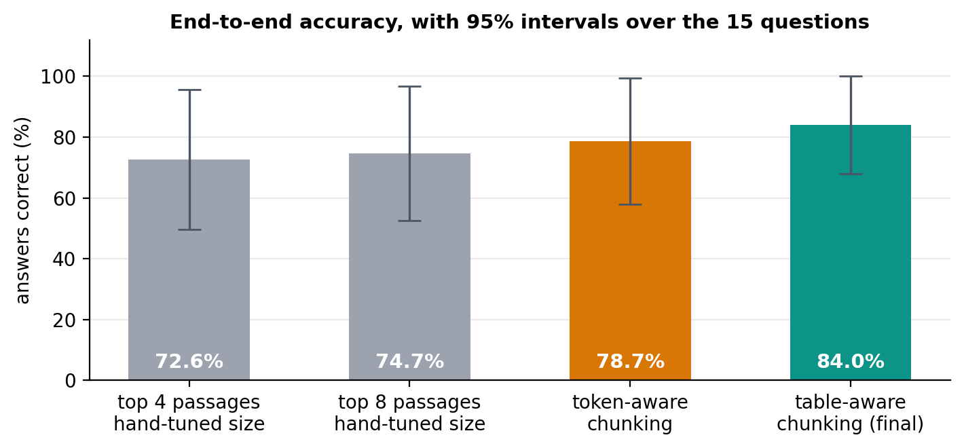
Figure 5. Accuracy after each change, with 95% intervals.
Accuracy rose from 72.6% to 84.0% across the project. The intervals, however, overlap, and they are wide because the unit that matters is the question, not the answer: 75 answers are 15 questions asked five times, and repeats of the same question are not independent of each other.
So the honest statement is that this question set cannot establish that one configuration beats another. I report the percentages as a description of what happened, not as proof that each change was an improvement. The evidence that does support the specific claims is in the next section, and it does not depend on sampling at all.

5.7 Retrieval measured on its own
Every accuracy figure above mixes retrieval and the model together, so a wrong answer could come either from the wrong passage being retrieved or from the model misreading the right one. To separate them I measured retrieval alone, with no model call at all.
Recall@k asks a simple question: is the passage that contains the answer among the top k the system retrieved? MRR - mean reciprocal rank - asks where it sits: a score of 1.0 means the right passage is always first, 0.5 means always second. These two are what retrieval work reports as standard; they are the headline numbers in collections such as BEIR, MS MARCO and TREC. I used them rather than inventing a measure so the numbers mean the same thing to a reader who already knows the field.
For each question I defined the passage containing its answer using an evidence string, and checked that each string appears exactly once in the whole corpus, so the correct passage is unambiguous however the documents are chunked. Two of the fifteen questions have no correct passage anywhere and are excluded. Precision@k is deliberately not reported: with exactly one correct passage per question it could never exceed 1/k and would carry no information, so including it would look thorough and mean nothing.
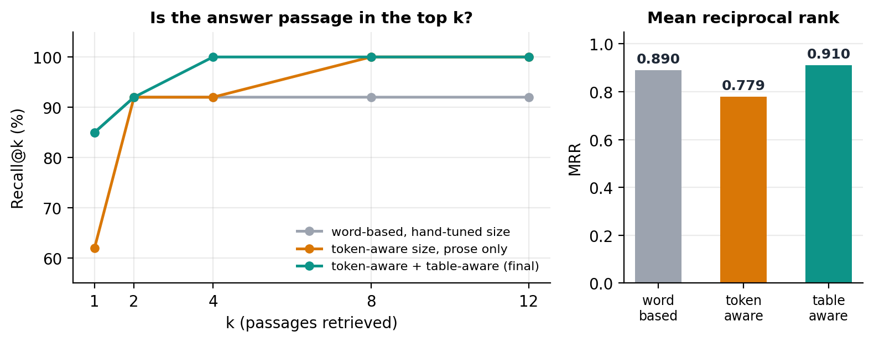
Figure 6. Retrieval quality under three chunking strategies, 13 questions.
The headline is a single question. The passage holding a clearance table row ranked 14th under word-based chunking, 8th under token-aware chunking, and 2nd once tables were chunked separately. The system retrieves 8 passages, so rank 14 was unreachable - and that question was answered wrongly in every repeat for weeks. After the change it is answered correctly in every repeat.
That chain is deterministic. Ranks are computed from embeddings with no sampling involved, so unlike the accuracy percentages this is not a statistical claim. It is the clearest demonstration of why the two measurements are worth keeping separate.
A second finding came out of the same measurement: the final system reaches full recall by the fourth passage, so retrieving eight is more than necessary. Retrieving fewer would make every miss faster and would probably improve the system's willingness to say it does not know, since more context makes it more likely to construct an answer. I did not act on this, because the code was frozen before the measurement was taken. It is the clearest single item of future work.

5.8 The model measured on its own
MMLU - Massive Multitask Language Understanding, published by Hendrycks and colleagues in 2021 - is one of the most widely used benchmarks for language models. It holds about 14,000 four-choice exam questions spread over 57 subjects, from law and medicine to mathematics, and nearly every model release reports a score on it. I used the electrical engineering subset, 145 questions, because it is the part that overlaps with this project.
This is the one measurement here that is external in every sense: I did not write the questions, I did not choose the answers, and because they are multiple choice the grading is exact rather than string matching. It says nothing about my system, since no documents are involved - but it measures the thing that Section 5.9 shows to be the system's main limitation.
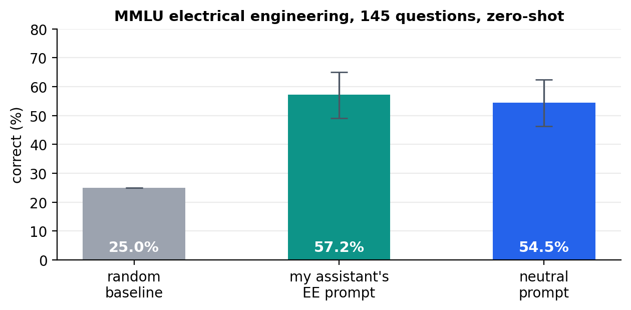
Figure 7. MMLU electrical engineering, 145 questions, zero-shot, temperature 0.
Two points of method. This is zero-shot, while the original MMLU paper reports five-shot results, which are normally higher; the published five-shot figure for Phi-3-mini on the full 57-subject suite is 68.8%, and mine is a single subject, zero-shot, on a 4-bit quantized copy, so the two are not directly comparable. The honest comparison here is the random baseline of 25%.
The model answers 54.5% correctly, well clear of chance. It has real electrical engineering knowledge - and the next section explains why that turned out to be a problem rather than a benefit.
The second variant is a result in itself. Running the same questions under my assistant's own system prompt - the one that restricts it to a single domain and tells it to answer only from provided information - scored 57.2%, with one refusal in 145 questions. The intervals overlap, so restricting the assistant to its domain costs nothing measurable on questions inside that domain.

5.9 The failure I could not explain, and how it was settled
One question was answered wrongly in every repeat, from the first day of the Electrical Engineering work to the last. It asks which breaker curve a 7 kW motor needs. The invented manual states that motors above 5 kW require a Type D curve, and the system kept answering Type C.
I proposed two explanations and both were wrong. First I assumed the small model could not compare 7 against a 5 kW threshold. Then, after improving retrieval, I concluded the context had been incomplete. A controlled experiment ruled out both: the model was given the entire rule in a single passage and still answered Type C.
The answer came from editing the document. I changed a conductor sizing rule in the manual from 125% to 130%, and confirmed the change had reached both stored passages. The system still answered 125% - the value from the National Electrical Code, which the model knows from training - while the document in front of it said 130%.
To check that retrieval was not at fault, I asked which section number of that manual covers conductor sizing. The answer, Section 4.3.5, is a number I invented; no model could know it from training.
[read 2 passage(s) from acme_manual_section_4.txt, 3.0s]
Answer: Section 4.3.5 covers conductor sizing for motor branch circuits
according to the ACME Industrial Electrical Installation Manual.
So retrieval works, grounding works, and document edits do reach the model. The failure is that when a document contradicts something the model already believes about electrical practice, the model follows its own knowledge. The breaker question has the same shape: requiring Type D above 5 kW runs against common practice, where Type C is usual for motors.
The last thing to test was whether an instruction could override it. I held retrieval fixed and varied only the instruction: none, an override line in the system message, the same line next to the context, and both at once.
[PROMPT EXPERIMENT] 5 trials per variant, 2 chunk(s) retrieved
current prompt (no override) 0/5 correct
override in system message 0/5 correct
override next to the context 0/5 correct
override in both places 0/5 correct
Twenty trials, no exception. This is a limitation of the small local model, not a bug in the pipeline and not a prompt that needs better wording. The MMLU result puts a number on the knowledge doing the overriding: the model answers more than half of professional electrical engineering questions correctly on its own, which is easily enough to hold confident opinions that disagree with a document.
It also means one of my own benchmark questions is weaker than I thought. The 3 kW version of the same question is answered correctly every time, but the model's own prior also says Type C, so that question cannot distinguish grounding from guessing. I would replace it if I were building the set again.

5.10 Two observations from using the system by hand
Using the assistant interactively found something the benchmark cannot see. Two questions that were related but asked something different - one about conductor sizing only, one about a section number - both matched a cached answer about breaker curves at around 60% similarity and received it. The threshold is 0.55, so this is the system working as configured, not a bug. The benchmark's paraphrase pairs sit in the same 61 to 74% band but genuinely ask the same thing, so the benchmark cannot distinguish the two cases. Raising the threshold to about 0.65 would cut these, but it would also reject a legitimate match measured at 60.99%. It is a real trade-off and I am reporting it rather than changing it, because there was no time left to measure the change properly.
Answer quality also tracks generation time. In the final run one question that had been solid became correct in only three repeats of five. Its two failures took 30.9 and 38.3 seconds; its three successes took 9.1, 13.7 and 9.8 seconds, with no overlap between the two groups. This is the same family as a 282-second runaway answer seen earlier in the project, and the small text corruptions that occasionally appear right after a number. It also means the 84.0% figure carries some dependence on machine conditions, which is part of why Section 5.6 treats it carefully.

6. Summary and Conclusion

6.1 What was built
- A complete offline pipeline: question, semantic cache, retrieval, local model, answer, saved back to the cache.
- A repeated question is answered about 39 times faster than the full pipeline: 0.2 seconds against 7.9.
- Three guards protect the cache from returning a confidently wrong answer, including a numeric guard built for this domain.
- Retrieval keeps documents apart, measures passage size in tokens rather than words, and chunks tables separately from prose.
- Adding or editing a document is a file operation; an edit removes the old passages and the cached answers built from them.
- A measurement harness records speed and accuracy together, and two further benchmarks measure retrieval and the model on their own.

6.2 What I learned
- Retrieval is free and the model is everything. 90% of a cache miss is inference, so the value of a cache is skipping the model, not searching faster.
- Cache hit rate on its own is a misleading metric. It went down when I fixed a correctness bug, because the hits it removed were wrong answers.
- A cache multiplies whatever accuracy a system already has, in both directions. A wrong answer, once stored, is served instantly to every later paraphrase.
- The most dangerous wrong answers are not invented ones. The worst case I found used a real number from the right document but the wrong paragraph, and read perfectly.
- More retrieved context is not simply better. It fixed one question and made another start inventing answers instead of refusing.
- The biggest speed gain of the project came from a hostname, not an algorithm. Measuring found it; reading the code would not have.
- Measure before concluding. Both of my explanations for the longest-running failure turned out to be wrong, and only a controlled experiment settled it.
- Knowing what a number cannot support is part of reporting it. The accuracy intervals here overlap, so the claims that survive are the deterministic ones.

6.3 Limitations
- A document that contradicts well-known practice loses to the model's own knowledge, and no instruction I tried changed that.
- The benchmark is small: 15 questions from 3 documents, graded by string matching, so failing cases must be read by hand.
- Accuracy differences between configurations are not statistically conclusive on a set this size.
- Timings vary between runs, and answer quality degrades when a generation runs unusually long.
- The similarity threshold is generous enough that a related but different question can receive a cached answer.
- The topic vocabulary and the pre-warming pipeline were built for the previous topic area and were not adapted. The numeric guard covers what mattered here, and Electrical Engineering has no equivalent of the country-slot pattern pre-warming relied on.
- The system assumes each question belongs to one document, so a question that genuinely spans two documents would be answered from only one.

6.4 Next steps
- Retrieve fewer passages. The final system reaches full recall by the fourth, so eight is more than needed; fewer would make misses faster and would likely improve refusals.
- Try a larger local model on the questions where the document contradicts common practice, since that failure is now known to be a model limit rather than a pipeline one.
- Grow the benchmark beyond 15 questions, so differences between configurations can be established rather than described.
- Measure the similarity threshold as a trade-off instead of leaving it at its current value.
- Add more documents, so retrieval is tested at a larger scale than 68 passages.
- Show which passage supports each part of an answer, which matters in a technical setting where a reader needs to check the source.

6.5 Closing
The system does what it was meant to do. It answers Electrical Engineering questions from real standards, entirely offline on a CPU, and it answers a repeated question roughly 39 times faster by not calling the model at all.
Looking back over the whole internship, the measurements corrected me more often than they confirmed me. The largest speed gain was a hostname rather than an algorithm; the accuracy differences I was most confident about turned out not to be statistically separable; and the failure I chased longest was not in my code at all. The most valuable outcome is not the accuracy figure but being able to say, for each remaining failure, exactly which part of the system it belongs to.

Appendix A: How to Run the System
Everything runs locally. No internet connection is needed at run time.

1. Start the two model servers
llama-server.exe -m "Phi-3-mini-4k-instruct-q4.gguf" -c 4096 --port 8000 -t 12
llama-server.exe -m "all-MiniLM-L6-v2-Q8_0.gguf" --embedding --pooling mean --port 8001

2. Put the documents in place
Any plain-text file in the ee_documents folder is loaded automatically the first time the system runs. Adding a document is a file copy; editing one is detected on the next run, and the old passages and any answers cached from them are replaced.

3. Ask questions
python domain_pipeline.py --chat

Electrical engineering technical support assistant.
Answering from 68 passages across 3 document(s), fully offline.
Type 'sources' to list the documents, 'stats' for cache statistics, 'exit' to quit.

Question: What type of circuit breaker curve should a 7 kW motor use?
[read 2 passage(s) from acme_manual_section_4.txt, 6.4s]
Answer: ...

Question: For a 7 kW motor, is Type C or Type D correct?
[answered from cache in 0.03s, similarity 90%]
Answer: ...
The line in brackets before each answer shows whether the answer came from the cache or from the documents, which makes the cache visible while the system is in use.

4. Reproduce the measurements
Command | What it does
python domain_pipeline.py | runs the 15-question benchmark, 5 repeats, appends to the results file
python analyze_benchmark.py | summarises every configuration in the results file
python retrieval_benchmark.py | Recall@k and MRR for three chunking strategies, no model calls
python mmlu_benchmark.py --data data | MMLU electrical engineering, 145 questions
The MMLU script needs the MMLU data archive unpacked into a folder; everything else runs from the repository as delivered.

Appendix B: Output From Test Runs
Console lines below are printed by the program. Answer text is written to the results file rather than the console, so answers are shown separately and labelled.

B.1 - The numeric guard (Section 4.3)
Before the guard existed. The 30 A question matched the cached 15 A question:
[DEBUG-ENTITY] sim=58.13% | q_ent=set() | c_ent=set() | entity_ok=True
| q_topic=set() | c_topic=set() | topic_ok=True | agree=True
[11] HIT (canonical_hit) total= 0.860s
The recorded answer was the cached 15 A one, ending "...the maximum cord-and-plug-connected load allowed is 12 amperes." The correct answer is 24 amperes.
After the guard was added, the same question is rejected and answered from the documents:
[DEBUG-ENTITY] sim=58.13% | entity_ok=True | topic_ok=True
| q_spec={'30a'} | c_spec={'15a', '20a'} | specs_ok=False | agree=False
[11] MISS (RAG) total= 5.276s
The recorded answer then gives 24 amperes, which is correct.

B.2 - Document change detection (Section 4.8)
After a document is edited, the next run replaces its passages and drops the answers that were built from it:
[INGEST] acme_manual_section_4.txt: CHANGED since it was loaded - removed
2 old passage(s) and 1 cached answer(s).

B.3 - Retrieval diagnostics (Section 5.7)
[CHUNK RANK] Looking for the chunk containing '762 mm'
Found at rank 5/30 (score=0.6523) -> OUTSIDE default top_k=4 - recall problem
scoped top_k=4 0/3 correct scoped top_k=8 3/3 correct

[CHUNK RANK] Looking for the chunk containing '9001 V-25 kV'
Found at rank 13/30 (score=0.4345) -> OUTSIDE default top_k=4 - recall problem

B.4 - Final benchmark summary (Section 5.3)
[BENCHMARK SUMMARY]
Queries : 75
Cache hit rate : 26.7% (20 hit / 55 miss)
Mean response (hit) : 0.202s
- semantic search : 0.0054s
Mean response (miss) : 7.925s
- canonicalize : 0.792s
- RAG retrieval : 0.0010s
- LLM inference : 7.110s (90% of a miss)
Hit vs miss speedup : 39x (averaged over 5 repeats)
Accuracy : 84.0% (63/75 graded)
- wrong cache hits : 5

