**Problem statement:**

To date the research on pipeline structures mostly focused on the buckling of different pipe configurations under compressive forces. Such research projects were carried out to investigate the buckling and fracture of pipe walls under compressive loading. The research projects [1], [2], [3] are some examples of experimental studies which analyzed the occurrence of local buckling in the form of wrinkles in the pipe wall due to bending. On the other hand there is a limited amount of research projects studying the tensile strain capacity of pipeline that considers the effect of the internal pressure.

Different mathematical descriptions of the tensile strain capacity $(ε_{t}^{crit})$ of pipes are available in the literature in the form of prediction equations. Some of these are incorporated in the CSA code for Pipeline Systems Operation (CSA Z662). However there is no well-established method for predicting the tensile strain capacity under internal pressure and the current equations in the CSA code don’t consider the effect of internal pressure on $ε_{t}^{crit}$. Also none of the currently available methods for tensile strain capacity prediction are applicable to vintage pipes with steel grade X52. The current equations in the literature assume a steel grade of X65 or higher. These conditions make it necessary to investigate the strain response of X52 pipes under internal pressure.

Cold bending is applied in order to change the direction of a pipeline in a horizontal or vertical plane. This can be necessary to conform with the terrain conditions. Cold bending is done on site using cold bending machines. In the process of cold bending the material properties of the tension and compression side can be affected differently since the compression side (intrados) of the pipe can be loaded beyond the yield stress in compression whereas the tension side (extrados) can be loaded beyond yield stress in tension. In case of the occurrence of local buckling in form of a wrinkle at the compression side, the wrinkled part of the cold bend experiences high tensile strains and is more likely to fail due to tensile strain than the tension side. However, experimental studies carried out by Sen et al [1], [2] demonstrated that failure of a cold bend at the tension side can occur earlier than compressive failure under certain loading configurations. However, the level of internal pressure at which such failure mechanism can occur is not well understood.

Pipes may undergo tensile strain due to a variety of reasons (see section 1). These strains can be detrimental if they exceed the tensile strain capacity of the pipe. It is crucial to develop an alarm mechanism which informs the pipeline operators when there is a danger of pipeline failure due to excessive tensile strain. This alarm mechanism should be based on criteria that define the likelihood of a pipe failure. In this research project we are concerned with defining failure criteria which consider the effect of internal pressure on the tensile strain capacity of pipes. We are analyzing the effect of internal pressure on the tensile strain capacity from two different viewpoints. Firstly, we are conducting full scale tests in which we load vintage girth welded pipes with tensile forces and internal pressure in the presence of a flaw in the heat affected zone of the girth weld. By varying the amount of pressure and the flaw size we are analyzing the effect of these parameters on the tensile strain capacity of the pipe. The second viewpoint is the analysis of cold bend pipe failure at the tension side. Our initial work showed that the occurrence of this mode of failure of a cold bend highly depends on the amount of applied internal pressure.

**Objectives and Specific Aims**

The main objective of this research is to identify the structural behaviour of pipes under tensile strain and to define the corresponding failure criteria. In the scope of this research the strain response of X52 vintage pipes with girth weld flaws under tensile forces and internal pressure is analyzed experimentally and numerically. Also previous experimental studies carried out by Sen et al [1], [2] are revisited in order to analyze them numerically and to define tensile failure criteria. The following outlines the two main objectives of this research along with their specific aims.

**Objective 1: Evaluating the Critical Strain Capacity of X52 Pipes.**

To achieve this main objective, we are proposing an experimental and numerical research program with the following specific aims:

**Specific aim 1.1:** Assessment of the sensitivity of CSA Z662.11 tensile strain capacity prediction equations to different geometric and material parameters.

**Specific aim 1.2:** Full Scale Experiments of X52 pipe

**Specific aim 1.3:** Developing a model for predicting the Tensile Strain Capacity of Girth welded X52 pipes.

**Specific aim 1.4:** Comparison between the different tensile strain capacity equations in the literature.

**Objective 2:** Developing generalized criteria for the tensile failure of cold bend pipes.

**Specific aim 2.1:** Numerical modelling of Sen et al experiments.

**Specific aim 2.2:** Developing a generalized model to predict the tensile failure of cold bend pipes

**Methods:**

**Objective 1: Evaluating the Critical Strain Capacity of X52 pipes.**

In order to achieve our objective, the current critical strain capacity equations available in the literature need to be studied and analyzed. Then, a full scale experimental study is designed to determine the critical strain capacity of X52 pipes with girth weld flaws under the effect of internal pressure. Finally, a numerical study is proposed in order to extend our experimental results and produce a prediction equation that is able to predict the strain capacity of X52 pipes as a function of the internal pressure and the flaw parameters. Following are the proposed methods to achieve our objective:

**Specific aim 1.1: Assessment of the sensitivity of tensile strain capacity prediction equations to different geometric and material parameters.** Different geometric parameters and material properties affect the tensile strain capacity of a pipe at different levels. Since our project consists of a limited number of full scale tests, it is not possible to test the effect of all parameters experimentally. Therefore it is necessary to narrow down the focus of the project to the most significant parameters affecting the tensile strain capacity. In order to achieve this, the sensitivity of the current CSA equations as well as other proposed equations in the literature should be analyzed with respect to changing magnitudes of different parameters.

**Specific aim 1.2: Full Scale Experiments of X52 pipe.** In order to investigate the critical strain capacity of X52 pipes, a full scale experimental study is proposed in which two levels of internal pressure, two different flaw thicknesses and two different flaw lengths are combined to produce 8 full scale tests (Table 1). Each experiment has a different combination of girth weld flaw size and internal pressure. The parameters which define the flaw size are the flaw length to pipe wall thickness ratio $(ξ)$ and the flaw depth to pipe wall thickness ratio $(η)$. According to the CSA code the allowable ranges for $ξ$ and $η$ are $ξ≤10$ and $≤0.5$. For $ξ<1$ and $η<0.1$ the flaw size is negligible according to the CSA code. Based on this information two different flaw depths (25% and 50% of the wall thickness) and two different flaw lengths (50mm and 150mm) are tested which gives us 4 different flaw size possibilities. The third variable internal pressure. In general, the internal pressure level is defined as the pressure leading to a circumferential stress of a certain percentage of the specified minimum yield strength (SMYS). The CSA code stipulates that the maximum operating pressure level is the 80%SMYS. For our tests, we are proposing 2 different levels (80% SMYS and 30%SMYS). With the addition of the internal pressure as the third variable a total of 8 different test configurations result each having a different combination of flaw depth, flaw length and internal pressure.

Table 1: Full Scale Test Matrix

| **Test number** | **Specimen length** | **Internal pressure (% SMYS)** | **Flaw length [mm]** | **Flaw depth [mm]** |
| --- | --- | --- | --- | --- |
| 1 | 72” | 80 | 50 | 1.7 |
| 2 | 72” | 30 | 50 | 1.7 |
| 3 | 72” | 80 | 50 | 3.4 |
| 4 | 72” | 30 | 50 | 3.4 |
| 5 | 48” | 80 | 150 | 1.7 |
| 6 | 48” | 30 | 150 | 1.7 |
| 7 | 48” | 80 | 150 | 3.4 |
| 8 | 48” | 30 | 150 | 3.4 |

**Machining the Girth Weld Flaw**

The flaws are machined in two stages using two different blades with thicknesses 0.012” and 0.006”. In the first stage the flaw is initiated with the 0.012” thick blade and cut up to a depth of 1.0 mm for the 1.7 mm deep flaw and up to a depth of 1.7 mm for the 3.4 mm deep flaw. In the second stage the blade is replaced with a 0.006” thick one and the rest of the flaw depth is cut. Before starting to cut the flaw it is checked with an L-shaped ruler that the pipe surface is perfectly perpendicular to the blade. During the flaw cutting process the pipe is located on roller stands. The circumferential length of the flaw is controlled with the rollers of the pipe stand and two magnets (G6 in Figure 1) on the pipe surface 50 mm or 150 mm apart from each other in the circumferential direction. The magnets stop the rotation of the pipe once 50 mm or 150 mm flaw length is reached. The depth of the flaw is increased in 0.05 mm steps and the depth is controlled using a dial indicator. There are two dial indicators denoted with G3 and G4 in Figure 1 showing the position of the blade in the directions parallel and perpendicular to the pipe surface respectively. G4 is brought to zero position at the beginning of the flaw cutting process once the blade touches the pipe surface and G3 is brought to zero position once the blade is aligned with the middle of the flaw location (within 5 mm distance from the girth weld). The position of the blade is adjusted using the x-y table denoted with G1 in Figure 1. An air driven motor (G2) is used to rotate the blade which is clamped between stiffeners and these stiffeners are connected to a steel block which is clamped in the x-y table. The blade-stiffener-steel block assembly is denoted with G7 in Figure 1.

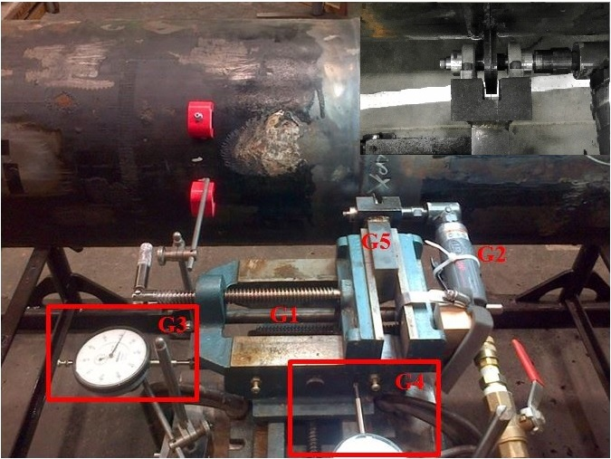

**G6**

**G7**

**G7**

Figure 1: Flaw Cutting Setup

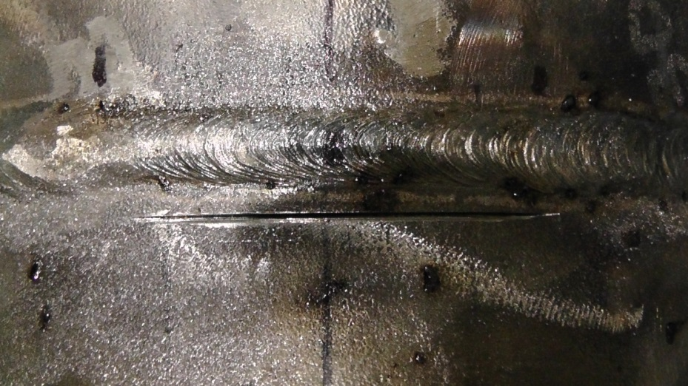

Figure 2: Flaw in the heat affected zone

**Loading the pipe:** (How and why?)

**Strain Measurements**

In each full scale experiment (Table 1) the longitudinal and hoop direction strains are measured with strain gauges at critical locations of the pipe. In addition to that, digital image correlation is used to obtain the variation of the strain field during each experiment at critical locations of the pipe. The results of these measurements are used to evaluate the tensile strain capacity of each specimen. The critical tensile strain is defined in the CSA code as the value of the global compressive strain at the onset of rupture. From our tests, we are proposing the following three different options for the evaluation of the tensile strain capacity of the full scale specimen:

**Option 1:** In the literature [4] the tensile strain capacity is defined as the average axial strain value at a uniform strain zone far away from the girth weld flaw location. In this case several strain gauges are mounted on this uniform strain zone. The average value of the strain measured by these strain gauges is called the remote strain.

**Option 2:** The tensile strain capacity of the pipe can be defined as the axial strain at the uniform strain zone closest to the girth weld flaw as observed in the image correlation.

**Option 3:** As an alternative to defining the tensile strain capacity as a single number for each test specimen, the critical strain profile could be defined in the longitudinal direction of the pipe. For this purpose the strain values from the digital image correlation and the strain gauge measurements are used in combination with each other. For the first two tests three measurements can be used to create the strain profile. These measurements are the strain value at 0.8 OD away from the end plate, the strain gauge measurement in the middle of the lower side of the pipe, and a strain measurement 0.7 OD away from the flaw.

The strain is measured using strain gauges and digital image correlation. For the image correlation, portions of pipe surface around the flaw and adjacent to the lower end plate are painted in white and speckled in a dark colour before the test. This is necessary since the image correlation method uses the initial and deformed positions of the speckles to calculate the strain field at different stages of the experiment. On the remaining parts, strain gauges are glued on the pipe surface at selected distances from the end plates. At each selected distance a ring which consists of four strain gauge couples (consisting of one axial and one hoop direction strain gauge) or single strain gauges (strain gauge only in axial direction) is used. These four strain gauge positions are 90 degrees apart from each other in the circumferential direction. Putting strain gauges at different positions around the circumference is necessary since the axial strain changes around the circumference due to the eccentricity of the applied displacement. Figure 3 shows four quarters of the pipe wall cross section denoted by $Q_{1}$ to $Q_{4}$. In the middle of each quarter the corresponding strain gauge location is shown with red lines and a strain gauge label. Each strain gauge label starts with the letters $SG$ standing for “strain gauge”. In the strain gauge labels the numbers $0$ to $270$ denote the angular distance of the gauge location from the flaw midline in degrees. The letters $A/H$ at the end of each label indicate that the gauge could be in axial or hoop direction.

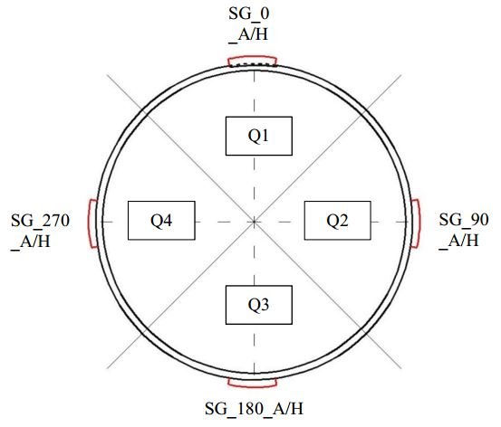

Figure 3: Strain gauge positions around the pipe circumference

**Specific aim 1.3: Developing a model for predicting the Tensile Strain Capacity of Girth welded X52 pipes.**

In the scope of this project we are aiming to develop a model which predicts the tensile strain capacity using three input variables. These variables are the same ones which take two different values in the full scale experiments: The ratio of flaw length to pipe wall thickness $(ξ)$, the ratio of flaw depth to pipe wall thickness $(η)$ and the internal pressure ${(p}_{i})$. Since the experimental results are limited to two levels of each parameter, a finite element model is developed which can accurately simulate the strain response of the pipe in order to obtain predictions for further levels of the parameters for which no experimental data is available.

The combination of experimental and simulated results will provide us with a large database of strain responses based on which the model can be developed. The model will consist of Bezier surface equations corresponding to different levels of internal pressure. The surface equations will describe the variation of the tensile strain capacity with respect to $ξ$ and $η$ for selected levels of $p_{i}$.

**Definition of the Bezier surfaces for the prediction of the tensile strain capacity**

Bezier surfaces are defined by a two dimensional grid of control points $P_{i,j}$. In this project the experimental and simulated $ε_{t}^{crit}$ values constitute the control points. Let $(ξ, η)$ be any flaw size combination which is neither experimentally tested nor simulated. Let ${(ξ}_{l}, η_{l})$ and $(ξ_{u},η_{u})$ be the lower and upper bounds for $(ξ,η)$. The first step in defining the Bezier surface is to map $ξ$ and $η$ into the interval $[0,1]$ as follows:

$$ξ^{'}=\frac{ξ-ξ_{l}}{ξ_{u}-ξ_{l}} , η^{'}=\frac{η-η_{l}}{η_{u}-η_{l}}$$

Where $ξ'$ and $η'$ are the transformed versions of $ξ$ and $η$ such that $ξ^{'}, η^{'}∈[0,1]$. The equation describing the Bezier surface is constructed using Bernstein polynomials as shown in equation (1).

|  |  |
| --- | --- |
| $$p\left(ξ,η\right)=\sum_{i=0}^{m}{\sum_{j=0}^{n}{B_{m,i}\left(ξ^{'}\right)B_{n,j}\left(η^{'}\right)P_{i.j}}}$$ | (1) |

In equation (1), $m$ and $n$ denote one less of the number of control points in $ξ$ and $η$ directions respectively. $B_{m,i}$ and $B_{n,j}$ are called the Bernstein polynomials and their values are calculated as in equation (2).

|  |  |
| --- | --- |
| $$B_{m,i}\left(ξ'\right)=\frac{m!}{i!\left(m-i\right)!}{(ξ')}^{i}{\left(1-ξ'\right)}^{m-i}$$ $$B_{n,j}\left(η'\right)=\frac{n!}{j!\left(n-j\right)!}{(η')}^{j}{\left(1-η'\right)}^{n-j}$$ | (2) |

The products $B_{m,i}\left(ξ^{'}\right)B_{n,j}\left(η^{'}\right)$ in equation (1) are weight coefficients which define the contribution of the control point $P_{i.j}$ to $p\left(ξ,η\right)$ which represents the predicted tensile strain capacity for the flaw configuration $(ξ, η)$.

**Specific aim 1.4: Comparison between the different tensile strain capacity equations in the literature.**

Several research groups have introduced equations for the prediction of the tensile strain capacity based on full scale tests and finite element analysis. These equations have certain limits of applicability in terms of flaw size limits or material property limits. A common approach is to develop a system whose input consists of flaw dimensions, pipe geometry, material properties and whose output is the tensile strain capacity of the pipe having these geometry and material properties. Our objective is to make a comparison between outputs of each equation in order to have an understanding of their applicability to different scenarios and the possibility of utilizing them for X52 pipes. The following equations are currently available in the literature for the prediction of the tensile strain capacity ([7],[4],[6]) :

|  |  |
| --- | --- |
| $$ε_{t}^{crit}=δ^{2.36-1.58λ-0.101ξη}(1+16.1λ^{-4.45})(-0.157+0.239ξ^{-0.241}η^{-0.315})$$ | (3) |
| $$ε_{t}^{crit}=A\frac{f\left({\left(Cδ_{A}\right)}^{Bδ_{A}^{D}}\right)}{1+f\left({\left(Cδ_{A}\right)}^{Bδ_{A}^{D}}\right)}$$ | (4) |
| $$ε_{t}^{crit}=β_{1}ln\left[\frac{aC}{{\left(t-a\right)}^{2}}\right]+β_{2}$$ | (5) |

Table 2: Nomenclature for equations (3), (4), (5)

|  |  |  |
| --- | --- | --- |
| Equation (1) | $$δ$$ | Crack-tip opening displacement (CTOD) toughness [mm] |
| $$λ$$ | Ratio of yield strength to tensile strength (Y/T) |
| $$ξ$$ | Ratio of flaw length to pipe wall thickness |
| $$η$$ | Ratio of flaw height to pipe wall thickness |
| Equation (2) | $$A,B,C,D$$ | Fitted functions of normalized geometry and material parameters |
| $$δ_{A}$$ | Girth weld CTOD toughness [mm] |
| Equation (3) | $$β_{1}, β_{2}$$ | Functions of flaw size and pipe material properties |
| A | Flaw depth |
| C | Half flaw length |
| T | Pipe wall thickness |

**Objective 2: Developing generalized criteria for the tensile failure of cold bend pipes.**

Any alarm system for the prevention of the tensile failure of cold bends needs to be implemented based on well established failure criteria. In this study we are aiming at developing such failure criteria by simulating the structural behaviour of cold bends under the combination of bending and internal pressure. Experimental studies of Sen et al [1], [3] showed that cold bends under internal pressure and closing mode bending loads can fail at the tension side after the formation of wrinkles at the compression side pipe wall. This is an unexpected mode of failure because of the large deformations at the compression side of the cold bend in the post-buckling phase.

Table 3: Geometry and Material Properties of the Cold Bend

|  |  |
| --- | --- |
| Nominal diameter | 762 mm |
| Wall thickness | 8.2 mm |
| Grade | X65 |
| Curvature | Bent 1 degree per diameter in length |
| SMYS | 448 MPa |
| Internal pressure | 80% SMYS hoop stress |

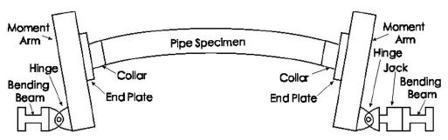

x

y

Figure 4: Experimental setup of the cold bend

**Specific aim 2.1:** **Numerical modelling of Sen et al experiments.**

In the scope of this research project, the load case and pipe geometry combination which lead to the tension side fracture of a cold bend in the experimental studies of Sen et al is simulated using finite element analysis. The objective of this simulation is to verify the outcome of the experimental studies of Sen et al and to obtain a better understanding of the conditions which lead to the tension side fracture of a cold bent pipe. Furthermore the numerical analysis of the strain distribution at the tension side of a cold bend for different load cases enables us to define failure criteria for the tension side failure mode of a cold bend pipe.

The finite element simulations are carried out for all steel grades (X60, X65, X80) tested in the experimental study of Sen[1]. In order to investigate the effect of the internal pressure level on the structural behaviour, a parametric study of the internal pressure is carried our for internal pressure values ranging between 1.93 MPa and 7.72 MPa which cause 20% SMYS and 80% SMYS hoop stress respectively. In these simulations the pipe geometry is meshed using 4-node general purpose shell elements with reduced integration (S4R). A non-linear isotropic hardening material behaviour is adopted in order to model the plastic material response. In this model, the relationship between the yield stress and the plastic strain is assumed to be non-linear between the initial yield stress and the ultimate strength. 237 mm long sections of the pipe next to the end plates are assigned a greater element thickness (16 mm) than the rest of the model (8.2 mm) in order to model the effect of the reinforcing collars (Figure 1) and to prevent an inappropriate buckling of the model due to the pipe - end plate interaction. The moment arm (Figure 1) is modeled using rigid beam and multi point constraints. The nodes on the left pipe edge (Figure 2, Figure 3) are connected to a reference point at the centroid of the cross section of the pipe edge using multi-point constraints. This reference point, on the other hand, is connected to another reference point 600 mm below in y-direction with rigid beam constraints. In the setup of Figure 1, the jack on the right hand side applies the displacement. This jack is connected to the moment arm with a pin-yoke assembly which is denoted as “hinge” in Figure 1. In the rest of this text this right hand side hinge is referred to as the “loading pin”. In the finite element model, the reference point located 600 mm below the pipe axis represents the loading pin.

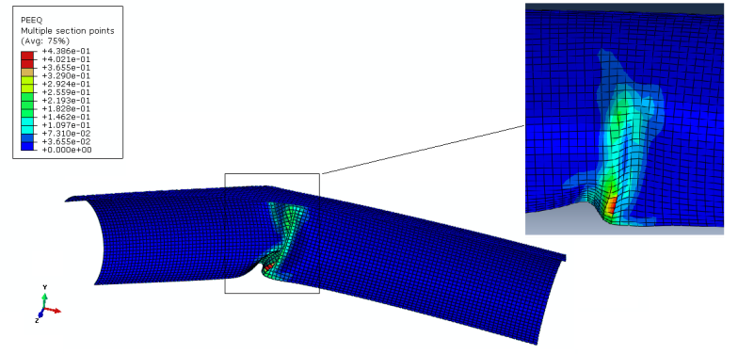

Figure 5: Plastic strain distribution under bending load without internal pressure

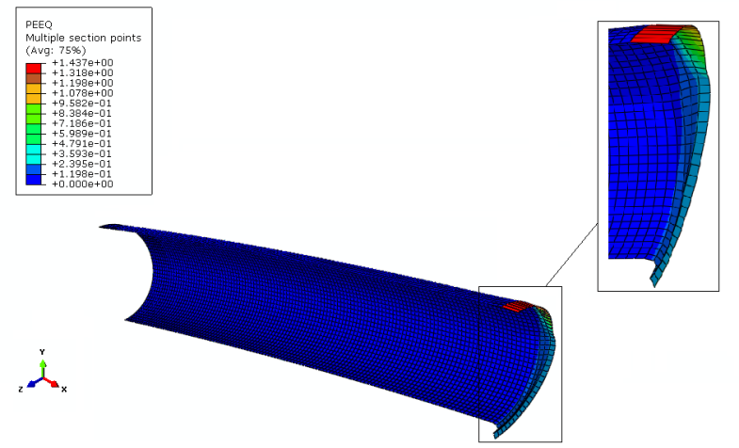

Figure 6: Plastic strain distribution under bending load and internal pressure

In order to increase the computational efficiency of the model, symmetry conditions are introduced. For this purpose symmetry planes parallel to x-y and y-z planes are introduced and one quarter of the entire cold bend pipe is simulated. As the first step of the simulations, internal pressure is applied on the inner surfaces of the pipe wall. In the parametric studies of the effect of internal pressure, the pressure value is varied between 1.93 MPa and 7.72 MPa which correspond to 20% SMYS and 80% SMYS hoop stress respectively. In the next step of the simulations a displacement load of 298.99 mm is applied to the loading pin in x-direction causing the closing mode bending stresses and increasing the initial curvature of the cold bend.

**Specific aim 2.2:****Developing a generalized model to predict the tensile failure of cold bent pipes**

The finite element simulations showed that the failure of a cold bent pipe at the tension side is limited to load cases with internal pressure. Furthermore the amount of internal pressure is a decisive factor for the failure mode. In order to define a failure criterion, the variation of the equivalent plastic strain with respect to applied curvature is plotted for different levels of internal pressure. These plots have revealed that starting from a certain level of internal pressure, the equivalent plastic strain at the compression side stays below 40% whereas the equivalent plastic strain at the tension side starts to exceed 40%. This internal pressure level is denoted as **transition pressure** in this text and can slightly change with respect to the steel grade of the pipe. Also for internal pressure levels below the transition pressure, the equivalent plastic strain at the compression side can exceed 40% whereas at the tension side it stays below 40%.

**References**

[1] Sen M. (2006); “Behaviour of Cold Bend Pipes Under Combined Loads” Ph.D. dissertation, University of Alberta

[2] Das S. (2003);” Fracture of Wrinkled Energy Pipelines” Ph.D. dissertation, University of Alberta

[3] DelCol P.R., Grondin G.Y., Cheng R.J.J., Murray D.W. (1998);”Behaviour of Large Diameter Line Pipe Under Combined Loads”, University of Alberta, Department of Civil Engineering, Structural Engineering Report No. 224

[4] Wang Y-Y.,et al (2011); “Second Generation Models for Strain-Based Design. Contract PR-ABD-1-Project 2. Final Approved Report Prepared for the Design, Materials and Construction Technical Committee of Pipeline Research Council International, (PRCI) Inc.

[5] Sen M., Cheng J.J.R., Zhou, J. (2011): ” Behavior of Cold Bend Pipes under Bending Loads ”, Journal of Structural Engineering, Volume 137, Issue 5, DOI:10.1061/(ASCE)ST.1943-541X.0000219

[6] Kibey S., Wang X., Minnaar K., Macia M.L., Fairchild D.P., Kan W.C., Ford S.J., Newbury B. (2010): “Tensile Strain Capacity Equations For Strain-Based Design of Welded Pipelines”, Proceedings of the 8th International Pipeline Conference, IPC2010-31661

[7] CSA Z662-11; Oil and gas pipeline systems - Sixth Edition; Update No. 1: January 2012