c

|  |  |
| --- | --- |
| b  a  d |  |

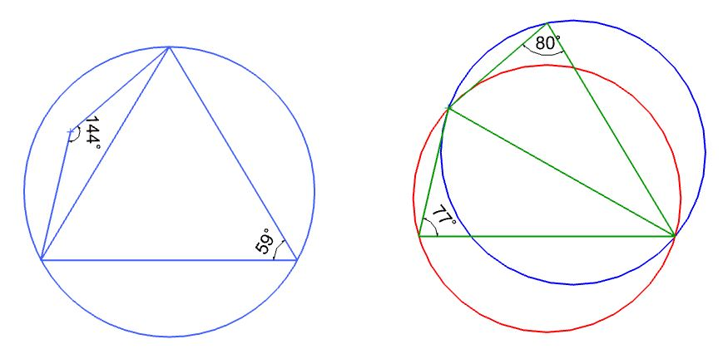

c

b

b

c

d

a

d

a