Build a highly available Redis Cluster based on the given architecture diagram.

<https://redis.io/learn/operate/redis-at-scale/scalability/exercise-1>

<https://kubernetes.io/docs/tutorials/configuration/configure-redis-using-configmap/>

<https://www.rancher.cn/blog/2019/deploying-redis-cluster>

<https://dev.to/dm8ry/how-to-deploy-a-redis-cluster-in-kubernetes-5541>

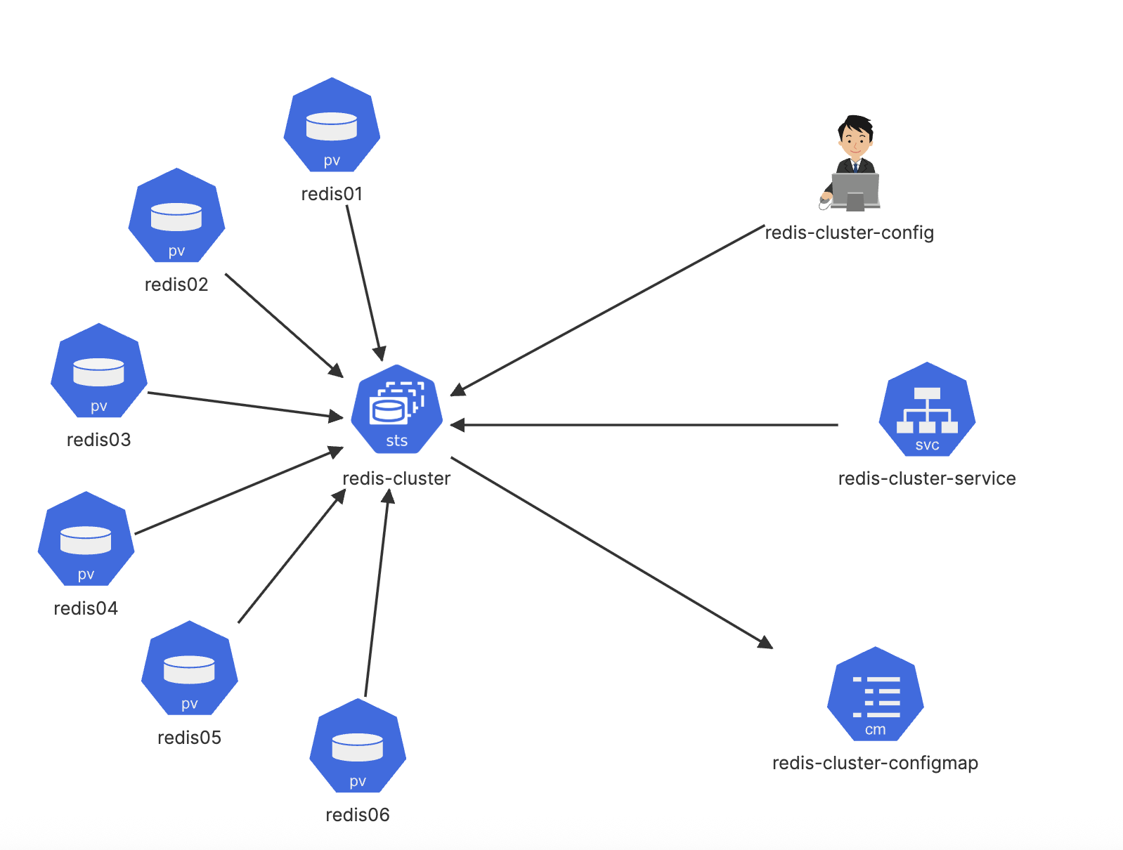

Redis-cluster-config

kubectl exec -it redis-cluster-0 -- redis-cli --cluster create --cluster-replicas 1 $(kubectl get pods -l app=redis-cluster -o jsonpath='{range.items[*]}{.status.podIP}:6379 {end}')

Redis01 … Redis06

PersistentVolume - Name: redis01

Access modes: ReadWriteOnce

Size: 1Gi

hostPath: /redis01, directory should be created on worker node

Redis-Cluster

StatefulSet - Name: redis-cluster

Replicas: 6

Pods status: Running (All 6 replicas)

Image: redis:5.0.1-alpine, Label = app: redis-cluster

container name: redis, command: ["/conf/update-node.sh", "redis-server", "/conf/redis.conf"]

Env: name: 'POD_IP', valueFrom: 'fieldRef', fieldPath: 'status.podIP' (apiVersion: v1)

Ports - name: 'client', containerPort: '6379'

Ports - name: 'gossip', containerPort: '16379'

Volume Mount - name: 'conf', mountPath: '/conf', readOnly:'false' (ConfigMap Mount)

Volume Mount - name: 'data', mountPath: '/data', readOnly:'false' (volumeClaim)

volumes - name: 'conf', Type: 'ConfigMap', ConfigMap Name: 'redis-cluster-configmap',

Volumes - name: 'conf', ConfigMap Name: 'redis-cluster-configmap', defaultMode = '0755'

volumeClaimTemplates - name: 'data'

volumeClaimTemplates - accessModes: 'ReadWriteOnce'

volumeClaimTemplates - Storage Request: '1Gi'

redis-cluster-service

Ports - service name 'redis-cluster-service', port name: 'client', port: '6379'

Ports - service name 'redis-cluster-service', port name: 'gossip', port: '16379'

Ports - service name 'redis-cluster-service', port name: 'client', targetPort: '6379'

Ports - service name 'redis-cluster-service', port name: 'gossip', targetPort: '16379'