Rainbow User Manual
First edition, 3nd September 2019

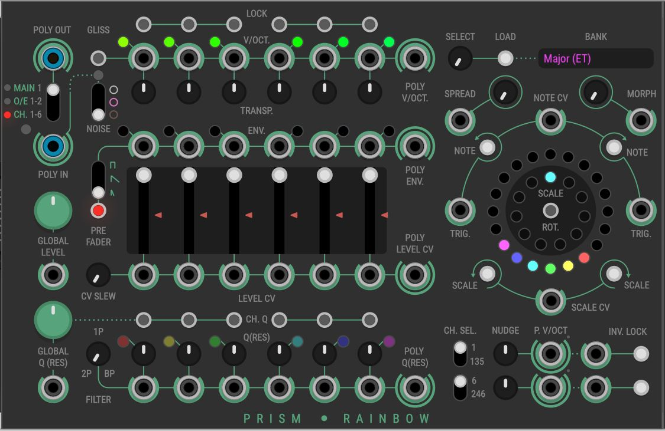
What is Rainbow?
Rainbow based on the 4ms Spectral Multiband Resonator Eurorack module to the VCV virtual modular synthesizer system.
The core of Rainbow are six resonant band-pass filters. Each filter is independently tuned with the tuning controlled through a scale of 20 notes. The filters are grouped into ‘odd’ and ‘even’ filters, with the odd filter being the first, third and fifth filters counting from the left, and the even filters being the second, fourth and sixth filters.
Rainbow is polyphonic with mono, stereo or six-channel input and output. Almost everything is user-controllable and voltage control is available for almost all controls.
The user is encouraged to refer to the original SMR manual as it gives a more in depth description of the original hardware and is broadly applicable to Rainbow.

Quick start
- Connect the POLY OUT output to the first output in the VCV Core Audio module.
- Noise is to all six filters. Use the NOISE switch to select different noise types.
- Use the GLOBAL Q control move between noise and sine waves.
- Connect a trigger source to the POLY IN input. This will excite the filter. If the input is a gate, the filter will be excited at the start and end of the gate
- Use the SPREAD control to move the notes around the scale ring
- Use the NOTE buttons to rotate the notes around the scale ring

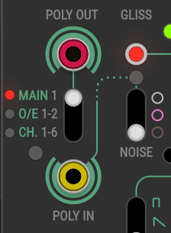

Audio in and out
Connect input audio sources to Rainbow with the POLY IN connector. It is polyphonic and there are four routing options depending on the number of active channels on the input cable.
- Channel 1 active: Single audio routed to all filters. The MAIN LED lights red.
- Channel 1-2 active: Channel 1 routed to the odd filters and Channel 2 routed to the even filters. The O/E LED lights red.
- Channel 1-3 active: Channel 1 routed to filters 1 and 2, Channel 2 routed to filters 3 and 4 and Channel 3 routed to filters 5 and 6. The O/E LED lights green.
- Channel 1-6 active: Each Channel is routed to its own filter. The CH. LED lights red.
The Clipping LED to the left of the input will light if the input clips.
If there is no input connected, Rainbow uses an internal noise source instead. The NOISE switch selects the type of noise, white, pink or brown generated, and the Noise LED immediately above indicates if the noise source is used.
Audio output from Rainbow is through the POLY OUT connector. It is a polyphonic output and there are three output modes, selectable through the switch underneath the jack.
- Main: Mono output, all filter output is merged onto cable Channel 1.
- O/E: The odd channel is output on Channel 1 and the even channel on Channel 2.
- CH.: Each filter is output on a separate channel.
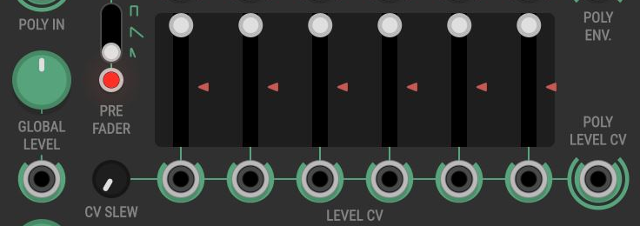

Levels
Global and per filter controls set the output level of the module. The GLOBAL LEVEL control is applied to all filters and the dial allows up to 2x gain. Each filter has an additional level setting using the level slider and both the LEVEL CV mono input and corresponding channel on the POLY LEVEL CV input. The level applied to the filter output is calculated as follows:
(GLOBAL LEVEL + GLOBAL LEVEL CV) x
(LEVEL CV + POLY LEVEL CV) x
SLIDER LEVEL
If neither the LEVEL CV nor POLY LEVEL CV are connected, the inputs are ignored, thus:
(GLOBAL LEVEL + GLOBAL LEVEL CV) x
SLIDER LEVEL
The level CV inputs use the -5V to 5V bipolar modulation standard.
The red level triangle next to the slider indicates the final level of each channel and the level is output on Channels 7-12 in the POLY ENV output (range 0V to 20V).
The CV SLEW control applies a slew to the CV level inputs allowing gates and clocks as level inputs without hearing pops and clicks.

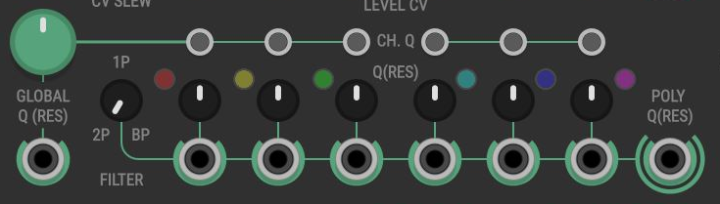

Filter controls
Rainbow has two modes for setting the filter resonance. The GLOBAL Q control sets the resonance of all the filters. The global level can be overridden per filter by pressing the CH. Q button. Once overridden, there are three controls for the resonance, the Q(RES) dial, a per-channel mono input and the corresponding channel on the POLY Q(RES) input.
The Q CV inputs use the -5V to 5V bipolar modulation standard.
The Q LED shows the Q level per channel increases in brightness as the Q level increase. The LED colour matches the colour in the outer LED ring on the right.
There are three different filters types available, the FILTER dial selects which filter to use.
- MaxQ/One-Pass (1-P)
- MaxQ/Two-Pass (2-P)
- BpRe

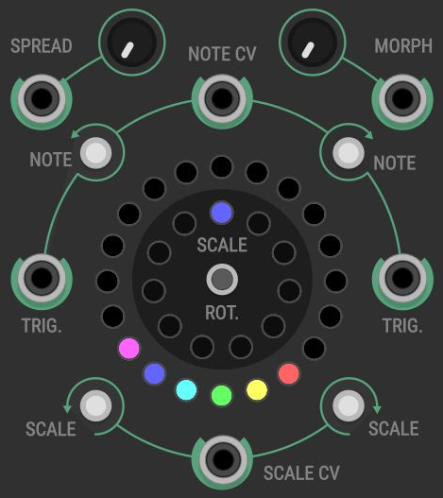

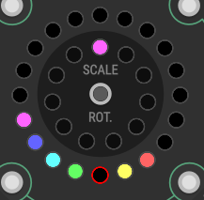

The scale ring
The Scale Ring and attached controls define the filter tuning frequencies. The Scale Ring shows the currently active notes for each of the filters. There are 20 notes arranged into a scale that in turn belong to a bank. The image above – the default setting – shows six consecutive notes (shown on the outer LED ring) from the first scale (the inner LED ring) belonging to the ‘Major (ET)’ Bank.
Notes can be rotated around the ring as a group using the NOTE button (with the direction indicated), the attached TRIG. gate input or the NOTE CV input.
The SCALE buttons or the SCALE CV input select the scale. If the SCALE ROT. button is pressed, when a note passes the first note in the scale (the top LED in the outer ring) it moves to the next scale (or back to the previous scale, if moving counter-clockwise).
The SPREAD control distributes notes around the ring. The MORPH control applies a slew to the movement of notes around the ring, either through the NOTE controls or through the SPREAD control. This can be useful for smoothing out filter clicks when moving from note to note.
Clicking on a LED in the outer ring activates frequency blocking for that note within the scale and will no longer be available for filter tuning. Blocked notes have a red LED border. Up to 14 notes can be blocked.

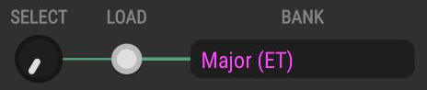

Presets

There are many scale banks with Rainbow available with the BANK control, these are the original presets from SMR. In order to avoid unpleasant changes in notes, the user must select a new bank and then press the LOAD button in order to activate it. The newly chosen bank will display an asterisk next to the name until the bank is loaded. Due to limitations in the module, it is not possible to select the User Scale with the BpRe filter; doing so will result in the bank returning to the last compatible setting.
With the Spectrum expander module, the user can specify any scale imaginable using the User Scale bank. Spectrum loads a bank into User Scale bank in Rainbow.
More details on the Spectrum module can be found later in this document.

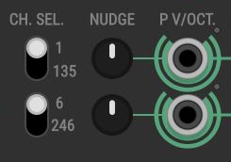



Tuning controls
The NUDGE control and P V/OCT. input applies a frequency offset to a filter tuning. The maximum NUDGE is a one semi-tone up or down. The P V/OCT. range is -3.33V to 4.5V. In BpRe filter mode the P V/OCT. input does not track 1V per Octave but it is approximately 2V per Octave.
The 1/135 and 6/246 switches control if the NUDGE and P V/OCT. controls are applied to just filter 1 (or 6) or to all odd (or even) channels.
The P V/OCT. inputs are polyphonic. If one channel is active on that input, that voltage offset is applied to the selected filter tuning (depending on the 1/135 or 6/246 setting). If three channels are active, the voltages are applied to the filter tuning individually (although it only makes sense to do this if in 135 or 246 modes.
The filter tuning can be transposed up or down 1 octave with the TRANSP. Dials.



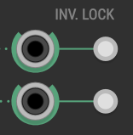

Locks
The LOCK button locks a filter. If a filter is locked, the NUDGE, P V/OCT. and TRANSP. controls are ignored for that filter.
The INV. LOCK buttons and CV trigger inverts the lock state for filter 1 or all odd filters (or 6 or all even filters) depending on the state of the 1/135 (6/246) switches.

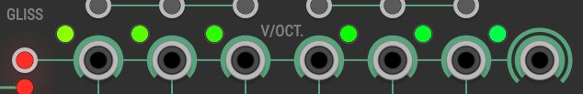

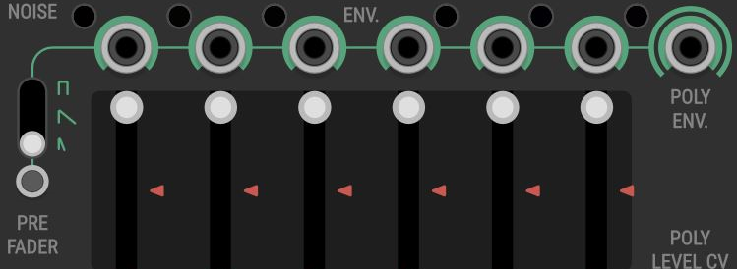

Auxiliary outputs
The V/OCT. mono output sends out the 1V/Octave tuning for a filter channel. The same is sent on the corresponding channel on the POLY V/OCT. output. The LED represents the V/OCT value compared to 0V/C4 represented by green. Yellow through to red is below C4, and cyan through to blue is above C4.
The GLISS button controls if a slew is applied to the V/OCT. and POLY V/OCT. outputs.
The ENV. mono output sends out an envelope signal for a filter channel which gives the overall frequency content/output level. The same is sent on the corresponding channel on the POLY ENV. output. The LED represents the overall level of the envelope.
The PRE FADER button adjusts whether the envelope is output before the LEVEL control is applied, or afterwards and the three-way switch determines the attack/decay of the envelope.

Tips
- The Merge module in the VCV Fundamental plugin is ideal for connecting audio sources to Rainbow.
- The Split module in the VCV Fundamental plugin is ideal for connecting Rainbow to downstream modules including Audio.
- The audio output is not limited and can get loud if the input audio frequencies coincide with filter frequencies. A compressor such as the Bogaudio Pressor is a great solution to control this.
- The more inputs and outputs need to be processed, the higher the CPU usage. We are aware that the CPU usage is high and future updates will work on reducing the CPU load.

Spectrum User Manual
First edition, 3nd September 2019
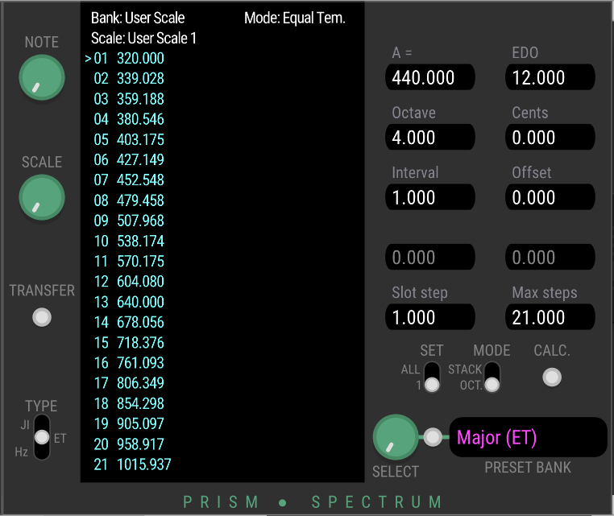

What is Spectrum?
Spectrum is an expander module for the Rainbow VCV module. It allows user to define their own User Scales. To transfer scales to Rainbow, it must be located immediately to the right and touch the Rainbow instance, however to create scales it can be used standalone.

Basic concepts
Rainbow (and the original SMR) define a scale with 21 notes. There are 11 scales in a bank, so there 231 notes needed to completely define a bank. A note is defined as a frequency in Hz and this frequency converted to one of the filter coefficients used within Rainbow for the MaxQ/One-Pass and MaxQ/Two-Pass filter modes.
We assume that the user is somewhat familiar with relevant music theory concept such as octaves, intervals and frequency ratios, cents and the like. A detailed exposition of all the background is beyond the scope of this document.

VCV module presets
It is possible that you have a much better/quicker/more convenient way of generating the scale information, or want to edit some of the information attached to the scale. Saving a scale as a module preset and using an external editor to alter the JSON file is a perfectly acceptable solution.

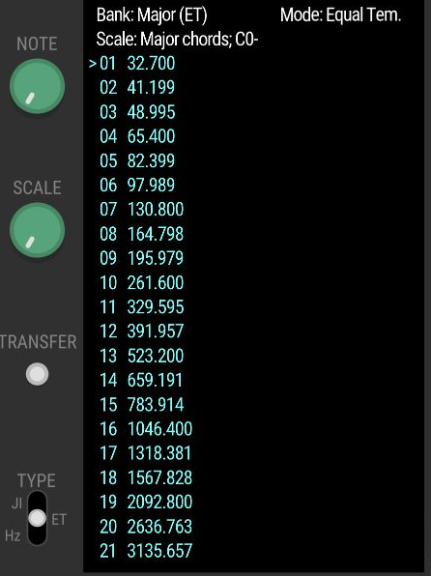

Displaying and working with Scales
In the centre of the module, the main display shows the currently loaded bank and scale, with the frequencies in Hertz of the notes in the current scale.
The notes will have different colours depending on their state
- Cyan: Loaded
- Purple: Edited
- Green: Transferred to Rainbow
The NOTE control selects the note in the scale, and the SCALE control selects the scale from the bank. The TYPE control selects the editing mode
- Hz: Directly setting frequencies
- ET: Calculate note frequencies using Equal Temperament tuning
- JI: Calculate note frequencies using Just Intonation tuning
The available parameters on the right hand side will change depending on the TYPE setting.

Presets

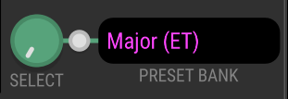
The existing presets in Rainbow can be loaded into Spectrum and further edited; choose the preset with the SELECT dial and press the adjacent button

Editing

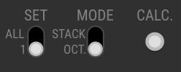
There are two general control applicable when editing scales. The SET switch selects between editing just one note at a time (1) or using the calculation facility for each mode to set multiple notes (ALL).
The MODE switch selects whether sequence of frequencies are calculated: per octave, or stacked.
The CALC. button set the note frequency (or frequencies) according to the note definition and the setting of the SET switch.

Calculation

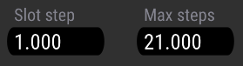
Calculation is a quick way of populating a scale, if it can be expressed as simple increments of a base note or frequency. What is common to all editing modes is the Slot step and Max steps parameters that control which notes in a bank are updated.
Slot step specifies the number and direction of slots in the bank to move in each step. The default value of 1 will move one-by-one through the bank, -1 will move backwards, 2 will skip a slot moving forwards, etc. Only whole number values are valid.
Max step controls how many notes to update, including the first note (step 1). The maximum practical value is 231, which will updated every note in the bank.
Spectrum will not generate frequencies above A10 and the calculation will step once this limit is reached. Only bats and dogs are likely to worry about this.

Frequency tuning

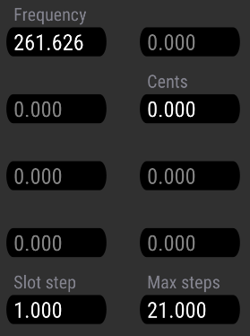
Frequency tuning is the simplest method; you know the frequency of the note, right click on Frequency parameter and enter the value and with SET set to 1 press CALC.
The frequency display is update to show the updated note. The cursor will automatically move to the next slot.
If the Cents is not zero, that number of cents will be added to the frequency.
1200 cents above 220Hz is 440Hz (A3 to A4)
With SET at ALL, the frequencies are calculated from the starting frequency and the number of cents to add to the frequency with each step. With the Frequency at the default value of 261.626 and the Cents at 100, pressing CALC. will generate the standard 12 semitone scale, starting at C4. With a Cents value of 78, we create Wendy Carlos’ Alpha scale.
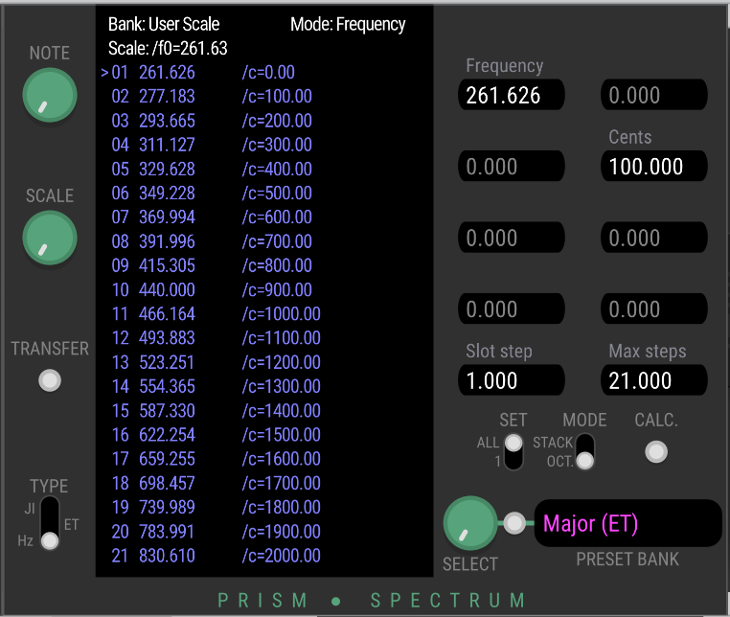

Equal Temperament Tuning
Modern western tuning uses a 12 note Equal Temperament tuning with the most common reference pitch being A=440Hz. Spectrum allows the definition of tempered scales which divide the octave into equal parts (equal temperament) and with different divisions the octave and changing the reference frequency.
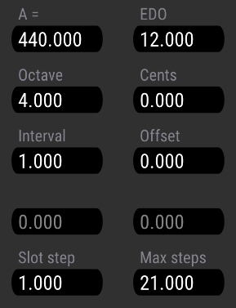

The Octave parameter sets the octave from which the interval is calculated. The Interval parameter controls the interval from the octave to calculate. Only whole octaves and intervals are used. With Octave set to 4 and Interval to 0 is C4.

With the Interval parameter set to 4 we have a major third, to E4.

The Offset parameter adds an initial number of intervals to the octave. With Octave set to 4, Offset set to 3 (minor third) and Interval set to 4 (major third), we have C4E4G4 (392Hz).
Cents can be added to the pitch for fine-tuning. 100 cents is one semitone, so we arrive at G#4. The value is truncated for display.
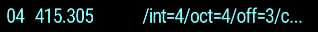
Negative intervals are also valid. One interval below C4 is B3.


Calculation with Octaves
Specify values in this way is somewhat tedious, so the Calculation process can quickly create scale data.
When SET is set to ALL and the MODE is set to OCT. Spectrum will calculate notes in increasing octaves with the frequency calculated as the number of intervals (the sum of Interval and Offset – positive or negative) from the octave. As explained previously, the Slot step and Max steps parameters control the calculation.
The simplest case is Interval = 0. This will generate the unison notes of each octave. Starting with Octave = 0:
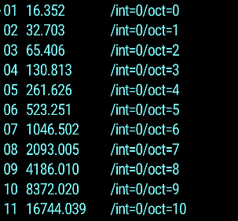
Using the Slot step parameter and moving the cursor to skip over lots during the calculation allows the user to interleave different intervals
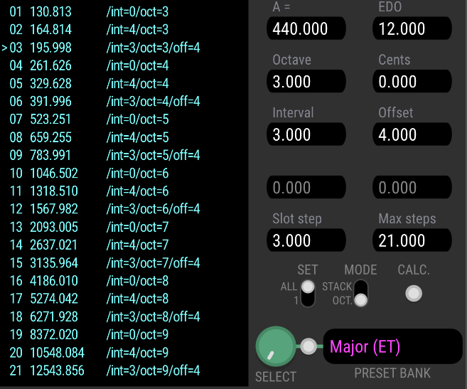
Here the Slot step is set to 3, which groups three intervals together; first with Interval = 0 to set the unison/octave note. Then, moving the cursor to slot 1, we set Interval = 4 for a major third and finally with the cursor at slot 2, we set Interval = 3 and Offset = 4 for minor third above a major third (or perfect fifth – of course the Interval could have been set directly to 7!)
The Cents parameter is added to the final frequencies

Stacking Intervals
An alternative is stacking intervals – MODE set to STACK. Here the same interval is repeatedly added to the initial Octave and Offset. In this example, A sequence of major third (Interval = 4) is created from the perfect fifth (Offset = 7) above C4 (Octave = 0)
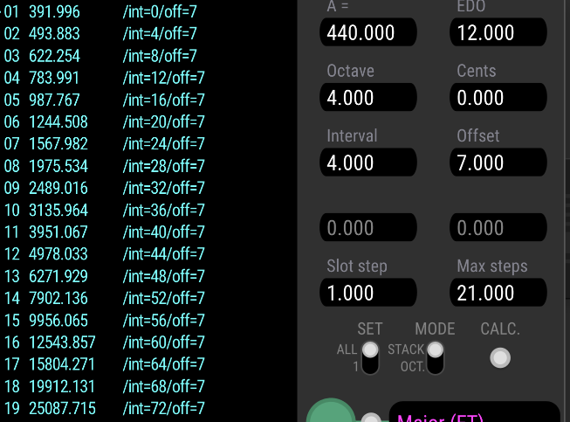

Beyond standard tuning
The A = parameter allows the user to change the reference pitch. The default is 440Hz. EDO specifies the divisions of the octave, 12 being the standard (12-TET). Many other interesting tunings have been created with different divisions, such as 19 or 31. In the case of 12-TET, an interval is a semitone.
To do this, Spectrum must recalculate the frequency of C0. C0 is assumed to be the interval that is closest in pitch to a justly-intoned minor third above A-1. This definition holds for different values of A = and EDO. Let’s see how that works:
- For A = 440 and EDO = 12 we calculate A-1 as 13.75Hz. A just minor third has a ratio of 6:5 (or 1.2) so we look for an interval that is closest to 13.75 x 1.2 = 16.5Hz. The closest interval is the third interval at 16.3516Hz (in fact since we know C0 for A440/EDO=12, we use that value directly).
- For A = 432 and EDO = 12 we calculate A-1 as 13.5Hz. We look for an interval that is closest to 13.5 x 1.2 = 16.2Hz. The closest interval is the third interval at 16.05Hz.
- For A = 440 and EDO = 19 again A-1 is 13.75Hz. The closest interval to target frequency of is 16.5Hz is the fifth interval at 16.5014Hz.
- For A = 446 and EDO = 31, A-1 = 13.9375Hz and the target frequency is 16.725Hz. The closest interval is the eighth interval at 16.6675Hz.
When working with non-standard tuning the Scale name will contain some information about the frequency of C0 and its distance in cents from the ideal just interval:

Just Intonation Tuning
Just intonation is the tuning of musical intervals as whole number ratios of frequencies. Just intonation tuning in Spectrum work in almost exactly the same way as Equal Temperament, but specifying ratios (Upper and Lower parts) instead of an integer number of intervals for both the interval and offset. Set TYPE set to JI.
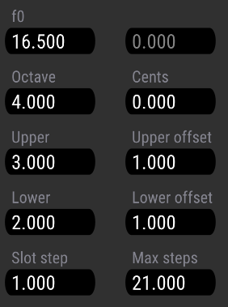
The significant difference is that user must supply the base frequency, the default is 16.5Hz (as described previously, this corresponds to C0 as an 6:5 interval above A-1 @ 440Hz)
Negative ratios will produce nonsense intervals, any negative number is flipped to the corresponding positive value.
If there is an exact frequency ratio that is available, that can be specified by setting the Upper part to the ratio, and the Lower part to 1. Offsets can be applied with the Upper offset and Lower offset parameters.
Although Just Intonation is intended to work with whole number ratios, Spectrum allows non-integer numbers to be used in the Upper and Lower parts. There might be interesting options with a scale based on the π:e ratio…

Scala and Scala files
Scala is a program designed for the creation, analysis and display of musical scales. It is an immensely detailed program. It is available for all VCV-supported platforms through the Scala website:
http://www.huygens-fokker.org/scala/
Scala files are simple text files generated by Scala that specify a sequence of intervals, either as ratios or cents. Spectrum supports loading and applying these files to a bank. For non-trivial scales, this is a probably the best way of creating and loading scales in Spectrum.
It is not necessary to use Scala to generate Scala files, simply following the file format instructions. However you will need some way of calculating the information to put into the file.
For more information on the Scala format, see:
http://www.huygens-fokker.org/scala/scl_format.html
There are nearly 5000 scales available from the Scala web site in a 1.5Mb ZIP file.

Working with Scala files
The file can be loaded through the module context menu Load Scala file option
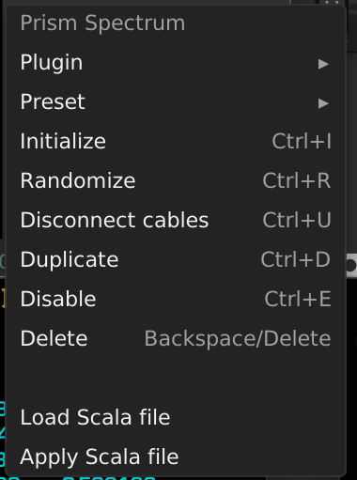

The files only specify intervals, so a base frequency has to be given. Each of the tuning types (Hz, ET and JI) allows the base frequency to be specified:
- Hz: The Frequency parameter.
- ET: The base frequency is calculated as the Octave plus the Offset, with the calculation of C0 specified previously, so A = and EDO is taken into account
- JI: The base frequency is calculated from as f0 plus the Upper offset / Lower offset
The user then select the Apply Scala file to apply the Scala file. Notes are updated from the cursor until the end of the bank, or when the maximum frequency (A10) is reached).

Credits and Acknowledgments

Rainbow and Spectrum use source code from the 4ms Spectral Multiband Resonator firmware. This is licenced under the MIT license and available through GitHub.
Many many thanks to Pierre Collard (Pyer) for the fantastic user interface. He really inspired me to continue improving Rainbow.
Thanks to Andrew Belt for the VCV environment. It is a fascinating project and great community.
Cheers,
John aka Amalgamated Harmonics
September 2019

This will seem strange as the scale ring contains 20 notes, however the 21st note is used as the target pitch when morphing.
The BpRe filter type uses a different coefficient set which is calculated by an external library (fidlib)
https://en.wikipedia.org/wiki/Cent_(music)
http://www.wendycarlos.com/resources/pitch.html
https://en.wikipedia.org/wiki/Equal_temperament
https://en.wikipedia.org/wiki/Just_intonation

