Strategy Report

**Summary Report:**  
  
Based on the provided technical indicator data for the ticker, here are the key observations and recommendations:  
  
1. **Price Trend Analysis:**  
 - The closing price has remained constant at $69.5 for the given dates.  
 - The high and low prices have also remained stable within the range of $68.8 to $72.9.  
  
2. **Moving Averages (MA):**  
 - The Moving Average (MA) is at $69.5, indicating a flat trend in the short term.  
  
3. **Relative Strength Index (RSI):**  
 - The RSI values are not provided in the data, making it challenging to assess the overbought or oversold conditions.  
  
4. **Exponential Moving Averages (EMA):**  
 - Both the short-term EMA and long-term EMA are close to the MA value, suggesting a lack of significant price momentum.  
  
5. **Moving Average Convergence Divergence (MACD):**  
 - The MACD is negative, indicating a bearish signal in the short term.  
  
6. **Bollinger Bands (BB):**  
 - The Bollinger Bands are tight around the price, reflecting low volatility and a consolidation phase.  
  
**Recommendations:**  
- **Hold Strategy:** Given the lack of significant price movements and the absence of clear trend signals, it may be prudent to hold the position for now.  
- **Monitor RSI:** Keep an eye on the R

# Portfolio Drawdown

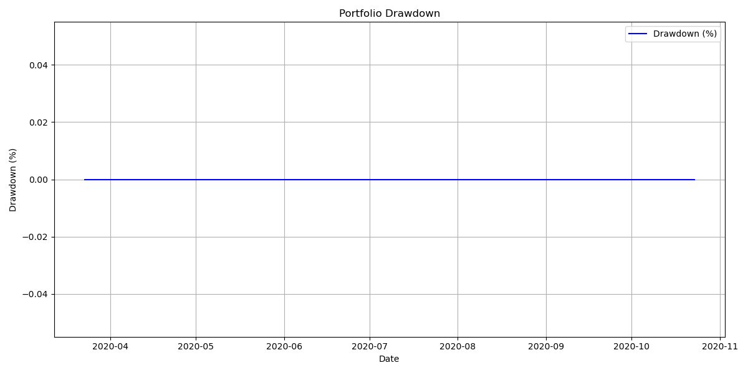

# Trade PnL Distribution

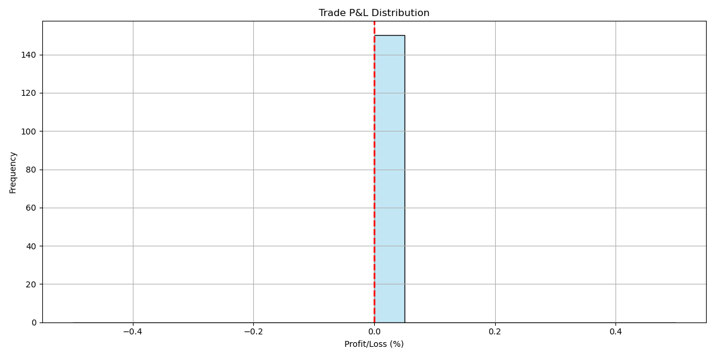

# Portfolio Value Over Time

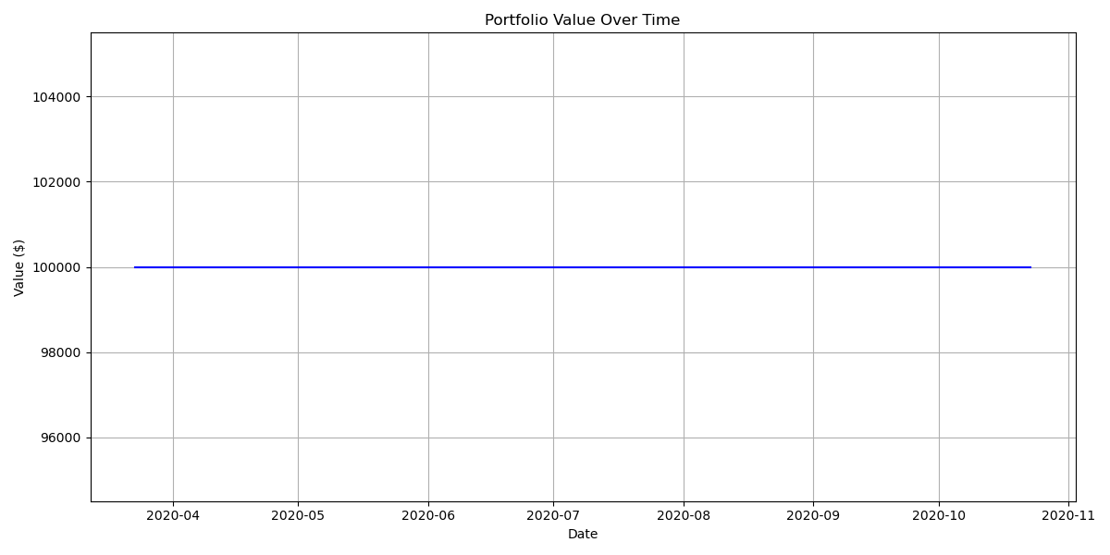

# Portfolio Performance with Trades

