Strategy Report

**Summary Report:**  
  
1. **Trend Analysis:**  
 - The total value of the portfolio has been fluctuating over the recent weeks, starting at $114,829.74 on 2025-02-14, dropping to $114,390.25 on 2025-03-03, and further decreasing to $112,570.50 on 2025-03-18.  
 - The drawdown has also been increasing, reaching -3.14% on 2025-03-18 from -1.20% on 2025-02-14.  
  
2. **Interpretation:**  
 - The portfolio has experienced a decline in total value, indicating potential losses or underperformance during the analyzed period.  
 - The increasing drawdown suggests higher risk exposure and potential for further downside if the trend continues.  
  
3. **Recommendations:**  
 - Given the recent performance, it may be prudent to review the current trading strategy and risk management approach to potentially reduce drawdown and enhance overall portfolio performance.  
 - Consider diversifying the positions to mitigate risk and improve the portfolio's resilience to market fluctuations.  
 - Regularly monitor and adjust the trading strategy based on market conditions to capitalize on opportunities and minimize potential losses.  
  
4. **Additional Information:**  
 - The risk-free rate (10-Year Treasury) stands at 4.24%, which can serve as a benchmark for evaluating the portfolio's performance relative to a low-risk alternative.  
  
Overall

# Portfolio Drawdown

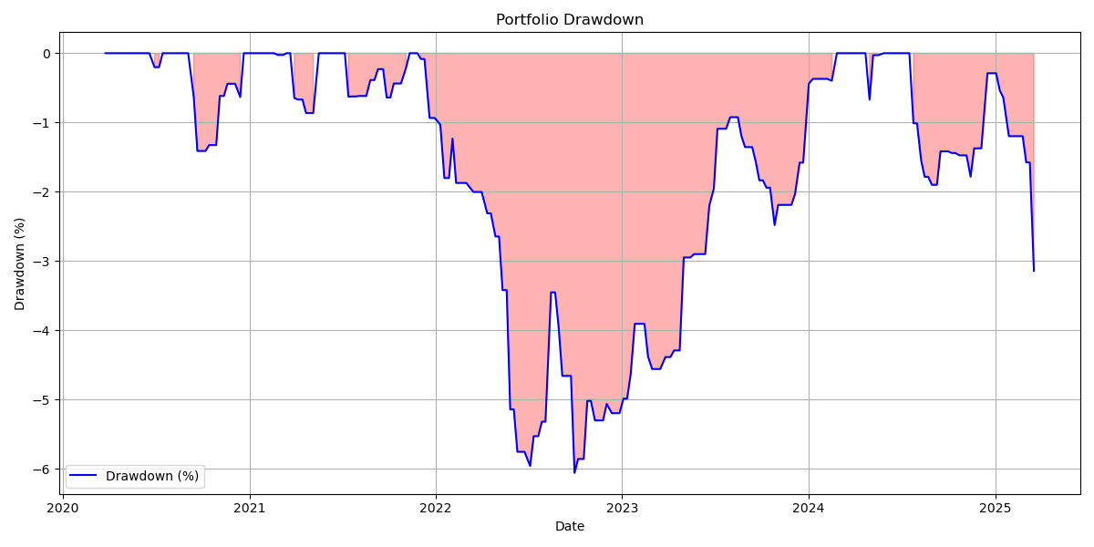

# Trade P&L Distribution

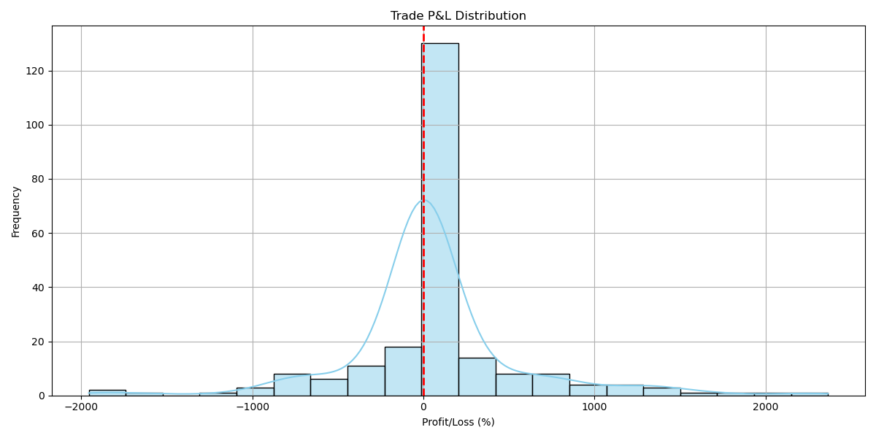

# Portfolio Value Over Time

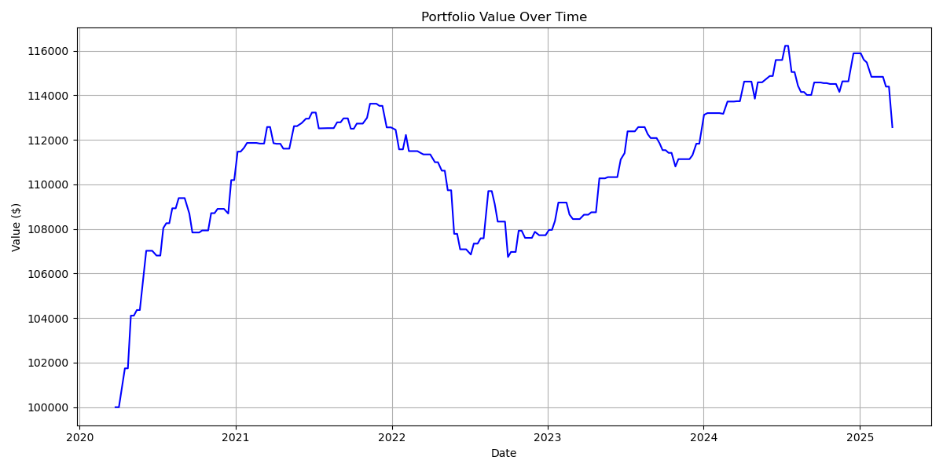

# Portfolio Performance with Trades

