# Trading System Report: SAMPLE

## Executive Summary

This report presents the performance of a trading strategy applied to SAMPLE using a combination of technical analysis, sentiment analysis, and predictive models.

The strategy achieved a total return of -3.14% (-3.14% annualized) with a Sharpe ratio of -0.83. Maximum drawdown was -5.27%. The strategy executed 9 trades with a win rate of 1.59%.

## Performance Metrics

|  |  |
| --- | --- |
| Metric | Value |
| Total Return | -3.14% |
| Annualized Return | -3.14% |
| Volatility | 3.79% |
| Sharpe Ratio | -0.83 |
| Maximum Drawdown | -5.27% |
| Calmar Ratio | -0.60 |
| Win Rate | 1.59% |
| Number of Trades | 9 |
| Average Trade Return | -0.35% |

## Equity Curve

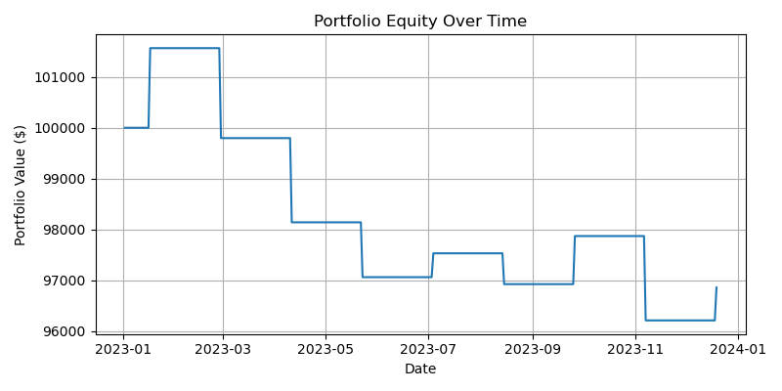

## Drawdown

