# Trading System Report: 5 Tech Stocks (Without Sentiment)

## Executive Summary

This report presents the performance of a trading strategy applied to 5 Tech Stocks (Without Sentiment) using a combination of technical analysis, sentiment analysis, and predictive models.

The strategy achieved a total return of -2.16% (-2.16% annualized) with a Sharpe ratio of -0.57. Maximum drawdown was -3.47%. The strategy executed 14 trades with a win rate of 3.17%.

## Performance Metrics

|  |  |
| --- | --- |
| Metric | Value |
| Total Return | -2.16% |
| Annualized Return | -2.16% |
| Volatility | 3.77% |
| Sharpe Ratio | -0.57 |
| Maximum Drawdown | -3.47% |
| Calmar Ratio | -0.62 |
| Win Rate | 3.17% |
| Number of Trades | 14 |
| Average Trade Return | -0.15% |

## Equity Curve

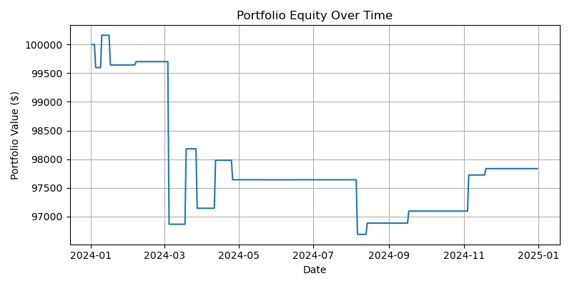

## Drawdown

