# Trading System Report: 5 Tech Stocks

## Executive Summary

This report presents the performance of a trading strategy applied to 5 Tech Stocks using a combination of technical analysis, sentiment analysis, and predictive models.

The strategy achieved a total return of -1.61% (-1.61% annualized) with a Sharpe ratio of -0.45. Maximum drawdown was -3.29%. The strategy executed 11 trades with a win rate of 2.38%.

## Performance Metrics

|  |  |
| --- | --- |
| Metric | Value |
| Total Return | -1.61% |
| Annualized Return | -1.61% |
| Volatility | 3.63% |
| Sharpe Ratio | -0.45 |
| Maximum Drawdown | -3.29% |
| Calmar Ratio | -0.49 |
| Win Rate | 2.38% |
| Number of Trades | 11 |
| Average Trade Return | -0.14% |

## Equity Curve

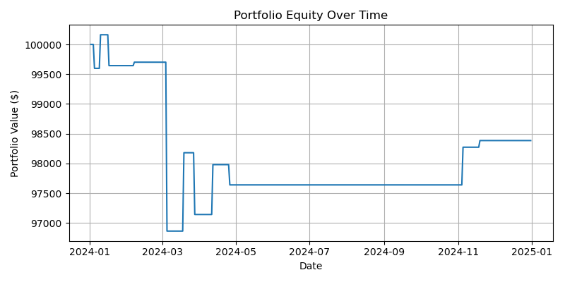

## Drawdown

