Configure Git hub actions.

* Cloned a simplewhaledemo(a docker project) project from git hub to my machine
* A separate folder for this project created in my desktop
* Created a new repo in git hub
* Pushed this project to that repo to work with it.

Setting up a GitHub action CI/CD pipeline with Docker:

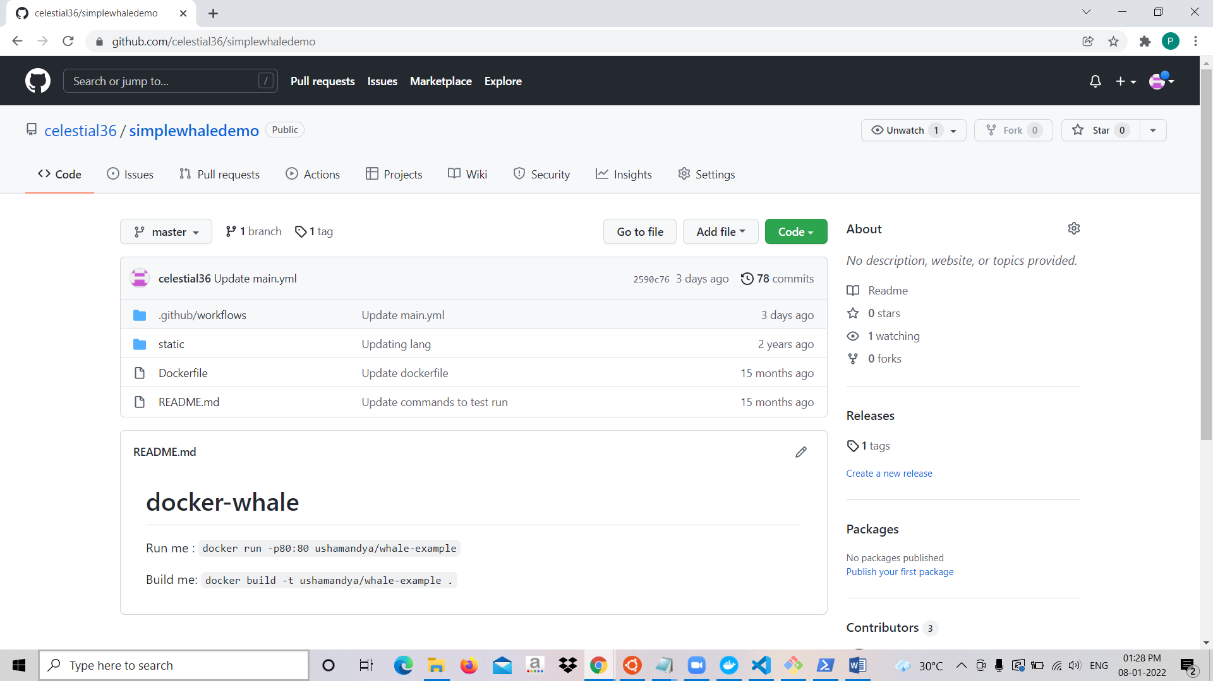

Setting up secrets (Docker hub PAT and username)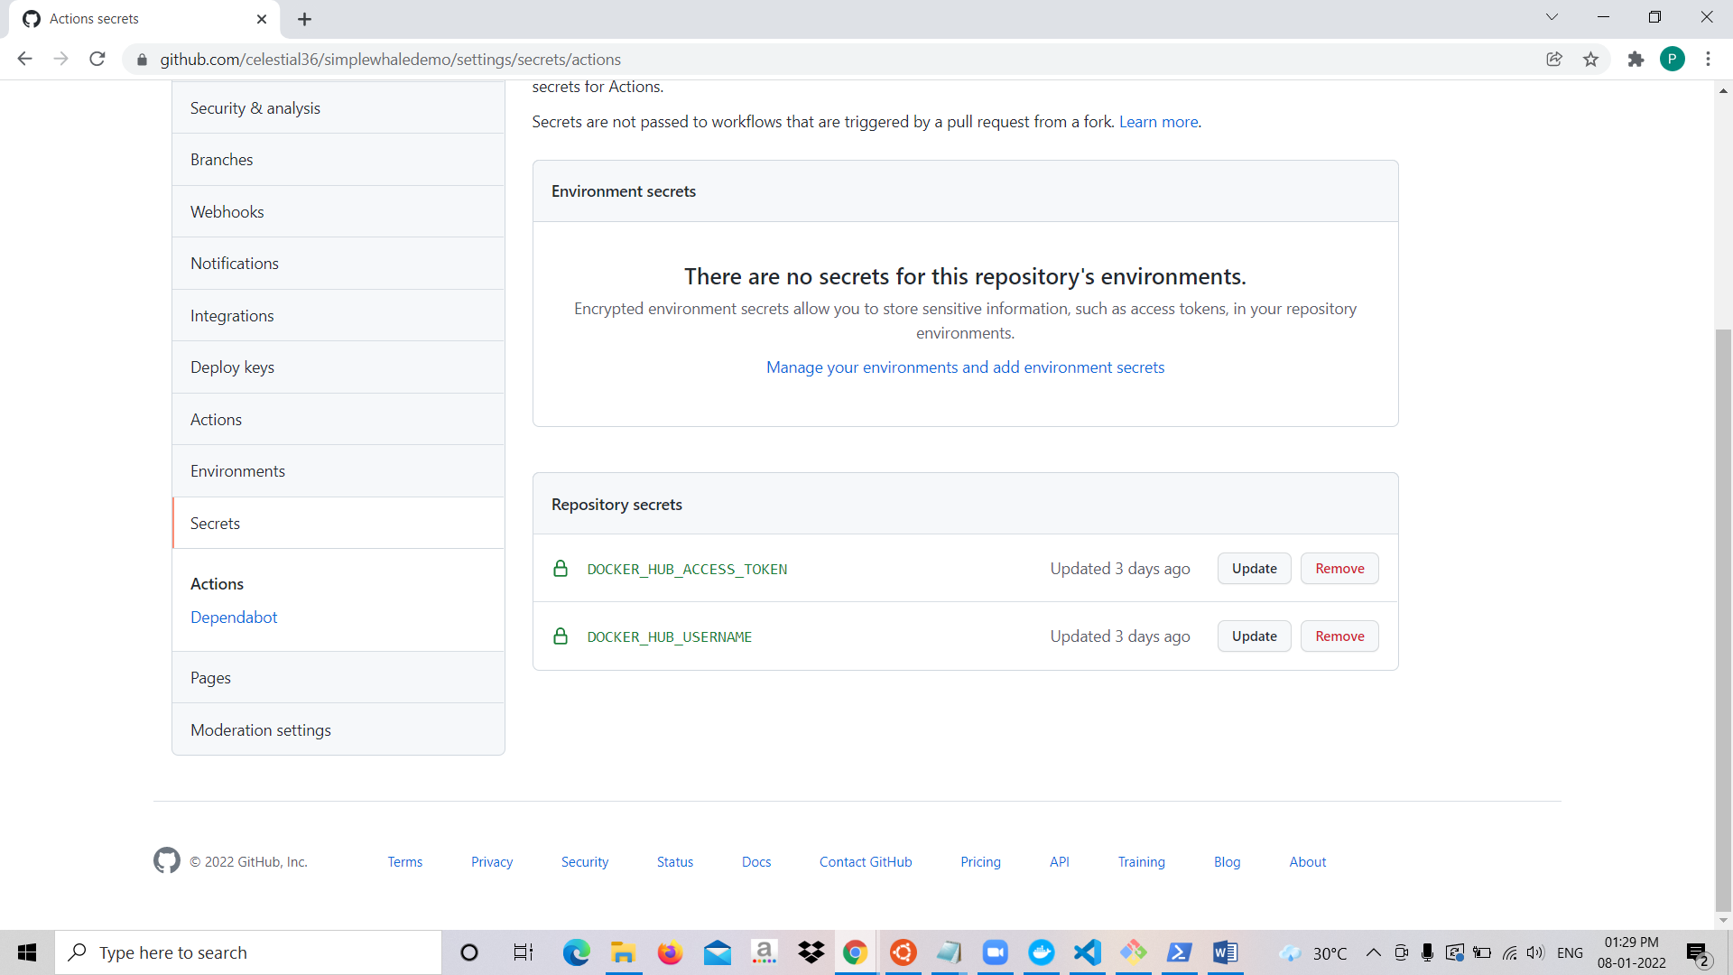

Set-up Git hub action workflow.

Simplewhale repo created in docker hub taking instruction from the yaml file in Git hub.

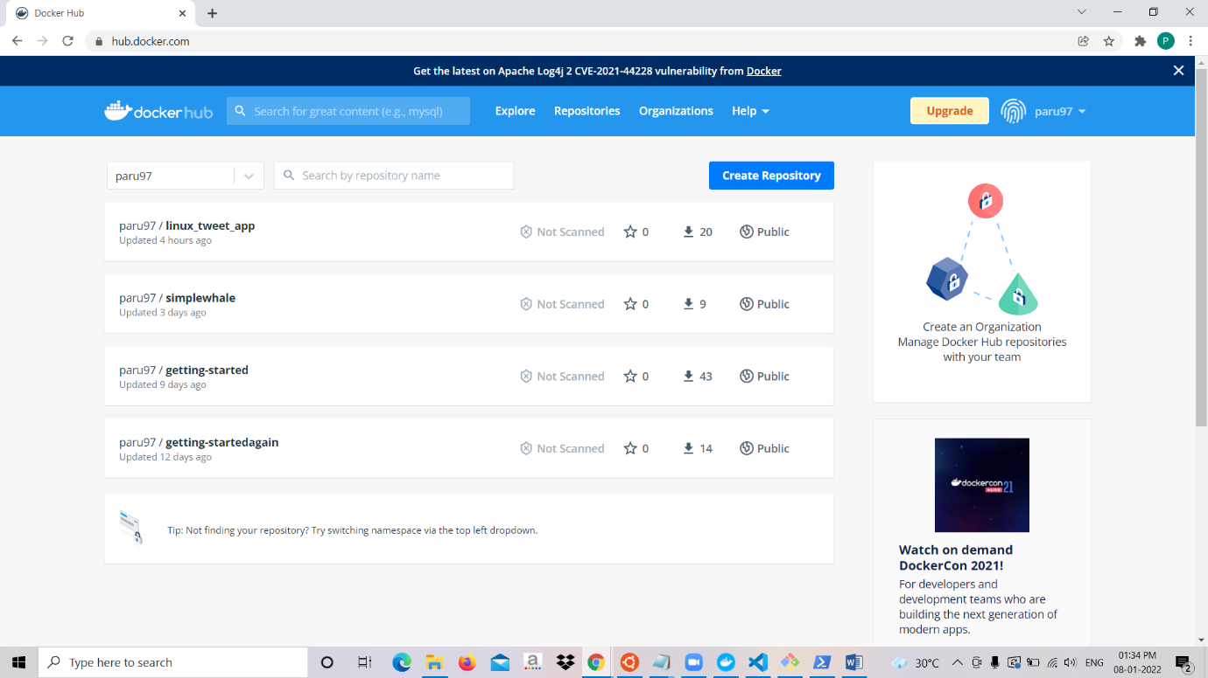

Successfully running the app from labs.play-with-docker.

