Report on

**Soil desiccation cracks recognition using deep learning**

by

Priyanshu Jain

B20CI032

Supervisor – Dr. Aali Pant

In partial fulfilment of the requirement for the

Design/Practical Experience [CIN2030]

DEPARTMENT OF CIVIL AND INFRASTRUCTURE ENGINEERING

INDIAN INSTITUTE OF TECHNOLOGY JODHPUR  
JODHPUR, INDIA

NOVEMBER 2022

Table Of Content

Abstract

1. Introduction
2. Objective
3. Methodology
   1. Development of Crack Identification Model
   2. Function for Quantification of the crack
   3. Testing of Soil Desiccation Crack Data
4. Result
5. Conclusion

Bibliography

**ABSTRACT**

Cracks on the soil surfaces are one of the earliest indications of the degradation of soil. Manual inspection is the acclaimed method for crack inspection. Each crack’s length, width, and several cracks are calculated manually in the manual method. Since the manual approach completely depends on the specialist’s knowledge and experience, it lacks objectivity in the quantitative analysis. So, automatic image-based crack detection is proposed as a replacement. The literature presents techniques to automatically identify the crack and its dimensions using image processing techniques. The literature will also give you a brief overview of how intermixing of different geomembranes affects the property of soil. We have designed a general algorithm that works on all types of cracks. Finally, we present the various research issues which can be useful for the researchers to accomplish further research on crack detection.

Keywords – Crack Detection, Dimension analysis of Crack, Image-based approach

1. **INTRODUCTION**

Cracks on the upper surface of the soil can appreciably influence the soil performance in a variety of agricultural, geotechnical, and environmental sectors. Though the wetting and drying cycle because of seasonal weather changes can be a dynamic force for dehydration cracking, climate change could potentially exacerbate the harmful effects. Identifying the quantifying the cracks concerning the temperature and time is important. If the cracks are not healed in the initial stages, then these cracks may lead to some hazardous incidents in the future. As cracks will expand the cost and manpower required to tackle the effects of cracks will be on the higher side. The approach discussed in this paper will be highly useful for classifying the image and whether it has a crack or not and the Characterisation of cracks in the soil. Our approach will reduce the load on manpower and also be cost-optimized it has a fewer chance of error and just in a very less amount of time it gives the desired result.

Due to climate transitions, cracks develop in soil. During dry weather, clay particles shrink and pull more tightly to each other. dis shrinking is what leads to cracks in the ground. Think of clay as a big sponge. Fill the sponge full of water and it puffs up; dry out the sponge and it shrinks. The technical term is called shrink-swell capacity. Clay soil has a high shrink-swell capacity. As the particles shrink, they separate and cause cracks, from whisper-thin to an inch or more. The more cracks and wider the cracks, the greater the shrink-swell capacity of the soil, which translates to higher clay content. Now as the temperature rises the crack dimensions also expand due to the property of thermal expansion.

In the past various researchers have worked on concrete crack detection using different machine-learning models they have got an accuracy of around 94.15% [1], [2]. Their work mainly uses a neural network with 3 channels some of them have used the R- masked CNN to get better results[3]. Other different classification models were also used but all of them reported the result around this only but constraint was all of them were reporting whether that image has cracked or not, and nobody is reporting the dimension of cracks. Their work has a limitation these models can only work on concrete cracks but the model designed by us is a generalized model which works on both concrete as well as on soil cracks.

There are 2 ways of checking the cracks in images: manual and image base analysis. The manual method requires a lot of time and it is not cost-friendly as manpower is costly. So, image base analysis it the rather has more advantages in terms of time and cost. In image analysis, we can also classify the types of cracks in terms of their length and breadth and we can also predict the future length and dimensions of cracks if we have sufficient information.

1. **OBJECTIVE**

The objective of this study was to quantify the crack dimensions in soils using image analysis techniques.

1. **METHODOLOGY**
   1. **Development of Crack Identification Model**

As we have a generalized model which works on all types of cracks. We trained our model on images from open-source Kaggle which consists of cracks and uncracked concrete images. I have taken some of those images and mixed them with some of the soil images. For training, a model to detect future images has a crack or not, I have augmented the dataset so that it can be trained on various types of images. In augmentation, I have mainly changed the axis of images, RGB values, Zoom, vertical shift, horizontal shift, rescaled, shear, and brightness of images. After augmentation, I got a total of 28210 images and I divided the set of images into 2 parts training and validation set. A training set will be used to train the model and a validation set will be used to verify that data is not overfitted and it will help us in the hyper tuning of the model. The training images set consists of 19747 images and the validation set consists of 8463 images. As images were of different sizes. I have standardized the size of all images. As mentioned by the author in [4]for getting the best result in binary classification we have to 32X32. To get more generalized results I have converted all images to grayscale images which will help the model in the reduction of noise.

We have designed a 3-layer Convolutional neural network. CNN’s are comprised of three types of layers. These are convolutional layers, pooling layers, and fully-connected layers. When these layers are stacked, a CNN architecture has been formed [5]. The CNN was designed as a feed-forward neural network. The convolution and pooling layers perform feature extraction steps[1]. The primary function of the convolution layer is to extract the data from the image sample provided of (32X32X1) 1 signifies that the image has only 1 channel or grayscale image. The work of the activation function is to define whom the weighted sum or convoluted sum will further transmit to the output of nodes. Two different activation functions are employed in this, namely a rectified linear unit (ReLU) and Sigmoid. ReLU is a linear function that is applied to the output of the convolution layer (i.e., the feature maps). For a positive input, ReLU produces the output as unity whereas, for a negative input, the output is zero. ReLU is specifically employed because it accelerates the computational processes compared with other activation functions such as tanh and sigmoid. The sigmoid function is also known as squashing input for input range in -infinity to +infinity output will be in range 0 to 1. The activation functions sigmoid and relu are defined as Eq1 and Eq 2, respectively.

σ(x) = 1/(1+exp(-x)) (1)

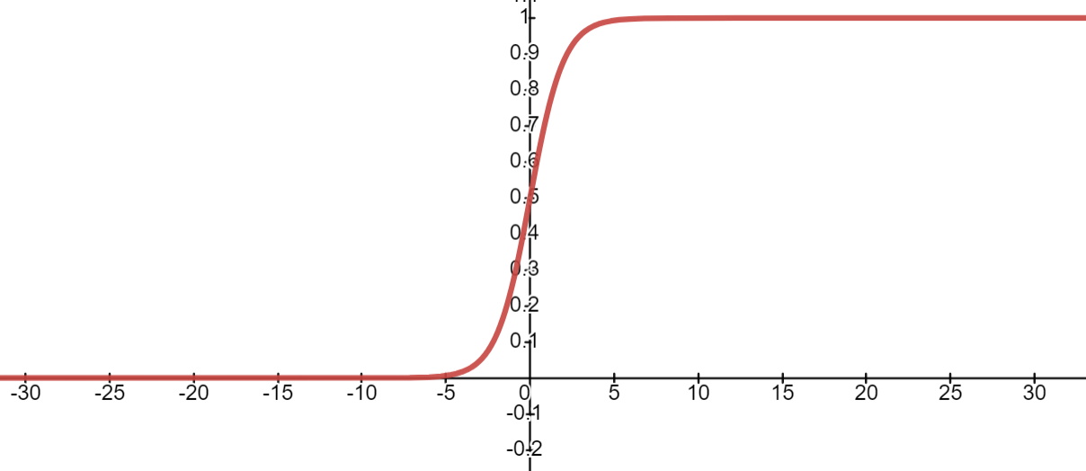

*Figure* 1:- Graph of sigmoid function

Relu = x if x>0; 0 if x<0 (2)

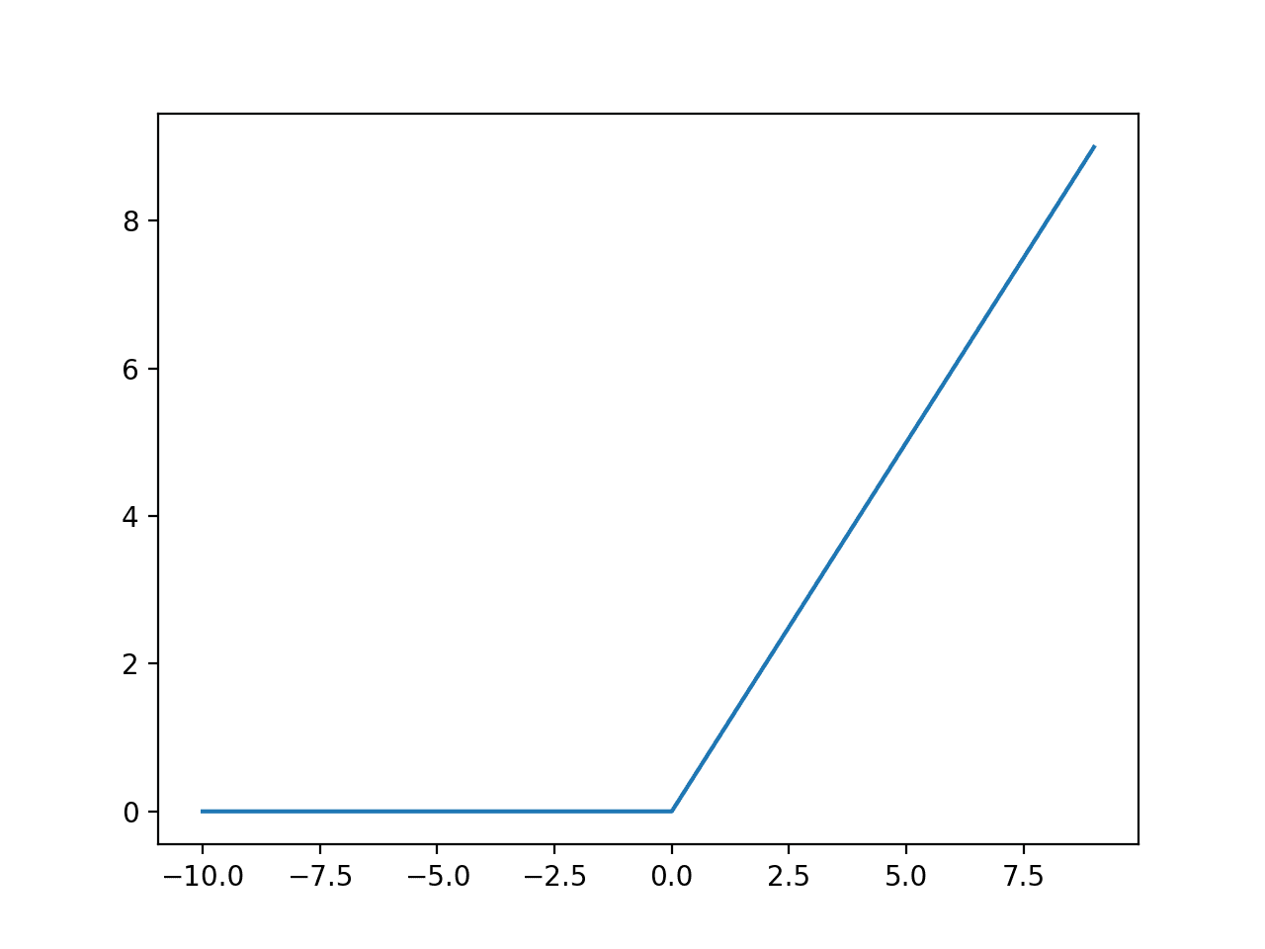

*Figure* 2*:* Graph of Relu Function

The pooling layer is further used to reduce the dimension of input. . It separates the feature map into non-overlapping pooling kernels. Specifically, it down samples the input and also reduces the number of model parameters. This has the positive effect of simplifying the computational complexity and improving the potential for the generalization of the model. We have used the max-pooling method in which the filter size matrix is replaced by the max value in that matrix.

In this fully connected layer, the feature maps that are generated in the previous layers are aligned into columns and then feed into the neural network. The fully connected layer is considered to be a traditional neural network that gives logical inference. It converts a three-dimensional matrix into a single-dimensional vector by using a full convolution operation. The mathematical equation that defines this layer is given as[5] Eq 3:

 (3)

where V0 and Vi are the input and output matrix size, respectively C denotes the outcome of the fully connected layer, and with and A represents the weight and bias matrices, respectively.

CNN model is constructed by tuning different hyperparameters including the number of filters, pooling locations, number of convolution layers, stride, sizes, and number of fully connected layers. The hyper-parameter selections are done on a trial-and-error basis and there is no standard mathematical formulation for setting the parameters for the specific dataset. The first, second, and third convolution layers have 32, 32, and 64 feature maps, respectively, employing the ReLU activation function. It is noteworthy that convolutional layers in a convolutional neural network summarize the presence of features in an input image. After each convolution layer, a 2 × 2 dimensions max pooling layer is used. Pooling layers provide an approach to down sampling feature maps by summarizing the presence of features in patches of the feature map. There are two dense layers used. The initial dense layer has 64 output perceptron with ReLU and the second dense layer has output perceptron with a sigmoid function. The hyper-tuning was done in Adam’s optimizer which is used as an optimizer in CNN. The learning rate is given as 0.001 with beta_1 as 0.9 and beta_2 as 0.999. Binary cross-entropy was chosen as the loss function.

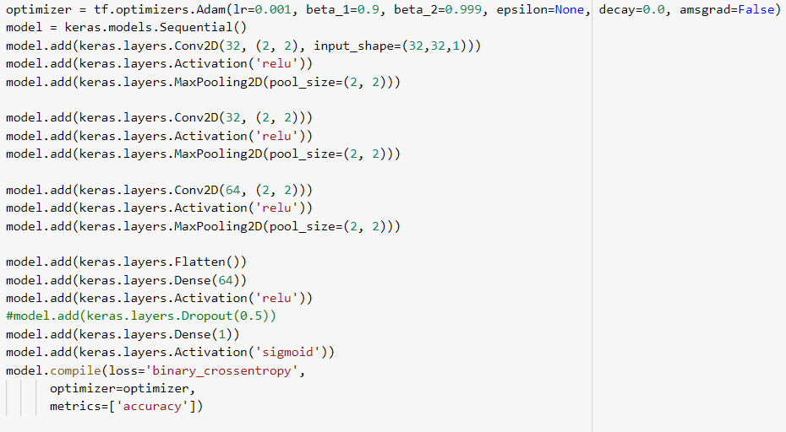

Figure 3: CNN Model

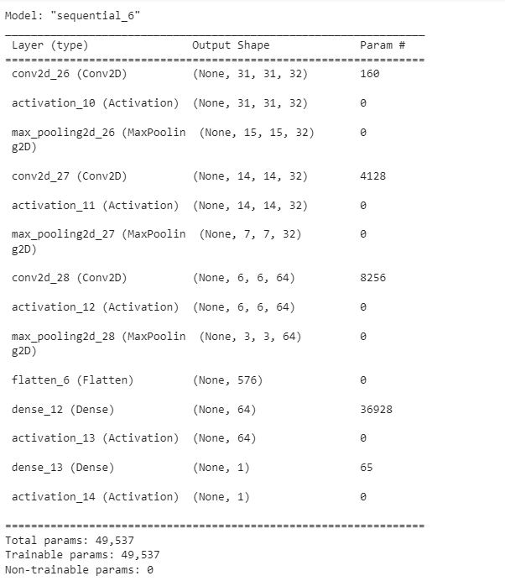

Figure 4: Summary of CNN model

* 1. **Function for Quantification of the crack**

We have defined an algorithm that will provide us with the dimensions of the crack which take an image as output and gives the pixel length and length of breadth of the crack. It first changes all RGB images into grayscale images. As we know that images are just a 2D array. So we have iterated to each array and calculated the maximum number of continuous black pixels in each array and the overall maximum of all arrays. We have reported the result as pixel*pixel length which is pre-defined by the device from which we captured the images.

* 1. **Testing of Soil Desiccation Crack Data**

The dataset consists of a set of soil images which was prepared by mixing different types of material to gain more strength for testing each sample of different widths was heated for a time and captured the images. They have a vertical strip as a sample.

As the sample size was less for tackling this problem, I have augmented the dataset with the same technique used for the training dataset. Before passing the images to the model I first converted all the images to grayscale as the model is been trained on grayscale images. From this, I have got 596 images. Images were passed in the model in which 572 images were predicted correctly which gives us an accuracy of 95.97%.

The original set of images was passed in the function which has given us the length and breadth of images and from visual observation, we have calculated the number of cracks.

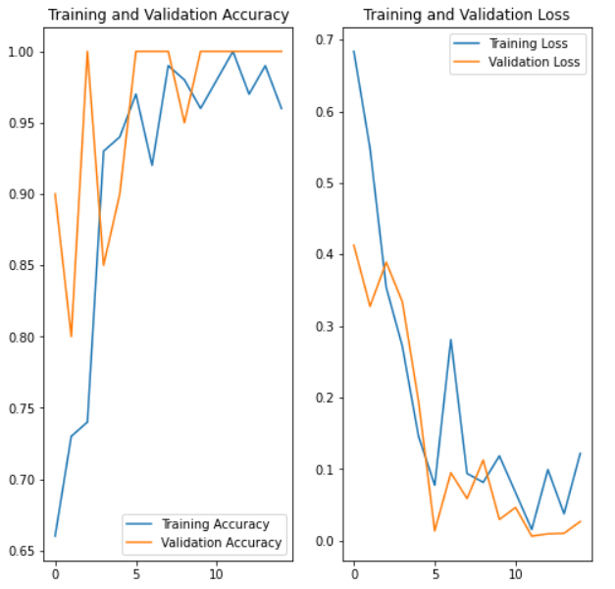

Figure 5: training and validation accuracy with respect to number of epochs

1. **Result**

The accuracy we got from our model on the prediction that the images have cracked or not is quite remarkable at 95.97%. on validation, data accuracy is 98.59% and on training data, accuracy is 98.75% which ensures that data is not overfitted.

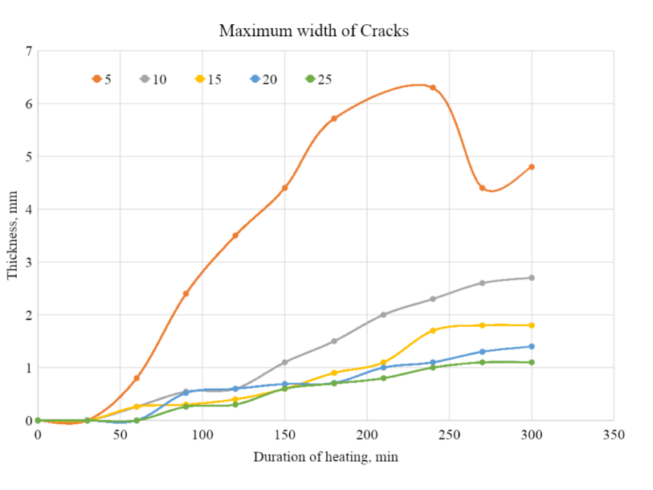

Figure 6: Thickness of crack with respect to duration of heating

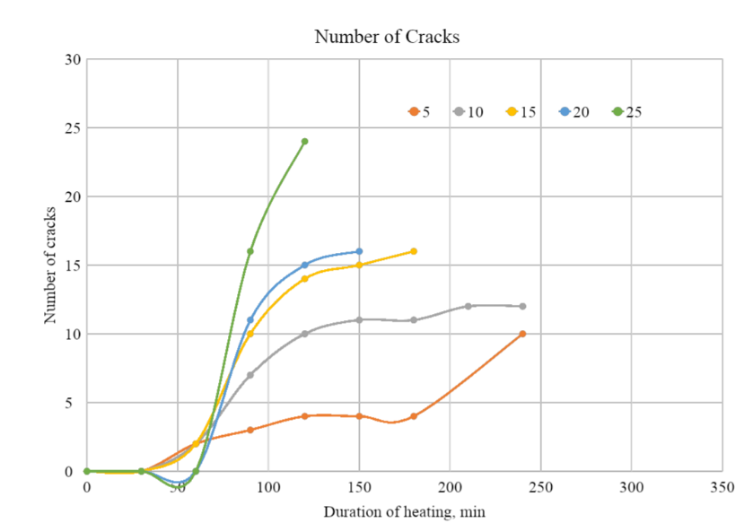

Figure 7: number of cracks with respect to heating

1. **Conclusion**

From this research, we have concluded the length, breadth, and number of cracks on the longitudinal soil sample. We have also developed a machine learning base model which predicts on any type of sample whether the image has cracked or not with very high accuracy.

*Databases:-*

[*Colab*](https://colab.research.google.com/drive/1eJMW4JwPiYsXP9d6bA5WGPz1-s41g5c_#scrollTo=iJ8p4IY1zX1Q)

[*Excel*](https://docs.google.com/spreadsheets/d/11WbSN54zgNFAfLwKHb29amIPKvGvaIF5/edit?usp=sharing&ouid=113257453670789895177&rtpof=true&sd=true)

[*Training Data*](https://drive.google.com/drive/folders/14pGJG6FYozrvO9ucc1Rf9U0n2_ApGOmx?usp=sharing)

[*Testing Data*](https://drive.google.com/drive/folders/1Yf11hddSyKAd_YcYxapf12cBiY36Twuw?usp=sharing)

# **Bibliography**

[1] A. D. Andrushia, T. M. Neebha, S. Umadevi, N. Anand, and K. A. Cashell, “Shrinkage Crack Detection in Expansive Soil using Deep Convolutional Neural Network and Transfer Learning,” *KSCE Journal of Civil Engineering*, vol. 26, no. 10, pp. 4202–4213, Oct. 2022, doi: 10.1007/s12205-022-1354-0.

[2] P. K. Shit, G. S. Bhunia, and R. Maiti, “Soil crack morphology analysis using image processing techniques,” *Model Earth Syst Environ*, vol. 1, no. 4, Dec. 2015, doi: 10.1007/s40808-015-0036-z.

[3] A. Mohan and S. Poobal, “Crack detection using image processing: A critical review and analysis,” *Alexandria Engineering Journal*, vol. 57, no. 2, pp. 787–798, Jun. 2018, doi: 10.1016/j.aej.2017.01.020.

[4] A. Sarraf, “Binary Image Classification Through an Optimal Topology for Convolutional Neural Networks,” *American Scientific Research Journal for Engineering*, [Online]. Available: http://asrjetsjournal.org/

[5] K. O’Shea and R. Nash, “An Introduction to Convolutional Neural Networks,” Nov. 2015, [Online]. Available: http://arxiv.org/abs/1511.08458