

Krakatau Essential PM (KEPM)
for ADA, C#, C/C++, Java, VB6 / VB.NET, Perl and PL/SQL

User Guide
1.02.000

Contents
Contents 2
Document 3
Purpose 3
Readership 3
Version History 3
Installation 4
Installing Krakatau Essential PM 4
Installing MySQL (optional) 4
Installing a License 4
Using Krakatau Essential PM 5
Startup 5
Creating a Project 6
Opening an Existing Project file 7
Setting Old and New 7
Analysis 8
FAQ 9
How does Krakatau Essential PM know which parser to use? 9
Why do I get ‘You do not have a valid license’? 10
What does the error stating the MySQL cannot start mean? 10

Document

Purpose
This document is an Installation and User Guide for the Krakatau Essential PM graphical source code metrics tool. It describes how to use KEPM to generate metrics results. It does not describe in detail how to use the command-line backend – Essential Project Manager (EPM) – this detail is covered in a separate EPM User Guide.

Readership
This User Guide is intended for end-users, system administrators. Management and non-technical users should refer to our website – http://www.powersoftware.com/kepm/

Version History
1.00.000 | 23-Sep-2005 | Initial Release
1.00.001 | 11-Oct-2005 | 152 : Correct inverted project bug
1.00.004 | 29-Nov-2005 | 160 : Added right-click to Projects for Set Old/New and also tooltip
1.00.005 | 20-Dec-2005 | 164 : Added NFILE metric
1.00.006 | 24-Jan-2006 | 179 : Readonly Project Filename box, limit Project Title to 30 non-space characters
1.01.001 | 14-Feb-2006 | 185 : Saved Project List request
1.01.002 | 13-Mar-2006 | 199 : Ensure Ada files are compared correctly
1.01.003 | 15-Mar-2006 | 202 : Correct summed/calculated Halstead project metrics
1.01.004 | 18-Mar-2006 | 210 : Added Deselect to right-click menu
1.02.000 | 26-Mar-2006 | 213 : Retrieve EPM Analysis options from project.txt.epm.cmd file

Installation

Installing Krakatau Essential PM
Unzip the downloaded file and double-click on setup.exe. Follow the installation prompts, clicking Next through the wizard as normal.

If you accept the defaults, Krakatau Essential PM will be installed in:

C:\Program Files\Power Software\Krakatau EPM

Installing MySQL (optional)
If you wish to use an existing MySQL server in the organisation, you can do so using the –s (and –u/-p if required) parameter.

Otherwise, a local MySQL database will be started implicitly as Essential Metrics runs.

Installing a License
You must obtain either a time-locked (for testing) or node-locked/floating (following purchase) license from Power Software. The recommended way to install the license is to place it where you installed Essential Metrics (see default directory above) and then simply launch Krakatau EPM from Start – Programs – Power Software – Krakatau EPM. This will prompt for you to Browse to the license.dat file.

If you do not have a valid license, you will see the following dialog on startup:

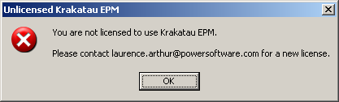

Using Krakatau Essential PM

Startup
When you launch KEPM, you will see the following window:

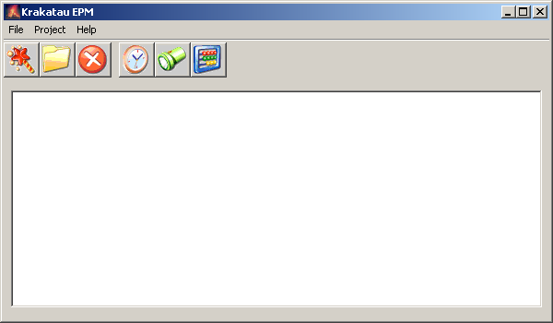
Menu Bar
Tool Bar
Projects Window

As with other applications, there is more than one way to carry out an operation. We will describe operations using the application Tool Bar:

 | New Project wizard – allows you to create new project files containing a Project Title, Snapshot date, Base directory and actual source files in the project.
 | Open an existing Project file.
 | Remove a Project from the Projects windows.
 | Set the currently selected Project as the Old Project.
 | Set the currently selected Project as the New Project.
 | Analyse. If Old and New Projects are selected, perform a Project comparison, otherwise a Single Project analysis.

Creating a Project
To create a new Project, click the New Project Wizard toolbar button.

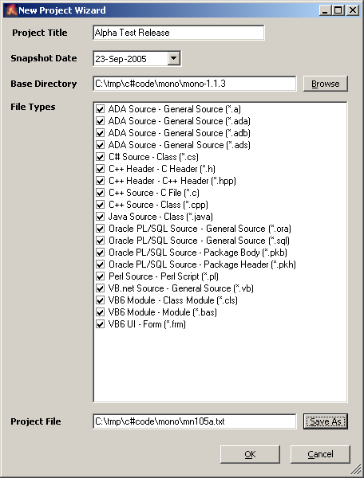 | Enter Project Title (a name for the Project, representing the software and possibly a version number)  Choose the Snapshot date – the date the source was extracted or labelled.  Browse to the Base Directory for the source code – the top-level directory where the source may be found.  If required, select the file types you require in the Project.  Finally, click Save As to save the Project file.

When you click OK, the Base directory will be examined (and all subdirectories below it) for the types of files you have selected. These files, along with the Project Title and Snapshot date are then stored in the Krakatau EPM Project file you chose.

Note: as well as the Project file (in the example above ‘mn105a.txt’), a Windows command file with the extension .cmd will also be created (e.g., ‘mn105a.txt.cmd’). Experienced users can use these sample command files to create their own Project files. They may be deleted, if not required. Each time you create a New Project, KEPM creates a command file for it.

Once the Project file has been created it will appear in the Project window.

Opening an Existing Project file
If you have previously created a Project file, you may open it in Krakatau EPM using the Open Project toolbar button. This loads the file into the Projects Window.

Setting Old and New
When you have a Project open, you can click on it then choose either Old or New toolbar buttons:

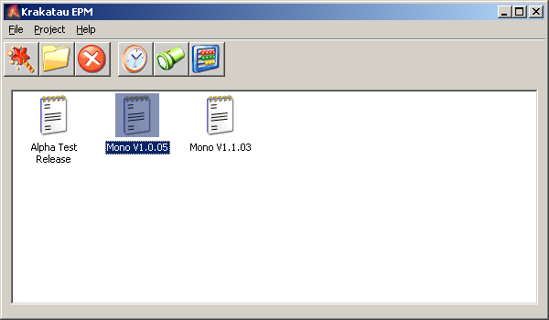 | The Mono V1.0.05 Project has been selected. By then clicking the Old button, it will be highlighted in red.  If we then click the Mono V1.1.03 Project and click the New button, it is highlighted in green, as below.  You may also right-click on a Project and choose Set as Old or Set as New from the popup menu.
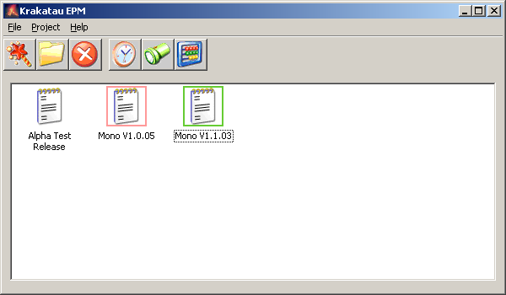 | We are telling Krakatau EPM that Mono V1.0.5 is the Old Snapshot of the source, and that Mono V1.1.03 is the New Snapshot.  When comparing these projects, Mono V1.1.03 will examined with reference to Mono V1.0.05.

For instance, a file that existed in Mono V1.0.05 but no longer exists in Mono V1.1.03 is considered to have been deleted. Source Lines that exist in a file in the new Project but not in the old are New Source Lines.

If you only set a New Project, Krakatau EPM will perform a Single Project analysis, with no changed information.

Analysis
To perform an analysis of your selected Project(s), click the Analyse:

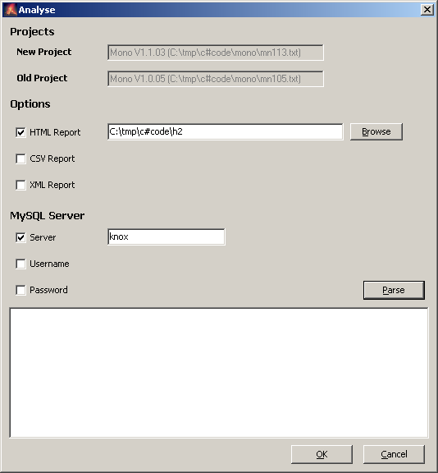  Results Window | The dialog tells you what the New and Old Projects are.  You can then select the reporting options you require – ticking a checkbox to force an option, and specifying files/folders in the textbox that appears. Use the Browse button if you wish.  If you have a MySQL server on your network that you wish to use, specify the hostname (Server) and user/password details as required.  When ready, click the Parse button.

The Parse button creates another Windows command file (e.g., called ‘mn105a.txt.epm.cmd’). This is then executed and the results are shown in the Results Window. As the Projects are parsed you will see the analysis and differences, and finally the reports you have selected.

Each time you press OK or Parse, the .epm.cmd file is recreated, and this file is also used to retrieve your Analysis options when you reopen the project. The checkboxes you have ticked, and the values entered, will be retrieved from the .epm.cmd file and populated in this dialog the next time you Analyse, in the same KEPM session or at a later date.

If you select an HTML report, it will be launched in your default browser once parsing is complete.

FAQ

How does Krakatau Essential PM know which parser to use?
Krakatau EPM is supplied with a default XML Configuration file that instructs the tool to apply different languages parsers to the files based on the following file extensions:

Language | Extensions | Parser Code
ADA | .a .ada .adb .ads | AD
C++ | .cpp .c .hpp .h | CP
C# | .cs | CS
Java | .java | JV
Perl | .pl | PL
PL/SQL | .sql .ora | S1
VB.NET | .vb | VB
VB6 | .frm .bas .cls | VB

All other files are treated as C/C++ files.

In a forthcoming release EPM will allow the user to user-defined parsers where comment begin/end tags are defined and LOC, SLOC, COM_LOC and BYTES can then be derived.

If you require to modify this configuration, you may edit the epm.xml Configuration file supplied with the tool. The default file looks like:

<?xml version="1.0" encoding="UTF-8"?>  <epm>  <lang name="C++" parser="CP">  <filetype name="Source">  <ext name="Class" value="cpp" />  <ext name="C File" value="c" />  </filetype>  <filetype name="Header">  <ext name="C++ Header" value="hpp" />  <ext name="C Header" value="h" />  </filetype>  </lang>  <lang name="C#" parser="CS">  <filetype name="Source">  <ext name="Class" value="cs" />  </filetype>  </lang>  …  </epm> | This extract from the file shows the definitions for two Languages: C++ and C#.  Within each lang entity there are filetype entities. The C++ Language has two filetypes: Source and Header. Each filetype then has one or more ext entities representing the file extensions that comprise the filetype.  C# only has one filetype – Source – and a single extension – cs.  Extensions are the characters after the last period (.) in the filename.

To add new filetype or ext entities, simply edit the file using a text editor, copy/paste an existing block and modify the name and value attributes accordingly.

The values in the name attributes are free-text. In a future version of EPM it will be possible to report on these values, including viewing files/metrics grouped by the same filetype (e.g. Source) across several languages.

The parser attribute of the lang entity must be one of the Parser Codes listed in the first table.

Why do I get ‘You do not have a valid license’?
If you have not requested a license from laurence.arthur@powersoftware.com, please do so. Once you have received this file (supplied as an attachment called ‘license.dat’), please detach this to the folder in which you installed Krakatau EPM.

If there is an existing license.dat, overwrite it. Then try re-executing Krakatau EPM. If you continue to experience problems, send an email support@powersoftware.com with the License [Code] value you see on starting up KEPM.

What does the error stating the MySQL cannot start mean?
If you are relying on Krakatau EPM to start a MySQL database for you, please ensure that you wait a few seconds between running successive KEPM sessions. MySQL takes a moment or so to start and stop the service at the beginning and end of an KEPM session.

