

Krakatau Professional (KPro)
for C/C++ & Java

User Guide
2.11.003

Contents
Contents 2
Document 3
Purpose 3
Readership 3
Version History 4
Installation 4
Installing Krakatau Professional 4
Installing a License 4
Using Krakatau Professional 5
Startup 5
Creating a New Project 6
Apply Metrics 8
Show Metrics 9

Document

Purpose
This document is an Installation and User Guide for the Krakatau Professional graphical source code metrics tool. It describes how to use KPro to generate metrics results.

Readership
This User Guide is intended for end-users, system administrators. Management and non-technical users should refer to our website – http://www.powersoftware.com/kp/

Version History
2.11.002 | 25-Mar-2008 | 341 : CBO metric corrected.  338 : SEIMI metric corrected.
2.11.003 | 10-Apr-2008 | 342 : User Guide created.

Installation

Installing Krakatau Professional
Unzip the downloaded file and double-click on setup.exe. Follow the installation prompts, clicking Next through the wizard as normal.

If you accept the defaults, Krakatau Professional will be installed in:

C:\Program Files\Power Software\Krakatau Professional (Language)

Where Language is either C/C++ or Java.

Installing a License
You must obtain either a time-locked (for testing) or node-locked/floating (following purchase) license from Power Software. The recommended way to install the license is to place it where you installed Krakatau Professional (see default directory above) and then simply launch Krakatau Professional from Start – Programs – Power Software – Krakatau Professional (Language). This will prompt for you to Browse to the license.dat file.

If you do not have a valid license, you will see a dialog on startup.

Using Krakatau Professional

Startup
When you launch Krakatau Professional, you will see the following window:

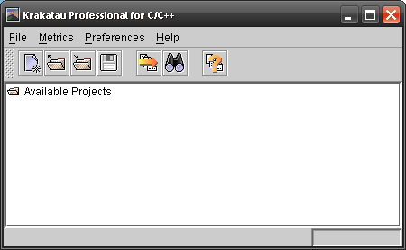 | Use the File menu to create a New Project or Open an existing Project.  The toolbar buttons are explained below.

 | When you Apply Metrics, Krakatau Professional will analyse the project file, calculate all the metrics and then Show Metrics results.  The Show Metrics option allows you to view the metrics results for a project that you have previously applied metrics.
  Create New Project
  Open an Existing Project
  Close the selected Project
  Save all open Projects
  Apply Metrics
  Show Metrics
  Preferences

Creating a New Project
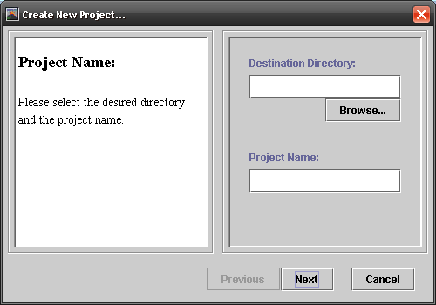 | After selecting New Project, you will see the first dialog in the New Project wizard.  Use the Browse button to select the Destination Directory where you would like to save your project file.  Type your desired Project Name. A file of <Project Name>.kpj will be created in the selected Destination Directory.

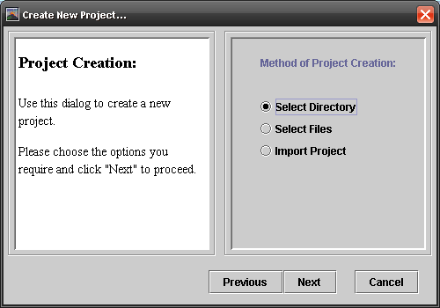 | The next dialog is the Method of Project Creation. In other words, how will you select the files to add to your project.  Select Directory is the simplest and most common and is used in the example following.  Select Files allows you to select individual files. Import Project allows you to references a MS Visual Studio 6 workspace file.

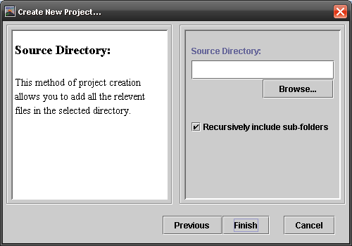 | If you chose Select Directory, use the Browse button to locate the directory containing your source code files.  The Recursively include sub-folders option will look through all sub-folders for appropriate source code files.

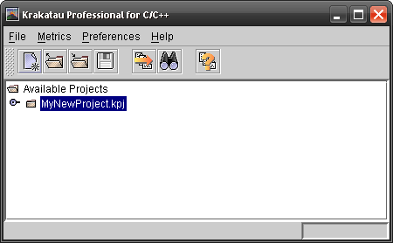 | When the wizard closes you will see your new project file in the list of Available Projects.  Click the Apply Metrics button to analyse the project.

Apply Metrics
When you select a project and then click Apply Metrics, you will a progress dialog that goes through the following stages:

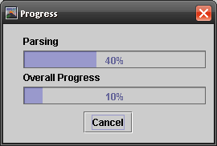 | 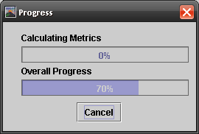
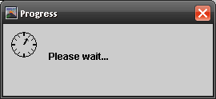

Show Metrics
After the Apply Metrics completes, or when you click Show Metrics, you will see the following dialog.

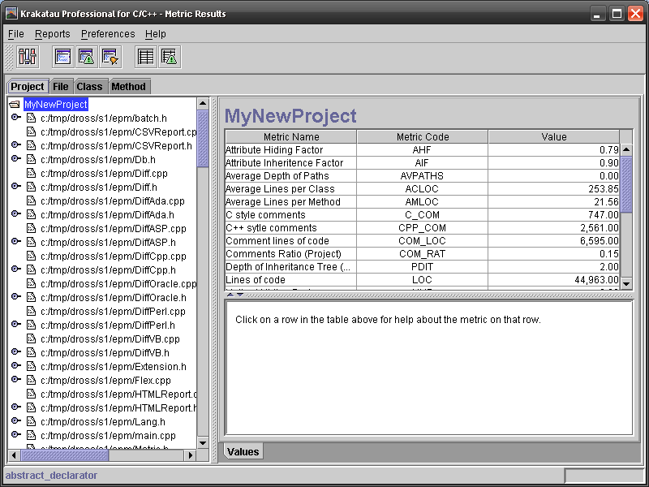
Object tabs
Object Tree: Project showing files
Currently selected Object
Metrics Results
Metrics Help

 | Use the Object tabs to select the objects you wish to study. Click on an object in the list to see the Metrics Results.  Clicking on any line in the Metrics Results will display Help for the selected metric in the Metrics Help window below.  The various report buttons can be used to output HTML and CSV reports.  The Alarm and Violating reports require you to configure bounds in Metrics Preferences.
  Metrics Preferences
  Create HTML Report
  Create Violating HTML Report
  Create Alarm HTML Report
  Create CSV Report
  Create Violating CSV Report

