

Krakatau Essential PM (KEPM)

ADA, Assembly, ASP, C#, C/C++, CSS, Fortran, IDL, HTML, Java, JavaScript, JSP, Perl, PHP, PL/SQL, PowerBuilder, Python, Ruby, ShellScript, Textfiles, VB6 / VB.NET / VBScript, VHDL, Windows Batch and XML

User Guide
1.15.1.0

Contents
1 Document 3
1.1 Purpose 3
1.2 Readership 3
1.3 Version History 3
2 Installation 6
2.1 Installing Krakatau Essential PM 6
2.2 Installing MySQL (optional) 6
2.3 Installing Krakatau Essential PM on Microsoft Windows Vista/7 6
2.4 Installing a License 6
3 Using Krakatau Essential PM 7
3.1 Startup 7
3.2 Creating a Project 8
3.2.1 Excluding Directories from the analysis 9
3.3 Opening an Existing Project file 10
3.4 Setting Old and New 10
3.5 Setting Preferences 11
3.6 Analysis 12
3.7 Results Browser 13
3.7.1 Filtering using a Metric Set 13
3.8 Metric Sets 14
3.9 Using KEPM with your CMVC System 15
4 FAQ 16
4.1 How does Krakatau Essential PM know which parser to use? 16
4.2 What does line_type in CSV reports mean? 18
4.3 Why do I get ‘You do not have a valid license’? 18
4.4 What does the error stating the MySQL cannot start mean? 18
4.5 What do the Metric IDs and Codes mean? 19

Document

Purpose
This document is an Installation and User Guide for the Krakatau Essential PM graphical source code metrics tool. It describes how to use KEPM to generate metrics results. It does not describe in detail how to use the command-line backend – Essential Project Manager (EPM) – this detail is covered in a separate EPM User Guide.

Readership
This User Guide is intended for end-users, system administrators. Management and non-technical users should refer to our website – http://www.powersoftware.com/kepm/

Version History
1.15.1.0 | 05-Mar-2010 | 10558 : Create database Results Browser in main Krakatau window  10574 : Create a Diagnostics menu to Install/Remove MySQL service, and Start/Stop the Service  10580 : Ensure last column on Results Browser is auto-filled so that the user isn't tempted to adjust  10583 : Results Browser - Map Status values to more user friendly values and colour rows appropriately
1.14.0.0 | 17-Feb-2010 | 10555 : KEPM seems to only operate if installed in C:\Program Files  10563 : Add FLEXlm to source control  10565 : Windows 7 - Remove dependence on LOCAL_MACHINE\SOFTWARE regkey
1.13.0.0 | 12-Dec-2009 | 10508 : Added PowerBuilder (PB) Language to EPM.
1.12.4.0 | 17-Nov-2009 | 10502 : Added Excluded Directories, such that files in these directories are not parsed.
1.12.3.0 | 27-Oct-2009 | 10496 : Ensure integrity of build (following missing files in 1.12.2.0).
1.12.2.0 | 15-Sep-2009 | 10479 : Add PLOC (Preprocessor LOC) for Preprocessor Directives to C/C++ and Assembly  10483 : Add logging to EPM  10484 : Add logging to KEPM  10488 : File extensions that do not exist in EPM.XML are excluded
1.12.0.0 | 22-Aug-2009 | 10450 : Added CSS Stylesheet (SS) Language to EPM  10452 : Added Ruby (RB) Language to EPM  10455 : Added Windows Batch File (WB) Language to EPM  10456 : Corrected issue with Halstead Bug Prediction (B) rounding to 0 or 1.  10461 : Added Check/Uncheck All to New Project Wizard
1.11.0.0 | 27-Jul-2009 | 10454 : Add Text files (TX) Language to EPM  10453 : Add Shell Script (SH) Language to EPM  10457 : Investigate Intel Issue: EPM crash parsing 'MKL sources'  10451 : Add Fortran (FT) Language to EPM
1.10.3.1 | 18-Jun-2009 | 10447 : Enabled installation on any drive other than C:.
1.10.3.0 | 12-May-2009 | 10445 : Ensure commas in filenames do not disrupt CSV reports.
1.10.2.0 | 05-May-2009 | 10441 : Ensure free text within HTML is counted as SLOC.
1.10.1.0 | 30-Apr-2009 | 10437 : Allow use of empty file extension using space (" ") and exclude directories in filelist
1.10.000 | 18-Apr-2009 | 10433 : Incorporate latest language additions to EPM:  10400 : Added JavaScript Language (JT)  10401 : Added HTML Language (HT)  10402 : Added Assembler Language (AY)  10403 : Added Python Language (PY)  10415 : Perl parser optimisation  10416 : C# parser optimisation  10418 : XML parser optimisation  10420 : Ada parser optimisation  10421 : ASP parser optimisation  10422 : C/C++ parser optimisation  10424 : Java parser optimisation  10426 : PHP parser optimisation  10428 : VB parser optimisation  10430 : Add Churn metrics (CRN_SLOC, CRN_LLOC & CRN_FILE)
1.09.000 | 30-May-2008 | 366 : Bundle EPM 1.16.005.
1.08.004 | 26-Apr-2008 | 360 : Build issues caused by compilation of EPM under VS2008 (upgraded from VC++6).
1.08.003 | 24-Apr-2008 | 359 : LLOC whitespace causing erroneous Diff values  355 : LLOC mismatch – C+-Style comments within C-style comments  356 : DEL_LLOC not being output to CSV file  357 : CHG_SLOC not being output to reports when using Metric Sets.
1.08.002 | 04-Jan-2008 | 338 : Added MetricsDefinitions.pdf to Help menu
1.08.001 | 14-Dec-2007
1.08.000 | 11-Dec-2007 | 324 : Added JSP Parsing  325 : Added XML Parsing  327 : Ensure MySQL Databasename contains only valid characters.
1.07.004 | 28-Nov-2007 | 323 : Resolved issues with missing PHP metrics.
1.07.003 | 01-Nov-2007 | 321 : Ensure Logical Lines are calculated corrected in Ada, ASP & C/C++/Java.
1.07.002 | 26-Oct-2007 | 319 : Remove duplicate files in projects before analysing
1.07.001 | 28-Jul-2007 | 317 : Changed default VHDL extension to *.vdh
1.07.000 | 26-Jul-2007 | 316 : Added VHDL language support.
1.06.000 | 16-Jul-2007 | 314 : Added IDL language support.
1.05.000 | 10-Nov-2006 | 301 : Added PHP language support.
1.04.000 | 02-Nov-2006 | 117 : Added ASP language support.
1.03.001 | 22-Jul-2006 | 291 : Added tooltips to Metric Sets buttons and Reporting options.
1.03.000 | 18-Jul-2006 | 272 : Added Changed Logical Lines of Code to EPM.
1.02.009 | 12-Jul-2006 | 282 : Cancel button frozen on Metric Sets.
1.02.008 | 08-Jul-2006 | 258 : Completion of Metric Sets in KEPM.
1.02.007 | 15-Jun-2006 | 258 : Development of Metric Sets in KEPM.
1.02.006 | 14-Jun-2006 | 268 : Better error handling during project creation.
1.02.002 | 02-Jun-2006 | 252 : Released including EPM 1.10.003.
1.02.001 | 10-Apr-2006 | 230 : Ensure Ada parsing is case-insensitive
1.02.000 | 26-Mar-2006 | 213 : Retrieve EPM Analysis options from project.txt.epm.cmd file
1.01.004 | 18-Mar-2006 | 210 : Added Deselect to right-click menu
1.02.003 | 06-Jun-2006 | 255 : Released including EPM 1.10.003.
1.02.005 | 08-Jun-2006 | 243 : Correctly remembers the file types chosen for the project when it was created.
1.01.003 | 15-Mar-2006 | 202 : Correct summed/calculated Halstead project metrics
1.01.002 | 13-Mar-2006 | 199 : Ensure Ada files are compared correctly
1.01.001 | 14-Feb-2006 | 185 : Saved Project List request
1.00.006 | 24-Jan-2006 | 179 : Readonly Project Filename box, limit Project Title to 30 non-space characters

Installation

Installing Krakatau Essential PM
Unzip the downloaded file and double-click on setup.exe. Follow the installation prompts, clicking Next through the wizard as normal.

If you accept the defaults, Krakatau Essential PM will be installed in:

C:\Program Files\Power Software\Krakatau EPM

Installing MySQL (optional)
If you wish to use an existing MySQL server in the organisation, you can do so using the –s (and -u/-p if required) parameter.

Otherwise, a local MySQL database will be started implicitly as Essential Metrics runs.

Installing Krakatau Essential PM on Microsoft Windows Vista/7
Be sure to read the separate Quick Start Guide which gives some good recommendations for installing KEPM on Vista and Windows 7. For a foolproof installation:

- Run the setup as Administrator (by right-clicking an chosing Run/Install as Administrator
- After installing, right-click on Krakatau EPM and Run as Administrator, then chose Diagnostics > MySQL > Install Service

Installing a License
You must obtain either a time-locked (for testing) or node-locked/floating (following purchase) license from Power Software. The recommended way to install the license is to place it where you installed Essential Metrics (see default directory above) and then simply launch Krakatau EPM from Start – Programs – Power Software – Krakatau EPM. This will prompt for you to Browse to the license.dat file.

If you do not have a valid license, you will see the following dialog on startup:

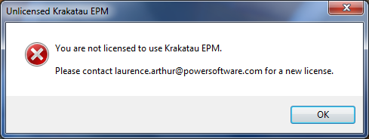
Figure 1: Unlicensed error dialog

Using Krakatau Essential PM

Startup
When you launch KEPM, you will see the window shown in Figure 2.

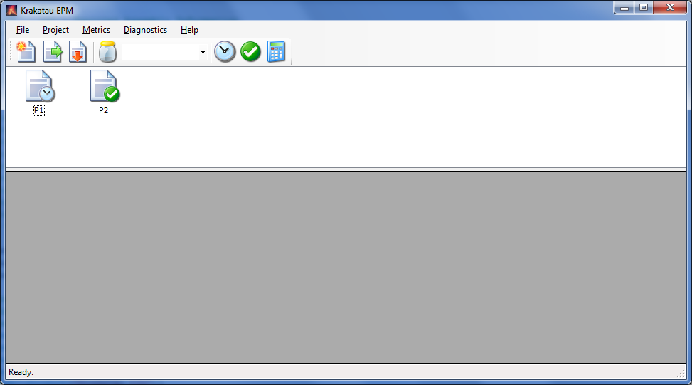
Menu Bar
Tool Bar
Projects Window
Results Browser
Metric Set Selector
Figure 2: Krakatau EPM main window

As with other applications, there is more than one way to carry out an operation. We will describe operations using the application Tool Bar:

 | New Project wizard – allows you to create new project files containing a Project Title, Snapshot date, Base directory and actual source files in the project.
 | Open an existing Project file.
 | Remove a Project from the Projects windows.
 | Open the Metric Sets dialog and add, edit and delete Metric Sets.
 | Set the currently selected Project as the Old Project.
 | Set the currently selected Project as the New Project.
 | Analyze. If Old and New Projects are selected, perform a Project comparison, otherwise a Single Project analysis.

Creating a Project
To create a new Project, click the New Project Wizard toolbar button.

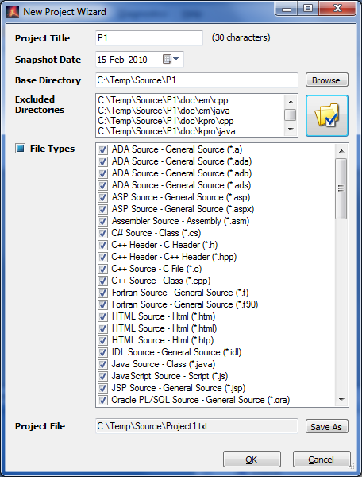  Figure 3: New Project Wizard | Enter Project Title (a name for the Project, representing the software and possibly a version number)  Choose the Snapshot Date – the date the source was extracted or labeled.  Browse to the Base Directory for the source code – the top-level directory where the source may be found.  You may exclude certain directories if that is appropriate – see 3.2.1.  If required, select the file types you require in the Project. You may use the checkbox beside File Types to Check/Uncheck All.  Finally, click Save As to save the Project file.

When you click OK, the Base directory will be examined (and all subdirectories below it) for the types of files you have selected. These files, along with the Project Title and Snapshot date are then stored in the Krakatau EPM Project file you chose.

Note: as well as the Project file (in the example above ‘mn105a.txt’), a Windows command file with the extension .cmd will also be created (e.g., ‘mn105a.txt.cmd’). Experienced users can use these sample command files to create their own Project files. They may be deleted, if not required. Each time you create a New Project, KEPM creates a command file for it.

Once the Project file has been created it will appear in the Project window.

Excluding Directories from the analysis
You may wish to exclude certain directories from the analysis, to prevent configuration or other undesirable code from being included in the metrics results.

To do this, click the Exclude Directories button and the following dialog will appear:

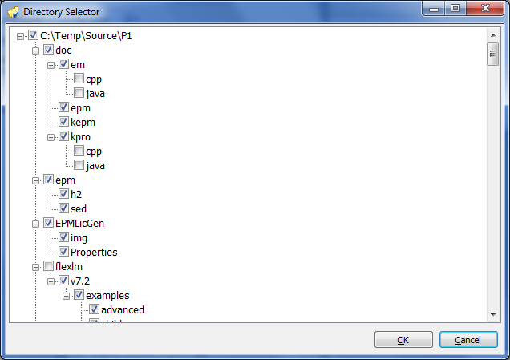
Figure 4: Directory Selector

All directories are expanded and selected by default. To exclude a directory, simply uncheck. Note: excluding a parent directory does not mean the child directories will be excluded, only the files in the parent.

Click OK when you have finished and you will see the Excluded Directories appear in the listbox for your information.

Opening an Existing Project file
If you have previously created a Project file, you may open it in Krakatau EPM using the Open Project toolbar button. This loads the file into the Projects Window.

Setting Old and New
When you have a Project open, you can click on it then choose either Old or New toolbar buttons:

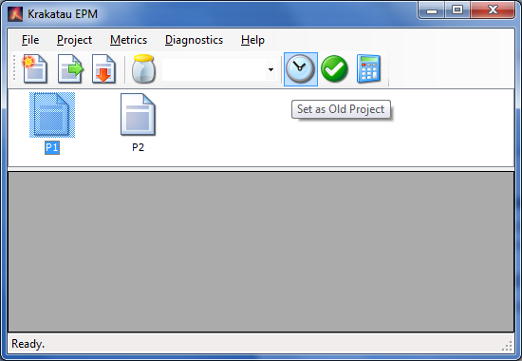  Figure 5: Setting Old Project | The P1 Project has been selected. By then clicking the Old button, it will get a clock icon.  If we then click the P2 Project and click the New button, it is highlighted in green, as below.  You may also right-click on a Project and choose Set as Old or Set as New from the popup menu.
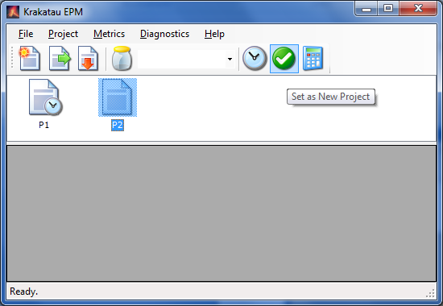  Figure 6: Setting New Project | We are telling Krakatau EPM that P1 is the Old Snapshot of the source, and that P2 is the New Snapshot.  When comparing these projects, P2 will be examined with reference to P1.

For instance, a file that existed in P1 but no longer exists in P2 is considered to have been deleted. Source Lines that exist in a file in the new Project but not in the old are New Source Lines.

If you only set a New Project, Krakatau EPM will perform a Single Project analysis, with no changed information.

Setting Preferences
Krakatau EPM preferences allow you to configure the default MySQL connection properties. Only change these settings if you have explicitly installed MySQL separately, or you wish to access a specific MySQL Server.

To set Preferences, select Project – Preferences…

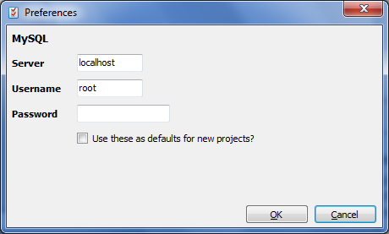  Figure 7: Preferences | To ensure these settings are set as the defaults for new projects, check the appropriate box.  Click OK to save.

Analysis
To perform an analysis of your selected Project(s), click the Analyze:

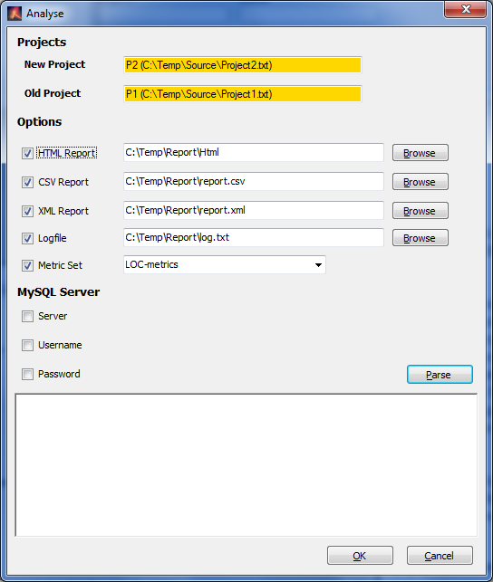  Results Window  Logging  Figure 8: Analysis dialog | The dialog tells you what the New and Old Projects are.  You can then select the reporting options you require – ticking a checkbox to force an option, and specifying files/folders in the textbox that appears. Use the Browse button if you wish.  Choose a Metric Set if you wish to filter the metrics that are output on the report.  If you have a MySQL server on your network that you wish to use, specify the hostname (Server) and user/password details as required.  When ready, click the Parse button.
The Parse button creates another Windows command file (e.g., called ‘mn105a.txt.epm.cmd’). This is then executed and the results are shown in the Results Window. As the Projects are parsed you will see the analysis and differences, and finally the reports you have selected.

Each time you press OK or Parse, the .epm.cmd file is recreated, and this file is also used to retrieve your Analysis options when you reopen the project. The checkboxes you have ticked and the values entered, will be retrieved from the .epm.cmd file and populated in this dialog the next time you Analyze, in the same KEPM session or at a later date.

If you select an HTML report, it will be launched in your default browser once parsing is complete.

Results Browser
To use the Results Browser, right-click on your project and select Refresh Results, see Figure 9. If the project has been parsed (using the Analysis dialog) then you will see the results in the Browser.

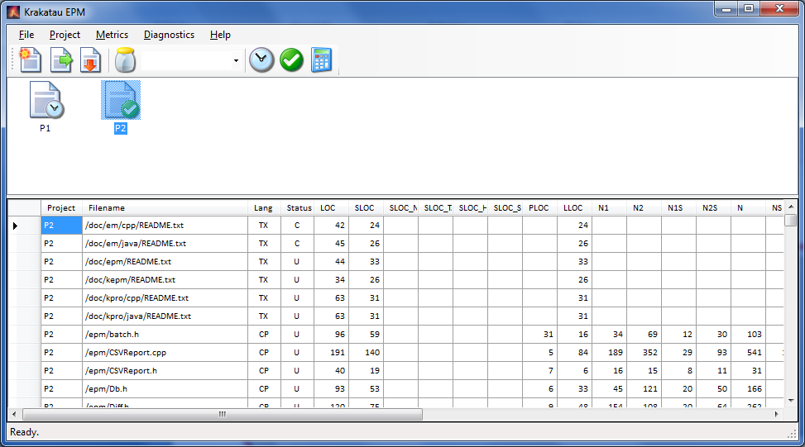
Figure 9: Results Browser populated

Filtering using a Metric Set
If you only wish to see a subset of metrics in the results, you should create a Metric Set. Refer to section 3.8 for help creating a Metric Set. Once you have created a Metric Set, you may select it from the Metric Set selector on the toolbar, and push F5 or right-click on your project to refresh the Results Browser with only the metrics you have defined in your Metric set.

Metric Sets
If you wish to limit the metrics that are output in your reports, you can define a Metric Set with only those metrics you wish to see. For example, your Project Manager is only interested in LOC, SLOC, the changed SLOC and the new changed LLOC.

From the main application, click the Metric Sets jar icon, or choose Metrics > Sets:

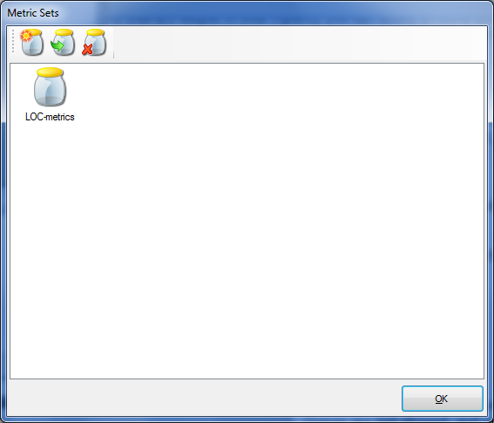  Figure 10: Metric Sets dialog | In this example, we already have an existing set called “LOC-metrics”. This set, and any we create, are stored in the epm.xml configuration file.  Let’s create a new one for our particular metric interests.  Click the New icon (the first one) on the toolbar.

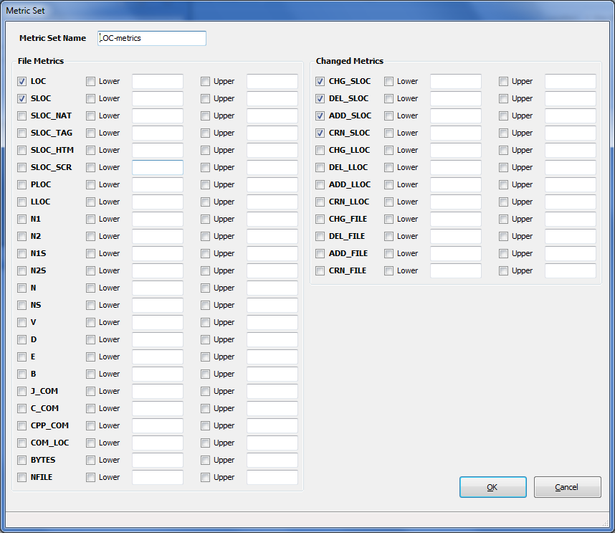  Figure 11: Metric Set definition | Enter a name for the metric set. Spaces are not allowed, and will be removed.  Check the box beside each metric code you wish to include in the set. The lower and upper bounds settings can also be set although they are not yet used by any EPM reports.  Click OK.  You can specify a metric set when you Analyze (see previous section).

Using KEPM with your CMVC System
Krakatau EPM does not restrict users to any CMVC (Configuration Management/Version Control) system, nor does it directly interface with any specific CMVC system. However, many of our customers are successfully using KEPM in conjunction with several popular CMVC systems, including:

- IBM Rational ClearCase
- Perforce
- Microsoft Team Foundation Server
- CVS
- Subversion

Krakatau EPM requires direct access to copies of your actual source files, not CMVC binaries such as ClearCase VOBs.

Typically this involves exporting a copy of your source to a location on your machine. You then create a new project in KEPM (see 3.2) and point it at your exported source and proceed to Analyze (see section 3.6).

FAQ

How does Krakatau Essential PM know which parser to use?
Krakatau EPM is supplied with a default XML Configuration file that instructs the tool to apply different languages parsers to the files based on the following file extensions:

Language | Extensions | Parser Code
ADA | .a .ada .adb .ads | AD
ASP | .asp .aspx | AS
Assembly | .asm | AY
C++ | .cpp .c .hpp .h | CP
C# | .cs | CS
CSS | .css | SS
Fortran | .f .f90 | FT
IDL | .idl | ID
HTML | .htm .html .htp | HT
Java | .java | JV
JavaScript | .js | JT
JSP | .jsp | JS
PHP | .php | PH
Perl | .pl | PL
PL/SQL | .sql .ora | S1
PowerBuilder | .srd .srf .srs .sru .srw | PB
Python | .py | PY
Ruby | .rb | RB
Shell Script | .ash .bash .bsh .csh .sh .tcsh .tsh .zsh | SH
Textfile | .cvs .install .readme .tsv .txt | TX
VB.NET | .vb | VB
VB6 | .frm .bas .cls | VB
VBScript | .vbs | VB
VHDL | .vhd | VH
Windows Batch | .bat .cmd | WB
XML | .xml .xsd .xsl .xslt .wsml | XM

You cannot simply add a language of your own. EPM only understands the Parser Codes listed above. Should you need a new language not listed here, please contact us to discuss.

If you need to modify this configuration, you may edit the EPM.XML configuration file supplied with the tool, but please take a backup before you start and if you experience any errors and you report these, please include your EPM.XML file and state what you were trying to achieve.

The default file looks like:

<?xml version="1.0" encoding="UTF-8"?>  <epm>  <lang name="C++" parser="CP">  <filetype name="Source">  <ext name="Class" value="cpp" />  <ext name="C File" value="c" />  </filetype>  <filetype name="Header">  <ext name="C++ Header" value="hpp" />  <ext name="C Header" value="h" />  </filetype>  </lang>  <lang name="C#" parser="CS">  <filetype name="Source">  <ext name="Class" value="cs" />  </filetype>  </lang>  …  </epm> | This extract from the file shows the definitions for two Languages: C++ and C#.  Within each lang entity there are filetype entities. The C++ Language has two filetypes: Source and Header. Each filetype then has one or more ext entities representing the file extensions that comprise the filetype.  C# only has one filetype – Source – and a single extension – cs.  Extensions are the characters after the last period (.) in the filename.

To add new filetype or ext entities, simply edit the file using a text editor, copy/paste an existing block and modify the name and value attributes accordingly.

The values in the name attributes are free-text. In a future version of EPM it will be possible to report on these values, including viewing files/metrics grouped by the same filetype (e.g. Source) across several languages.

If you have files that have no extension, you may use a value of “ “ (single space). This means that all files with no extension will be parsed using the language parser you have selected.

<ext name="MyFileType" value=" " />

The parser attribute of the lang entity must be one of the Parser Codes listed in the first table.

The parser attribute of the lang entity must be one of the Parser Codes listed in the first table.

What does line_type in CSV reports mean?
Line Type | Description | Meaning
C | Changed | The File/Project has Changed. This line gives details of the New File/Project and the original metrics can be found on a corresponding Old (O) line.
O | Old | Where a File/Project has Changed, the Old line will also be output to the CSV file.
X | Diff | Where a File/Project has Changed, the Diff line will also be output to the CSV file, showing the difference between Changed (C) and Old (O) lines.
U | Unchanged | The File/Project has not changed.
N | New | The File is New, it has been added to the Project.

Deleted files are not shown in CSV reports.

Why do I get ‘You do not have a valid license’?
If you have not requested a license from laurence.arthur@powersoftware.com, please do so. Once you have received this file (supplied as an attachment called ‘license.dat’), please detach this to the folder in which you installed Krakatau EPM.

If there is an existing license.dat, overwrite it. Then try re-executing Krakatau EPM. If you continue to experience problems, send an email support@powersoftware.com with the License [Code] value you see on starting up KEPM.

What does the error stating the MySQL cannot start mean?
If you are relying on Krakatau EPM to start a MySQL database for you, please ensure that you wait a few seconds between running successive KEPM sessions. MySQL takes a moment or so to start and stop the service at the beginning and end of a KEPM session.

What do the Metric IDs and Codes mean?
We use a unique numeric code for each metric, as well as an alpha code which is more descriptive.

For efficiency reasons, these numeric codes may change between releases, when a new metric is inserted into the list. We upgrading, be sure to check your Metric Sets and any other interfaces that rely upon the Metric ID.

ID | Code | Description | Project | File
100 | LOC | Lines of Code | ✓ | ✓
101 | SLOC | Source Lines of Code | ✓ | ✓
102 | SLOC_NAT | Source Native Lines of Code | ✓ | ✓
103 | SLOC_TAG | Source Tag Lines of Code | ✓ | ✓
104 | SLOC_HTM | Source HTML Lines of Code | ✓ | ✓
105 | SLOC_SCR | Source Script Lines of Code | ✓ | ✓
106 | PLOC | Preprocessor Directive Lines of Code | ✓ | ✓
107 | LLOC | Logical Lines of Code (semi-colon count – formerly NSC) | ✓ | ✓
108 | N1 | Total No. of Operators |  | ✓
109 | N2 | Total No. of Operands |  | ✓
110 | n1 | No. of unique or distinct Operators |  | ✓
111 | n2 | No. of unique or distinct Operands |  | ✓
112 | N | Halstead program Length (calculated as N1 + N2) |  | ✓
113 | n | Halstead program Vocabulary (calculated as n1 + n2) |  | ✓
114 | V | Halstead Volume (calculated as V = Nlog2n) |  | ✓
115 | D | Halstead program Difficulty |  | ✓
116 | E | Halstead program Effort (calculated as D * V) |  | ✓
117 | B | Halstead Bug Prediction |  | ✓
118 | J_COM | Java-style Comment Lines | ✓ | ✓
119 | C_COM | C-style Comment Lines | ✓ | ✓
120 | EOL_COM | To End of Line Comment Lines | ✓ | ✓
121 | COM_LOC | Total Comment Lines | ✓ | ✓
122 | BYTES | File size in bytes | ✓ | ✓
123 | NFILE | Number of Files | ✓
124 | CHG_SLOC | Changed Source Lines of Code | ✓ | ✓
125 | DEL_SLOC | Deleted Source Lines of Code | ✓ | ✓
126 | ADD_SLOC | Added Source Lines of Code | ✓ | ✓
127 | CRN_SLOC | Churn Source Lines of Code (CHG_SLOC + DEL_SLOC + ADD_SLOC) | ✓ | ✓
128 | CHG_LLOC | Changed Logical Lines of Code | ✓ | ✓
129 | DEL_LLOC | Deleted Logical Lines of Code | ✓ | ✓
130 | ADD_LLOC | Added Logical Lines of Code | ✓ | ✓
131 | CRN_LLOC | Churn Logical Lines of Code (CHG_LLOC + DEL_LLOC + ADD_LLOC) | ✓ | ✓
132 | CHG_FILE | Changed Files | ✓
133 | DEL_FILE | Deleted Files | ✓
134 | ADD_FILE | Added Files | ✓
135 | CRN_FILE | Churn Files (CHG_FILE + DEL_FILE + ADD_FILE) | ✓

