

Krakatau EPM & EPM on Vista
Installation of MySQL

User Guide
1.00.000

Contents
Contents 2
Document 3
Purpose 3
Readership 3
Version History 3
Installation of MySQL 4
Download MySQL 5.1 4
Installing MySQL 4

Document

Purpose
This document is an User Guide for installing Krakatau Essential Project Manager (graphical source code metrics) and EPM (command-line source code metrics) tools on Microsoft Windows Vista.

Vista’s User Account Control prevents EPM from installing and starting the MySQL service. A simple solution to this problem is to install MySQL separately, and reference accordingly within KEPM or to the command-line of EPM.

Readership
This User Guide is intended for end-users, system administrators. Management and non-technical users should refer to our website – http://www.powersoftware.com/kepm/

Version History
1.00.000 | 20-May-2008 | 361 : Document created.

Installation of MySQL

Download MySQL 5.0
Please use the following URL to download the current release of MySQL 5.0:

http://dev.mysql.com/downloads/mysql/5.0.html#win32

We recommend “Windows Essentials (x86)” (typically ~22Mb)

Installing MySQL
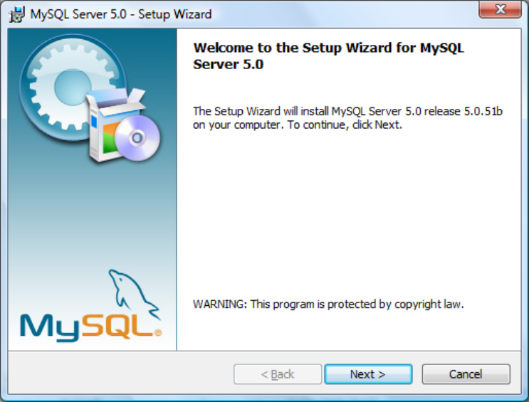 | Welcome screen  Click Next
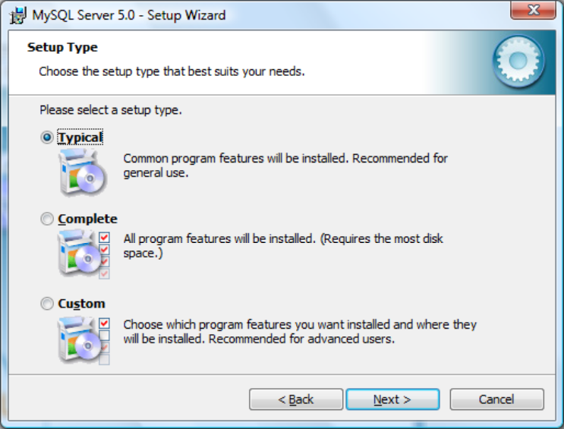 | Setup Type - leave as Typical  Click Next
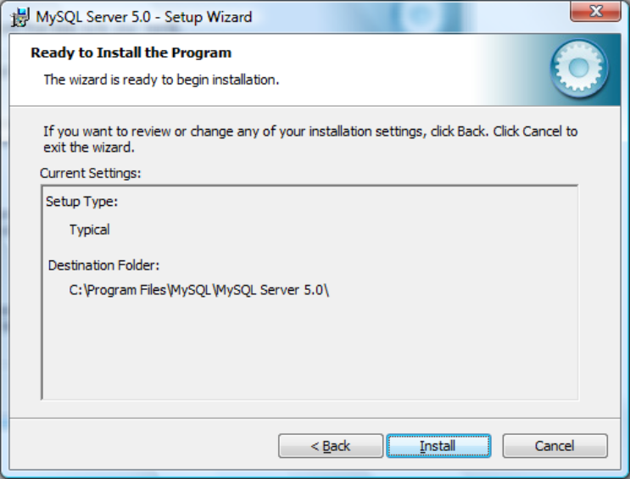 | Ready to Install  Click Install
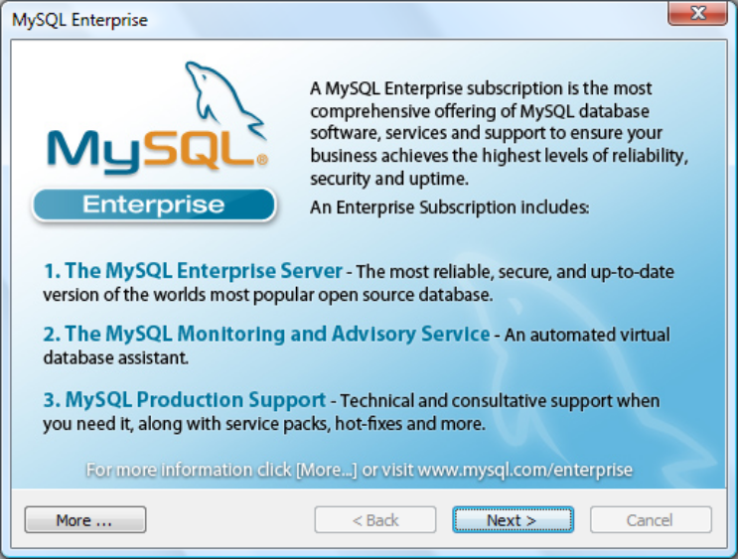 | When the installation completes, you will see MySQL Enterprise  Click Next
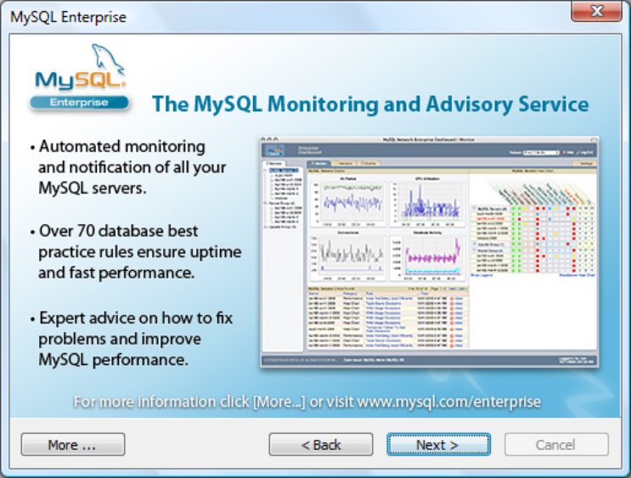 | MySQL Enterprise – Monitoring  Click Next
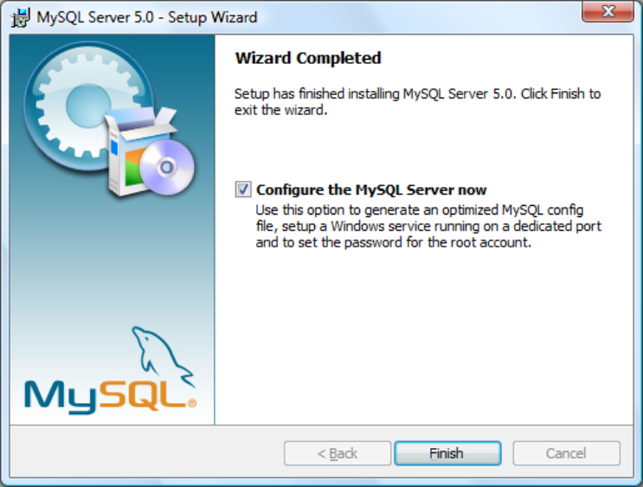 | Wizard Completed - Configure the MySQL Server now (leave checked)  Click Finish
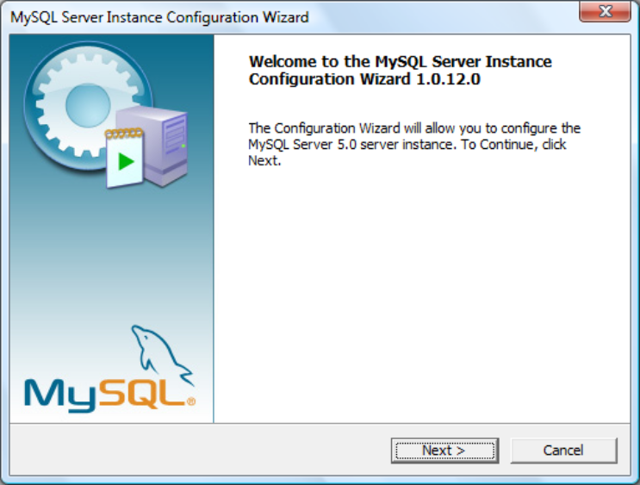 | Welcome to Instance Configuration  Click Next
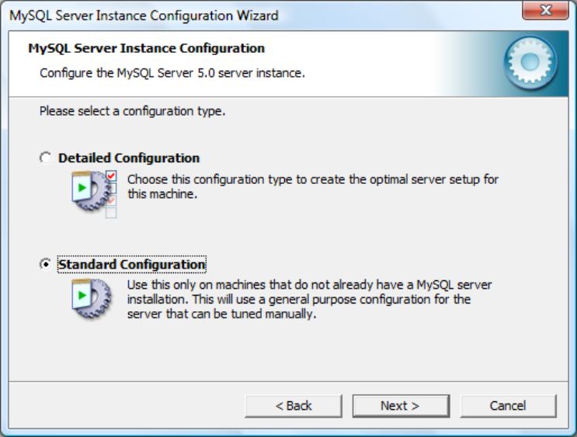 | Instance Configuration - select Standard Configuration  Click Next
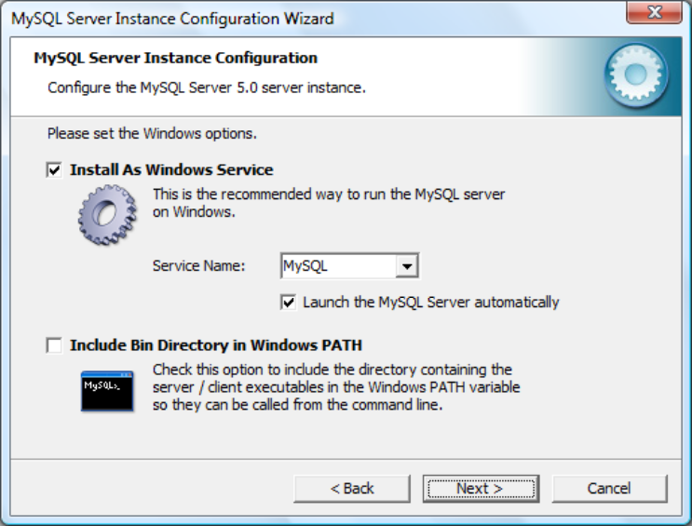 | Instance Configuration - accepts the defaults as opposite.  Click Next
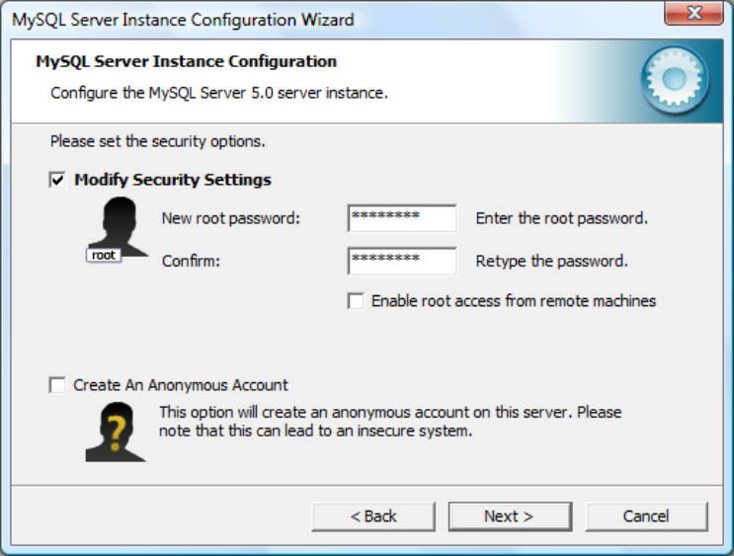 | Security Settings - enter a password for the root user, e.g. “password” - remember this as you will need it later.  Click Next
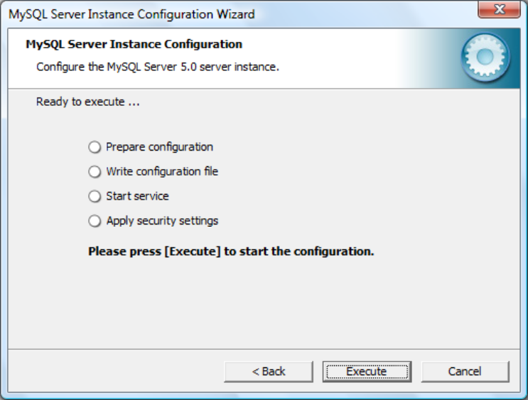 | Ready to Execute  Click Execute
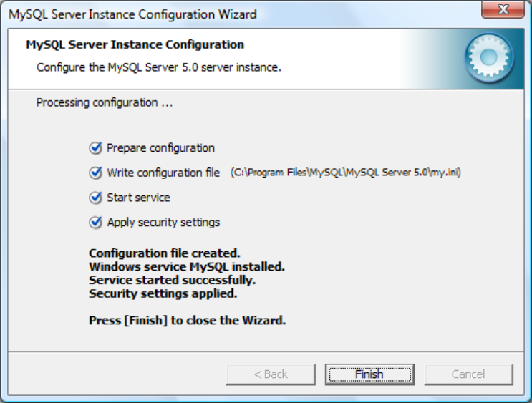 | Configuration completed  Click Finish

You have now installed MySQL. Please proceed to install Essential Program Manager or Krakatau EPM.

Installation of Essential Metrics PM
Install EPM normally.

Follow the steps in the EPM User Guide – “Installing MySQL (optional)” to connect to the database. Connect to:

-s localhost
-u root
-p password (or if you entered a different password above, specify it here)

Installation of Krakatau EPM
Install KEPM normally.

Follow the steps in the Krakatau EPM User Guide – “Installing Krakatau Essential PM on Microsoft Windows Vista” and “Error: Reference source not found” to set the default MySQL Connection settings for connecting to the database.

