

**Krakatau Essential PM (KEPM)**

Quick Start Guide

*2.3.0.0*

# Before starting

You must obtain either a time-locked (for testing) or node-locked/floating (following purchase) license from Power Software. The recommended way to install the license is to place it where you installed Krakatau EPM and then simply launch Krakatau EPM from Start – Programs – Power Software – Krakatau EPM. This will prompt for you to Browse to the license.dat file.

If you do not have a valid license, you will see the following dialog on startup:

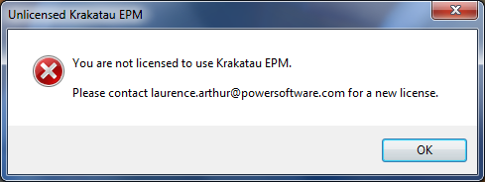

Figure 1: Unlicensed error dialog

# Installation under Windows 2000/XP

There are no special instructions for installing under Windows 2000/XP. Unzip the archive and launch KrakatauEpmSetup.exe to install the software. Please refer to the User Guide for instructions creating projects and analysing.

# Installation under Windows Vista/7/8

For a trouble-free installation under Windows Vista/7/8, it is recommended that you observe the following procedure. This will ensure that the software is installed correctly, including the MySQL server instance.

1. Extract KrakatauEpmSetup.exe from the archive
2. Right-click on KrakatauEpmSetup.exe and choose **Install as Administrator** or **Run as Administrator** (whichever is available)
3. Complete the installation as normal
4. Once the software has been installed, locate it in the Programs menu, and then right-click to **Run as Administrator** (note: you only need to do this the first time)
5. Use Krakatau’s built-in diagnostics facility to start the MySQL server instance:  
   Click on menu *Diagnotics > MySQL > Install Service*

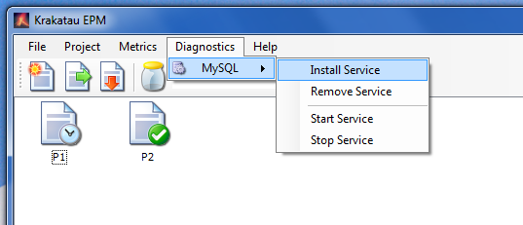

Figure 2: Installing the MySQL Windows Service

If you now close Krakatau EPM and relaunch (normally, not as Administrator), you should be able to build and analyse projects correctly.