AERO21111 GMAT coursework question sheet:
Based on Tutorial 1 [30 marks]
You want to launch an experimental satellite with a low mass and high drag area to try to improve our understanding of the atmosphere and atmospheric drag. To do this, you will observe the spacecraft’s behaviour as its altitude decreases by 50km from its initial starting value. The spacecraft will have a mass of 10 kg and a drag area of 1m². You have three possible orbits available to you:
- A circular 500km altitude polar orbit, with RAAN = AOP = TA = 0 deg.
- A circular 400km altitude polar orbit, with RAAN = AOP = TA = 0 deg.
- A circular 500km altitude equatorial orbit, with RAAN = AOP = TA = 0 deg.

Question 1.1:
Define suitable initial Keplerian orbit elements for each of these possible orbits. Define each value to the nearest whole number (assume the radius of the Earth is 6,371km):
 | SMA (km) | ECC (-) | INC (deg) | RAAN (deg) | AOP (deg) | TA (deg)
a) | 6871 | 0 | 90 | 0 | 0 | 0
b) | 6771 | 0 | 90 | 0 | 0 | 0
c) | 6871 | 0 | 0 | 0 | 0 | 0

[10 marks]
1 mark for each correct element plus 1 additional mark for all correct

Question 1.2:
Use GMAT to model the motion of your spacecraft under the influence of a complex gravitational field to the order of J2 and atmospheric drag using the MSISE90 drag model. Use a report file (or otherwise) to determine the changes in orbit elements over the propagation period for each starting orbit, and use this information to determine how long (to the nearest day) it will take for your spacecraft altitude to decrease by 50km in each case. Include a copy of X-Y plots created in GMAT for each case to support your answer (add annotations or captions in PowerPoint, or similar, to communicate your interpretation of the graph):
- 29
- 6
- 35
[20 marks]
3 marks for each correct answer plus 1 additional mark for all correct
3 marks for each graph (if suitable) plus 1 additional mark for all graphs included and suitable

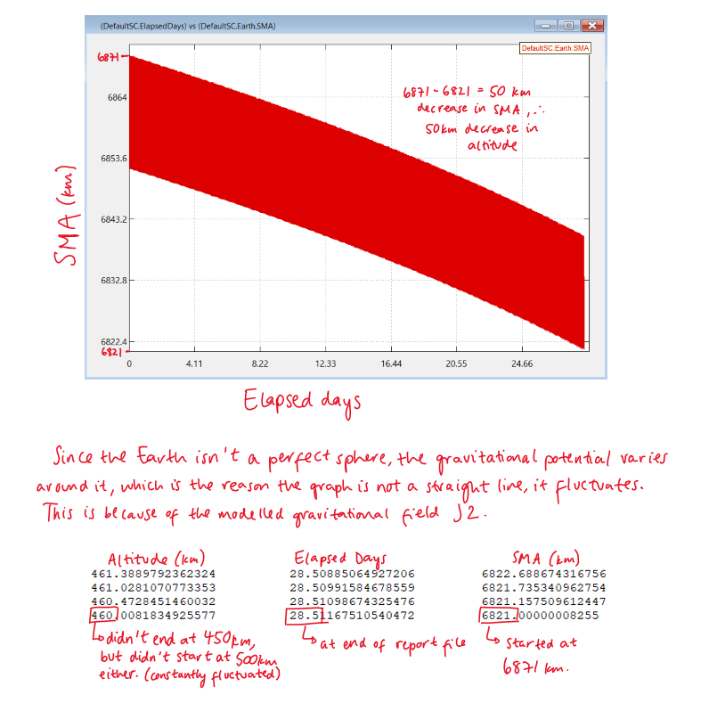
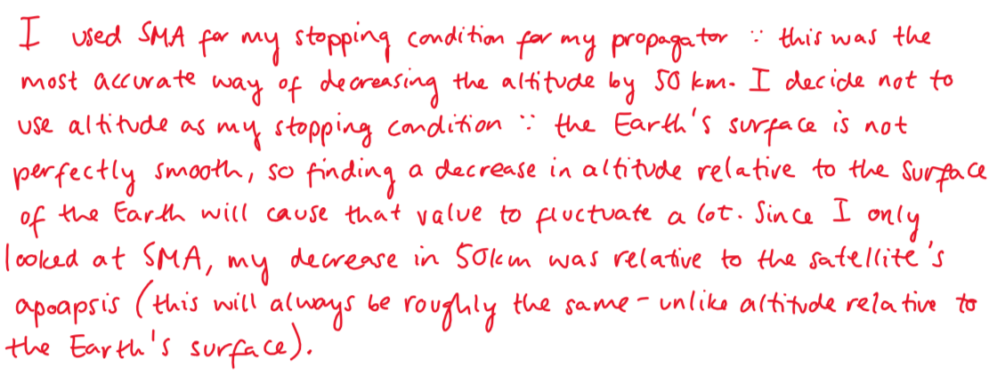
Spacecraft 1 Plot

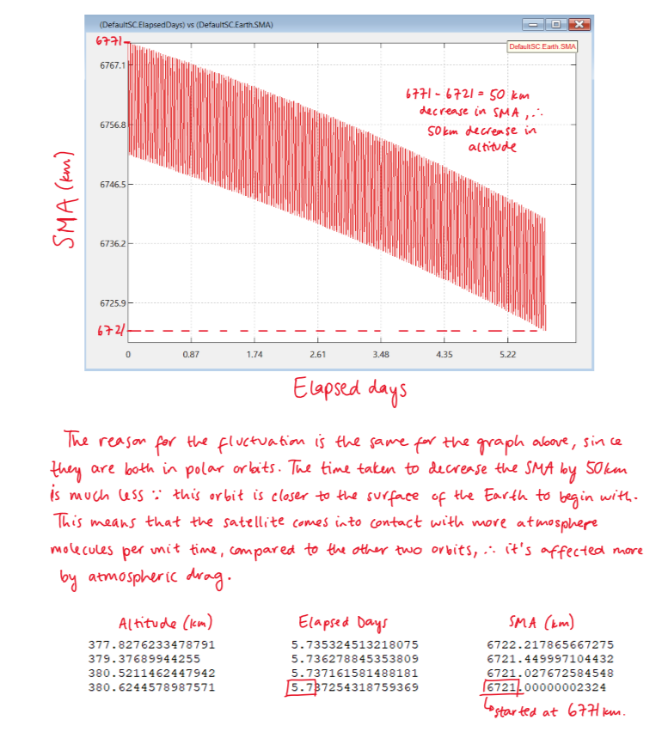
Spacecraft 2 Plot

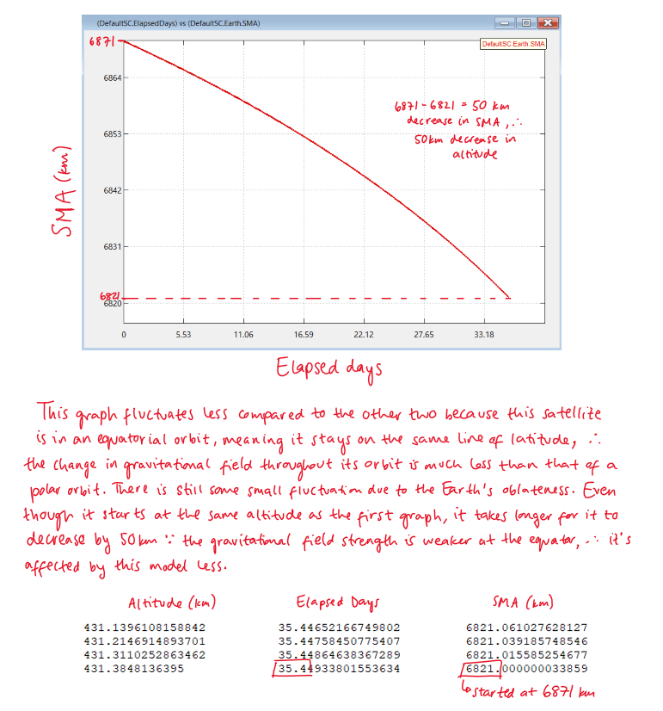
Spacecraft 3 Plot

Based on Tutorial 2 [30 marks]
Question 2.1:
The data in Table 2.1 gives the parameters of a number of satellite orbits around Earth. Calculate the period of each orbit and add it to the Table in the appropriate rows.
Hint: Assume the standard gravitational parameter for Earth, μ, is 398600 km³s⁻².
[8 marks]
1 mark for each correct period
Question 2.2:
Use the data in Table 2.1 to propagate each orbit for one orbit period using a complex gravitational model to the order of J2. Identify the various orbit types in Table 2.1 from their ground tracks or otherwise and add these to the appropriate row in the Table.
HINT: refer to section 3.3 of your notes for help with this.
[8 marks]
2 marks for each correctly identified orbit
Question 2.3:
Include a screen shot of each ground track produced with appropriate captions. You can also include any other plots/screen shots that will help show the properties of your orbit.
HINT: Consider overriding the colour of your groundtrack (Mission Tab > Propagate1) to make it easier to see.
[14 marks]
3 marks for each suitable ground track figure and 2 marks for all present and suitable
Table 2.1 Orbit parameters.
Keplerian orbital elements | Orbit 1 | Orbit 2 | Orbit 3 | Orbit 4
SMA [km] | 20,000 | 42,160 | 26,570 | 42,160
ECC | 0 | 0 | 0.72 | 0
INC [deg] | 50 | 50 | 63.4 | 0
RAAN [deg] | 180 | 180 | 0 | 0
AOP [deg] | 0 | 0 | 270 | 0
TA [deg] | 0 | 0 | 0 | 0
Orbit Period [secs] | 28150 | 86150 | 43100 | 86150
Orbit Period [hrs] | 7.819 | 23.93 | 11.97 | 23.93
Orbit Type | MEO | GSO | HEO | GEO

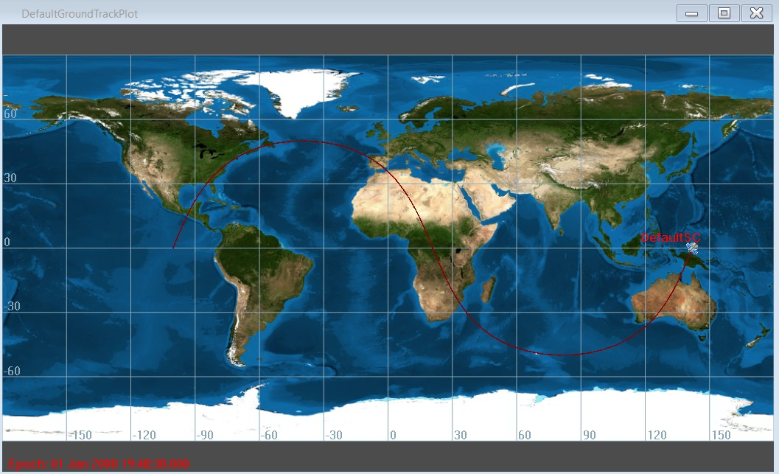
Orbit 1 Plot(s)

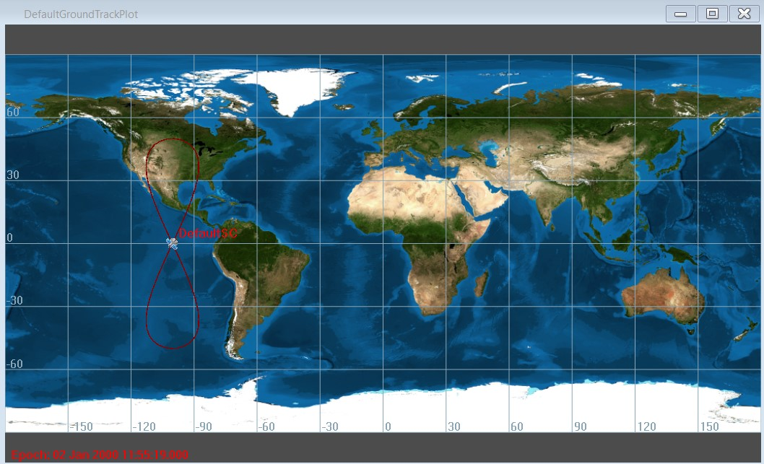
Orbit 2 Plot(s)

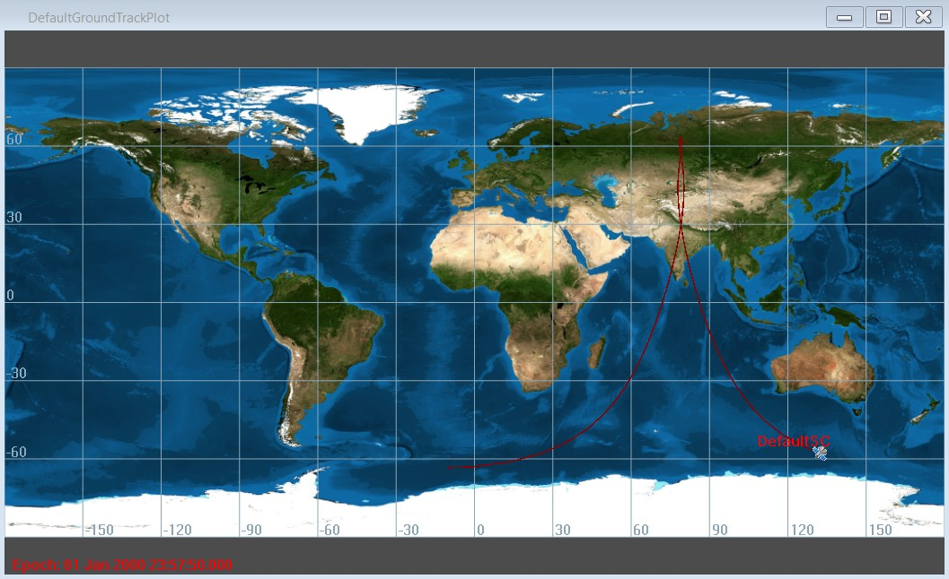
Orbit 3 Plot(s)

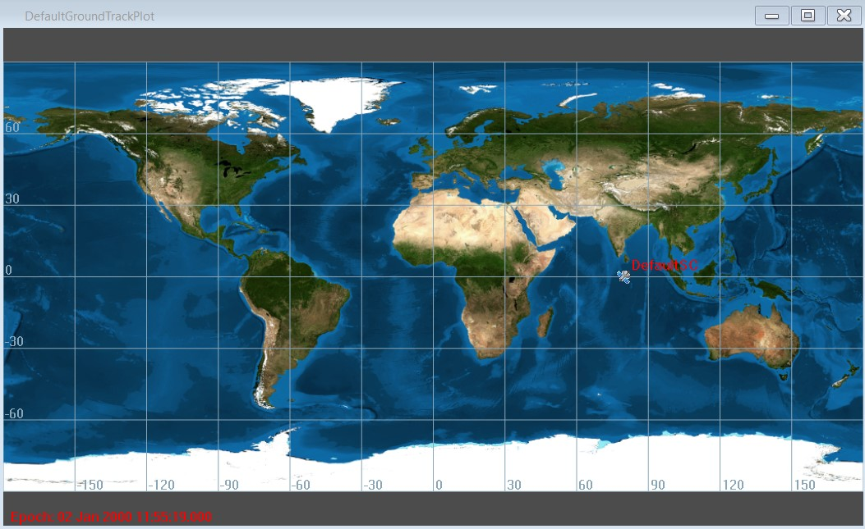
Orbit 4 Plot(s)

Based on Tutorial 3 [40 marks]
SpaceX launches its Starlink spacecraft to an altitude of approximately 300km and then raises their orbit altitude using electric propulsion to a final operational altitude of 550km. You would like to propose an alternative system that uses high thrust propulsion to raise its orbit altitude using a Hohmann transfer.

Question 3.1:
Calculate the ΔV that would be required by the new spacecraft to transfer from a circular 53 deg inclined 300km launch altitude to a circular 53 deg inclined 550km final operational altitude using a Hohmann transfer. Fill in the ΔV values for each burn and the total ΔV for the manoeuvre in Table 3.1.
Hint: Assume the radius of the Earth is 6371km and the standard gravitational parameter for Earth, μ, is 398600 km³s⁻².

Question 3.2:
Model this Hohmann transfer in GMAT using two different propagators:
  - A simple model with a central Earth point mass;
  - A complex model with gravitation field including J2 and atmospheric drag using the MSISE90 model;
and finish the below sentences, commenting on whether your manoeuvre in each case was successful in reaching the desired final orbit. Include in your answer the magnitude of the difference, whether your initial calculations have underestimated or over-estimated the ΔV needed for the manoeuvre, what could have caused this difference, and what this would mean for your mission. Support your answer with the use of graphs and/or report file outputs from GMAT.
Table 3.1: Calculated Hohman transfer ΔVs.
Burn 1 ΔV (km/s) | 0.07011
Burn 2 ΔV (km/s) | 0.07012
Total manoeuvre ΔV (km/s) | 0.14023

[10 marks]
3 marks for each correct value and 1 mark for all correct

Using a simple Earth point mass propagator the simulation showed… that the manoeuvre was successful in reaching the desired final orbit. The magnitude of the difference between the calculated ΔV and the actual value is 0.00258, meaning the calculated value is a slight overestimate. This small difference could be due to numerical approximations that GMAT uses which could lead to small errors in the output values.
[12 marks]
3 marks for each discussion point suitably addressed
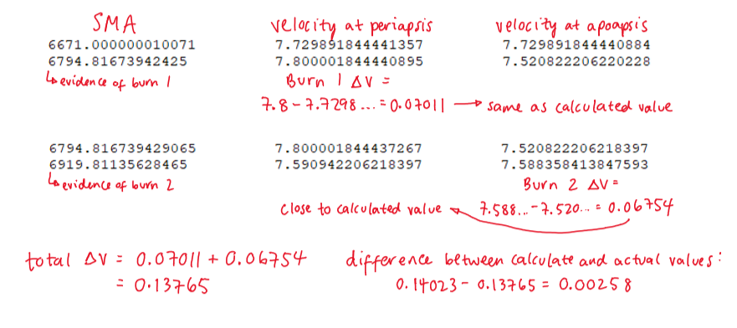
Supporting graphs:

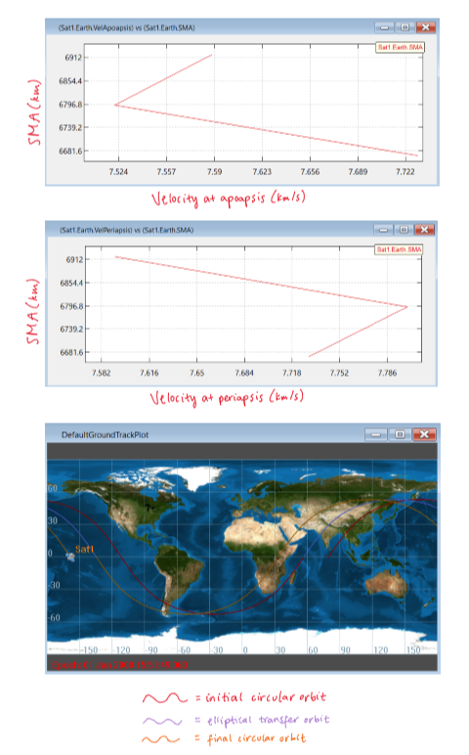
[3 marks]

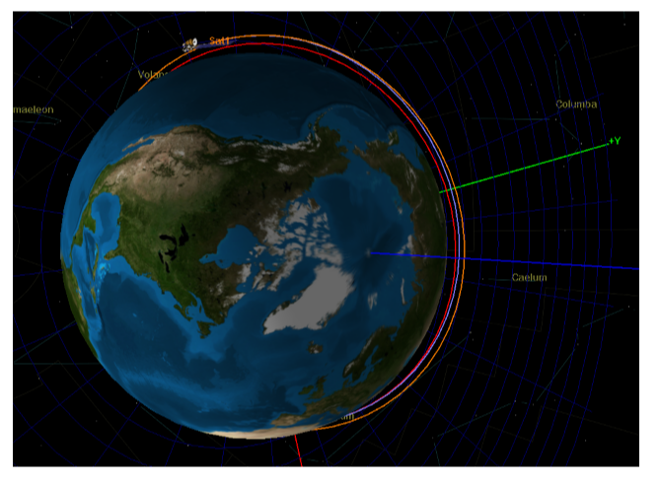
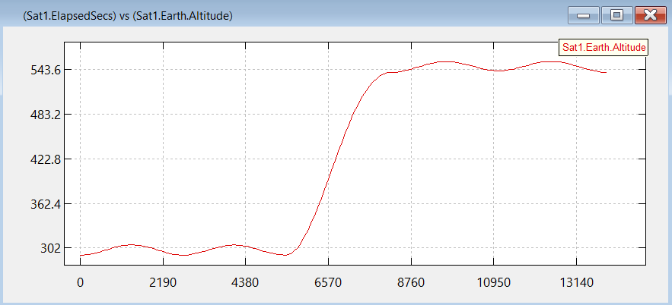

Using a complex propagator with J2 and drag the simulation showed… that the manoeuvre was successful in reaching the desired final orbit. The magnitude of the difference between the calculated ΔV and the actual value is 0.02718, meaning the calculated value is an overestimate. This difference is one order of magnitude greater than that for the simple Earth point mass propagator. This difference could have been caused by atmospheric drag, since this satellite is in Low Earth Orbit. When I calculated the ΔV, I did not take into account the drag force, which would slow down the satellite during the manoeuvre. The difference could also be caused by gravity perturbations due to the influence of other nearby planets. In my calculations, I assumed that it was an ideal 2-body model.
[12 marks]
3 marks for each discussion point suitably addressed

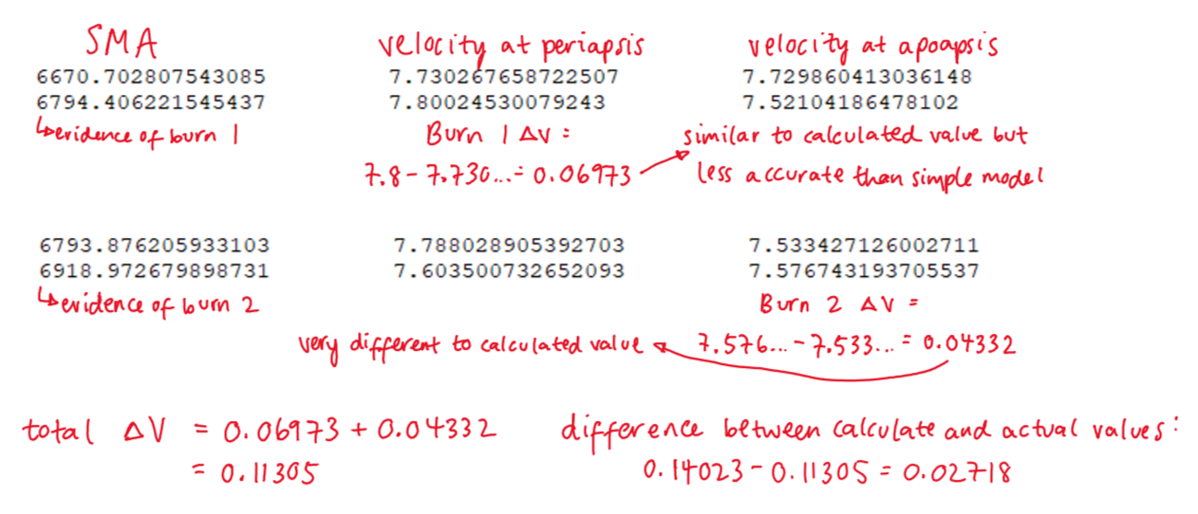
Supporting graphs:

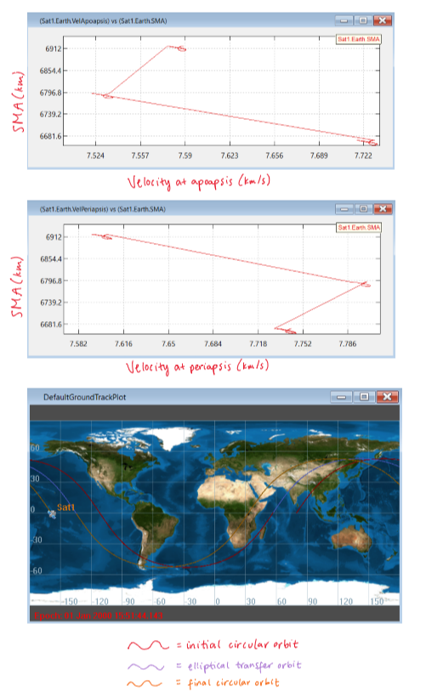
[3 marks]
