Max Thrust Riot V2 User Manual (5-part series)
- Physical setup of foam aircraft
- Physical setup of avionics
- Transmitter and receiver setup and binding
- Autopilot setup
- Pre/post flight checks
Physical setup of foam aircraft:
Parts list:
- Transmitter
- Transmitter control cover (blue)
- Fuselage
- Main wing set
- Wing connection rods (wood and metal)
- Wing stand
- Two wheels (undercarriage)
- Horizontal stabiliser
- Rudder
- Propeller
- Plastic bag for bolts/screws
- Spinner (nose)
- 3x 50mm bolt (main wing attachment)
- 3x 12mm bolt (rudder servo attachment)
- 3x 10mm bolt (horizontal stabiliser servo attachment)
- 2x 35mm bolt (tail-fuselage attachment)
- 4x 12mm screw (undercarriage attachment)
- 2x 7mm screw (spinner attachment)
- Multispanner
- Plastic wing connectors
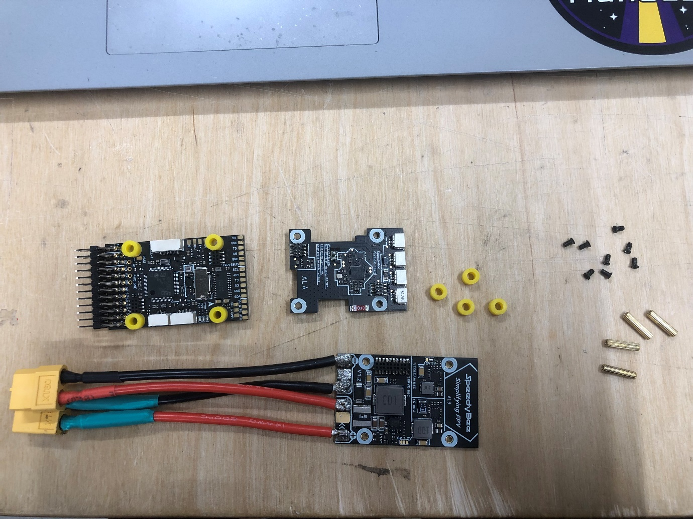

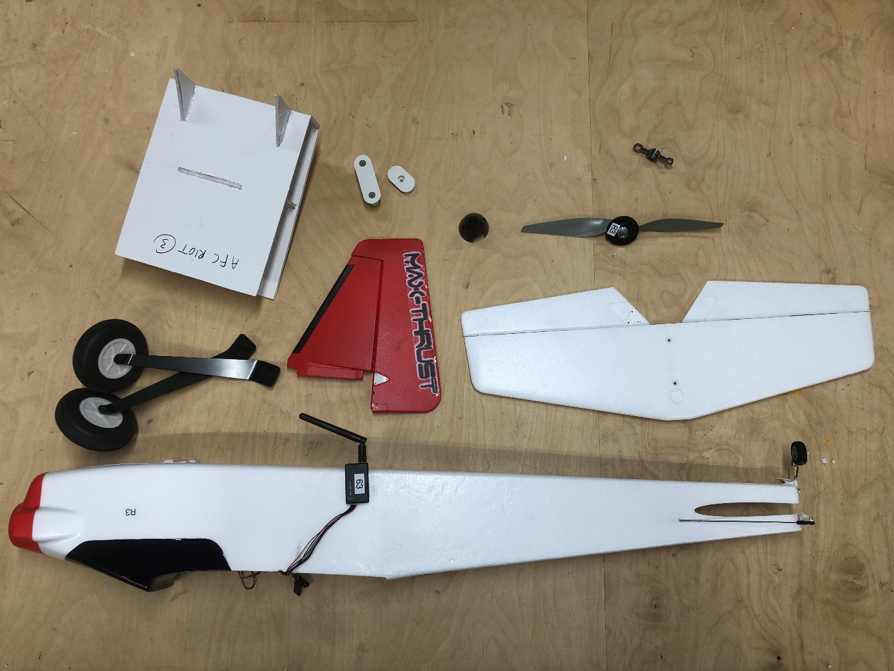
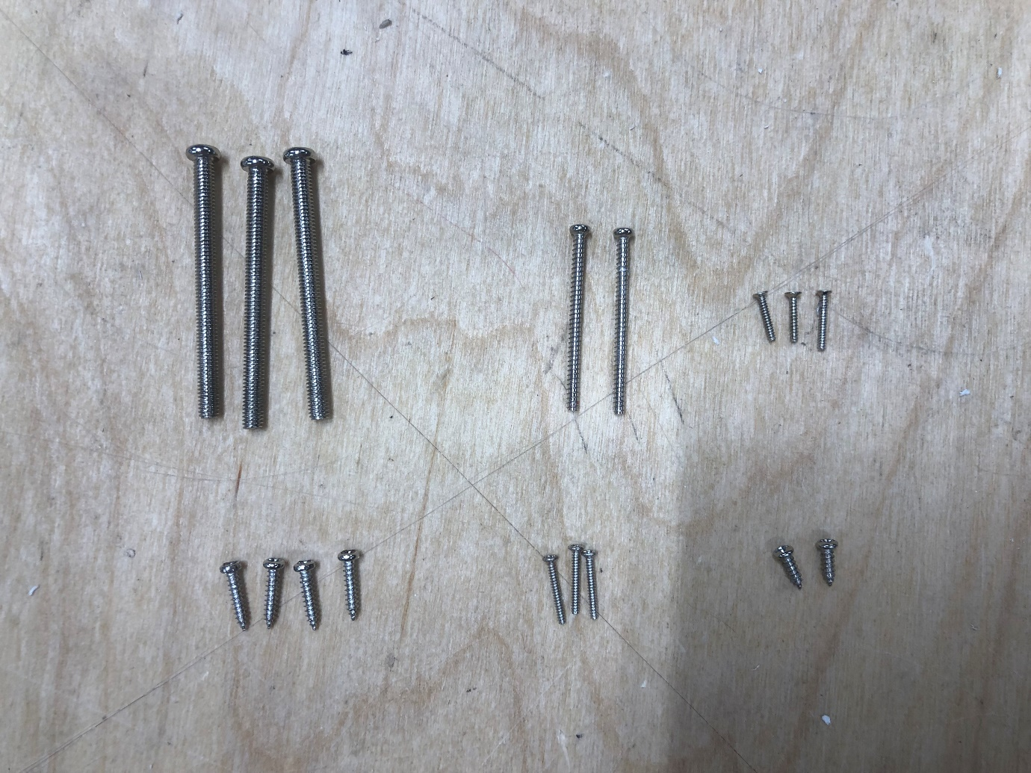

How to build:
(1) Assemble two halves of main wing set with both wood and metal connection rods, ensure wires don’t get stuck. | 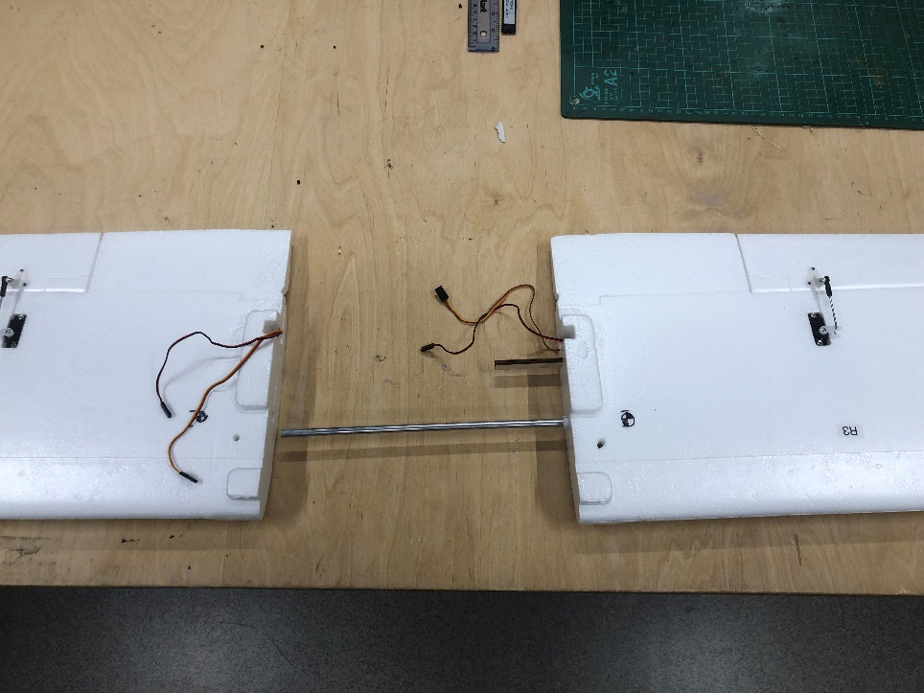
(2) Insert both plastic wing connectors and keep wing on stand for now. | 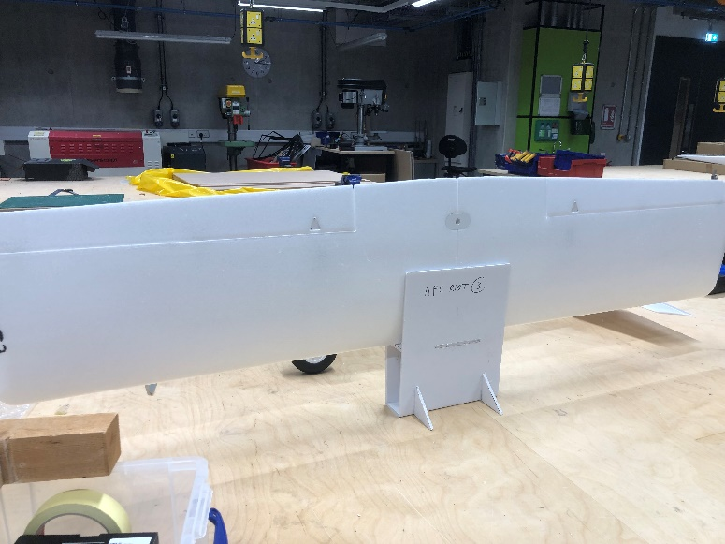
(3) Using 12mm screws, screw undercarriage to the fuselage, ensure they are angled towards the front of the nose. | 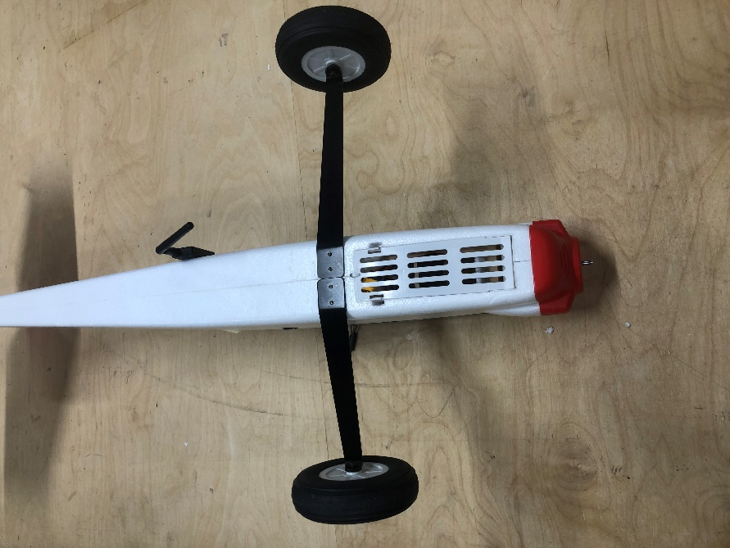
(4) Insert horizontal stabilizer into slot at back of fuselage. | 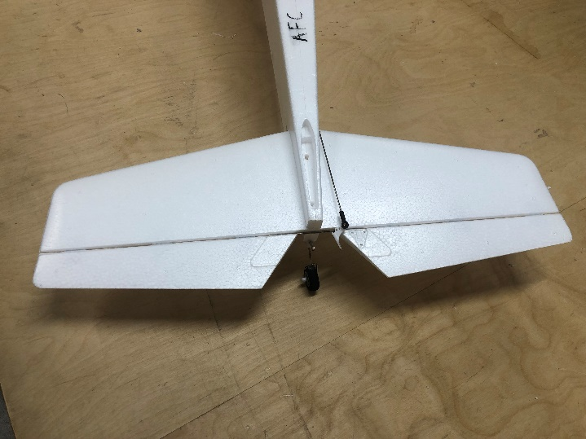
(5) Slot in rudder, ensuring tail-wheel control wire also slots in. | 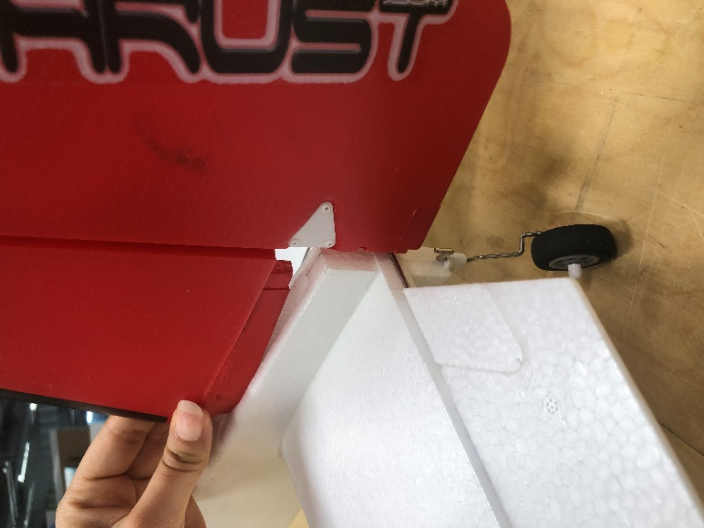
(6) Use a very small screwdriver to screw in the 10mm screws for the control surface connections (triangular). | 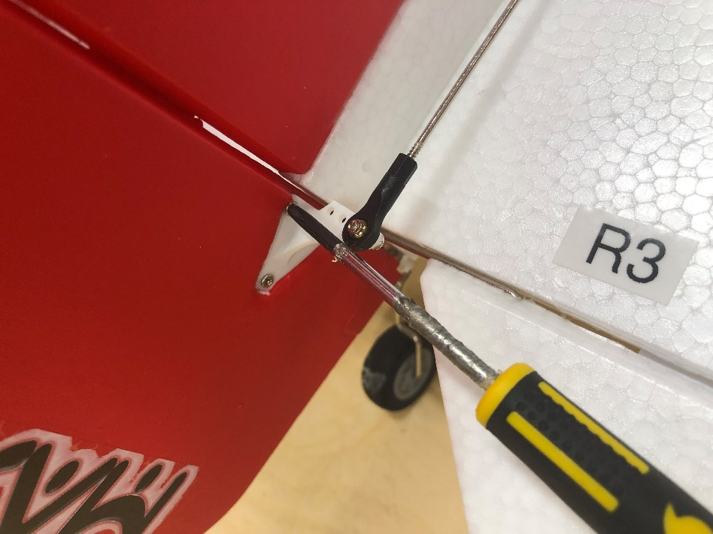
(7) Screw rudder and horizontal stabilizer in using 35mm bolts.
(8) Remove wing from its stand and connect wires correctly (doesn’t matter which one goes into which connector). ** See (10) of ‘Physical setup of avionics’
(9) Screw wing into the fuselage using 50mm bolts, ensure all avionics are tucked away and no wires get stuck).
(10) Put propeller on shaft and screw on tightly using multi-spanner. | 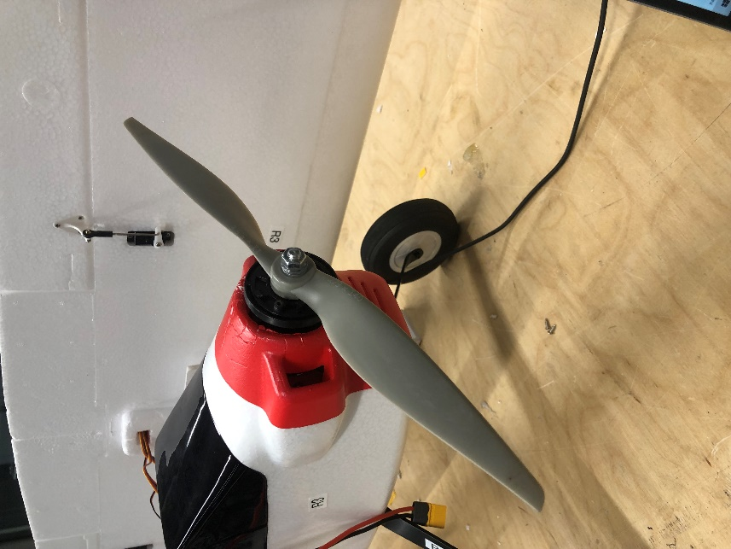
(11) Screw on spinner. | 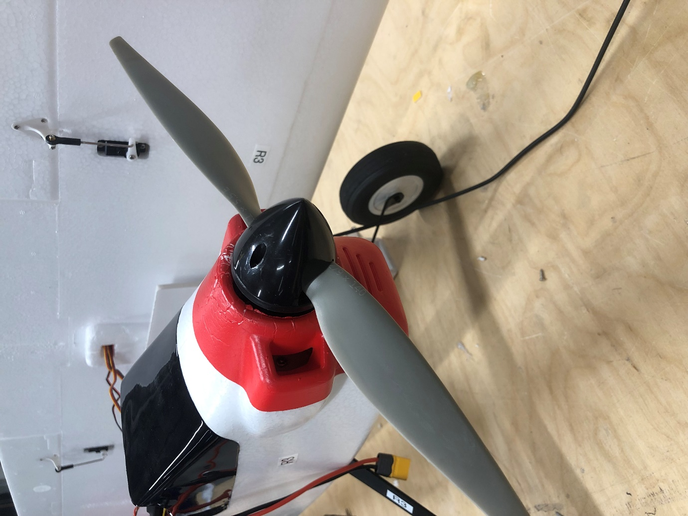

Physical setup of avionics:
(1) Solder the power wires onto the PDB board (bottom one with 6 large solder pads on one end), follow the guide in the pictures to make sure the colours are correct. | 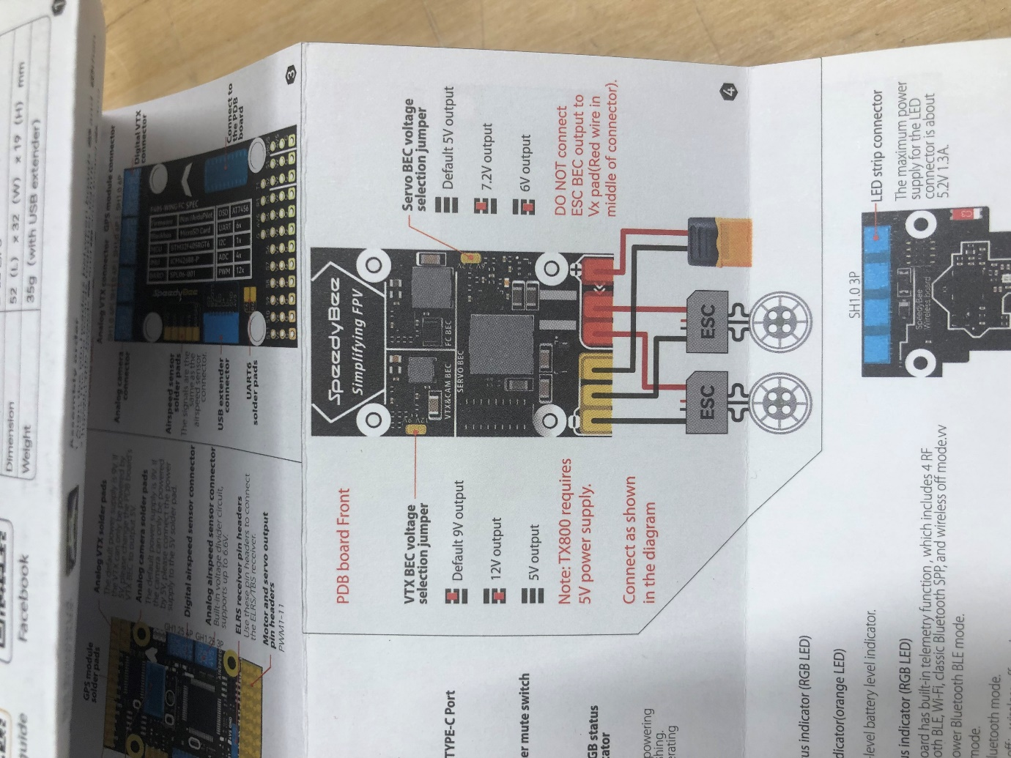
(2) Solder the L shaped pin receivers onto the FC board (middle one with 36 little holes on one end), it’s worth doing a dry fit of the whole controller before soldering. | 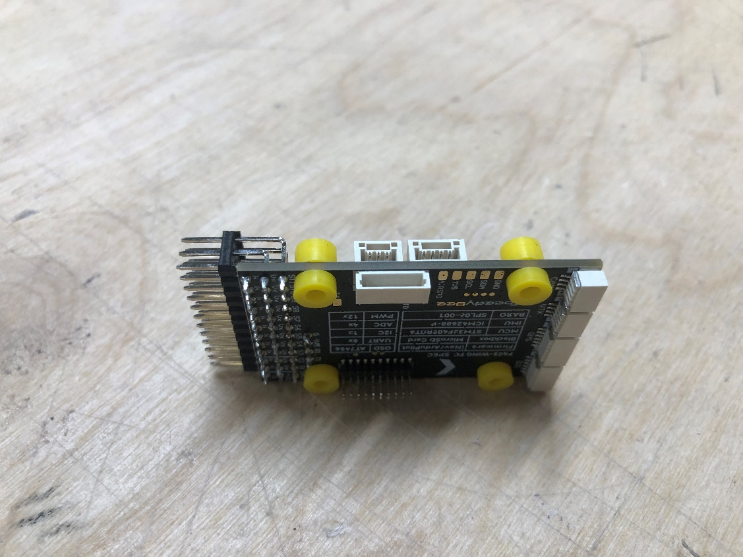
(3) Put the spacers in and screw in the wireless board (top one and smallest).
(4) Add the silicone grommets to the other side and screw in the PDB board. | 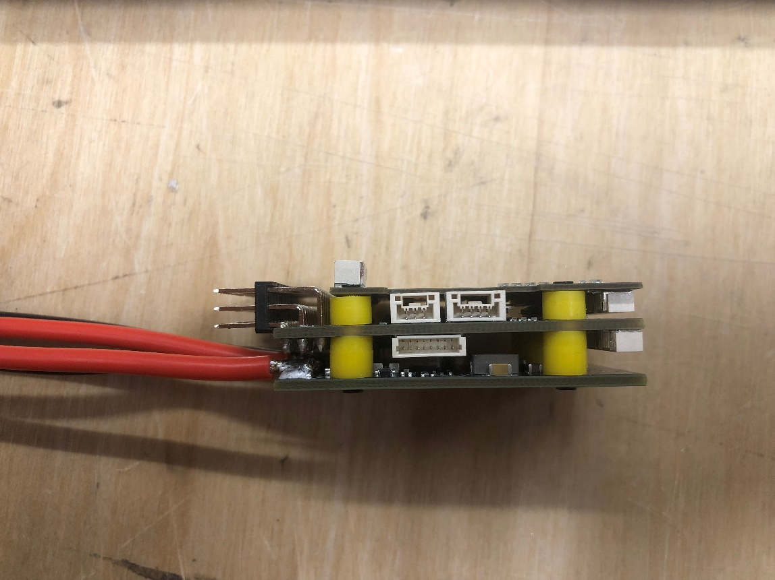
(5) Plug in the GPS, USB extender and telemetry radio to the controller as shown and use the CAD model to check where the avionics fit into the fuselage, also refer to the picture and see the diagrams at the end of the document. | 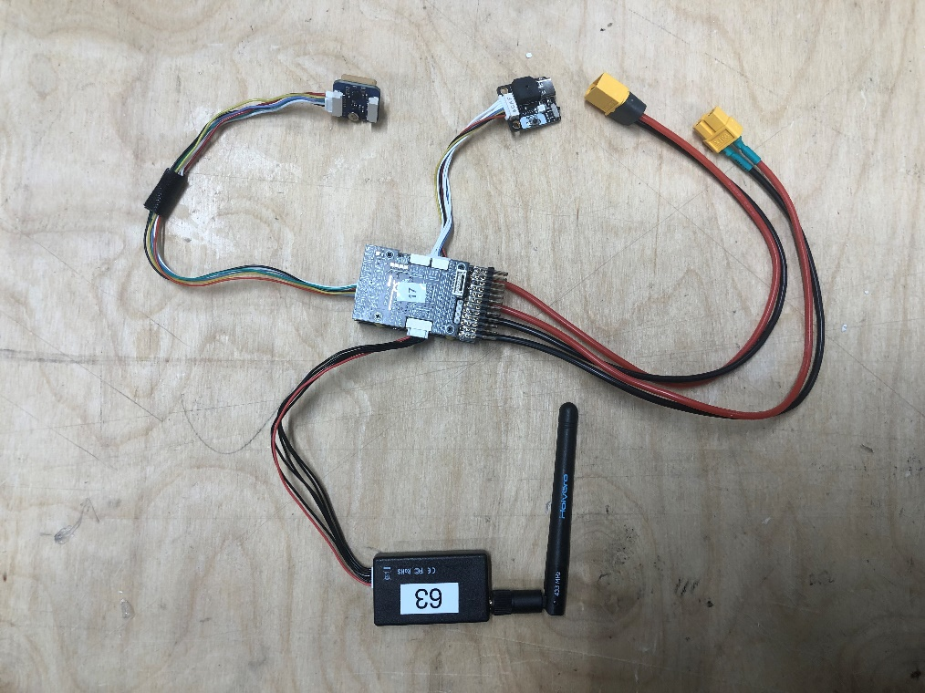
(6) Ensure the wireless board is facing upwards towards the ceiling and plug the control surface wires into 6 of the 12 pins available from the controller.
(7) Check: with the USB extender going away from you and the telemetry radio coming towards you, the receiver goes into the first pin, then aileron, elevator, throttle, rudder (all will be labelled), in the third last pin is the extra connector for the wing controls, the rest of the pins are empty. Check the diagrams at the end of the document for a clearer wiring diagram. | 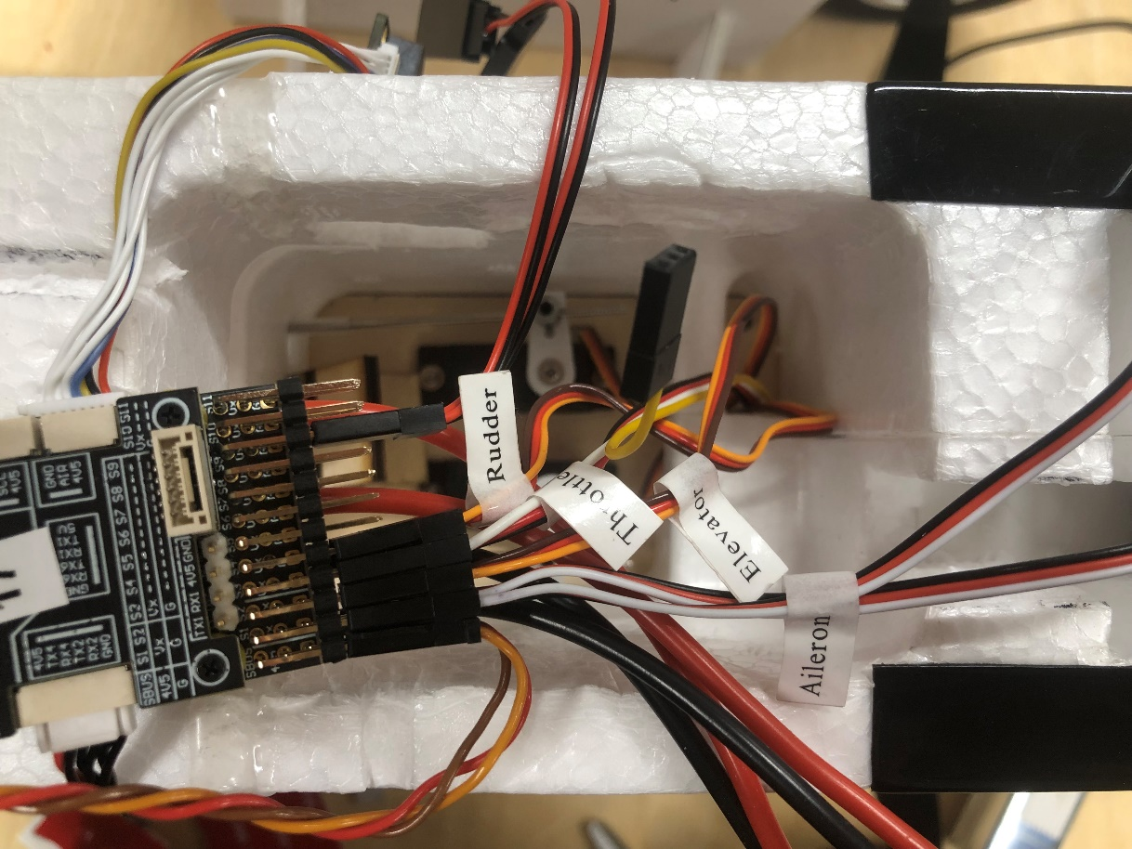
(8) Each one you plug in will have two or three wires and in this configuration, the lightest coloured wire should be on top.
(9) For the power connections, it will be obvious what to connect to the battery because it will need a male connection.
(10) When connecting the wing control surface wires, ensure the lightest coloured wires are aligned and so are the black ground wires (it doesn’t matter which aileron wire connects to which controller wire). | 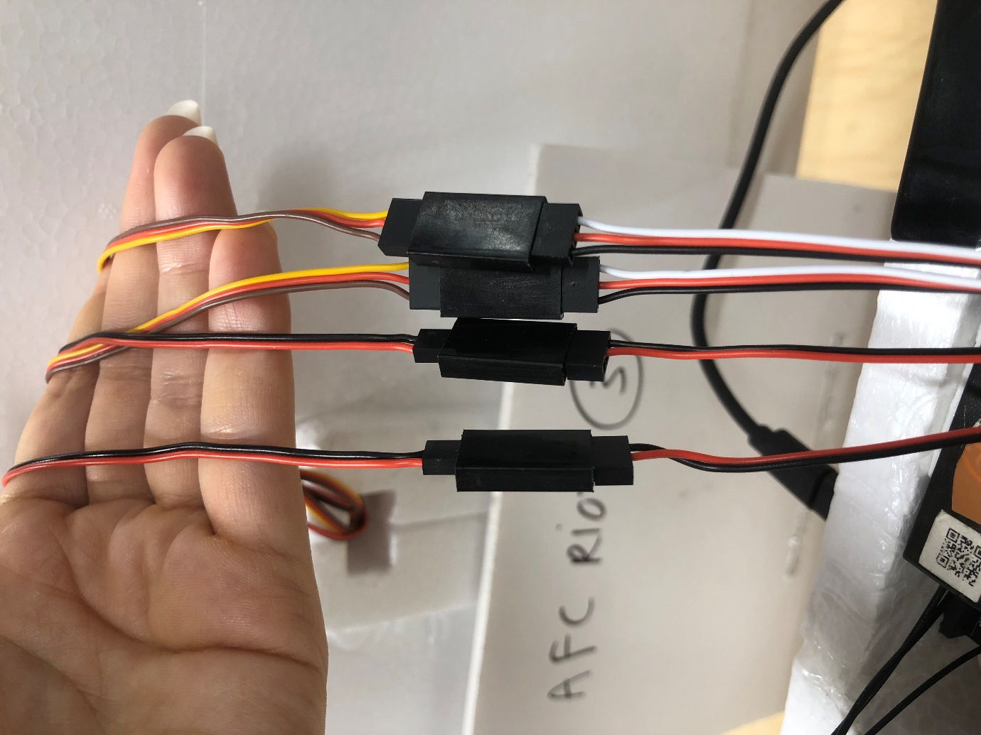

Transmitter and receiver setup and binding:
(1) Turn on the transmitter (hold down the power button until you feel haptic feedback).
(2) Hold down the failsafe button (F/S) with something very small and thin and plug in the wire, then let go of the failsafe button. It should be green and red.
(3) On the transmitter, click on ‘MDL’, scroll to ‘Riot 3’ and click ‘PAGE>’.
(4) Scroll down to ‘Internal RF’ and where it says ‘Receiver’, click on ‘Bnd’, then ‘CH1-8 Telem ON’. | 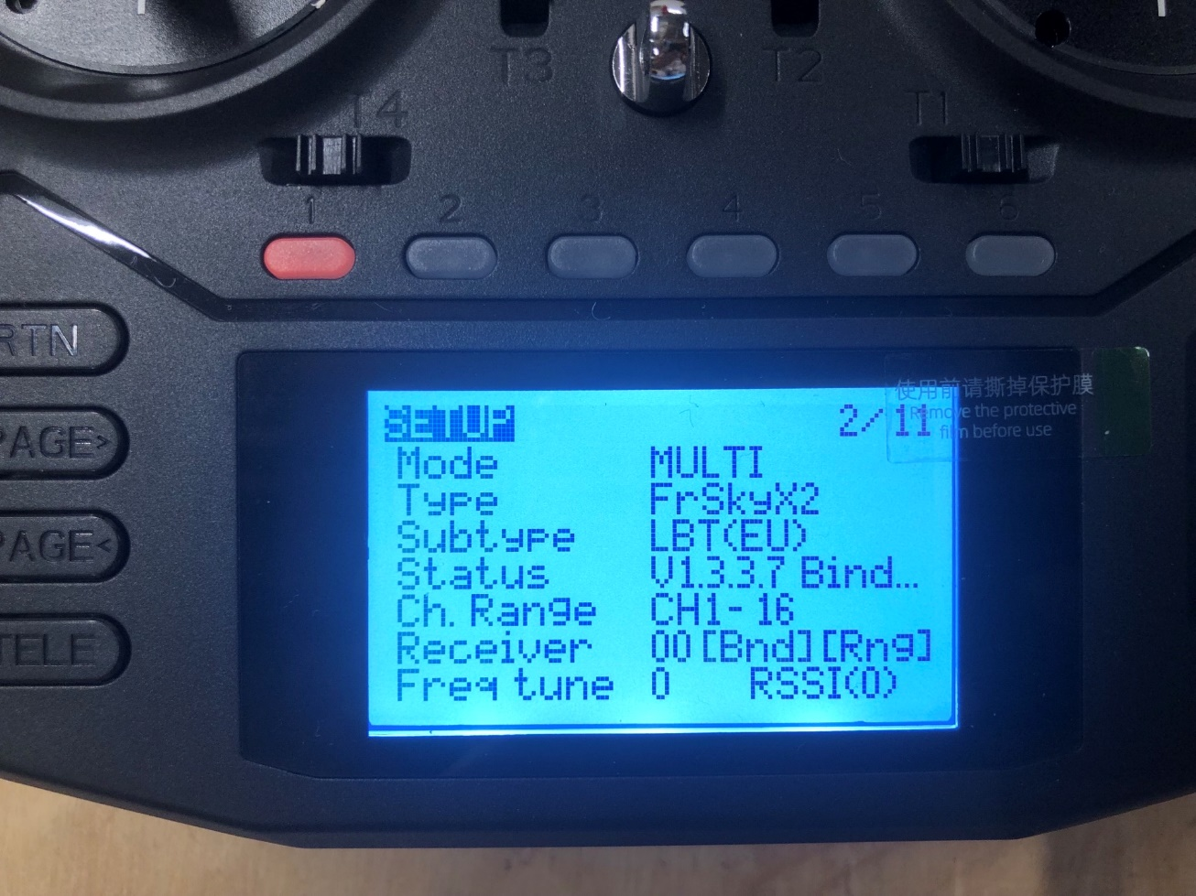
(5) It will make some beeping noises and the ‘Status’ row will say ‘Binding’, the light should be solid green and flashing red. Wait for it to return to ‘AETR’ after a few seconds. | 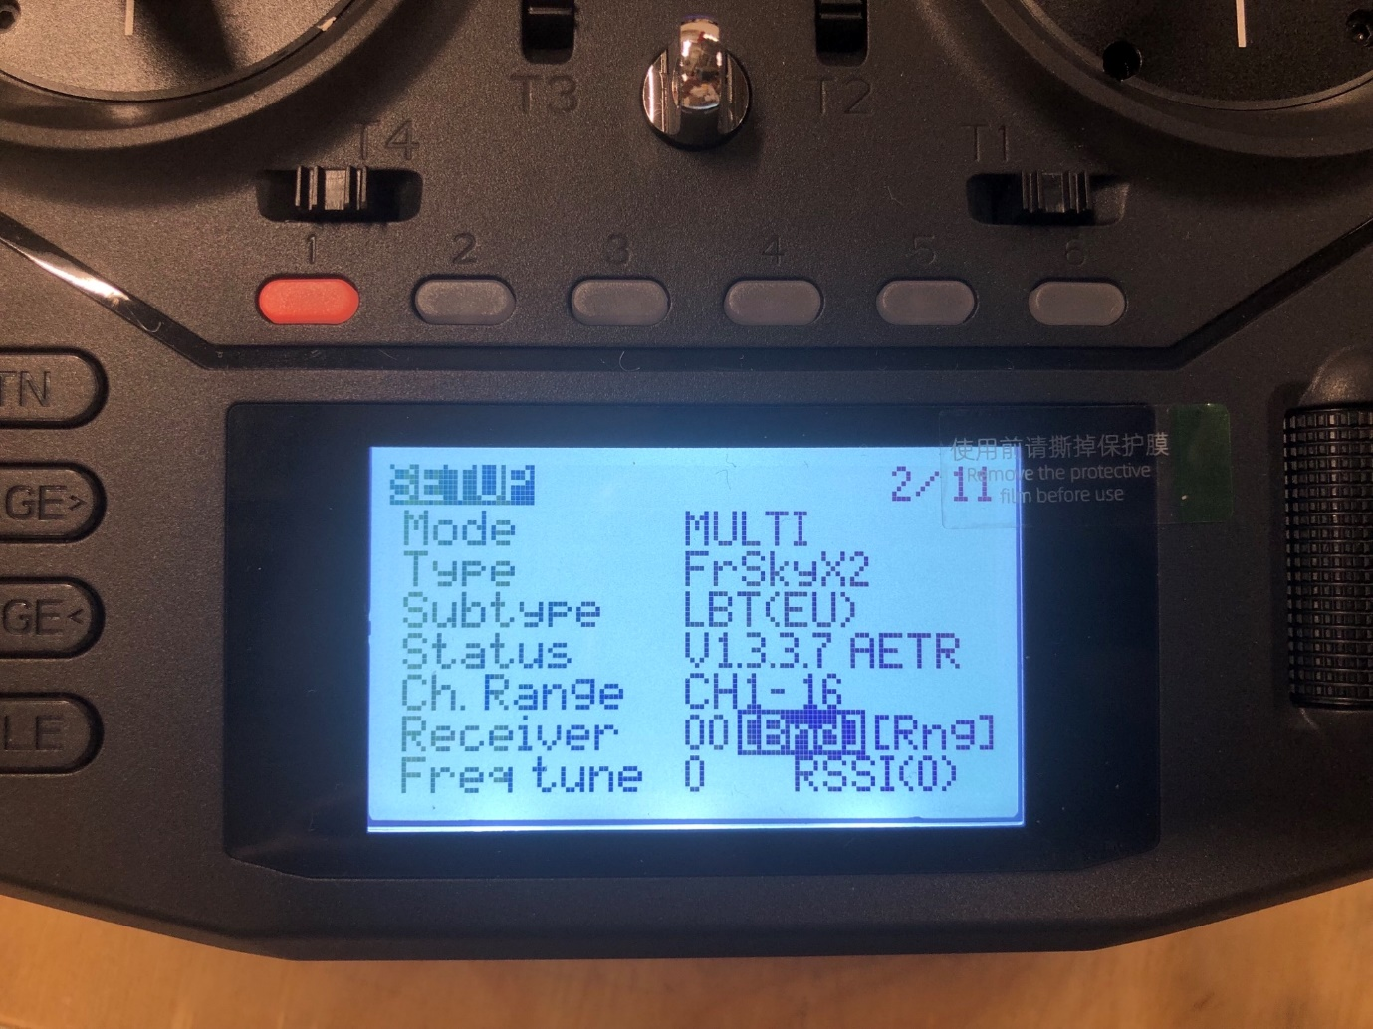
(6) Then unplug the wire from the receiver and plug it back in, wait for the light to turn green (the LED should be solid green, not flashing). | 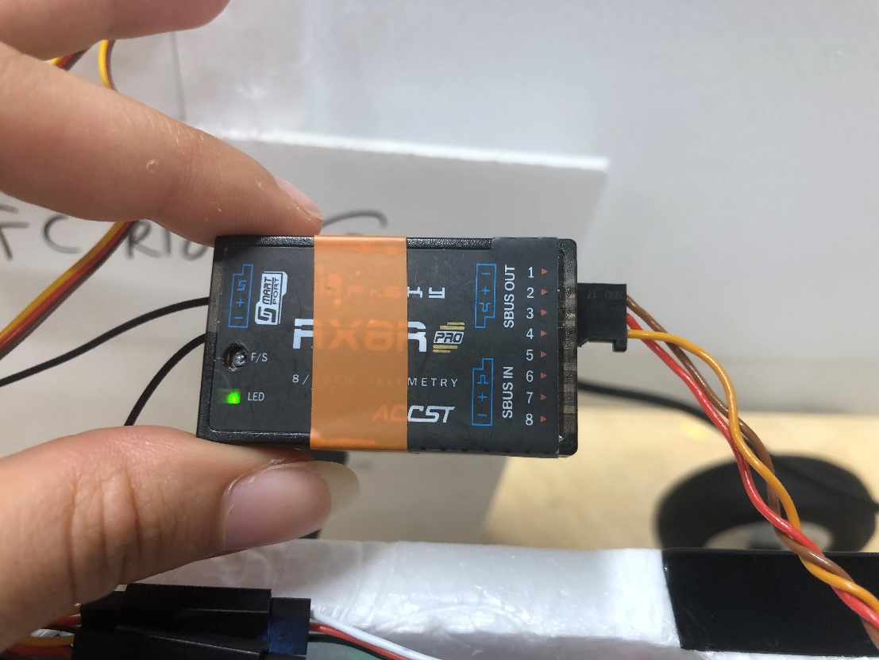

Autopilot setup:
(1) Connect the riot to Mission Planner by plugging it in with the provided USB cable (USB extender on riot >>> USB port on laptop) and go to the data tab at the top left.
(2) In the top right corner, select the COM port that shows up. The baud rate should automatically be selected but if not, usually either 56700 or 115200 is used. Then press ‘Connect’. | 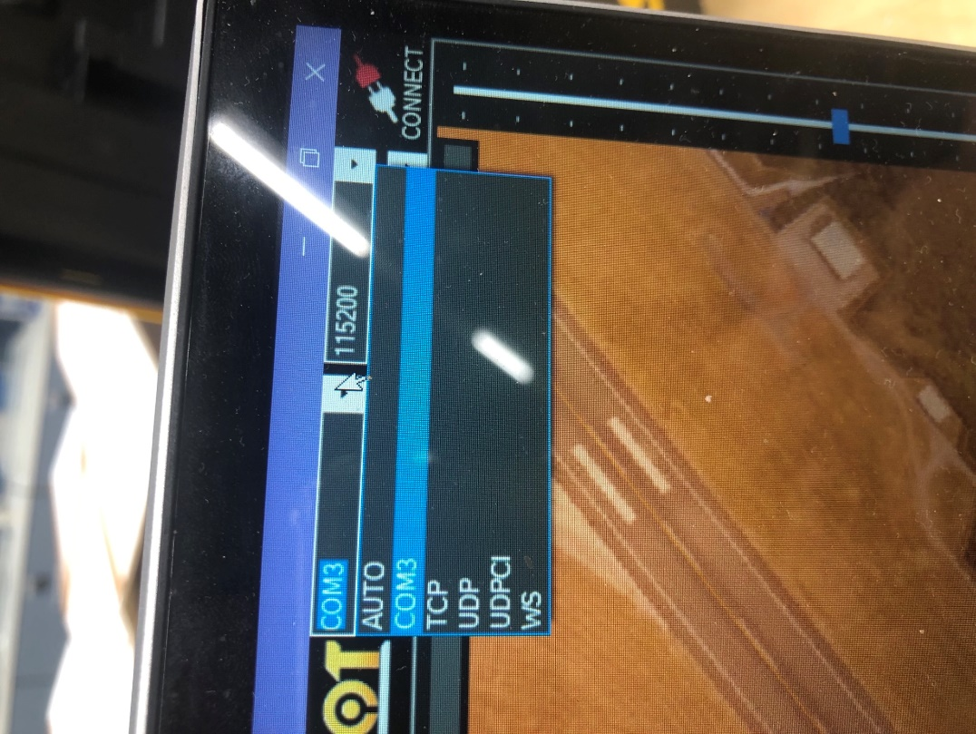
(3) Plug in the battery, you should hear 3 short beeps followed by one long one.
(4) On the transmitter, click on ‘MDL’, scroll to ‘Riot 3’ and click ‘PAGE>’ four times until you get to ‘Mixes’. | 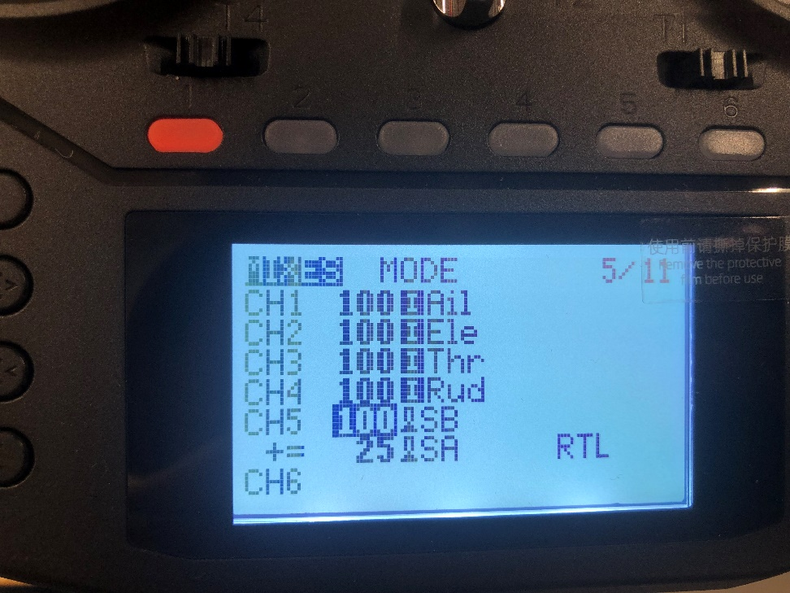
(5) Scroll down and click on ‘CH5’, name it ‘MODE’. Click on ‘Source’, move the ‘SB’ switch and it should look like the picture. | 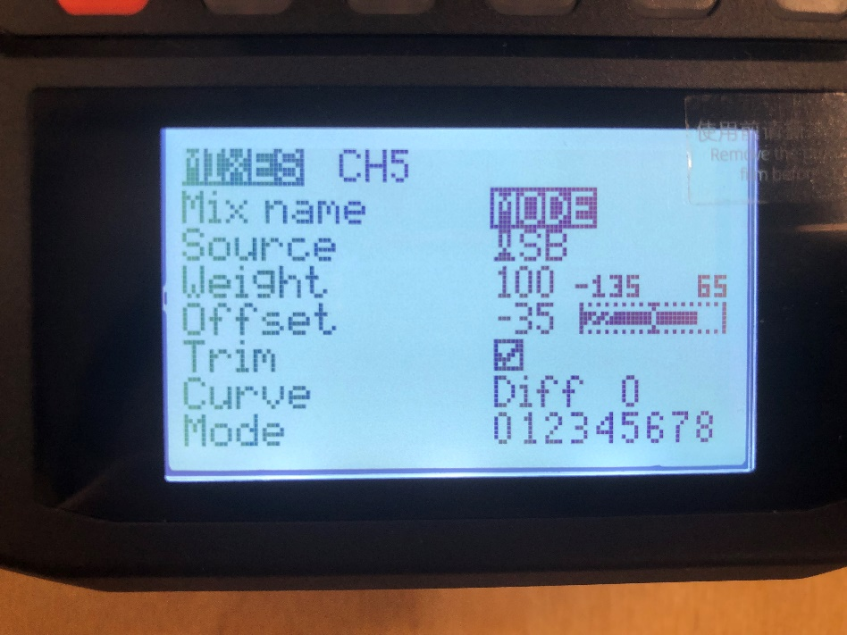
(6) Change the ‘Weight’ to be 100 and the ‘Offset’ to be -35.
(7) Hold down on ‘CH5’ and click ‘Insert after’. Do the same as before but name it ‘RTL’ and make the source the ‘SA’ switch, with weight 25 and offset 75. | 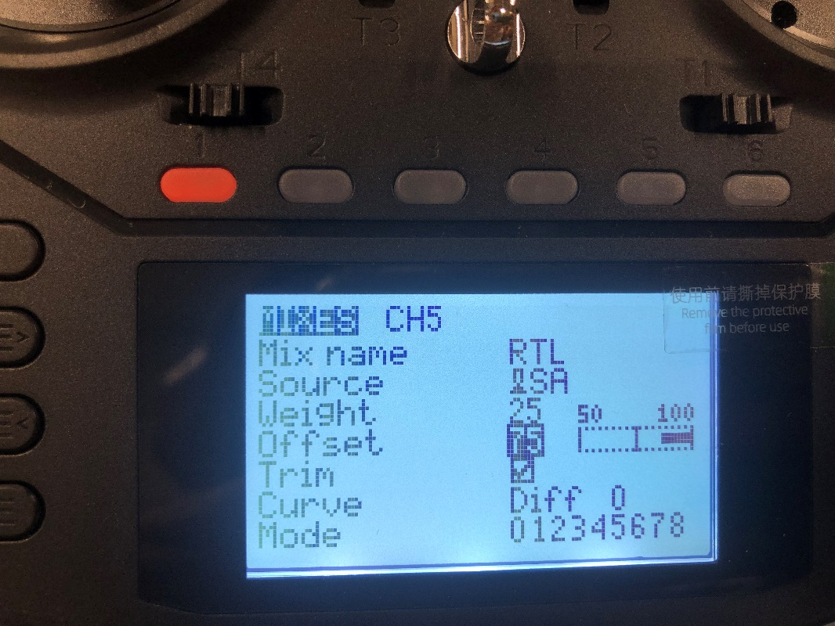
(8) Go on Mission Planner and click on ‘Flight Modes’. Set them as shown in the picture. You have now setup both switches on the left to correspond to four different flight modes that are all on radio channel 5: RTL (return to launch), Manual, FBWA (Fly-by-wire) and Loiter. | 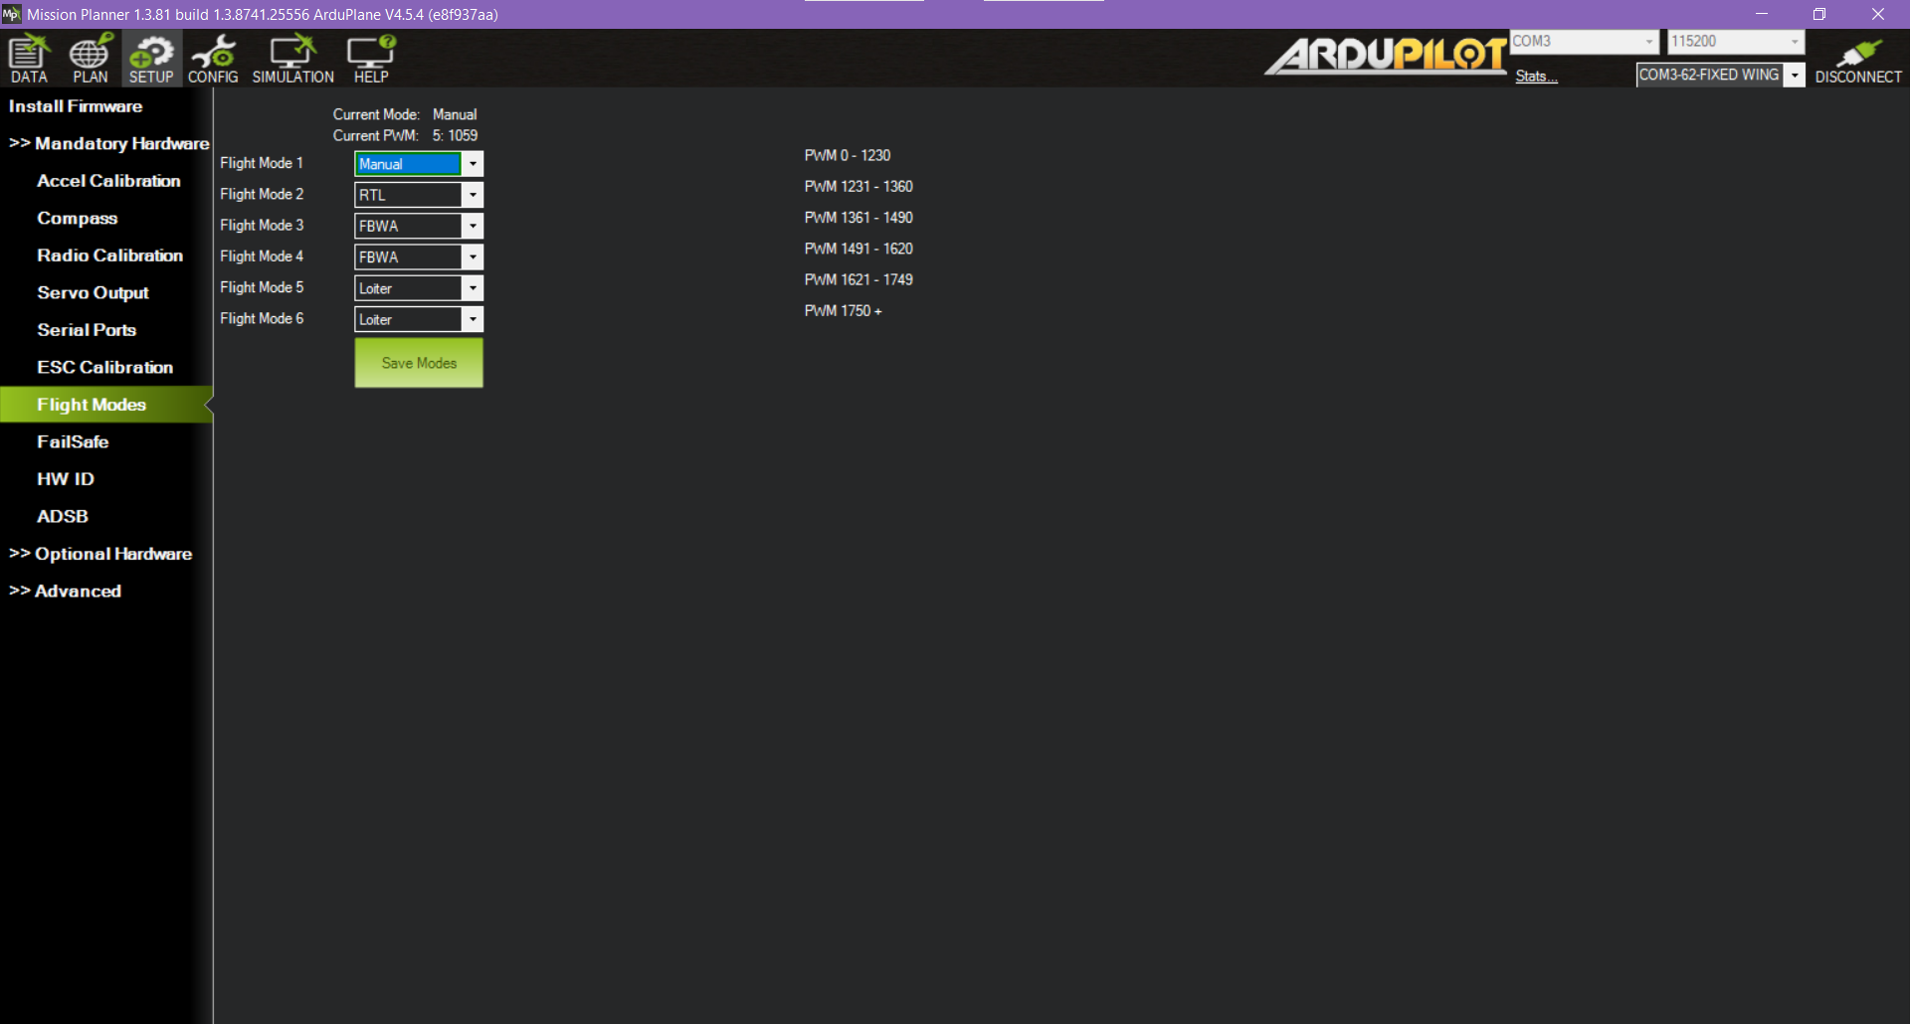
(9) In order to make the RTL switch override other flight modes when it is down, return to the mixes page and click page> 4 more times until you get to the special functions page. Create a new one and it should look like the picture shown. | 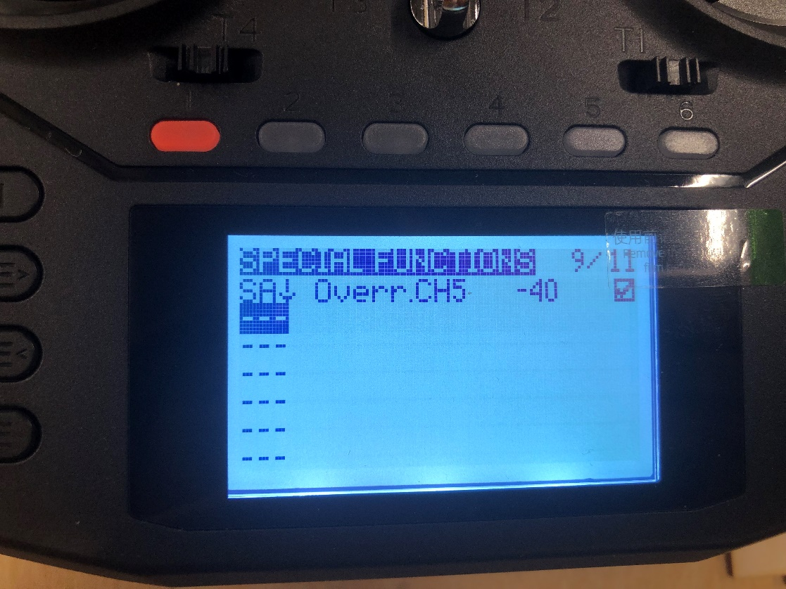
(10) Return to the ‘Mixes’ page, click on ‘CH6’ and name it ‘KILL’. For this one, leave the weight and offset the same but make the source the ‘SC’ switch. | 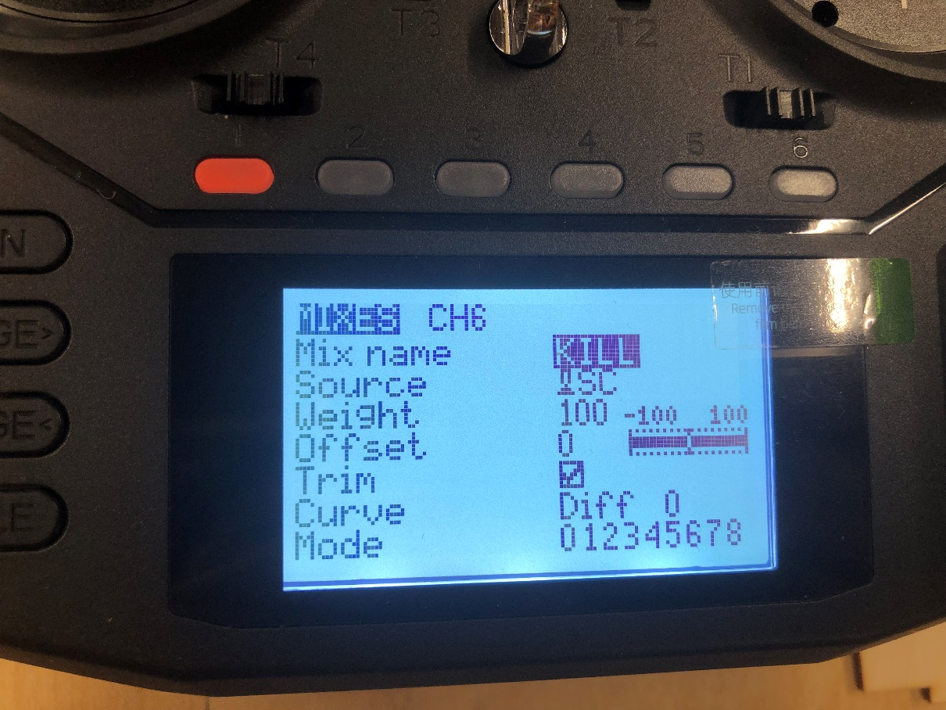
(11) On mission planner, go on ‘Configuration’, then ‘Full parameter list’ and on the right side, search ‘rc6_option’. Click on its drop down and select number 31 which is ‘Motor emergency stop’. Click on ‘Write params’ so that it saves the changes. This is the throttle failsafe which is the kill switch that will kill the engine in case of emergencies. | 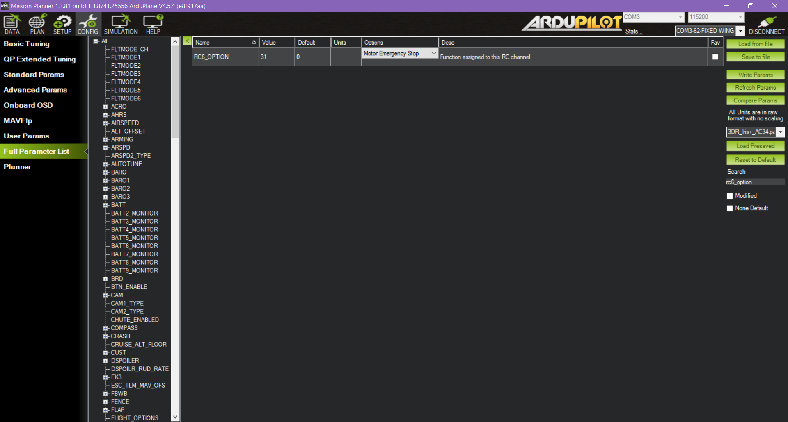
(12) Next is the radio calibration which is in ‘Setup’ > ‘Mandatory Hardware’ > ‘Radio Calibration’. Click on ‘Calibrate radio’ and follow the steps. When you move the control sticks and switches on the transmitter, red lines will appear on each bar to show the maximum and minimum frequencies, so make sure you move each stick all the way up/down and left/right. | 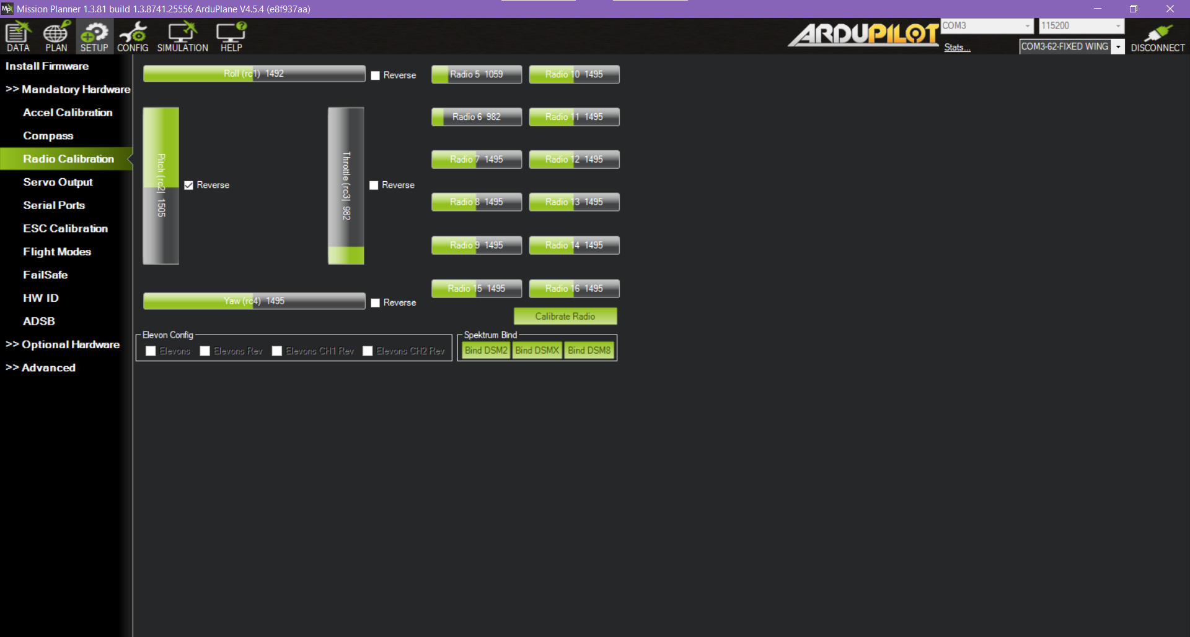
(13) Click on ‘Accelerometer Calibration’ and you only need to do the first one out of the three. Click on ‘Calibrate Accel’ and follow the steps. At this point, you will need to be carrying the riot to put it in different positions, so the USB no longer needs to be connected. You should have full control with only the transmitter and the riot should be free to move around. | 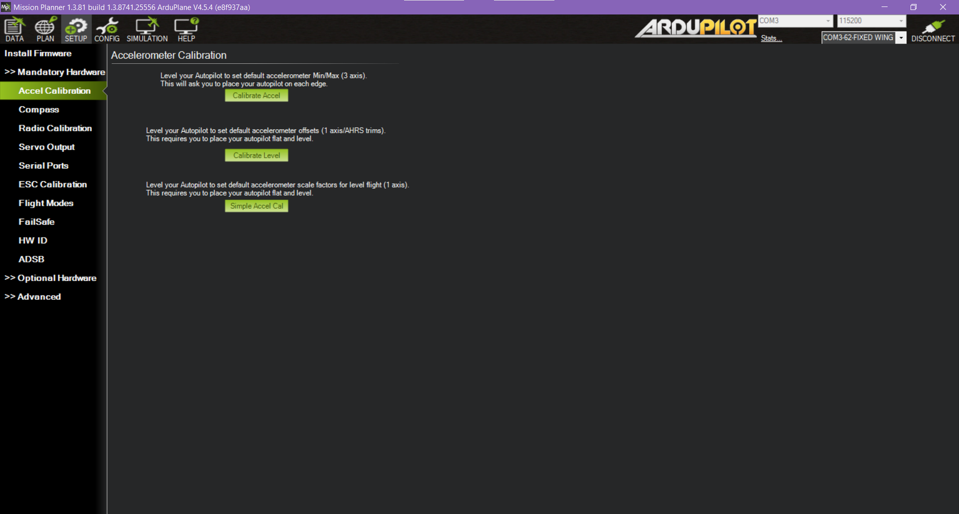
(14) The last step is the compass calibration, so click on ‘Compass’ and then ‘Start’. Follow the steps on screen- you need to rotate the riot 360° on all three axes until the green bar is at 100%. If it is still not at 100% after this, just move the riot around randomly in different orientations until it’s done. | 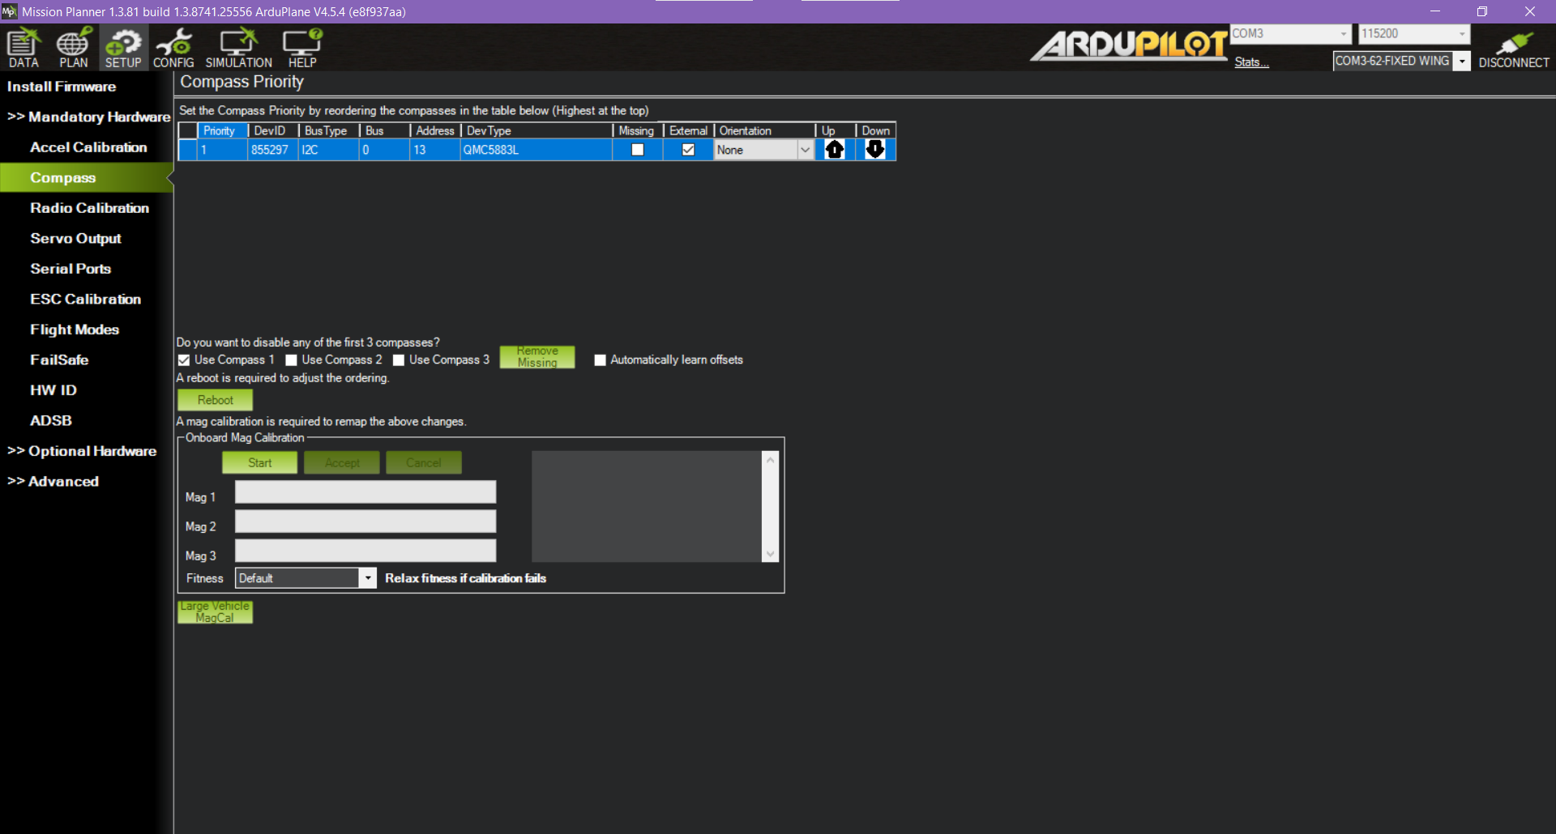

Pre-flight checks:
(1) Try to pull the nose/propeller off the shaft, it should not come off. If it does, tighten it more with the multi-spanner.
(2) Physically check all of the mechanical joints to see if any screws are loose (do this post-flight as well). This would be wiggling the rudder, horizontal stabilizer, undercarriage and servo connections.
(3) Thrust test: get someone to stand behind the plane and hold it in place (make sure no one is stood beside or in front of the riot) and slowly push the left control stick on the transmitter all the way up to full throttle and then slowly back down again. During this, also check if the motor is spinning the propellers in the correct orientation (should be clockwise when viewed from the back).
(4) Always have the kill switch on ‘KILL’ unless you are doing a thrust test or flying the riot.
(5) Then check whether the servos are working correctly. Move the left and right sticks on the transmitter to command roll, pitch and yaw and check to see if the control surfaces are doing what they should.
(6) To roll right, the wing’s starboard control surface should go up and port should go down. To pitch up, the elevator should go up. To yaw right, the rudder’s back should point right.
(7) If any of the servos are not outputting what you expect, go on Mission Planner > ‘Setup’ > ‘Radio Calibration’ and click on ‘Reverse’ for that control surface. | 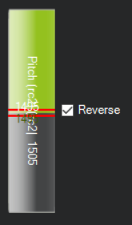
(8) Check the two bolts in the tail because one tends to come loose during flight.

Autopilot main connection diagrams:
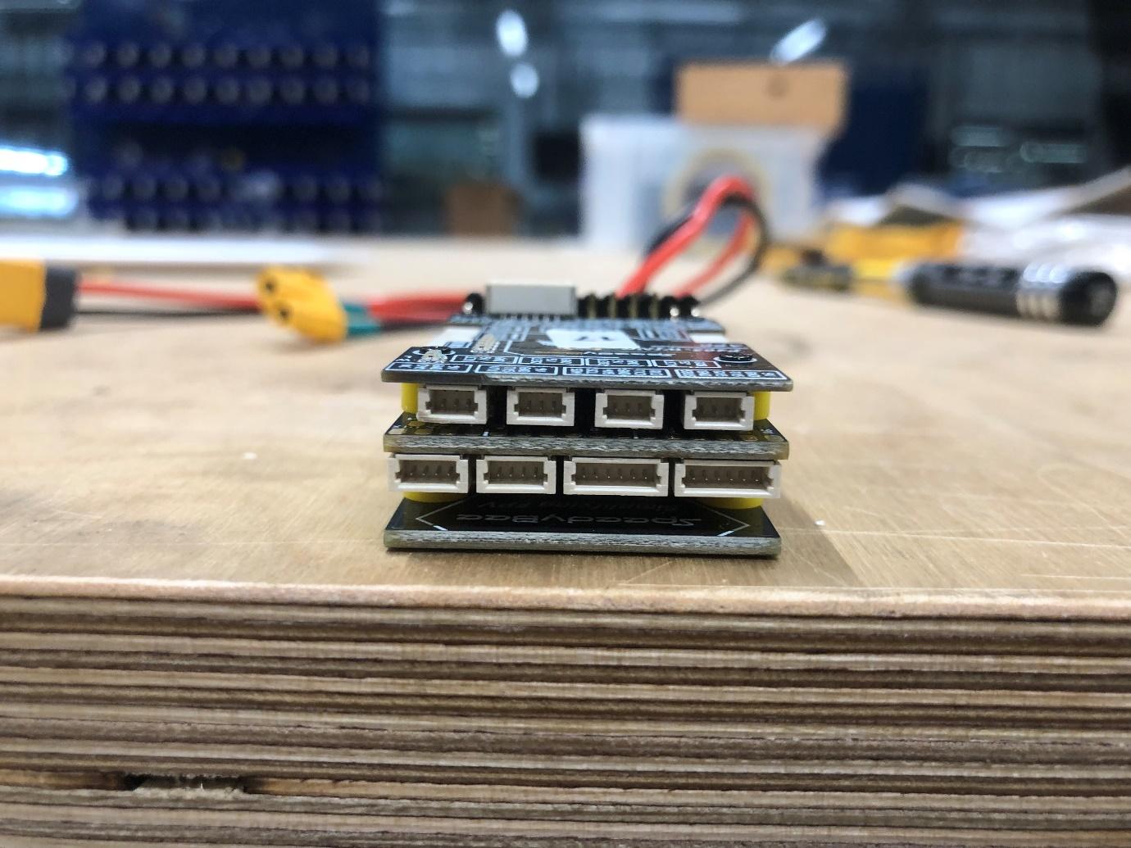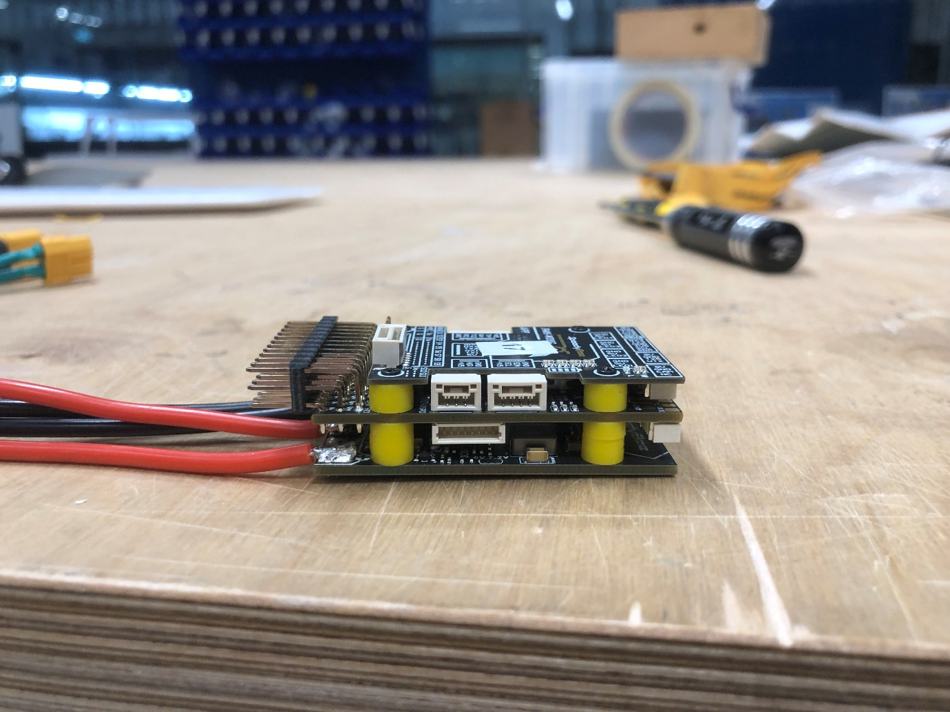
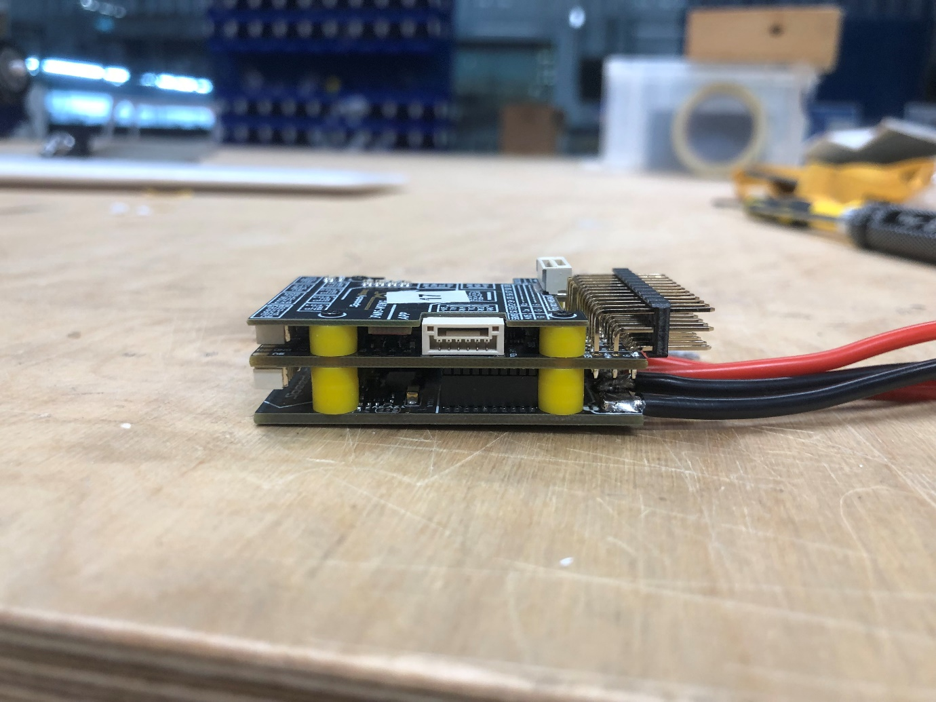
Servo rail connection diagram:

