SMART LIGHTING SYSTEM USING ARDUINO
Embedded Systems & IoT Mini-Project Report

Prepared by: __NJARATIANA Orlando celestin____________________________
Internship / Organization: __Minecraft intership____________________________
Date: __17 ^{th}_October 2026___________________________

Project type: Beginner-friendly simulation / prototype

1. Introduction
An embedded system is a computer-based system designed to perform a specific function within a larger device. It usually combines hardware, such as a microcontroller and sensors, with software that reads inputs and controls outputs. Embedded systems are used in home appliances, vehicles, medical equipment, industrial machines, security systems and smart devices.
This project demonstrates a simple smart lighting system. A light-dependent resistor (LDR) senses the surrounding light level. An Arduino Uno reads the sensor signal and switches an LED on when the measured value is below a selected threshold, and off when the value is above the threshold. This is a basic example of sensing, decision-making and actuation.

2-Microprocessors vs microcontrollers

A microprocessor is mainly a CPU (Central Processing Unit) that processes data and executes instructions. It usually needs external memory and peripherals to build a complete system.

A microcontroller is a small computer on a single chip that contains a CPU, memory, and input/output peripherals.

a. Microprocessor

Contains mainly the CPU.

Usually requires external memory and peripherals.

Generally used for complex computations.

Often consumes more power at the system level.

Used in computers, laptops, and high-performance systems.

Examples: Intel Core and AMD Ryzen.

b. Microcontroller

Contains a CPU, memory, and peripherals on one chip.

Requires fewer external components.

Generally consumes less power.

Compact and often less expensive for dedicated control tasks.

Used in washing machines, traffic lights, robotics, and embedded systems.

Examples: 8051, PIC, ATmega328P, and STM32.Main difference

Microprocessor = CPU-focused processing.Microcontroller = CPU + Memory + Input/Output peripherals on a single chip.

3. Project Objectives

- Understand the basic role of an embedded controller.
- Read an analogue sensor using an Arduino input.
- Use a conditional statement to make a decision from a sensor value.
- Control an LED output based on the measured light level.
- Document the circuit, program, expected tests and practical applications.

3. Components and Their Functions
Component | Purpose
Arduino Uno | Microcontroller development board; reads the sensor value and controls the LED.
LDR / photoresistor | A light-sensitive component whose resistance changes with illumination.
10 kΩ resistor | Works with the LDR as a voltage divider so the changing light level can be measured at A0.
LED | Visual output indicator; lights when the controller sets the output HIGH.
220 Ω resistor | Limits current through the LED to help protect the LED and Arduino output.
Breadboard and jumper wires | Allow the circuit to be assembled without soldering.
USB cable / simulator | Provides a way to program the board or run the virtual circuit.

4. Circuit Diagram and Connections

The diagram below is a functional schematic to show the main signal and power relationships. Wire the simulator circuit according to the connection list that follows.
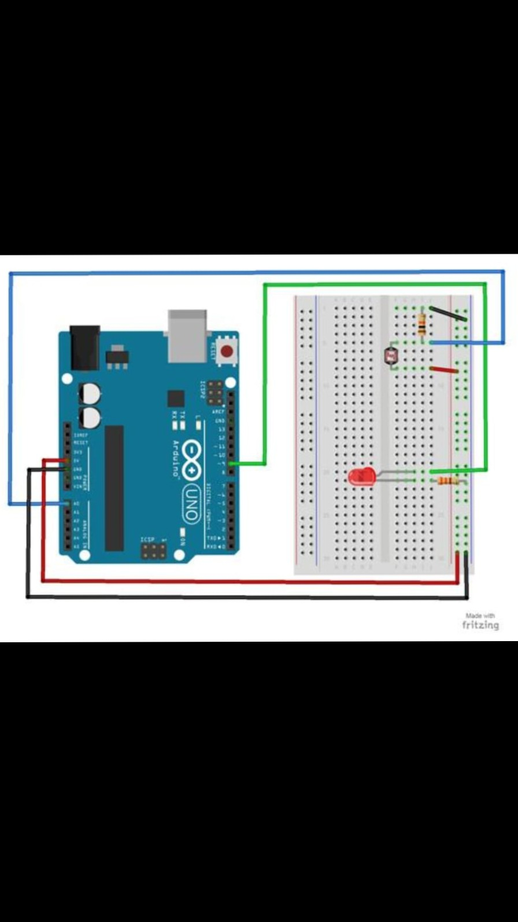
- LDR voltage divider: connect 5 V to one side of the LDR. Connect the other side of the LDR to the sensor junction and Arduino A0.
- Connect a 10 kΩ resistor from the sensor junction to GND. This makes the junction voltage vary with light.
- LED output: connect Arduino digital pin D9 through a 220 Ω resistor to the LED anode (long leg). Connect the LED cathode (short leg/flat side) to GND.
- Ensure the Arduino and circuit share the same GND.
Important: with the LDR connected to 5 V and the 10 kΩ resistor connected to GND, the analogue reading will generally rise as the light increases. The sample program below assumes lower readings mean darker conditions, so the threshold comparison may need to be reversed depending on the simulator's LDR model and exact wiring. Check the Serial Monitor and adjust the threshold after testing.

5. Source Code (Arduino C++)

const int lightSensor = A0;
const int led = 9;
const int threshold = 500;
void setup() {
pinMode(led, OUTPUT);
Serial.begin(9600);
}
void loop() {
int lightValue = analogRead(lightSensor);
Serial.println(lightValue);
// Assumes the sensor reading is lower in darkness.
if (lightValue < threshold) {
digitalWrite(led, HIGH); // Dark: LED ON
} else {
digitalWrite(led, LOW); // Bright: LED OFF
}
delay(200);
}

6. Code Explanation

Constants: A0 is used for the light sensor input, D9 is used for the LED output, and 500 is the initial threshold.
setup(): Runs once at startup. It configures D9 as an output and starts serial communication at 9600 baud.
analogRead(): Reads the analogue voltage on A0 and returns a value typically between 0 and 1023 on an Arduino Uno.
if / else: Compares the reading with the threshold. The LED is turned on for one side of the threshold and off for the other.
delay(200): Waits 200 milliseconds before taking the next reading, making the loop easier to observe.

7. Testing and Results

The table below gives expected behaviour for a correctly wired and calibrated simulation. These are expected results, not a claim that a simulator run has already been completed. Run the circuit, observe the Serial Monitor and replace or confirm the results with your actual observations before submitting.
Test condition | Expected observation | Result to record
Low light / darkness | LED turns ON if the reading is below the chosen threshold. | Pending actual simulation
Bright light | LED turns OFF if the reading is at or above the chosen threshold. | Pending actual simulation
Change light gradually | Serial Monitor reading changes as the LDR illumination changes. | Pending actual simulation
Threshold adjustment | Changing the threshold changes the switching point. | Pending actual simulation
Calibration note: record the analogue reading in bright and dark conditions. Choose a threshold between those readings. If the LED behaves in the opposite way, reverse the comparison (< to >) or adjust the LDR divider wiring.

8. Real-World Applications

- Automatic outdoor and street lighting that reduces unnecessary energy use.
- Corridor, staircase and parking-area lights that respond to ambient brightness.
- Smart home lighting systems that combine light sensing with schedules or motion sensors.
- Display and indicator brightness control in electronic equipment.
- Educational demonstrations of sensor inputs, microcontroller logic and output control.

9. Limitations and Possible Improvements

This is a simple demonstration, not a complete commercial lighting controller. Sensor readings can vary with component tolerances and simulator behaviour. The switching point should be calibrated, and a real installation would need appropriate electrical isolation, enclosure, protection and safety review. Possible improvements include adding hysteresis to prevent rapid flickering near the threshold, adding a motion sensor, logging readings, or using an ESP32 for network connectivity.

10. Conclusion

The smart lighting prototype illustrates the main embedded-system cycle: a sensor collects information, a microcontroller processes the reading, and an output responds to the result. The project provides beginner-level practice with analogue input, conditional logic, digital output and technical documentation. Final results should be completed after the circuit is run in Tinkercad or Wokwi.

11. References

- Arduino Documentation — https://docs.arduino.cc/
- Tinkercad Circuits — https://www.tinkercad.com/circuits
- Wokwi Arduino Simulator — https://wokwi.com/
- Arduino Language Reference — https://docs.arduino.cc/language-reference/

