**Report**

**Average mortality rate per temperature**

|  |  |  |  |  |
| --- | --- | --- | --- | --- |
| **No** | **Temperature (Celsius)** | **Number of larvaes** | **Accumulation of deaths after 4 days** | **Mortality rate per temperature (%)** |
| 0 | 16 | 560 | 288 | 51.43 |
| 1 | 24 | 560 | 352 | 62.86 |
| 2 | 26 | 560 | 369 | 65.89 |
| 3 | 30 | 560 | 188 | 33.57 |

The results indicate significant differences in mortality rates at varying temperatures.

* At 26 degrees Celsius, 369 out of 560 larvae died, corresponding to a mortality rate of 65.89 %.
* At 24 degrees Celsius, 352 out of 560 larvae died, with a mortality rate of 62.86%.
* At 16 degrees Celsius, 288 out of 560 larvae died, resulting in a mortality rate of 51.43%.
* In contrast, at 30 degrees Celsius, 188 out of 560 larvae died, yielding a mortality rate of 33.57%.

In conclusion, the data suggests that larvae mortality is highest at temperatures between 24 and 26 degrees Celsius and decreases significantly at higher temperatures, such as 30 degrees Celsius. The lowest mortality rate observed at 30 degrees Celsius implies that this temperature is the most favorable for larvae survival among the conditions tested. Conversely, temperatures in the mid-range (24-26 degrees Celsius) are the least favorable, indicating that these temperatures may be closer to the thermal limits for larvae survival.

**Distribution of data on graph**

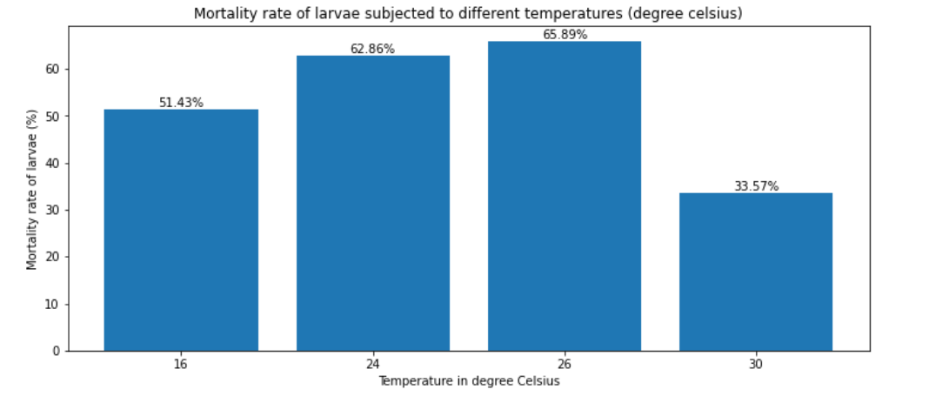

**Average Mortality rate per type of Isolate**

|  |  |  |  |  |
| --- | --- | --- | --- | --- |
| No | isolate | Number of larvaes | Accumulation of deaths after 4 days | Mortality rate per isolate (%) |
| 0 | ALL | 320 | 193 | 60.31 |
| 1 | Control (water) | 320 | 9 | 2.81 |
| 2 | GR3a-2 | 320 | 269 | 84.06 |
| 3 | HO6 | 320 | 229 | 71.56 |
| 4 | Hr-1a | 320 | 48 | 15 |
| 5 | MC2b-1 | 320 | 224 | 70 |
| 6 | NC4a | 320 | 225 | 70.31 |

In general, for all temperature:

* GR3a-2 isolate has high mortality rate 84.06 % compared to other isolates.
* HO6 has the proportion of mortality rate 71.56 %.
* NC4a has the proportion of mortality rate of 70.31 %.
* MC2b-1 has the proportion of mortality rate of 70.00 %.
* ALL has the proportion of mortality rate of 60.31 %.
* Hr-1a has the proportion of mortality rate of 15.00 %.
* Control (water) has the lowest mortality rate of 2.81 % compared to others isolates

**Distribution of data on graph**

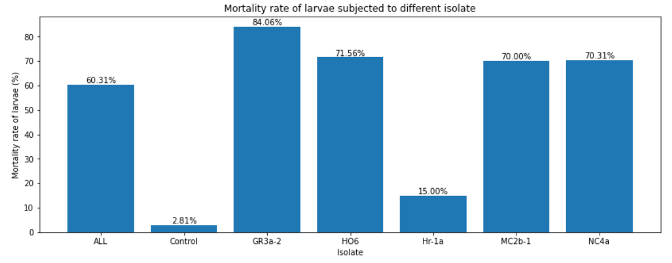

**Comparison of Isolate effect on larvaes at specific temperature**

1. **Degree: 24**

|  |  |  |  |  |  |
| --- | --- | --- | --- | --- | --- |
| No | temperature | isolate | Number of larvaes | Accumulation of deaths after 4 days (Day4_acc) | Mortality rate per isolate (%) |
| 0 | 24 | ALL | 80 | 64 | 80 |
| 1 | 24 | Control (water) | 80 | 0 | 0 |
| 2 | 24 | GR3a-2 | 80 | 75 | 93.75 |
| 3 | 24 | HO6 | 80 | 72 | 90 |
| 4 | 24 | Hr-1a | 80 | 14 | 17.5 |
| 5 | 24 | MC2b-1 | 80 | 71 | 88.75 |
| 6 | 24 | NC4a | 80 | 56 | 70 |

**Interpretation:**

**Isolate Comparison:**

* Isolate Hr-1a has a notably lower 'Day4_acc' value 14 compared to the other isolates, suggesting a potentially lower performance on the fourth day of the experiment.
* Similarly, Isolate Hr-1a also exhibits the lowest mortality rate at 17.50%, which is considerably lower than the rates for the other isolates except for the Control (water).
* Isolate GR3a-2 has the highest 'Day4_acc' value at 75, indicating relatively better performance compared to the other isolates.
* Isolate GR3a-2 also has the highest mortality rate at 93.75%, indicating a higher mortality rate compared to the other isolates.
* Isolate Control (water) has the lowest value of ‘Day4_acc’ of 0 compared to the other isolates and it has the lowest mortality rate of 0.00%.
* Isolate HO6 has ‘Day4_acc’ of 72 with mortality rate of 90%.
* Isolate ALL has ‘Day4_acc’ of 64 with mortality rate of 80%.
* Isolate MC2b-1 has ‘Day4_acc’ of 71 with mortality rate of 88.75%.
* Isolate NC4a has ‘Day4_acc’ of 56 with mortality rate of 70.00%.

**Perform Analysis of Variance (ANOVA)**

Analysis of variance is performed to assess whether the variation obtained in mortality rate is statistically significant.

The results of ANOVA

|  |  |  |
| --- | --- | --- |
| No | isolate | mean_day4_acc |
| 0 | ALL | 4 |
| 1 | Control | 0 |
| 2 | GR3a-2 | 4.6875 |
| 3 | HO6 | 4.5 |
| 4 | Hr-1a | 0.875 |
| 5 | MC2b-1 | 4.4375 |
| 6 | NC4a | 3.5 |
| F-statistic: 51.20933892969572 | | | |
| p-value: 5.37160521858768e-29 | | | |

**ANOVA Results**

* F-statistic: 51.209
* p-value: 5.3716e-29

**Explanation**:

**Table Analysis:**

The table presents the mean day4_acc values for each isolate at a temperature of 24°C.

* Isolate **ALL** has a mean day4_acc of 4.0000.
* Isolate **GR3a-2** has a mean day4_acc of 4.6875.
* Isolate **HO6** has a mean day4_acc of 4.5000.
* Isolate **Hr-1a** has a significantly lower mean day4_acc of 0.8750.
* Isolate **MC2b-1** has a mean day4_acc of 4.4375.
* Isolate **NC4a** has a mean day4_acc of 3.5000.
* Isolate **Control (water)** has a mean day4_acc of 0.

The isolate 'Hr-1a' stands out with a much lower mean day4_acc compared to the others, suggesting a different response or behavior at this temperature.

**ANOVA Results Interpretation:**

The F-statistic of 51.209 indicates a high level of variance between the group means relative to the variance within the groups. This suggests that at least one group mean is significantly different from the others. The p-value of 5.3716e-29 is extremely low (essentially zero), which strongly indicates that the differences observed in the means of day4_acc between the isolates are statistically significant.

Conclusion

The ANOVA results, combined with the mean values of day4_acc for each isolate, show that there are significant differences in day4_acc among the different isolates at the temperature of 24°C. Specifically, the isolate 'Hr-1a' exhibits a much lower day4_acc compared to the other isolates, suggesting it behaves differently or is less effective under these conditions. The low p-value confirms that these differences are not due to random chance.

**Post Hoc Test**

After observing the significance difference in means, Tukey's HSD post-hoc test were carried out to see which of the isolates means are statistically different. The result is:

Tukey HSD Results:

Multiple Comparison of Means - Tukey HSD, FWER=0.05

======================================================

group1 group2 meandiff p-adj lower upper reject

------------------------------------------------------

ALL Control -4.0 0.0 -5.1321 -2.8679 True

ALL GR3a-2 0.6875 0.534 -0.4446 1.8196 False

ALL HO6 0.5 0.8374 -0.6321 1.6321 False

ALL Hr-1a -3.125 0.0 -4.2571 -1.9929 True

ALL MC2b-1 0.4375 0.9067 -0.6946 1.5696 False

ALL NC4a -0.5 0.8374 -1.6321 0.6321 False

Control GR3a-2 4.6875 0.0 3.5554 5.8196 True

Control HO6 4.5 0.0 3.3679 5.6321 True

Control Hr-1a 0.875 0.2428 -0.2571 2.0071 False

Control MC2b-1 4.4375 0.0 3.3054 5.5696 True

Control NC4a 3.5 0.0 2.3679 4.6321 True

GR3a-2 HO6 -0.1875 0.9988 -1.3196 0.9446 False

GR3a-2 Hr-1a -3.8125 0.0 -4.9446 -2.6804 True

GR3a-2 MC2b-1 -0.25 0.9942 -1.3821 0.8821 False

GR3a-2 NC4a -1.1875 0.0333 -2.3196 -0.0554 True

HO6 Hr-1a -3.625 0.0 -4.7571 -2.4929 True

HO6 MC2b-1 -0.0625 1.0 -1.1946 1.0696 False

HO6 NC4a -1.0 0.1204 -2.1321 0.1321 False

Hr-1a MC2b-1 3.5625 0.0 2.4304 4.6946 True

Hr-1a NC4a 2.625 0.0 1.4929 3.7571 True

MC2b-1 NC4a -0.9375 0.1738 -2.0696 0.1946 False

Interpretation of post hoc results:

* Significant differences (rejecting the null hypothesis) were found in the following pairs:
  + ALL vs. Control, ALL vs. Hr-1a
  + Control vs. GR3a-2, Control vs. HO6, Control vs. MC2b-1, Control vs. NC4a
  + GR3a-2 vs. Hr-1a, GR3a-2 vs. NC4a
  + HO6 vs. Hr-1a
  + Hr-1a vs. MC2b-1, Hr-1a vs. NC4a
* No significant differences were found in the remaining pairs.

The "reject" column indicates whether there is a statistically significant difference between the groups at the 0.05 significance level. If "True", the difference is significant; if "False", it is not.

1. **Degree: 26**

|  |  |  |  |  |  |
| --- | --- | --- | --- | --- | --- |
| No | temperature | isolate | number of larvaes | Accumulation of deaths after 4 days (Day4_acc) | Mortality rate per isolate (%) |
| 0 | 26 | ALL | 80 | 69 | 86.25 |
| 1 | 26 | Control | 80 | 1 | 1.25 |
| 2 | 26 | GR3a-2 | 80 | 74 | 92.5 |
| 3 | 26 | HO6 | 80 | 71 | 88.75 |
| 4 | 26 | Hr-1a | 80 | 17 | 21.25 |
| 5 | 26 | MC2b-1 | 80 | 65 | 81.25 |
| 6 | 26 | NC4a | 80 | 72 | 90 |

**Interpretation:**

* **Isolate Comparison:**
  + Isolate Hr-1a has the low Day4_acc value at 17, suggesting potentially lower performance compared to the other isolates.
  + Isolate GR3a-2 has the highest Day4_acc value at 74, indicating relatively better performance compared to the other isolates
  + In terms of mortality rate, Isolate GR3a-2 has the highest mortality rate at 92.50%, indicating a higher susceptibility to mortality at 26 degrees Celsius compared to the other isolates.
  + Isolates ALL, HO6, and NC4a have similar mortality rates ranging from 86.25% to 90.00%.
  + Isolate Control (water) has the lowest Day4_acc value of 1 with the lowest mortality rate of 1.25 %.

**Perform ANOVA**

The ANOVA result table for 26 degrees is:

|  |  |  |  |
| --- | --- | --- | --- |
|  |  |  |  |
| No | isolate | mean_day4_acc |
| 1 | ALL | 4.3125 |
| 2 | Control (water) | 0.0625 |
| 3 | GR3a-2 | 4.625 |
| 4 | HO6 | 4.4375 |
| 5 | Hr-1a | 1.0625 |
| 6 | MC2b-1 | 4.0625 |
| 7 | NC4a | 4.5 |
| F-statistic: 84.00955690703736 | | |  |
|  |  |  |  |
| p-value: 8.32969563053469e-38 | | |  |

**Interpretation:**

* Isolate Hr-1a has the lower mean 'Day4_acc' value at 1.0625, suggesting potentially lower performance compared to the other isolates.
* Isolate Control (water) has the lowest mean 'Day4_acc' value at 0.0625.
* Isolate GR3a-2 has the highest mean 'Day4_acc' value at 4.625, indicating relatively better performance compared to the other isolates.
* Isolate NC4a has a mean 'Day4_acc' value of 4.5, which is slightly lower than 'GR3a-2' but higher than most other isolates, suggesting relatively good performance.

**ANOVA Results:**

* **F-statistic:** The F-statistic is a measure of the variation between groups' mean values relative to the variation within the groups. In this case, the F-statistic is 84.009.

A high F-statistic indicates a high degree of variability between group means, which may suggest that at least one group differs significantly from the others in terms of the metric being measured.

**p-value:** The p-value associated with the F-statistic is 8.329e-38, which is extremely low.

A low p-value indicates strong evidence against the null hypothesis (i.e., the group means are equal). In this case, the low p-value suggests that there is a significant difference in the mean values of the metric among the different isolates.

**Conclusion:**

The ANOVA results indicate that there are significant differences in the mean values of the metric among the different isolates. Isolate Hr-1a stands out with the lowest mean 'Day4_acc', suggesting potential differences in performance compared to the other isolates.

Isolate GR3a-2 exhibits the highest mean 'Day4_acc', indicating relatively better performance or activity.

Isolate NC4a also shows a high mean 'Day4_acc', suggesting relatively good performance, although slightly lower than 'GR3a-2'.

**Post Hoc Test**

The results of post Hoc Test is:

Tukey HSD Results:

Multiple Comparison of Means - Tukey HSD, FWER=0.05

======================================================

group1 group2 meandiff p-adj lower upper reject

------------------------------------------------------

ALL Control -4.25 0.0 -5.1298 -3.3702 True

ALL GR3a-2 0.3125 0.9361 -0.5673 1.1923 False

ALL HO6 0.125 0.9995 -0.7548 1.0048 False

ALL Hr-1a -3.25 0.0 -4.1298 -2.3702 True

ALL MC2b-1 -0.25 0.9783 -1.1298 0.6298 False

ALL NC4a 0.1875 0.9953 -0.6923 1.0673 False

Control GR3a-2 4.5625 0.0 3.6827 5.4423 True

Control HO6 4.375 0.0 3.4952 5.2548 True

Control Hr-1a 1.0 0.0153 0.1202 1.8798 True

Control MC2b-1 4.0 0.0 3.1202 4.8798 True

Control NC4a 4.4375 0.0 3.5577 5.3173 True

GR3a-2 HO6 -0.1875 0.9953 -1.0673 0.6923 False

GR3a-2 Hr-1a -3.5625 0.0 -4.4423 -2.6827 True

GR3a-2 MC2b-1 -0.5625 0.4705 -1.4423 0.3173 False

GR3a-2 NC4a -0.125 0.9995 -1.0048 0.7548 False

HO6 Hr-1a -3.375 0.0 -4.2548 -2.4952 True

HO6 MC2b-1 -0.375 0.8589 -1.2548 0.5048 False

HO6 NC4a 0.0625 1.0 -0.8173 0.9423 False

Hr-1a MC2b-1 3.0 0.0 2.1202 3.8798 True

Hr-1a NC4a 3.4375 0.0 2.5577 4.3173 True

MC2b-1 NC4a 0.4375 0.7472 -0.4423 1.3173 False

------------------------------------------------------

Interpretation

* Significant differences (rejecting the null hypothesis) were found in the following pairs:
  + ALL vs. Control, ALL vs. Hr-1a
  + Control vs. GR3a-2, Control vs. HO6, Control vs. Hr-1a, Control vs. MC2b-1, Control vs. NC4a
  + GR3a-2 vs. Hr-1a
  + HO6 vs. Hr-1a
  + Hr-1a vs. MC2b-1, Hr-1a vs. NC4a
* No significant differences were found in the remaining pairs.

The "reject" column indicates whether there is a statistically significant difference between the groups at the 0.05 significance level. If "True", the difference is significant; if "False", it is not.

1. **Degree 16**

|  |  |  |  |  |  |
| --- | --- | --- | --- | --- | --- |
| No | temperature | isolate | Number of larvaes | Accumulation of deaths after 4 days (Day4_acc) | mortality_rate_per_isolate (%) |
| 0 | 16 | ALL | 80 | 34 | 42.5 |
| 1 | 16 | Control (water) | 80 | 0 | 0 |
| 2 | 16 | GR3a-2 | 80 | 78 | 97.5 |
| 3 | 16 | HO6 | 80 | 28 | 35 |
| 4 | 16 | Hr-1a | 80 | 6 | 7.5 |
| 5 | 16 | MC2b-1 | 80 | 80 | 100 |
| 6 | 16 | NC4a | 80 | 62 | 77.5 |

Interpretation:

* Isolate Comparison:
* Isolate Hr-1a has the lower 'Day4_acc' value at 6, suggesting potentially lower performance compared to the other isolates.
* Isolate MC2b-1 has the highest 'Day4_acc' value at 80, indicating relatively better performance compared to the other isolates. This means that all the 80 larvae were died at the end of day 4.
* In terms of mortality rate, Isolate MC2b-1 has the highest mortality rate at 100%, indicating a complete loss of all larvae. This suggests that the temperature may have adverse effects on this isolate's survival.
* Isolates GR3a-2 and NC4a have high mortality rates at 97.5% and 77.5%, respectively, indicating significant losses in larval population under the given conditions.
* Isolate Control (water) have the lowest ‘Day4_acc’ at 0, suggesting the lowest performance compared to the other isolates.

**Perform ANOVA**

|  |  |  |  |  |
| --- | --- | --- | --- | --- |
| **No** | **isolate** | | **mean_day4_acc** | |
| 0 | ALL | | 2.125 | |
| 1 | Control | | 0 | |
| 2 | GR3a-2 | | 4.875 | |
| 3 | HO6 | | 1.75 | |
| 4 | Hr-1a | | 0.375 | |
| 5 | MC2b-1 | | 5 | |
| 6 | NC4a | | 3.875 | |
| F-statistic: 41.529411764705856 | | | | |
|  | |  | |  |
| p-value: 1.3916777853128337e-25 | | | | |

Intepretation:  
Isolate Comparison:

* Isolate Hr-1a has the lower mean 'Day4_acc' value at 0.375, suggesting potentially very low performance compared to the other isolates.
* Isolate MC2b-1 has the highest mean 'Day4_acc' value at 5, indicating relatively excellent performance compared to the other isolates.
* Isolate GR3a-2 also exhibits a high mean 'Day4_acc' value at 4.875, suggesting relatively strong performance.
* Isolate HO6 has a lower mean 'Day4_acc' value at 1.75, indicating lower performance compared to GR3a-2 and MC2b-1 but higher than 'Hr-1a'.
* Isolate NC4a has a mean 'Day4_acc' value of 3.875, which is also relatively high, indicating good performance.
* Isolate Control (water) has the lowest mean 'Day4_acc' of 0.

**ANOVA Results:**

* F-statistic: The F-statistic is a measure of the variation between groups' mean values relative to the variation within the groups. In this case, the F-statistic is 41.5294.
* A high F-statistic indicates a high degree of variability between group means, which may suggest that at least one group differs significantly from the others in terms of the metric being measured.
* p-value: The p-value associated with the F-statistic is 1.3916e-25, which is extremely low.
* A low p-value indicates strong evidence against the null hypothesis (i.e., the group means are equal).
* In this case, the low p-value suggests that there is a significant difference in the mean values of the metric among the different isolates at 16 degrees Celsius.

**Conclusion:**

* The ANOVA results indicate that there are significant differences in the mean values of the metric among the different isolates at 16 degrees Celsius.
* Isolate Hr-1a stands out with the lowest mean 'Day4_acc', suggesting potential differences in performance compared to the other isolates.
* Isolate MC2b-1 exhibits the highest mean 'Day4_acc', indicating relatively excellent performance.

**Post Hoc Test**

Tukey HSD Results:

Multiple Comparison of Means - Tukey HSD, FWER=0.05

======================================================

group1 group2 meandiff p-adj lower upper reject

------------------------------------------------------

ALL Control -2.125 0.0001 -3.4774 -0.7726 True

ALL GR3a-2 2.75 0.0 1.3976 4.1024 True

ALL HO6 -0.375 0.9809 -1.7274 0.9774 False

ALL Hr-1a -1.75 0.0032 -3.1024 -0.3976 True

ALL MC2b-1 2.875 0.0 1.5226 4.2274 True

ALL NC4a 1.75 0.0032 0.3976 3.1024 True

Control GR3a-2 4.875 0.0 3.5226 6.2274 True

Control HO6 1.75 0.0032 0.3976 3.1024 True

Control Hr-1a 0.375 0.9809 -0.9774 1.7274 False

Control MC2b-1 5.0 0.0 3.6476 6.3524 True

Control NC4a 3.875 0.0 2.5226 5.2274 True

GR3a-2 HO6 -3.125 0.0 -4.4774 -1.7726 True

GR3a-2 Hr-1a -4.5 0.0 -5.8524 -3.1476 True

GR3a-2 MC2b-1 0.125 1.0 -1.2274 1.4774 False

GR3a-2 NC4a -1.0 0.2924 -2.3524 0.3524 False

HO6 Hr-1a -1.375 0.0436 -2.7274 -0.0226 True

HO6 MC2b-1 3.25 0.0 1.8976 4.6024 True

HO6 NC4a 2.125 0.0001 0.7726 3.4774 True

Hr-1a MC2b-1 4.625 0.0 3.2726 5.9774 True

Hr-1a NC4a 3.5 0.0 2.1476 4.8524 True

MC2b-1 NC4a -1.125 0.1697 -2.4774 0.2274 False

------------------------------------------------------

Intepretation:

Significant differences (rejecting the null hypothesis) were found in the following pairs:

* ALL vs. Control
* ALL vs. GR3a-2
* ALL vs. Hr-1a
* ALL vs. MC2b-1
* ALL vs. NC4a
* Control vs. GR3a-2
* Control vs. HO6
* Control vs. MC2b-1
* Control vs. NC4a
* GR3a-2 vs. HO6
* GR3a-2 vs. Hr-1a
* HO6 vs. Hr-1a
* HO6 vs. MC2b-1
* HO6 vs. NC4a
* Hr-1a vs. MC2b-1
* Hr-1a vs. NC4a

No significant differences were found in the remaining pairs.

The "reject" column indicates whether there is a statistically significant difference between the groups at the 0.05 significance level. If "True," the difference is significant; if "False," it is not.

1. **Degree 30**

|  |  |  |  |  |  |
| --- | --- | --- | --- | --- | --- |
| No | temperature | isolate | number of larvaes | Accumulation of deaths after 4 days (Day4_acc) | Mortality rate per isolate (%) |
| 0 | 30 | ALL | 80 | 26 | 32.5 |
| 1 | 30 | Control (water) | 80 | 8 | 10 |
| 2 | 30 | GR3a-2 | 80 | 42 | 52.5 |
| 3 | 30 | HO6 | 80 | 58 | 72.5 |
| 4 | 30 | Hr-1a | 80 | 11 | 13.75 |
| 5 | 30 | MC2b-1 | 80 | 8 | 10 |
| 6 | 30 | NC4a | 80 | 35 | 43.75 |

Mortality_rate_per_isolate: This column represents the mortality rate observed for each isolate. It's expressed as a percentage. The values range from 10.00% to 72.50%.

Interpretation:

* Isolate Comparison:
* Isolate MC2b-1 has the lowest number of larvae and the lowest mortality rate at 8 larvae and 10.00% mortality rate, respectively which is similar to that of Control (water).
* Isolate HO6 has the highest number of larvae and the highest mortality rate at 58 larvae and 72.50% mortality rate, respectively.
* Isolate Hr-1a has a relatively low number of larvae and mortality rate at 11 larvae and 13.75% mortality rate, respectively.
* Isolates ALL, 'GR3a-2', and NC4a fall in between, with varying numbers of larvae and mortality rates.

Conclusion:

* The results indicate significant differences in larval mortality rates among the different isolates.
* MC2b-1 and Control (water) had the lowest mortality rate 10.00 %, while HO6 had the highest mortality rate 72.5 %.

### Perform ANOVA

|  |  |  |
| --- | --- | --- |
| No | isolate | mean_day4_acc |
| 0 | ALL | 1.625 |
| 1 | Control | 0.5 |
| 2 | GR3a-2 | 2.625 |
| 3 | HO6 | 3.625 |
| 4 | Hr-1a | 0.6875 |
| 5 | MC2b-1 | 0.5 |
| 6 | NC4a | 2.1875 |
| F-statistic: 10.02699228791774 | | |
|  |  |  |
| p-value: 9.705255905069084e-09 | | |

### Interpretation:

### Isolate Comparison:

### Isolate HO6 has the highest mean 'Day4_acc' value at 3.625, suggesting relatively better performance compared to the other isolates at 30 degrees Celsius.

### Isolate GR3a-2 has the second-highest mean 'Day4_acc' value at 2.625, indicating relatively good performance.

### Isolate NC4a has a moderate mean 'Day4_acc' value at 2.1875, suggesting moderate performance.

### Isolate ALL has the lowest mean 'Day4_acc' value at 1.625, indicating relatively poorer performance.

### Isolates Hr-1a and MC2b-1 and Control (water) have similarly low mean 'Day4_acc' values at 0.6875 and 0.5, respectively, suggesting the lowest performance among the isolates.

### ANOVA Results:

### F-statistic: The F-statistic is a measure of the variation between groups' mean values relative to the variation within the groups. In this case, the F-statistic is 10.0269.

### A high F-statistic indicates a high degree of variability between group means, which may suggest that at least one group differs significantly from the others in terms of the metric being measured.

### p-value: The p-value associated with the F-statistic is 9.7052e-09, which is extremely low.

### A low p-value indicates strong evidence against the null hypothesis (i.e., the group means are equal).

### In this case, the low p-value suggests that there is a significant difference in the mean values of the metric among the different isolates at 30 degrees Celsius.

### Conclusion:

### The ANOVA results indicate significant differences in the mean values of the metric among the different isolates at 30 degrees Celsius.

### Isolate HO6 exhibits the highest mean 'Day4_acc', indicating relatively better performance, while MC2b-1, Control (water) and Hr-1a show the lowest mean 'Day4_acc'.

### Post Hock

Tukey HSD Results:

Multiple Comparison of Means - Tukey HSD, FWER=0.05

======================================================

group1 group2 meandiff p-adj lower upper reject

------------------------------------------------------

ALL Control -1.125 0.3656 -2.7424 0.4924 False

ALL GR3a-2 1.0 0.5121 -0.6174 2.6174 False

ALL HO6 2.0 0.0058 0.3826 3.6174 True

ALL Hr-1a -0.9375 0.5893 -2.5549 0.6799 False

ALL MC2b-1 -1.125 0.3656 -2.7424 0.4924 False

ALL NC4a 0.5625 0.942 -1.0549 2.1799 False

Control GR3a-2 2.125 0.0026 0.5076 3.7424 True

Control HO6 3.125 0.0 1.5076 4.7424 True

Control Hr-1a 0.1875 0.9999 -1.4299 1.8049 False

Control MC2b-1 0.0 1.0 -1.6174 1.6174 False

Control NC4a 1.6875 0.0349 0.0701 3.3049 True

GR3a-2 HO6 1.0 0.5121 -0.6174 2.6174 False

GR3a-2 Hr-1a -1.9375 0.0085 -3.5549 -0.3201 True

GR3a-2 MC2b-1 -2.125 0.0026 -3.7424 -0.5076 True

GR3a-2 NC4a -0.4375 0.9831 -2.0549 1.1799 False

HO6 Hr-1a -2.9375 0.0 -4.5549 -1.3201 True

HO6 MC2b-1 -3.125 0.0 -4.7424 -1.5076 True

HO6 NC4a -1.4375 0.1158 -3.0549 0.1799 False

Hr-1a MC2b-1 -0.1875 0.9999 -1.8049 1.4299 False

Hr-1a NC4a 1.5 0.0877 -0.1174 3.1174 False

MC2b-1 NC4a 1.6875 0.0349 0.0701 3.3049 True

------------------------------------------------------

Interpretation:

* Significant differences (rejecting the null hypothesis) were found in the following pairs:
  + ALL vs. HO6
  + Control vs. GR3a-2, Control vs. HO6, Control vs. NC4a
  + GR3a-2 vs. Hr-1a, GR3a-2 vs. MC2b-1
  + HO6 vs. Hr-1a, HO6 vs. MC2b-1
  + MC2b-1 vs. NC4a
* No significant differences were found in the remaining pairs.

The "reject" column indicates whether there is a statistically significant difference between the groups at the 0.05 significance level. If "True", the difference is significant; if "False", it is not.

**Propagation**

To find the propagation for each temperature and each isolation, the dataset were aggregated for each these two variables.

|  |  |  |  |
| --- | --- | --- | --- |
| No | temperature | isolate | average_propagation_per_1_dead_larvae |
| 0 | 16 | ALL | 0 |
| 1 | 16 | Control | 0 |
| 2 | 16 | GR3a-2 | 200 |
| 3 | 16 | HO6 | 0 |
| 4 | 16 | Hr-1a | 0 |
| 5 | 16 | MC2b-1 | 330.1471 |
| 6 | 16 | NC4a | 0 |
| 7 | 24 | ALL | 604.3651 |
| 8 | 24 | Control | 0 |
| 9 | 24 | GR3a-2 | 618.75 |
| 10 | 24 | HO6 | 928.3333 |
| 11 | 24 | Hr-1a | 4357.361 |
| 12 | 24 | MC2b-1 | 917.1429 |
| 13 | 24 | NC4a | 1281.944 |
| 14 | 26 | ALL | 979.5833 |
| 15 | 26 | Control | 0 |
| 16 | 26 | GR3a-2 | 1056.859 |
| 17 | 26 | HO6 | 1313.095 |
| 18 | 26 | Hr-1a | 919.2708 |
| 19 | 26 | MC2b-1 | 476.6667 |
| 20 | 26 | NC4a | 1318.75 |
| 21 | 30 | ALL | 0 |
| 22 | 30 | Control | 0 |
| 23 | 30 | GR3a-2 | 0 |
| 24 | 30 | HO6 | 0 |
| 25 | 30 | Hr-1a | 0 |
| 26 | 30 | MC2b-1 | 0 |
| 27 | 30 | NC4a | 0 |

The result of the table is on the graph:

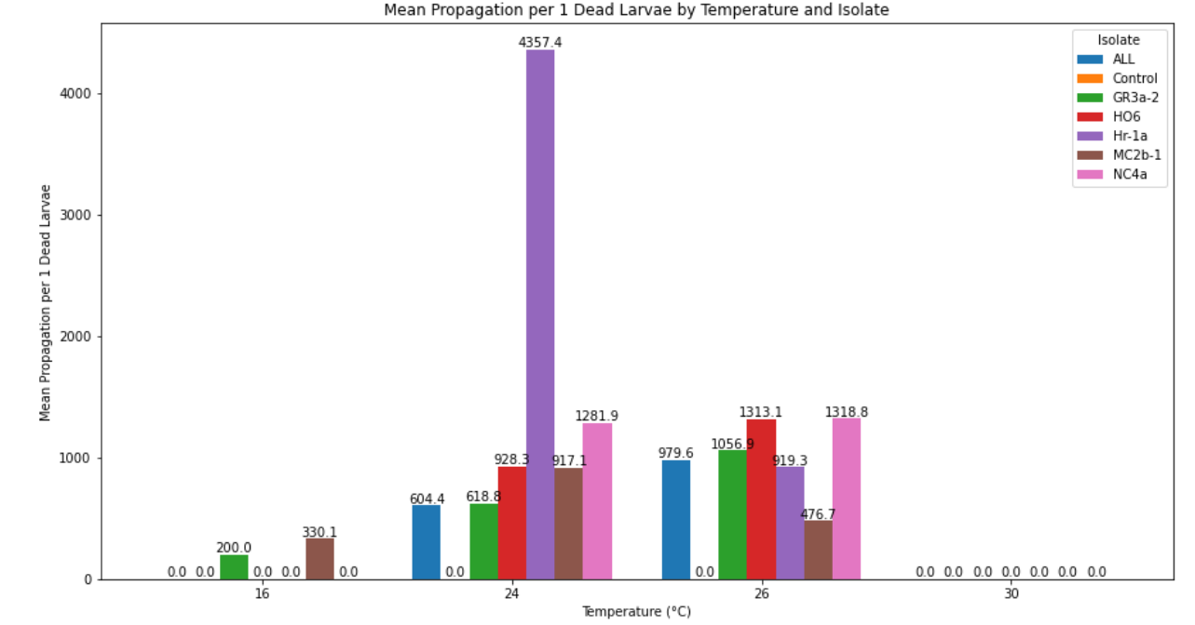

Interpretation of the findings:

Temperature 16°C:

* ALL, Control,HO6, Hr-1a, NC4a: No propagation observed (0.000000).
* GR3a-2: Moderate propagation with an average of 200.0.
* MC2b-1: High propagation with an average of 330.1.

Temperature 24°C:

* ALL: High propagation with an average of 604.0.
* Control has propagation of 0.0.
* GR3a-2: High propagation with an average of 618.0.
* HO6: Very high propagation with an average of 928.3.
* Hr-1a: Extremely high propagation with an average of 4357.4.
* MC2b-1: High propagation with an average of 917.1.
* NC4a: Very high propagation with an average of 1281.9.

Temperature 26°C:

* ALL: High propagation with an average of 979.6.
* Control has propagation of 0.0.
* GR3a-2: High propagation with an average of 1056.9.
* HO6: Very high propagation with an average of 1313.1.
* Hr-1a: Moderate propagation with an average of 919.3.
* MC2b-1: High propagation with an average of 476.7.
* NC4a: Very high propagation with an average of 1318.8.

Temperature 30°C:

* ALL, Control, GR3a-2, HO6, Hr-1a, MC2b-1, NC4a: No propagation observed (0.000000).

Summary:

Temperature 16°C:

* Most isolates show no propagation, except for GR3a-2 and MC2b-1, which show moderate and high propagation respectively.

Temperature 24°C:

* All isolates show significant to extremely high propagation, with Hr-1a showing exceptionally high propagation. This temperature seems optimal for most isolates in terms of propagation.

Temperature 26°C:

* Propagation remains high for most isolates, with significant propagation observed across all isolates, though slightly lower than at 24°C for some isolates.

Temperature 30°C:

* No propagation observed for any isolate, indicating that this temperature is not conducive for propagation for any of the isolates

**Finding the linear relationship between propagation and mortality rate**

We test whether there is relationship between propagation and mortality rate, we combined mortality rate and propagation for each temperature for each isolate.

|  |  |  |  |  |  |  |
| --- | --- | --- | --- | --- | --- | --- |
| **No** | **temperature** | **isolate** | **Number of larvaes** | **day4_acc** | **mortality_rate_per_isolate (%)** | **average_propagation_per_1_dead_larvae** |
| 0 | 16 | ALL | 80 | 34 | 42.5 | 0 |
| 1 | 16 | Control | 80 | 0 | 0 | 0 |
| 2 | 16 | GR3a-2 | 80 | 78 | 97.5 | 200 |
| 3 | 16 | HO6 | 80 | 28 | 35 | 0 |
| 4 | 16 | Hr-1a | 80 | 6 | 7.5 | 0 |
| 5 | 16 | MC2b-1 | 80 | 80 | 100 | 330.1471 |
| 6 | 16 | NC4a | 80 | 62 | 77.5 | 0 |
| 7 | 24 | ALL | 80 | 64 | 80 | 604.3651 |
| 8 | 24 | Control | 80 | 0 | 0 | 0 |
| 9 | 24 | GR3a-2 | 80 | 75 | 93.75 | 618.75 |
| 10 | 24 | HO6 | 80 | 72 | 90 | 928.3333 |
| 11 | 24 | Hr-1a | 80 | 14 | 17.5 | 4357.361 |
| 12 | 24 | MC2b-1 | 80 | 71 | 88.75 | 917.1429 |
| 13 | 24 | NC4a | 80 | 56 | 70 | 1281.944 |
| 14 | 26 | ALL | 80 | 69 | 86.25 | 979.5833 |
| 15 | 26 | Control | 80 | 1 | 1.25 | 0 |
| 16 | 26 | GR3a-2 | 80 | 74 | 92.5 | 1056.859 |
| 17 | 26 | HO6 | 80 | 71 | 88.75 | 1313.095 |
| 18 | 26 | Hr-1a | 80 | 17 | 21.25 | 919.2708 |
| 19 | 26 | MC2b-1 | 80 | 65 | 81.25 | 476.6667 |
| 20 | 26 | NC4a | 80 | 72 | 90 | 1318.75 |
| 21 | 30 | ALL | 80 | 26 | 32.5 | 0 |
| 22 | 30 | Control | 80 | 8 | 10 | 0 |
| 23 | 30 | GR3a-2 | 80 | 42 | 52.5 | 0 |
| 24 | 30 | HO6 | 80 | 58 | 72.5 | 0 |
| 25 | 30 | Hr-1a | 80 | 11 | 13.75 | 0 |
| 26 | 30 | MC2b-1 | 80 | 8 | 10 | 0 |
| 27 | 30 | NC4a | 80 | 35 | 43.75 | 0 |

The correlation analysis were performed and the results are:

Correlation Coefficient: 0.1694969672832501

P-value: 0.38854112770492344

Interpretation:

Correlation Coefficient (0.1694):

* The Pearson correlation coefficient measures the linear relationship between two variables. It ranges from -1 to 1.
* A coefficient of 0.1694 indicates a very weak positive linear relationship between the two variables. This means that as one variable increases, the other variable tends to increase slightly, but the relationship is not strong.
* In practical terms, a correlation coefficient this low suggests that there is minimal linear association between the two variables.

P-value (0.3885):

* The p-value tests the null hypothesis that there is no linear relationship between the two variables.
* A p-value of 0.3885 is much higher than the common significance levels (default: 0.05). This high p-value indicates that we fail to reject the null hypothesis.
* In other words, there is no statistically significant evidence to suggest that the observed correlation is different from zero. The weak correlation observed is likely due to random chance rather than a true relationship.

Conclusion:

* Strength of Relationship: The very weak correlation coefficient suggests that there is almost no linear relationship between average_propagation_per_1_dead_larvae and mortality_rate_per_isolate.
* Statistical Significance: The high p-value indicates that this weak relationship is not statistically significant, meaning we do not have enough evidence to conclude that there is any meaningful association between the variables namely average_propagation_per_1_dead_larvae and mortality_rate_per_isolate.

Overall, these results imply that there is no significant linear relationship between the two variables. The weak positive correlation observed is not strong enough to be considered meaningful, and the high p-value supports the conclusion that the relationship is not statistically significant.