Supplementary Information:
Context Without Contact: Top-Down Information Flow from Shared Modulation in Uncoupled Prebiotic Systems
This PDF file includes:
Supporting Figures S1 to S3
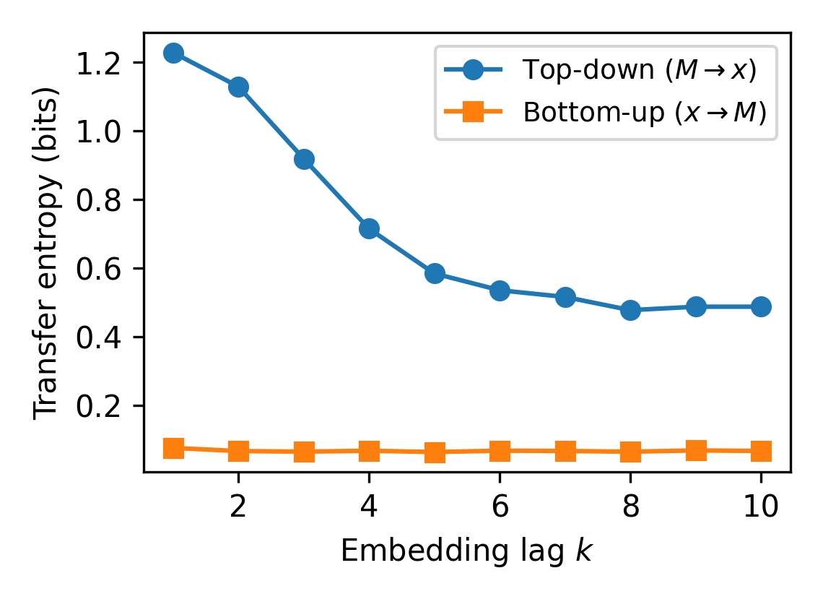
Figure S1. Mean transfer entropy (TE) as a function of embedding lag k for modulation amplitude A=25. Top-down TE (M→x, circles) measures information from the macroscopic mean field to an individual unit, while bottom-up TE (x→M, squares) measures the reverse direction. Values are averaged over 10 random seeds. Parameters: N=1000, K₀=100, r_{i}∈[3.9,4.0], T=10,000 steps (first 1,000 discarded), 15-bin histograms.

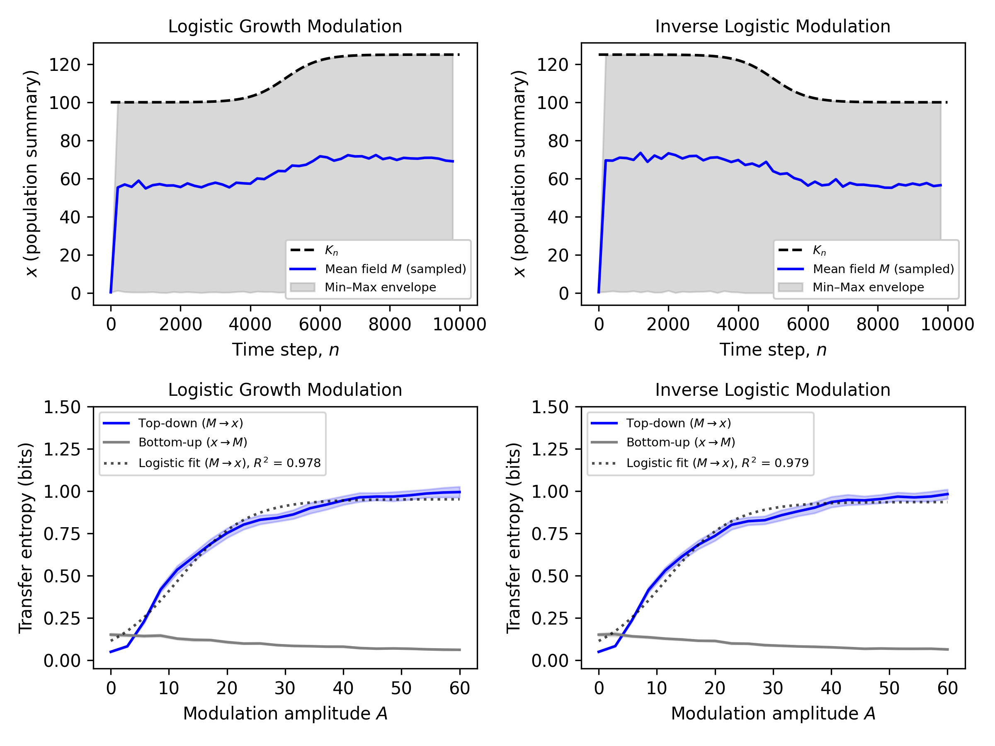
Figure S2. Directional information flow from macroscopic to microscopic dynamics under different modulation profiles. Transfer entropy (TE) between the mean field M_{n} and a representative unit x_{n}, computed in both directions: M → x (blue) and x → M (gray), for a population of N = 1000 uncoupled logistic units evolving under carrying capacity modulated by (A,C) logistic increase, and (B,D) inverse logistic. In all cases K₀ = 100, A = 25, r_{i} ∈ [3.9, 4.0], and steepness is k = 0.05, simulated over 10 independent simulations, each run for T = 10,000 steps (first 1,000 discarded). Top row: The black curve shows the external modulation K_{n}, the blue line corresponds to the mean field M, sampled every 200 steps, and the shaded gray band indicates the range of individual states at each sampled point. Bottom row: TE estimated using a histogram-based method with lag k = 2 and 15 bins. Shaded regions indicate 95% confidence intervals.

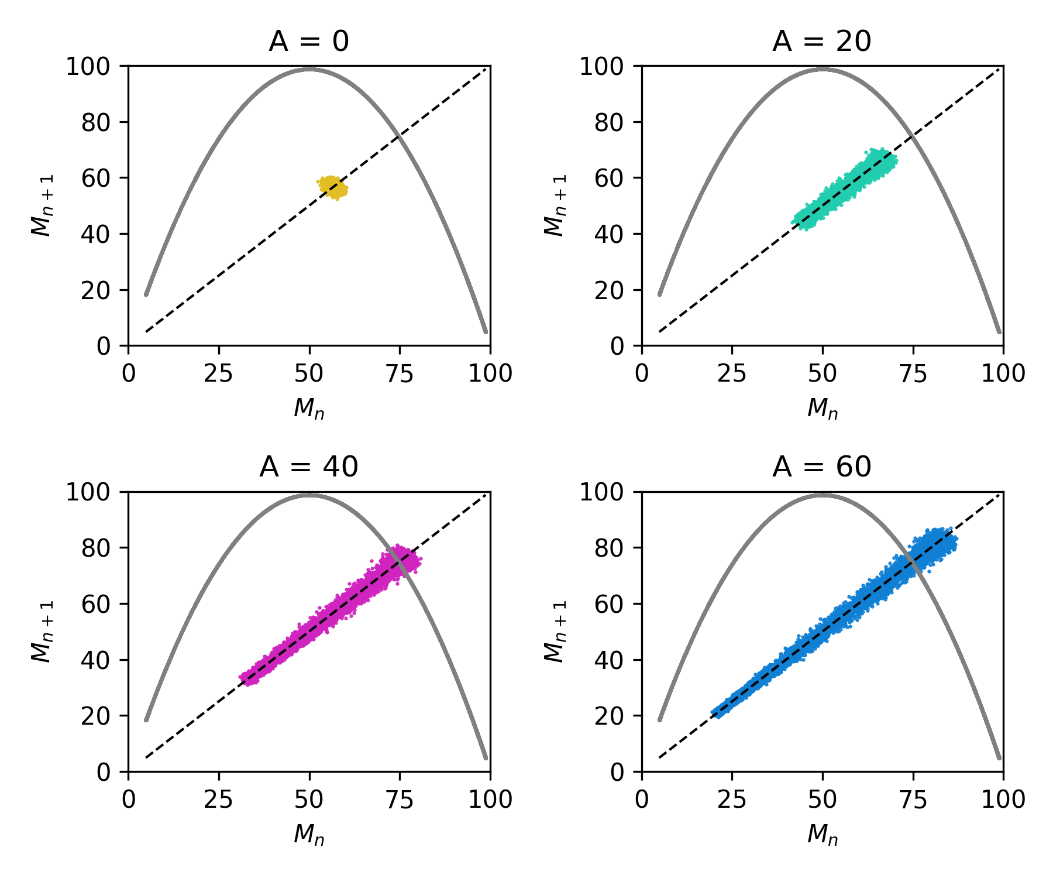
Figure S3. Structural modulation induces low-dimensional macroscopic dynamics. Return maps of (M_{n}, M_{n+1}) for A = {0, 20, 40, 60}, N = 1,000, K₀ = 100, r_{i} ∈ [3.9, 4.0], and T = 10,000 steps (first 1,000 discarded). The dashed line shows the identity M_{n+1} = M_{n} and the gray curve shows the single-unit logistic map for comparison. At A=0, points cluster near (K₀/2, K₀/2). As A increases, shared modulation widens the distribution of M_{n}, producing a diagonal spread.

