DATABASE MANAGEMENT SYSTEM

PROJECT REPORT

A). Detail Problem Description:

The website includes Clients’ ,Lawyers’, Employees’ , Trial Files’ informations. It should be control that username and password’s of admin and lawyers. In addition, on the database side; this informations and entries should be stored. Lawyer has attributes such as baro number,name,surname,address,phone…

Also client and files have different attributes those stored in database.

Admin and lawyers can display relevant informations and also update these if they want.

This website provides that make easier and faster all works on files and other require components.

B). Business Rules

Lawyer can; update,insert,delete,search Files.

Admin can update, insert, delete, search Files, Lawyers, Clients, Employee, Partnership.

C). ER Diagram

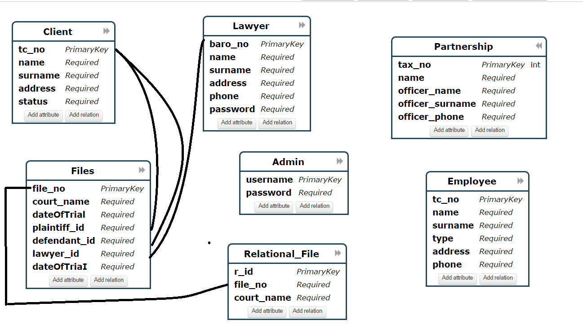

D). Database Schema

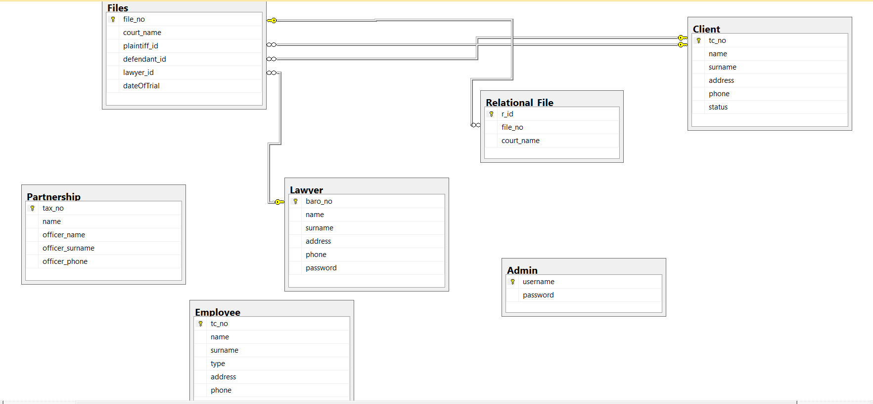

E). SQL Statements

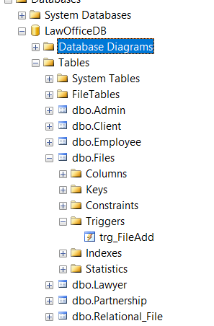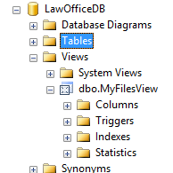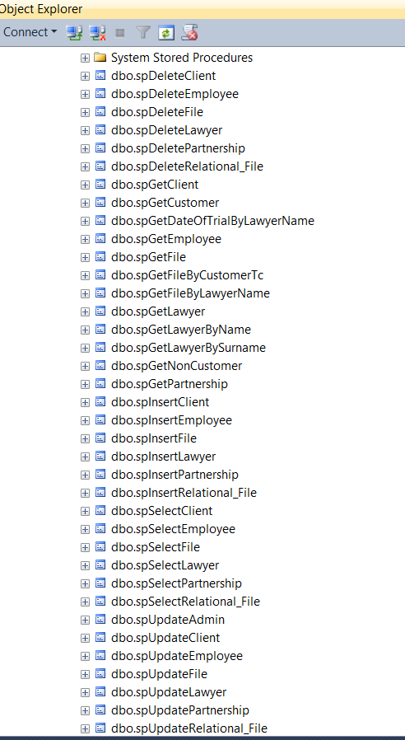

F). Screenshots

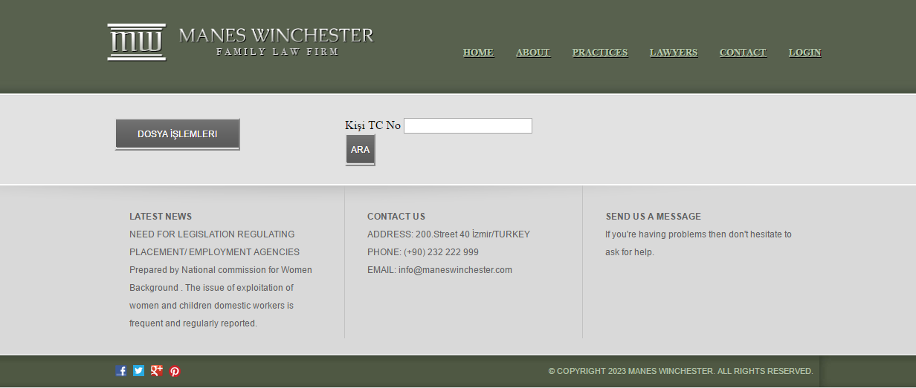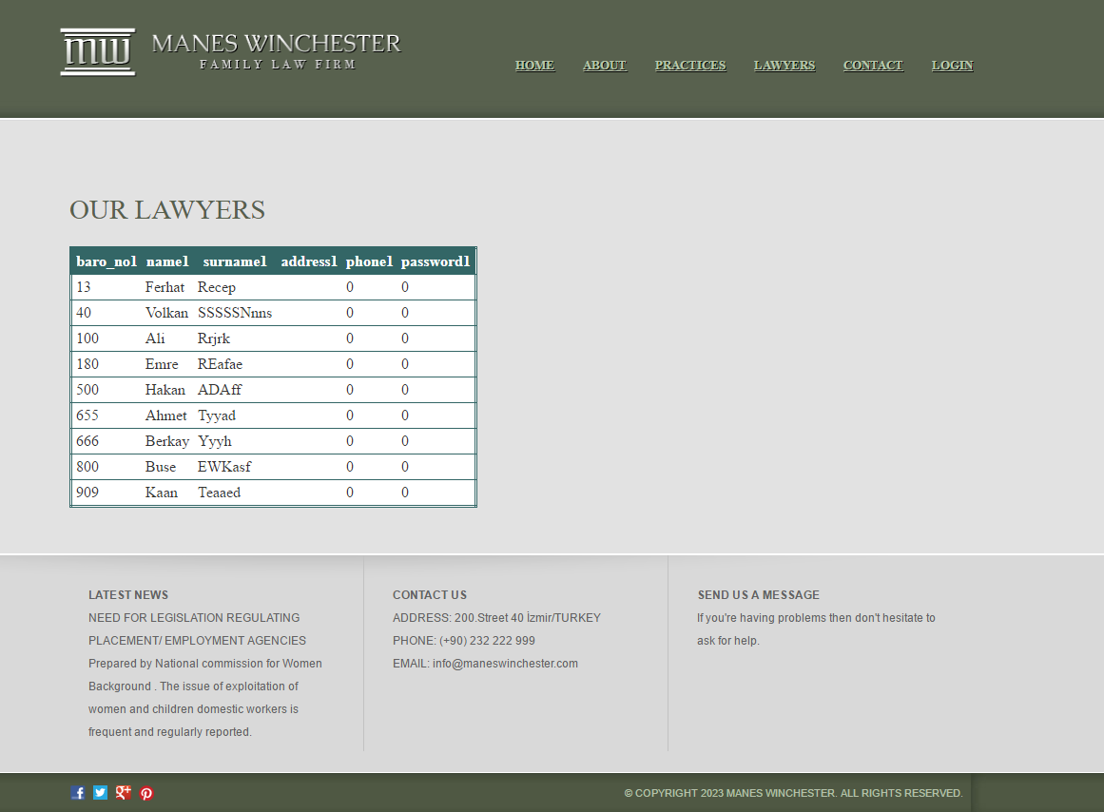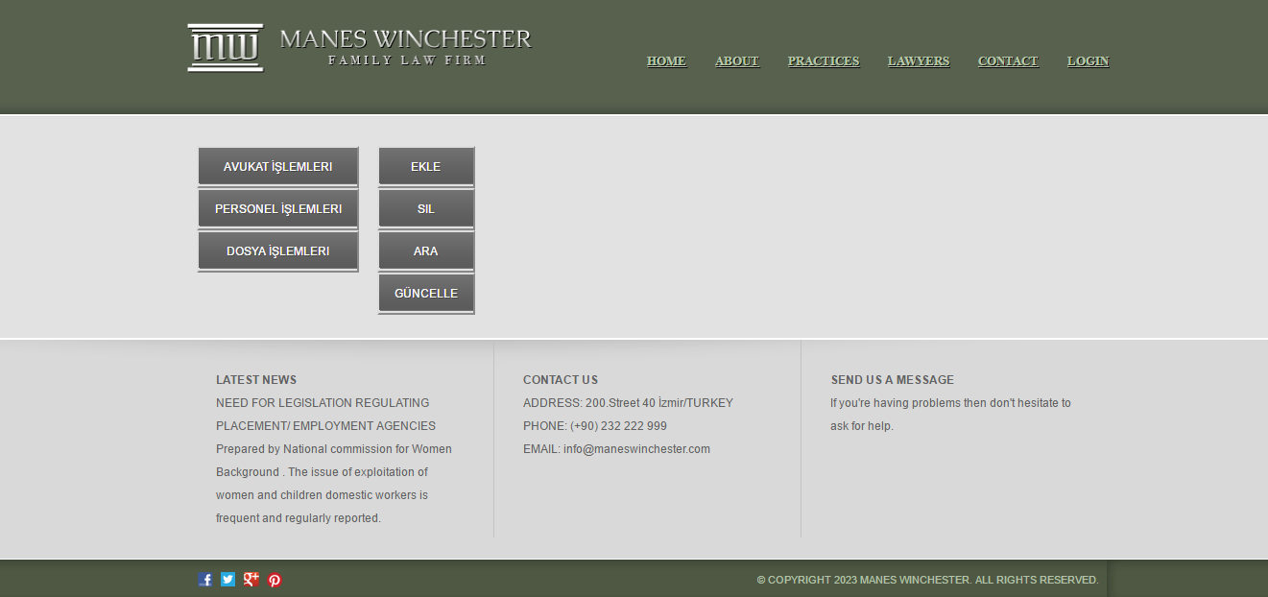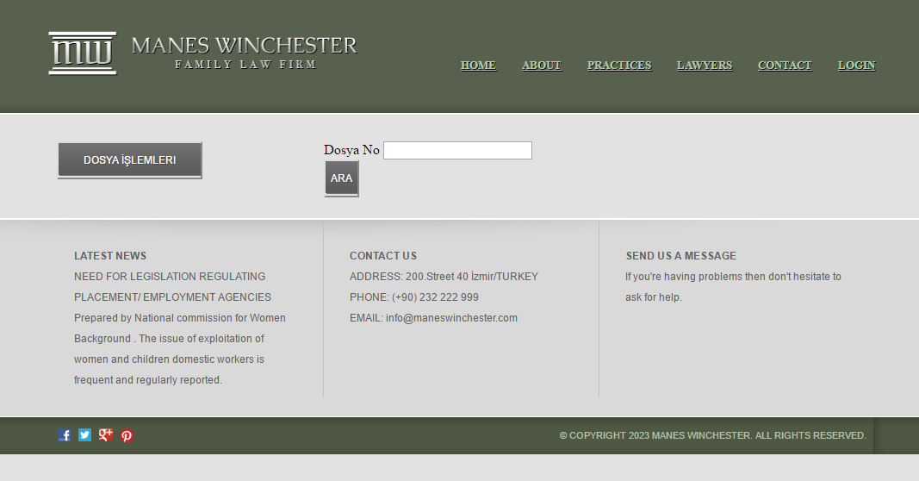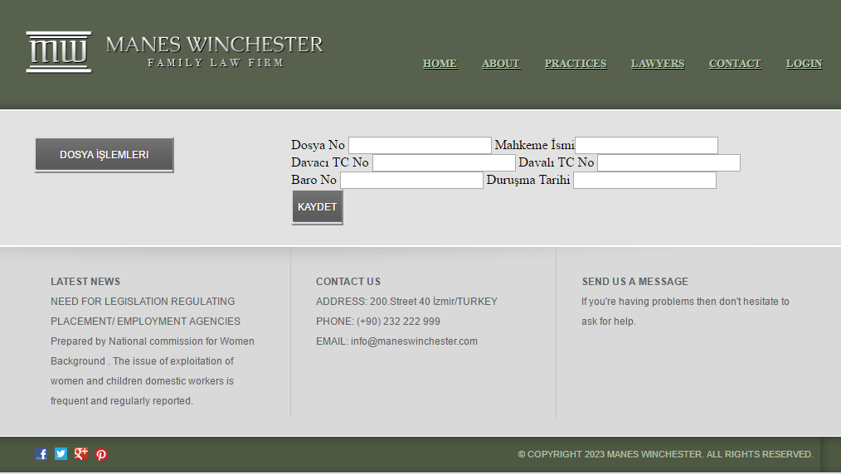

G). Logging

admin username: admin

admin password: 123

lawyer no: 13

lawyer password: 1995

H). Additional Properties

1. Search by using Lawyer surname
2. List all files’ date of trials
3. List customer’s files
4. List our customer’s information and non customer’s information

I). Challenges

1. Alignment problems in design

Solution: Using div and master page

1. Errors while stored procedures

Solution: Controlling methods’ parameters in Facade and Business Layer

1. Needing of different list methods

Solution: Using inner SQL queries

BERKAY ÇELİK 2013510085