Temperature dependent dispersal: A distributed experiment
Sarah Elliott, Chloe Guicharnaud, Celina Baines

Supplementary methods for Folsomia candida

Author contributions
Conceptualization: Celina Baines, Chloe Guicharnaud
Statistical analysis: Sarah Elliott, Chloe Guicharnaud
Methodology (design of methodology): Sarah Elliott, Chloe Guicharnaud, Celina Baines
Investigation/conduct experiment: Sarah Elliott, Chloe Guicharnaud
Funding acquisition: Celina Baines
Writing (original draft, supplement): Sarah Elliott, Celina Baines
Writing (review and editing): Chloe Guicharnaud

Study organism
Folsomia candida Willem 1902 is a terrestrial arthropod present in soils across the globe. The average body size is 1.5-3.0mm at adult stages (Fountain and Hopkin 2005) and they use active crawling as their dispersal mode. The species is generally short-lived with an average lifespan of 110 days at 20 °C and reaching sexual maturity around 10-25 days (Roeben, Montoya-Tzschoppe, and Roß-Nickoll 2023). The species reproduces asexually through parthenogenesis where embryos can develop from an unfertilized egg (Fountain and Hopkin 2005).
For this experiment, we used individuals that were from an initial stock population sourced from the Soil Toxicology Laboratory at Environment of Climate Change Canada in November 2024. Populations were kept within a climatic chamber with conditions of 20 °C, 70 % Relative Humidity (RH), and 16:8 L:D cycle. Sub-populations from the initial stock were kept inside plastic containers filled with substrate consisting of plaster of Paris and charcoal (at an 8:1 ratio), which acts as artificial soil. In the laboratory, their diet consists of granulated bakers dried yeast. Water and food were replenished once per week as needed to ensure food supply was constant and organisms wouldn’t desiccate.
Organisms used in the experiment were age-matched approximately a month prior to the start of the experiment during which they were kept within containers with substrate at 20 °C, 70 % Relative Humidity (RH), and 16:8 L:D cycle. Food and water were replenished once per week as needed. As traits related to dispersal are dependent on age and development stage in this system, age-matching was done to ensure F. candida were of the same age and instar at the start of an experiment. To do so, approximately 100 individuals were placed in
a clean container with a layer of substrate and left for 3 days. Following a three-day egg-laying period, all adults were removed with the eggs remaining. The eggs can hatch, grow and can be used approximately one month after the initial adults were added.

Study design

Temperature treatments
For this experiment, T_{Low.medium} = 22°C, T_{opt} = 26°C, and T_{low} = 18°C. The optimal temperature was chosen based off literature which estimates the optimal temperature to be approximately 21°C (Snider and Butcher 2017). A pilot was conducted to determine temperatures for T_{opt} and T_{low}. For the pilot, temperatures ranging from 14-26°C with increments of 2°C were tested using number of offspring as a proxy for fitness. No temperatures above 26°C were chosen because eggs lose viability at 28°C (Fountain and Hopkin 2005). To assess number of offspring as a proxy for population growth, mesocosms were adjusted to each temperature and stock containers were added to each mesocosm a week prior to the start date. Five age matched individuals were placed in each replicate and allowed an egg laying period of three days. Following this period, adults were removed and populations of new adults were counted after approximately one month. From this we concluded 18°C and 26°C would be appropriate temperatures for T_{low} and T_{opt}. Temperatures varied slightly around the three means of temperature treatments (18,22 and 26°C) with deviations of ± 1°C across all replicates and blocks.

Phase 1: Fitness assay
For phase 1 of the experiment, we assessed growth rate as a proxy for fitness. We used 3D printed habitat nodes that have a round arena with a diameter of 3cm across. The arena has a layer of substrate and possible connections to other nodes. For this phase, all connections were blocked by cording fit to size of the connection holes. Water reservoirs are located at the base of the habitat nodes and were filled with 2 mL twice per week, an amount that previously has been demonstrated to be the optimal level of moisture. The water reservoir has holes which allows the substrate to absorb the water through capillary action. This prevents inconsistent water levels and reduces daily moisture variation. Additionally, petri dishes were placed on top of the nodes to maintain a constant humidity and to keep individuals within their respective node.
Phase 1 was conducted in a climatic chamber set at 18°C, with consistent humidity and light cycle, similar to rearing conditions. The chamber had five spatially separated benches that were approximately 1 meter apart from each other and each bench could fit three mesocosms, therefore one from each treatment was placed on the bench to homogenize temperture treatments within the chamber. Mesocosms for 22°C and 26°C were fitted with heat mats along both sides and all mesocosms had a layer of insulation surrounding it. Mesocosm lids were constructed using a wooden frame and a semi-transparent plastic to ensure similar light conditions.
Each mesocosm had three replicate nodes within it, and nodes remained in their respective mesocosm for the entirety of the experiment. No variance in fitness was attributed to mesocosms so the linear mixed model was simplified to a linear model. For acclimation, stock containers were added to each temperature treatment one week prior to the start of the experiment. At the start of the experiment, a total of 10 acclimated individuals were randomly added to each habitat node along with 2 pellets of food per node and water. Twice per week, old food was removed, and food (2+ pellets) and water (2 ml) were replenished. During the maintenance of the nodes, dead individuals were removed and noted, and pictures of nodes were taken so population size could be counted. Phase 1 of the experiment lasted a total of 28 days, which was based on the pilot and generation time of the lowest temperature group. The organism reproduces asexually, so no consideration was given to sex ratios, and no phenotypes were measured as a variable.

Phase 2: Dispersal assay
For Phase 2 of the experiment, we assessed dispersal of F. candida with discrete, two-node systems. We used the same 3D printed habitat patches as Phase 1; except we connected two nodes using clear Tygon tubing that was 8cm in length. Phase 2 was conducted in the same climatic chamber and mesocosms as Phase 1, but phase 2 took place shortly after phase 1 was conducted. For Phase 2, each mesocosm had three replicate two-node systems within it, and landscapes remained in their respective mesocosm for the entirety of the experiment.
At the start of the experiment, a total of 100 acclimated and age-matched individuals were randomly added to each initial habitat node along with 6 pellets of yeast per initial node, 2 pellets of yeast per secondary node and 2 mL of water in every node. Twice per week, old food was removed, and food (6 and 2 pellets respectively) and water (2 mL) were replenished. Four days prior to phase 2, age matched stock populations that were different from those used in phase 1 were put in temperature regulated mesocosms to acclimate. Age-matched individuals were used because dispersal traits and ability in this system are correlated with age and body size.
Phase 2 lasted 10 days, which was based on egg generation time in the highest temperature in order to prevent various density related effects on dispersal. Three times per week dispersal data was collected, where dispersers in the second node were counted, photographed and removed. Initial nodes were also photographed to collect population sizes throughout the experiment. Dead individuals were not removed from initial nodes during the experiment. However, we removed any individuals that died in the tubing to prevent mould impeding dispersal. The organism reproduces asexually, so no consideration was given to sex ratios, and no phenotypes were measured as a variable.

Statistical Analysis

Does fitness change with temperature (phase 1)?
NA
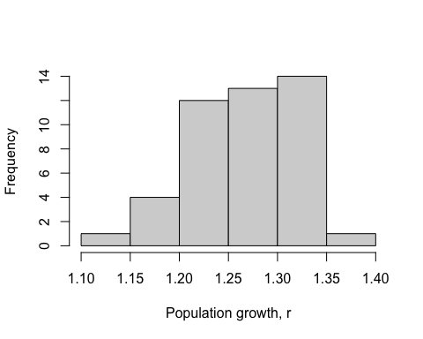
Figure 1. Histogram of fitness ( population growth, r ) values.
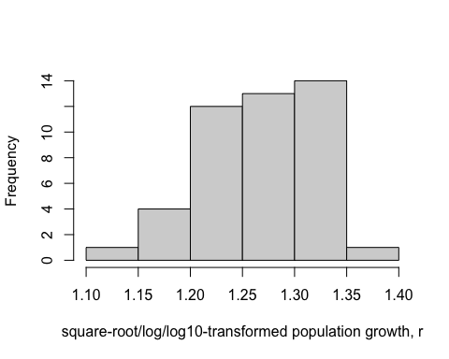
Figure 1. Histogram of square-root/log/log10 -transformed population growth, r values.
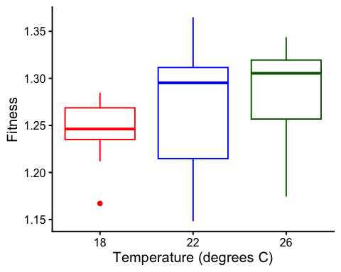
Figure 2. Boxplot of fitness ( population growth, r ), as a function of temperature treatment. low = 18 C, opt = 22 C, high = 26 C.
To estimate the effects of temperature (a factor) on fitness, we used a linear model with population growth, r as the response variable. We used the formula:
Fitness ~ Temp.treatment

Results for main effect of temperature on fitness
## Analysis of Variance Table
##
## Response: Fitness
## Df Sum Sq Mean Sq F value Pr(>F)
## Temp.treatment 2 0.012476 0.006238 2.4656 0.09717 .
## Residuals 42 0.106262 0.002530
## ---
## Signif. codes: 0 '***' 0.001 '**' 0.01 '*' 0.05 '.' 0.1 ' ' 1

Post-hoc pairwise contrasts: differences in fitness between temperature treatments
## contrast estimate SE df lower.CL upper.CL t.ratio p.value
## opt - low 0.0408 0.0184 42 0.00372 0.0778 2.220 0.0318
## opt - medium.low 0.0199 0.0184 42 -0.01719 0.0569 1.082 0.2853
## low - medium.low -0.0209 0.0184 42 -0.05797 0.0162 -1.138 0.2615
##
## Confidence level used: 0.95

Does dispersal change with temperature (phase 2)?
To estimate the effect of temperature treatment (a factor) on dispersal, we used a generalized linear mixed model with a binomial error structure and a logit link. Dispersal (the number of dispersers vs non-dispersers) was the response variable. We used the formula:
cbind(Num.disp, Num.nondisp) ~ Temp.treatment + (1|Group) + (1|Block)
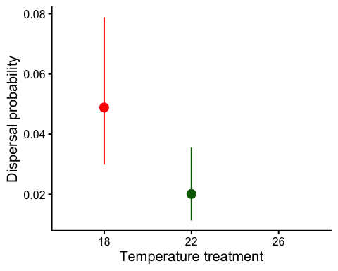
Figure 1. Dispersal as a function of temperature treatment. low = 18 C, opt = 22 C, high = 26 C. Error bars represent 95% confidence intervals predicted from GLMM.

Results for main effect of temperature on dispersal
## Single term deletions
##
## Model:
## cbind(Num.disp, Num.nondisp) ~ Temp.treatment + (1 | Group) +
## (1 | Block)
## npar AIC LRT Pr(Chi)
## <none> 249.72
## Temp.treatment 2 252.37 6.653 0.03592 *
## ---
## Signif. codes: 0 '***' 0.001 '**' 0.01 '*' 0.05 '.' 0.1 ' ' 1

Post-hoc pairwise contrasts: differences in dispersal between temperature treatments
## contrast odds.ratio SE df asymp.LCL asymp.UCL null z.ratio p.value
## opt / low 0.400 0.124 Inf 0.218 0.734 1 -2.956 0.0031
## opt / medium.low 0.657 0.211 Inf 0.349 1.234 1 -1.307 0.1914
## low / medium.low 1.642 0.478 Inf 0.927 2.906 1 1.701 0.0889
##
## Confidence level used: 0.95
## Intervals are back-transformed from the log odds ratio scale
## Tests are performed on the log odds ratio scale

Model Diagnostics
There was no evidence for lack of fit for either the fitness or the dispersal model.

Diagnostic plots for fitness data
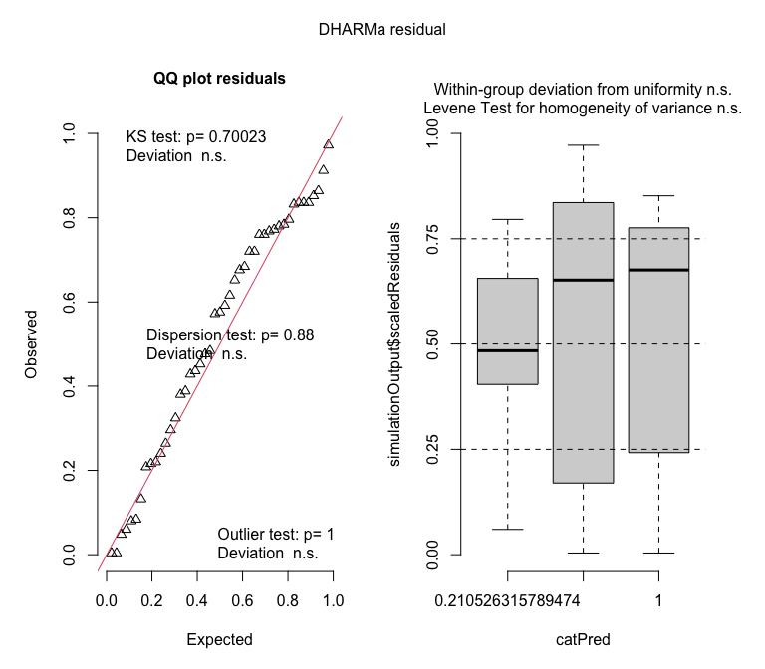

Diagnostic plots for dispersal data
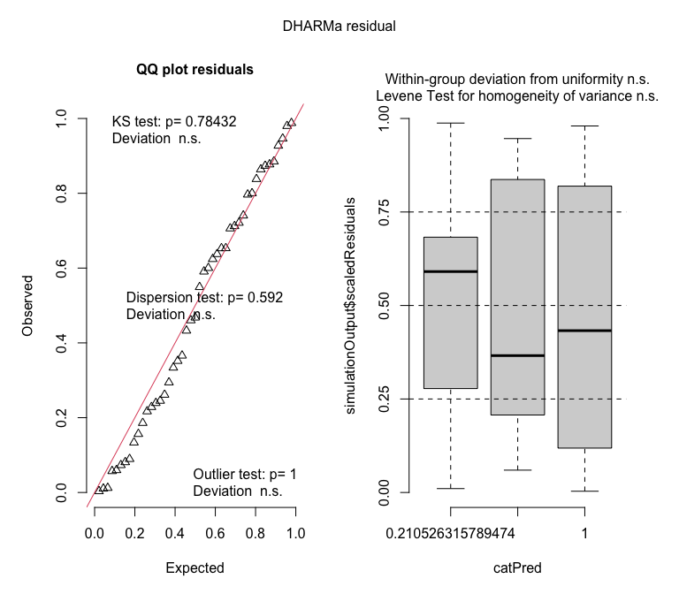

References
Fountain, Michelle T., and Steve P. Hopkin. 2005. “Folsomia Candida (Collembola): A “Standard” Soil Arthropod.” Annual Review of Entomology 50 (1): 201–22. https://doi.org/10.1146/annurev.ento.50.071803.130331.
Roeben, Vanessa, Luisa Montoya-Tzschoppe, and Martina Roß-Nickoll. 2023. “Long Life at Low Temperatures The Life-History of Folsomia Candida at Ecological Relevant Temperatures.” Pedobiologia 96 (March): 150847. https://doi.org/10.1016/j.pedobi.2022.150847.
Snider, Renate M., and James W. Butcher. 2017. “The Life History of Folsomia Candida (Willem) (Collembola: Isotomidae) Relative to Temperature.” The Great Lakes Entomologist 6 (4). https://doi.org/10.22543/0090-0222.1187.

