Temperature dependent dispersal: A distributed experiment
Raquel Gaspar, Sofia Costa, Leonor R Rodrigues

Supplementary methods for Tetranychus cinnabarinus_PT

Study organism
Name and strain/origin of species: Tetranychus cinnabarinus
#Provide basic life history information (aquatic/terrestrial, mode of dispersal, lifespan, etc.).
Terrestrial plant-feeding Acari, cosmopolitan distribution, polyphagous, reproduce through arrhenotoky (haplodiploids), capable of diapause during winter, capable of both active and passive dispersal, lifespan between 2 and 4 weeks, capable of producing approximately 100 eggs during a lifetime.
#Briefly describe what is known about the temperature range the species experiences (geographic range, seasonality, type of habitat, etc.) in its natural system or the history of the conditions it has experienced in the lab.
Tetranychus cinnabarinus is a generalist species with a worldwide distribution range recently diverged from the well-studied T. urticae . In its natural environment, it is most active during the warmer months, with populations typically peaking in spring and summer. It inhabits plant surfaces, especially the undersides of leaves, and is commonly associated with crops, ornamentals, and weeds. In the lab, they are maintained at 25C on 14-day-old bean plants (25 ± 2°C, 60% RH, 16/8 h L/D) .
#How were organisms sourced?
‘WuSS’ originated from five population replicates (the ‘iC’ populations in Rodrigues et al., 2022), themselves formed by merging six populations collected in crop fields in the region of Lisbon, Portugal, in 2013 (Zélé et al., 2018) from several host plants. The field populations were established at the University of Lisbon and maintained under standard conditions (25 ± 2°C, 60% RH, 16/8 h L/D) at the laboratory in high numbers (about 500–1000 females) inside cages containing bean plants (Phaseolus vulgaris, Fabaceae, var. Enana; Germisem Sementes Lda, Oliveira do Hospital, Portugal). The five population replicates were treated with rifampicin following the procedure described in Zélé et al. (2020) to remove Wolbachia. These replicates were merged in September 2020 forming the base population used here.
Rodrigues, L. R., Zélé, F., Santos, I., & Magalhães, S. (2022). No evidence for the evolution of mating behavior in spider mites due to Wolbachia-induced cytoplasmic incompatibility. Evolution, 76, 623–635. Zélé, F., I. Santos, I. Olivieri, M. Weill, O. Duron, and S. Magalhães. (2018). Endosymbiont diversity and prevalence in herbivorous spider mite populations in South-Western Europe. FEMS Microbiol. Ecol. 94, fiy015
#Note: I’m not providing more information because a) it’s published and b) the pops we’re merged many generations prior to the onset of the experiments, but if needed, do let me know.
#How were individuals/populations treated before the experiment?
‘WuSS’ was maintained under standard conditions (25 ± 2°C, 60% RH, 16/8 h L/D) at the laboratory in high numbers (about 500–1000 females) inside cages containing 14-day-old bean plants (Phaseolus vulgaris, Fabaceae, var. Enana; Germisem Sementes Lda, Oliveira do Hospital, Portugal) ad lib.
#Were specific individuals/phenotypes/stages selected for the experiment?
Mated females (ca. 8 days at high temperatures - opt and high - and 10 to 11 days at control temperature).

Study design

Temperature treatments
- Tlab: 25°C; Temperature at which the mite population was kept in the laboratory since 2020.
- Topt: 33°C; Optimal temperature for spider mites, as their generation time decreases and number of offspring increases (based on Costa et al. 2024).
- Thot: 36°C; Established as a sub-lethal high temperature (causing a toll in fertility but not so much in survival)
There was no variation in temperature.

Phase 1: Fitness assay
Fitness proxy: number of eggs produced per mated female in 3 days.
#- Physical details about the experimental setup including size/shape/volume of experimental arenas, substrate/medium of experimental arenas.
Squared petri dishes with a layer of water-soaked cotton. In each, 16 circles (16Ø) cut from 14 day-old bean leaves. Females were individually added to each circle.
- Replicates
  - Specify number of experimental replicates: Tlab:32 ; Topt:32; Thigh:29
  - Number of strains and number of replicates per strain: 1 outbred population
  - Indicate if experimental blocks were used and the blocking design (number of blocks, how many replicates of each treatment per block, time/space between blocks): Two identical incubators were used. Each block corresponded to a test temperature and the control temperature (Tlab) for this population. All replicates of each temperature treatment were done at the same time, amounting to 2 blocks (block 1: test Thigh + Control; block 2: Topt + Control).
- Type and amount of food provided during experiment: 16Ø circles of 14 day-old bean leaves per individual, corresponding to food ad lib. Water is added to the petri dishes when they start drying.
- Starting density: 1 female per circle
- Duration of fitness assay: 3 days
- Controlled variables: food (ad lib), only females
- Phenotypes measured (activity, body condition, body size, etc.) and how they were estimated: fecundity (number of eggs)

Phase 2: Dispersal assay
- Physical details about the experimental setup including size/shape/volume of experimental arenas, substrate/medium of experimental arenas, type of system (1 or 2 patches).
Squared petri dishes with a layer of water-soaked cotton will be used. In each, 12 circles (18 mm Ø) cut from 14 day-old bean leaves. Groups of 3 circles in line connected with an acetate bridge (1x3 cm) (i.e., 4 setups per petri dish were created) such that movement between the patches is possible. Fifteen females were added to the circle on the right (the source patch).
- Replicates
  - Specify number of experimental replicates: Tlab:32 ; Topt:32; Thigh:31
  - Number of strains and number of replicates per strain: 1 outbred population
  - Indicate if experimental blocks were used and the blocking design (number of blocks, how many replicates of each treatment per block, time/space between blocks): Two identical incubators were used. Each block corresponded to a test temperature and the control temperature (Tlab) for this population. All replicates at 33 were measured at on the same block, replicates at 36C were collected across 2 blocks (block 1: Topt + Control; block 2: test Thigh + Control; block 3: test Thigh + Control;).
- Type and amount of food provided during experiment: Three 16 mm Ø circles of 14 day-old bean leaves per setup, corresponding to food ad lib. Water is added to the petri dishes when they start drying.
- Starting density:15 mated females
- Duration of dispersal assay including:
  - time between birth and start of acclimation period:0 days (individuals were exposed since egg)
  - duration of acclimation period: 8 to 11 days (at 25C and 33/36C respectively)
  - timing and duration of dispersal assay: 24h, 48h, 72h (covariate “Time”)
- Controlled variables: food (ad lib), all females because they are the dispersing sex
- Phenotypes measured (activity, body condition, body size, etc.) and how they were estimated: number of females in patch 1 vs patches 2 and 3 (I have nr of eggs per patch and damage as well but I do not provide here)
- Whether individuals used in phase 2 were the same as used in phase 1: no
- Provide details on data collection including:
  - The sampling regime (time intervals between sampling).
  - Sampling method including whether individuals were marked and whether sampling was observed or automated: observed
- State whether mortality during the dispersal assay was recorded. Describe how mortality was handled for the statistical analysis (e.g., individuals that died during the dispersal assay were excluded from the analysis of dispersal). Yes, we discriminated between alive and dead females on each patch/bridge. Individuals that died during the dispersal assay were excluded from the analysis of dispersal

Statistical Analysis
## 'data.frame': 378 obs. of 6 variables:
## $ Block : int 3 3 3 3 3 3 3 3 3 3 ...
## $ Temp.treatment: chr "low" "low" "low" "low" ...
## $ Temp.value : int 25 25 25 25 25 25 25 25 25 25 ...
## $ Time : int 24 48 72 24 48 72 24 48 72 24 ...
## $ Num.nondisp : int 13 10 9 14 12 11 15 12 7 13 ...
## $ Num.disp : int 0 0 1 0 1 1 0 0 0 0 ...

Does fitness change with temperature (phase 1)?
NA
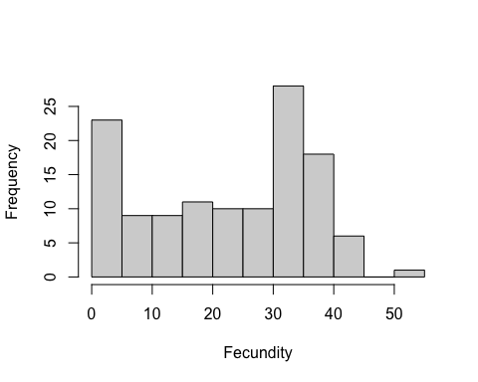
Figure 1. Histogram of fitness ( fecundity ) values.
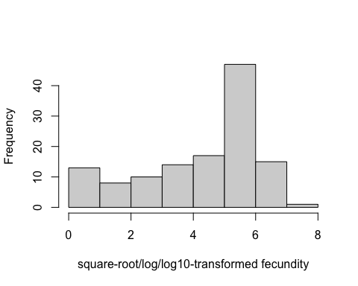
Figure 1. Histogram of square-root/log/log10 -transformed fecundity values.
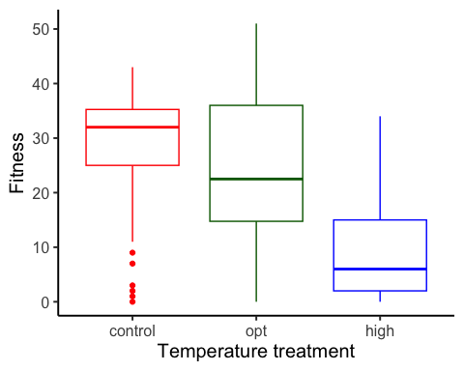
Figure 2. Boxplot of fitness ( fecundity ), as a function of temperature treatment. low = 25 C, opt = 33 C, high = 36 C.
To estimate the effects of temperature (a factor) on fitness, we used a linear mixed model with fecundity as the response variable. We used the formula:
Fitness ~ Temp.treatment + (1 | Female_survival)
## Warning in glmer(fitness.formula, data =
## d_phase1): calling glmer() with family=gaussian
## (identity link) as a shortcut to lmer() is
## deprecated; please call lmer() directly

Results for main effect of temperature on fitness
## Analysis of Variance Table
## npar Sum Sq Mean Sq F value
## Temp.treatment 2 3167.8 1583.9 16.4

Post-hoc pairwise contrasts: differences in fitness between temperature treatments
## contrast estimate SE df lower.CL
## opt - control -3.57 2.15 2.15 -12.239
## opt - high 9.81 2.59 2.16 -0.584
## control - high 13.38 2.35 2.15 3.896
## upper.CL t.ratio p.value
## 5.1 -1.662 0.2298
## 20.2 3.791 0.0560
## 22.9 5.691 0.0251
##
## Degrees-of-freedom method: inherited from kenward-roger when re-gridding
## Confidence level used: 0.95

Does dispersal change with temperature (phase 2)?
To estimate the effect of temperature treatment (a factor) on dispersal, we used a generalized linear mixed model with a binomial error structure and a logit link. Dispersal (the number of dispersers vs non-dispersers) was the response variable. We used the formula:
cbind(Num.disp, Num.nondisp) ~ Temp.treatment * Time + (1 | Block)
## Warning in checkConv(attr(opt, "derivs"), opt$par, ctrl = control$checkConv, : Model is nearly unidentifiable: very large eigenvalue
## - Rescale variables?
## NOTE: Results may be misleading due to involvement in interactions
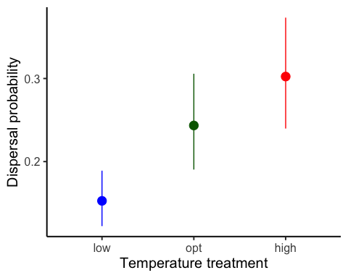
Figure 1. Dispersal as a function of temperature treatment. low = 25 C, opt = 33 C, high = 36 C. Error bars represent 95% confidence intervals predicted from GLMM.

Results for main effect of temperature on dispersal
## Single term deletions
##
## Model:
## cbind(Num.disp, Num.nondisp) ~ Temp.treatment * Time + (1 | Block)
## npar AIC LRT Pr(Chi)
## <none> 1523.7
## Temp.treatment:Time 2 1528.5 8.8855 0.01176 *
## ---
## Signif. codes:
## 0 '***' 0.001 '**' 0.01 '*' 0.05 '.' 0.1 ' ' 1

Post-hoc pairwise contrasts: differences in dispersal between temperature treatments
## contrast odds.ratio SE df asymp.LCL
## opt / high 0.743 0.137 Inf 0.517
## opt / low 1.785 0.202 Inf 1.431
## high / low 2.404 0.358 Inf 1.796
## asymp.UCL null z.ratio p.value
## 1.07 1 -1.608 0.1078
## 2.23 1 5.129 <.0001
## 3.22 1 5.889 <.0001
##
## Confidence level used: 0.95
## Intervals are back-transformed from the log odds ratio scale
## Tests are performed on the log odds ratio scale

Model Diagnostics
There was no evidence for lack of fit for either the fitness or the dispersal model.

Diagnostic plots for fitness data
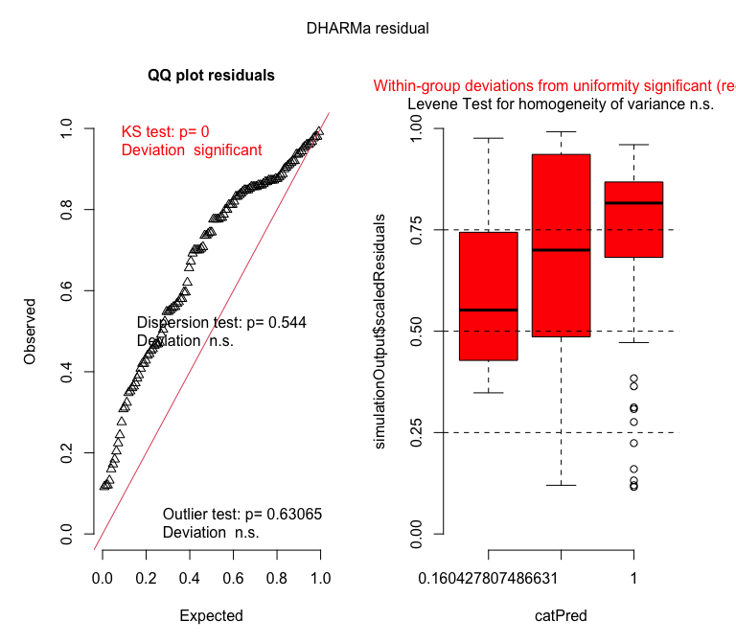

Diagnostic plots for dispersal data
