Temperature dependent dispersal: A distributed experiment
researcher names here
Table of Contents

## ── Attaching core tidyverse packages ──────────────────────── tidyverse 2.0.0 ──
## ✔ dplyr 1.1.4 ✔ readr 2.1.5
## ✔ forcats 1.0.0 ✔ stringr 1.5.1
## ✔ ggplot2 3.5.1 ✔ tibble 3.2.1
## ✔ lubridate 1.9.3 ✔ tidyr 1.3.1
## ✔ purrr 1.0.2
## ── Conflicts ────────────────────────────────────────── tidyverse_conflicts() ──
## ✖ dplyr::filter() masks stats::filter()
## ✖ dplyr::lag() masks stats::lag()
## ℹ Use the conflicted package (<http://conflicted.r-lib.org/>) to force all conflicts to become errors
## Loading required package: Matrix
##
##
## Attaching package: 'Matrix'
##
##
## The following objects are masked from 'package:tidyr':
##
## expand, pack, unpack
##
##
## Welcome to emmeans.
## Caution: You lose important information if you filter this package's results.
## See '? untidy'
##
## This is DHARMa 0.4.7. For overview type '?DHARMa'. For recent changes, type news(package = 'DHARMa')
## [1] "Notofit.csv"
## [2] "Notonecta_undulata.docx"
## [3] "Notonecta_undulata.Rmd"
## [4] "Notonecta_undulata_files"
## [5] "outputs"
## [6] "Phase1_fitness_Notonecta.undulata.csv"
## [7] "Phase1_FitnessAssay.R"
## [8] "Phase2_Dispersal.R"
## [9] "Phase2_dispersal_Notonecta.undulata.csv"

Supplementary methods for Notonecta undulata

Study organism
Name and strain/origin of species.
Provide basic life history information (aquatic/terrestrial, mode of dispersal, lifespan, etc.).
Briefly describe what is known about the temperature range the species experiences (geographic range, seasonality, type of habitat, etc.) in its natural system or the history of the conditions it has experienced in the lab.
How were organisms sourced?
- Field caught: provide information on timing, geographic coordinates, type of habitat.
- Lab sourced: provide information on source.
- Provide license/ authorization numbers for catching animals in the field and/or doing experiments, where applicable.
How were individuals/populations treated before the experiment?
- Rearing/holding conditions (temperature, food, light).
- How long were experimental subjects held before the experiment?
Were specific individuals/phenotypes/stages selected for the experiment?

Study design

Temperature treatments
State the temperatures used for T_{opt}, T_{hot}, T_{cold}, and explain how they were chosen.
State whether there was daily variation in temperature, and if so, describe (e.g., mean and standard deviation temperature for each treatment).

Phase 1: Fitness assay
Describe the fitness proxy (growth rate, survival, body condition, reproductive output, etc.). If proxy is indirect (e.g., body condition), explain what is known about the relationship between the proxy and actual fitness in the species.
Provide details about the methods for estimating the fitness proxy including:
- Physical details about the experimental setup including size/shape/volume of experimental arenas, substrate/medium of experimental arenas.
- Replicates
- Specify number of experimental replicates
- Number of strains and number of replicates per strain
- Indicate if experimental blocks were used and the blocking design (number of blocks, how many replicates of each treatment per block, time/space between blocks)
- Type and amount of food provided during experiment
- Starting density
- Duration of fitness assay
- Controlled variables: food (ad lib?), water (ad lib?), sex ratio
- Phenotypes measured (activity, body condition, body size, etc.) and how they were estimated

Phase 2: Dispersal assay
Provide details about the methods for estimating dispersal including:
- Physical details about the experimental setup including size/shape/volume of experimental arenas, substrate/medium of experimental arenas, type of system (1 or 2 patches).
- Replicates
- Specify number of experimental replicates
- Number of strains and number of replicates per strain
- Indicate if experimental blocks were used and the blocking design (number of blocks, how many replicates of each treatment per block, time/space between blocks)
- Type and amount of food provided during experiment
- Starting density
- Duration of dispersal assay including:
- time between birth and start of acclimation period
- duration of acclimation period
- timing and duration of dispersal assay
- Controlled variables: food (ad lib), water (ad lib if applicable), sex ratio
- Phenotypes measured (activity, body condition, body size, etc.) and how they were estimated
- Whether individuals used in phase 2 were the same as used in phase 1 (note that the same individuals do NOT have to be used for phase 1 and phase 2)
- Provide details on data collection including:
- The sampling regime (time intervals between sampling).
- Sampling method including whether individuals were marked and whether sampling was observed or automated. Please include validation if automated.
- State whether mortality during the dispersal assay was recorded. Describe how mortality was handled for the statistical analysis (e.g., individuals that died during the dispersal assay were excluded from the analysis of dispersal).

Statistical Analysis

Does fitness change with temperature (phase 1)?
Fecundity was not normally distributed so we log(x+1)-transformed it. The transformed variable followed a normal distribution.
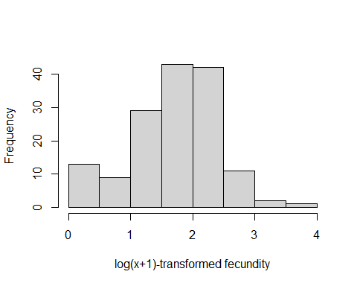
Figure 1. Histogram of log(x+1) -transformed fecundity values.
## Warning: Removed 75 rows containing missing values or values outside the scale range
## (`stat_boxplot()`).
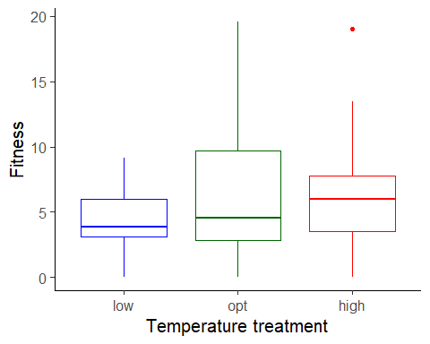
Figure 2. Boxplot of fitness ( fecundity ), as a function of temperature treatment. low = 16 C, opt = 26 C, high = 30 C.
To estimate the effects of temperature (a factor) on fitness, we used a linear mixed model with fecundity as the response variable. We used the formula:
log(Fitness + 1) ~ Temp.treatment + (1|Block/Mesocosm)

Results for main effect of temperature on fitness
## Analysis of Variance Table
## npar Sum Sq Mean Sq F value
## Temp.treatment 2 0.47565 0.23782 0.448

Post-hoc pairwise contrasts: differences in fitness between temperature treatments
## contrast estimate SE df lower.CL upper.CL t.ratio p.value
## opt - high 0.0509 1.18 4.7 -3.05 3.16 0.043 0.9675
## opt - low 0.9130 1.10 4.7 -1.97 3.80 0.830 0.4465
## high - low 0.8621 1.09 4.7 -2.00 3.73 0.788 0.4684
##
## Degrees-of-freedom method: inherited from kenward-roger when re-gridding
## Confidence level used: 0.95

Does dispersal change with temperature (phase 2)?
To estimate the effect of temperature treatment (a factor) on dispersal, we used a generalized linear mixed model with a binomial error structure and a logit link. Dispersal (the number of dispersers vs non-dispersers) was the response variable. We used the formula:
Dispersal ~ Temp.treatment + (1|Mesocosm)
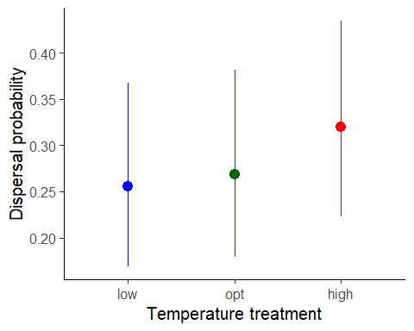
Figure 1. Dispersal as a function of temperature treatment. low = 16 C, opt = 26 C, high = 30 C. Error bars represent 95% confidence intervals predicted from GLMM.

Results for main effect of temperature on dispersal
## Single term deletions
##
## Model:
## Dispersal ~ Temp.treatment + (1 | Mesocosm)
## npar AIC LRT Pr(Chi)
## <none> 285.50
## Temp.treatment 2 282.32 0.81862 0.6641

Post-hoc pairwise contrasts: differences in dispersal between temperature treatments
## contrast odds.ratio SE df asymp.LCL asymp.UCL null z.ratio p.value
## opt / high 0.78 0.283 Inf 0.383 1.59 1 -0.684 0.4939
## opt / low 1.07 0.400 Inf 0.513 2.22 1 0.178 0.8588
## high / low 1.37 0.501 Inf 0.669 2.80 1 0.861 0.3894
##
## Confidence level used: 0.95
## Intervals are back-transformed from the log odds ratio scale
## Tests are performed on the log odds ratio scale

Model Diagnostics
There was no evidence for lack of fit for either the fitness or the dispersal model.

Diagnostic plots for fitness data
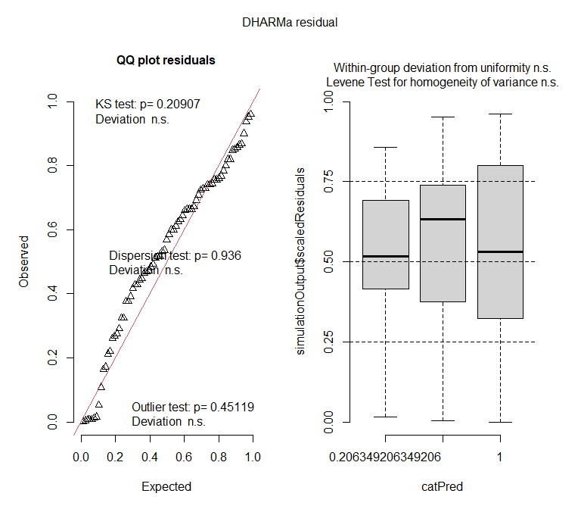

Diagnostic plots for dispersal data
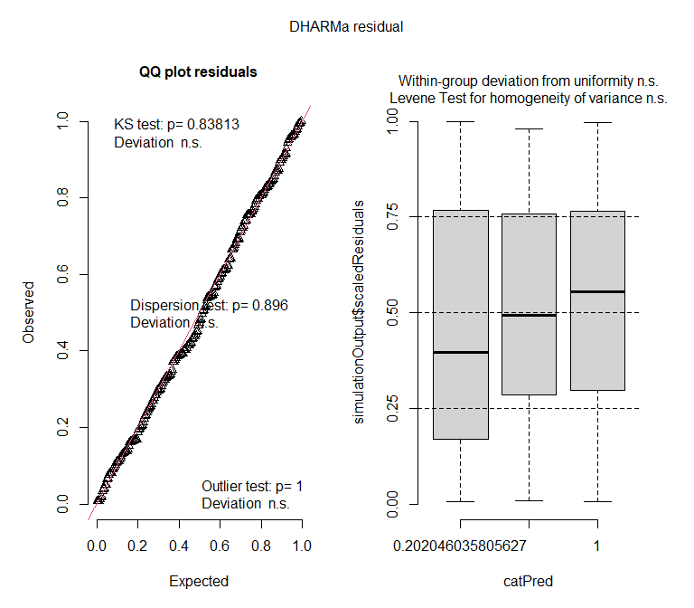
#{r markdownrender} setwd("../") # move up one directory rmarkdown::render(paste(Genus, "_", species, "/", Genus, "_", species, ".Rmd", sep = ""), output_file = paste("Knitted_RMarkdowns/", Genus, "_", species,".docx", sep = "")) #

