Temperature dependent dispersal: A distributed experiment
Greta Bocedi, Caterina Berardo, Nicky Lustenhouwer, Lesley Lancaster
## ── Attaching core tidyverse packages ─────────────────────────────────────────────── tidyverse 2.0.0 ──
## ✔ dplyr 1.1.4 ✔ readr 2.1.5
## ✔ forcats 1.0.0 ✔ stringr 1.5.1
## ✔ ggplot2 3.5.1 ✔ tibble 3.2.1
## ✔ lubridate 1.9.3 ✔ tidyr 1.3.1
## ✔ purrr 1.0.2
## ── Conflicts ───────────────────────────────────────────────────────────────── tidyverse_conflicts() ──
## ✖ dplyr::filter() masks stats::filter()
## ✖ dplyr::lag() masks stats::lag()
## ℹ Use the conflicted package (<http://conflicted.r-lib.org/>) to force all conflicts to become errors
## Loading required package: Matrix
##
##
## Attaching package: 'Matrix'
##
##
## The following objects are masked from 'package:tidyr':
##
## expand, pack, unpack
##
##
## Welcome to emmeans.
## Caution: You lose important information if you filter this package's results.
## See '? untidy'
##
## This is DHARMa 0.4.7. For overview type '?DHARMa'. For recent changes, type news(package = 'DHARMa')

Author contributions
Possible categories: - conceptualization - statistical analysis
- methodology (design of methodology)
- investigation/conduct experiment
- funding acquisition
- writing (original draft, supplement) - list others as needed

Acknowledgements
Research assistants, funding sources, etc.

Supplementary methods for Callosobruchus maculatus

Study organism
Seed beetles (Callosobruchus maculatus), also known as the southern cowpea weevil.
C. maculatus is a seed beetle originated from Africa but is now spread across the tropics and sub-tropics (Kébé et al. 2017). Its ancestral host is Vigna unguiculata (black-eyed pea) but it is considered a major pest of many plants from the Fabaceae family such as adzuki or mung beans (Tuda et al. 2006). With agriculture, it became a stored-product pest as females lay their eggs on dry bean surface. After hatching, the larva will develop entirely inside the bean, digging a chamber causing severe damage to the bean. Adult beetles will emerge from the beans about 3-4 weeks after ovipositon at 27°C. Their life expectancy as adults at 27°C is about 8 to 12 days when not supplied with food or water.
We used individuals from a labporatory stock population we created in April 2022 by mixing individuals from 2 populations sourced from agricultural fields in 2010 in Nigeria and Togo respectively (Berger et al. 2014). These 2 populations were maintained separately for approximatively a decade at 29°C in the laboratory. We kept the mixed population at 27°C, under a 12:12 (L:D) photoperiod, in controlled-temperature incubators. Beetles were reared on their ancestral host V. unguiculata (cowpea).

Study design

Temperature treatments
Topt = 33 ± 0.5°C Thot = 37 ± 0.5°C Tcold = 22 ± 0.5°C
We chose these temperature based on previous assays performed by the group and literature. We aslo tested an additional temperature Tlab = 27 ± 0.5°C, as this is the temperature we keep the stock population at.

Phase 1: Fitness assay
A virgin male and a virgin female were collected from the stock population at 27°C, and placed in a petri dish for 24 hours to ensure mating. Different mating pairs were collected at the same time. After 24 hours, each female was located in a petri dish with 10g of beans to allow oviposition. After other 24 hours, the female was removed and the beans were located in the incubators at the 4 different temperatures (still in the petri-dishes). 20 replicate females per temperature were assayed. To ensure beetles were virgin at collection, after 10 days, we isolated beans in 48-well culture plates and we counted the eggs. Beans were checked daily as the emergence time approached and emerging offspring were counted daily (F1 hatching success).Only individuals found alone at emergence, or with other individuals of the same sex within a well, were used in the assay. A virgin F1 female from each replicate, younger than 24 h, was mated with a virgin male (taken from another plate at the same temperature) and the cycle was repeated to evaluate the fecundity of the generation reared at the treatment temperature (F2 fecundity). Seed beetles do not require to eat for mating so they were not supplied with food or water, as in many experimental set-ups (Miller and Inouye 2013; Downey et al. 2015; Ochocki et al. 2020).
We measured three fitness proxies:
- F1 hatching success: number of offspring emerged / number of eggs laid at different temperature by parents reared and mated at 27 °C.
- F2 fecundity: number of eggs laid by females reared at the treatment temperature. Fathers were also reared at the treatment temperature.
- F2 hatching success: number of offspring emerged / number of eggs laid at different temperature by parents reared at the treatment temperature.
In this analyses we only consider the F2 fecundity as fitness proxy.

Phase 2: Dispersal assay
We applied a fully factorial design, collecting individuals reared at 4 different temperatures and assaying their dispersal propensity at each temperature.
We assessed dispersal propensity and dispersal distance using linear mazes adapted from Ochocki and Miller (2017) experimental design. Mazes consisted of plastic tubs (volume: 75ml) connected by 20cm long plastic tubes (diameter: 0.5cm). Each tub contained 9g of cowpeas (~45 beans). All individuals (coming from 85 plates per temperature) were collected as virgin and aged not more than 24 hours old when assayed. 10 individuals (sex ratio 1:1) were introduced in the first tub. Each individual was sourced from different families to avoid pseudoreplication. We allowed an acclimation phase without dispersal of approximately 40 min (a quarter of the subsequent dispersal phase duration). After this amount of time, we opened the tube and allowed individuals to disperse for the 2 hours. After these 2 hours, we recorded the length (photographing them from 25 cm of distance and using ImageJ’ “Measure” function 3 times per individual), the sex and the position of each individual in the maze (Emigrated? Yes or No). If the individuals, after the 2h, were in between tubes, we have considered them as dispersed. Assessments were made on 8 replicates (8 runs in linear maze) per each treatment, for a total of 128 replicates. The experiment was divided in 2 consecutive days (4 replicates per day). The individuals were not the same as the ones used for the fitness assay. Mortality did not occur during these assays.

Statistical Analysis

Does fitness change with temperature (phase 1)?
Fecundity was normally distributed.
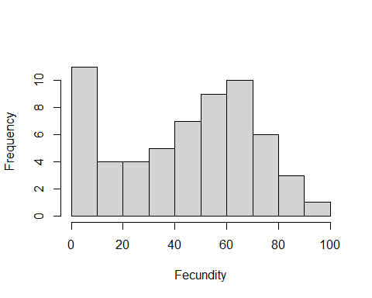
Figure 1. Histogram of fitness ( fecundity ) values.
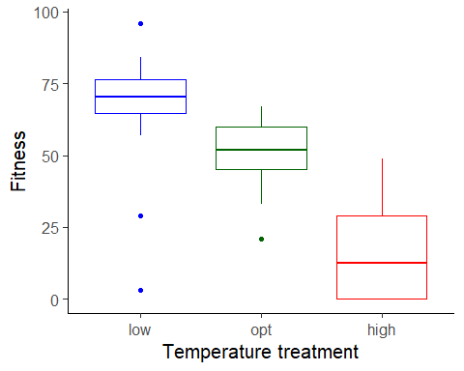
Figure 2. Boxplot of fitness ( fecundity ), as a function of temperature treatment. low = 22 C, opt = 33 C, high = 37 C.
To estimate the effects of temperature (a factor) on fitness, we used a linear mixed model with fecundity as the response variable. We used the formula:
Fitness ~ Temp.treatment

Results for main effect of temperature on fitness
## Analysis of Variance Table
##
## Response: Fitness
## Df Sum Sq Mean Sq F value Pr(>F)
## Temp.treatment 2 28843 14421.5 55.13 4.74e-14 ***
## Residuals 57 14911 261.6
## ---
## Signif. codes: 0 '***' 0.001 '**' 0.01 '*' 0.05 '.' 0.1 ' ' 1

Post-hoc pairwise contrasts: differences in fitness between temperature treatments
## contrast estimate SE df lower.CL upper.CL t.ratio p.value
## opt - high 36.0 5.11 57 25.8 46.29 7.048 <.0001
## opt - low -16.4 5.11 57 -26.7 -6.21 -3.216 0.0021
## high - low -52.5 5.11 57 -62.7 -42.26 -10.265 <.0001
##
## Confidence level used: 0.95

Does dispersal change with temperature (phase 2)?
To estimate the effect of temperature treatment (a factor) on dispersal, we used a generalized linear mixed model with a binomial error structure and a logit link. Dispersal (the number of dispersers vs non-dispersers) was the response variable. We used the formula:
Dispersed ~ Temp.treatment + Sex + Length + (1|Group)
## boundary (singular) fit: see help('isSingular')
## boundary (singular) fit: see help('isSingular')
## boundary (singular) fit: see help('isSingular')
## boundary (singular) fit: see help('isSingular')
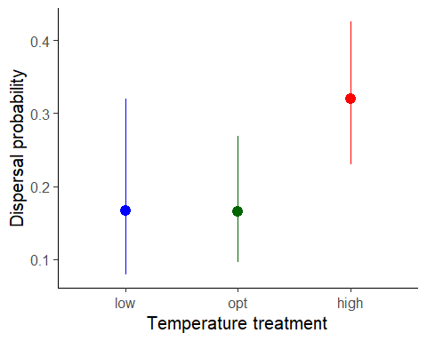
Figure 1. Dispersal as a function of temperature treatment. low = 22 C, opt = 33 C, high = 37 C. Error bars represent 95% confidence intervals predicted from GLMM.

Results for main effect of temperature on dispersal
## Single term deletions
##
## Model:
## Dispersed ~ Temp.treatment + Sex + Length + (1 | Group)
## npar AIC LRT Pr(Chi)
## <none> 242.26
## Temp.treatment 2 245.35 7.0893 0.0288790 *
## Sex 1 252.34 12.0773 0.0005104 ***
## Length 1 244.29 4.0308 0.0446769 *
## ---
## Signif. codes: 0 '***' 0.001 '**' 0.01 '*' 0.05 '.' 0.1 ' ' 1

Post-hoc pairwise contrasts: differences in dispersal between temperature treatments
## contrast odds.ratio SE df asymp.LCL asymp.UCL null z.ratio p.value
## opt / high 0.420 0.155 Inf 0.203 0.867 1 -2.346 0.0190
## opt / low 0.985 0.504 Inf 0.362 2.683 1 -0.030 0.9763
## high / low 2.346 1.117 Inf 0.922 5.967 1 1.790 0.0734
##
## Results are averaged over the levels of: Sex
## Confidence level used: 0.95
## Intervals are back-transformed from the log odds ratio scale
## Tests are performed on the log odds ratio scale

Model Diagnostics
There was no evidence for lack of fit for either the fitness or the dispersal model.

Diagnostic plots for fitness data
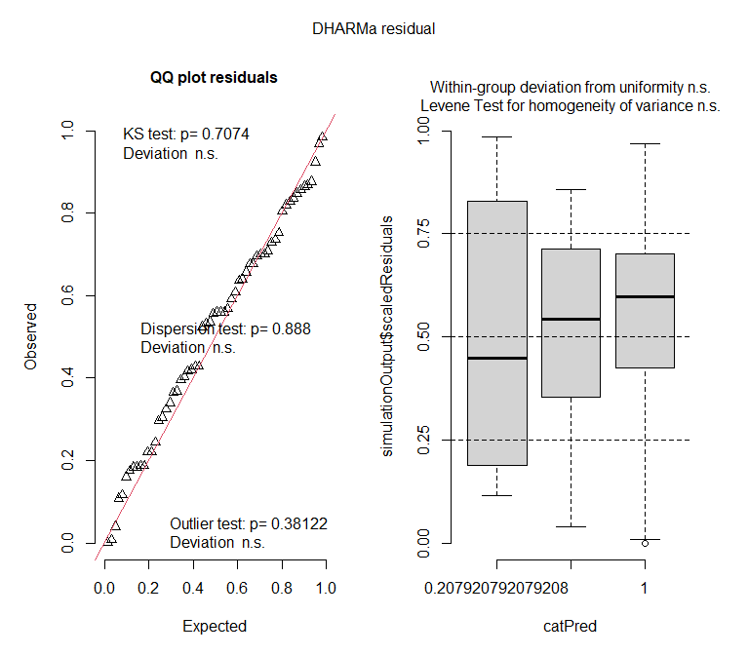

Diagnostic plots for dispersal data
