meta-analysis_code

to do
- overall effect of temp on fitness and dispersal
- tetranychus cinnabarinus_PT, Tetranychus evansi calls low temp “control” - changed it to ‘low’ but can’t re-run Rmd because of issues with analysis
- tetranychus turkestani, cinnabrinus, urticae - check sample size with researchers
library(tidyverse)
## ── Attaching core tidyverse packages ──────────────────────── tidyverse 2.0.0 ──
## ✔ dplyr 1.1.4 ✔ readr 2.1.6
## ✔ forcats 1.0.1 ✔ stringr 1.6.0
## ✔ ggplot2 4.0.1 ✔ tibble 3.3.0
## ✔ lubridate 1.9.4 ✔ tidyr 1.3.1
## ✔ purrr 1.2.0
## ── Conflicts ────────────────────────────────────────── tidyverse_conflicts() ──
## ✖ dplyr::filter() masks stats::filter()
## ✖ dplyr::lag() masks stats::lag()
## ℹ Use the conflicted package (<http://conflicted.r-lib.org/>) to force all conflicts to become errors
library(mgsub)
library(esc)
library(metafor)
## Loading required package: Matrix
##
## Attaching package: 'Matrix'
##
## The following objects are masked from 'package:tidyr':
##
## expand, pack, unpack
##
## Loading required package: metadat
## Loading required package: numDeriv
##
## Loading the 'metafor' package (version 4.8-0). For an
## introduction to the package please type: help(metafor)
library(lme4)

Effects of temperature on fitness

Pairwise temperature treatment comparisons
We calculated Hedge’s g for the pairwise temperature treatment comparisons of fitness for all studies using the ‘esc’ package in R. For fitness proxies that were normally distributed, we used the esc_mean_se function to convert treatment means and standard error to Hedge’s g. For binary fitness proxies (i.e., survival) we used the convert_or2d function to convert log-odds ratios to Hedge’s g.
## Warning: Either `se` or `v` must be specified.
## Warning: Either `se` or `v` must be specified.
## Warning: Either `se` or `v` must be specified.
## Warning: Either `se` or `v` must be specified.
## Warning: Either `se` or `v` must be specified.
## Warning: Either `se` or `v` must be specified.
## Warning: Either `se` or `v` must be specified.
## Warning: Either `se` or `v` must be specified.
# random effects metaanalytical model
m_fitnessOH <- rma(yi = d_g_fitness_OH$es, vi = d_g_fitness_OH$var)
## Warning: 20 studies with NAs omitted from model fitting.
m_fitnessOL <- rma(yi = d_g_fitness_OL$es, vi = d_g_fitness_OL$var)
## Warning: 19 studies with NAs omitted from model fitting.
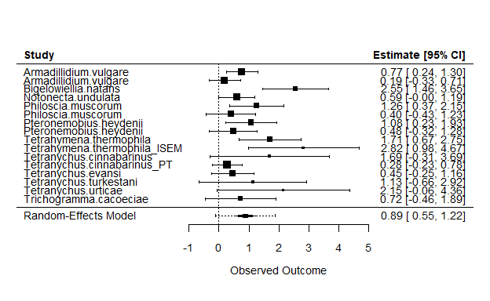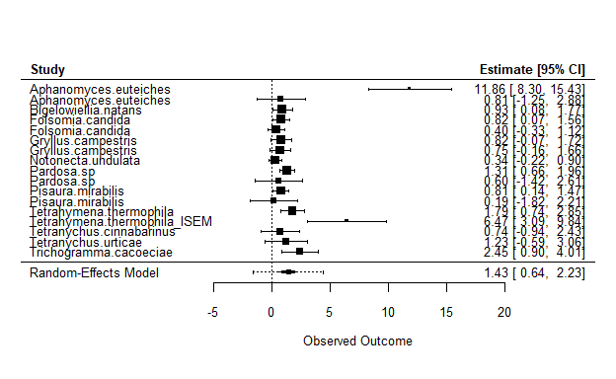
## Warning: 4 studies with NAs omitted from model fitting.
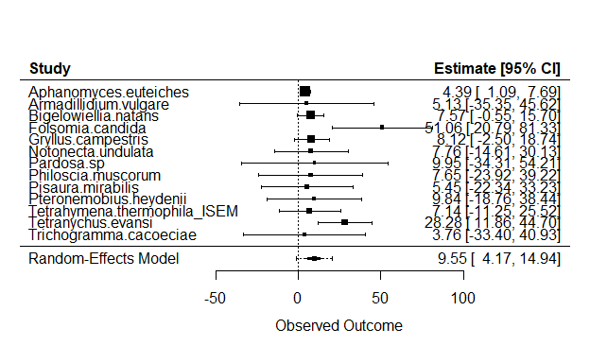
# join moderator dataset
d_dispmeta_OH <- full_join(d_OR_dispersal_OH, d_mods)
## Joining with `by = join_by(species)`
d_dispmeta_OL <- full_join(d_OR_dispersal_OL, d_mods)
## Joining with `by = join_by(species)`
# random effects metaanalytical model
m_dispersalOH <- rma(yi = OR, sei = se, mods = ~Taxonomic.group, data = subset(d_dispmeta_OH, species != "Tetranychus.turkestani" & species != "Tetranychus.cinnabarinus"))
## Warning: 18 studies with NAs omitted from model fitting.
## Warning: Redundant predictors dropped from the model.
m_dispersalOL <- rma(yi = OR, sei = se, mods = ~Taxonomic.group+Dispersal.assay.duration, data = subset(d_dispmeta_OL, species != "Tetranychus.turkestani" & species != "Tetranychus.cinnabarinus"))
## Warning: 15 studies with NAs omitted from model fitting.
# repeating the models because overall effect is removed from forest plots when moderators are included
m_dispersalOH <- rma(yi = OR, sei = se, data = subset(d_dispmeta_OH, species != "Tetranychus.turkestani" & species != "Tetranychus.cinnabarinus"))
## Warning: 18 studies with NAs omitted from model fitting.
m_dispersalOL <- rma(yi = OR, sei = se, data = subset(d_dispmeta_OL, species != "Tetranychus.turkestani" & species != "Tetranychus.cinnabarinus"))
## Warning: 15 studies with NAs omitted from model fitting.
forest(m_dispersalOH, slab = subset(d_OR_dispersal_OH, species != "Tetranychus.turkestani" & species != "Tetranychus.cinnabarinus")$species, addcred = TRUE)
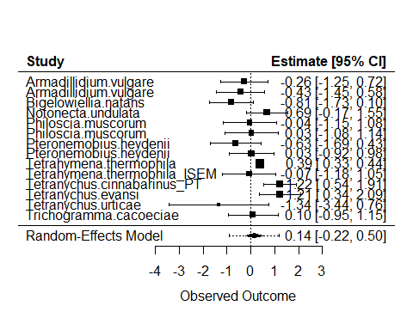
forest(m_dispersalOL, slab = subset(d_OR_dispersal_OL, species != "Tetranychus.turkestani" & species != "Tetranychus.cinnabarinus")$species, addcred = TRUE)
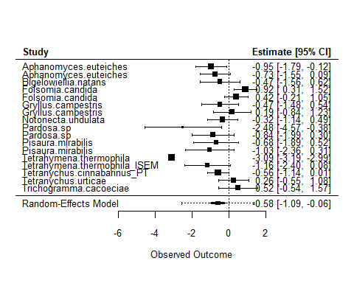
d_g_fitness <- rbind(d_g_fitness_OH, d_g_fitness_OL)
d_g_fitness$species <- d_g_fitness$study
d_g_fitness <- d_g_fitness %>%
rename(se_fitness = se)
d_OR_dispersal <- rbind(d_OR_dispersal_OH, d_OR_dispersal_OL)
d_OR_dispersal <- d_OR_dispersal %>%
rename(se_dispersal = se)
d_fitdispcontr <- full_join(d_g_fitness, d_OR_dispersal, by = c("species", "Temp.contr"))
d_fitdispcontr$HILO <- with(d_fitdispcontr, ifelse(Temp.contr == "OH" | Temp.contr == "OMH", "hot", "cold"))
d_fitdispcontr <- full_join(d_fitdispcontr, d_mods)
## Joining with `by = join_by(species)`
# note -es so that when hot/cold have high fitness, "relative fitness" is greater
ggplot(subset(d_fitdispcontr, species != "Tetranychus.turkestani" & species != "Tetranychus.cinnabarinus"), aes(x = -es, y = OR, col = HILO, fill = HILO))+
geom_point()+
geom_smooth(method = "lm", alpha = 0.1)+
geom_hline(yintercept = 0, lty = 2)+
scale_y_continuous("Relative dispersal")+
scale_x_continuous("Relative fitness")+
scale_color_manual("", values = c("blue", "red"))+
scale_fill_manual("", values = c("blue", "red"))+
theme_classic(base_size = 20)
## `geom_smooth()` using formula = 'y ~ x'
## Warning: Removed 34 rows containing non-finite outside the scale range
## (`stat_smooth()`).
## Warning: Removed 34 rows containing missing values or values outside the scale range
## (`geom_point()`).
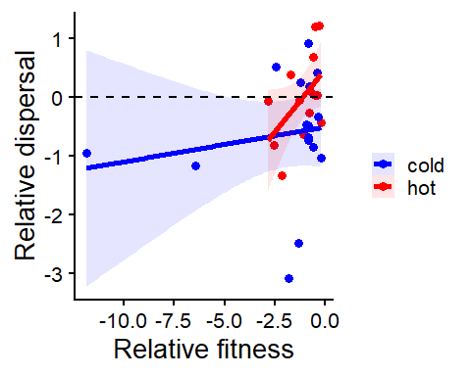
# same species from different labs look like different species - need to correct
m_fitdispcontr <- lmer(OR ~ es+HILO + (1|Taxonomic.group/species), data = na.omit(subset(d_fitdispcontr, select = c(OR, es, HILO, Taxonomic.group, species), species != "Tetranychus.turkestani" & species != "Tetranychus.cinnabarinus")))
summary(m_fitdispcontr)
## Linear mixed model fit by REML ['lmerMod']
## Formula: OR ~ es + HILO + (1 | Taxonomic.group/species)
## Data:
## na.omit(subset(d_fitdispcontr, select = c(OR, es, HILO, Taxonomic.group,
## species), species != "Tetranychus.turkestani" & species !=
## "Tetranychus.cinnabarinus"))
##
## REML criterion at convergence: 81.6
##
## Scaled residuals:
## Min 1Q Median 3Q Max
## -2.60489 -0.31903 -0.02424 0.69610 1.49385
##
## Random effects:
## Groups Name Variance Std.Dev.
## species:Taxonomic.group (Intercept) 0.03952 0.1988
## Taxonomic.group (Intercept) 0.03242 0.1800
## Residual 0.76987 0.8774
## Number of obs: 30, groups: species:Taxonomic.group, 16; Taxonomic.group, 4
##
## Fixed effects:
## Estimate Std. Error t value
## (Intercept) -0.52011 0.30995 -1.678
## es -0.07243 0.07686 -0.942
## HILOhot 0.56415 0.33627 1.678
##
## Correlation of Fixed Effects:
## (Intr) es
## es -0.553
## HILOhot -0.574 0.179
drop1(m_fitdispcontr, test = "Chisq")
## Single term deletions
##
## Model:
## OR ~ es + HILO + (1 | Taxonomic.group/species)
## npar AIC LRT Pr(Chi)
## <none> 88.053
## es 1 87.399 1.3460 0.24598
## HILO 1 88.904 2.8516 0.09128 .
## ---
## Signif. codes: 0 '***' 0.001 '**' 0.01 '*' 0.05 '.' 0.1 ' ' 1
m_fitdispcontr_OH <- lmer(OR ~ es + (1|Taxonomic.group/species), data = na.omit(subset(d_fitdispcontr, select = c(OR, es, Taxonomic.group, species), HILO == "hot" & species != "Tetranychus.turkestani" & species != "Tetranychus.cinnabarinus")))
summary(m_fitdispcontr_OH)
## Linear mixed model fit by REML ['lmerMod']
## Formula: OR ~ es + (1 | Taxonomic.group/species)
## Data: na.omit(subset(d_fitdispcontr, select = c(OR, es, Taxonomic.group,
## species), HILO == "hot" & species != "Tetranychus.turkestani" &
## species != "Tetranychus.cinnabarinus"))
##
## REML criterion at convergence: 25.6
##
## Scaled residuals:
## Min 1Q Median 3Q Max
## -1.1139 -0.5270 0.2683 0.4175 0.6961
##
## Random effects:
## Groups Name Variance Std.Dev.
## species:Taxonomic.group (Intercept) 0.27812 0.5274
## Taxonomic.group (Intercept) 0.13772 0.3711
## Residual 0.09535 0.3088
## Number of obs: 14, groups: species:Taxonomic.group, 11; Taxonomic.group, 3
##
## Fixed effects:
## Estimate Std. Error t value
## (Intercept) 0.7981 0.4490 1.778
## es -0.5381 0.2114 -2.545
##
## Correlation of Fixed Effects:
## (Intr)
## es -0.727
drop1(m_fitdispcontr_OH, test = "Chisq")
## boundary (singular) fit: see help('isSingular')
## Single term deletions
##
## Model:
## OR ~ es + (1 | Taxonomic.group/species)
## npar AIC LRT Pr(Chi)
## <none> 32.671
## es 1 35.724 5.0535 0.02458 *
## ---
## Signif. codes: 0 '***' 0.001 '**' 0.01 '*' 0.05 '.' 0.1 ' ' 1
m_fitdispcontr_OL <- lmer(OR ~ es + (1|Taxonomic.group/species), data = na.omit(subset(d_fitdispcontr, select = c(OR, es, Taxonomic.group, species), HILO == "cold" & species != "Tetranychus.turkestani" & species != "Tetranychus.cinnabarinus")))
summary(m_fitdispcontr_OL)
## Linear mixed model fit by REML ['lmerMod']
## Formula: OR ~ es + (1 | Taxonomic.group/species)
## Data: na.omit(subset(d_fitdispcontr, select = c(OR, es, Taxonomic.group,
## species), HILO == "cold" & species != "Tetranychus.turkestani" &
## species != "Tetranychus.cinnabarinus"))
##
## REML criterion at convergence: 46.7
##
## Scaled residuals:
## Min 1Q Median 3Q Max
## -1.82024 -0.14361 0.07749 0.48141 0.84035
##
## Random effects:
## Groups Name Variance Std.Dev.
## species:Taxonomic.group (Intercept) 0.5399 0.7348
## Taxonomic.group (Intercept) 0.4333 0.6583
## Residual 0.4082 0.6389
## Number of obs: 16, groups: species:Taxonomic.group, 11; Taxonomic.group, 4
##
## Fixed effects:
## Estimate Std. Error t value
## (Intercept) -0.82545 0.51267 -1.610
## es -0.01213 0.07311 -0.166
##
## Correlation of Fixed Effects:
## (Intr)
## es -0.391
drop1(m_fitdispcontr_OL, test = "Chisq")
## Single term deletions
##
## Model:
## OR ~ es + (1 | Taxonomic.group/species)
## npar AIC LRT Pr(Chi)
## <none> 53.337
## es 1 51.433 0.096642 0.7559
d_sub <- subset(d_fitdispcontr, HILO == "hot" & species != "Tetranychus.turkestani" & species != "Tetranychus.cinnabarinus")
d_sub$V_dispersal <- with(d_sub, I(se_dispersal)^2)
m_fitdispcontr_OH_meta <- rma.mv(yi = OR, V = V_dispersal, random = list(~ 1 | study), mods = ~Taxonomic.group + es, data = na.omit(subset(d_sub, select = c(OR, V_dispersal, study, Taxonomic.group, es))))
summary(m_fitdispcontr_OH_meta)
##
## Multivariate Meta-Analysis Model (k = 14; method: REML)
##
## logLik Deviance AIC BIC AICc
## -8.7404 17.4808 27.4808 28.9938 42.4808
##
## Variance Components:
##
## estim sqrt nlvls fixed factor
## sigma^2 0.1738 0.4169 11 no study
##
## Test for Residual Heterogeneity:
## QE(df = 10) = 15.4685, p-val = 0.1159
##
## Test of Moderators (coefficients 2:4):
## QM(df = 3) = 6.5545, p-val = 0.0875
##
## Model Results:
##
## estimate se zval pval ci.lb ci.ub
## intrcpt 0.7691 0.3255 2.3625 0.0182 0.1310 1.4071
## Taxonomic.groupciliate 0.9684 0.6708 1.4435 0.1489 -0.3464 2.2832
## Taxonomic.groupmicroalgae 0.2893 0.9892 0.2925 0.7699 -1.6495 2.2282
## es -0.7333 0.3829 -1.9151 0.0555 -1.4839 0.0172
##
## intrcpt *
## Taxonomic.groupciliate
## Taxonomic.groupmicroalgae
## es .
##
## ---
## Signif. codes: 0 '***' 0.001 '**' 0.01 '*' 0.05 '.' 0.1 ' ' 1

