Temperature dependent dispersal: A distributed experiment
Elvire Bestion, Margot Trinquier, Delphine Legrand

Supplementary methods for Aphanomyces euteiches

Author contributions
- Delphine Legrand: Conceptualization, Methodology, Investigation
- Margot Trinquier: Investigation
- Elvire Bestion: Conceptualization, Methodology, Statistical analysis, Investigation, Writing

Acknowledgements
We are thankful to our high school interns, Elena Hattinguais and Kalis Eliot, for help running the experiment, as well as to Lucie Di Gesu for punctual help running the growth curve experiment. This work was supported by funding from the LABEX TULIP (ANR-10-LABX-0041).

Study organism
Name and strain/origin of species
Aphanomyces euteiches Drechsler, strains RB84 and FIfi46
Life history information
Aphanomyces euteiches is an oomycete pathogen causing the root rot disease in legumes and was recognized as one of the most damaging soil-borne pathogens on peas (Gaulin et al., 2007). It was first recognized as the causal agent of destructive pea root-rot in North America in the 1920s and was formally described by Drechsler in 1925 (Jones & Drechsler, 1925). Then, it was recorded in many other pea-growing regions worldwide - Europe (notably France and Norway ), Canada and other parts of North America, Australia, New Zealand and Japan.
The life cycle of A. euteiches includes asexual and sexual stages that occur only in soil, allow an efficient dissemination and conservation of the parasite and rely on a plant host (Gaulin et al., 2007). First, filamentous hyphae emerging either from germinated sexual non-motile oospore (resistant structure produced after reproduction, able to survive in soil for decades, which disperse in a passive way mainly with agricultural practices) or from encysted asexual motile zoospores can explore soils to colonize roots. Second, the biflagellate zoospores can swim in the search of a potential infection site. Once found, the cell loses its motile flagella, synthesizes a cell wall and develops a hypha that penetrates the root tissue. A successful infection relies on the versatility of dispersal structures to perceive diverse stimuli like plant roots, soil particles, humidity and temperature variation, or the presence of other rhizospheric microorganisms (Gaulin et al., 2007).
This soilborne pathogen has been recorded mostly in the north hemisphere in cool and wet soils. The optimal temperature for the disease development (root rots) in artificial condition is comprised between 15°C-16°C and 28°C-30°C (Jones & Drechsler, 1925; Papavizas and Ayers, 1974).
A growth curve experiment done by the authors using 6 temperatures (14, 18, 22, 26, 30 and 34°C) allowed fitting a temperature performance curve using the Sharpe-Schoolfield model with high temperature inactivation with the rTPC package in R (Schoolfield et al., 1981, Padfield et al., 2021) to calculate CTmax. The FIFi46 strain had a CTmax of 34.9 °C [34.7, 35.2] [95% CI], and the RB84 strain had a CTmax of 36.1 °C [35.3, 41.4].
How were the organisms sourced
The Ae FIFi46 strain was isolated in June 2020 from the Itä Uusimaa region (south-east Finland, detailed coordinates not available) from 20-25cm depth soil samples (Kälin et al., 2022). This strain was baited using the susceptible pea cultivar Linnea as described by Olofsson (1967).
The Ae RB84 strain was isolated from Riec-sur-Bélon (Brittany, Finistère, France) in December 2000 from infected pea field from the “Pois Baccara” strain (Moussart et al., 2009).
For FIFi46: Department of Forest Mycology and Plant Pathology, Swedish University of Agricultural Sciences, Uppsala, Sweden For RB84: Terres Inovia, Le Rheu, France and IGEPP, INRAE, Institut Agro, Univ Rennes, Le Rheu, France.
A. euteiches isolates are stored long term as mycelium grown on 1.7% corn meal agar (CMA) (Sigma-Aldrich), at 10°C in the dark. Fresh mycelial subcultures are produced from these long-term storage plates before the experiment. Fresh mycelial is grown for a week on petri-dishes plates (Ø 9 cm) filled with 1.7% CMA (20 mL) at 22°C in the dark. Zoospore production was done from this fresh mycelial material as followed: twenty plugs (0.5mm) were incubated (dark, 22°C, 48 hrs) in 20 ml of PG media (2% bactopeptone, 0.4% glucose). The plugs were 4 times washed in Volvic® water (30ml) every two hours, before incubation (overnight at 22°C in dark) in Volvic® (10ml).
Zoospores were produced the day of the experiment from a seven-days old mycelium culture.
Dispersal was measured in zoospores (biflagellate motile cells).

Study design

Temperature treatments
We created a growth curve and a dispersal experiment at 6 temperature treatments, 14, 18, 22, 26, 30 and 34°C. We chose tree temperatures out of the 6 to be the Tlow, Topt and Thigh, so that we had Topt, and Tlow and Thigh would be the most different temperatures from Topt where there is still enough cells to detect dispersal. This led to choose 14, 22 and 26 °C. The growth curve at the 6 temperatures was used to measure CTmax by fitting a temperature performance curve using the Sharpe-Schoolfield model with high temperature inactivation with the rTPC package in R (Schoolfield et al., 1981, Padfield et al., 2021).

Phase 1: Fitness assay
We studied population growth rate as a fitness proxy. We measured growth rate by absorbance on 12 technical replicates per temperature, over 16 days of experiment.
The experiments were done in PolEko SmartPro incubators.
Five days before the experiment, oomycetes were prepared by taking thirty plugs (diameter 0.5 mm) from a seven-days-old mycelium (growth on Corn Meal Agar plate at 22°C in the dark) and incubated (dark, 22°C, 48 hours) in 50 ml of PG media (2% bactopeptone, 0.4 % glucose). The plugs were washed 4 times in Volvic water (100 ml) every two hours, before incubation (overnight at 22°C in the dark) in 30 ml of volvic water.
On the day of the experiment, 12 wells of a 96 well plate were filled with 250 ul of PG medium and 10 ul of oomycetes inoculate for each temperature. The other wells were filled with medium, and the reservoirs filled with 12 ml of pure water to limit evaporation during the experiment. Plates were placed in PolEko SmartPro incubators at the three chosen temperatures on a 12:12 light:dark cycle. Absorbance was measured at 600 nm to measure growth rate thrice then twice a day for 16 days with a TECAN Infinite M200 Pro reader.
Growth rate was measured from the growth curves using the easylinear function from the growthrates R package, as mean absorbance dependent of time in hours for each replicate and temperature, with the with of the windows h fixed to 10.We used the maximum growth rate as our fitness measure.

Phase 2: Dispersal assay
Dispersal assays were done over one day in two-patch systems made of two 1.5 ml Eppendorf tubes connected by a corridor (4 mm internal diameter silicon tube, 2.5 cm long). Six replicates were done by temperature, and temperature was controlled by PolEko SmartPro incubators.
Oomycetes for the dispersal experiment were from the same transfer as the fitness assay.
Systems were filled with 2.5 ml of sterile volvic water and then clamped. Then 300 ul of oomycete inoculate was added to the “departure” patch, and oomycetes were acclimated to the temperature in the closed systems in the incubators set at each given temperature and in light conditions for 30 minutes. After 30 minutes, systems were unclamped, and left for 2 hours for the oomycetes to disperse. Then, after 2 hours, systems were re-clamped, and 80 ul of homogenized medium was collected from each tube (the “departure” and “arrival” patch), and placed onto multi-chambered counting slides (Kima).
We took from each sample a 15 second video under dark-field macroscopy (Axio Zoom V16, Zeiss) and quantified cell abundances in the departure and arrival patches using ImageJ and R stoftware with the BEMOVI R package (Pennekamp et al, 2015).

Statistical Analysis

Does fitness change with temperature (phase 1)?
Population growth, r was not normally distributed so we log-transformed it. The transformed variable followed a normal distribution.
## `stat_bin()` using `bins = 30`. Pick better value `binwidth`.
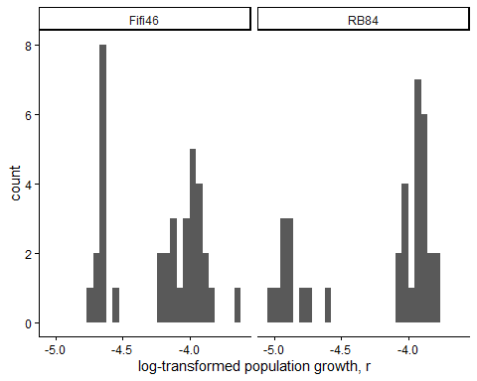
Figure 1. Histogram of log -transformed population growth, r values for each strain .
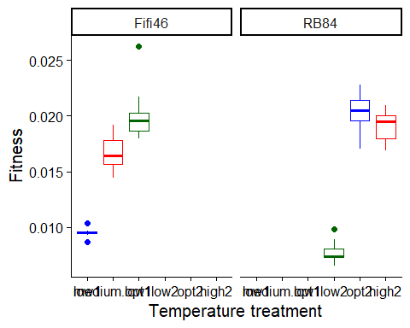
Figure 2. Boxplot of fitness ( population growth, r ), as a function of temperature treatment for each strain . low1 = 14 C, low2 = 14 C, medium.low1 = 22 C, opt1 = 26 C, opt2 = 22 C, high2 = 26 C.
To estimate the effects of temperature (a factor) on fitness, we used a linear mixed model with population growth, r as the response variable. We used the formula:
log(Fitness) ~ Temp.treatment

Results for main effect of temperature on fitness
## $Strain_Fifi46
## Analysis of Variance Table
##
## Response: log(Fitness)
## Df Sum Sq Mean Sq F value Pr(>F)
## Temp.treatment 2 3.5630 1.78152 265.58 < 2.2e-16 ***
## Residuals 33 0.2214 0.00671
## ---
## Signif. codes: 0 '***' 0.001 '**' 0.01 '*' 0.05 '.' 0.1 ' ' 1
##
## $Strain_RB84
## Analysis of Variance Table
##
## Response: log(Fitness)
## Df Sum Sq Mean Sq F value Pr(>F)
## Temp.treatment 2 6.7273 3.3636 403.64 < 2.2e-16 ***
## Residuals 32 0.2667 0.0083
## ---
## Signif. codes: 0 '***' 0.001 '**' 0.01 '*' 0.05 '.' 0.1 ' ' 1

Post-hoc pairwise contrasts: differences in fitness between temperature treatments
## $Strain_Fifi46
## contrast estimate SE df lower.CL upper.CL t.ratio p.value
## opt1 - low1 0.01039 0.000522 33 0.00933 0.01145 19.922 <.0001
## opt1 - medium.low1 0.00324 0.000614 33 0.00199 0.00449 5.285 <.0001
## low1 - medium.low1 -0.00715 0.000454 33 -0.00807 -0.00623 -15.758 <.0001
##
## Confidence level used: 0.95
##
## $Strain_RB84
## contrast estimate SE df lower.CL upper.CL t.ratio p.value
## high2 - low2 0.01143 0.000546 32 0.01031 0.012539 20.921 <.0001
## high2 - opt2 -0.00124 0.000736 32 -0.00274 0.000256 -1.690 0.1008
## low2 - opt2 -0.01267 0.000577 32 -0.01384 -0.011496 -21.976 <.0001
##
## Confidence level used: 0.95

Does dispersal change with temperature (phase 2)?
To estimate the effect of temperature treatment (a factor) on dispersal, we used a generalized linear mixed model with a binomial error structure and a logit link. Dispersal (the number of dispersers vs non-dispersers) was the response variable. We used the formula:
cbind(Num.disp, Num.nondisp) ~ Temp.treatment
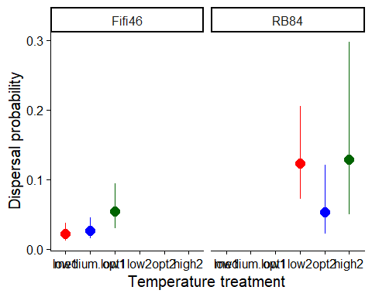
Figure 1. Dispersal as a function of temperature treatment for each strain. low1 = 14 C, low2 = 14 C, medium.low1 = 22C, opt1 = 26 C, opt2 = 22C, high2 = 26C. Error bars represent 95% confidence intervals predicted from GLMM.

Results for main effect of temperature on dispersal
## $Strain_Fifi46
## Single term deletions
##
## Model:
## cbind(Num.disp, Num.nondisp) ~ Temp.treatment
## Df Deviance AIC LRT Pr(>Chi)
## <none> 16.809 58.329
## Temp.treatment 2 21.708 59.228 4.8985 0.08636 .
## ---
## Signif. codes: 0 '***' 0.001 '**' 0.01 '*' 0.05 '.' 0.1 ' ' 1
##
## $Strain_RB84
## Single term deletions
##
## Model:
## cbind(Num.disp, Num.nondisp) ~ Temp.treatment
## Df Deviance AIC LRT Pr(>Chi)
## <none> 11.979 43.707
## Temp.treatment 2 15.454 43.182 3.4754 0.1759

Post-hoc pairwise contrasts: differences in dispersal between temperature treatments
## $Strain_Fifi46
## contrast odds.ratio SE df asymp.LCL asymp.UCL null z.ratio p.value
## opt1 / low1 2.589 1.102 Inf 1.124 5.96 1 2.234 0.0255
## opt1 / medium.low1 2.069 0.866 Inf 0.911 4.70 1 1.738 0.0822
## low1 / medium.low1 0.799 0.324 Inf 0.361 1.77 1 -0.552 0.5807
##
## Confidence level used: 0.95
## Intervals are back-transformed from the log odds ratio scale
## Tests are performed on the log odds ratio scale
##
## $Strain_RB84
## contrast odds.ratio SE df asymp.LCL asymp.UCL null z.ratio p.value
## high2 / low2 1.05 0.649 Inf 0.312 3.52 1 0.078 0.9378
## high2 / opt2 2.64 1.861 Inf 0.661 10.52 1 1.374 0.1695
## low2 / opt2 2.51 1.391 Inf 0.849 7.44 1 1.665 0.0959
##
## Confidence level used: 0.95
## Intervals are back-transformed from the log odds ratio scale
## Tests are performed on the log odds ratio scale

Model Diagnostics
There was no evidence for lack of fit for either the fitness or the dispersal model.

Diagnostic plots for fitness data
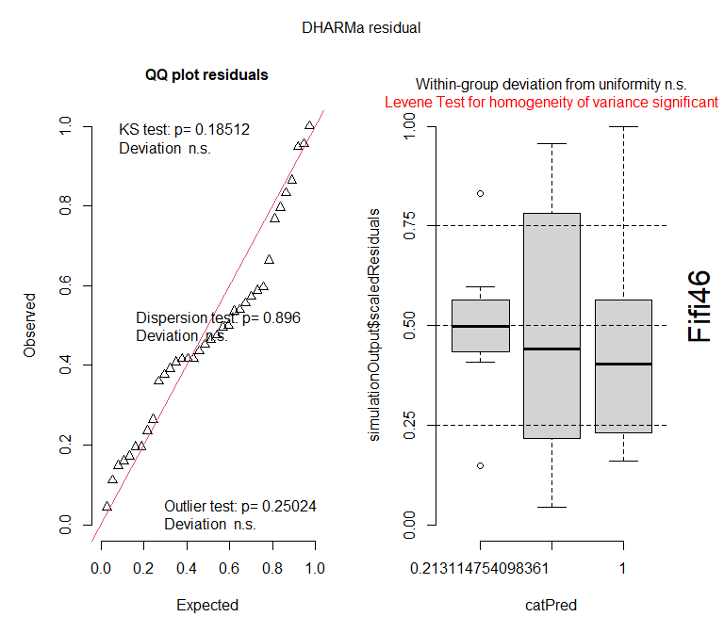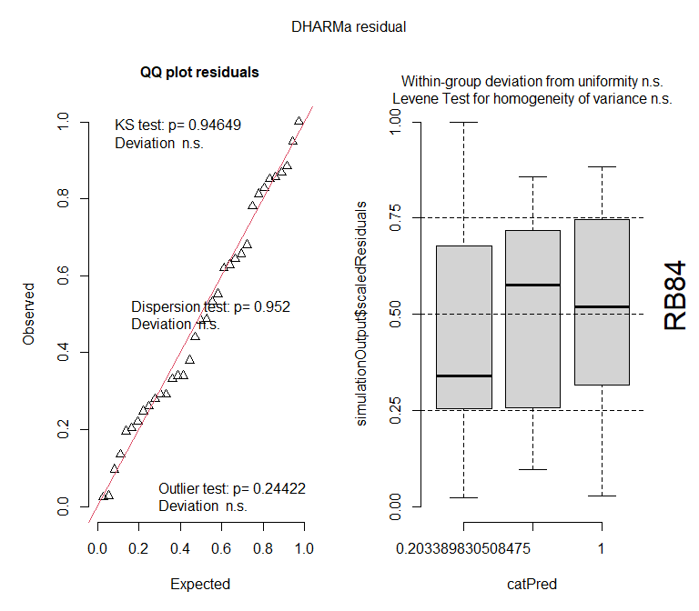

Diagnostic plots for dispersal data
## We had to increase `err` for some of the quantiles. See fit$calibr$err
## qu = 0.5, log(sigma) = -2.435315 : outer Newton did not converge fully.
## qu = 0.5, log(sigma) = -2.108055 : outer Newton did not converge fully.
## qu = 0.5, log(sigma) = -1.905797 : outer Newton did not converge fully.
##
## DHARMa: qgam was unable to calculate quantile regression for quantile 0.5. Possibly to few (unique) data points / predictions. The quantile will be ommited in plots and significance calculations.
## We had to increase `err` for some of the quantiles. See fit$calibr$err
