Temperature dependent dispersal: A distributed experiment
Anna-Gaëlle De Groote, Siebe van Wunnik, Dries Bonte

Supplementary methods for Tetranychus cinnabarinus

Author contributions
- Anna-Gaëlle De Groote (A.D.G.): conduct experiment
- Siebe van Wunnik (S.v.W.): statistical analysis, writing
- Dries Bonte (D.B.): conceptualization, methodology, funding acquisition

Acknowledegements
We thank Nicky Wybouw for providing access to the spider mite populations used in this study.
Funding for S.v.W. and D.B. was provided by the FWO research network EVENET (W001322N). Additional support for S.v.W. was obtained through FWO grant G020524N.

Study organism
Tetranychus cinnabarinus:
- Köln-3
- Merc-1
- Pora
- Sioure
- Trio
#Provide basic life history information (aquatic/terrestrial, mode of dispersal, lifespan, etc.).
Terrestrial plant-feeding Acari, cosmopolitan distribution, polyphageous, reproduce through arrhenotoky (haplodiploids), capable of diapause during winter, capable of both active and passive dispersal, lifespan between 2 and 4 weeks, capable of producing approximately 70 eggs during a lifetime.
#Briefly describe what is known about the temperature range the species experiences (geographic range, seasonality, type of habitat, etc.) in its natural system or the history of the conditions it has experienced in the lab.
Tetranychus urticae is a cosmopolitan species found worldwide in temperate, subtropical, and tropical regions. In its natural environment, it is most active during the warmer months, with populations typically peaking in spring and summer. It inhabits plant surfaces, especially the undersides of leaves, and is commonly associated with crops, ornamentals, and weeds. The species thrives in temperatures ranging from approximately 20–30°C, with optimal development occurring around 25–28°C. While it can tolerate brief periods of higher temperatures, extreme heat above 40°C or prolonged exposure to cold below 10°C significantly reduces survival and reproduction. In the lab, the species is maintained within its optimal temperature range on bean.
#How were organisms sourced?
Field caught: line, location, original host plant
- Köln-3: Cologne, Germany. Rose
- Merc-1: Tarragona, Spain. Oleander
- Pora: Oradour, France. Greater celandine
- Sioure: Fontanès, France. Tomato
- Trio: Montpellier, France. Tomato
#How were individuals/populations treated before the experiment?
- The mites were made isofemale lines, after which they were maintained under constant conditions as a stock. Food was ad libitum, temperature was kept at 24°C, and there was constant light. When were the lines collected:
- Köln-3: 2023
- Merc-1: 2023
- Pora: 2024
- Sioure: 2021
- Trio: 2021
#Were specific individuals/phenotypes/stages selected for the experiment?
No Wolbacchia present (capable of skewing sex-ratio)

Study design

Temperature treatments
- Tcold: 24°C; Sufficiently cold to be suboptimal, while still above diapause temperature and mites will still show activity and movement.
- Topt: 30°C; Optimal temperature for spider mites, as here their generation time and number of offspring increases.
- Thot: 36°C; Sufficiently hot to affect the spider mites, while not causing complete mortality.

Phase 1: Fitness assay
Fitness proxy: malthusian fitness = number of viable female offspring produced by one female.
#- Physical details about the experimental setup including size/shape/volume of experimental arenas, substrate/medium of experimental arenas.
- Adult females were kept in incubator at treatment temperature for 24 hours, after which they were placed on a bean leaf. Here, they were allowed to lay eggs for 24 hours. These eggs were controlled daily to check for hatching, and female hatched offspring were placed on a dispersal plate (2 patches). Here, they were allowed to lay eggs for four days on either of the bean leaf discs. These eggs were checked daily for hatching success and sex determination of the offspring.
- Replicates
  - Three replication rounds
  - Variable number of replicates per adult female: dependent on number of eggs laid
  - Blocked on replication rounds
- Food was available ad libitum in the form of bean leaves.
- Starting density of one mite.
- Fitness assay lasted until all eggs were hatched or visible defect
- Only females were used for the fitness assay
- Daily fecundity was estimated by dividing the number of hatched female offspring by the developmental time.

Phase 2: Dispersal assay
- Adult females were kept in incubator at treatment temperature for 24 hours, after which they were placed on a bean leaf. Here, they were allowed to lay eggs for 24 hours. These eggs were controlled daily to check for hatching, and female hatched offspring were placed on a dispersal plate (2 patches). Here, they were allowed to lay eggs for four days on either of the bean leaf discs. These eggs were checked daily for hatching success and sex determination of the offspring.
- Replicates
  - Three replication rounds
  - Variable number of replicates per adult female: dependent on number of eggs laid
  - Blocked on replication rounds
- Food was available ad libitum in the form of bean leaves.
- Starting density of one mite.
- Duration of dispersal assay including:
  - Parent already experienced treatment temperature
  - No acclimation period
  - Dispersal assay lasted four days
- Only females were used for the dispersal assay
- Dispersal was measured by calculating the number of eggs laid on the second patch compared to the total number of eggs laid.
- Individuals used in phase 2 were the same as used in phase 1
- Provide details on data collection including:
  - Daily sampling
  - Sampling consisted of checking both patches and counting the number of eggs.
- Individuals that died during the dispersal assay were excluded from the analysis of dispersal.

Statistical Analysis

Does fitness change with temperature (phase 1)?
Population growth, r was not normally distributed so we log-transformed it. The transformed variable followed a normal distribution.
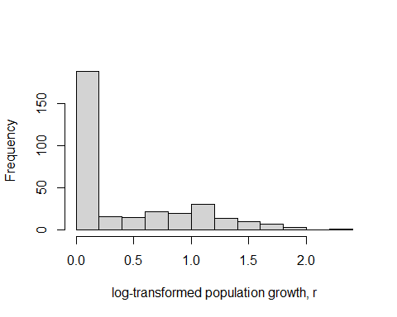
Figure 1. Histogram of log -transformed population growth, r values.
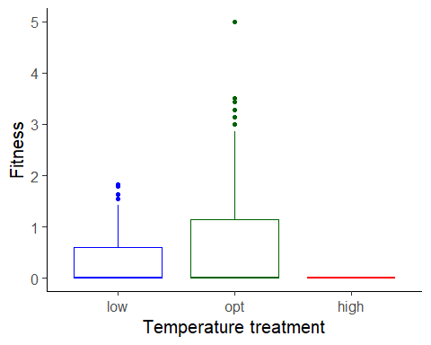
Figure 2. Boxplot of fitness ( population growth, r ), as a function of temperature treatment. low = 24 C, opt = 30 C, high = 36 C.
To estimate the effects of temperature (a factor) on fitness, we used a linear mixed model with population growth, r as the response variable. We used the formula:
Fitness ~ Temp.treatment + population + (1 | dispersion_id)

Results for main effect of temperature on fitness for zero part
## Single term deletions
##
## Model:
## zero ~ Temp.treatment + population + (1 | dispersion_id)
## Df AIC LRT Pr(>Chi)
## <none> 383.05
## Temp.treatment 2 405.99 26.941 1.412e-06 ***
## population 4 406.36 31.305 2.652e-06 ***
## ---
## Signif. codes: 0 '***' 0.001 '**' 0.01 '*' 0.05 '.' 0.1 ' ' 1

Post-hoc pairwise contrasts: differences in fitness between temperature treatments for zero part
## contrast odds.ratio SE df asymp.LCL asymp.UCL null z.ratio p.value
## opt / high 0.00e+00 0.00e+00 Inf 0.000 Inf 1 -0.002 0.9987
## opt / low 1.00e+00 0.00e+00 Inf 0.583 2 1 -0.157 0.8755
## high / low 3.76e+09 5.09e+13 Inf 0.000 Inf 1 0.002 0.9987
##
## Results are averaged over the levels of: population
## Confidence level used: 0.95
## Intervals are back-transformed from the log odds ratio scale
## Tests are performed on the log odds ratio scale

Results for main effect of temperature on fitness for positive part
## Single term deletions
##
## Model:
## Fitness ~ Temp.treatment + population + (1 | dispersion_id)
## Df AIC LRT Pr(>Chi)
## <none> 259.82
## Temp.treatment 1 280.11 22.285 2.350e-06 ***
## population 4 281.51 29.691 5.657e-06 ***
## ---
## Signif. codes: 0 '***' 0.001 '**' 0.01 '*' 0.05 '.' 0.1 ' ' 1

Post-hoc pairwise contrasts: differences in fitness between temperature treatments for positive part
## contrast ratio SE df asymp.LCL asymp.UCL null z.ratio p.value
## opt / low 1.9 0.242 Inf 1.48 2.43 1 5.011 <.0001
##
## Results are averaged over the levels of: population
## Confidence level used: 0.95
## Intervals are back-transformed from the log scale
## Tests are performed on the log scale

Does dispersal change with temperature (phase 2)?
There was evidence of overdispersion in our dispersal data. Therefore, to estimate the effect of temperature treatment (a factor) on dispersal, we used a generalized linear mixed model with a negative binomial error structure. Dispersal (the number of dispersers vs non-dispersers) was the response variable. We used the formula:
cbind(Num.disp, Num.res) ~ Temp.treatment + population + (1 | , dispersion_id)
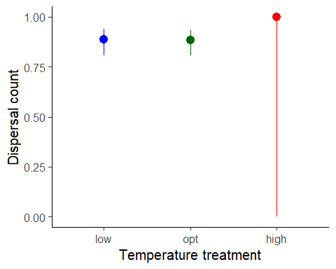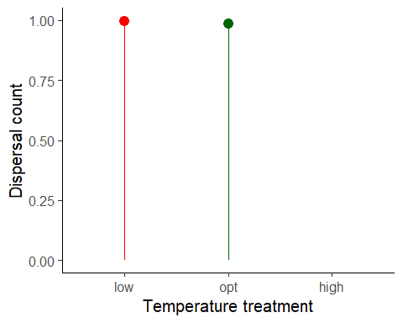

Results for main effect of temperature on dispersal for zero part
## Single term deletions
##
## Model:
## zero ~ Temp.treatment + population + (1 | dispersion_id)
## Df AIC LRT Pr(>Chi)
## <none> 383.05
## Temp.treatment 2 405.99 26.941 1.412e-06 ***
## population 4 406.36 31.305 2.652e-06 ***
## ---
## Signif. codes: 0 '***' 0.001 '**' 0.01 '*' 0.05 '.' 0.1 ' ' 1

Post-hoc pairwise contrasts: differences in dispersal between temperature treatments for zero part
## contrast odds.ratio SE df asymp.LCL asymp.UCL null z.ratio p.value
## opt / high 0.00e+00 0.00e+00 Inf 0.00 Inf 1 0.000 0.9997
## opt / low 1.00e+00 0.00e+00 Inf 0.48 2 1 -0.159 0.8739
## high / low 1.89e+10 1.27e+15 Inf 0.00 Inf 1 0.000 0.9997
##
## Results are averaged over the levels of: population
## Confidence level used: 0.95
## Intervals are back-transformed from the log odds ratio scale
## Tests are performed on the log odds ratio scale

Results for main effect of temperature on dispersal for positive part
## Single term deletions
##
## Model:
## cbind(Num.disp, Num.res) ~ Temp.treatment + population + (1 |
## dispersion_id)
## Df AIC LRT Pr(>Chi)
## <none> 365.11
## Temp.treatment 1 394.31 31.202 2.325e-08 ***
## population 4 589.81 232.699 < 2.2e-16 ***
## ---
## Signif. codes: 0 '***' 0.001 '**' 0.01 '*' 0.05 '.' 0.1 ' ' 1

Post-hoc pairwise contrasts: differences in dispersal between temperature treatments for positive part
## contrast odds.ratio SE df asymp.LCL asymp.UCL null z.ratio p.value
## opt / low 0.256 0.0657 Inf 0.154 0.423 1 -5.305 <.0001
##
## Results are averaged over the levels of: population
## Confidence level used: 0.95
## Intervals are back-transformed from the log odds ratio scale
## Tests are performed on the log odds ratio scale

Model Diagnostics
There was no evidence for lack of fit for either the fitness or the dispersal model.

Diagnostic plots for fitness data - zero part
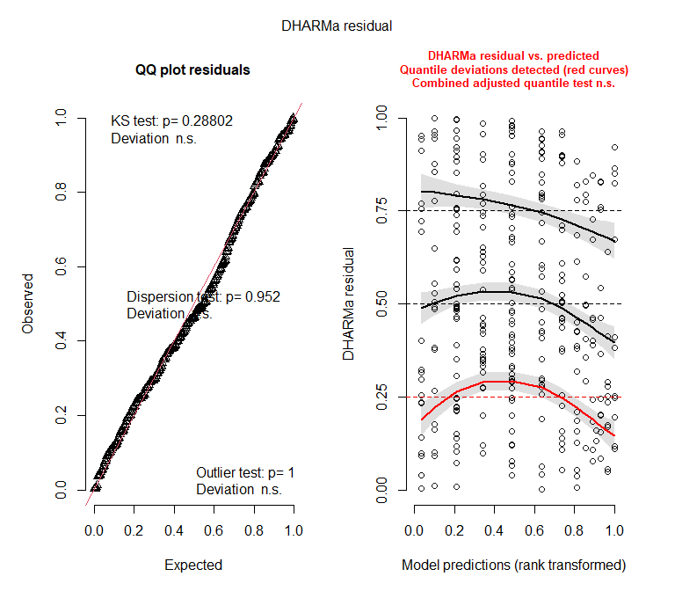

Diagnostic plots for fitness data - positive part
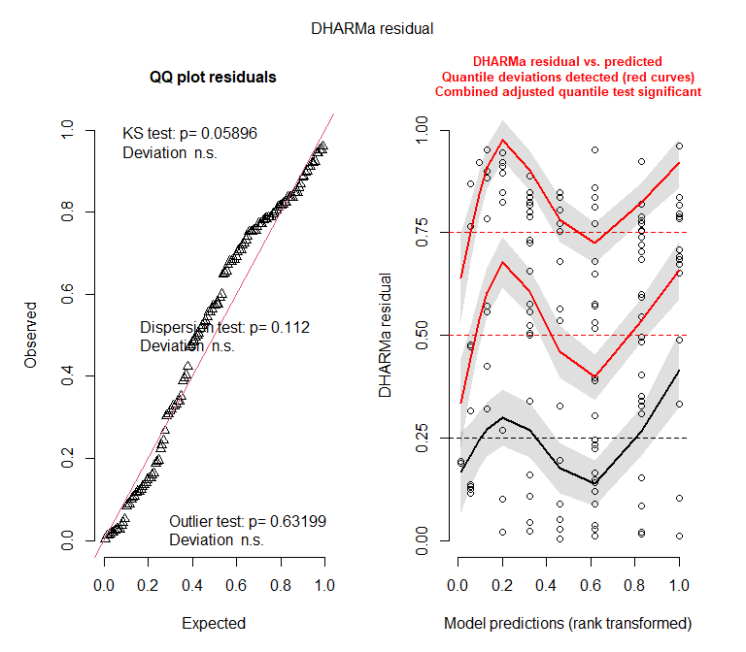

Diagnostic plots for dispersal data - zero part
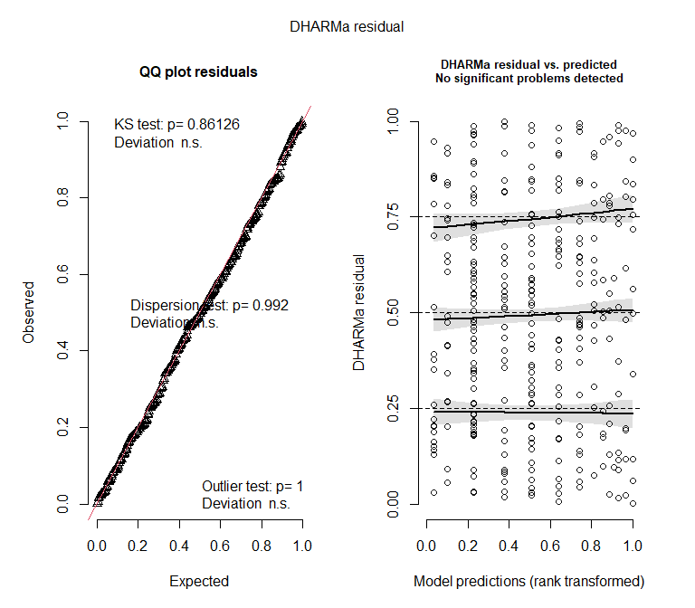

Diagnostic plots for dispersal data - positive part
