Temperature dependent dispersal: A distributed experiment
Nicolas Schtickzelle

Supplementary methods for Tetrahymena thermophila

Author contributions
N.S.: conceptualization, methodology, conduct experiment, statistical analysis and visualization, writing, funding acquisition, project administration

Acknowledgements
N.S. thanks Julie Jadoul for general culture and laboratory maintenance and Julie Jadoul and Michaëlla Dacek for helping with conducting the experiment. This work was supported by F.R.S.-FNRS grants to N.S. (EQP U.N035.16 and PDR T.0211.19) and from UCLouvain (ARC 18-23/095: DIVERCE).

Study organism
Tetrahymena thermophila is a unicellular ciliate eukaryote whose natural habitat is freshwater ponds and streams in the east regions of North America where it feeds on aggregates of bacteria and dissolved nutrients. It actively disperses via swimming and has a generation time of c. 8h in our lab conditions. It lives originally in streams, ponds and lakes on the Atlantic coast of North America, where it disperses actively. As biological replicates, we used five strains (D3, D13, D16, D19, D21), i.e. isogenic lines of cells bearing a single genotype, that differ in various phenotypic traits; they were originally collected in the field by F.P. Doerder from 2003 to 2009. Upon their arrival in our lab, they were cryoconserved in liquid nitrogen. Stock cultures from this experiment were thawed and maintained for a few months (at 23°C 14:10 day/night light cycle) in an axenic PPYE liquid medium (2% of Proteose Peptone and 0.2% of Yeast Extract, diluted in ultrapure water, referred to as “1X medium” for its standard resource concentration); cultures were reinoculated into new medium every 10 days on average. All culture manipulations were performed under a laminar flow hood to maintain their axenic condition (Schtickzelle et al., 2009).

Study design
For each of the 5 strains, we established two different mother cultures that were cultured independently from each other over a few weeks, so 10 mother cultures in total. The experiment (both phase 1 and 2 below) followed a factorial design with 3 temperatures, 5 strains and 2 biological replicates, so 30 experimental populations in total.

Temperature treatments
As temperature treatments, we used Tcold = 15°C, Topt = 31°C, and Thot = 39°C. Tcold is the below the standard culture temperature but growth is still fast enough to be measured in a reasonable time frame; Topt is around the temperature at which the growth rate is maximal (which differs among strains: Jacob et al. 2018); Thot is the temperature at which some growth is still possible, but it is on the descending side of the temperature performance curve, just below lethal temperature (c. 42°C). There was no daily variation in temperature. Due to logistic constraints, each temperature was allocated to one incubator (identicial model: Sanyo MIR-554); the temperature of each of the 3 incubators was monitored every 5 min over the duration experiment to confirm temperature treatments were stable and accurate.

Phase 1: Fitness assay
As a fitness proxy, we used maximum growth rate (r), i.e. the exponential population growth observed of a population starting from very low density. For each of the 30 experimental populations, we inoculated two wells (technical replicates to accommodate for potential culture contamination) of a 24 well plate (Greiner 662102) with 2 ml of 0.3X culture medium and 100 µl of mother culture. We recorded population growth, using optical density measurements (OD at 550nm, using a Biotek Synergy H1 multiplate reader: Jacob et al. 2018) as a cell density proxy, regularly over a period of 23 days maximum (where the populations at 15°C were declining after reaching and maintaining carrying capacity for some time). One plate was used for each temperature and each plate contained 4 wells with medium only used a blank to correct OD. Each of the 3 plates was placed at its experimental temperature except for a few minutes when an OD read was performed on the multiplate reader. For every read, the OD value was the average of 9 measurements spread as a grid over the well area. During the experiment, we monitored populations for a sudden sharp increase in OD, and in these cases checked for bacterial contamination under the microscope. Contaminated populations were discarded and their monitoring was stopped; this never happened during the exponential growth phase that is analysed.
Growth curves (i.e. time series of OD) were first cleaned for obvious outliers (e.g. due to a bubble at the surface of the liquid culture that biased the value upwards) by discarding values that were higher than 110% of the maximum observed OD. Then, they were truncated after the stationary phase by cutting the time series after the last time where OD was above 90% of the median of the highest 5 OD values in the curve. Maximum growth rate (r) was then calculated for each growth curve separately as the maximum linear slope of the temporal increase of the log-transformed optical density with the easy linear fit in the growthrates package.

Phase 2: Dispersal assay
To quantify dispersal, we used standard two-patch microcosms consisting of two habitat patches (1.5 ml standard microtubes) connected by a corridor (4 mm internal diameter silicon pipe, 2.5 cm long) and filled with growth medium (Schtickzelle et al. 2009); one system was used for each of the 30 experimental populations. The dispersal system was filled prior to the experiments with 3 ml of 0.3X medium through one tube to ensure fluid transition between the tubes, and then closed by placing a clamp in the middle of the connecting pipe. To start the experiment, a specific volume from the corresponding mother culture was placed into the “start” tube of the system so that the population was at a 100.000 cells/ml density. The tube content was then homogenized to encourage cells to move freely throughout the start tube and the dispersal system placed in the incubator at its experimental temperature. After 1.5 h of acclimation, the clamp closing the connecting pipe was removed and cells could freely disperse between the two tubes for 4 hours. The 30 dispersal systems were launched at a 5 min interval to ensure the 1.5 h + 4 h was strictly respected for each system.
At the end of 5.5 h, the dispersal system was closed and a series of measures extracted for the “start” and “target” tubes using a digital image analysis procedure, which allows estimation of cell densities and several phenotypic traits in an objective and automated manner. To do so, five independent samples were taken from each tube after culture homogenization, and each loaded in a chamber of a counting slide (Kima Precision cell 301890, Italy); for each chamber, a dark field image was taken using a Canon EOS 5D Mark II mounted on a Nikon Eclipse 50i microscope. Images were then treated and segmented using Fiji software (Version 1.47, Schneider et al. 2012) to identify individual cells and extract measures. This workflow, containing several data cleaning steps to eliminate artefacts, has been carefully validated and extensively optimized to produce accurate and repeatable results (see details and measures of error rates in Pennekamp and Schtickzelle (2013)).

Statistical Analysis

Does fitness change with temperature (phase 1)?
NA
## `stat_bin()` using `bins = 30`. Pick better value `binwidth`.
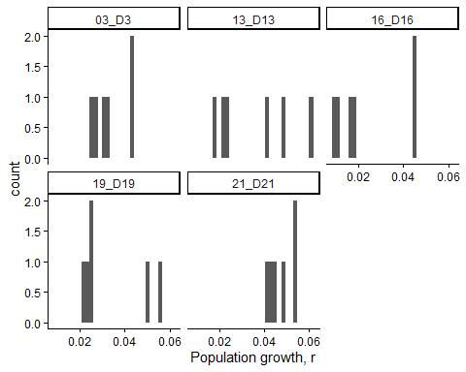
Figure 1. Histogram of fitness ( population growth, r ) values for each strain .
## `stat_bin()` using `bins = 30`. Pick better value `binwidth`.
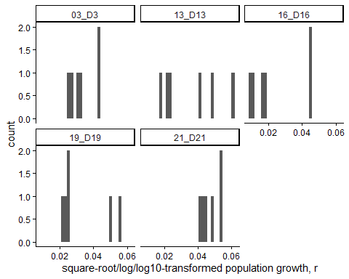
Figure 1. Histogram of square-root/log/log10 -transformed population growth, r values for each strain .
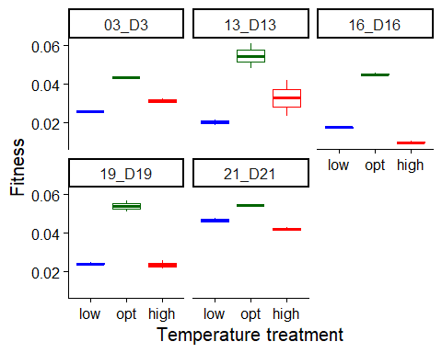
Figure 2. Boxplot of fitness ( population growth, r ), as a function of temperature treatment for each strain . low = 15 C, opt = 31 C, high = 39 C.
To estimate the effects of temperature (a factor) on fitness, we used a linear mixed model with population growth, r as the response variable. We used the formula:
Fitness ~ Temp.treatment

Results for main effect of temperature on fitness
## $Strain_03_D3
## Analysis of Variance Table
##
## Response: Fitness
## Df Sum Sq Mean Sq F value Pr(>F)
## Temp.treatment 2 3.1207e-04 1.5603e-04 158.82 0.000905 ***
## Residuals 3 2.9470e-06 9.8200e-07
## ---
## Signif. codes: 0 '***' 0.001 '**' 0.01 '*' 0.05 '.' 0.1 ' ' 1
##
## $Strain_13_D13
## Analysis of Variance Table
##
## Response: Fitness
## Df Sum Sq Mean Sq F value Pr(>F)
## Temp.treatment 2 0.00120247 0.00060123 7.0068 0.07404 .
## Residuals 3 0.00025742 0.00008581
## ---
## Signif. codes: 0 '***' 0.001 '**' 0.01 '*' 0.05 '.' 0.1 ' ' 1
##
## $Strain_16_D16
## Analysis of Variance Table
##
## Response: Fitness
## Df Sum Sq Mean Sq F value Pr(>F)
## Temp.treatment 2 0.00136736 0.00068368 762 8.708e-05 ***
## Residuals 3 0.00000269 0.00000090
## ---
## Signif. codes: 0 '***' 0.001 '**' 0.01 '*' 0.05 '.' 0.1 ' ' 1
##
## $Strain_19_D19
## Analysis of Variance Table
##
## Response: Fitness
## Df Sum Sq Mean Sq F value Pr(>F)
## Temp.treatment 2 0.0011779 0.00058894 71.836 0.002925 **
## Residuals 3 0.0000246 0.00000820
## ---
## Signif. codes: 0 '***' 0.001 '**' 0.01 '*' 0.05 '.' 0.1 ' ' 1
##
## $Strain_21_D21
## Analysis of Variance Table
##
## Response: Fitness
## Df Sum Sq Mean Sq F value Pr(>F)
## Temp.treatment 2 1.5249e-04 7.6246e-05 52.068 0.004686 **
## Residuals 3 4.3930e-06 1.4640e-06
## ---
## Signif. codes: 0 '***' 0.001 '**' 0.01 '*' 0.05 '.' 0.1 ' ' 1

Post-hoc pairwise contrasts: differences in fitness between temperature treatments
## $Strain_03_D3
## contrast estimate SE df lower.CL upper.CL t.ratio p.value
## opt - high 0.01188 0.000991 3 0.00872 0.01503 11.982 0.0013
## opt - low 0.01726 0.000991 3 0.01411 0.02042 17.417 0.0004
## high - low 0.00539 0.000991 3 0.00223 0.00854 5.435 0.0122
##
## Confidence level used: 0.95
##
## $Strain_13_D13
## contrast estimate SE df lower.CL upper.CL t.ratio p.value
## opt - high 0.0217 0.00926 3 -0.0078 0.0512 2.340 0.1012
## opt - low 0.0343 0.00926 3 0.0048 0.0638 3.701 0.0343
## high - low 0.0126 0.00926 3 -0.0169 0.0421 1.361 0.2668
##
## Confidence level used: 0.95
##
## $Strain_16_D16
## contrast estimate SE df lower.CL upper.CL t.ratio p.value
## opt - high 0.03518 0.000947 3 0.0322 0.0382 37.138 <0.0001
## opt - low 0.02746 0.000947 3 0.0244 0.0305 28.990 <0.0001
## high - low -0.00772 0.000947 3 -0.0107 -0.0047 -8.147 0.0039
##
## Confidence level used: 0.95
##
## $Strain_19_D19
## contrast estimate SE df lower.CL upper.CL t.ratio p.value
## opt - high 0.029972 0.00286 3 0.02086 0.03908 10.468 0.0019
## opt - low 0.029466 0.00286 3 0.02035 0.03858 10.291 0.0020
## high - low -0.000506 0.00286 3 -0.00962 0.00861 -0.177 0.8710
##
## Confidence level used: 0.95
##
## $Strain_21_D21
## contrast estimate SE df lower.CL upper.CL t.ratio p.value
## opt - high 0.01218 0.00121 3 0.00833 0.016033 10.067 0.0021
## opt - low 0.00784 0.00121 3 0.00399 0.011693 6.480 0.0075
## high - low -0.00434 0.00121 3 -0.00819 -0.000489 -3.587 0.0371
##
## Confidence level used: 0.95

Does dispersal change with temperature (phase 2)?
To estimate the effect of temperature treatment (a factor) on dispersal, we used a generalized linear mixed model with a binomial error structure and a logit link. Dispersal (the number of dispersers vs non-dispersers) was the response variable. We used the formula:
cbind(Num.disp, Num.nondisp) ~ Temp.treatment
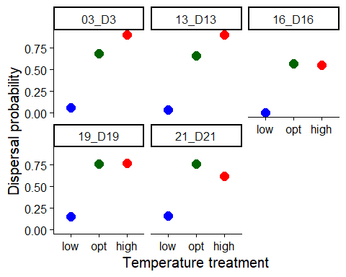
Figure 1. Dispersal as a function of temperature treatment for each strain. low = 15C, opt = 31C, high = 39C. Error bars represent 95% confidence intervals predicted from GLMM.

Results for main effect of temperature on dispersal
## $Strain_03_D3
## Single term deletions
##
## Model:
## cbind(Num.disp, Num.nondisp) ~ Temp.treatment
## Df Deviance AIC LRT Pr(>Chi)
## <none> 79.69 124.77
## Temp.treatment 2 2758.28 2799.36 2678.6 < 2.2e-16 ***
## ---
## Signif. codes: 0 '***' 0.001 '**' 0.01 '*' 0.05 '.' 0.1 ' ' 1
##
## $Strain_13_D13
## Single term deletions
##
## Model:
## cbind(Num.disp, Num.nondisp) ~ Temp.treatment
## Df Deviance AIC LRT Pr(>Chi)
## <none> 135.55 175.7
## Temp.treatment 2 2551.15 2587.3 2415.6 < 2.2e-16 ***
## ---
## Signif. codes: 0 '***' 0.001 '**' 0.01 '*' 0.05 '.' 0.1 ' ' 1
##
## $Strain_16_D16
## Single term deletions
##
## Model:
## cbind(Num.disp, Num.nondisp) ~ Temp.treatment
## Df Deviance AIC LRT Pr(>Chi)
## <none> 143.83 181.62
## Temp.treatment 2 1072.72 1106.51 928.89 < 2.2e-16 ***
## ---
## Signif. codes: 0 '***' 0.001 '**' 0.01 '*' 0.05 '.' 0.1 ' ' 1
##
## $Strain_19_D19
## Single term deletions
##
## Model:
## cbind(Num.disp, Num.nondisp) ~ Temp.treatment
## Df Deviance AIC LRT Pr(>Chi)
## <none> 84.34 131.99
## Temp.treatment 2 1759.68 1803.33 1675.3 < 2.2e-16 ***
## ---
## Signif. codes: 0 '***' 0.001 '**' 0.01 '*' 0.05 '.' 0.1 ' ' 1
##
## $Strain_21_D21
## Single term deletions
##
## Model:
## cbind(Num.disp, Num.nondisp) ~ Temp.treatment
## Df Deviance AIC LRT Pr(>Chi)
## <none> 22.23 70.5
## Temp.treatment 2 1422.42 1466.7 1400.2 < 2.2e-16 ***
## ---
## Signif. codes: 0 '***' 0.001 '**' 0.01 '*' 0.05 '.' 0.1 ' ' 1

Post-hoc pairwise contrasts: differences in dispersal between temperature treatments
## $Strain_03_D3
## contrast odds.ratio SE df asymp.LCL asymp.UCL null
## opt / high 0.248 0.0208 Inf 0.21 0.292 1
## opt / low 32.535 3.8400 Inf 25.82 40.996 1
## high / low 131.371 17.9000 Inf 100.58 171.587 1
## z.ratio p.value
## -16.633 <0.0001
## 29.525 <0.0001
## 35.799 <0.0001
##
## Confidence level used: 0.95
## Intervals are back-transformed from the log odds ratio scale
## Tests are performed on the log odds ratio scale
##
## $Strain_13_D13
## contrast odds.ratio SE df asymp.LCL asymp.UCL null z.ratio
## opt / high 0.208 0.014 Inf 0.182 0.237 1 -23.303
## opt / low 53.186 10.600 Inf 36.014 78.545 1 19.977
## high / low 256.263 52.400 Inf 171.685 382.509 1 27.139
## p.value
## <0.0001
## <0.0001
## <0.0001
##
## Confidence level used: 0.95
## Intervals are back-transformed from the log odds ratio scale
## Tests are performed on the log odds ratio scale
##
## $Strain_16_D16
## contrast odds.ratio SE df asymp.LCL asymp.UCL null
## opt / high 1.09 0.0703 Inf 0.959 1.24 1
## opt / low 427.26 303.0000 Inf 106.406 1715.59 1
## high / low 392.56 279.0000 Inf 97.639 1578.33 1
## z.ratio p.value
## 1.311 0.1898
## 8.540 <0.0001
## 8.413 <0.0001
##
## Confidence level used: 0.95
## Intervals are back-transformed from the log odds ratio scale
## Tests are performed on the log odds ratio scale
##
## $Strain_19_D19
## contrast odds.ratio SE df asymp.LCL asymp.UCL null z.ratio
## opt / high 0.952 0.0603 Inf 0.84 1.08 1 -0.784
## opt / low 17.075 1.5100 Inf 14.36 20.31 1 32.064
## high / low 17.945 1.6000 Inf 15.06 21.38 1 32.332
## p.value
## 0.4331
## <0.0001
## <0.0001
##
## Confidence level used: 0.95
## Intervals are back-transformed from the log odds ratio scale
## Tests are performed on the log odds ratio scale
##
## $Strain_21_D21
## contrast odds.ratio SE df asymp.LCL asymp.UCL null z.ratio
## opt / high 2.00 0.121 Inf 1.77 2.25 1 11.422
## opt / low 16.59 1.440 Inf 13.99 19.68 1 32.256
## high / low 8.31 0.728 Inf 7.00 9.86 1 24.152
## p.value
## <0.0001
## <0.0001
## <0.0001
##
## Confidence level used: 0.95
## Intervals are back-transformed from the log odds ratio scale
## Tests are performed on the log odds ratio scale

Model Diagnostics
There was no evidence for lack of fit for either the fitness or the dispersal model.

Diagnostic plots for fitness data
## Warning in eval(family$initialize): non-integer #successes in a
## binomial glm!
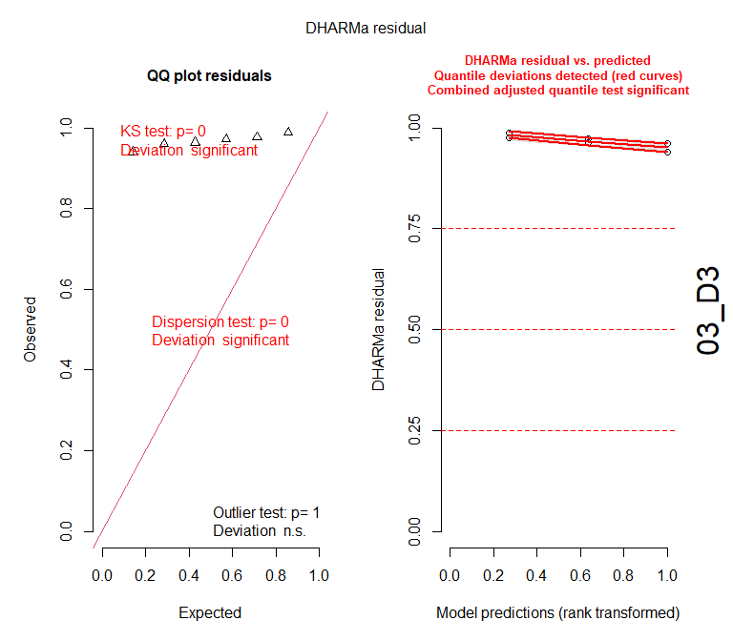
## Warning in eval(family$initialize): non-integer #successes in a
## binomial glm!
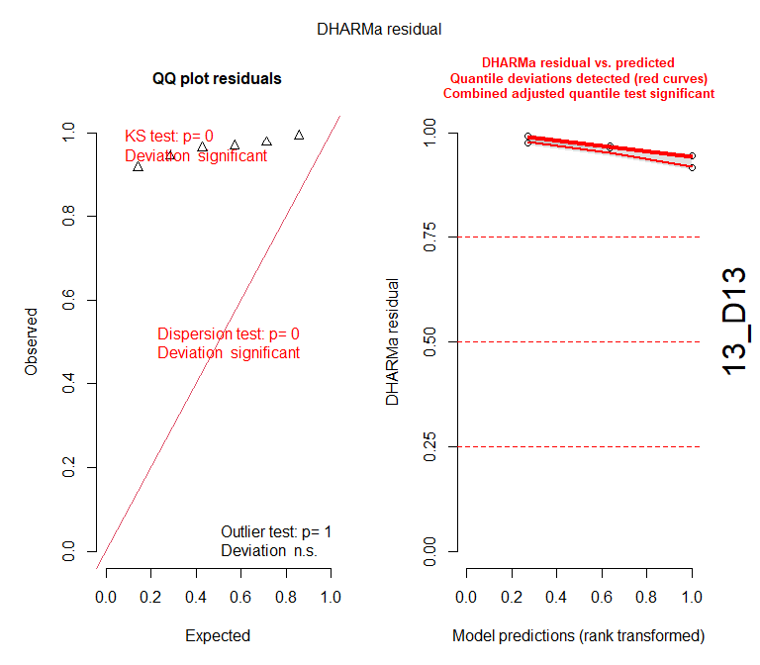
## Warning in eval(family$initialize): non-integer #successes in a
## binomial glm!
##
## DHARMa: qgam was unable to calculate quantile regression for quantile 0.5. Possibly to few (unique) data points / predictions. The quantile will be ommited in plots and significance calculations.
##
## DHARMa: qgam was unable to calculate quantile regression for quantile 0.75. Possibly to few (unique) data points / predictions. The quantile will be ommited in plots and significance calculations.
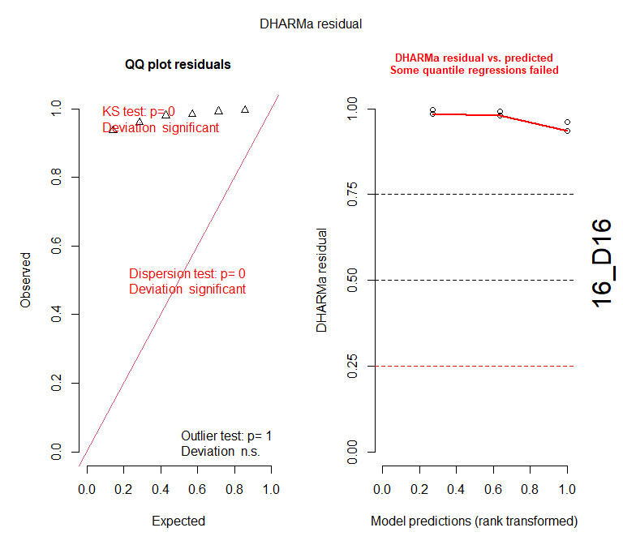
## Warning in eval(family$initialize): non-integer #successes in a
## binomial glm!
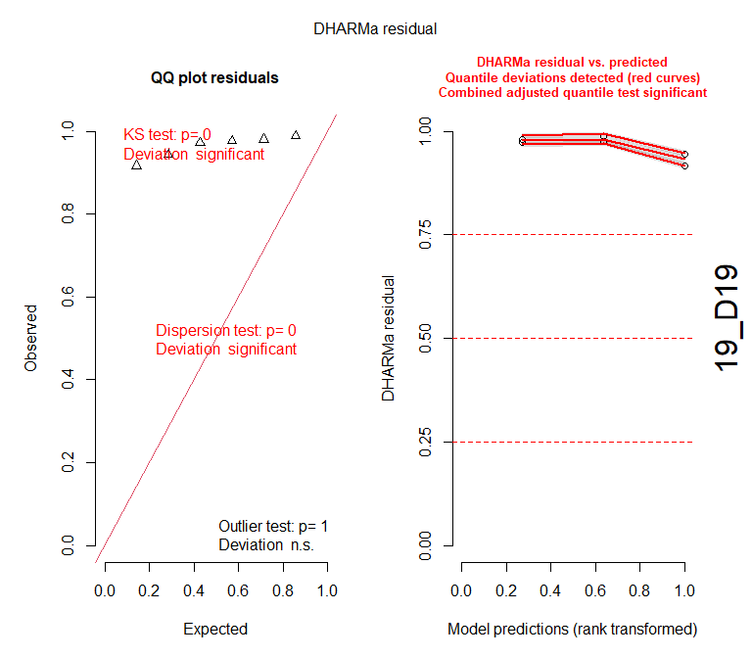
## Warning in eval(family$initialize): non-integer #successes in a
## binomial glm!
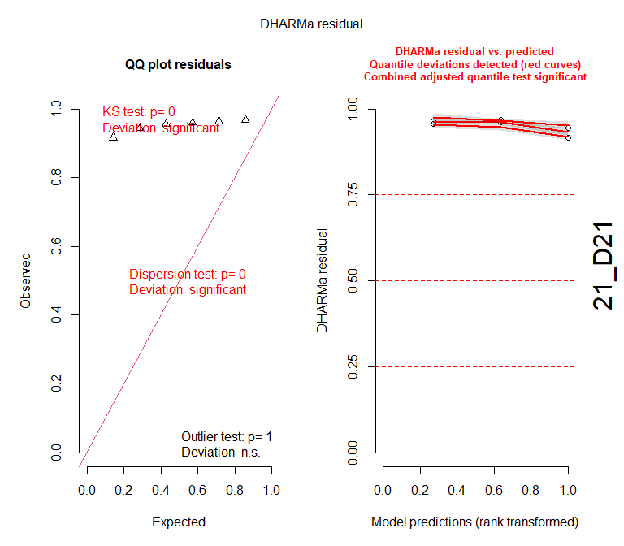

Diagnostic plots for dispersal data
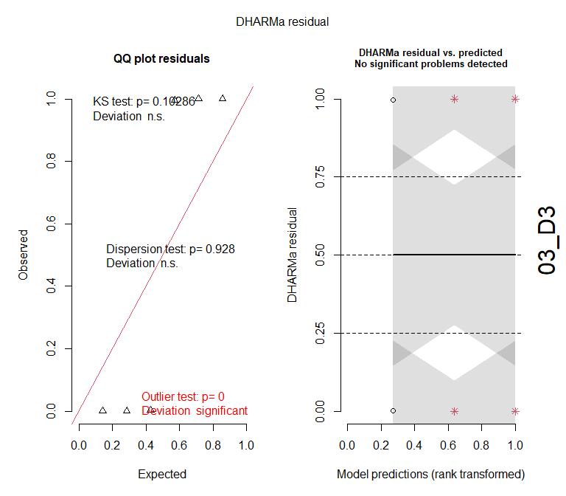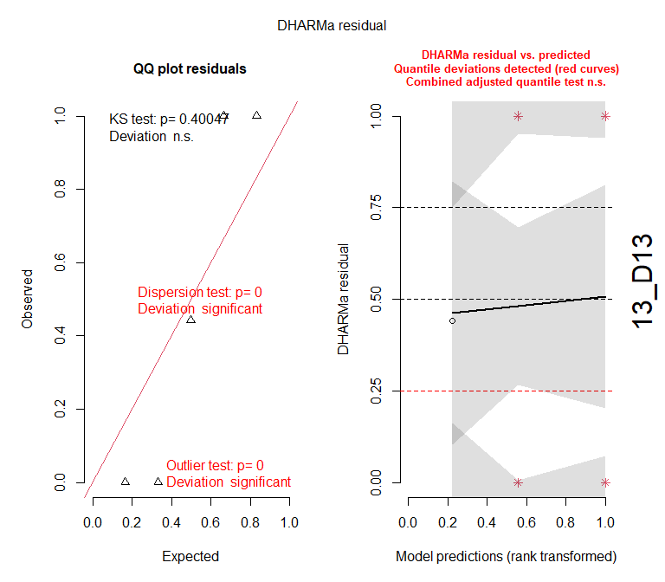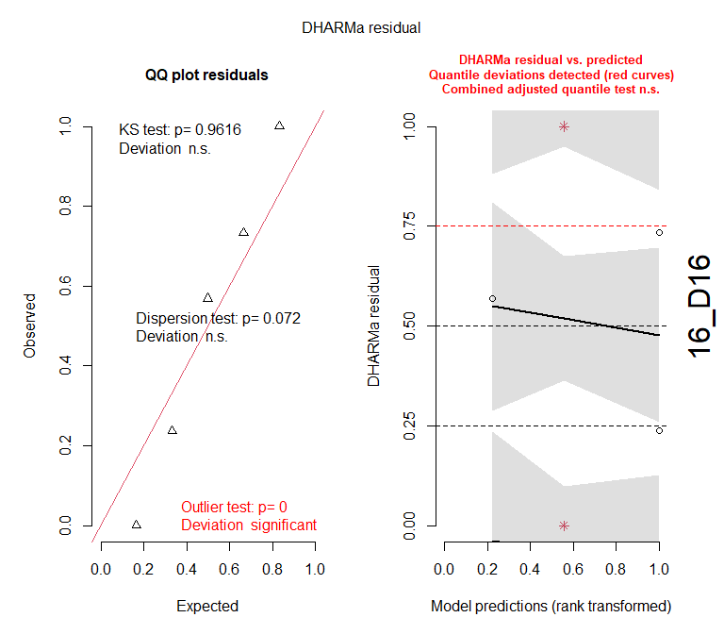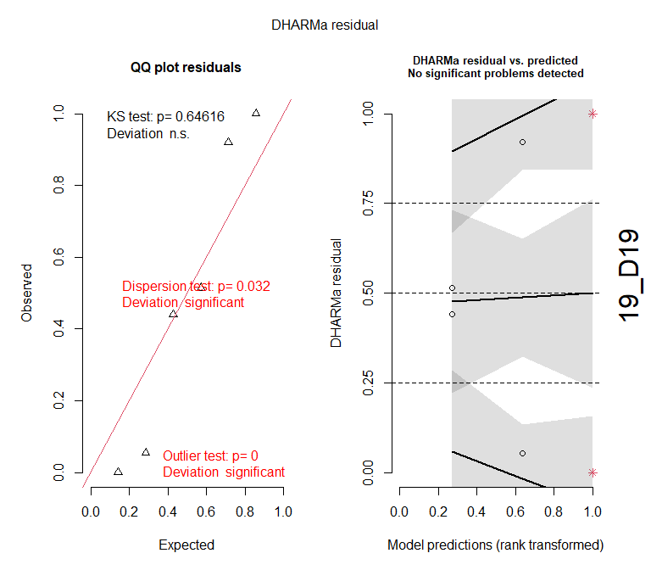
##
## DHARMa: qgam was unable to calculate quantile regression for quantile 0.25. Possibly to few (unique) data points / predictions. The quantile will be ommited in plots and significance calculations.
##
## DHARMa: qgam was unable to calculate quantile regression for quantile 0.5. Possibly to few (unique) data points / predictions. The quantile will be ommited in plots and significance calculations.
## We had to increase `err` for some of the quantiles. See fit$calibr$err
