Temperature dependent dispersal: A distributed experiment
Inês Fragata, Sofia Henriques, Ana Lima

Supplementary methods for Tetranychus evansi

Study organism
Name and strain/origin of species: Tetranychus evansi
The collection and creation of this outbred population is described in Godinho et al. “Creating outbred and inbred populations in haplodiploids to measure adaptive responses in the laboratory.” Ecology and Evolution 10.14 (2020): 7291-7305.

Provide basic life history information (aquatic/terrestrial, mode of dispersal, lifespan, etc.).
Terrestrial plant-feeding Acari, polyphagous, reproduce through arrhenotoky (haplodiploids), capable of both active and passive dispersal, lifespan between 2 and 4 weeks, capable of producing approximately 100 eggs during a lifetime. This spider mite originated in South America and is now found across Africa, Europe, and Asia, being considered a major invasive pest in Europe and Africa.

Briefly describe what is known about the temperature range the species experiences (geographic range, seasonality, type of habitat, etc.) in its natural system or the history of the conditions it has experienced in the lab.
Tetranychus evansi is a specialist, feeding on solanaceous crops. It originated from South America and was introduced in Africa and Europe. It is most active during warmer and dry season, with populations typically peaking in summer. It inhabits plant surfaces, especially the undersides of leaves, and is commonly associated with solanaceous crops, specially tomatoes. In the lab, they are maintained at 25C on 14-day-old bean plants (25 ± 2°C, 60% RH, 16/8 h L/D).

How were organisms sourced?
- Lab sourced: provide information on source.
The outbred population used in the experiments originated from 4 symbiont-free à priori compatible populations of T. evansi (all from clade I) collected in crop fields in the region of Lisbon, Portugal, in 2017 (Godinho et al 2020). The populations were merged by performing interpopulation crosses in a controlled match design, maximizing genetic variation within population. Prior to merging all populations were cured from endosymbiont infection by heat shock (continuous exposure to 33°C) for 6 generations. After the merging the outbred population was maintained under standard conditions (25 ± 2°C, 60% RH, 16/8 h L/D) at the laboratory in high numbers (about 500–1000 females) inside cages containing tomato plants, variant money maker.
Note: I’m not providing more information because a) it’s published and b) the pops we’re merged many generations prior to the onset of the experiments, but if needed, do let me know.

How were individuals/populations treated before the experiment?
T. evansi outbred was maintained under standard conditions (25 ± 2°C, 60% RH, 16/8 h L/D) at the laboratory in high numbers(about 500–1000 females) inside cages containing leafs from 5 weeks old tomato plants, variety money maker ad libidum.

Were specific individuals/phenotypes/stages selected for the experiment?
Mated females (ca. 8 days at high temperatures - opt and high - and 10 to 11 days at control temperature).

Study design

Temperature treatments
- Tlab: 25°C; Temperature at which the mite population was kept in the laboratory since 2020.
- Topt: 30°C; Optimal temperature for spider mites, as their generation time decreases and number of offspring increases.
- Thot: 35°C; Established as a sub-lethal high temperature (causing a toll in fertility but not so much in survival)
There was no variation in temperature.

Phase 1: Fitness assay
Fitness proxy: number of eggs produced per mated female in 3 days.
#- Physical details about the experimental setup including size/shape/volume of experimental arenas, substrate/medium of experimental arenas.
Squared petri dishes with a layer of water-soaked cotton. In each, 16 circles (16Ø) cut from 14 day-old bean leaves. Females were individually added to each circle.
- Phenotypes measured (activity, body condition, body size, etc.) and how they were estimated
- Replicates
  - Specify number of experimental replicates: Tlab:31 ; Topt:16; Thigh:16
  - Number of strains and number of replicates per strain: 1 outbred population
  - Indicate if experimental blocks were used and the blocking design (number of blocks, how many replicates of each treatment per block, time/space between blocks): Three identical incubators were used, only one block was done for this experiment. All replicates of each temperature treatment were done at the same time.
  - Type and amount of food provided during experiment: circles of 5 week-old tomato leaves per individual, corresponding to food ad lib. Water is added to the petri dishes when they start drying.
  - Starting density: 1 female per circle
  - Duration of fitness assay: 3 days
  - Controlled variables: food (ad lib), only females
  - Phenotypes measured: fecundity (number of eggs)

Phase 2: Dispersal assay
- Physical details about the experimental setup: Squared petri dishes with a layer of water-soaked cotton were used. In each, 12 circles (18 mm Ø) cut from 5 week-old tomato leaves. Groups of 3 circles in line were connected with an acetate bridge (1x3 cm) (i.e., 4 setups per petri dish were created) such that movement between the patches was possible. Fifteen females were added to the circle on the right (the source patch).
- Replicates
  - Specify number of experimental replicates: Tlab:15 ; Topt:18; Thigh:11
  - Number of strains and number of replicates per strain: 1 outbred population
  - Indicate if experimental blocks were used and the blocking design (number of blocks, how many replicates of each treatment per block, time/space between blocks): Three identical incubators were used, so all temperatures were tested at the same time. There were some problems in development of the eggwaves, so we lost several replicates on block 1, and there was only one replicate for each temperature in block 2.
- Type and amount of food provided during experiment: Three 16 mm Ø circles of 5 week-old tomato leaves per setup, corresponding to food ad lib. Water is added to the petri dishes when they start drying.
- Starting density: 15 mated females
- Duration of dispersal assay including:
  - time between birth and start of acclimation period:0 days (individuals were exposed since egg)
  - duration of acclimation period: 8 to 11 days (at 25C and 30/35C respectively)
  - timing and duration of dispersal assay: 48h
- Controlled variables: food (ad lib), all females because they are the dispersing sex
- Phenotypes measured (activity, body condition, body size, etc.) and how they were estimated: number of females in patch 1 vs patches 2 and 3
- Whether individuals used in phase 2 were the same as used in phase 1: no
- Provide details on data collection including:
  - The sampling regime (time intervals between sampling).
  - Sampling method including whether individuals were marked and whether sampling was observed or automated: observed
- State whether mortality during the dispersal assay was recorded. Describe how mortality was handled for the statistical analysis (e.g., individuals that died during the dispersal assay were excluded from the analysis of dispersal). Yes, we discriminated between alive and dead females on each patch/bridge. Individuals that died during the dispersal assay were excluded from the analysis of dispersal

Statistical Analysis
Note that here I used as ref the control temperature. This was changed, so that everytime there was a mention to low, it would be control instead.

Does fitness change with temperature (phase 1)?
Fecundity was not normally distributed so we square-root-transformed it. The transformed variable followed a normal distribution.
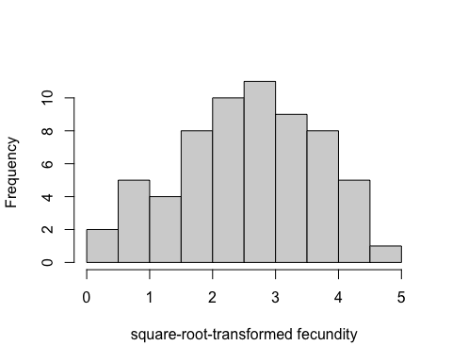
Figure 1. Histogram of square-root -transformed fecundity values.
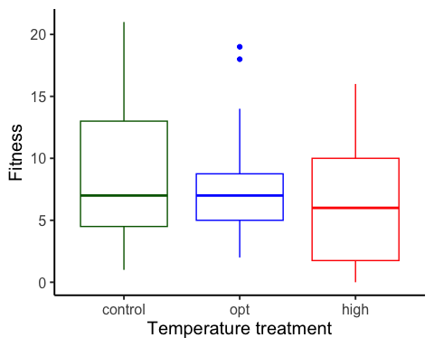
Figure 2. Boxplot of fitness ( fecundity ), as a function of temperature treatment. low = 25 C, opt = 30 C, high = 35 C.
To estimate the effects of temperature (a factor) on fitness, we used a linear mixed model with fecundity as the response variable. We used the formula:
Fitness ~ Temp.treatment

Results for main effect of temperature on fitness
## Analysis of Variance Table
##
## Response: Fitness
## Df Sum Sq Mean Sq
## Temp.treatment 2 46.05 23.025
## Residuals 60 1827.89 30.465
## F value Pr(>F)
## Temp.treatment 0.7558 0.4741
## Residuals

Post-hoc pairwise contrasts: differences in fitness between temperature treatments
## contrast estimate SE df
## control - high 2.085 1.70 60
## control - opt 0.585 1.70 60
## high - opt -1.500 1.95 60
## lower.CL upper.CL t.ratio p.value
## -1.31 5.48 1.227 0.2246
## -2.81 3.98 0.344 0.7320
## -5.40 2.40 -0.769 0.4451
##
## Confidence level used: 0.95

Does dispersal change with temperature (phase 2)?
To estimate the effect of temperature treatment (a factor) on dispersal, we used a generalized linear mixed model with a binomial error structure and a logit link. Dispersal (the number of dispersers vs non-dispersers) was the response variable. We used the formula:
cbind(Num.disp, Num.nondisp) ~ Temp.treatment + (1|block)
## boundary (singular) fit: see help('isSingular')
## boundary (singular) fit: see help('isSingular')
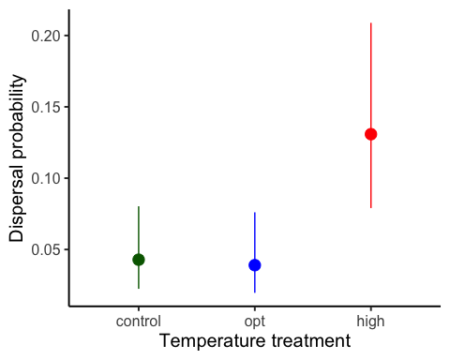
Figure 1. Dispersal as a function of temperature treatment. low = 25 C, opt = 30 C, high = 35 C. Error bars represent 95% confidence intervals predicted from GLMM.

Results for main effect of temperature on dispersal
## Single term deletions
##
## Model:
## cbind(Num.disp, Num.nondisp) ~ Temp.treatment + (1 | block)
## npar AIC LRT
## <none> 122.16
## Temp.treatment 2 128.43 10.274
## Pr(Chi)
## <none>
## Temp.treatment 0.005875 **
## ---
## Signif. codes:
## 0 '***' 0.001 '**' 0.01 '*'
## 0.05 '.' 0.1 ' ' 1

Post-hoc pairwise contrasts: differences in dispersal between temperature treatments
## contrast odds.ratio SE
## control / high 0.297 0.132
## control / opt 1.103 0.547
## high / opt 3.707 1.710
## df asymp.LCL asymp.UCL null
## Inf 0.124 0.712 1
## Inf 0.417 2.916 1
## Inf 1.503 9.145 1
## z.ratio p.value
## -2.723 0.0065
## 0.197 0.8439
## 2.844 0.0045
##
## Confidence level used: 0.95
## Intervals are back-transformed from the log odds ratio scale
## Tests are performed on the log odds ratio scale

Model Diagnostics
There was no evidence for lack of fit for either the fitness or the dispersal model.

Diagnostic plots for fitness data
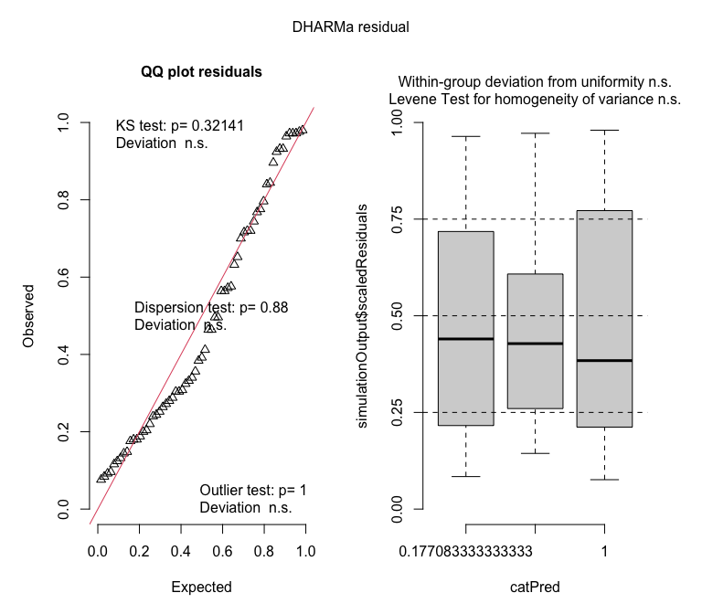

Diagnostic plots for dispersal data
