Temperature dependent dispersal: A distributed experiment
Emelda Aceng, Silène Lartigue, Elodie Vercken
## ── Attaching core tidyverse packages ──────────────────────────────── tidyverse 2.0.0 ──
## ✔ dplyr 1.1.4 ✔ readr 2.1.5
## ✔ forcats 1.0.0 ✔ stringr 1.5.1
## ✔ ggplot2 4.0.2 ✔ tibble 3.2.1
## ✔ lubridate 1.9.3 ✔ tidyr 1.3.1
## ✔ purrr 1.0.2
## ── Conflicts ────────────────────────────────────────────────── tidyverse_conflicts() ──
## ✖ dplyr::filter() masks stats::filter()
## ✖ dplyr::lag() masks stats::lag()
## ℹ Use the conflicted package (<http://conflicted.r-lib.org/>) to force all conflicts to become errors
## Loading required package: Matrix
##
##
## Attaching package: 'Matrix'
##
##
## The following objects are masked from 'package:tidyr':
##
## expand, pack, unpack
##
##
## Welcome to emmeans.
## Caution: You lose important information if you filter this package's results.
## See '? untidy'
##
## This is DHARMa 0.4.7. For overview type '?DHARMa'. For recent changes, type news(package = 'DHARMa')

Supplementary methods for Trichogramma cacoeciae

Author contributions
EA methodology (design of methodology), investigation/conduct experiment SL conceptualization, methodology (design of methodology), investigation/conduct experiment EV conceptualization, methodology (design of methodology), investigation/conduct experiment, statistical analysis, funding acquisition, writing (original draft, supplement)

Acknowledgements
Biological material and advice on thermal performance of the different Trichogramma strains were graciously provided by the Biological Resource Center CRB EP-Coll.

Study organism
Trichogramma cacoeciae Trichogramma are minute parasitic wasps belonging to the order Hymenoptera. They are oophagous endoparasitoid, meaning they lay their eggs inside the eggs of other insects, particularly those of Lepidopteran species. The developing Trichogramma larvae consumes the host egg from within, ultimately killing it. Trichogramma are widely used as biological model organisms, and most of what is known about their ecology comes either from lab-rearing assays or field studies in agricultural environments. From those, it appears that Trichogramma disperse at short distances (within-plant scale, less than a few meters) by walking, and at longer-distances (between-plants scales, from 10 to 100 meters) with a combination of active flight and passive wind-borne dispersal. Trichogramma cacoeciea is an asexual species (consisting entirely of females) present over all continental Europe. A comparative study on T. cacoeciae populations sampled along an altitudinal and a longitudinal gradient in Southern France showed that these populations display local adaptation regarding their thermal environments (i.e., variation in thermal tolerance indices, winter survival, diapause frequency).
For this study we used three populations of T. cacoeciae collected from three French regions (Essonne : 48°27’36.0”N 2°29’24.0”E ; Savoie: 45°33’00.0”N 6°37’48.0”E ; Alpes-de-Haute-Provence: 43°57’36.0”N 6°30’00.0”E) between 2015 and 2017. These populations were sourced from the CRB EP-Coll, a Biological Resource Center for egg parasitoids hosted at the Institut Sophia Agrobiotech (ISA), in which they have been maintained at 18°C since their sampling in the field (i.e., between 150-200 generations). Prior to the experiment, we reared all strains for three generations under common garden conditions (20 °C, 70% RH, L: D 16:8), using sterilized eggs of Ephestia kuehniella as host material. Egg sterilization was assured by UV-irradiation (15 minutes under UV light), preventing the host embryo from developing and thus eliminating competition for the parasitoid larvae, while keeping the eggs viable for parasitism.

Study design

Temperature treatments
We chose the three temperature treatments based on recommendations from the CRB EP-Coll. The optimal temperature was set at 25°C, which allows fast development with no adverse effects on fecundity or survival. The low temperature was set at 18°C, to keep development time compatible with the requirements of an experiment over several generations. The high temperature was set at 30°C, above which individual survival becomes severely compromised.
All rearings and experiments were done within climatic chambers (Panasonic MLR-352H), with constant temperature settings, a 16h photoperiod and 70% relative humidity. Climatic chambers allow for a variation of +/- 1°C from the set point, and replicates were moved daily within chambers to smooth out any micro-variations of temperature from bottom to top shelf. Temperature treaments were initiated by exposing host eggs (sterilized E. kuehiella eggs) to the freshly emerged Trichogramma adults from the stock population at 20°C for 72 hours. After 72 hours’ exposure to parasitism, eggs were transferred into fresh tubes and distributed into the three temperature treatments, with 12 replicates of each Trichogramma population in each treatment. The eggs were maintained at each temperature until adult emergence, and each replicate population was then used to assess either fecundity or dispersal (i.e., 6 replicates for each combination of trait x strain x temperature).

Phase 1: Fitness assay
Fitness was estimated as the number of offspring surviving until adult emergence frelative to the initial density of adults, which is a close proxy to per capita growth rate in the case of an asexual species like T. cacoeciae.
Each experimental replicate consisted of a batch of parasitized host eggs (250 +/- 50) from the stock population (see above) set into a plastic vial (5 cm diameter, 10 cm height) with unlimited honey drops and let to develop at each temperature treatment (8-18 days after transfer, depending on temperature). 24h after adult emergence, non-limiting host eggs were provided and left to parasitize for 72 hours. Eggs were then isolated into glass vials (1 cm diameter, 4 cm height) under the same conditions and temperature treatments for one week, allowing for parasitoid larvae to develop enough to blacken the host egg, allowing the visual identification of successfully parasitized eggs. Parasitized eggs turn black at the end of the pupation stage, when adult development is complete and is very highly correlated with actual emergence rate (r>0.98). Black eggs were counted automatically using a Nikon D750 camera equipped with an AF-S Micro NIKKOR 60 mm 1:2.8 G ED macro lens. The camera was mounted on a fixed stand at a height of 28 cm above the egg strips, and images were captured at a resolution of 6016 × 4016 pixels. Lighting was provided by diffuse LED panel from below and on both sides to avoid reflections and shadows, ensuring even illumination across the egg strip surface. Egg counts were performed using AutoCodi, an Imageji macro developed locally at ISA, adapted from the existing CodiCount tool (Perez et al., 2017). Per capita growth rate was calculated by dividing the number of black eggs at the end of the development period divided by the number of black eggs initially assigned to each replicate from the stock population.

Phase 2: Dispersal assay
Dispersal was estimated with a 2-patch system, and calculated as the proportion of offspring surviving into adult emergence that were laid in the “dispersal patch” relative to the “emergence patch”. This measure reflects effective dispersal, as the relative contribution of dispersers and non-dispersers to the next generation.
Similarly to the fitness assay, each experimental replicate consisted of a batch of parasitized host eggs (250 +/- 50) from the stock population set into a plastic vial (5 cm diameter, 10 cm height) with unlimited honey drops and let to develop at each temperature treatment. 24h after emergence, the emergence tube was connected to another plastic vial of the same dimensions (arrival tube) with a see-through 40 cm long plastic pipe (5 mm of internal diameter, large enough for species of less than a millimeter in size). Each tube was provided with non-limiting number of host eggs that were left to parasitize for 72 hours. Eggs were then isolated into glass vials (1 cm diameter, 4 cm height) under the same conditions and temperature treatments for one week, until the parasitized eggs turned black and could be counted. The same method for automatic egg counting as for the fitness assay was used.

Statistical Analysis

Does fitness change with temperature (phase 1)?
NA
## `stat_bin()` using `bins = 30`. Pick better value `binwidth`.
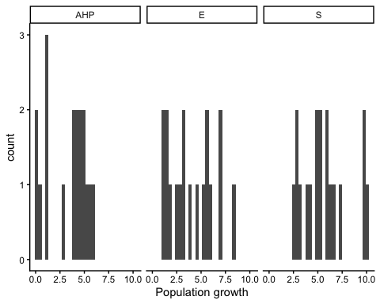
Figure 1. Histogram of fitness ( population growth ) values for each strain .
## `stat_bin()` using `bins = 30`. Pick better value `binwidth`.
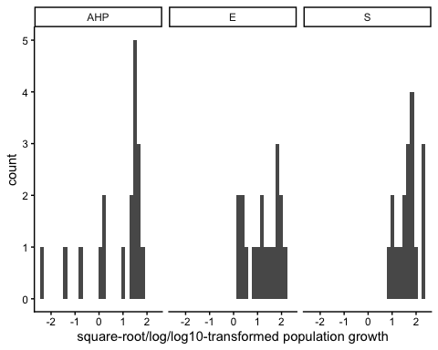
Figure 1. Histogram of square-root/log/log10 -transformed population growth values for each strain .
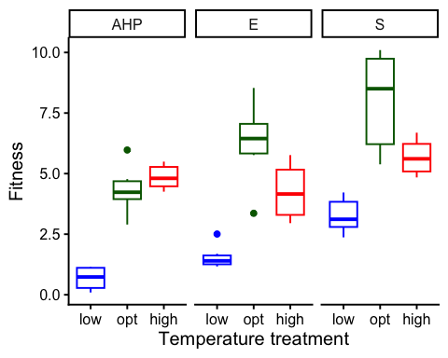
Figure 2. Boxplot of fitness ( population growth ), as a function of temperature treatment for each strain . low = 18 C, opt = 25 C, high = 30 C.
To estimate the effects of temperature (a factor) on fitness, we used a linear mixed model with population growth as the response variable. We used the formula:
Fitness ~ Temp.treatment

Results for main effect of temperature on fitness
## $Strain_S
## Analysis of Variance Table
##
## Response: Fitness
## Df Sum Sq Mean Sq F value Pr(>F)
## Temp.treatment 2 67.707 33.854 18.271 9.538e-05 ***
## Residuals 15 27.793 1.853
## ---
## Signif. codes: 0 '***' 0.001 '**' 0.01 '*' 0.05 '.' 0.1 ' ' 1
##
## $Strain_E
## Analysis of Variance Table
##
## Response: Fitness
## Df Sum Sq Mean Sq F value Pr(>F)
## Temp.treatment 2 67.157 33.579 21.921 3.532e-05 ***
## Residuals 15 22.977 1.532
## ---
## Signif. codes: 0 '***' 0.001 '**' 0.01 '*' 0.05 '.' 0.1 ' ' 1
##
## $Strain_AHP
## Analysis of Variance Table
##
## Response: Fitness
## Df Sum Sq Mean Sq F value Pr(>F)
## Temp.treatment 2 62.270 31.1348 60.951 6.275e-08 ***
## Residuals 15 7.662 0.5108
## ---
## Signif. codes: 0 '***' 0.001 '**' 0.01 '*' 0.05 '.' 0.1 ' ' 1

Post-hoc pairwise contrasts: differences in fitness between temperature treatments
## $Strain_S
## contrast estimate SE df lower.CL upper.CL t.ratio p.value
## opt - high 2.33 0.786 15 0.657 4.01 2.968 0.0096
## opt - low 4.75 0.786 15 3.075 6.43 6.045 <0.0001
## high - low 2.42 0.786 15 0.743 4.09 3.077 0.0077
##
## Confidence level used: 0.95
##
## $Strain_E
## contrast estimate SE df lower.CL upper.CL t.ratio p.value
## opt - high 2.02 0.715 15 0.498 3.54 2.829 0.0127
## opt - low 4.72 0.715 15 3.192 6.24 6.599 <0.0001
## high - low 2.69 0.715 15 1.171 4.22 3.770 0.0019
##
## Confidence level used: 0.95
##
## $Strain_AHP
## contrast estimate SE df lower.CL upper.CL t.ratio p.value
## opt - high -0.522 0.413 15 -1.40 0.357 -1.266 0.2248
## opt - low 3.658 0.413 15 2.78 4.538 8.866 <0.0001
## high - low 4.181 0.413 15 3.30 5.060 10.132 <0.0001
##
## Confidence level used: 0.95

Does dispersal change with temperature (phase 2)?
To estimate the effect of temperature treatment (a factor) on dispersal, we used a generalized linear mixed model with a binomial error structure and a logit link. Dispersal (the number of dispersers vs non-dispersers) was the response variable. We used the formula:
cbind(Num.disp, Num.nondisp) ~ Temp.treatment
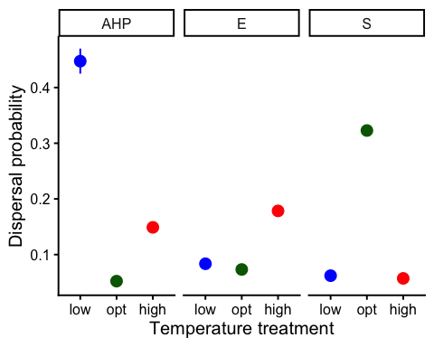
Figure 1. Dispersal as a function of temperature treatment for each strain. low = 18C, opt = 25C, high = 30C. Error bars represent 95% confidence intervals predicted from GLMM.

Results for main effect of temperature on dispersal
## $Strain_S
## Single term deletions
##
## Model:
## cbind(Num.disp, Num.nondisp) ~ Temp.treatment
## Df Deviance AIC LRT Pr(>Chi)
## <none> 2181.7 2302.0
## Temp.treatment 2 5530.4 5646.7 3348.6 < 2.2e-16 ***
## ---
## Signif. codes: 0 '***' 0.001 '**' 0.01 '*' 0.05 '.' 0.1 ' ' 1
##
## $Strain_E
## Single term deletions
##
## Model:
## cbind(Num.disp, Num.nondisp) ~ Temp.treatment
## Df Deviance AIC LRT Pr(>Chi)
## <none> 995.76 1111.7
## Temp.treatment 2 1527.27 1639.2 531.5 < 2.2e-16 ***
## ---
## Signif. codes: 0 '***' 0.001 '**' 0.01 '*' 0.05 '.' 0.1 ' ' 1
##
## $Strain_AHP
## Single term deletions
##
## Model:
## cbind(Num.disp, Num.nondisp) ~ Temp.treatment
## Df Deviance AIC LRT Pr(>Chi)
## <none> 2132.1 2240.3
## Temp.treatment 2 3944.1 4048.3 1812 < 2.2e-16 ***
## ---
## Signif. codes: 0 '***' 0.001 '**' 0.01 '*' 0.05 '.' 0.1 ' ' 1

Post-hoc pairwise contrasts: differences in dispersal between temperature treatments
## $Strain_S
## contrast odds.ratio SE df asymp.LCL asymp.UCL null z.ratio p.value
## opt / high 7.850 0.3940 Inf 7.114 8.66 1 41.008 <0.0001
## opt / low 7.196 0.3790 Inf 6.491 7.98 1 37.508 <0.0001
## high / low 0.917 0.0615 Inf 0.804 1.05 1 -1.297 0.1945
##
## Confidence level used: 0.95
## Intervals are back-transformed from the log odds ratio scale
## Tests are performed on the log odds ratio scale
##
## $Strain_E
## contrast odds.ratio SE df asymp.LCL asymp.UCL null z.ratio p.value
## opt / high 0.364 0.0188 Inf 0.329 0.403 1 -19.554 <0.0001
## opt / low 0.867 0.0543 Inf 0.767 0.981 1 -2.272 0.0231
## high / low 2.383 0.1250 Inf 2.150 2.641 1 16.558 <0.0001
##
## Confidence level used: 0.95
## Intervals are back-transformed from the log odds ratio scale
## Tests are performed on the log odds ratio scale
##
## $Strain_AHP
## contrast odds.ratio SE df asymp.LCL asymp.UCL null z.ratio p.value
## opt / high 0.3153 0.01670 Inf 0.284 0.3498 1 -21.784 <0.0001
## opt / low 0.0682 0.00443 Inf 0.060 0.0774 1 -41.281 <0.0001
## high / low 0.2162 0.01170 Inf 0.194 0.2403 1 -28.350 <0.0001
##
## Confidence level used: 0.95
## Intervals are back-transformed from the log odds ratio scale
## Tests are performed on the log odds ratio scale

Model Diagnostics
There was no evidence for lack of fit for either the fitness or the dispersal model.

Diagnostic plots for fitness data
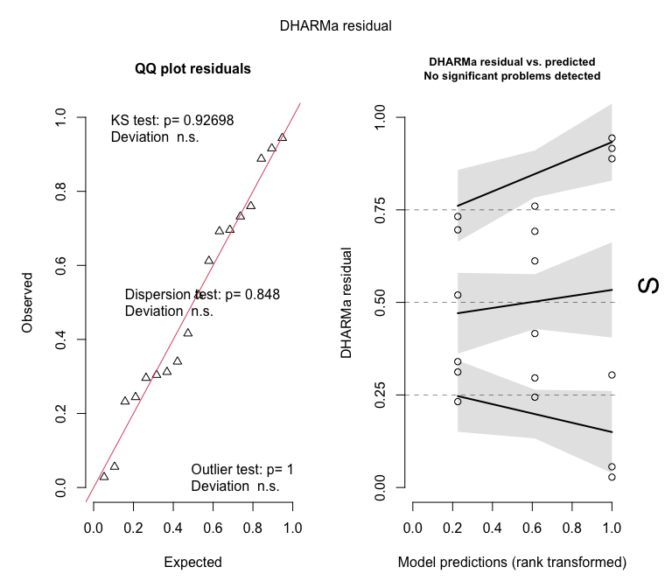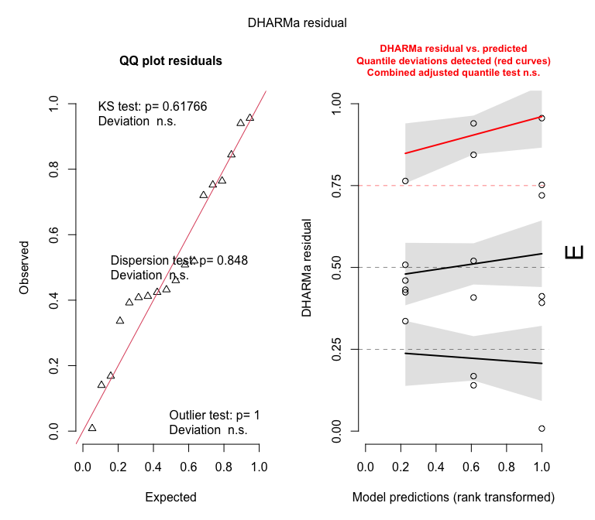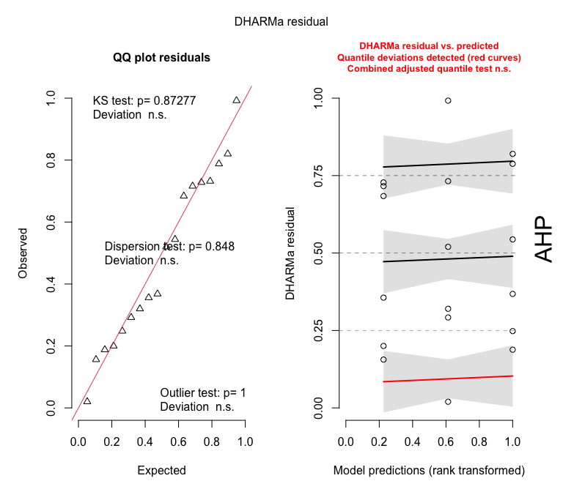

Diagnostic plots for dispersal data
##
## DHARMa: qgam was unable to calculate quantile regression for quantile 0.25. Possibly to few (unique) data points / predictions. The quantile will be ommited in plots and significance calculations.
##
## DHARMa: qgam was unable to calculate quantile regression for quantile 0.5. Possibly to few (unique) data points / predictions. The quantile will be ommited in plots and significance calculations.
