Temperature dependent dispersal: A distributed experiment
Celina Baines, Nicole Regimbal

Supplementary methods for Notonecta undulata

Author contributions
CB conceptualized the project. NR and CB designed the methodology. NR conducted the experiment and collected the data. CB conducted the statistical analysis. NR and CB wrote the supplementary material.

Acknowledgements
Funding was provided by a National Science and Engineering Council of Canada Discovery Grant awarded to CB.

Study organism
Our experiment used backswimmers (Notonecta undulata) that were field caught from experimental ponds at the University of Toronto’s Koffler Scientific Reserve (KSR; 44°01’N, 79°32’W) in King City, Ontario. Backswimmers are semi-aquatic insects that are common in freshwater ponds throughout North America (Hungerford 1919). In these habitats, backswimmers are voracious generalist predators that has strong impacts on community structure (Hungerford 1934, Blaustein et al. 1995). They also commonly exhibit opportunistic cannibalism (Zalom 1978). Backswimmers fly to disperse between patches of aquatic habitat (Hungerford 1934), but this process is energetically intensive (Baines et al. 2015) and requires a light cue (Essenberg 1915). At high temperatures, the predatory behaviors of backswimmers increase, imposing greater top-down effects on the community (Ingram and Burns 2018). At high temperatures, some species of backswimmer have shown an increase in paddling rate (Krishnan and Narayanan 2024), swimming duration (Bailey 1988) and swimming speed (Ferris and Wilson 2012).
Backswimmers for Phase 1 were sourced in May and individuals for Phase 2 were sourced in August. Prior to the start of the experiment, backswimmers were separated into individual holding containers, which they remained in throughout the duration of the experiment, at ambient temperatures to reduce stress for a minimum of 24 hours. Backswimmers in Phase 2 underwent 4 acclimation days in their temperature treatments prior to the dispersal assay. While acclimating, backswimmers were fed ad libitum. For Phase 1, we specifically used female adult backswimmers since we were measuring reproductive output. Phase 2 used any adult backswimmer regardless of sex.

Study design

Phase 1 - Fitness assay
We assessed the effects of temperature on survival, body condition, and reproductive rate for female backswimmers over a 2-week long fitness assay. Higher fecundity and survival are indicators of higher relative fitness. We manipulated water temperature in indoor mesocosms to 16℃, 22℃, 26℃, 28℃, and 30℃. The water temperature of warm treatments was manipulated using aquaria heaters. The 16℃ was manipulated by putting the mesocosms in coolers surrounded with ice packs that were replaced twice a day. This cooled the water temperature externally without adding ice directly into the water. The experiment was conducted in 2 temporally overlapping blocks. In the first block, 3 individually separated backswimmers were added to each mesocosm and in the second block 2 additional individually separated backswimmers were added to each mesocosm. Each temperature treatment had 8 replicates, totalling 48 mesocosms and 240 backswimmers. Each cup contained a black zip tie as structure for the backswimmer. Backswimmers lay white eggs on available structure, the black zip tie provides contrast which allows us to easily count eggs laid. Every other day for 2 weeks we removed and replaced the zip ties in each cup for data collection and to create room for more eggs to be laid. We recorded the number of eggs on each zip tie when it was removed. This data was used to create total reproductive output (total number of eggs laid) and reproductive rate (average number of eggs laid per day). Survival was assessed throughout the experiment. At the end of the experiment, we calculated body condition the backswimmer mass (g) divided by body size (thorax width, mm). Backswimmers were fed zooplankton and mosquito larvae which was replenished ad lib.

Phase 2 - Dispersal assay
The dispersal assay was conducted using an outdoor mesocosm field experiment. The temperatures 16℃, 26℃, and 30℃ were chosen for the dispersal assay with 6 replicates of each treatment (18 total mesocosms). For the 26℃ and 30℃ treatments, water temperature was manipulated using aquaria heaters. To keep the 16℃ treatment below ambient temperatures, the mesocosms were wrapped in insulation with ice packs between the insulation and mesocosm, the ice packs were switched out twice a day. Backswimmers were separated into individual cups throughout the experiment, with 13 backswimmers per mesocosm (234 backswimmers total). Dispersal is dichotomous and can be determined from the presence-absence of a backswimmer from a cup, if a backswimmer is absent it is assumed to have dispersed via flight. Backswimmers were labeled on one hemelytron with their assigned mesocosm number to identify if short distance dispersal (flight from between mesocosms) occurred. Backswimmers were fed zooplankton and mosquito larvae which was replenished ad lib. This phase used separate individuals from Phase 1, including randomly sampled adult backswimmers regardless of sex collected in August. Since interspecific interactions such as density (Baines et al. 2014) and cannibalism (Regimbal and Baines 2024) influence dispersal, the backswimmers remained individually separated to isolate the independent effects of temperature on dispersal. Backswimmers acclimated to their temperature treatments for 4 days, during which each backswimmer cup was covered with mesh to prevent dispersal and the mesocosms covered to prevent light cues which may induce dispersal attempts. The backswimmers then underwent a 2 week dispersal assay where the backswimmer containers were uncovered allowing dispersal to occur. We assessed dispersal and survival every day during this period.

Temperature treatments
For Phase 1, we chose 5 temperature treatments of 16℃, 22℃, 26℃, 28℃, and 30℃. Based on our results of how temperature affects reproduction in Phase 1, we chose the three temperatures of 16℃, 26℃, and 30℃; such that 26℃ is Topt.

Statistical Analysis

Does fitness change with temperature (phase 1)?
Fecundity was not normally distributed so we square-root-transformed it. The transformed variable followed a normal distribution.
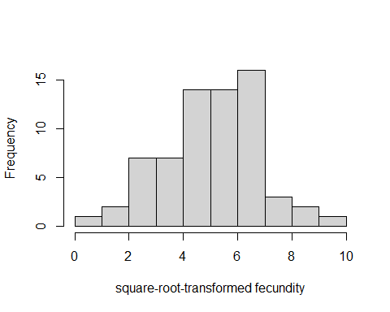
Figure 1. Histogram of square-root -transformed fecundity values.
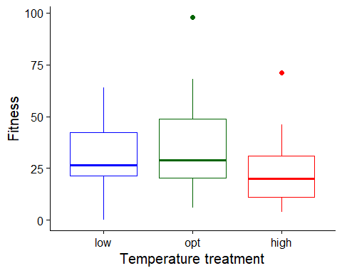
Figure 2. Boxplot of fitness ( fecundity ), as a function of temperature treatment. low = 16 C, opt = 26 C, high = 30 C.
To estimate the effects of temperature (a factor) on fitness, we used a linear mixed model with fecundity as the response variable. We used the formula:
sqrt(Fitness) ~ Temp.treatment + (1|Mesocosm)

Results for main effect of temperature on fitness
## Analysis of Variance Table
## npar Sum Sq Mean Sq F value
## Temp.treatment 2 11.516 5.758 2.1434

Post-hoc pairwise contrasts: differences in fitness between temperature treatments
## contrast estimate SE df lower.CL upper.CL t.ratio p.value
## opt - high 12.98 6.34 25.1 -0.0802 26.0 2.047 0.0513
## opt - low 7.72 6.50 23.5 -5.7121 21.1 1.187 0.2469
## high - low -5.26 5.79 23.5 -17.2313 6.7 -0.909 0.3726
##
## Degrees-of-freedom method: inherited from kenward-roger when re-gridding
## Confidence level used: 0.95

Does dispersal change with temperature (phase 2)?
To estimate the effect of temperature treatment (a factor) on dispersal, we used a generalized linear mixed model with a binomial error structure and a logit link. Dispersal (the number of dispersers vs non-dispersers) was the response variable. We used the formula:
Dispersed ~ Temp.treatment + (1|Mesocosm)
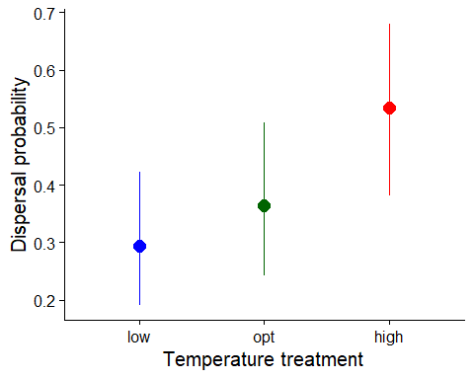
Figure 1. Dispersal as a function of temperature treatment. low = 16 C, opt = 26 C, high = 30 C. Error bars represent 95% confidence intervals predicted from GLMM.

Results for main effect of temperature on dispersal
## Single term deletions
##
## Model:
## Dispersed ~ Temp.treatment + (1 | Mesocosm)
## npar AIC LRT Pr(Chi)
## <none> 230.20
## Temp.treatment 2 231.29 5.0912 0.07843 .
## ---
## Signif. codes: 0 '***' 0.001 '**' 0.01 '*' 0.05 '.' 0.1 ' ' 1

Post-hoc pairwise contrasts: differences in dispersal between temperature treatments
## contrast odds.ratio SE df asymp.LCL asymp.UCL null z.ratio p.value
## opt / high 0.501 0.219 Inf 0.212 1.18 1 -1.578 0.1145
## opt / low 1.382 0.576 Inf 0.611 3.13 1 0.777 0.4372
## high / low 2.758 1.190 Inf 1.188 6.41 1 2.360 0.0183
##
## Confidence level used: 0.95
## Intervals are back-transformed from the log odds ratio scale
## Tests are performed on the log odds ratio scale

Model Diagnostics
There was no evidence for lack of fit for either the fitness or the dispersal model.

Diagnostic plots for fitness data
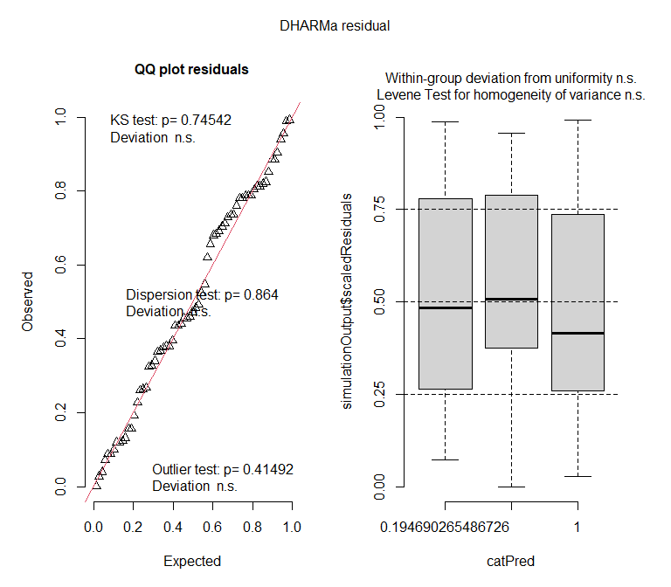

Diagnostic plots for dispersal data
