SP_TEMPLATE
Subtitle
Thiago R. Oliveira
14/02/2020
Abstract: test test test test test test test test test test test test test test test test test test test test test test test test test test test test test test test test test test test test test test test test test test test test test test test test test test test test test test test test test test test test.

Heading 1

R Markdown

Heading 3
This is an R Markdown document. Markdown is a simple formatting syntax for authoring HTML, PDF, and MS Word documents. For more details on using R Markdown see http://rmarkdown.rstudio.com.
When you click the Knit button a document will be generated that includes both content as well as the output of any embedded R code chunks within the document. You can embed an R code chunk like this:
summary(cars)
## speed dist
## Min. : 4.0 Min. : 2.00
## 1st Qu.:12.0 1st Qu.: 26.00
## Median :15.0 Median : 36.00
## Mean :15.4 Mean : 42.98
## 3rd Qu.:19.0 3rd Qu.: 56.00
## Max. :25.0 Max. :120.00

Including Plots
You can also embed plots, for example:
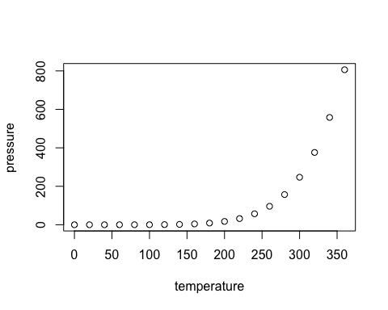
caption
Note that the echo = FALSE parameter was added to the code chunk to prevent printing of the R code that generated the plot. Test test test
test | test | Test
 |  | test
Test

Bullet points:
Point 1
- Point 2

Quote quote quote quote quote quote quote quote quote quote quote quote quote quote quote quote quote quote quote quote quote quote quote quote quote quote quote quote quote quote quote quote quote quote quote quote quote quote quote quote quote quote quote quote quote quote quote quote quote quote quote quote quote quote quote.

Footnote

