**The Lebanese Diaspora and the Refugees in Lebanon**

C. G. Fadel, M. L. Germanos.

Lebanon witnessed many waves of immigration throughout history due to the many wars and economic crises in the region. Moreover, many ethnic groups sought asylum in this country. These events helped spread the Lebanese culture through its diaspora abroad, as well as affected Lebanese society by accepting and learning from many cultures. In this project, we visualize these waves of immigration to and from Lebanon. We show the cumulative number of the Lebanese diaspora in every country and how it changed throughout the years. The project also recognizes the many successful people of Lebanese descent and lists them to show the impact the Lebanese diaspora has on the world. This project aims to shed light on the growing number of Lebanese immigrants, hoping to emphasize the necessity of new laws guaranteeing their easy return back home. Additionally, it aims to show the diversity and versatility of Lebanese immigrants as well as shed light on the growing number of refugees in Lebanon.

The source code of this project can be found on Github following the link: <https://github.com/celineFadel/Data-Visualization>

# Introduction

Emigration has loomed over Lebanon for centuries up till Since the declaration of Great Lebanon in 1920, the country witnessed many internal and regional conflicts, the most prominent one was the Lebanese Civil War that spanned two and a half decades[1]. The effects of these conflicts are still present.

With all of these conflicts, the Lebanese lost their sense of security, their economy, and their hope for a better future. This pushed some Lebanese families to seek better opportunities in other countries, leading to a significant human capital flight. These Lebanese immigrants form along with their descendants the large Lebanese diaspora.

On the other hand, despite all the instability, insecurity, and decaying economy in Lebanon, the country welcomed many refugees. In fact, according to the UNRWA, Lebanon has been recognized as the largest refugee-holding country per capita.

# The purpose of this research is to conceptualize the immigration patterns of Lebanon, understand the reasons that pushed the Lebanese to immigrate, the large spread of the Lebanese diaspora on the globe, and raise awareness on the increasing number of refugees in Lebanon. Additionally, we hope to raise the interest of the Lebanese immigrants in their home country and eventually encourage immigrants to return to their country of origin and to reconnect with their roots by introducing them to the large community of Lebanese diaspora. We also honor the many successful people of Lebanese descent that succeeded abroad in their respective fields. Finally, this research also aims to reveal how Lebanon is perceived as a haven for refugees in the Middle East as the increasing number of refugees in Lebanon shows how the country takes great responsibility for helping displaced people despite the country needing help itself.

In this report, we will explain the methods used for this project. We will talk about the datasets used to create the visualizations, the challenges we faced and the authors contribution.

# Existing work

Many organizations keep track of all the refugees around the globe along with different information about them. Such organizations include the United Nations (UN), where we found a large portion of our data sets on the Lebanese diaspora.

Other organizations such as the Lebanese American University (LAU) and Notre Dame University (NDU) have initiated research regarding this matter. NDU initiated and officiated the Lebanese Emigration Research in April 2003. This center is dedicated specifically to the study of migration where it is actively involved in worldwide academic conferences with its research papers.

LAU’s Department of Social Sciences established the Institute for Migration Studies in 2007. Ever since its foundation, the IMS has been interested in developing into an interdisciplinary research institute in the domain of migration as well as a resource center for graduate students and scholars interested in the effect of migration on Lebanon and countries abroad. IMS collaborates with governmental and non-governmental organizations that deal with diasporic migrant communities and migrant workers in the region.

Additionally, some research has been made about the Lebanese immigrants. [2] studied the reasons for youth emigration decisions, where this research focused on Lebanon where they collected a data set of the Lebanese youth in 2016 where their ages range from 15 to 29 years old. This paper aimed to identify the inclination to why emigrants left Lebanon. The empirical results show that the youth that is from a lower socioeconomic class that live in underdeveloped shelters have a higher inclination to leave the country. The study also shows that unemployed males are also more inclined to leave the country, and people who received university education show willingness to leave.

# Methods

This project tackled multiple topics. Therefore, multiple sources and datasets were gathered to form the final product. Most of these datasets needed pre-processing in order to obtain the desired knowledge.

# *Datasets*

First, when reporting the causes of immigration from Lebanon, multiple data sets offered by different resources were retrieved. In an attempt to show the fragile security that Lebanon and the region had, the Global Peace Index (GPI) and the Global Peace Ranking (GPR) of Lebanon across the years were extracted from [Country Economics](https://countryeconomy.com/demography/global-peace-index/lebanon). The GPR shows the rank of Lebanon among 163 countries, and the GPI is the calculated index used to do such ranking.

Then, the Gross Domestic Product (GDP) of the country was examined to study the economy of Lebanon. The dataset was retrieved from [the World Bank dataset](https://data.worldbank.org/indicator/NY.GDP.PCAP.KD.ZG?locations=LB), and shows the annual GDP per capita growth percentage.

Next, one dataset for the Lebanese diaspora was retrieved from [the UN](https://www.un.org/en/development/desa/population/migration/data/empirical2/migrationflows.asp). This data will be referred to as D1 in this report. In this dataset, each country had its own Excel sheet that tracked the immigrants coming from most countries of the world from 1982 till 2012. Another dataset, referred to as D2, was retrieved for the Lebanese diaspora containing information about the number of immigrants that left Lebanon from the year 1999 till 2016 from the [UN data bank](https://data.un.org/Data.aspx?q=refugees+in+lebanon&d=UNHCR&f=indID%3aType-Ref%3boriID%3aleb).

Finally, for the refugees that resided in Lebanon, another dataset was retrieved from [the UN](https://data.un.org/Data.aspx?q=refugees+in+lebanon&d=UNHCR&f=indID%3aType-Ref%3basyID%3aleb) listing the number of refugees that came to Lebanon from 1999 till 2016.

# *Preprocessing*

# The first two mentioned datasets, the ones containing information about the GDP and GPR of Lebanon, were taken as they are as they did not contain any irrelevant information.

# However, the remaining datasets required some data preprocessing to use them for different visualizations. D1 contained information about immigrants from most countries on the globe. Each country reported these numbers in an Excel sheet of its own. To amass the information of Lebanon alone, we iterate over all the Excel sheets and save the information about Lebanon in a stand-alone sheet. Then, the information from D2 was added to the data collected from D1. Some conflict of information was found between D1 and D2. This disagreement was resolved by taking the highest value of the two datasets as we considered that both of these datasets come from a reliable source, therefore a disagreement between the two might be due to missing values or a failure to annotate the proper count of Lebanese immigrants in the one with the smaller value. These datasets kept track of the number of immigrants that left Lebanon to country X in year Y. To compute the total number of immigrants in country X, the cumulative of all the recorded values for country X across the years was computed. The resulting dataset from combining D1 and D2 will be referred to as D3.

# Finally, for the refugees' dataset, the cumulative number of refugees from country T that resided in Lebanon was also computed by taking the sum of all the refugees that left T across the years. Additionally, the total number of refugees in Lebanon, regardless of country of origin, was computed. We noticed that this number increased exponentially in some years, therefore the values were divided by 1000 to make the visualizations more visually appealing. Further minor changes were performed on the data to fit the needs of every visualization, these methods will be listed under each visualization that used them.

# *Visualizations*

# In this work, we tried to incorporate an element of symmetry when visualizing the diaspora and refugees of Lebanon. Some visualization techniques were used for both such as Choropleth maps to show the distribution of the country of residence of the diaspora, and country of origin of the refugees. Simple line plots were also used to show the growing size of the Lebanese diaspora in a selected country of interest and the growing numbers of refugees in Lebanon. There is also the element of contrast were the visualizations pertaining to the Lebanese Diaspora were predominantly colored in shades of blue, whereas visualizations referring to the refugees were colored in red. The choice of blue for the Lebanese diaspora was to show the oceans that separate the scatter population of Lebanon, and to represent the same sky that unites them. The color blue is also calm in nature. On the other hand, red was chosen to represent the refugees as a to show the urgency in addressing the growing numbers of refugees in Lebanon, as well as a reminder that these people are seeking refuge in Lebanon due to war in their home country. Red was also chosen as it stands out from blue, so that the separation between visualizations relating to the Lebanese immigrants and others relating to the refugees in Lebanon can be made easily and rapidly.

All of the visualizations in this work focused on showing colors of different luminescence so that color blind people won’t find it difficult to analyze the visualizations. Additionally, most visualizations are interactive, showing simple information to the user so that they won’t get overwhelmed.

The first visualization that the user sees whenever they visit the website is a bar chart of the GPR of Lebanon across the years. GPR is a ranking system used to measure the security of a country. It ranks 163 nations according to its peacefulness. It can be noted in the visualization that Lebanon consistently ranks in the worst quartile, this enforces our previous statement that Lebanon lacked security. This visualization is interactive, when the user hovers over a bar, the GPR and GPI of the year the bar chart belongs to appears. The bar chart was chosen to visualize this data due to its simplicity, yet efficacity. The user can see the low rank that Lebanon has, they can understand that this country lacks peacefulness. The interactivity also offers additional information, namely the GPI, which is the index used to rank these countries and it ranges from 1 to 5, 5 being a peaceful country. Figure 1 shows this visualization.

**Figure 1** GPR of Lebanon.

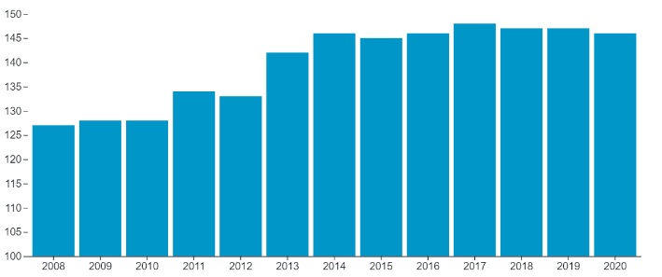

When the user scrolls. They are met with a line plot depicting the annual GDP change of Lebanon. This line plot shows the fluctuation of the GDP in the earlier years, thus indicating instability in the economy. The line plot then shows GDP close to zero in the remaining years. The user can hover over the line and see the GDP for corresponding years. This near asymptotic behavior on zero shows the dorming Lebanese economy.

This visualization was chosen to show the GDP, and many other values in the project as it is simple and straightforward. Figure 2 shows this visualization.

**Figure 2** GDP of Lebanon.

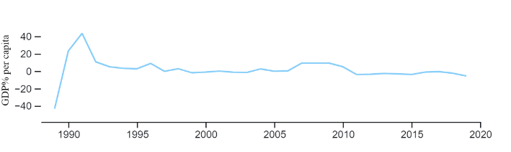

**Figure 3** Countries with most Lebanese immigrants population.

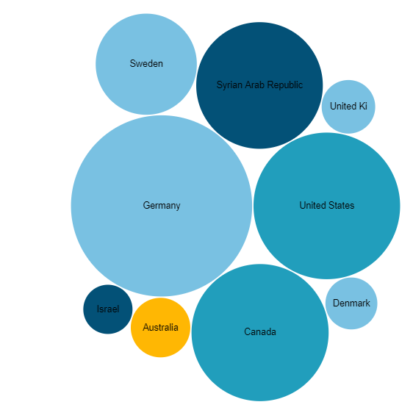

After tackling some of the causes that pushed the Lebanese to immigrate, the user can then see a bubble plot showing the countries with most Lebanese Diaspora density. The larger the bubble, the more Lebanese diaspora settled in this country. The circles are also colored according to region (North America, Middle East, etc…), this helps the user see the countries and regions with most Lebanese diaspora density. The user can also hover over a bubble to see the total number of diaspora living in the country. Figure 3 shows this visualization. The entire data D3 could not be visualized using this bubble chart as the total count of Lebanese Immigrant in each country widely varied. Therefore, if D3 was to be visualized entirely, then most countries would be represented with a tiny dot, and we could no longer locate these countries easiy.

This visualization represents the cumulative number of refugees in Lebanon throughout the years. The darker the red, the higher the number of refugees.

This visualization was chosen to show the major countries whose citizens seek refuge in Lebanon.

Based on this visualization, and keeping in mind the years, we are able to relate the number of immigrants in a current year-country combination, to the events happening in that country at that time. Based on the analysis, we can extract information about what makes Lebanon a destination for refuge seekers. It shows Lebanon’s qualities.

Visualizing our data using a map leads to a greater ability to more easily understand the countries that the refugees in Lebanon came from. It also allows us to compare the number of refugees across several countries at a glance, contextualizing our data in the real world.

This map displays geographical countries that are colored in relation to a numeric value, the number of refugees per country. It allows to study how the number of refugees in Lebanon changes throughout the years, what events caused it to increase and what events caused the number to drop.

The chosen attributes in the visualization are the countries of origin of the refugees in Lebanon and the number of these refugees in Lebanon, per year.

Those attributes were chosen because our aim is to show the hospitable nature of Lebanon.

In other words, we wanted to show the qualities that Lebanon has that attracted the people fleeing their countries. Hence, visualizing all the countries and showing them on a map makes it easier to see the difference in qualities of the home countries and Lebanon.  
Moreover, visualizing the years makes us understand what major events affected the refugee situation in Lebanon.  
And finally, the number of refugees makes it evident that Lebanon has reached its maximum hosting capacity.   
On another note, the color density allows us to see more clearly where the majority of our refugees come from.  
Ultimately, we chose the color red because it represents danger and also because it is a dramatic color.

This visualization represents the cumulative number of Lebanese immigrants per country from the year 1980 till the year 2016.

The data used to create this visualization is retrieved from the UN. Some countries might not be 100% accurate.

Why did we use map visualizations?

Visualizing our data using a map leads to a greater ability to more easily understand the distribution of the Lebanese diaspora's presence across countries. It also allows us to compare the number of immigrants across several countries at a glance. Contextualizing your data in the real world.

This map displays geographical countries that are colored in relation to a numeric value, the number of immigrants. It allows to study how the number of immigrants, evolutes throughout the years.

Why did we choose these attributes to be visualized?

The chosen attributes are the countries that hosted Lebanese immigrants and the number of these Lebanese immigrants in these countries, per year.

Those attributes were chosen because our aim is to treat the dilemma of Lebanon losing its youth and brains. So, with some analytics, as well as some other visualizations, we can relate the reason why at a specific year, this number of Lebanese people left their country. The number of immigrants per country is important to narrow down the possibilities of why these immigrants left. This means that through this visualization, we can select the countries with the highest number of diaspora because these countries must have what these people are looking for that Lebanon does not have.

# Discussion

In this project, we shed light on the growing number of Lebanese immigrants, hoping to emphasize the necessity of new laws guaranteeing their easy return back home. Additionally, it aims to show the diversity and versatility of Lebanese immigrants as well as the refugees in Lebanon.

This project sheds the light on the countries in which Lebanese immigrants found refuge, and the number of the immigrants per country throughout the years. It shows the countries that the Lebanese people find most fitting for their lifestyle. Also, it highlights the loss that Lebanon has been through since the loss of its people. We show how the Lebanese people can adapt and integrate in a community while aiding this community and shining in their respective fields.

Moreover, we show the countries whose people found asylum in Lebanon, and the number of these refugees per country throughout the years. By comparing Lebanon with the countries of the people that it hosts, we can find the qualities that the rest of the world admires about Lebanon.

While developing the project, we faced many challenges. Reliable datasets were very hard to find. And although we found some datasets, the data is missing. Not all countries keep track of the diaspora and therefore some of the numbers are not exact. This resulted in some missing values in our dataset.

Moreover, the brilliant Lebanese diaspora dataset was created from scratch. We were not able to find a dataset that represents the distinguished Lebanese diaspora.

We tried to contact multiple organizations that keep track of such data suck as [the Lebanese diaspora energy](https://www.lde-leb.com/), [information internationals](https://information-international.com/) and [Khayrallah Center for Lebanese Diaspora Studies](https://lebanesestudies.ncsu.edu/).

However, none of these organizations cooperated with us.

In the future, we aim for this project to be the push needed for the Lebanese diaspora to reconnect with their roots, and for the Lebanese polity to make an initiative with laws that encourage the diaspora to come back. Moreover, this visualization can lead, with the help of specialists to find out the reason that the Lebanese flee their country, and we are aiming to find a way to treat that so that Lebanon does not lose its people anymore.

On the other hand, refugees wise, the study can be continued so that it visualizes the refugee per capita ratio, and it shows its consequences on the Lebanese people. In return, we hope that the countries can help our Lebanon with this situation just like Lebanon helped many refugees find peace on its land.

# Conclusion

In this project, a world map was used to visualize the different waves of migration from and to Lebanon. The user is given the option of choosing between visualizing the movement of the Lebanese immigrants or the Lebanese refugees across the years. Color saturation will be used as a magnitude channel. All countries are colored using the same color, but with different saturation. When visualizing the movement of the Lebanese immigrants, a country with a dark color indicates that a large number of Lebanese diasporas that settled in this country. Whereas a light-colored country indicates that a small number of Lebanese citizens that live in it. Meanwhile, when visualizing the refugees that sought asylum in Lebanon, a country with a saturated color indicates that a large number of its citizens migrated to Lebanon.

The user will be able to track the immigration waves through the years with the varying reasons that caused the people to migrate and the total number of people that immigrated for each year.

Additionally, a section of the project will be reserved for the Lebanese diaspora and their accomplishments. The user will be able to select the country of interest and a list of successful people of Lebanese descent will be shown along with a summary of their accomplishments.

# Authors Contribution

The work for this project has been distributed evenly among the members of its group. One person specialized in the map visualization while the other developed the website. The work to implement the rest of the visualizations and to write the report was split evenly among the members.

# References

1. (25 April 2018). *Lebanon profile – Timeline*. BBC. https://www.bbc.com/news/world-middle-east-14649284

2. Dibeh, G., Fakih, A., & Marrouch, W. (2018). Decision to emigrate amongst the youth in Lebanon. *International Migration*, 56(1), 5-2.