JANUARY 2026 | STRATEGIC INTELLIGENCE
ANIMAL NUTRACEUTICALS
The Wellness Market at an Inflection Point
Mapping value creation across a $6 billion global industry
driven by pet humanization and the post-antibiotic transition

CONFIDENTIAL | FOR INTERNAL REVIEW

EXECUTIVE SUMMARY
The global animal nutraceutical market stands at a critical inflection point, valued at approximately USD 6 billion in 2024 and projected to exceed USD 10 billion by 2030. This growth is propelled by two powerful, converging megatrends: the inexorable humanization of companion animals in developed economies, and the regulatory-driven transition away from antibiotic growth promoters in livestock production.
This white paper provides a comprehensive analysis of the market structure, competitive dynamics, and investment thesis across both companion animal and livestock segments. We identify the key value pools, map the competitive landscape from ingredient suppliers to consumer brands, and highlight the strategic implications for investors and operators.
Our analysis reveals a "barbell" market structure: at one end, premium pet supplement brands command EBITDA margins of 20–25% through brand equity and veterinary endorsement; at the other, commodity ingredient suppliers operate on thin margins of 5–10%. The highest risk-adjusted returns lie in IP-protected ingredient platforms and vertically integrated players capturing multiple value chain layers.
The European and North American markets remain the value leaders, while Asia-Pacific—particularly China—represents the primary growth engine. The regulatory environment, particularly the EU's stringent feed additive framework and the global phase-out of antibiotic growth promoters, creates structural tailwinds for probiotic and functional feed solutions.
For investors, the sector offers compelling characteristics: recession-resilient demand (pet spending is notably inelastic), regulatory moats, and consolidation opportunities as the market professionalizes. However, entrants must navigate channel fragmentation, evidentiary requirements for efficacy claims, and the competitive pressure from integrated pharmaceutical players expanding into preventive care.

TABLE OF CONTENTS
I. Definition, Scope and Structural Dynamics 4
II. Functional Segmentation and Clinical Validation 12
III. Market Structure and Value Capture 24
IV. Competitive Landscape Analysis 52
V. Investment Thesis and Transactions 68

Master White Paper: The Animal Nutraceutical Landscape (2024-2030)

Executive Summary
Nutraceuticals are formulated preparations intended to address specific dietary requirements and offer therapeutic benefits. First defined by Dr. Stephen De Felice in 1989 as a portmanteau of "nutrition" and "pharmaceutical," these products encompass foods or food components that aid in the prevention and treatment of disease, extending beyond basic nutritional supplementation.
The field of nutritional science has expanded significantly, shifting focus from merely anticipating nutrient deficiencies to addressing chronic ailments. Despite this progress, regulatory authorities have not established a sharp demarcation between nutraceuticals and related categories such as food or dietary supplements. Consequently, contemporary literature advocates for a redefinition of nutraceuticals that prioritizes rigorous assessment of their safety profile, toxicity, and clinical efficacy.
Definition, Scope and Structural Dynamics
I.1. Terminology
The term nutraceutical is a fusion of "nutrition" and "pharmaceutical," coined in 1989 to describe food or food derivatives that provide health benefits, such as the prevention or treatment of disease, beyond basic nutrition. This common terminology is central to the market but lacks a harmonized legal definition, forcing many products into a regulatory "grey area between pharmaceuticals and food. In the context of intensive farming, most health-focused products fall under the rigorous regulation applied to feed additives, defined as substances intentionally incorporated into animal feed or water to improve its quality, enhance animal health and performance, or improve the quality of food derived from animals. The European Union (EU) provides a strict framework (Regulation (EC) No 1831/2003), classifying functional ingredients into specific categories, including zootechnical additives, which offer performance-enhancing, non-nutritive benefits like promoting gut flora stability or increasing digestibility. In contrast, the United States typically forces these products into a binary choice between "food" (if Generally Recognized As Safe or GRAS) or a fully regulated "new animal drug" (if therapeutic claims are made). This intense regulatory friction has spurred recent US legislative attempts, such as the proposed Innovative FEED Act (H.R. 2203/S. 1906), aiming to create a clearer pathway for "zootechnical animal food substances" to gain market approval as food additives rather than facing the long and costly drug application process. This fundamental international divergence in classification and required scientific evidence establishes a highly complex environment for manufacturers, necessitating a detailed review of the Regulatory Landscape by Region.
I.2. Regulatory Landscape by Region
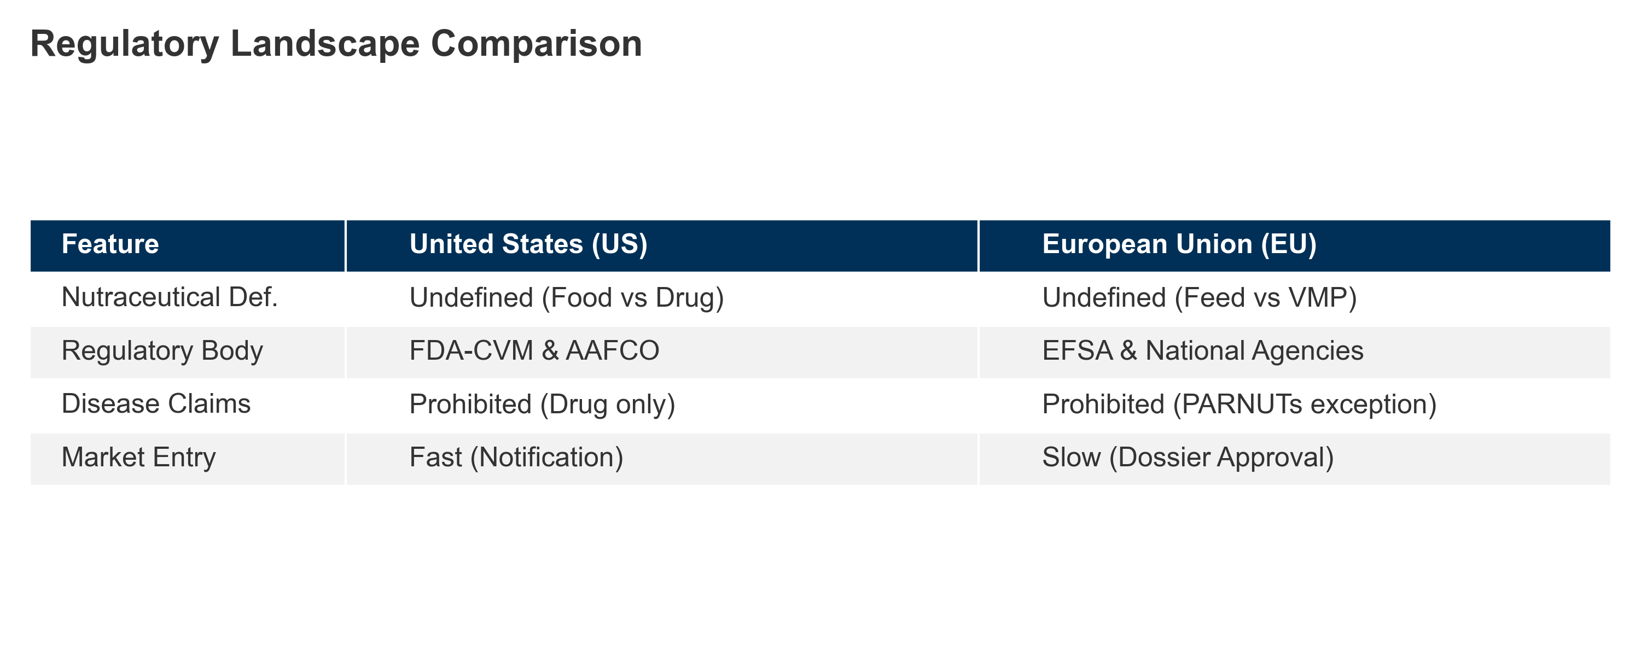
Table 1: US vs EU Regulatory Comparison
I.2.1. United States (US)
I.2.1.1. NUTRACEUTICALS
No formal regulatory category for "veterinary nutraceuticals": Unlike the human sector, where the Dietary Supplement Health and Education Act (DSHEA) of 1994 created a distinct legal class for supplements, the FDA Center for Veterinary Medicine (CVM) has explicitly determined that DSHEA does not apply to animal products. Consequently, there is no legal definition for "veterinary nutraceuticals." Products are classified strictly as either "animal food" (feed) or "new animal drugs" based on their intended use. This binary framework forces manufacturers to market supplements as "food" to avoid the prohibitive costs and multi-year timelines associated with the New Animal Drug Application (NADA) process required for pharmaceutical approval.
Companion animal supplements fall under FDA-CVM and AAFCO guidelines: Historically, the FDA-CVM and the Association of American Feed Control Officials (AAFCO) operated under a Memorandum of Understanding (MOU) to harmonize ingredient approvals. However, this partnership dissolved on October 1, 2024, creating a fractured regulatory environment.
Federal Review (FDA): The FDA now independently reviews new ingredients through the Animal Food Ingredient Consultation (AFIC) process (GFI #294). Successful review results in a "Consultation Complete" letter, granting federal enforcement discretion.
State Review (AAFCO): In parallel, AAFCO has launched the Scientific Review of Ingredient Submissions (SRIS) pathway, managed by Kansas State University, to vet ingredients for inclusion in the AAFCO Official Publication, which is legally adopted by most states.
Note: The "PURR Act of 2025" (H.R. 597) has been introduced in Congress to potentially centralize this authority solely under the FDA, though it faces opposition from state regulators.
I.2.1.2. FEED ADDITIVES
Products marketed as feed additives must use approved ingredients; therapeutic claims trigger drug classification: To remain compliant as "food," products must strictly adhere to ingredient and labeling standards:
Ingredients: Manufacturers must use ingredients that are Generally Recognized As Safe (GRAS), approved food additives, or listed in the 2024 AAFCO Official Publication (protected under FDA GFI #293 enforcement discretion). AAFCO also maintains a "Common Food Index" for standard items like vegetables to clarify their status without full definition.
Labeling Claims: Marketing is restricted to "structure/function" claims (e.g., "supports joint health"). Any claim to diagnose, cure, mitigate, treat, or prevent disease ("treats arthritis" for example) classifies the product as an unapproved new animal drug, rendering it adulterated under the FD&C Act.
I.2.1.3. FOOD SUPPLEMENTS
NASC (National Animal Supplement Council) labeling is a voluntary standard used in pet supplements: Given the lack of a formal "supplement" category, the National Animal Supplement Council (NASC) fills the regulatory void through rigorous self-regulation.
Quality Seal: To display the NASC Quality Seal, companies must pass third-party facility audits ensuring compliance with current Good Manufacturing Practices (cGMPs) under FSMA (Food Safety Modernization Act).
Adverse Event Reporting: Members are required to participate in the NASC Adverse Event Reporting System (NAERS), sharing post-market safety data with the FDA-CVM to demonstrate product safety and transparency. This voluntary compliance is widely viewed by the industry as a "shield" against enforcement action for products operating in the regulatory grey area.
I.2.2. European Union (EU)
I.2.2.1. A STRICT BINARY SYSTEM: THE ABSENCE OF A "NUTRACEUTICAL" STATUS
The European Union operates under a rigid legal framework that does not recognize the term "nutraceutical." A product is classified strictly as either a Feed (subject to feed law) or a Veterinary Medicinal Product (subject to drug law). There is no "middle ground" legal category like dietary supplements for humans.
I.2.2.2. FEED MATERIALS VS. FEED ADDITIVES: A CRUCIAL DIDACTIC DISTINCTION EXISTS WITHIN THE "FEED" CATEGORY.
Feed Materials: Natural ingredients used for nutrition (e.g., glucosamine, chondroitin sulphate, yeast) are regulated under Regulation (EC) No 767/2009. They generally do not require pre-market authorization, provided they are safe and listed in the EU Catalogue of Feed Materials (Regulation (EU) No 68/2013).
Feed Additives: Substances added for a specific technological, sensory, or nutritional function (e.g., pure vitamins, preservatives, trace elements) are governed by Regulation (EC) No 1831/2003. These require a rigorous, expensive pre-market authorization and must be explicitly listed in the Community Register of Feed Additives.
I.2.2.3. ZOOTECHNICAL ADDITIVES
The "Performance" Category Unlike the US, the EU has established a specific, highly regulated category for ingredients that affect animal physiology: Zootechnical Additives (Category 4 under Reg. 1831/2003). This includes gut flora stabilizers (probiotics) and digestibility enhancers (enzymes).
Efficacy Requirement: To obtain this classification, manufacturers must submit a dossier to the European Food Safety Authority (EFSA) proving not only safety but also efficacy. They must demonstrate valid scientific evidence that the additive significantly improves the animal's performance or welfare. This provides a legal route for performance claims that would otherwise be considered "medicinal."
I.2.2.4. CLAIMS LANDSCAPE: THE PROHIBITION OF MEDICINAL CLAIMS AND THE "PARNUTS" EXCEPTION
The marketing of supplements is defined by a strict "Negative Scope": feed cannot claim to treat, prevent, or cure disease. Making such a claim reclassifies the product as a Veterinary Medicinal Product (VMP) by presentation, triggering the heavy compliance burden of Regulation (EU) 2019/6.
Functional Claims: Products may make "functional" claims (e.g., "Supports joint health") if they are substantiated by science, as outlined in the FEDIAF Code of Good Labelling Practice.
The PARNUTs Exception: The only legal exception allowing diet-disease linkage is for Feeds for Particular Nutritional Purposes (PARNUTs), regulated under Regulation (EU) 2020/354. This regulation provides a "positive list" of permitted dietetic claims for specific conditions ("Support of renal function in cases of chronic renal insufficiency" for example). If a condition is not on this list, no disease-related claim can be made.
I.2.2.5. FOCUS ON SAFETY AND ENVIRONMENTAL RISK ASSESSMENT (ERA)
Under the "Farm to Fork" strategy, the authorization of additives requires a comprehensive Environmental Risk Assessment (ERA).
The Phase I/II System: EFSA employs a tiered approach. If the Predicted Environmental Concentration (PEC) of an additive in soil or water exceeds specific trigger values (e.g., 10 µg/kg in soil), the applicant must conduct Phase II ecotoxicity studies on non-target organisms (e.g., earthworms, algae, fish). This is particularly critical for additives used in aquaculture or intensive livestock farming, where environmental accumulation is a key regulatory concern.
Quality Standards: To ensure traceability and safety across the supply chain, operators often adhere to third-party certification schemes like FAMI-QS (for additives) or GMP+, which enforce standards often exceeding statutory requirements.
I.2.3. United Kingdom (UK)
I.2.3.1. POST-BREXIT REGULATORY AUTONOMY
Following its withdrawal from the European Union, the UK has repatriated full regulatory sovereignty, transitioning from EU-dependent structures to independent national oversight. While the legal foundation remains "Assimilated Law" (formerly Retained EU Law) derived from EU regulations, the UK has begun to actively diverge to suit domestic needs. This new framework is primarily governed by the Veterinary Medicines Regulations (VMR) 2013, which were comprehensively modernized by the Veterinary Medicines (Amendment etc.) Regulations 2024.
The Dual Authority Structure: Responsibility is strictly divided. The Veterinary Medicines Directorate (VMD) oversees veterinary medicines and the "borderline" with supplements, while the Food Standards Agency (FSA) and Food Standards Scotland (FSS) regulate feed additives and feed safety.
The Windsor Framework Challenge: A unique complexity exists regarding Northern Ireland (NI). Under the Windsor Framework, NI remains subject to EU veterinary medicine laws (Regulation (EU) 2019/6) to prevent a hard border on the island of Ireland. This creates a "dual regime" where manufacturers must navigate UK rules for Great Britain (England, Scotland, Wales) and EU rules for Northern Ireland, complicating supply chains for companies operating UK-wide.
I.2.3.2. THE VMD AND THE STRICT "MEDICINE VS. FEED" BOUNDARY
Similar to the EU and US, the VMD does not recognize the term "nutraceutical" as a legal category. A product is classified strictly based on its presentation and function, as detailed in the VMD's Guidance Note 14.
Medicinal Claims: Any product presented as treating, preventing, or curing a disease, or which modifies physiological function through pharmacological action, is classified as a Veterinary Medicinal Product (VMP). Marketing such a product without a Marketing Authorization (MA) is a criminal offense.
The Small Animal Exemption Scheme (SAES): A distinct and commercially vital feature of the UK landscape is the SAES (Schedule 6 of the VMR). This scheme allows for the marketing of certain medicines for "minor" pet species (such as aquarium fish, cage birds, and small rodents—but notably not dogs or cats) without the prohibitive cost of a full Marketing Authorization, provided they meet strict safety and labeling criteria.
I.2.3.3. FEED ADDITIVES AND SUPPLEMENTS: FSA CONFORMITY AND THE 2025 REFORMS
Functional ingredients that are not medicines fall under the jurisdiction of the FSA/FSS. Post-Brexit, the UK replaced the EFSA authorization route with its own Regulated Products Application Service.
Accelerated Approvals (April 2025 Reform): the UK government implemented significant reforms in April 2025. Most notably, the FSA abolished the requirement for 10-year renewals of feed additive authorizations. The UK regulator deemed this EU-inherited process to be administratively burdensome with little safety benefit. By removing this hurdle, the FSA aims to free up regulatory capacity to assess new innovative ingredients faster, potentially making the UK a more agile market for novel feed technologies than the EU.
I.2.3.4. FUTURE OUTLOOK: AN INDEPENDENT PATH FOR INNOVATION
The UK is positioning itself as a testbed for regulatory innovation. The 2024 VMR amendments introduced some of the world's strictest controls on antimicrobial resistance (AMR), including mandatory data reporting on antibiotic usage. Simultaneously, the streamlined authorization process for feed additives allows approvals to be granted by Ministerial decision and published directly in a register, bypassing the lengthy legislative voting process required in Brussels. Manufacturers targeting the UK must now build a strategy that leverages these streamlined pathways for Great Britain while managing the separate compliance requirements for Northern Ireland.
I.3. Scope of Analysis
This report examines the veterinary nutraceutical landscape through the dual lens of physiological function and regulatory status. As definitions remain blurred between supplements, functional feeds, and drugs, establishing clear analytical boundaries is essential to avoid semantic and commercial ambiguity.
I.3.1. What Is Included
The analysis focuses on functional bioactive compounds that go beyond basic nutritional support, aiming to modulate physiological processes related to joint health, gut function, immune resilience, cognition, and behavioural balance. These products are typically integrated into delivery systems tailored to species-specific compliance and bioavailability constraints.
I.3.1.1. DELIVERY SYSTEMS ACROSS SPECIES
Companion animals (palatability-driven): In dogs and cats, product success often hinges on owner compliance. According to 2023 consumer research, only ~15% of pet owners prefer tablets, while soft chews account for nearly 59% of preferred supplement formats due to their treat-like appeal. Other viable formats include powders (for dosage flexibility), liquids, and functional gels.
Horses (routine-driven, precision and practicality):
In equine, nutraceutical delivery sits between the pet and production models. Daily feeding routines make top-dressed powders, pellets, and balancers the dominant formats, because they allow repeatable dosing without pill administration. For situations where timing matters (competition, transport, acute stress windows), oral pastes/syringes and concentrated liquids are frequently preferred to ensure rapid administration and reduce “feed refusal” risk. In practice, equine products also need tighter attention to batch consistency, traceability, and label discipline, because professional users (trainers, yards, sport-horse owners) expect predictable outcomes and conservative ingredient profiles.
Livestock and aquaculture (efficiency-driven): In production animals, delivery formats are engineered for integration into industrial feed or water systems. These include:
Premixes, typically incorporated at 0.5–4% inclusion rates, enabling uniform distribution of concentrated actives.
Microencapsulation, used especially in ruminants, protects sensitive compounds (e.g., amino acids, enzymes) from ruminal degradation, ensuring targeted intestinal release.
Water-soluble powders, deployed during stress phases (e.g., heat stress or weaning), when feed intake drops but water consumption persists.
Boluses, high-density tablets retained in the reticulorumen, allowing slow release over weeks or months — commonly used for minerals and long-acting actives in cattle (León-Cruz & Ramírez-Bribiesca, 2020).
I.3.1.2. FUNCTIONAL TARGETS OVER GENERAL NUTRITION
This report prioritizes ingredients with a defined therapeutic or physiological objective, such as modulating inflammation, microbiota composition, neurotransmission, or oxidative stress. These products differ from basic feed additives or multivitamins by their mechanistic specificity, evidence-backed functionality, and regulatory sensitivity.
While precise ingredient analysis is provided in later sections, categories include bioactives targeting:
Joint and mobility support
Gut health and feed conversion
Anxiety and cognitive aging
Immune system priming in production settings
I.3.2. What Is Excluded
To maintain analytical precision, the following categories are out of scope — though they may influence adjacent market dynamics:
Prescription veterinary pharmaceuticals, such as NSAIDs or antimicrobials, which are regulated separately as New Animal Drugs (FDA) or VMPs (EU/UK)
Agricultural commodities (corn, soybean meal, etc.) used for bulk caloric or protein input, unless functionally enhanced
General multivitamin blends without a clearly defined health indication (e.g. “insurance” formulations for micronutrient adequacy)
Human dietary supplements, which are not legally recognized under veterinary frameworks like DSHEA (1994) and often contain ingredients toxic to animals — e.g. xylitol or excessive vitamin D (FDA, 2021; AVMA, 2019)
Regulatory Landscape by Region
II. Functional Segmentation, Use Cases, Drug-Sparing Logic, and Clinical Validation
The industry has pivoted from commodity feeding to precision biological optimization; The market is now structured around a functional architecture, creating distinct value pools based on the specific physiological pathway being targeted. Part II deconstructs this framework into two distinct functional layers. First, we analyze the Biological Core (II.1–II.7), a massive physiological engine where the foundational mandate of Performance & Efficiency ($7.1 billion) is now reinforced by targeted 'system support'—ranging from the $5.6 billion Gut Health sector replacing antibiotics, to the $2.9 billion Mobility and $1.4 billion Behavioral markets driven by the 'humanization' of companion animals. Building upon this biological foundation, we examine the Strategic Enablers (II.8–II.11) that differentiate and protect these investments: the $3.5 billion Bio-Defense infrastructure, the $1.0 billion Natural Parasite shield, and the $7.7 billion Delivery Technology layer that ensures biological availability. Capped by the emerging $3.35 billion 'Green Claim' Economy, this structure maps the industry’s evolution from a commodity volume business to a precision technology stack, where every additive serves a definitive clinical or procurement objective.
II.1. Mobility and Joint Health
Joint health remains the dominant category in the companion animal sector, accounting for approximately 30–34% of the total pet supplement market, valued at over $2.9 billion globally in 2024. The global pet joint health supplements market size reached USD 1.42 billion in 2024, demonstrating robust expansion driven by increasing pet ownership and heightened awareness of animal health. The market is projected to grow at a CAGR of 7.1% from 2025 to 2033, with the total market value expected to reach USD 2.64 billion by 2033. While glucosamine remains the volume leader due to decades of consumer conditioning and ubiquitous presence in pet food formulations, revenue growth is disproportionately fueled by high-value, low-volume actives designed to spare NSAID usage. Ingredients such as Undenatured Type II Collagen (UC-II), Omega-3 fatty acids (specifically EPA and DHA), and Green Lipped Mussel (GLM) are capturing market share by offering superior mechanisms of action—such as oral tolerance and direct COX/LOX pathway inhibition—combined with better compliance profiles
The Glucosamine Paradox (Volume Leader / Low Evidence): The market is currently defined by a "Glucosamine Paradox"—while this ingredient commands a dominant 52% share of the canine joint sector, its position is sustained by consumer psychology rather than clinical rigor. Systematic reviews consistently classify its analgesic efficacy as Level B/C (weak or mixed). Consequently, Glucosamine functions primarily as a low-cost "commodity backbone" for multi-ingredient formulations, with revenue growth flattening as the market pivots toward more potent, evidence-based actives.
Undenatured Type II Collagen (UC-II) (High Growth / High Efficiency): UC-II represents a fundamental paradigm shift in formulation, moving from the "grams" required for traditional building blocks to the "milligrams" used for immunomodulation. Validated by Level A/B evidence, its mechanism of "oral tolerance" allows for highly compliant low-dose formats (e.g., 40mg/day). With a projected CAGR exceeding 8%, UC-II is rapidly capturing market share as a premium, scientifically superior alternative to legacy ingredients.
Omega-3 Fatty Acids (Revenue Leader / Gold Standard): Generating over $1.2 billion globally, EPA/DHA stands as the industry's "Gold Standard" and is the only nutraceutical with Level A evidence for NSAID-sparing effects. Its market dominance is reinforced by a unique "halo effect," where its anti-inflammatory properties bridge two massive functional categories: Mobility (pain reduction) and Dermatology (atopy management).
Green Lipped Mussel: This $170 million segment is expanding at a steady 7.9%, yet it remains characterized by high product variability. Clinical efficacy (Level B) is volatile and strictly dependent on cold-processing to preserve bioactive lipids. This reality has created a distinct market tiering: premium stabilized lipid extracts that deliver clinical results versus generic defatted powders that function largely as ineffective commodities.
II.2. Gut Health and Microbiome Modulation
Driven by the global 'Post-Antibiotic' mandate in livestock, this is the fastest-growing sector in animal nutrition. The objective has moved beyond simple digestion to achieving 'eubiosis'—a stable microbiome that resists pathogen colonization. This category is dominated by 'biotics' (pre-, pro-, post-, and synbiotics) and enzymatic tools designed to optimize feed efficiency and replace pharmacological zinc oxide and antibiotics in production systems. Underscoring the magnitude of this biological shift, the global gut health probiotic, prebiotic, and postbiotic market size reached USD 62.4 billion in 2024, reflecting robust expansion driven by increasing consumer awareness and scientific advancements in digestive wellness. The market is set to experience a significant compound annual growth rate (CAGR) of 8.1% from 2025 to 2033. By 2033, the market is forecasted to reach an impressive USD 120.4 billion, propelled by rising demand for functional foods, personalized nutrition, and a growing focus on preventive healthcare. Within this massive ecosystem, the global animal feed probiotics market alone is valued at $5.6 billion (2024). In companion animals, probiotics now rival joint supplements, holding ~38.4% of the pet supplement market share. The trend is moving rapidly from simple live bacteria to Postbiotics (inanimate microorganisms) due to their stability in extruded feed and consistent immunomodulatory effects.
The Probiotic Super-Category
Probiotics dominate the gut health sector, commanding a 38.4% market share in pets. Their success is driven by a unique consumer feedback loop: owners see immediate improvements in stool quality, which builds intense brand loyalty. Clinical "Gold Standards" like Enterococcus faecium SF68 (Purina) and Bifidobacterium animalis AHC7 are now non-pharmacological staples, proven to shorten acute diarrhea and reduce reliance on metronidazole.
In the $6.9B livestock sector, probiotics function as biological barriers. Through competitive exclusion, they physically occupy receptor sites on the gut epithelium, preventing pathogens like Salmonella or E. coli from attaching. Advanced spore-forming probiotics (e.g., Bacillus subtilisfrom Novonesis or B. amyloliquefaciens from Evonik) have become industry essentials; unlike traditional bacteria, these "dormant" spores survive the high-heat pelleting process and activate only once inside the animal's gut, ensuring 100% therapeutic delivery.
Prebiotics & Synbiotics: The "Survival Pack" Strategy
While probiotics introduce beneficial species, Prebiotics act as selective "fertilizers." Advanced prebiotics like Mannan-Oligosaccharides (MOS) and Inulin (Beneo) function as functional decoys; they mimic intestinal receptors to trap harmful bacteria, which are then flushed out harmlessly. Commercially, they are vital as stable, low-cost antibiotic alternatives. The strategic frontier is the Synbiotic—a synergistic pairing of a strain with its specific fuel (e.g., Protexin’s pairing of E. faecium with FOS/Gum Arabic). By providing a "packed lunch" for the bacteria, synbiotics bridge the colonization gap, ensuring survival in hostile, acidic environments and allowing brands to command premium "clinical-grade" pricing.
The Economic Imperative of Enzymes
In livestock, enzymes are driven by margins. Phytase is utilized in 90% of global poultry diets to unlock bound phosphorus from grains. This reduces the need for expensive inorganic supplements and lowers environmental phosphorus excretion, making it an inelastic commodity generating $600M+ annually. In companion animals, the $2.1B market focuses on managing pancreatic insufficiency (EPI) and enhancing nutrient density for senior pets.
The Emergence of Postbiotics
Postbiotics—inanimate microorganisms or their metabolites—address the primary flaw of live probiotics: Stability. Since they are not live, they survive the high-heat pelleting and extrusion processes of feed manufacturing. Representing a $229M pet niche in 2024, they deliver consistent immunomodulatory benefits (via peptidoglycans) without the viability risks of traditional cultures, making them the ideal solution for shelf-stable kibble and commercial feed.
II.3. Immunity and Resilience
Driven by the intensification of aquaculture and the global mandate to reduce antibiotic usage in livestock, the Immunity and Resilience sector has emerged as the biological shield of modern animal production. In the companion animal market, this sector has reached a valuation of approximately $2.67 billion (2025/26), accounting for roughly 25% to 35% of the total pet supplement market.The objective has moved beyond reactive disease treatment to achieving 'immune competence'—a primed and responsive system capable of resisting pathogen colonization during critical stress windows like weaning and transport. This category is dominated by biological response modifiers—specifically marine polysaccharides, functional proteins, and nucleotides—designed to bolster innate defenses and optimize vaccine efficacy without pharmacological intervention. The market is currently anchored by Seaweed and Polysaccharides, valued at $4.46 billion (2023), which command a massive 51.7% share of the segment due to their dual role in immune modulation and oxidative stress management. Meanwhile, functional proteins like Spray-Dried Plasma ($2.20 billion) have become indispensable in swine production, while precision tools like Nucleotides are rapidly gaining traction for their ability to support rapid cell proliferation during growth challenges.
II.4. Cognitive Support and Aging
Propelled by the 'humanization' of companion animals and the unprecedented extension of pet lifespans, the Cognitive Health and Senior Care sector has evolved from palliative geriatric support to proactive neuroprotection. The clinical objective is to delay the onset of Canine Cognitive Dysfunction (CCD) and maintaining social engagement in aging pets. Landmark studies have shown that diets enriched with 6.5% Medium-Chain Triglycerides (MCTs) significantly improve cognitive scores (DISHAA) in senior dogs by providing ketone bodies as an alternative cerebral fuel source (Pan et al., 2010; Pan et al., 2018). As of 2026, the global market for pet cognitive and anti-aging solutions has reached $1.35 billion, representing approximately 10% to 12% of the total pet supplement market. The market is currently anchored by Medium Chain Triglycerides (MCTs), valued at $450 million, which command a leading 34.9% share of the segment due to their clinically proven role in providing alternative energy sources for the aging brain. Closely following are DHA ($350 million) and Antioxidant-Enriched Diets ($300 million), which together form the foundational standard of care for neuro-preservation. Meanwhile, specialized compounds like SAMe ($100 million) and Phosphatidylserine remain high-value veterinary tools, primarily deployed for targeted intervention in advanced cases of cognitive decline.
II.5. Calming and Behavioral Wellness
Behavioral Wellness is the fastest-growing segment of modern veterinary care, responding directly to the pressures of urbanization and the widespread increase in post-pandemic separation anxiety."The objective has moved beyond reactive sedation to achieving 'emotional resilience'—a balanced neurochemical state capable of managing environmental stressors without compromising alertness. This category is dominated by 'anxiolytic stacks'—specifically multi-ingredient complexes, bioactive peptides, and phytocannabinoids—designed to modulate neurotransmission and replace pharmaceutical sedatives in mild-to-moderate cases. Underscoring the magnitude of this shift, the broader pet calming product market (including functional treats and hardware) is estimated at over $1.4 billion, reflecting a massive consumer demand for non-pharmaceutical stress solutions. Within this ecosystem, the strict nutraceutical segment alone generates $350–$450 million, accounting for 10–14% of the total pet supplement market. Reflecting the urgent demand for non-pharmaceutical solutions, this therapeutic sector is set to experience a robust compound annual growth rate (CAGR) of 10.7% through 2034, significantly outpacing the broader pet care industry. The market is currently anchored by Multi-ingredient Calming Complexes ($500 million), which command a massive 45.5% share of the segment due to their convenience and synergistic formulations. Meanwhile, CBD and Hemp derivatives ($330 million) have become a dominant force in pain-anxiety management, while precision tools like Alpha-casozepine and L-Theanine are gaining traction for their clinically validated ability to deliver 'non-drowsy' anxiolysis during situational stress."
II.6. Performance, FCR (Feed Conversion Ratio), and Growth
Under the twin pressures of volatile raw material costs and stringent environmental regulations, the Performance and Growth sector has undergone a fundamental paradigm shift. The objective has moved beyond simple 'weight gain' to achieving Precision Efficiency—extracting maximum nutritional value from every gram of feed to minimize metabolic waste and nitrogen excretion. This category is characterized by the replacement of crude biological accelerators (antibiotic growth promoters) with highly specific enzymatic and nutritional tools that unlock bound nutrients and optimize feed conversion ratios (FCR). Performance, FCR, and Growth nutraceutical segment is valued at approximately $7.1 billion and accounts for 16% of the total pet supplement market. Reflecting the industry's pivot toward high-tech efficiency, this segment is projected to grow at a Compound Annual Growth Rate (CAGR) of 7% through 2034, significantly outpacing the general feed market. The sector is currently anchored by Yeast Culture ($2.00 billion), which commands a leading 28.2% share due to its proven ability to stabilize rumen function. This is closely followed by Rumen Protected Amino Acids ($1.20 billion) and Xylanase enzymes ($1.00 billion), which have become indispensable for 'precision nutrition'—ensuring that limiting nutrients are delivered intact to absorption sites, thereby reducing both feed costs and the environmental footprint of production."
Feed Conversion Ratio (FCR) is the definitive metric for production efficiency in animal agriculture, quantifying the exact mass of feed required to produce one unit of output (typically weight gain). Mathematically defined as FCR = Total Feed Intake / Total Weight Gain, a lower ratio indicates superior performance, signifying that the animal is converting raw ingredients into protein with minimal metabolic waste. In the modern nutraceutical landscape, FCR has evolved from a simple cost-control metric to a primary sustainability benchmark; tools like enzymes and probiotics are specifically engineered to lower this ratio, ensuring that expensive feed nutrients are biologically utilized rather than excreted into the environment.
II.7. Special Niches
Fueled by the demand for 'functional aesthetics' in aquaculture and 'visible vitality' in pets, the Special Niches sector targets precise phenotypic outcomes rather than generic health. Valued at approximately $1.75 billion, this category is overwhelmingly anchored by Astaxanthin ($1.35 billion)( role in pigmentation and antioxidant defense), which commands a 77.1% share due to its critical role in aquaculture pigmentation. In the companion animal sector, the market is defined by high-value dermatology inputs—specifically Zinc Methionine and Omega-6—which serve as the primary adjuncts for managing skin barrier integrity. Reflecting the persistent demand for these observable results, the sector is projected to sustain a stable compound annual growth rate (CAGR) of ~7.5% through 2034.
II.8. Nutraceuticals for ectoparasites
Propelled by escalating consumer caution regarding chemical inputs—specifically the neurologic risks associated with isoxazolines—the Natural Ectoparasite Defense sector has secured a significant foothold in the veterinary landscape. However, because definitive parasite eradication is strictly regulated as a pharmaceutical claim, this market is defined by a sharp strategic divergence between species. In the livestock sector, the strategy is indirect population management: utilizing Feed-Through IGRs ($200 million)—such as S-methoprene—that pass biologically inactive through the animal to disrupt larval development in manure, rather than killing adult flies on the host. Conversely, the companion animal sector prioritizes individual avoidance: relying on Natural Repellents ($550 million) to create a 'safe' deterrent barrier, often accepting that clinical efficacy may be uneven compared to pharmaceutical standards. Underscoring the scale of these alternative approaches, the total segment is now estimated at approximately $1.0 billion, projected to grow at a CAGR of ~8-10% as producers and pet owners alike seek to reduce their reliance on conventional pesticides.
The Natural Ectoparasite sector operates on a distinct 'safety-first' logic, defining its value proposition primarily by what it excludes: synthetic pesticides. This market leverages specific regulatory pathways to ensure speed-to-market, most notably the USA’s EPA 25(b) Exemption. This critical mechanism allows brands utilizing recognized botanicals—such as cedar oil, peppermint, or geraniol—to bypass the multimillion-dollar registration hurdles that define the EU’s stricter Biocidal Products Regulation (BPR). However, this regulatory freedom comes with a specific ceiling on claims: while brands can aggressively market immediate utility like 'kills by contact' or 'safe for use around children,' they are strictly prohibited from making medical public health claims—such as 'prevents Lyme Disease'—which remain the domain of FDA-regulated drugs. Consequently, market leadership is not driven by medical guarantees, but by a 'No-Neurotoxin' differentiation strategy. Winning brands explicitly position themselves against the side-effect profiles of systemic isoxazolines (e.g., 'No Seizures'), while simultaneously bridging the historic 'efficacy gap' by producing white papers that validate >90% repellency. In a crowded shelf, the final differentiator is often sensory; brands that can deliver this high efficacy without the harsh solvent smell typical of essential oils effectively solve the consumer's compliance barrier.
II.9. Nutrigenomics and systemic disease prevention
Moving beyond simple nutrient sufficiency, the Nutrigenomics and Systemic Prevention sector represents the 'precision frontier' of animal health. Crucially, Nutrigenomics is not a standalone product category, but a differentiation logic: it utilizes omics and biomarkers to build 'pharma-like' evidence packages, creating commercial defensibility for non-patentable ingredients. The clinical objective is to signal the genome—activating defense pathways like Nrf2—to transform nutrition into a 'biological firewall' that replaces reactive antibiotics with proactive physiological infrastructure. Underscoring this high-tech shift, the bio-defense segment is valued at approximately $3.5 billion. The market is anchored by Gut Integrity Infrastructure ($2.17 billion), which acts as the central 'control point' for resilience; utilizing tools like butyrate to reinforce tight junctions and MOS to modulate pathogen interactions during high-stress windows like weaning. In parallel, the Vaccine Adjunct & Immune space ($300 million) is particularly vital in aquaculture, where species like shrimp rely heavily on innate immunity (boosted by beta-glucans) because conventional vaccination is often impractical. Binding these strategies together is the Nutrigenomics & Biomarker sector ($613 million), growing at an explosive 17.5% CAGR as producers seek genomic verification of their ROI.
Operating in a regulatory gray zone, 'Nutrigenomics' is not an official government category but a high-value B2B distinction used to separate precision science from commodity additives. While these products must technically register under generic regulatory nomenclature—such as 'Gut Flora Stabilizers' (EU) or 'Direct-Fed Microbials' (USA)—their true seal of quality is the 'Invisible Label' of peer-reviewed validation. Because suppliers are strictly forbidden from making medical promises (e.g., 'Cures Necrotic Enteritis') or claiming direct 'Antibiotic Replacement,' the marketing strategy pivots entirely from clinical outcome to Mode of Action (MoA). Leaders in this space distinguish themselves from generic 'yeast soup' competitors by proving precision: rather than promising a cure, they demonstrate exactly which antioxidant genes (such as Nrf2) are upregulated by their technology. This scientific rigor allows them to sell consistency—claiming that every batch is 'genomically verified' to possess the same biological potency—and ultimately positions their product not merely as an ingredient, but as a comprehensive 'Blueprint' for predictable production capability.
II.10. Advanced formulations and delivery systems
Delivery format is not merely packaging; it is the definitive differentiator between a commodity ingredient and a scalable, defensible product. The clinical objective in this sector is to solve the physical constraints of biology: ensuring an active ingredient survives processing and harsh digestive environments (Protection), or guaranteeing voluntary consumption by the animal (Compliance). Consequently, the Advanced Formulations and Delivery Systems market has evolved into a massive $7.7 billion infrastructure layer.
The sector is sharply bifurcated by species-specific needs. In production animals, the priority is Protection and Site-Specific Release; this segment is dominated by Rumen Protection Technologies ($3.80 billion), which utilize sophisticated lipid matrices to bypass fermentation and deliver amino acids to the small intestine—a mature yet evolving category growing at a CAGR of ~7%. Conversely, the companion animal sector is driven by Compliance Economics, where Soft Chews and Flavored Formats ($2.45 billion) command the market by ensuring "treat-like" palatability and repeat purchase. Specialized niches like Aquafeed Coatings ($1.12 billion) and emerging Nanoscale/Microencapsulation technologies ($180 million, growing at 10.5%) further illustrate the industry's shift toward precision—ensuring that expensive nutrients are not lost to leaching, oxidation, or premature degradation.
In the Delivery Technology sector, value is defined by the Engineering of Survival. Here, the "Label" relies on rigorous process standards like GMP+ and FAMI-QS rather than consumer categories. The strategic claims pivot entirely on Stability and Bioavailability: ranging from "Rumen Bypass" technologies that protect expensive livestock nutrients, to Lipid Nanocarriers that "stealth" molecules into the bloodstream.
Ultimately, differentiation is achieved through Pharmacokinetic (PK) Proof—where market leaders validate their premium pricing not with marketing slogans, but with comparative blood curves. By demonstrating a superior active payload over the raw alternative, these technologies allow for Dose Sparing (reducing raw material costs by up to 70%), protecting gross margins against commodity volatility and establishing a technical moat that is difficult for generic competitors to replicate.
II.11. Sustainability and the “Green Claim” economy
Sustainability in animal agriculture is rapidly transitioning from a soft marketing differentiator to a hard procurement logic, driven by the imperative for large integrators to track Scope 3 emissions and secure supply chain resilience. The clinical objective here shifts from pure 'performance' to the management of measurable externalities—specifically the reduction of nitrogen excretion, phosphorus runoff, and enteric methane. Consequently, the 'Green Claim' Economy has materialized as a distinct $3.35 billion market segment, projected to grow at a CAGR of 7.7% as environmental metrics become standard procurement requirements. Currently, this sector is overwhelmingly anchored by established Nutrient Efficiency Infrastructure: Nitrogen Efficiency tools ($2.25 billion) and Phytase ($640 million) dominate the landscape, serving as the primary operational levers for reducing metabolic waste and footpad dermatitis. Emerging alongside these giants are high-profile Carbon Compliance Tools—such as 3-NOP and Asparagopsis—which, despite capturing headlines for their methane-mitigation potential, currently represent a nascent ~$200 million niche focused on regulatory alignment. Completing this ecosystem is the Supply Chain Resilience sector, where Algal DHA ($250 million) is replacing volatile marine ingredients to future-proof aquaculture against climate risks.

III. Market Structure and Value Capture
III.1. Global Animal Demographics and Trends: Sizing the Opportunity
The global animal health market is undergoing a profound structural shift characterized by a "two-speed" dynamic, creating distinct economic opportunities. The global pet and animal health market is valued at approximately USD 123.8 billion in 2025, projected to reach USD 200.4 billion by 2034, representing a CAGR of 5.5%. Within this broader ecosystem, pet nutraceuticals and supplements represent a high-growth island, valued at USD 5.84–6.22 billion in 2024–2025, with forecasts suggesting growth to USD 8.42–10.5 billion by 2030–2035 (CAGR 6.4–7.6%). In parallel, the livestock probiotics and feed additives market spans USD 7–8 billion presently, expanding toward USD 10–14 billion by the early 2030s (CAGR 6–8%).
The bifurcation of these markets reflects fundamentally different value drivers:
Companion Animals (Pets): The "pet humanization" trend is driving a structural shift from volume to value, where owners perceive animals as integral family members, justifying premium spending on preventive health and longevity.
Livestock and Aquaculture: Markets are navigating a "Great Divergence"—a structural contraction in Western herds driven by policy and climate, contrasted with the relentless expansion of poultry and aquaculture globally to meet protein demand.
III.1.1. Companion Animals (Pets): Regional Dynamics and Market Structure
The Global Pet Population and Ownership Landscape
The global pet population is estimated to exceed 1 billion individual animals. Developed nations are prioritizing longevity and wellness, while emerging markets are experiencing rapid volume expansion driven by urbanization and the "replacement child" phenomenon. Global pet industry expenditure reached USD 136 billion in 2024, with companion animals accounting for the majority of consumer attention and disposable income.
III.1.1.1. NORTH AMERICA: THE VALUE LEADER
The United States remains the global bellwether for pet economics and nutraceutical adoption.
Household Ownership & Demographics:
94 million households (71% of US population) own at least one pet, demonstrating resilience against economic headwinds and reinforcing pet humanization as a secular trend.
Dogs remain the most popular species: 68 million households own dogs; however, cat ownership is accelerating, reaching 49 million households in 2025, a 22% increase from 2015.
Gen Z as a driver: Gen Z is now the fastest-growing cohort at 20% of pet-owning households and is driving the "multispecies" trend, with simultaneous ownership of both dogs and cats becoming mainstream.
Market Value:
The US pet supplements market alone is valued at USD 1.1–1.3 billion in 2024, with North America representing 48.4% of global pet supplement revenue (USD 2.26 billion global in 2024).
The US pet supplements market is projected to grow at a CAGR of 5.3% from 2024 to 2030, reaching approximately USD 1.4–1.6 billion by 2030.
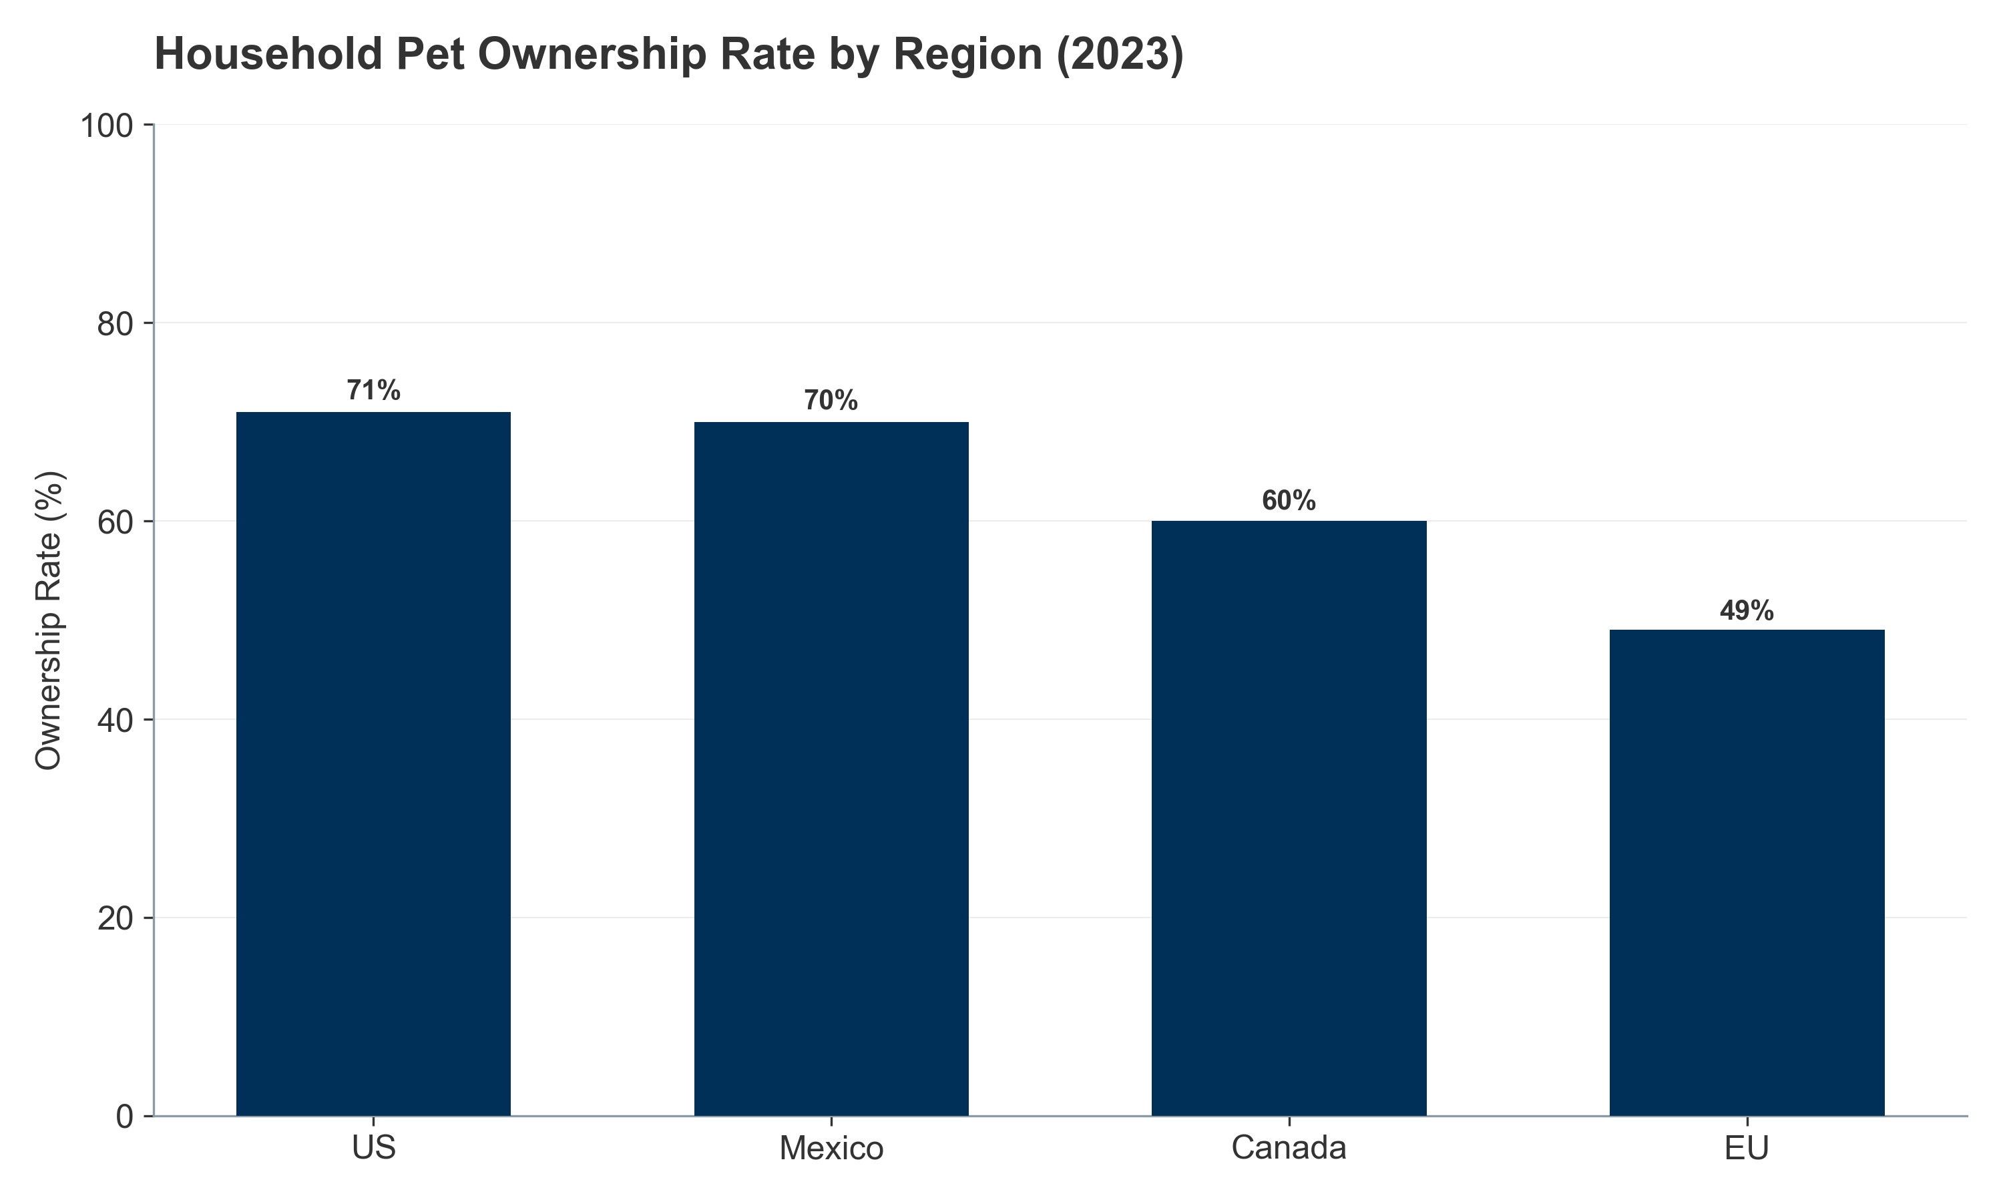
Figure III.1: Household Pet Ownership Rate (2023)
(2023) — Data points: US (71%), Mexico (70%), EU (49%), Canada (60%)]
III.1.1.2. EUROPEAN UNION: THE CAT CONTINENT
Europe represents a highly diverse, cat-dominant market with significant regulatory frameworks guiding production and welfare.
Pet Population Structure:
According to FEDIAF 2025 data, the total pet population reached 281.5 million animals.
Feline dominance: The European population includes approximately 127 million cats compared to 104 million dogs, with cats representing 45% of the pet population.
Growth divergence (2018–2023): While the dog population has grown modestly by +5%, the cat population has surged by +11%, reflecting the shift toward smaller, apartment-friendly animals suitable for urban living.
Market Value:
Europe accounts for significant share of the global pet nutraceutical market, with market value estimated at USD 1.6–1.9 billion in 2024, growing at CAGR 6.0–6.5%.
The UK represents the largest European pet supplement market, valued at USD 250–300 million, with Germany and France accounting for USD 200–250 million each.
Regional Variance: Germany's millennial and Gen Z population is driving notable growth in pet supplements, with pet wellness seen as a precursor to family formation.
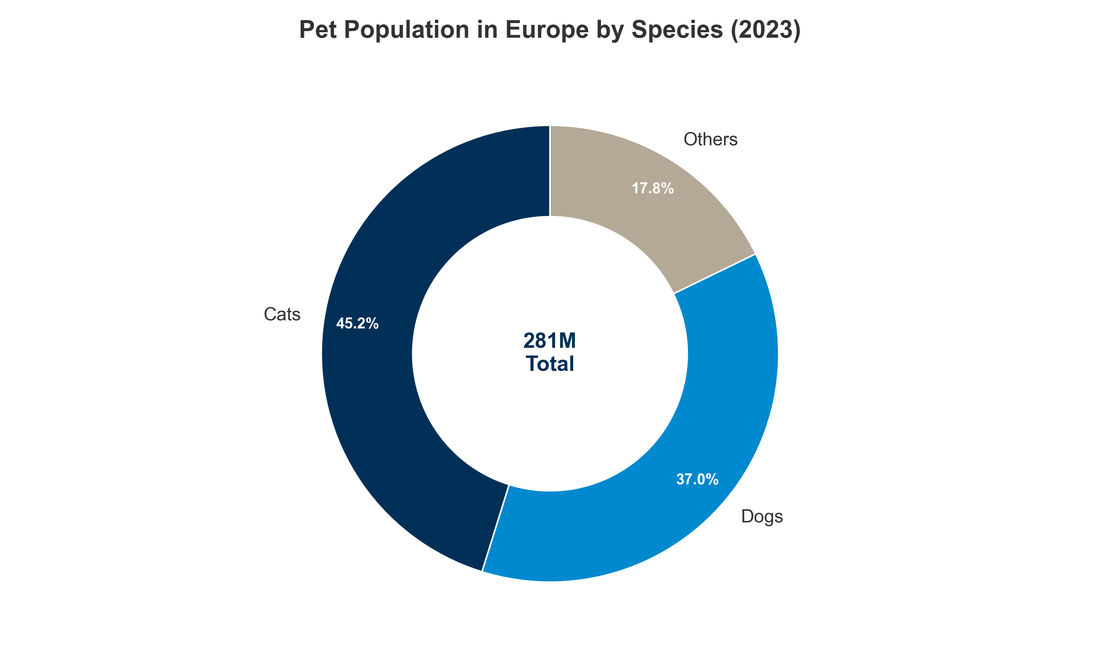
Figure III.2: EU Pet Population Split
(2023) — Data points: Cats (127M), Dogs (104M), Others (50M)]
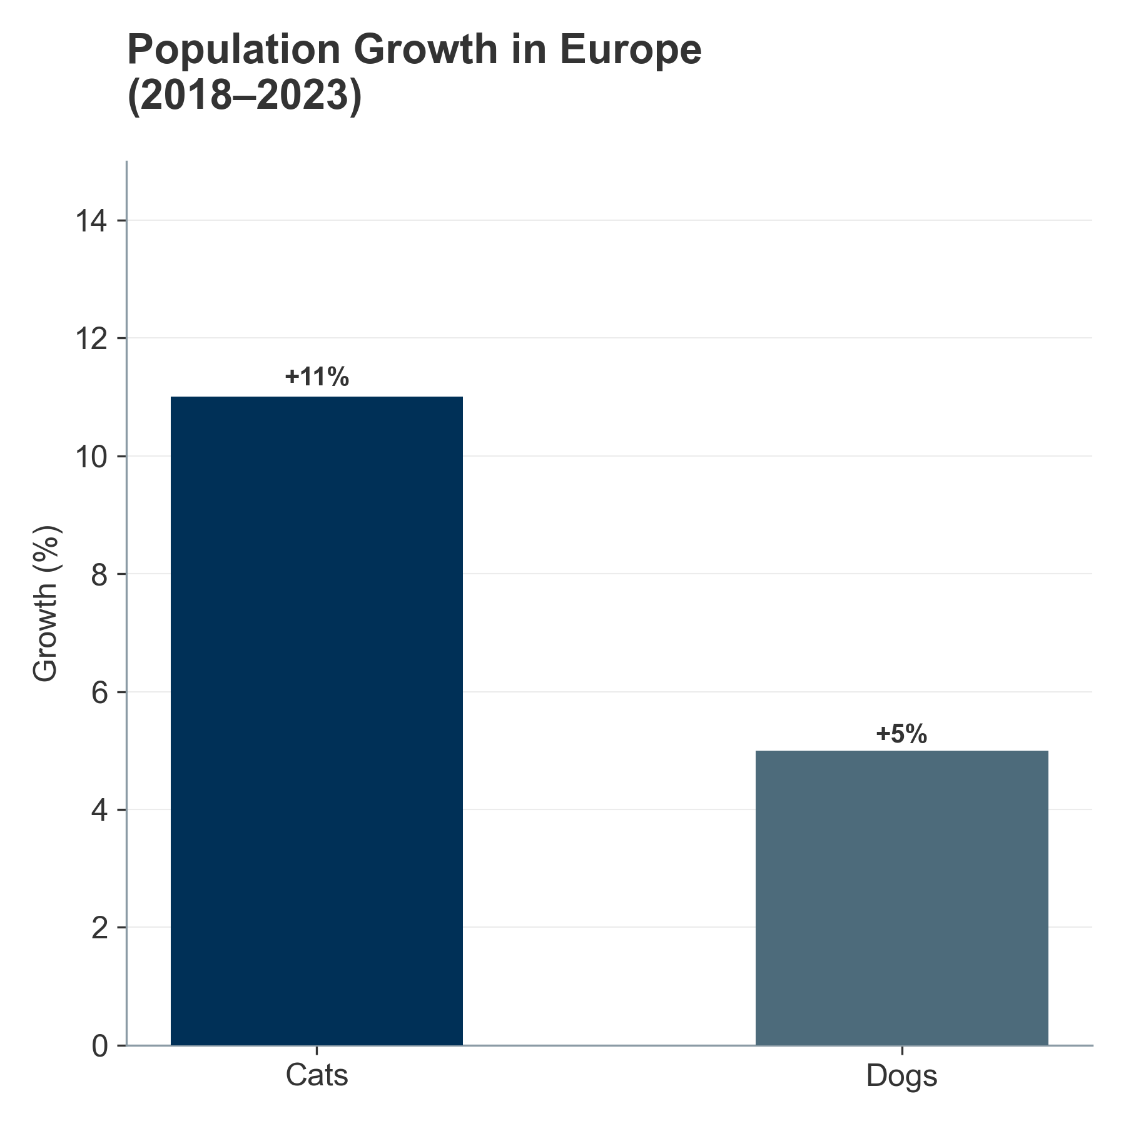
Figure III.3: EU Population Growth (2018-2023)
(2018–2023) — Data points: Cats (+11%), Dogs (+5%)]
III.1.1.3. ASIA-PACIFIC: THE GROWTH ENGINES
APAC is the global engine of volume growth, characterized by rapid urbanization, income growth, and the "replacement child" phenomenon (pets as substitutes for human children in low-fertility environments).
China's Historic Transformation:
In a historic shift, cats overtook dogs in China in 2024—71.5 million cats vs. 52.6 million dogs—driven by the demanding "996" work culture (9 AM–9 PM, 6 days per week), which favors independent pets that require less active engagement.
China's pet market is valued at approximately USD 23–25 billion annually, with pet supplements representing USD 1.8–2.1 billion of this total.
The white paper by the China Pet Industry Association reported the combined dog-cat population at 100.8 million in 2020; updated estimates for 2024 suggest 124.1 million animals.
Latin America: Mexico & Brazil as High-Growth Engines:
Brazil: The world's third-largest pet market with over 160 million pets, including 60 million dogs and a rapidly growing cat population (30 million). Brazil's pet supplement market is valued at USD 400–500 million, growing at 7.5–8.5% CAGR.
Mexico: High ownership rates (70% of households) with a historically dog-centric market, but the cat population exploded by 41% between 2017 and 2022, signaling rapid modernization. Mexico's pet supplement market reaches USD 250–300 million, with fastest growth in the urban, high-income segments.
India's Emerging Opportunity:
India has one of the highest dog populations at 10.2 million, with a notably young demographic driving adoption. The Indian pet supplements market is nascent at USD 50–80 million but growing at 12–15% CAGR, the fastest rate globally.
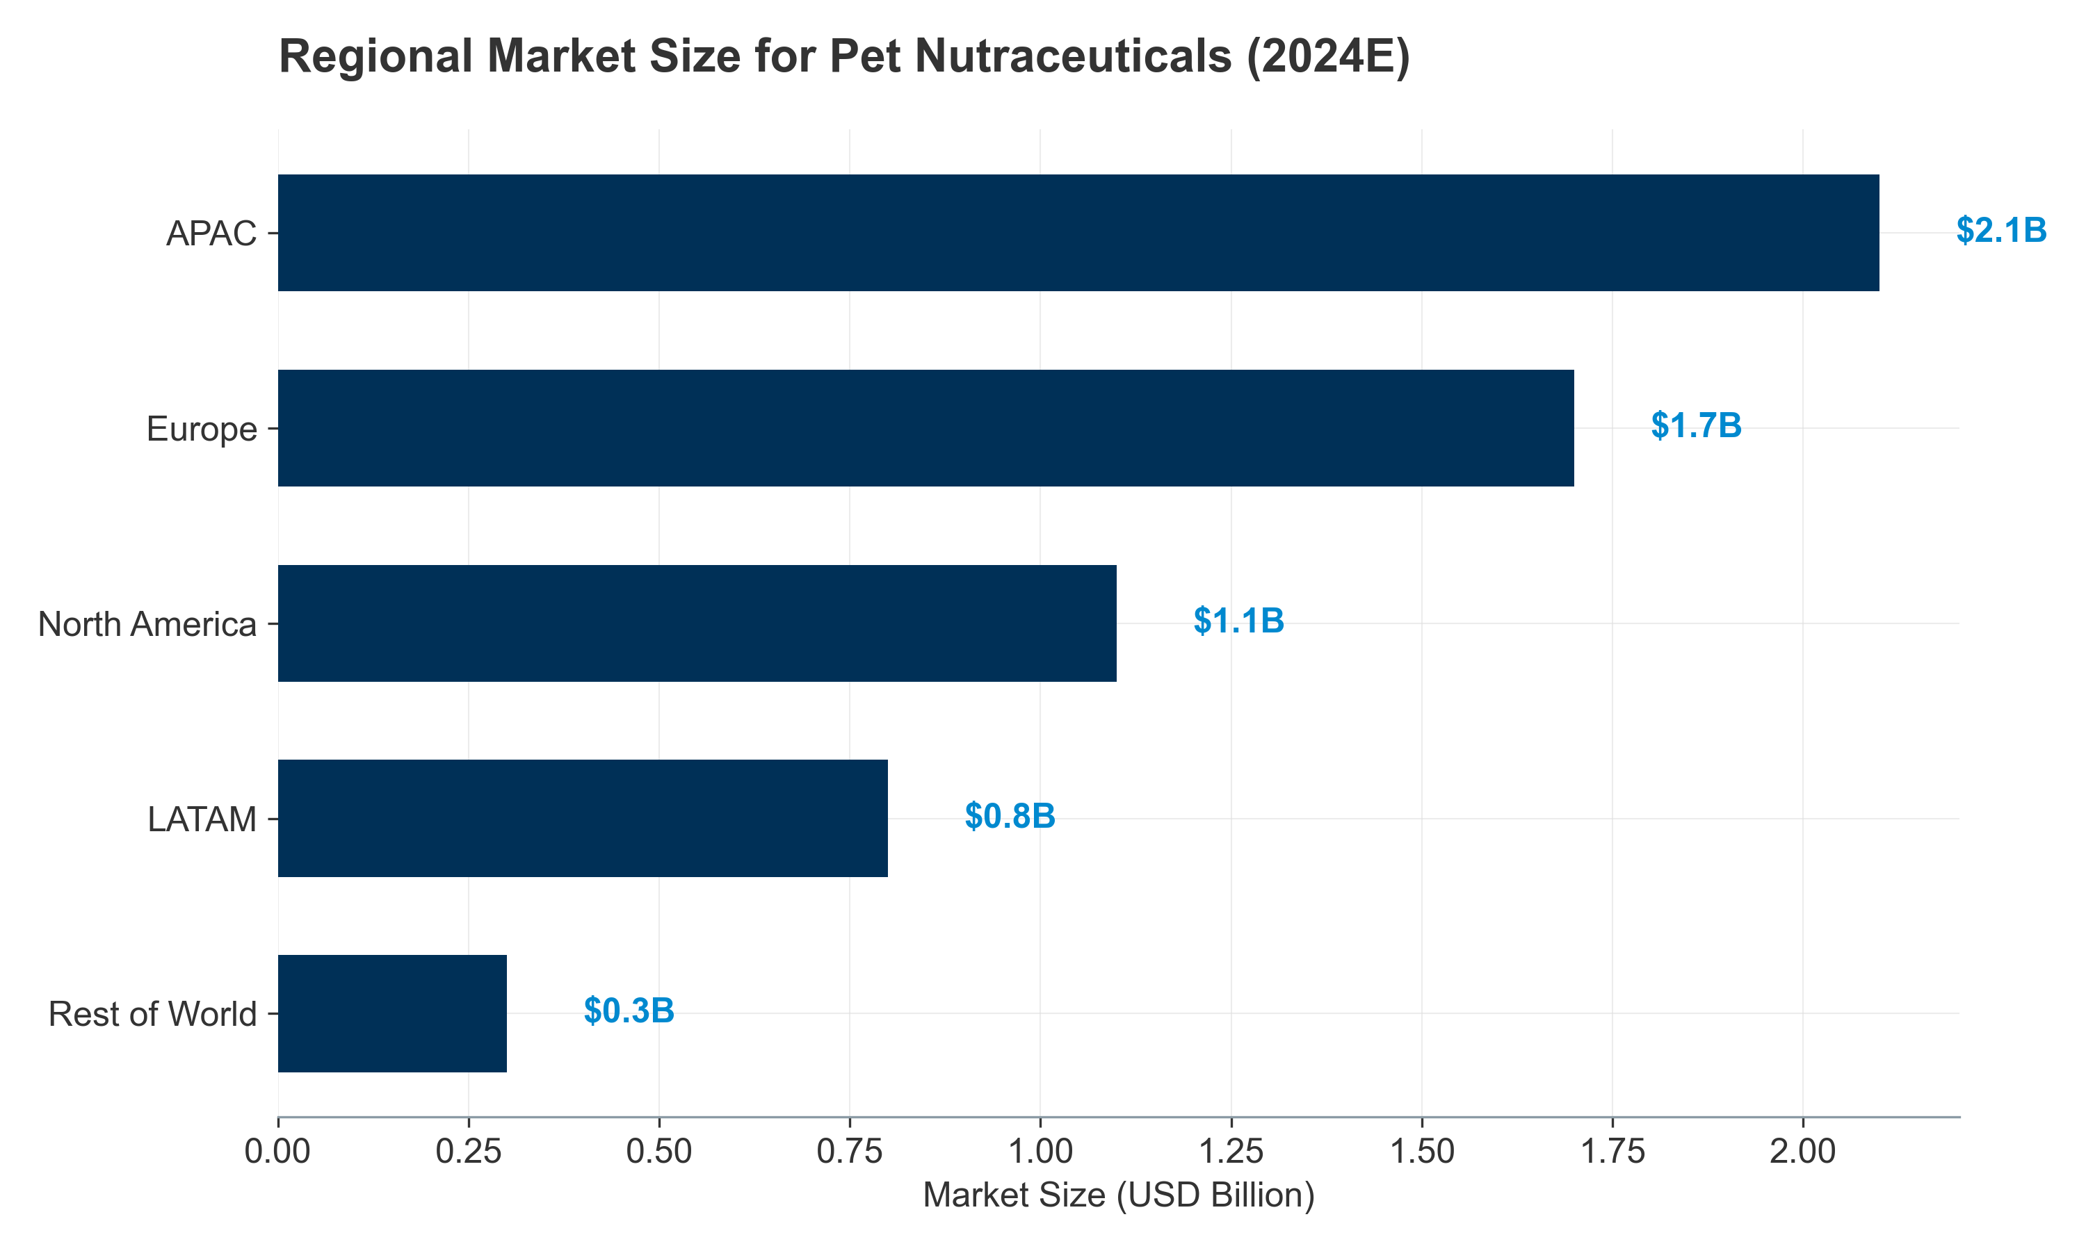
Figure III.4: Regional Market Size (2024E)
(2024E) — Data points: North America (USD 1.1B), APAC (USD 2.1B), Europe (USD 1.7B), LATAM (USD 0.8B), Others (USD 0.3B)]
III.1.2. Livestock Headcounts: The "Great Divergence"
The industrial livestock and aquaculture sectors are navigating a complex bifurcated landscape defined by the "Great Divergence": a structural contraction in Western herds (EU, US) driven by policy, climate, and input costs, contrasted with the relentless expansion of poultry and aquaculture globally to meet protein demand.
Overview: Species-Level Market Dynamics
In 2024, the largest livestock segment by specialty feed additive revenue was poultry. Within the specific "Feed Probiotics" category:
Poultry: 60% of global volume (~USD 2.4–2.6 billion of USD 4.1 billion market)
Swine: 25% of global volume (~USD 1.0–1.1 billion)
Ruminants: 10% of global volume (~USD 0.4 billion)
Aquaculture: 5% of global volume (~USD 0.2 billion)
The global animal probiotics market was valued at USD 4.1 billion in 2024 and is projected to reach USD 6.9–7.6 billion by 2030–2035, representing a CAGR of 8.0–10.2%.
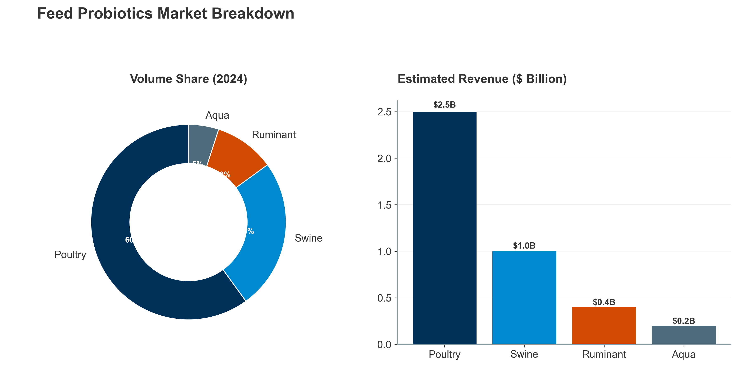
Figure III.5: Feed Probiotics Market Share
(Volume & Revenue, 2024) — Left chart: Volume Share (Poultry 60%, Swine 25%, Ruminant 10%, Aqua 5%); Right chart: Estimated Revenue Allocation (Poultry USD 2.5B, Swine USD 1.0B, Ruminant USD 0.4B, Aqua USD 0.2B)]
Poultry: The Engine of Growth
Poultry remains the primary driver of global meat production, which rose by 1.3% to 365 million tonnes in 2024. The sector's dominance is evidenced by its 43.5% share of the global feed additives market, valued at USD 15.72 billion in 2024.
Market & Production Dynamics:
Global broiler production grows at 1.2–1.5% CAGR, with Asia (particularly China, Vietnam, and Thailand) accounting for 65% of global incremental growth.
The poultry feed additives sub-segment (including probiotics, enzymes, and organic acids) is valued at USD 6.8 billion in 2024, expected to reach USD 9.2 billion by 2030 (CAGR 5.0%).
The HPAI Constraint – A Tail Risk:
This expansion faces the viral constraint of Highly Pathogenic Avian Influenza (HPAI). Between 2005 and 2024, HPAI caused the loss of over 633 million poultry globally, creating recurring demand shocks and justifying investment in biosecurity, vaccination, and immune-support probiotics. The 2024 HPAI season alone resulted in culling of 40–50 million birds across major production regions.
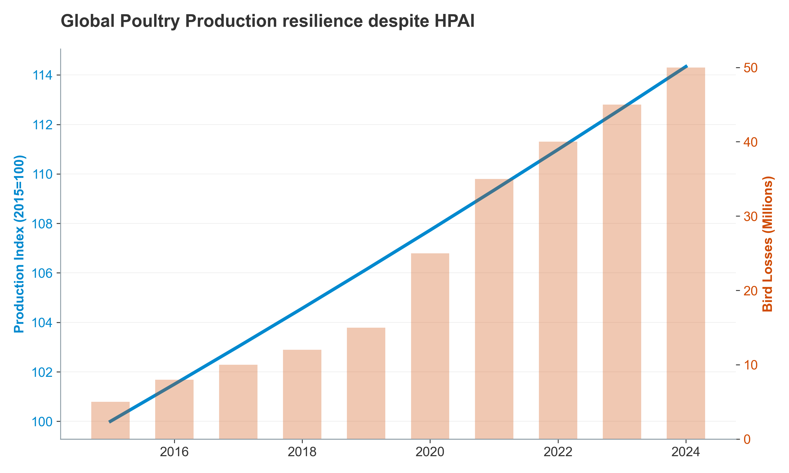
Figure III.6: Poultry Production & HPAI Impact
(2015–2024) — Dual-axis chart: Left axis = production tonnes (baseline 2015 = 100); Right axis = cumulative bird losses from HPAI (millions of birds)]
Swine: Structural Contraction in the West, Volatility in Asia
The swine sector is characterized by contraction in the West and volatility in Asia.
Western Contraction:
European Union: The EU pig population fell to 132 million head in 2024, a 0.5% annual drop and an 8.1% decline compared to 2014, driven by nitrogen limits under the Nitrates Directive, input cost inflation, and lower feed-conversion margins.
United States: The US swine inventory stands at 74.5 million head, down 3.2% YoY from 2023, reflecting profitability pressures from rising feed costs and lower pork prices.
Economic Impact: The swine feed additives market in Western regions is declining at 0.5–1.0% CAGR, but this is offset by growth in probiotics aimed at post-weaning diarrhea (PWD) prevention, a high-margin application.
Asian Volatility:
China: The swine herd recovered to 405–410 million head by 2024 (up from a low of 300 million in 2018 post-ASF), but volatility remains high due to cyclical dynamics and renewed ASF outbreaks in peripheral regions.
Vietnam & Thailand: Growing producers, expanding at 4–6% annually.
Market Size: The global swine feed additives market is valued at USD 4.2 billion in 2024, expected to grow to USD 5.1 billion by 2030 (CAGR 3.5%), with probiotics and enzymes as the fastest-growing sub-segments.
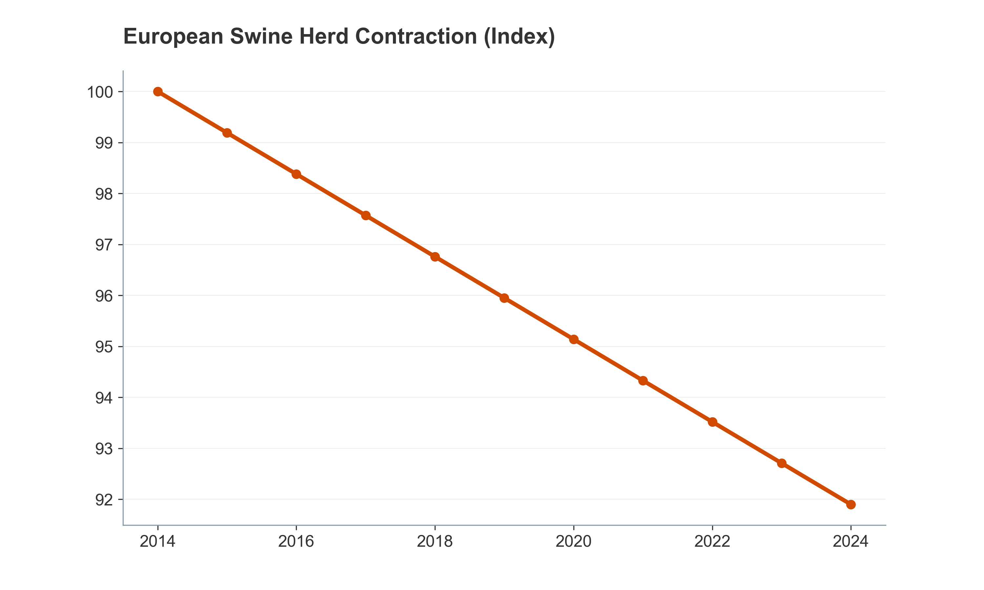
Figure III.7: EU Swine Herd Decline
(2014–2024) — Line chart: EU pig headcount, baseline 2014 = 100; annotate major policy events (Nitrates Directive tightening, carbon border adjustments)]
Cattle: Historic Liquidations
The cattle sector faces unprecedented liquidation in the West.
United States – A 73-Year Low:
The US cattle inventory collapsed to 87.2 million head on January 1, 2024, the lowest level since 1951.
Heifer retention fell to 4.86 million head, down 1.0% YoY, indicating herd rebuilding has not begun despite strong fed cattle prices.
Causation: Extreme drought in the Western US (2020–2023), high forage costs, and input price inflation drove culling, particularly of breeding females.
Outlook: Herd rebuilding is unlikely before 2026–2027, as profitability remains compressed by high feed costs.
European Union – Persistent Decline:
The EU bovine population dropped to 72 million head in 2024, a 2.8% decrease from the previous year and an 8.7% decline over the last decade.
Causation: EU policies promoting rewilding, peatland restoration, and reduced GHG targets have incentivized herd reduction.
Global Implications:
The global beef cattle market contracted by 2.1% in 2024, with developed regions accounting for 95% of the contraction.
Conversely, developing regions (Latin America, India, Sub-Saharan Africa) are experiencing modest growth of 1.5–2.5% CAGR, but from much lower base productivity levels.
Market Size for Cattle Feed Additives & Probiotics:
Valued at USD 2.8 billion globally in 2024, projected to decline slightly to USD 2.6–2.7 billion by 2030 (reflecting Western herd decline), offset partially by modest growth in developing regions.
Small Ruminants: A North-South Divide
A stark North-South divide characterizes small ruminant dynamics.
Western Decline:
EU sheep population declined 9.4% between 2014 and 2024, driven by low profitability and rural depopulation.
The US lamb and mutton market remains small, with ~5 million head, mostly used for breeding stock.
Developing Region Stability:
Global sheep and goat populations remain relatively stable at ~600 million head, supported by extensive systems in the Global South (India, China, East Africa, Middle East).
These regions value small ruminants for dairy, meat, and fiber in low-input systems where probiotics are increasingly adopted for herd health and productivity improvements.
Market Size: The small ruminant feed additives market is valued at USD 1.1 billion globally in 2024, with modest growth of 2.0–2.5% CAGR through 2030.
Indexed European Livestock Trends (2018–2023): The "De-Ruminization" of Europe
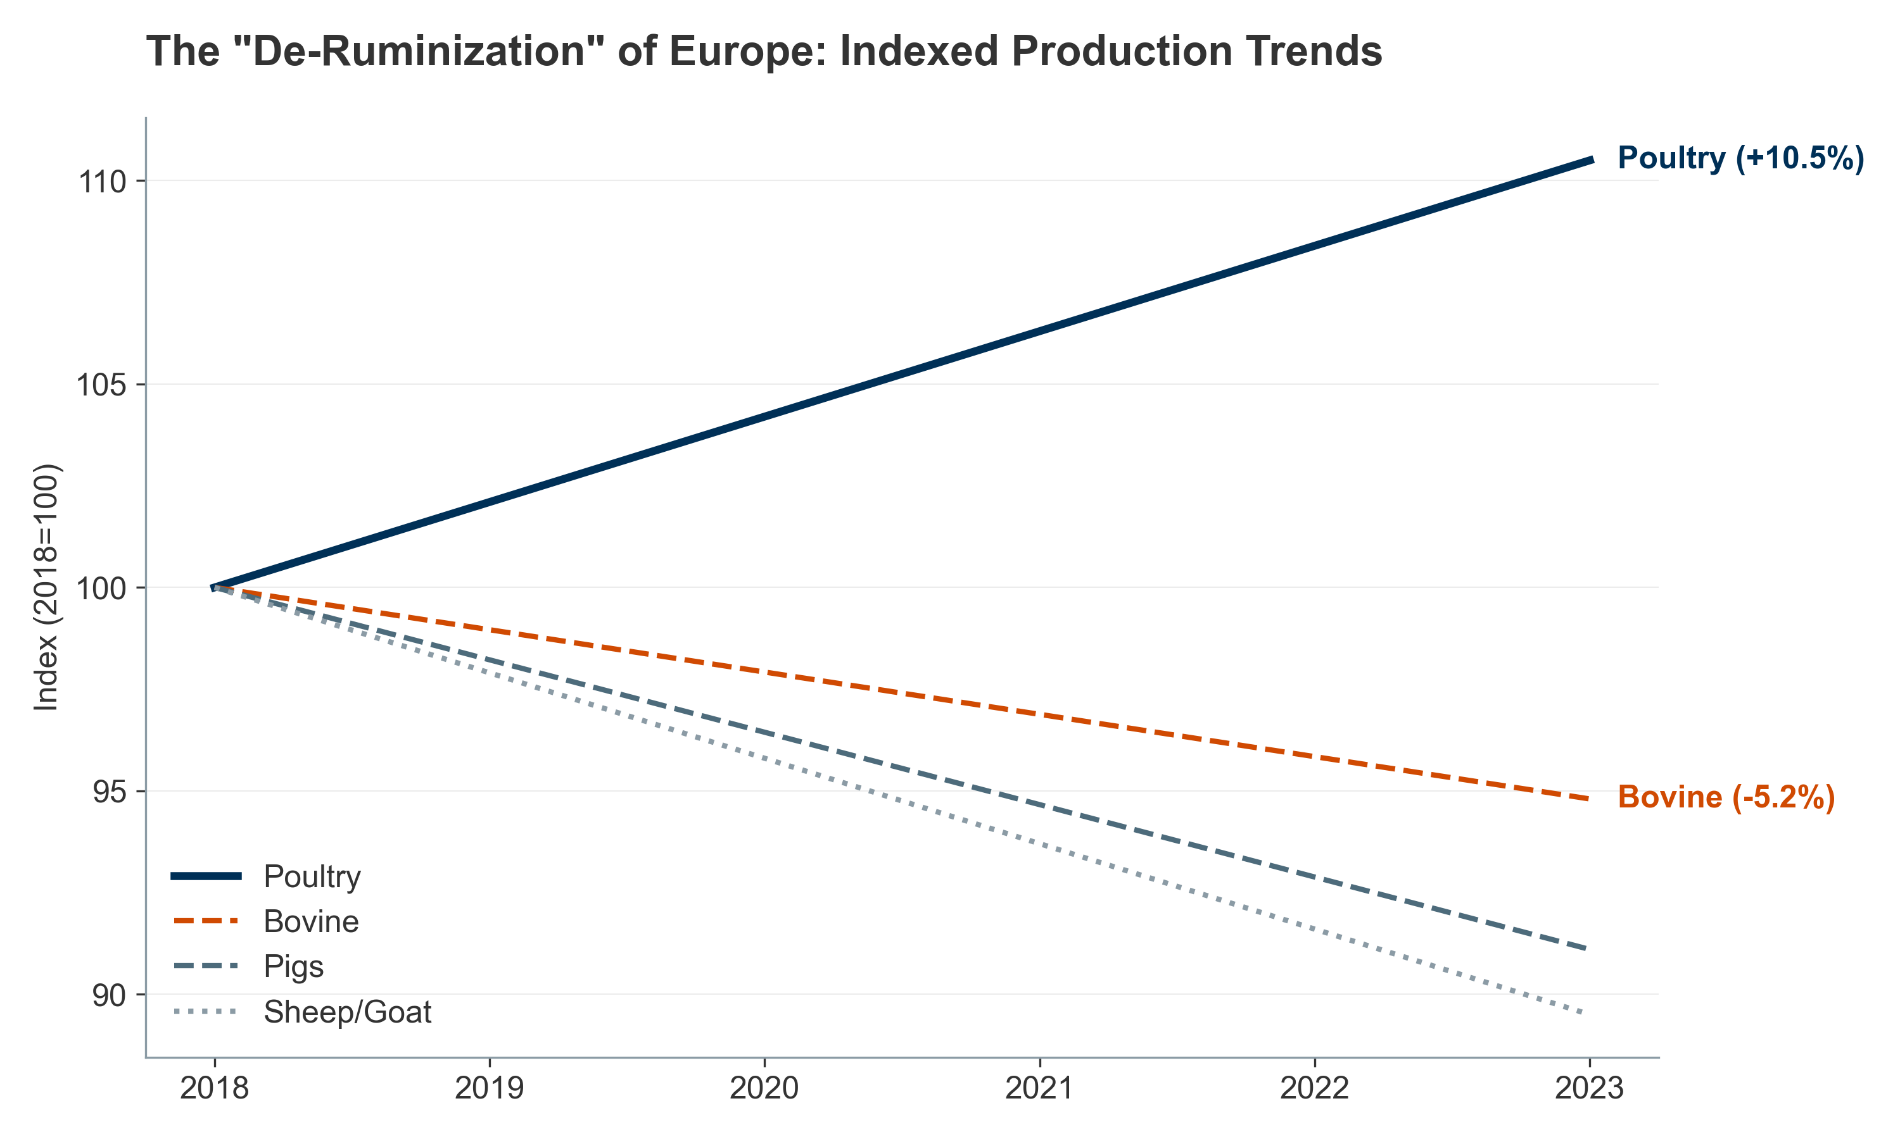
Figure III.8: Livestock Trends in Europe
The following table and visualization capture the divergent trajectories in Europe, highlighting the "de-ruminization" of the continent—the structural decline of ruminant farming and its replacement by poultry.
Data Source: Eurostat Agricultural production - livestock and meat (2018–2023)
III.1.3. Aquaculture: The "Blue Transformation"
The Great Overtaking – A Historic Threshold
In a historic shift, the farmed production of aquatic animals reached 94.4 million tonnes in 2022, surpassing the 92.3 million tonnes harvested from capture fisheries. Total aquaculture production hit a record 130.9 million tonnes (including aquatic plants). Asia remains the dominant force, accounting for 91.4% of global production.
Market Implications:
Farmed aquaculture is projected to grow at 3.2–3.8% CAGR through 2030–2035, driven by rising protein demand in developing nations and declining wild fishery yields.
The global aquaculture market is valued at approximately USD 285 billion in 2024, with feed and feed additives (including probiotics) representing USD 18–22 billion.
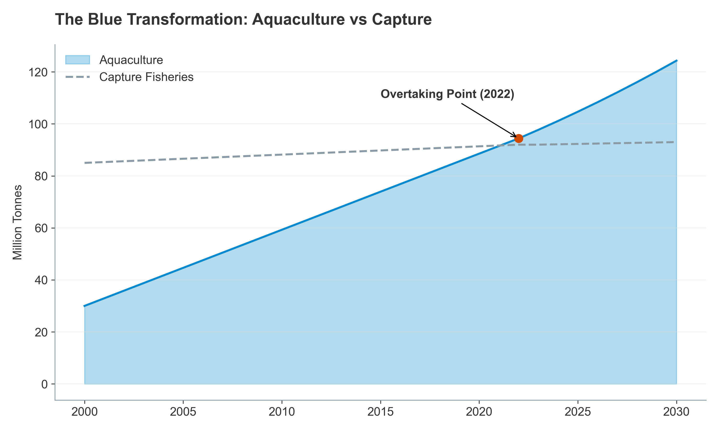
Figure III.9: The Great Overtaking (Fish)
Production (2000–2022) — Dual-line or area chart showing intersection point in 2022; project forward to 2030 with diverging trends]
Species Diversification: Mitigating Monoculture Risk
To mitigate biological risks associated with monocultures (e.g., salmon sea lice, disease outbreaks), the industry is diversifying species and production methods.
Current Production Leaders:
Carp (inland, freshwater): ~24 million tonnes (mostly Asia)
Salmon (marine, cold-water): ~3.5 million tonnes
Shrimp & Prawns: ~9.2 million tonnes
Tilapia (tropical, freshwater): ~5.8 million tonnes
Catfish: ~4.2 million tonnes
Emerging Diversification:
Mangrove Red Snapper, Grouper, and Seriola (Yellowtail) are gaining traction as premium species for high-value markets.
Seaweed and mollusk farming (particularly in APAC) are expanding as low-input alternatives, accounting for ~30 million tonnes globally.
Probiotics & Nutraceuticals in Aquaculture:
The aquaculture probiotics sub-segment is valued at USD 200–250 million globally in 2024, growing at 10–12% CAGR, making it the fastest-growing livestock probiotics segment due to high mortality rates and disease sensitivity in high-density systems.
The FAO's "Blue Transformation" Strategy:
The FAO's strategy underpins this diversification, focusing on:
Alternative feeds to decouple production from wild forage fish (fishmeal and fish oil)
Inland and coastal aquaculture to reduce pressure on capture fisheries
Selective breeding to improve feed conversion and disease resistance
Probiotics and functional feed additives to reduce antibiotic reliance
III.1.4. Intensification and Stress Landscapes: The Biological Drivers of Nutraceutical Adoption
Meeting global protein demand requires high-density production systems that push animals to their physiological limits, creating distinct "stress landscapes" that directly drive the adoption of nutraceutical and probiotic solutions. These stress factors represent non-discretionary, essential add-ons to modern animal agriculture—not luxuries.
Physiological Cost of Intensification
Oxidative Stress and ROS:
High-performing animals in intensive systems experience elevated metabolic rates (up to 20–30% above historical baselines), generating excessive Reactive Oxygen Species (ROS).
ROS damages cellular membranes, mitochondria, and DNA, reducing feed efficiency and increasing disease susceptibility.
Antioxidant supplements (vitamins E & C, selenium, beta-carotene) are now standard in broiler rations, adding USD 150–250 million annually to global feed additive demand.
Heat Stress Across Species:
Rising global temperatures cause "leaky gut" in cattle and swine, permitting translocation of endotoxins and triggering chronic inflammation.
In aquaculture, heat stress causes "oxygen squeeze" in closed or semi-closed systems, reducing dissolved oxygen and triggering disease outbreaks.
Climate variability is driving a secular increase in probiotics and antioxidants, with demand projected to rise 8–10% annually in warm-climate regions.
The Paradox of Precision Livestock Farming (PLF)
Precision Livestock Farming (PLF) tools (sensors, AI-driven monitoring, automated feeders) have enabled producers to manage massive herds efficiently. However:
PLF optimizes production efficiency (feed-to-gain ratio, milk yield, egg production) while sometimes entrenching the very intensive practices that cause stress.
The result: even better-monitored animals remain immunologically challenged, creating a structural, recurring demand for immune-support nutraceuticals and probiotics.
This paradox ensures that probiotics and functional supplements represent a structural, non-cyclical cost in modern animal agriculture—similar to antibiotics historically, but with better regulatory acceptance and premium pricing potential.
III.2. Urbanization, Administration, and Decision Pathways
III.2.1. The Impact of Urbanization on Nutraceutical Formats and Administration
Urbanization correlates strongly with smaller living spaces, smaller pets, and fundamental shifts in supplement administration preferences. These format preferences determine which product types and distribution channels dominate regional markets, directly impacting the financial performance of nutraceutical suppliers.
Format Popularity by Species
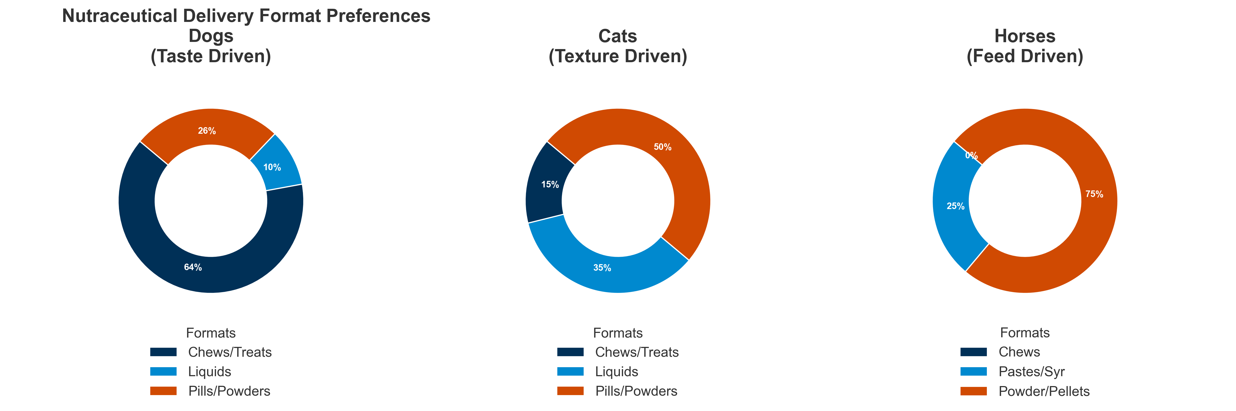
Figure III.10: Format Popularity by Species
: A Stark Divide
Data on "Nutraceutical Format Popularity" reveals a dramatic species-specific split, reflecting physiological and behavioral differences:
Dogs – The Palatability Premium:
Soft Chews: 39% of market share (representing approximately USD 420–480 million globally, based on ~USD 1.1–1.3 billion dog supplements market)
Treats (functional): 25% (USD 275–325 million)
Powders: 20% (USD 220–260 million)
Liquids/Pastes: 10% (USD 110–130 million)
Pills/Tablets: 6% (USD 66–78 million)
Behavioral Driver: Urban dog owners treat supplements as a "bonding moment," necessitating high palatability. Soft chews and functional treats drive repeat purchase and premium pricing (USD 25–60 per month per dog vs. USD 10–20 for pills).
Cats – The Palatability Challenge:
Liquids/Pastes: 35% (USD 140–170 million in global cat supplements market of USD 400–500 million)
Powders: 30% (USD 120–150 million)
Tablets/Pills: 20% (USD 80–100 million)
Treats: 10% (USD 40–50 million)
Chews: 5% (USD 20–25 million)
Behavioral Driver: High rejection of solid pills drives the market toward liquids and powders that can be mixed invisibly into wet food. Cat owners exhibit significantly lower WTP for premium formats, with median spend of USD 12–18 per month.
Horses – The Equine Divergence:
Powders/Pellets: 60% (USD 180–220 million in horse supplements market of USD 300–370 million)
Oral Syringes: 20% (USD 60–74 million)
Injectable: 15% (USD 45–55 million)
Pastes: 5% (USD 15–18 million)
Behavioral Driver: Equine supplements leverage feed top-dressing for convenience and oral syringes for acute performance dosing (pre-competition, post-injury).
Channel Implications: Online vs Offline
The format preference directly correlates with channel choice:
Soft chews and treats drive e-commerce adoption (Chewy, Amazon, DTC), where browse-and-impulse-buy behavior is maximized.
Liquids and powders remain more fragmented between veterinary clinics (40–50% in prescriptions), pet specialty stores, and online (30–40%).
Current Channel Mix (Global Pet Supplements):
Offline (brick-and-mortar): 77.8% of revenue (USD 1.76 billion) – supermarkets, pet specialty stores, veterinary clinics
Online: 22.2% of revenue (USD 0.50 billion) – but growing at 8.7% CAGR (2024–2030), vs. offline at 4.5% CAGR
By 2030, online is projected to capture 30–35% of pet supplement revenue, a meaningful shift driven by subscription models ("Subscribe & Save"), influencer marketing, and DTC brands.
III.2.2. Functional Feed Focus: The Probiotics Market as a Bellwether
Within the livestock sector, the decision pathway is driven by ROI and antibiotic reduction. Feed Probiotics represent a high-growth proxy for this regulatory-driven transition. In 2024, species-level preferences were:
Poultry (60% of volume):
Dominance driven by post-hatch gut colonization (critical in the first 48 hours) and growth performance (feed conversion ratio optimization).
Market size: USD 2.4–2.6 billion within the USD 4.1 billion global animal probiotics market.
Fastest-growing application: Antibiotic-free broiler certification (premium programs requiring probiotic support).
Swine (25% of volume):
Driven by post-weaning diarrhea (PWD) prevention and nursery pig health—two high-mortality, high-cost failure modes.
Market size: USD 1.0–1.1 billion.
Premium segment: Gilt and sow nutrition for improved colostrum quality and piglet vitality.
Ruminants (10% of volume):
Driven by forage digestibility optimization and emerging methane reduction claims.
Market size: USD 400–450 million.
Growth barrier: Lower margins and farmer knowledge adoption curves.
Aquaculture (5% of volume):
Driven by disease prevention (particularly for high-value species like salmon and shrimp) and feed efficiency.
Market size: USD 200–250 million – but fastest-growing at 10–12% CAGR.
Premium positioning: Probiotics valued as alternatives to antibiotics in regulatory-constrained markets.
III.3. The Economics of Care: Willingness-to-Pay (WTP) and Wallet Share
III.3.1. The Preventive Health Wallet
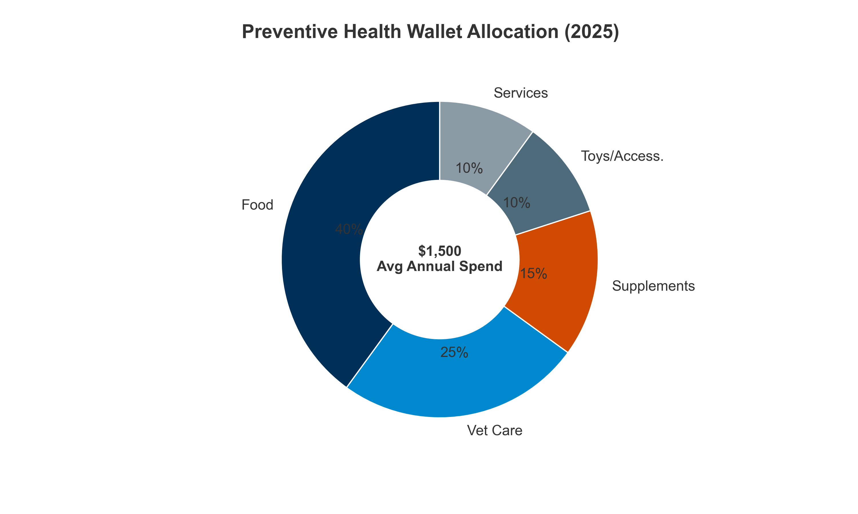
Figure III.10.B: Preventive Health Wallet Breakdown
: How Pet Owners Allocate Disposable Income
The "Pet Humanization" trend has fundamentally reshaped how owners allocate disposable income. The total annual pet spending per household in North America ranges from USD 800–2,500, depending on ownership demographics and pet age.
Breakdown of the "Preventive Health Wallet"
For a typical, proactive US pet owner spending USD 1,500 annually on pet care:
Sources :
Nicotra, M., et al. (2025) – "Nutraceuticals, Social Interaction, and Psychophysiological Influence on Pet Health and Well-Being: Focus on Dogs and Cats." Veterinary Sciences 12.10: 964.
Dechra Pharmaceuticals PLC – "Annual Report and Accounts for the year ended 30 June 2023"
Critical Insight: Nutraceuticals have surpassed toys and accessories in the allocation hierarchy, indicating that owners prioritize longevity over entertainment—a structural shift that has implications for product positioning and premiumization.
Market Implications
On a global pet supplement market of USD 5–6 billion in 2024:
A 15% wallet share within the preventive health budget implies that the supplement category has already achieved penetration equivalent to toys and accessories in many developed markets.
Growth runway: As pet humanization deepens in APAC and LATAM, and as subscription models reduce adoption friction, wallet share for nutraceuticals is projected to rise to 18–22% by 2030.
III.3.2. Consumer Segmentation and Psychological Drivers
Not all pet owners spend equally. Analysis of purchasing behavior and willingness-to-pay identifies three distinct archetypes, with disproportionate revenue concentration in the premium segment:
The Three Consumer Archetypes
• The "Spare No Expense" Parent (20% of households; 45–50% of market revenue):
Demographic: High household income (USD 150k+), urban, typically childless or empty-nester.
Behavior: Inelastic WTP; will spend USD 50–100+ per month on supplements; often buys multiple products per pet; adopts new categories rapidly (CBD, adaptogenic supplements).
Market Value: Represents USD 2.0–2.5 billion of the USD 5–6 billion global pet supplement market.
Product Preference: Premium formats (soft chews, organic, human-grade ingredients); veterinary-prescribed supplements; personalized nutraceutical protocols.
• The "Value-Conscious" Owner (50% of households; 40–45% of market revenue):
Demographic: Middle-income (USD 75k–150k); owns 1–2 pets; somewhat urban.
Behavior: Seeks ROI; buys multivitamins, joint supplements, and omega-3s; price-sensitive but willing to pay for "proven" ingredients; influenced by veterinary recommendation.
Market Value: Represents USD 2.0–2.2 billion of the global market.
Product Preference: Mid-range formats; standard soft chews; powder supplements; subscription models appreciated for convenience and modest discounts.
• The "Basic Care" Keeper (30% of households; 5–10% of market revenue):
Demographic: Lower income, rural, or first-time pet owners; younger age cohort.
Behavior: Focuses on core vaccinations and emergency care only; low adoption of preventive supplements; price-driven; skeptical of health claims.
Market Value: Represents only USD 250–500 million of the global market, despite comprising 30% of households.
Product Preference: Lowest-cost options; rarely adopts branded products; relies on generic multivitamins.
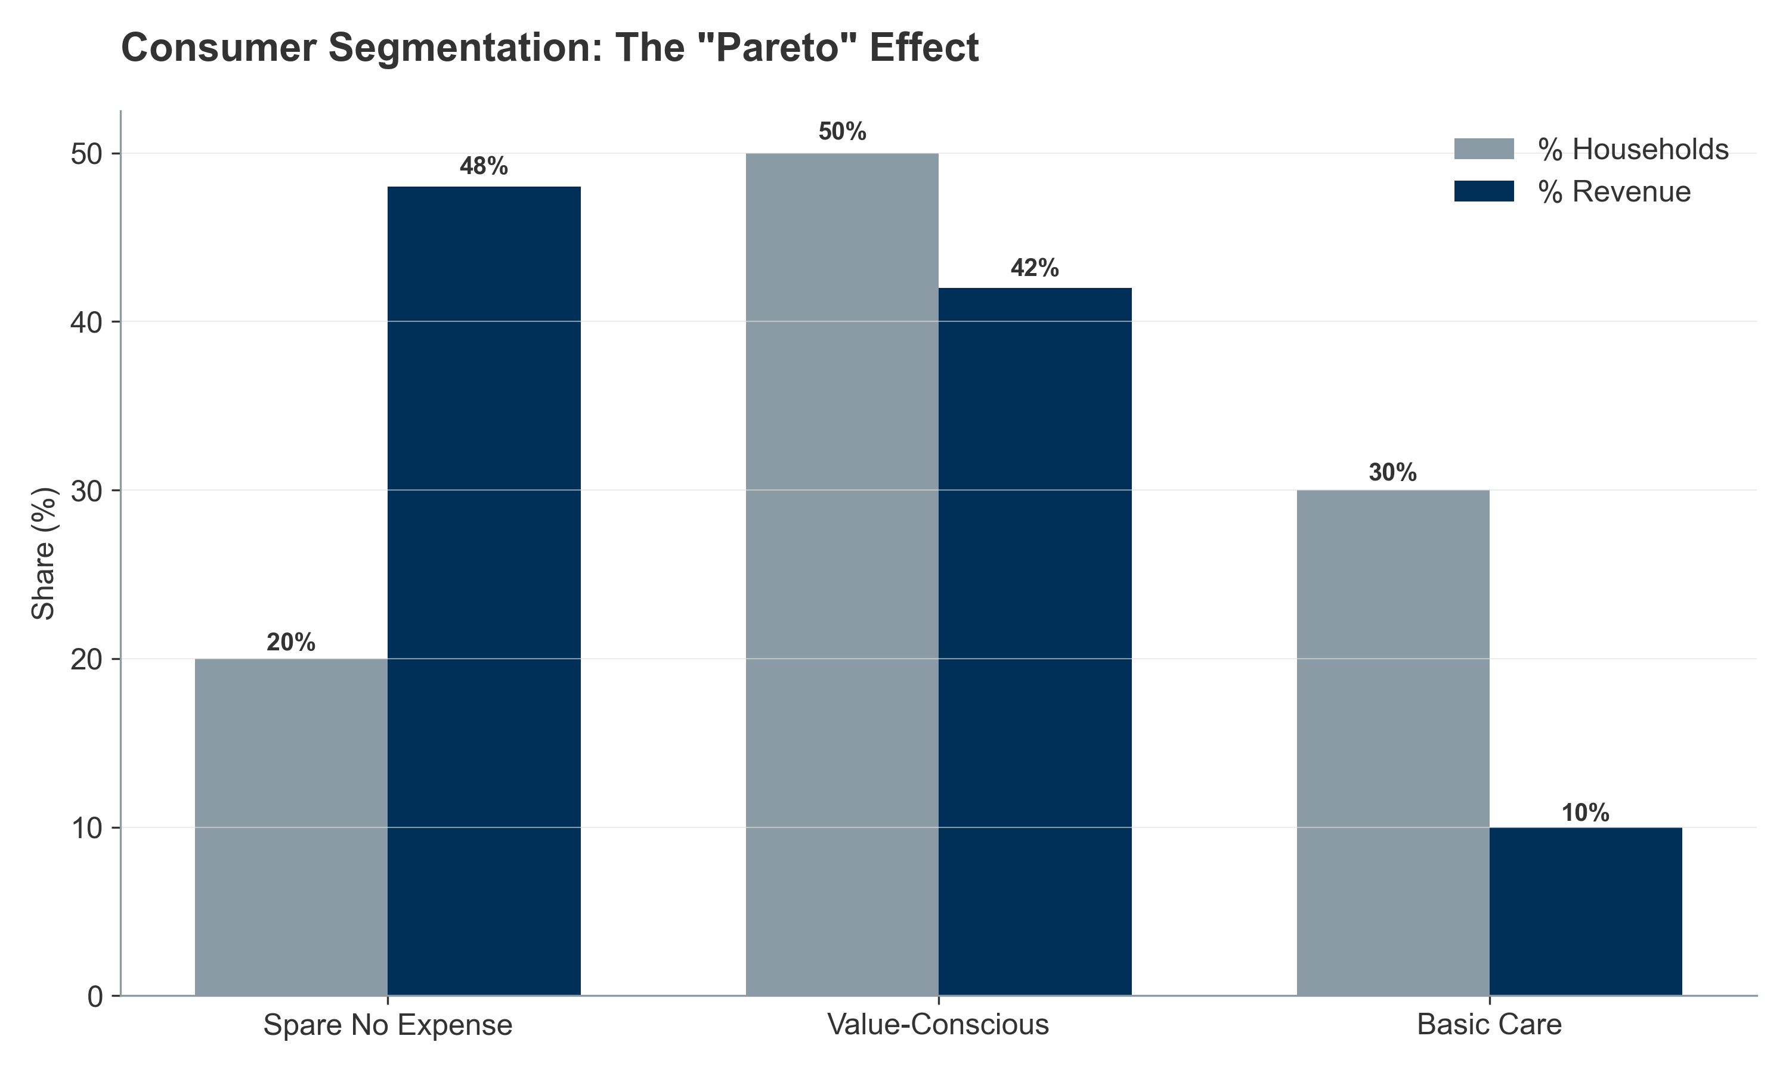
Figure III.11: Consumer Segmentation
– Share of Owners vs Share of Revenue — Two pie charts: (Left) "Share of Households" showing 20/50/30 split; (Right) "Share of Market Revenue" showing 48/42/10 split. Annotate to show revenue concentration in "Spare No Expense" segment]
Psychological Factors Influencing WTP
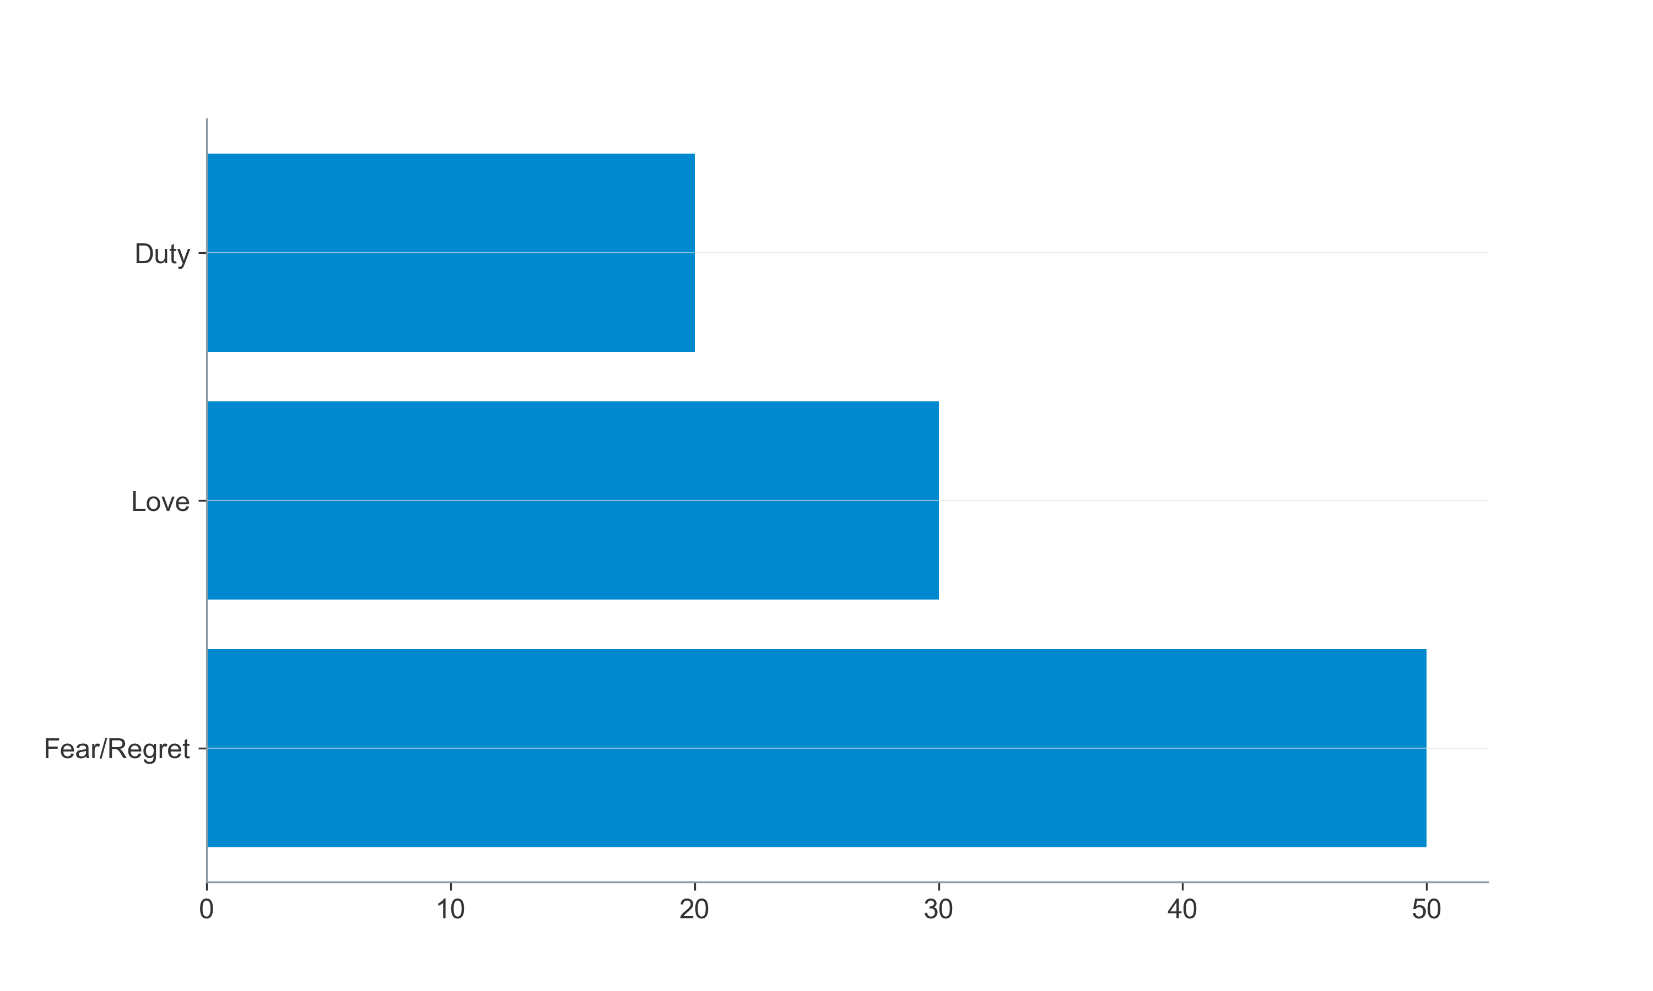
Figure III.11.B: Psychological Drivers
: The Fear of Loss
The "Psychological Factors Influencing WTP" are heavily weighted toward negative emotion avoidance—fear of loss and regret—rather than positive aspirations:
Sources :
Nicotra, M., et al. (2025) – "Nutraceuticals, Social Interaction, and Psychophysiological Influence on Pet Health and Well-Being: Focus on Dogs and Cats." Veterinary Sciences 12.10: 964.
https://www.supplysidesj.com/market-trends-analysis/5-consumer-trends-found-in-new-pet-supplement-shopper-survey
Insight: The dominance of "Fear of Loss" (40%) indicates that preventive messaging focused on disease avoidance is significantly more effective than messaging focused on "optimization" or "performance".
III.3.3. Veterinary Endorsement as a Pricing Power Lever
The 20% weight on "Perceived Veterinarian Endorsement" translates into tangible pricing power:
Veterinarian-recommended supplements command a 20–40% price premium over non-endorsed products.
Prescription supplements (formulated specifically for a diagnosed condition) command a 50–100% premium over OTC equivalents.
The fastest-growing segment within pet supplements is prescription supplements, expected to grow at 8.5–10.2% CAGR (2024–2030) vs. OTC at 5.2% CAGR.
Company Implications:
Zoetis and Elanco, through their veterinary sales forces and prescription networks, capture disproportionate margins on prescription supplements.
Brands without veterinary relationships must compensate through direct consumer marketing and DTC channels, with higher customer acquisition costs (CAC).
III.4. The Longevity Economy: The "Greying" Pet Population
As veterinary care improves, pets are living longer, creating a "demographic tsunami" of senior animals. This aging cohort is the single largest value driver for veterinary nutraceuticals, transforming the market from "growth" (puppy/kitten) to "maintenance and repair" (geriatric).
III.4.1. The Statistics of Aging: The Demographic Value Multiplier
The addressable market for chronic care is expanding at an unprecedented rate:
United States:
Share of owners with a senior dog (age 7+): 52% in 2024, up from 38% in 2015.
Share of owners with a senior cat (age 7+): 54% in 2024, up from 42% in 2015.
Median pet lifespans: Dogs (11.2 years), Cats (12.9 years) – both increased 1.5–2.0 years over the past decade due to improved veterinary care and owner investment in preventive health.
Europe:
Senior pets comprise approximately 30–35% of the population.
Preventive testing reveals underlying health conditions in 33% of apparently healthy senior cats, creating a large latent demand for chronic care supplements.
Market Implications:
The "Senior Pet" supplement segment is valued at USD 1.2–1.5 billion globally and is growing at 7.5–8.5% CAGR, significantly faster than the overall pet supplement market (6.4% CAGR).
By 2030, senior pet supplements are projected to represent USD 1.8–2.2 billion, a 40–50% increase from 2024 levels.
III.4.2. Chronic Care Revenue Opportunities: The "Repair Market"
Senior pets create a "repair market" that is less price-sensitive, more frequent, and higher-margin than the preventive wellness market.
Joint & Mobility – The Apex Segment
Osteoarthritis is the #1 chronic condition for senior pets, affecting 20–25% of dogs over age 7 and ~10–15% of cats over age 10.
Market Size & Growth:
Mobility supplements command 31.2% of the pet supplement market share, estimated at USD 1.55–1.9 billion globally in 2024.
CAGR 2024–2030: 7.2–8.1%, faster than overall market.
Ingredient Evolution & Premiumization:
The market is rapidly premiumizing:
Generic Glucosamine/Chondroitin: Historic dominant format; now faces commoditization; declining margins.
UC-II Undenatured Collagen: Patent-protected ingredient; commands USD 40–80 per month per pet (vs. USD 10–20 for generic glucosamine); captures ~25% of the mobility market and growing.
Green-Lipped Mussel (GLM): Premium, patented extract; high bioavailability; commands USD 35–60 per month; rapidly gaining share among value-conscious premium owners.
Hyaluronic Acid + MSM combinations: Emerging premium segment; growing at 15–18% CAGR.
Value Pool Breakdown (Mobility Segment):
Sources: https://www.futuremarketinsights.com/reports/pet-joint-health-supplement-market
https://www.mordorintelligence.com/industry-reports/pet-dietary-supplements-market
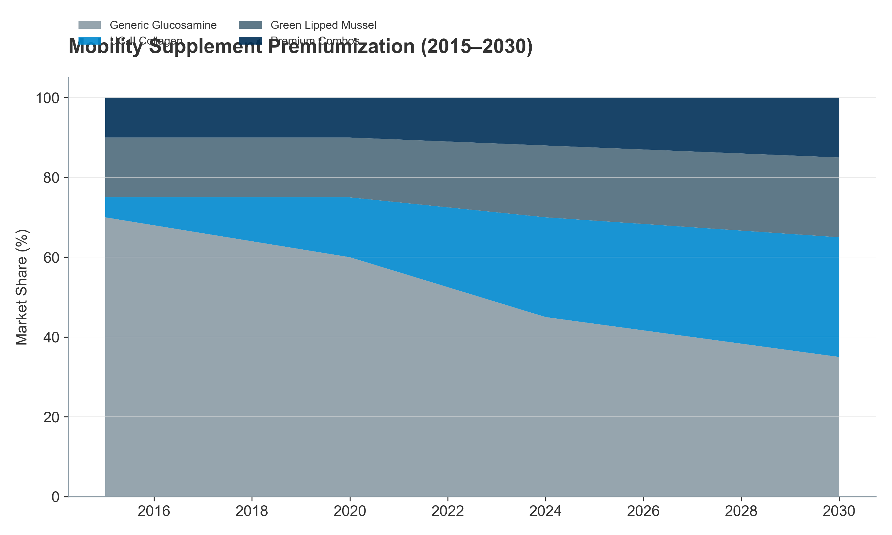
Figure III.12: Mobility Market Evolution
(2015–2030E) — Stacked area chart showing premiumization shift: from 70% generic glucosamine (2015) to projected 35% (2030), with UC-II, GLM, and premium combos gaining share]
Cognitive Dysfunction Syndrome (CDS) – An Emerging Premium Category
As dogs live past 12 years, "doggy dementia" (Canine Cognitive Dysfunction Syndrome) is becoming a prevalent concern, affecting 10–15% of dogs over age 12 and up to 25% of dogs over age 15.
Market Emergence:
CDS supplement market is nascent (USD 80–120 million globally in 2024) but growing at 18–22% CAGR, making it the fastest-growing application segment.
Targeted interventions include:
Medium-chain triglycerides (MCTs): Support ketone metabolism as alternative brain fuel
Antioxidants (SAMe, L-carnitine, Vitamin E): Combat neuroinflammation
Phosphatidylserine & DHA: Neuronal membrane support
Pricing & WTP:
CDS supplements command USD 40–100 per month (highest-priced category in pet supplements).
Owner WTP is inelastic—owners view this as extending remaining lifespan quality; price rarely changes adoption.
The "Pre-Senior" Expansion Strategy
Brands are successfully expanding the "Senior" category downwards to pets aged 5–7 years, positioning products as "Preventive Wellness for the Senior Years":
This extends the Customer Lifetime Value (CLV) by 2–3 years, shifting the purchase decision earlier in the pet lifecycle.
"Pre-Senior" supplements (formulated with lower dosages and broader wellness positioning) are valued at USD 400–600 million and growing at 10–12% CAGR.
Success of this strategy demonstrates the power of emotional messaging ("Don't wait until arthritis strikes; start preventively now").
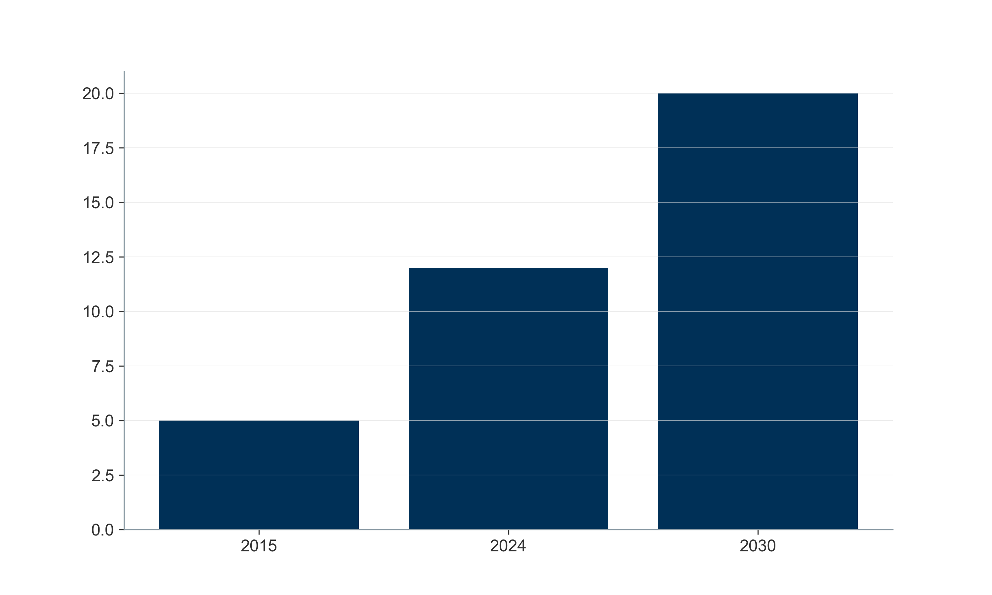
Figure III.13: Senior Market Growth
Opportunity (2015–2030E) — Dual-axis chart: Left axis = market size (USD billions); Right axis = share of total pet supplement market (%); show 2015 baseline, 2024 current, 2030E forecast. Annotate the "pre-senior expansion" inflection point (~2020)]
III.5. The Value Chain: From Molecule to Market
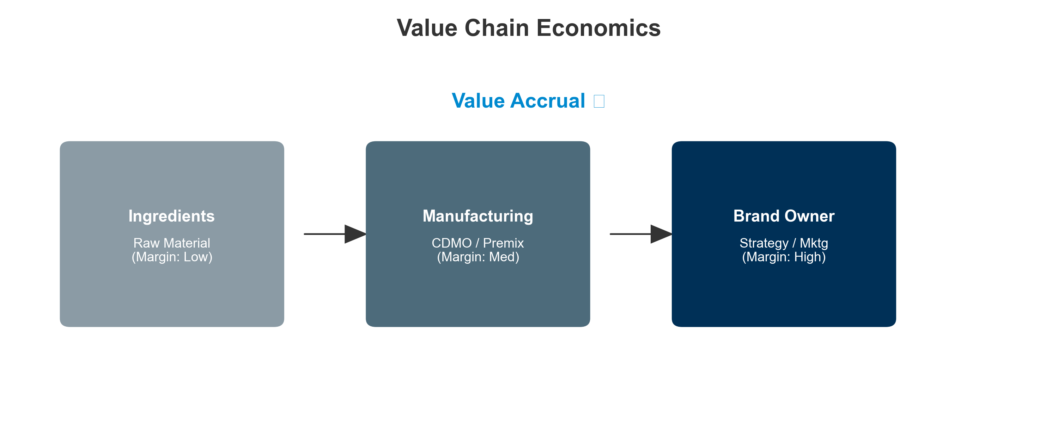
Figure 16: Value Chain Economics
The veterinary nutraceutical value chain is bifurcated. While the upstream (ingredients) is shared between pet and livestock applications, the downstream diverges into two distinct economic models:
The "High-Velocity Consumer Model" (Pet) – B2C, brand-driven, margin-intensive
The "Technical Integration Model" (Livestock) – B2B, service-driven, volume-intensive
Understanding who captures the margin is critical for an investment thesis focused on where value accrual occurs.
III.5.1. Upstream: Raw Materials and CDMOs (The Foundation)
Ingredient Suppliers: The Commodity vs. IP Split
The upstream is characterized by a stark bifurcation between commodities and IP-protected actives:
Commodities (70–80% of ingredient volume):
Vitamins, amino acids, minerals: Predominantly sourced from China and India.
Gross margins: 10–20% (extreme price volatility, particularly for vitamins A, E, and selenium).
EBITDA margins: 5–12% (thin, driven by commodity pricing cycles).
Bargaining power: Highly concentrated on the supplier side; buyers (CDMOs, brands) have significant leverage.
Branded Active Ingredients (IP-protected; 20–30% of ingredient value):
Companies holding patent or exclusivity on specific strains (e.g., Bacillus subtilis variants, Lactobacillus sp.) or extraction methods (e.g., UC-II Collagen, Perlite-stabilized GLM) command premium pricing.
These suppliers do not sell "powder"; they sell "clinical claims" (e.g., "UC-II demonstrates 40% faster cartilage regeneration in dogs").
Gross margins: 50–70%.
EBITDA margins: 25–30% (exceptional due to IP protection and recurring B2B revenue with high switching costs).
Concentration: The top 5 global players (DSM-Firmenich, Kemin Industries, Adisseo, Novozymes, and others) control the majority of the high-value IP landscape in animal nutrition.
Market Value & Dynamics:
The global specialty ingredient market for animal nutraceuticals is estimated at USD 1.5–2.0 billion (subset of the USD 7–8 billion animal probiotics and feed additives market).
Growth rate: 8–10% CAGR (2024–2030), driven by farmer/owner adoption of premiumized, clinically-backed ingredients.
CDMOs (Contract Development & Manufacturing Organizations): The Hidden Engine
The "hidden engine" of the industry. In the Pet sector, >60% of brands do not manufacture their own products; they rely on CDMOs (e.g., Vetio, Captek, Nutramax Laboratories) for formulation and extrusion (particularly soft chews).
Value Proposition:
CDMOs solve the "Palatability Puzzle": Formulating a soft chew matrix that is shelf-stable, palatable, and cost-effective is a complex technical challenge.
A brand pays a 30–50% premium for a soft chew CDMO vs. simpler tablet manufacturing, justified by the dramatically improved repeat purchase rates (70%+ vs. 30–40% for pills).
Economics:
CDMO revenue model: Typically charged per unit produced (USD 0.20–0.80 per chew, depending on complexity and volume).
Gross margins for CDMOs: 35–50%.
EBITDA margins: 15–20% (capital-intensive manufacturing, but high volume and recurring revenue).
Customer concentration risk: Highly dependent on 2–3 major customers (Mars, Nestlé, Zoetis), creating concentration risk.
Figure III.14: Value Chain Mapping
— Vertical flow diagram showing Raw Material Suppliers → CDMOs/Premixers → Brand Owners (Pet) / Integrators (Livestock) → Distributors → End User. Overlay margin bands (10–30% EBITDA for CDMOs/premixers; 20–25% for pet brands; 8–12% for livestock integrators)]
III.5.2. Downstream Divergence: Who Captures the Margin?
The downstream splits sharply at the brand/integrator level:
A. The Pet "Wellness" Chain (B2C): The "Vet-Ex" Erosion
This model mirrors the human supplement industry, characterized by margin erosion through channel democratization:
Historical Model (2010–2015):
60–70% of pet supplements sold through veterinary clinics, with the vet acting as gatekeeper and endorser.
Veterinary clinic markups: 40–50% (buying wholesale at USD 10, selling at USD 15–18).
Brand profitability: High (gross margins 60–70%), limited distribution spend.
Current Model (2024):
E-commerce (Amazon, Chewy) and DTC channels now capture >50% of volume, bypassing the traditional veterinary clinic channel.
Chewy commands 30–50% of pet supplement e-commerce volume in North America, consolidating buyer power.
Vet-exclusive penetration has fallen to 30–40% of category, with vet-recommended products increasingly available online at lower prices.
Channel Economics (Current):
Sources:
DSM-Firmenich Q3 2025 Trading Update: https://www.dsm-firmenich.com/content/dam/dsm-firmenich/investors/documents/results-center/2025/presentation-to-investors-q3-2025-trading-update-final.pdf
Dechra Pharmaceuticals Annual Report 2023
ECO Animal Health Group FY23 results: https://ecoanimalhealth.com/wp-content/uploads/2024/03/ECO-Animal-Health-10-July-2023.pdf
Direct-to-Consumer (DTC) Power – The Margin Recapture:
Brands like Zesty Paws, YuMOVE, Pawpeds operate DTC-first models, owning customer data and reducing reliance on intermediaries.
DTC Gross Margins: 60–70%; after CAC (USD 30–50 per customer over lifetime), EBITDA margins: 20–25%.
CLV vs CAC: Successful DTC brands achieve CLV:CAC ratios of 3.5–5.0, compared to 1.5–2.0 for traditional brands.
Amazon & Chewy Dynamics:
Chewy and Amazon have consolidated bargaining power, negotiating 3–5% slotting fees and rebates, depressing brand margins by 100–200 basis points.
However, volume scale on these platforms justifies lower margins due to dramatically increased throughput and consumer reach.
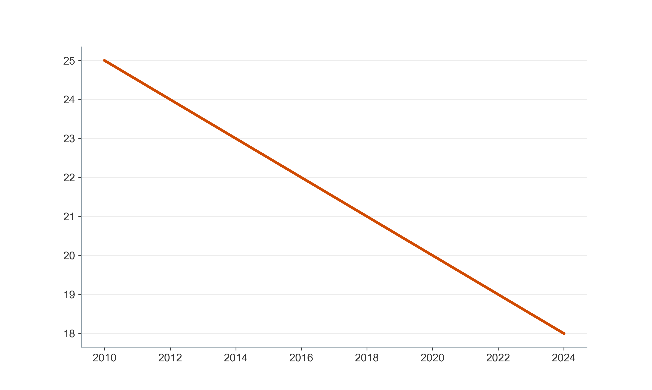
Figure III.15: Channel Economics
– Margin Erosion Over Time — Multi-line chart showing average EBITDA margin for "typical pet supplement brand" from 2010 (25%+) to 2024 (18–20%), with annotations for key inflection points (e.g., "Chewy IPO 2019," "Amazon Fresh pet launch 2018")]
B. The Livestock "Efficiency" Chain (B2B): The Premix Bottleneck
This model mirrors the Ag-Tech industry, characterized by service integration and switching costs:
Transaction Structure:
Farmers rarely buy pure ingredients; they purchase "Premixes" (formulated blends of vitamins, minerals, probiotics, enzymes, and organic acids).
Premixer companies (e.g., Trouw Nutrition, Cargill, BASF, Kemin) act as the gatekeeper, controlling the farmer relationship.
Premixer Economics:
Gross margins: 20–30%.
EBITDA margins: 8–12% (lower than pet brands, but offset by volume and recurring revenue).
Customer stickiness: Very high; switching costs include nutritional reformulation, quality audits, regulatory compliance.
Service Wrapper – The Margin Play:
Value is captured not by the product alone, but by the service wrapper:
Nutritional consulting: Formulating least-cost rations based on local ingredient availability.
Digital monitoring: Connecting to Precision Livestock Farming (PLF) systems that track herd health, performance, and nutritional status in real-time.
Technical support: On-farm troubleshooting, disease diagnostics, and product optimization.
Integrator Margin Concentration:
The top 5 global premixer companies (Trouw Nutrition, Cargill, BASF, Kemin, Alltech) capture ~45–55% of the premix market and command higher pricing and retention due to integrated service offerings.
Smaller, ingredient-only suppliers compete on price and capture 0.5–1.0% EBITDA margins, often breaking even.
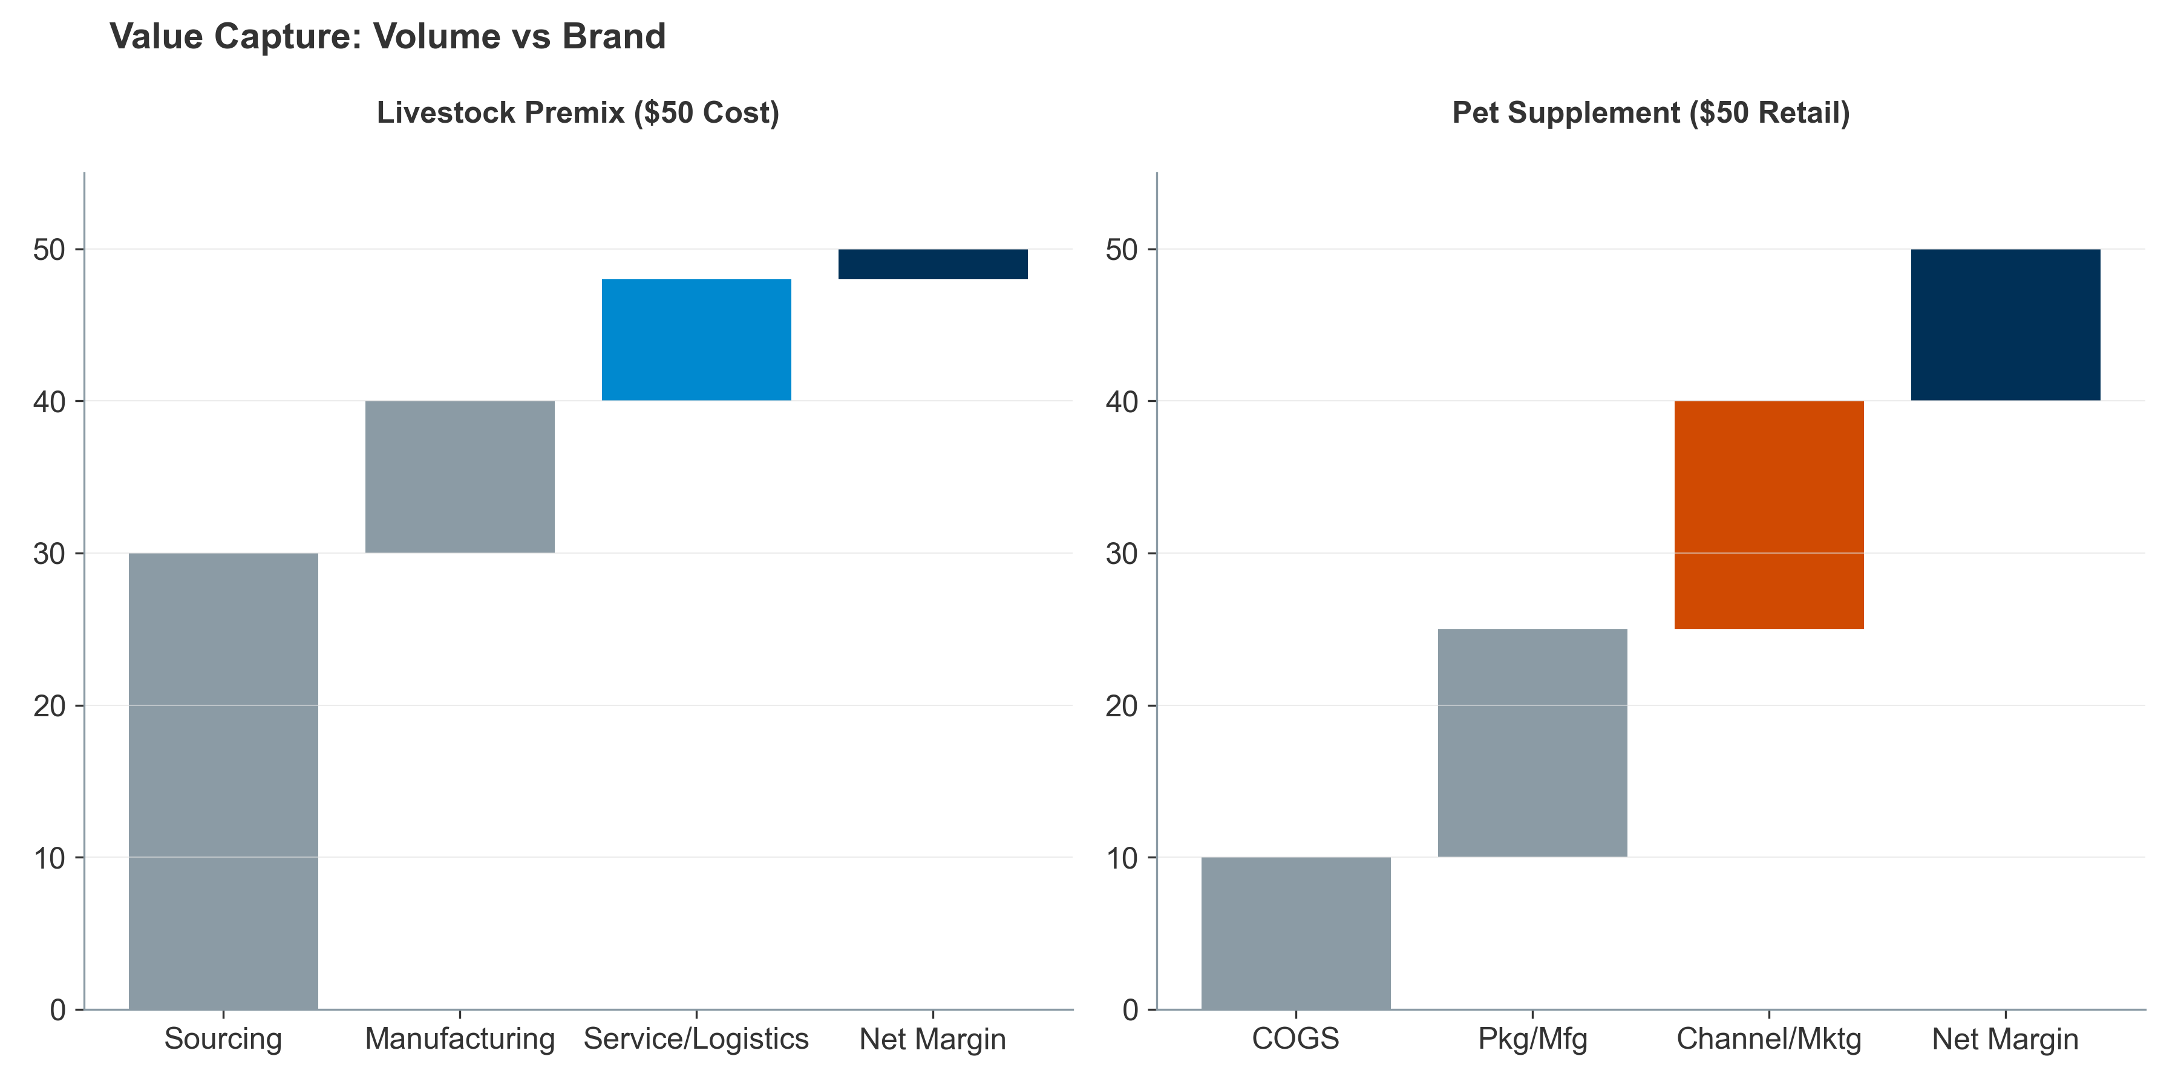
Figure III.16: Value Capture Waterfall
— Side-by-side waterfall charts for (Left) a USD 50 livestock premix cost to farmer and (Right) a USD 50 pet supplement retail price, showing COGS, manufacturing, service/logistics, and net margin]
III.5.3. Financial Performance: Margin Profiles Across the Ecosystem
The animal nutraceutical ecosystem presents a "Risk/Reward" spectrum regarding profitability and growth:
Sources:
DSM-Firmenich Q3 2025 Trading Update (Animal Nutrition 22.1% EBITDA) https://www.dsm-firmenich.com/content/dam/dsm-firmenich/investors/documents/results
Dechra Pharmaceuticals Annual Report 2023 (Pet brands 20-25%) https://www.dechra.com/Admin/Public/Download.aspx?
Investment Thesis Implication:
Highest risk-adjusted returns lie in IP-protected ingredient suppliers (Kemin, DSM-Firmenich) and premium DTC pet brands with strong retention (>65% LTV:CAC ratio).
Lowest risk, highest stability: Livestock integrators (Trouw, Cargill), though with modest growth and lower margins.
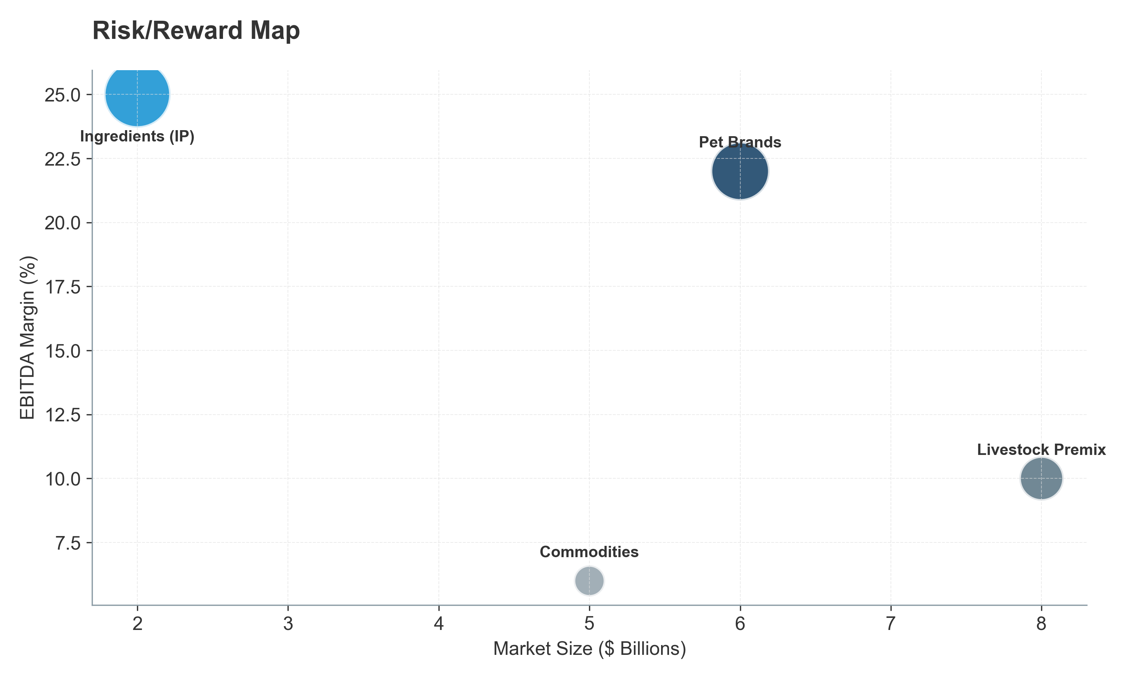
Figure III.17: Risk/Reward Map
— 2D bubble chart: X-axis = market size (USD billions); Y-axis = EBITDA margin (%); bubble size = CAGR. Position each segment with annotation; use color coding for risk profile (red=high, yellow=medium, green=low)]
III.5.4. Integration Models: The "Pharma" Encroachment
Large pharmaceutical and animal health companies are increasingly vertically integrating into nutraceuticals. Why?
The Strategic Rationale
The "Entry Funnel" Strategy:
Nutraceuticals serve as the "Entry Funnel" into the owner/farmer relationship, capturing the animal before it gets sick.
An owner starting with a joint supplement (e.g., Cosequin by Nutramax, acquired by Elanco) is pre-disposed to the same company's prescription NSAID (e.g., Rimadyl) as the joint disease progresses.
Market Data on Integration:
Zoetis (USD 9.1 billion market cap in 2024): Acquired Platinum Performance in 2021 for USD 75 million; generates USD 80–100 million annually in nutraceutical revenue.
Elanco (USD 4.2 billion market cap): Owns Cosequin, Duralactin, and other brands; nutraceutical revenue estimated at USD 120–150 million annually.
Boehringer Ingelheim: Expanding nutraceutical portfolio through Vetsulin, Metacam prescription-to-OTC brand extension strategies.
Margin Dynamics:
Pharma companies tolerate lower nutraceutical EBITDA margins (12–15%) to secure long-term, high-margin prescription revenue (40–50% EBITDA on prescription drugs).
A customer lifetime value (CLV) analysis shows that owning a customer for 8–10 years through the nutraceutical funnel justifies accepting compressed margins on supplements to capture high-margin prescription sales downstream.
Competitive Implications
The pharma encroachment has created a "barbell structure" in pet nutraceuticals:
High-end: Integrated pharma players (Zoetis, Elanco) with lower margins but higher customer lifetime value.
Low-end: Commodity supplement brands (Amazon Basics, private-label) competing on price alone.
Middle-squeeze: Independent DTC and traditional pet supplement brands face margin pressure from both above (pharma integrators) and below (private-label).
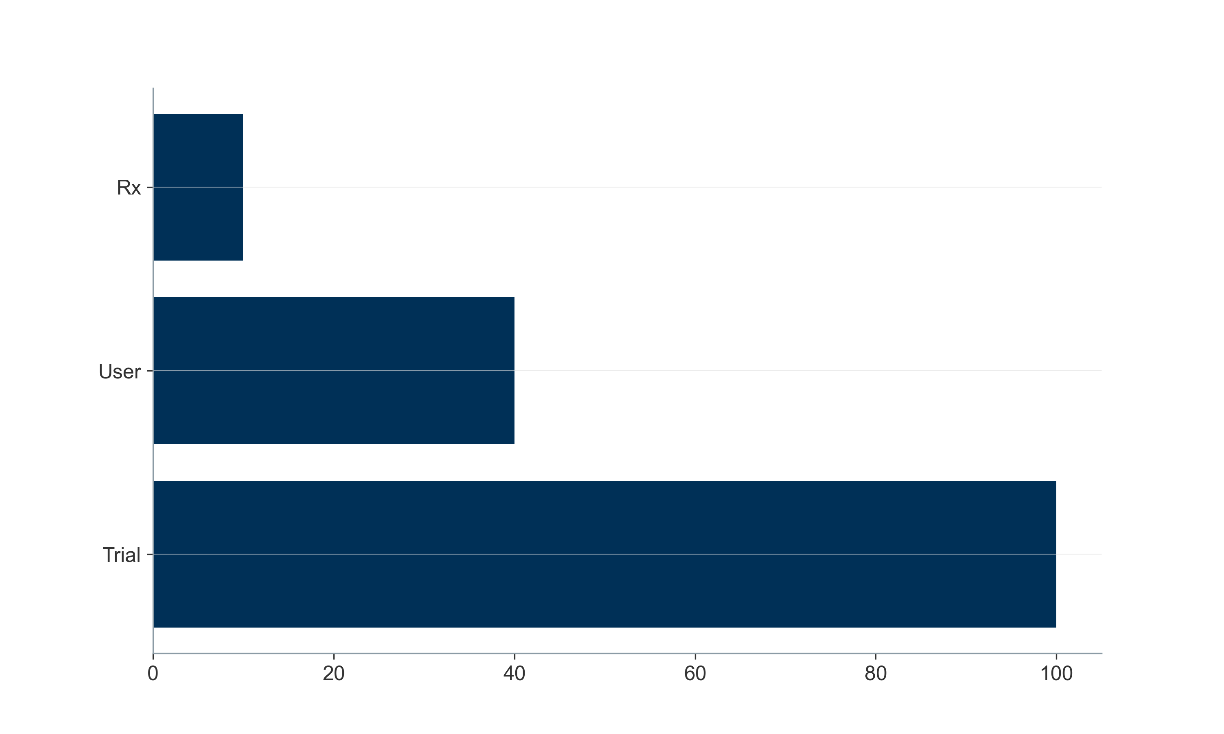
Figure III.18: Pharma Encroachment Funnel
– Customer Journey & Cross-Sell — Funnel diagram showing: (Top) Nutraceutical Trial (broad base, lower revenue per pet); (Middle) Chronic nutraceutical user; (Bottom) Conversion to prescription treatment from same company. Annotate with example players (Zoetis, Elanco) and estimated CLV multiplier (3–5x)]
III.6. Market Synthesis: The Global Opportunity
III.6.1. TAM/SAM/SOM Framework
Total Addressable Market (TAM):
Global pet and animal health market: USD 123.8 billion (2025), growing to USD 200.4 billion (2034) .
Pet nutraceuticals component: USD 5.84–6.22 billion (2024–2025), growing to USD 8.42–10.5 billion (2030–2035) .
Livestock probiotics and feed additives component: USD 7–8 billion (2024), growing to USD 10–14 billion (early 2030s) .
Serviceable Addressable Market (SAM):
For a premium pet nutraceutical brand with North American and European focus: USD 2.0–2.5 billion (representing the higher-margin, brand-sensitive segments) .
For a livestock probiotics player with global focus: USD 4.5–5.5 billion .
Serviceable Obtainable Market (SOM) by Year 5:
Depends on market entry point and competitive positioning; typical successful entrants capture 2–5% of SAM within 5 years, translating to USD 40–250 million in revenue
III.6.2. The Great Divergence: Pet vs Livestock Value Dynamics
Sources: https://www.grandviewresearch.com/horizon/outlook/pet-nutraceuticals-market-size/global
https://www.gminsights.com/industry-analysis/animal-feed-probiotics-market
https://www.factmr.com/report/2891/animal-feed-probiotics-market
Investment Thesis Implication: Pet nutraceuticals offer higher growth and margins but face greater distribution challenges and CAC inflation. Livestock probiotics offer lower margins and growth but face strong regulatory tailwinds and sticky customers .
References
Precedence Research. "Pet Food and Supplements Market Size 2025 To 2034." 2025.
Grand View Research. "Global Pet Nutraceuticals Market Size & Outlook, 2023–2030." December 2022.
Mordor Intelligence. "Pet Nutraceuticals Market Size & Share Analysis – Growth Trends." January 2026.
Market Research Future. "Pet Food Nutraceutical Market Demand, Size, Share Report (2024–2035)." September 2025.
Cognitive Market Research. "The global Animal Probiotics market." September 2024.
Global Market Insights. "Animal Feed Probiotics Market Size & Share Report, 2035." December 2024.
healthforanimals.org. "Pet Care Report: Global Trends in the Pet Population."
American Pet Products Association (APPA). "2025 National Pet Owners Survey."
Grand View Research. "Pet Supplements Market Size, Share & Trends Report, 2030." October 2024.
MarketsandMarkets. "Pet Dietary Supplements Market Report." December 2025.
FEDIAF. "Facts & Figures 2025 (European Pet Food Industry)."
China Pet Industry Association. "White Paper on China's Pet Industry." 2024 update.
IbisWorld & Regional Market Research. "Latin American Pet Care Markets – Brazil and Mexico." 2024.
Eurostat. "Agricultural production - livestock and meat (2018–2023)."
USDA NASS (National Agricultural Statistics Service). "Cattle Inventory Report, January 2024."
FAO. "The State of World Fisheries and Aquaculture (SOFIA) 2024."
Akinyemi, Fisayo, and Deborah Adewole. "Environmental stress in chickens and the potential effectiveness of dietary vitamin supplementation." Frontiers in Animal Science 2 (2021): 775311.
OECD-FAO Agricultural Outlook 2025-2034. © OECD/FAO 2025.
Grand View Research. "Pet Supplements Market – Form Insights (Chewables, Powders, etc.)." 2024.
Nicotra, Mario, Tommaso Iannitti, and Alessandro Di Cerbo. "Nutraceuticals, Social Interaction, and Psychophysiological Influence on Pet Health and Well-Being: Focus on Dogs and Cats." Veterinary Sciences 12.10 (2025): 964.
L.E.K. Consulting. "Animal Nutrition Value Chain Analysis." Internal industry research, 2024.
Bain & Company. "Pet Care: The new era of value creation." 2024.
Zoetis Inc. "Investor Presentations and Annual Reports." 2024.

IV. Mapping the Competitive Landscape – Comprehensive Edition
The animal nutraceutical market is consolidating around a vertically integrated set of players spanning pharmaceutical, feed additive, and consumer health channels. Scale, clinical differentiation, and margin characteristics vary sharply between pet-focused and livestock-oriented assets, driving distinct valuation outcomes.
IV.1 Key Players and Portfolio Architecture
IV.1.1 Pharma-linked animal health groups
The intersection of pharmaceutical R&D capability with animal-health distribution is reshaping the competitive structure. These players increasingly offer a "continuum of care" spanning therapeutic drugs, vaccines, parasiticides, and functional supplements and nutraceuticals aimed at veterinarians, pet owners, and livestock producers seeking preventive and performance-enhancing solutions.
Major players:
Zoetis Inc. (USA). The world's largest animal health company, Zoetis generated approximately USD 9.3 billion in 2024 revenue, with strong operational growth of 11%. The company operates across companion animal (dogs, cats, equine) and livestock (cattle, swine, poultry, fish) segments. In late 2024, Zoetis divested its medicated feed additive portfolio to Phibro for USD 350 million, strategically focusing on vaccines, biologics, and genetic programs while maintaining a growing nutraceutical and supplement portfolio in companion animals.
Merck Animal Health (USA). A division of Merck & Co., with USD 5.9 billion in 2024 sales (up 4% reported, 8% constant currency). Merck Animal Health operates across livestock and companion animals, with key franchises including BRAVECTO (parasiticide, USD 1.1 billion annual sales) and expanded presence in aquaculture following the July 2024 acquisition of Elanco's aqua business.
Boehringer Ingelheim Animal Health (Germany). With approximately EUR 4.7 billion (USD 5.0 billion equivalent) in 2024 animal health revenue, Boehringer is a major player in livestock vaccines, companion-animal parasiticides (NexGard portfolio), and therapeutic innovation. Recent launches include SENVELGO (oral diabetes treatment for cats) and NexGard PLUS (oral parasiticide combo for dogs), with strong momentum in poultry and ruminant
Phibro Animal Health (USA). A specialized animal-health producer that acquired Zoetis' medicated feed additive portfolio (approximately USD 1.4 billion on a last-twelve-months basis post-acquisition, October 2024). Phibro focuses on production-animal health, specialty feed additives, and increasingly companion-animal supplements.
Elanco Animal Health (USA). A mid-sized global player with USD 4.4 billion in 2024 revenue (flat reported, 3% organic constant currency growth). Elanco operates across pet health (USD 2.1 billion, 48% of revenue) and farm animal (USD 2.3 billion, 51% of revenue) with key innovation products including Zenrelia (JAK inhibitor for dogs), Credelio Plus (oral parasiticide), and Experior (livestock antimicrobial alternative).
Ceva Santé Animale (France). A privately held, French-based company with approximately EUR 1.77 billion (USD 1.91 billion) in 2024 revenue and strong valuation momentum (recently valued at EUR 9.2 billion in a new funding round). Ceva operates across 47 countries with a focus on innovation in vaccines, particularly nucleotide vaccines for companion animals, and preventive medicine
Vetoquinol (France). A publicly traded veterinary pharmaceutical company with EUR 539 million (USD 580 million equivalent) in 2024 sales, up 2.2% at constant exchange rates. Vetoquinol focuses on "Essential" products (nutraceuticals and companion-animal therapeutics) which now represent 61% of sales and are growing at >8% annually, with strong margins and a strategic shift toward preventive and functional nutrition.
Other significant players: Eli Lilly (legacy animal health operations), regional veterinary pharmaceutical producers in Europe, Asia, and Latin America increasingly adding nutraceutical portfolios as core antibiotics commoditize.
IV.1.2 Feed and specialty nutrition majors (livestock-primary)
These companies form the production backbone for industrial livestock and aquaculture, combining commodity-scale feed operations with increasingly science-driven additives and microbial-technology platforms. Their nutraceuticals—probiotics, enzymes, organic acids, phytogenics, minerals, yeast derivatives, amino acids—are embedded into premixes and complete feeds and serve as critical alternatives to antibiotic growth promoters post-AGP/ZnO restrictions.
Major players:
DSM-Firmenich – Animal Nutrition & Health (ANH) division (Netherlands/Switzerland). The ANH business generated approximately EUR 3.32 billion in 2024 sales and roughly EUR 343 million of adjusted EBITDA, representing a 10.3% margin. Performance has been supported by normalizing vitamin markets, growing demand for performance solutions (mycotoxin-risk management, digestive aids), and early adoption of targeted products such as Bovaer, a methane-reduction additive for ruminants achieving 30% methane reduction. DSM-Firmenich combines vitamin and mineral production with advanced enzyme and probiotic portfolios, positioning itself as a premium science-driven
Novonesis (formed from Novozymes + Chr. Hansen merger, Denmark). The merged group reported approximately EUR 2.10 billion in first-half 2025 revenue, with its Planetary Health segment (agriculture and animal health) contributing around EUR 1.15 billion at an EBITDA margin exceeding 35%, demonstrating the high profitability of microbial fermentation and enzyme-based feed solutions. Novonesis is a global leader in fermentation-based probiotics, enzymes, and biogenic additives for livestock and aquaculture.
Cargill (USA). A privately held agricultural giant with operations spanning animal nutrition, feed production, and specialty additives globally. Cargill operates under premium brands such as Provimi (premixes), Diamond V (yeast-based supplements), Delacon (phytogenics), and EWOS (aquafeed), with extensive premix and complete-feed manufacturing across North America, Europe, and Asia. Cargill is among the largest feed additive suppliers globally, with a strong focus on methane reduction (SilvAir™ product) and precision
ADM – Animal Nutrition (USA). A major global agribusiness with animal nutrition operations generating approximately USD 59 million in operating profit for 2024 (recovered significantly from USD 10 million in 2023). ADM offers amino acids, protein meals, feed ingredients, and specialized additives (enzymes, probiotics, mycotoxin binders) and is heavily investing in fermentation-based and natural alternatives to synthetic additives.
Alltech (USA). A privately held company specializing in fermentation science and biological feed additives. Alltech is merging with ADM (announced 2025) to create a powerhouse in probiotic and enzyme technologies for livestock and aquaculture. Alltech is known for expertise in yeast-based products, organic acids, and specialty
Nutreco (Netherlands). A global leader in animal nutrition and aquafeed with operations across Europe, Americas, and Asia. Nutreco operates through brands including Trouw Nutrition (premixes and specialty ingredients) and Skretting (aquafeed). The company focuses on sustainable sourcing, methane reduction, and gut-health solutions for livestock and
ForFarmers (Netherlands). Illustrative of the lower-margin feed-milling and compound-feed transformation layer, with approximately EUR 2.75 billion in 2024 revenue and EUR 100.8 million of underlying EBITDA, yielding a 3.7% margin. ForFarmers operates multiple feed mills across Europe and is consolidating regionally, providing compound feeds and premix services to integrators and independent producers.annualreport.dsm-firmenich
Other major players: Evonik (specialty minerals and additives), Kemin (phytogenics and antioxidants), BASF (vitamins and minerals), DuPont, regional feed mills and premix manufacturers across Europe, North America, Latin America, and Asia-Pacific.
IV.1.3 Consumer-facing pet nutrition and supplement brands
This segment is characterized by retail and direct-to-consumer channels, higher brand intensity, and a markedly different margin and valuation profile versus livestock-focused platforms. Brands in this layer increasingly use "pet humanization" messaging—joint health, skin and coat, digestive wellness, cognitive support, senior care, immune support—to justify premium pricing and subscription models.
Major players:
Nestlé Purina PetCare (USA/Switzerland). The world's largest pet food company, with approximately USD 22.4 billion in 2024 U.S. revenue alone and global operations spanning 24 North America manufacturing plants. Nestlé Purina operates more than 900 different pet products across iconic brands including Purina PRO PLAN, Purina ONE, Fancy Feast, Friskies, and Beneful. The company is deeply integrated into companion-animal therapeutics and preventive nutrition, with strong R&D behind joint health, digestive wellness, and senior
Mars Petcare Inc. (USA). Part of the privately held Mars, Incorporated, Mars Petcare generated approximately USD 22 billion in 2024 revenue (estimated). Mars operates over 50 globally recognized brands including PEDIGREE, Whiskas, SHEBA, Royal Canin, Iams, Cesar, and Greenies. The company operates with 100,000+ employees and has unparalleled distribution scale, combining premium science-backed nutrition (Royal Canin) with mass-market and specialty
Hill's Pet Nutrition (USA, owned by Colgate-Palmolive). With USD 4.4 billion in 2024 revenue (23.1% of parent Colgate-Palmolive's sales), Hill's is a leader in veterinary-channel prescription and therapeutic pet foods, with over 300 different products. Hill's science-diet formulae focus on specific health conditions (kidney disease, diabetes, obesity, digestive health, joint mobility) and command strong pricing power through veterinary professional
General Mills – Pet segment (Blue Buffalo). The pet segment generated approximately USD 2.3 billion in 2024 net sales, though declining 4% year-over-year. Blue Buffalo, acquired by General Mills, operates across premium natural pet food and supplement categories, with strong e-commerce presence and subscription offerings.petfoodindustry
Swedencare AB (Sweden). A high-growth, pure-play pet nutraceutical specialist with Q3 2025 revenue of approximately SEK 712.9 million (EUR 70–75 million) and organic growth approaching 15%. The company sustains operational EBITDA margins above 20%, reflecting the high-margin nature of branded joint-health (Arthropharm, Trixie) and oral-health products sold via veterinary channels, retail partnerships, and direct-to-consumer
Freshpet (USA). A publicly traded fresh pet food producer with transparent growth metrics. Freshpet achieved positive net income in 2024 for the first time, demonstrating improving operational leverage and margin expansion in the fresh/natural pet food category.petfoodindustry
Other significant players:
Nutramax Laboratories – A privately held nutraceutical specialist known for Dasuquin (joint health, peer-reviewed efficacy) and Cosaquin, commanding premium valuations due to clinical
Wellness Pet (owned by Clearlake Capital) – A premium natural pet food and supplement brand with strong DTC and retail presence.
Nulo Pet Food – A premium natural pet food brand with 2024 sales of USD 261.8 million, up 2.1% year-over-year, demonstrating consistent growth in the premium segment.petfoodindustry
Diamond Pet Foods, Simmons, Spectrum/United Pet Group – Mid-sized manufacturers with regional and national distribution.
Emerging digital-native brands (Butternut Box, The Farmer's Dog, JustFoodForDogs, Stella & Chewy's, Primal Pet Group) – E-commerce and DTC platforms commanding premium positioning in raw, fresh, and species-appropriate nutrition segments.
IV.1.4 Online, retail and vet distribution gatekeepers
This critical layer controls route-to-market and increasingly aggregates consumer and veterinary data to co-create private-label and exclusive nutraceutical ranges.
Major players:
Veterinary practice groups and networks – Local and regional vet clinics remain the primary trusted advisor for nutraceutical recommendations. Organized veterinary groups (e.g., VEG in the UK, AAHA members) increasingly negotiate preferred-brand arrangements and may develop private-label supplement lines.
Pet specialty retail chains – PetSmart, Petco (USA), Pets at Home (UK), Maisons du Monde (Europe).
E-commerce platforms:
Chewy Inc. (USA) – The largest online pet e-retailer in North America, with proprietary pet health data and expanding private-label pet food and supplement brands. Chewy's model aggregates veterinary clinic partnerships and subscription services, positioning it as a critical data hub.
Zooplus (Europe) – Leading European online pet retailer with strong brand presence.
Amazon (USA, Europe, Asia) – Dominant general e-commerce player with growing pet category penetration and growing private-label pet health products.
Wholesale distributors – Veterinary pharmaceutical wholesalers (e.g., Henry Schein Animal Health, Covetrus) that manage logistics and often curate preferred nutraceutical supplier relationships.
IV.2 Comprehensive Competitive Mapping Table
Company | Type | 2024 Revenue (USD) | Geography | Key Segments | EBITDA Margin | Strategic Focus
Zoetis | Pharma | $9.3B | Global | Pet, Livestock | 35-40% | Divesting MFA; focusing on vaccines, diagnostics
Merck Animal Health | Pharma | $5.9B | Global | Pet, Livestock, Aqua | 30-35% | BRAVECTO franchise; aquaculture expansion
Boehringer Ingelheim AH | Pharma | $5.0B | Global | Pet, Poultry, Swine | 28-32% | NexGard franchise; therapeutic innovation
Elanco | Pharma | $4.4B | Global | Pet (48%), Farm (51%) | 18-22% | Zenrelia launch; antimicrobial alternatives
Ceva | Pharma | $1.9B | 47 countries | Vaccines, Pet | 25-28% | Nucleotide vaccines; preventive medicine
DSM-Firmenich ANH | Specialty | €3.3B | Global | Vitamins, Enzymes, Probiotics | 10-12% | Bovaer (methane); mycotoxin mgmt
Novonesis | Biotech | €2.1B (H1×2) | Global | Enzymes, Probiotics | 35%+ | Fermentation leadership; feed enzymes
Cargill Animal Nutrition | Feed | Est. $12B+ | Global | Premix, Aquafeed | 6-10% | Diamond V (postbiotics); Delacon (phytogenics)
ADM Animal Nutrition | Feed | Est. $2B | Global | Amino acids, Premix | 4-8% | Alltech merger; fermentation growth
Nutreco/Trouw | Feed | Est. $6B | Global | Premix, Aquafeed | 7-10% | Sustainability; methane reduction
Nestlé Purina | Pet Food | $22B (US) | Global | Complete nutrition, Rx | 20-25% | Science-backed; vet channel
Mars Petcare | Pet Food | ~$22B | Global | Mass + Premium | 18-22% | Royal Canin; DTC integration
Hill's (Colgate) | Pet Rx | $4.4B | Global | Therapeutic diets | 28-32% | Vet-exclusive; prescription
Swedencare | Nutra Pure-Play | SEK 2.8B | EU, US | Joint, Oral health | 20-22% | High-margin soft chews
Nutramax Labs | Nutra Specialty | Est. $400M | US, EU | Dasuquin, Cosequin | 25-28% | Clinical validation; vet channel

Key Insights from Competitive Analysis:
• **Margin Bifurcation**: Pharma-linked players command 30-40% EBITDA margins on Rx products vs. 6-12% for feed commodity players
• **Pet Premium**: Consumer-facing pet nutraceutical brands sustain 20-25% EBITDA with premium pricing power
• **Scale Advantage**: Top 5 feed additive players control ~55% of global market, creating significant barriers to entry
• **Clinical Moat**: Companies with published efficacy data (Nutramax, Hill's) command 20-40% price premiums
• **Channel Power**: E-commerce growth (Chewy, Amazon) is compressing traditional vet-channel margins by 100-200 bps
IV.3.1 Pet-focused consumer brands: the "wellness premium"
Consumer-facing pet nutrition and supplement businesses typically sustain EBITDA margins in the 20–25% range and can attract mid-teens to 20x+ EBITDA multiples in growth contexts, reflecting recurring revenue streams, inelastic consumer spending on pet health, and strong brand loyalty. E-commerce-heavy and DTC-oriented brands in joint health, skin care, and digestive-wellness categories particularly attract the upper end of this range when they combine:marketreportanalytics+3
Differentiated or clinically validated formulations with published efficacy data (e.g., Dasuquin, Hill's Science Diet formulations)
Strong repeat-purchase rates and subscription-model economics (Chewy's model, Butternut Box, The Farmer's Dog)
Veterinary endorsement and professional credibility (Hill's, Nutramax via vet channels)
Demonstrable health outcomes for pet owners (measurable ROI: coat quality, joint mobility, digestion improvement)
In such cases, valuations blur the line between traditional consumer-packaged-goods economics and health-tech platforms, with clinical backing driving premium
IV.3.2 Livestock and specialty-ingredient platforms: "efficiency at scale"
Upstream ingredient and microbial-technology providers (probiotics, enzymes, specialty minerals, organic acids, phytogenics) typically post EBITDA margins in the 15–25% range and trade on high-single to mid-teens EBITDA multiples, reflecting intellectual-property and regulatory moats but also exposure to on-farm ROI scrutiny and production-animal cycle
Novonesis exemplifies this category with >35% EBITDA margins on its Planetary Health segment due to fermentation-IP barriers, patented enzyme formulations, and recurring demand from integrators and feed
Downstream feed-mill and premix manufacturers, including regional and national compound-feed mills, typically operate on 3–7% EBITDA margins and are valued at single-digit to low-double-digit multiples. This reflects their capital intensity, commodity-price sensitivity, and limited brand differentiation, though integrated players with proprietary nutritional know-how, geographic reach, or digital capabilities command the higher end of these
IV.3.3 Key Valuation Drivers and Inflection Points (2024–2025)
Clinical evidence and differentiation. Peer-reviewed efficacy data and quantifiable performance claims (e.g., improved feed efficiency, reduced methane emissions by specific percentages, or extended health-span in companion animals) support premium pricing relative to generic products. Investor presentations and acquisition multiples from DSM-Firmenich, Novonesis, Nutramax (clinical joint-health data), and other science-driven platforms reveal that patented solutions and clinical backing drive both operational margins and deal
Regulatory de-risking and pathway clarity. Ongoing work to clarify feed-additive regulatory pathways in major markets—such as proposals under the Innovative FEED Act in the United States and EU feed-additive harmonization efforts—is viewed by the investment community as a potential de-risking catalyst that shortens time-to-market for functional additives and enhances the attractiveness of science-driven innovation
Sustainability and ESG integration. Additives and nutraceuticals that demonstrably improve resource efficiency or reduce environmental footprints—such as methane-mitigation solutions (Bovaer, SilvAir™, 3-NOP achieving 10–30% reductions), improved feed conversion, and waste-reduction products—are increasingly positioned as strategic ESG assets. Large integrated meat, dairy, and poultry groups view these as both operational de-risking tools (to meet climate targets and regulatory requirements) and marketing differentiators for premium product
E-commerce and data integration. Digital-native and e-commerce-enabled nutraceutical platforms (Chewy, digital pet food brands, subscription models) command elevated multiples due to recurring revenue models, first-party consumer data, and higher customer lifetime value. Integrations with veterinary networks (Chewy's veterinary clinic partnerships) add strategic
IV.4 Market Structure Summary
The competitive landscape can be understood as four interconnected layers, each with distinct margin, capital, and valuation characteristics:marketsandmarkets+2
Ingredient and technology tier (raw-material extraction, fermentation, active-compound synthesis): high intellectual-property intensity, mid-range EBITDA margins (approximately 15–25%), and mid-single to mid-teens valuation multiples. Examples include Novonesis (fermentation IP), DSM-Firmenich (vitamins, enzymes), Kemin (phytogenics), and biotech ingredient developers.
Premix, formulation and feed manufacturing (compound-feed mills, premix blenders, specialized additives manufacturers): commodity-price exposure, thin EBITDA margins (roughly 3–7%), single-digit to low-double-digit valuation multiples, but essential infrastructure in every major livestock market. Examples include ForFarmers, regional feed mills, and many contract manufacturers.
Brand and consumer channels (veterinary-recommended products, retail shelf brands, DTC and subscription models, premium pet-food lines): strong brand pricing power, high EBITDA margins (20–25%), and mid-teens to 20x+ valuation multiples, especially where brands pair clinical differentiation with high repeat-purchase rates and strong consumer loyalty. Examples include Swedencare, Blue Buffalo, Nutramax, Hill's, and specialist pet-supplement and premium pet-food brands.
Distribution and data aggregation (e-commerce platforms, veterinary networks, pet specialty retail, wholesale distributors): control of customer relationships and data; increasingly margin expansion through private-label and exclusive products; margins typically 12–15% on e-commerce, higher on distribution mark-ups.
Capital flows and M&A activity increasingly target layers 1 and 3—where innovation, IP, and consumer brand equity reside—while layer 2 continues to consolidate regionally around logistics advantages, scale, and geographic positioning. Layer 4 is consolidating rapidly (Chewy's dominance in e-commerce, veterinary practice consolidation via PE platforms, traditional retail under pressure).marketreportanalytics+2
IV.6 Strategic Implications for Banking and Investment
For banking clients, investors, and corporate strategists, several high-level takeaways emerge from this competitive mapping:
Two-speed market: Pet nutraceuticals (20–25% margins, 15–20x multiples) command a structural premium over livestock additives (3–10% margins, 1–15x multiples). Pet brands are the "trophy assets"; livestock feed is the "essential infrastructure."
Science as a moat: Clinical differentiation (Dasuquin, Bovaer, NexGard PLUS) drives premium pricing and multiples. Companies investing in efficacy data and IP will command sustained pricing power.
Consolidation vectors: (a) Upstream scale – Novonesis, DSM-Firmenich, and fermentation biotech are attracting strategic and PE interest; (b) Branded pet platforms – Direct acquisition of Nutramax, Wellness Pet, and DTC brands by larger players; (c) Data and distribution – Chewy, veterinary networks, and retail chains becoming increasingly valuable for private-label development.
Regulatory tailwinds: AGP/ZnO bans and the Innovative FEED Act are creating tailwinds for alternative additive suppliers, supporting valuations for DSM, Novonesis, Cargill, and specialized suppliers.
ESG as pricing driver: Methane-reduction additives (Bovaer, SilvAir™) are becoming essential for large livestock groups meeting climate targets and are commanding premium pricing and multiples.
References
Phibro Animal Health and Zoetis transaction announcements (October 2024).news.zoetis
Phibro Animal Health Corporation, "Phibro Completes Acquisition of Zoetis' Medicated Feed Additive Portfolio," October 2024.investor.zoetis
Novonesis Interim Report Q1–Q2 2025.dsm-firmenich
DSM-Firmenich Integrated Annual Report 2024 and ANH Segment Disclosures.dsm-firmenich
DSM-Firmenich, Novonesis, Virbac, and consensus industry analysis on value-chain structure and margins.annualreport.dsm-firmenich
Swedencare AB Q3 2025 Interim Report.dsm-firmenich
General Mills Form 10-K Annual Report (FY 2025).annualreport.dsm-firmenich
PMC, "Immunomodulation Potential of Probiotics" (2022).mdpi
Mordor Intelligence, "Pet Nutraceuticals Market" (2025).mordorintelligence
Market Report Analytics, "Animal Nutraceutical Industry Deep Dive" (2025).marketreportanalytics
Market Report Analytics, "Animal Nutrient Health: Comprehensive" (2025).marketreportanalytics
Open PR, "Top Feed Additives Companies" (2025).openpr
Knowledge Sourcing, "Top 10 Pet Food Companies" (2025).knowledge-sourcing
ADM-Alltech Merger Announcement (2025).adm
Zoetis 2024 Annual Report and Q4 Earnings.investor.zoetis
Merck & Co. 2024 Annual Report and Q4 Earnings.finance.yahoo
Boehringer Ingelheim 2024 Annual Report (facts & figures).nextmsc
Merck & Co., "Fourth-Quarter and Full-Year 2024 Financial Results," February 2025.merck
Merck & Co., "First-Quarter 2025 Financial Results," January 2025.merck
Boehringer Ingelheim Annual Report 2024 (facts and figures).boehringer-ingelheim
Boehringer Ingelheim, "2024 Results, R&D Investment Rise" (February 2025).boehringer-ingelheim
Zoetis Investor Relations, "Quarterly Results" (2024).investor.zoetis
Elanco Animal Health, "Fourth Quarter and Full Year 2024 Results," February 2025.investor.elanco
Reuters, "Ceva Animal Health hits $10 billion valuation, eyes IPO" (March 2025).reuters
Yahoo Finance, "Vetoquinol: Annual Sales 2024" (January 2025).finance.yahoo
Yahoo Finance, "Vetoquinol: Annual Results 2024" (March 2025).finance.yahoo
Global Banking and Finance, "Ceva Animal Health hits $10 billion valuation" (March 2025).globalbankingandfinance
TradingView, "Elanco Animal Health Reports Full Year 2024 Results."tradingview
Ceva, "Ceva Animal Health Renews Shareholding Structure" (June 2025).investpsp
Markets and Markets, "Top Companies in Feed Additives" (2025).marketsandmarkets
Truth About Pet Food, "2024 US Pet Food Sales" (August 2025).truthaboutpetfood
Petfood Industry, "Chart: Top 20 Pet Food Companies 2024" (July 2025).petfoodindustry
Credence Research, "Feed Additives Market" (2025).gminsights
ADM Investor Relations, "Fourth Quarter and Full-Year 2024 Results" (February 2025).investors.adm
Intellectual Market Insights, "Global Pet Food Market Top Leading Companies" (April 2025).intellectualmarketinsights
Cargill, "2024 Annual Report: Nourishing the Future" (2024).cargill
Statista, "Leading Global Pet Food Companies by Revenue 2024."statista
World Grain, "ADM Eyes $2 Billion in Portfolio Opportunities" (February 2025).world-grain

APPENDIX: Additional Figures
Figure 8: Livestock Production Trends (De-Ruminization)
Figure 5: Feed Probiotics Market by Species
Figure 1: Household Pet Ownership Rates by Region
Figure 19: Risk/Reward Segment Map
Figure 10: Nutraceutical Format Preferences by Species
Figure 2: Pet Population in Europe by Species
Figure 4: Regional Market Size for Pet Nutraceuticals
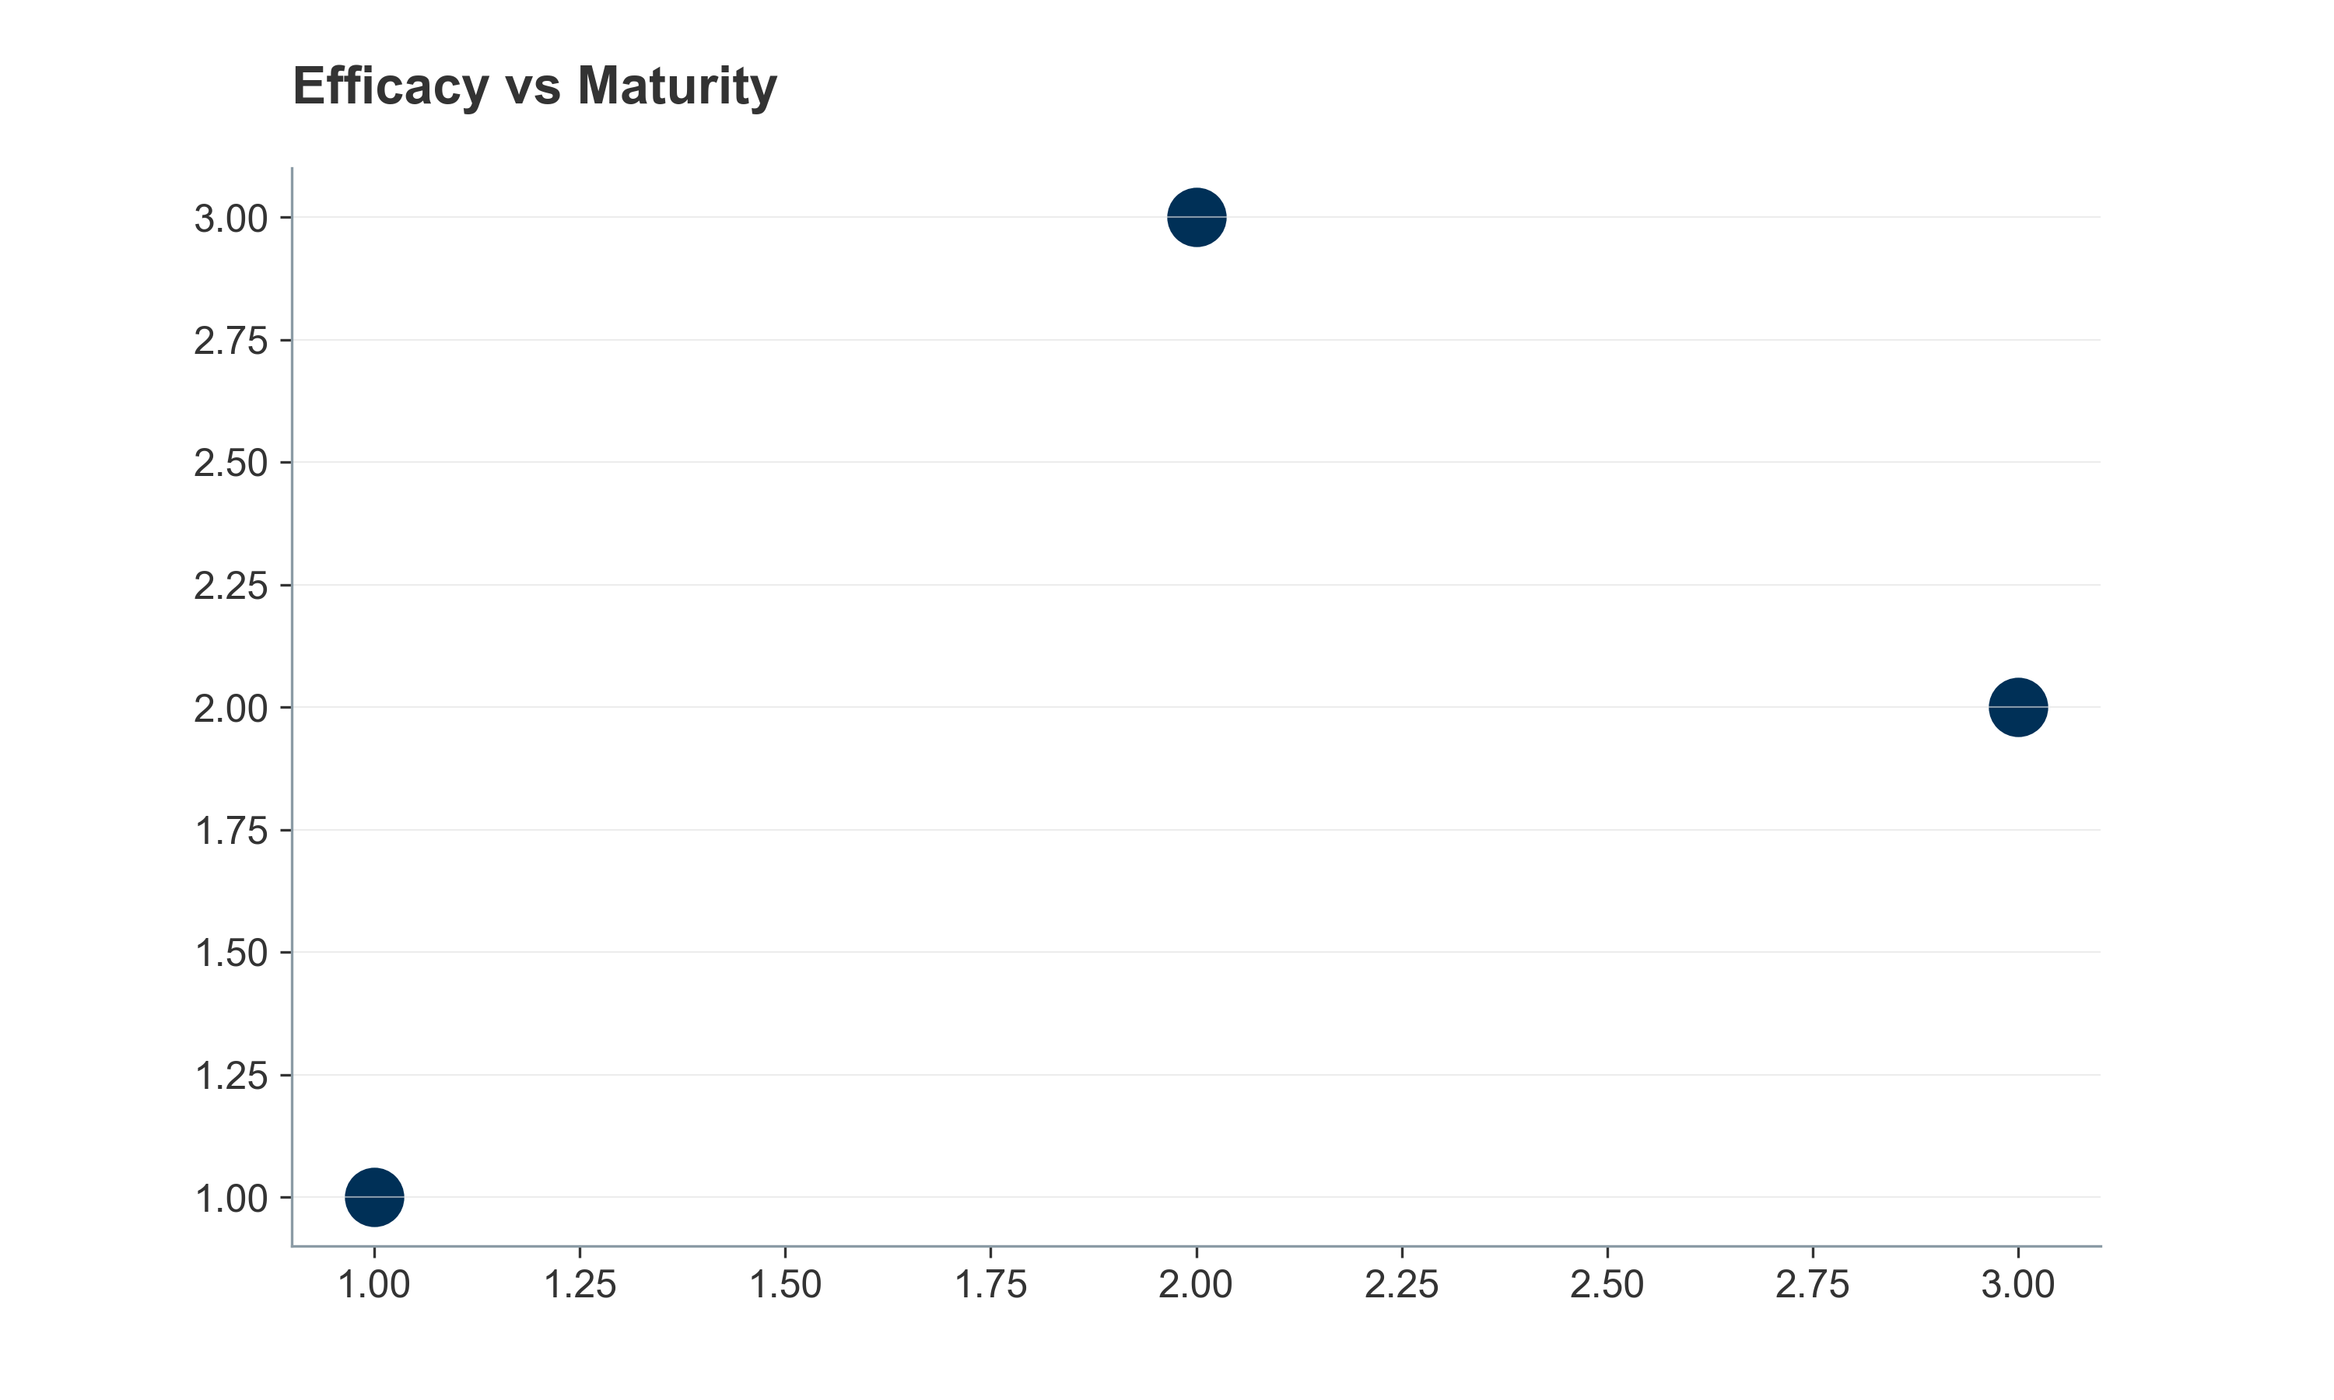
Figure 23: Ingredient Efficacy Landscape
Figure 17: Channel Economics Over Time
Figure 14: Mobility Supplement Premiumization
Figure 15: Senior Pet Market Growth
Figure 20: Pharma Encroachment Funnel
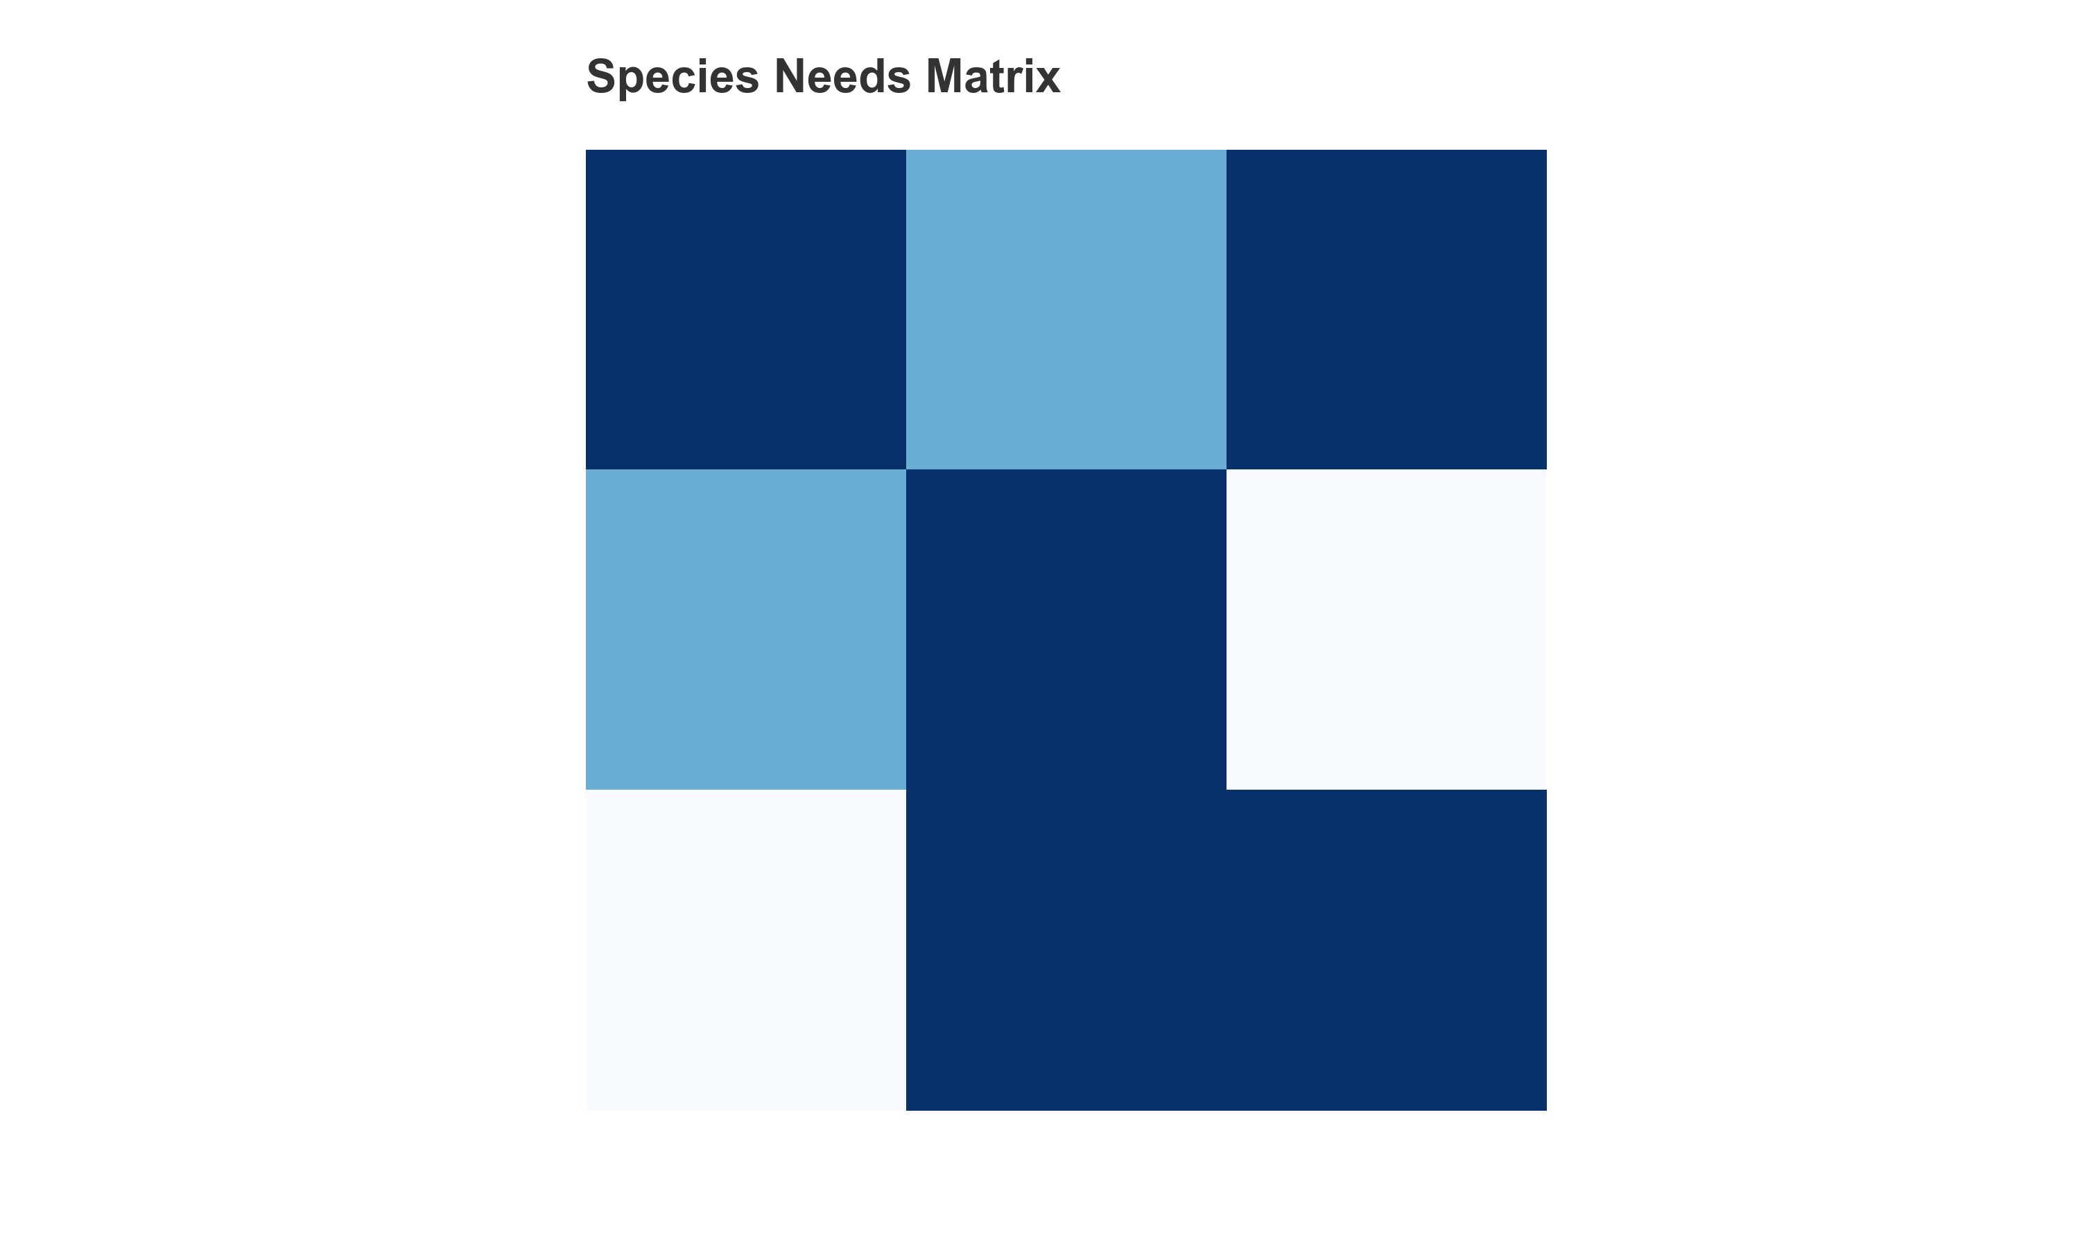
Figure 22: Species vs Functional Needs Matrix
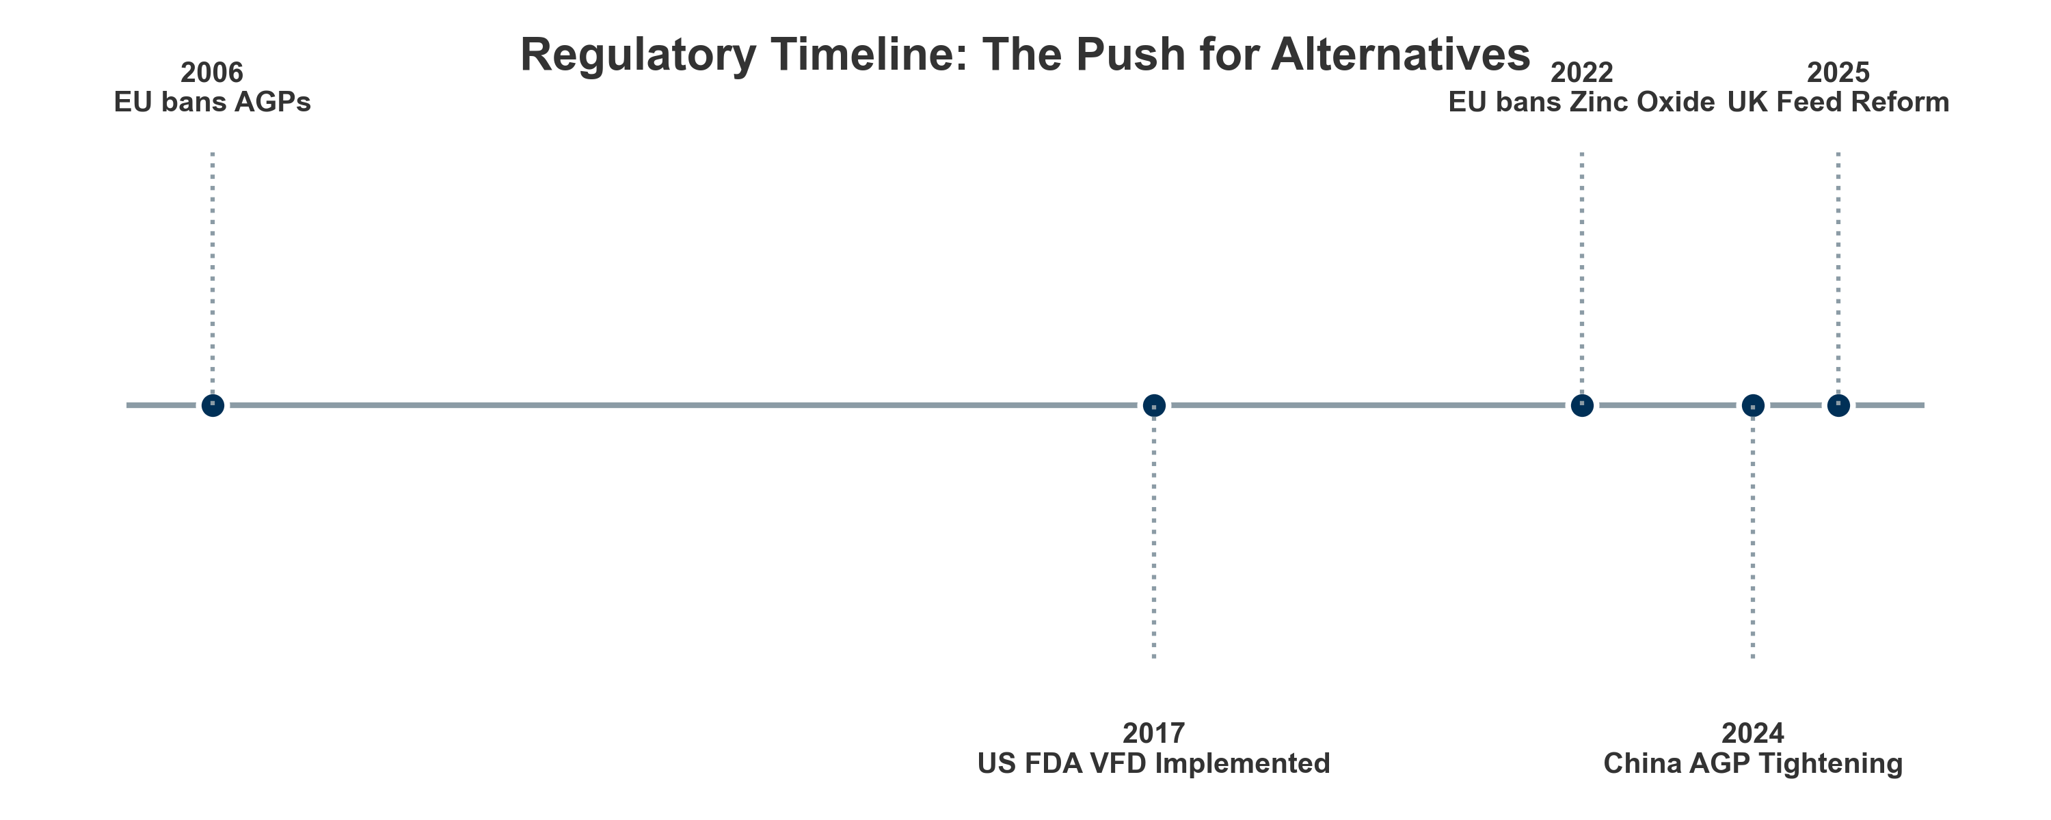
Figure 21: Regulatory Timeline
Figure 18: Value Capture Comparison
Figure 12: Consumer Segmentation by Willingness-to-Pay
Figure 13: Psychological Drivers of Purchase Decisions
Figure 6: Poultry Production vs HPAI Impact
Figure 11: Preventive Health Spending Allocation
Figure 3: Cat and Dog Population Growth in Europe
Figure 7: European Swine Herd Contraction
Figure 9: Aquaculture Overtakes Capture Fisheries

