Git Repository

Del Mundo, Celine

Bellevue University, CSD 310

Module 1

January 14, 2024

Git Repository

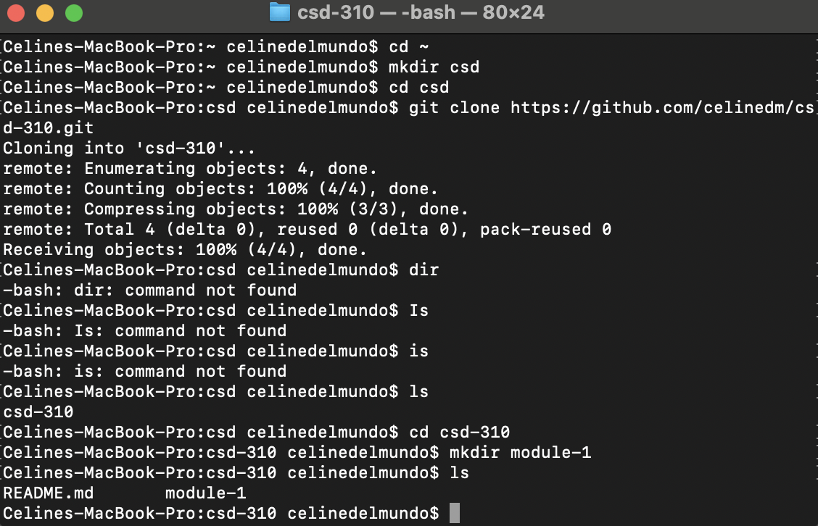

**Git Link:** [**https://github.com/celinedm/csd-310**](https://github.com/celinedm/csd-310)