Table Queries

Del Mundo, Celine

Bellevue University, CSD 310

Module 7

February 18, 2024

Table Queries

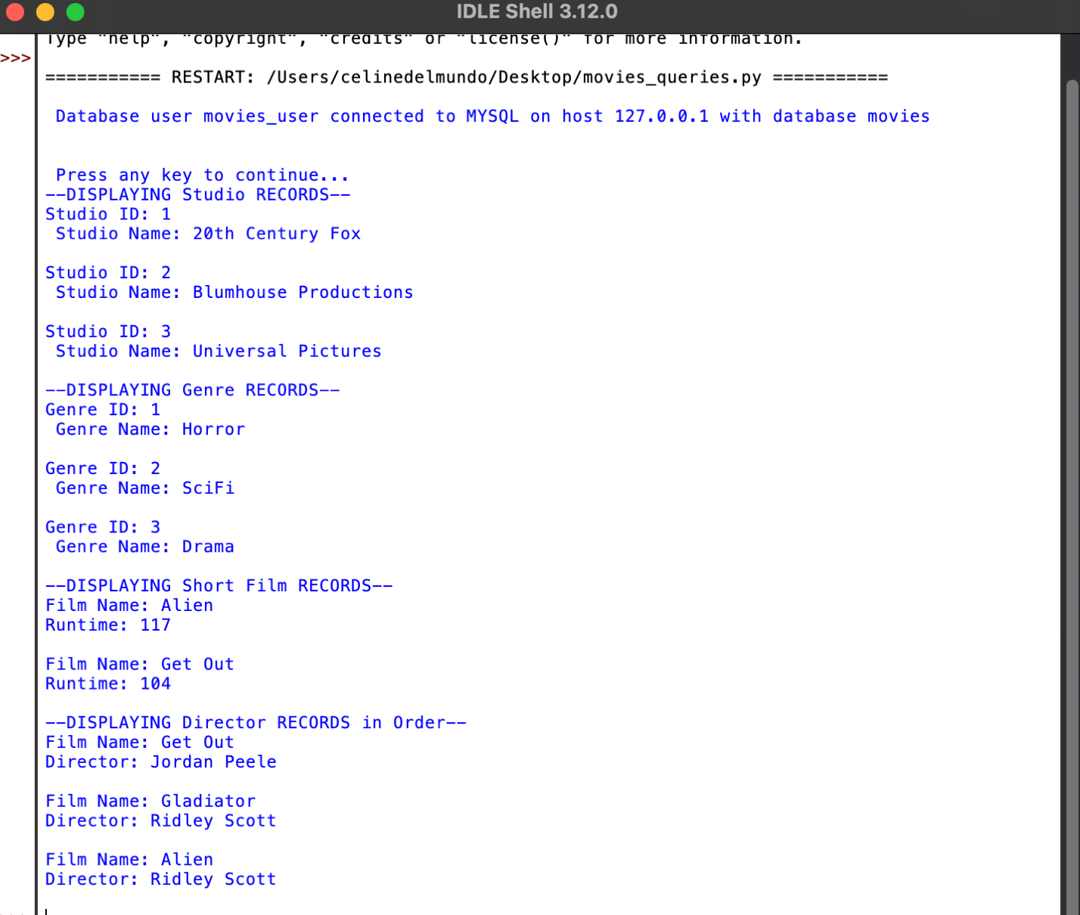

**Git hub repository:**

[**https://github.com/celinedm/csd-310**](https://github.com/celinedm/csd-310)