Shared Code Repository

Celine Del Mundo

Bellevue University, CSD 380

10/6/2024

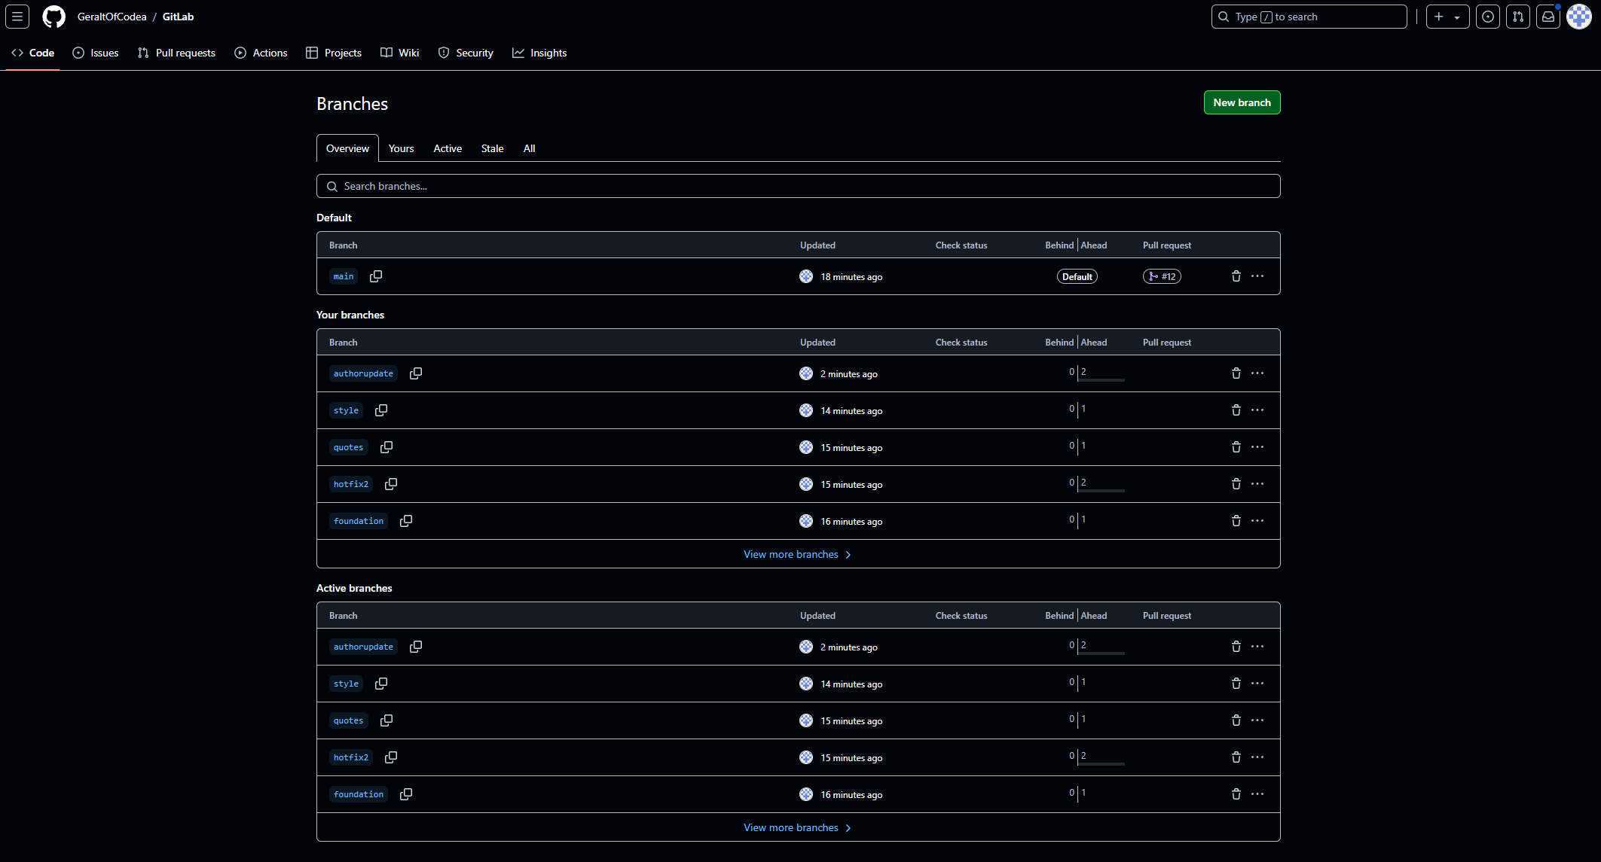

GitLab: git@github.com:GeraltOfCodea/GitLab.git

GitHub User Name: CelineDM

Assignment: 10.2