- Introduction and Client-Consulting Scenario
1.1 Client-Consulting Project Scenario
ABC Foodmart is a local grocery chain with two stores in Queens, New York, and plans to open three new stores in Brooklyn. Its staffing, inventory, purchasing, sales, and accounting records are currently managed through separate spreadsheets and paper documents. Our consulting team was hired to design a centralized database and reporting system that can better support the company’s expansion.
  - Project Motivation and Initial Research
We selected grocery retail because its operations are closely connected: sales affect inventory, inventory drives purchasing, and staffing and operating costs influence store performance. Our review of these business processes showed that ABC Foodmart needed not only centralized data storage, but also a system that connects information across departments for faster and more consistent decision-making.
1.3 Proposed Solution and Business Benefits
We proposed a PostgreSQL relational database supported by a Python ETL pipeline and Metabase dashboards. Together, these components centralize and validate operational data, support cross-functional SQL analysis, and allow management to monitor sales, inventory, workforce, and costs. The solution reduces fragmented record keeping and provides a scalable information system for ABC Food Mart’s planned expansion.
- Team contract
The team established a working agreement with clear responsibilities based on each member’s primary role and strengths. The agreed division of responsibilities is summarized in Table below.
Team Member | Primary Role | Major Responsibilities
Xilin Wang | Organizer & Final Integration | Weekly meetings, meeting notes, task assigning, feedback, final revisions, data-generation rules/code, report writing, final PPT & presentation script
Xiangzhou Tan | Database & Dashboard Lead | Initial database schema, technical database development, Metabase dashboard, dashboard deployment/publication
Oracle | Report Lead | Final report Writing, continuous documentation of schema/data/ETL/generation-rule changes
Cloris | Data Validation & Schema Support | Data correction and validation, refinement of synthetic data rules, addressing weaknesses in initial generated data, schema development support
- Data Selection and Sample
Because actual operational data from ABC Foodmart was not available, a synthetic dataset was generated specifically for this project. The dataset covers all 19 tables in the relational database and was designed to provide sufficient data for database implementation, SQL analysis, and dashboard development without using confidential company information.
The data was not generated as independent random records. Business relationships and constraints were incorporated to maintain consistency across tables.
For example, the following sample data, employee records, were assigned valid stores and job roles, while subsequent staffing data considered employment status, hire dates, approved time off, store operating hours, and weekly working-hour limits. A fixed random seed was used to make the dataset reproducible.
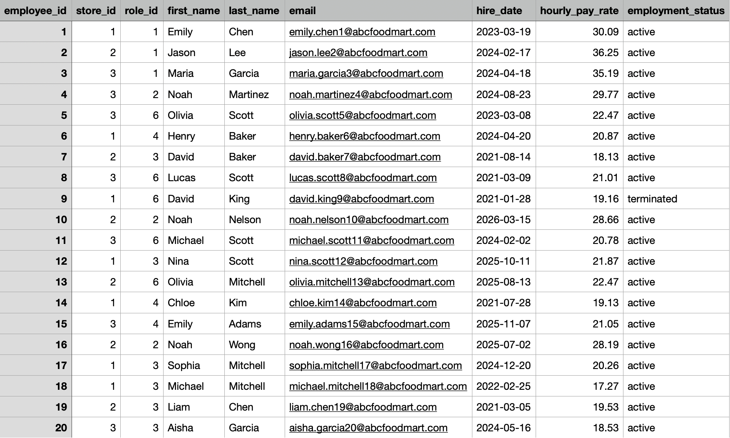
The complete synthetic dataset for all 19 tables is available at: [Dataset link].

4. Database Schema Design

4.1 Business and Database Requirements

The database was designed to integrate five major operational areas of ABC Food Mart: store and workforce management, product and inventory management, vendor and purchasing management, sales and returns, and operating expenses. The system therefore needed to maintain consistent master data, preserve relationships between operational records, track transaction and inventory history, and enforce business rules such as valid quantities, dates, monetary values, and inventory balances.

4.2 Entity-Relationship Diagram
The ERD diagram [Lucidchart link] presents the final Entity-Relationship Diagram (ERD), consisting of 19 relational tables organized into five connected business areas:
- Store and workforce:
stores, job_roles, employees, staff_shifts, time_off_requests
- Products and inventory:
product_categories, products, store_inventory, inventory_adjustments
- Vendors and purchasing:
vendors, vendor_products, purchase_orders, purchase_order_items, deliveries
- Sales and returns:
sales_transactions, sales_items, customer_returns, payments
- Expenses: operating_expenses
The complete ERD pdf version is attached in Appendix.

4.3 Relational Database Design
The 19-table relational schema was designed to reduce duplication while preserving the relationships required by ABC Food Mart. Reusable master data is stored separately and referenced through foreign keys. For example, job_roles is separated from employees, and product_categories is separated from products, so role and category information does not need to be repeated across individual records.
Transaction processes use a header-item structure. sales_transactions stores information applying to the overall sale, while sales_items stores the individual products within that sale. Similarly, purchase_orders stores order-level information, while purchase_order_items records individual products and quantities. This prevents transaction-level attributes such as store, vendor, date, and status from being repeated for every item.
Relationship-specific information is stored in associative tables. store_inventory represents each store-product combination because inventory levels differ by location, while vendor_products represents each vendor-product combination because purchase cost, minimum order quantity, and lead time vary by supplier. The design also separates current state from historical activity: store_inventory stores the current balance, while inventory_adjustments records the movements that caused inventory to change. Together, these design choices reduce redundancy and support normalization through Third Normal Form (3NF).

4.4 Data Integrity and Business Rules
Data integrity is enforced directly in PostgreSQL using primary keys, foreign keys, NOT NULL, UNIQUE, DEFAULT, and CHECK constraints. These constraints enforce rules within and between records, while triggers are used for business rules that require operations across multiple tables.

4.4.1 Entity and Referential Integrity
Primary keys uniquely identify records, while foreign keys ensure that records reference existing entities. The employees table provides a simple example:
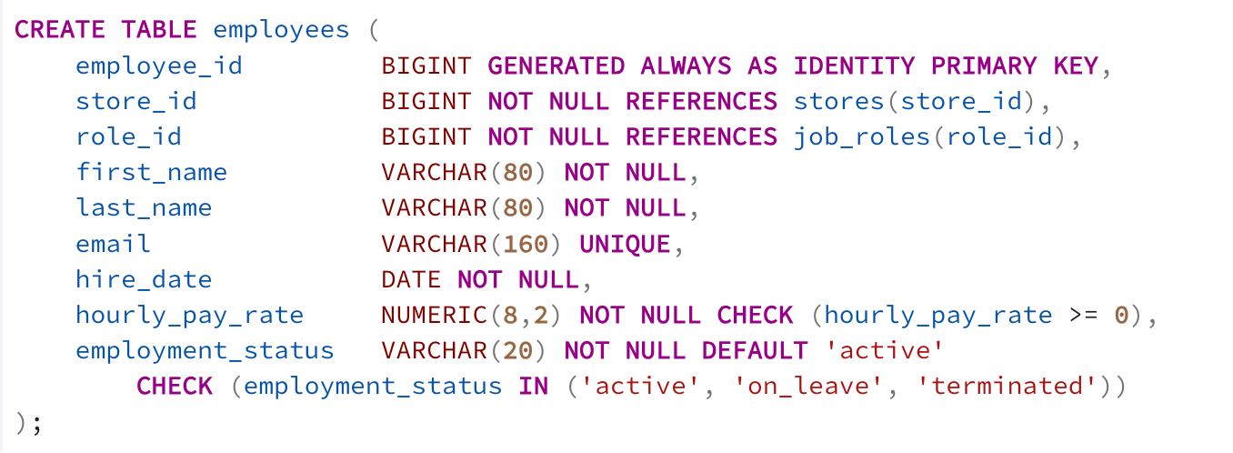
The identity primary key provides a unique identifier for each employee, while the two foreign keys ensure that every employee belongs to an existing store and job role. NOT NULL makes these relationships mandatory. The same PK/FK principle is applied throughout the schema to connect products, inventory, vendors, purchasing, sales, returns, payments, and expenses.
Relationship tables also use keys to prevent duplicate relationships. For example, store_inventory uses:
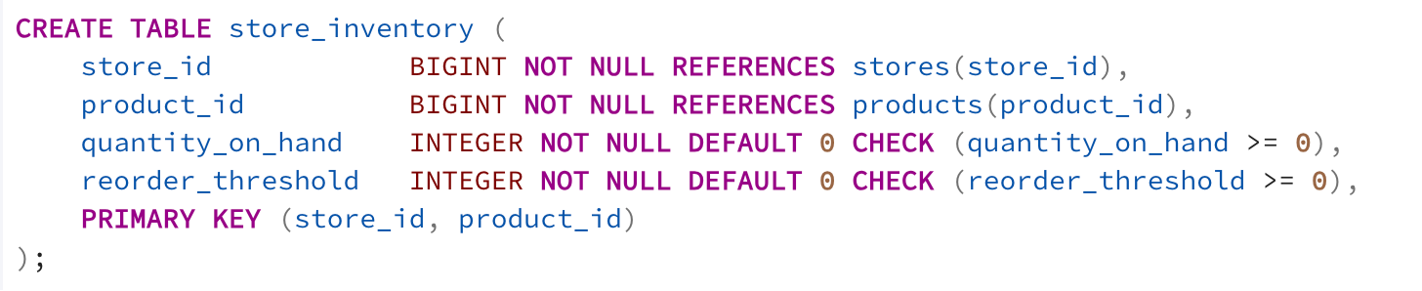
because only one current inventory record should exist for each store-product combination. Similarly, vendor_products uses UNIQUE (vendor_id, product_id) to prevent the same vendor-product relationship from being defined more than once.
4.4.2 Business-Logic Constraints
Business rules are further enforced through NOT NULL, DEFAULT, UNIQUE, and CHECK constraints. The purchase_order_items table provides a representative example: 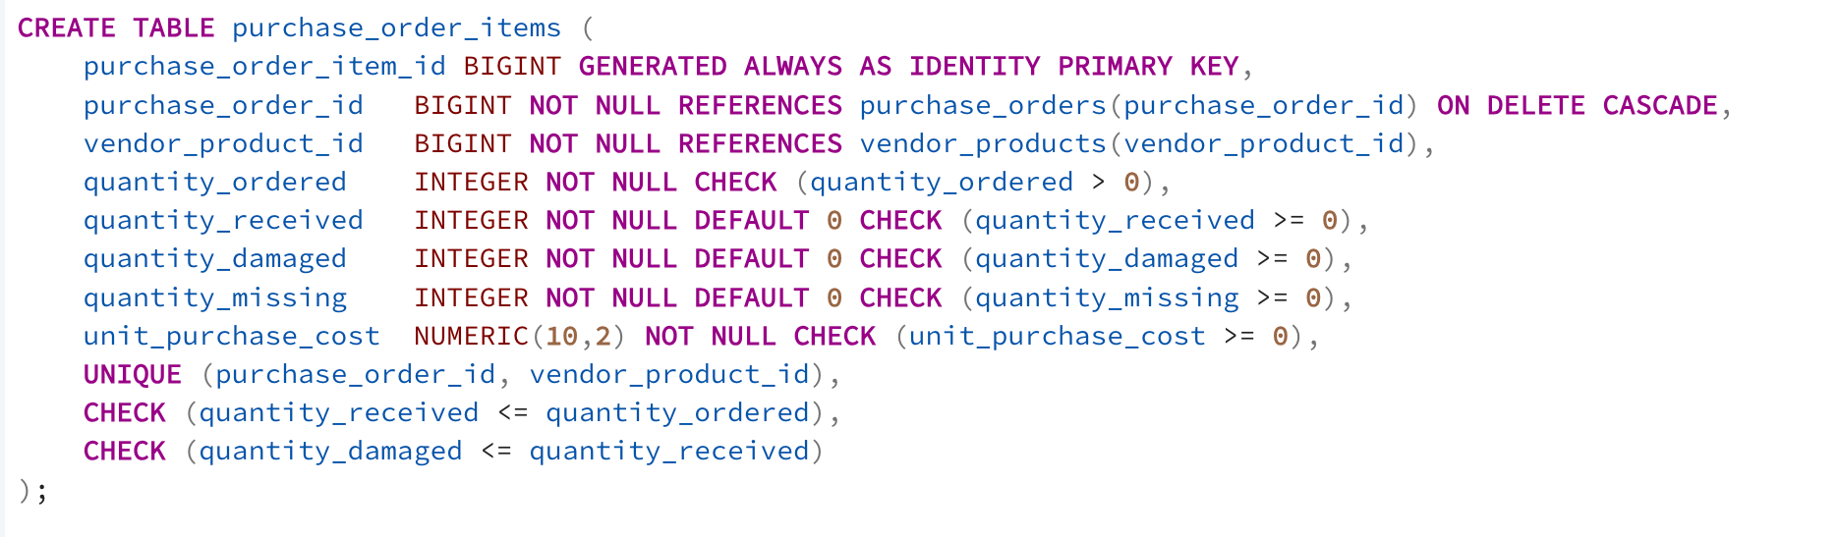
These constraints translate purchasing rules directly into the database. NOT NULL ensures that required information cannot be omitted, while DEFAULT 0 provides an appropriate initial value when no units have yet been received, damaged, or identified as missing. UNIQUE (purchase_order_id, vendor_product_id) prevents the same vendor-product from appearing twice within one purchase order. The CHECK constraints prevent invalid quantities and costs: ordered quantities must be positive, received, damaged, and missing quantities cannot be negative, purchase cost cannot be negative, received units cannot exceed ordered units, and damaged units cannot exceed units actually received.
ON DELETE CASCADE reflects the dependency between an order and its line items. A purchase_order_items has no independent meaning once its parent purchase order is deleted, so dependent items are removed with the parent rather than being left as orphan records.
The same constraint principles are applied to the remaining tables according to their business meaning. Date checks maintain valid sequences for shifts, time-off requests, and purchase orders; controlled-value checks standardize statuses, payment methods, inventory-adjustment types, and expense types; and financial checks prevent invalid prices, discounts, refunds, payments, and expenses.
4.4.3 Triggers and Cross-Table Integrity
Some business rules depend on multiple tables and cannot be enforced using row-level CHECK constraints. Three PostgreSQL triggers were therefore implemented.
Inventory adjustment trigger. trg_apply_inventory_adjustment updates the corresponding store_inventory balance whenever an inventory adjustment is inserted and rejects the transaction if the resulting inventory would become negative. This keeps the current inventory balance consistent with its adjustment history.
Sales inventory trigger. trg_reduce_inventory_after_sale automatically creates a negative inventory adjustment when a sales_items record is inserted. This keeps sales activity and inventory movements synchronized.
Purchase-order vendor validation trigger. trg_validate_purchase_order_vendor verifies that the vendor_product selected for a purchase-order item belongs to the same vendor as the parent purchase order. This prevents a cross-table inconsistency that cannot be detected by either foreign key independently.
Together, primary and foreign keys preserve entity relationships, constraints enforce record-level business rules, and triggers enforce rules that require coordination across multiple tables. All the sql code is attached in Appendix

5. ETL Process
5.1 ETL Overview
After the relational database was designed, an ETL pipeline was developed in Python to prepare and load operational data into PostgreSQL. Because ABC Foodmart's existing records are assumed to come from separate spreadsheets and paper-based processes, the pipeline represents how data from different operational areas can be standardized, validated, and integrated into the centralized relational database.
For this project, reproducible synthetic data was generated to represent ABC Foodmart's operations because real company records were not available. The pipeline covers all 19 tables and follows three main stages: extraction into CSV staging files, transformation and validation using Python and pandas, and loading into PostgreSQL in dependency order. A fixed random seed and separate domain-level seeds were used to make the generated dataset reproducible.
5.2 Data Generation and Staging
In the generation stage, synthetic operational records were generated for the 19 tables in the database. The dataset covers store operations including staffing, products, inventory, vendors, purchasing, deliveries, sales, returns, payments, and operating expenses. The generated records are fictional and are intended to simulate the types of data that ABC Foodmart would maintain in a real operating environment.
The default dataset covers November 1, 2025 through July 31, 2026 and generates 36,000 sales transactions and 80 employees. A fixed random seed was used to make the generation process reproducible, while separate seeds were assigned to staffing, sales, purchasing, inventory loss, and expenses so that changes in one area would not unintentionally alter another.
The generated tables were not treated as independent random datasets. Related operational records were generated with business dependencies. For example, sales demand was aggregated by store, week, and product and used to determine replenishment requirements. Purchase quantities considered projected inventory, reorder thresholds, minimum order quantities, and a safety allowance. This produced purchasing records that were logically connected to simulated demand rather than completely random orders.
5.3 Cleaning and Standardization
During this stage, the staging files were read into pandas DataFrames and standardized before loading. Column names were converted to a consistent lowercase underscore format, text values were trimmed, and common representations of missing values such as "N/A", "null", and "unknown" were converted to null values. Monetary values were handled at two-decimal precision, while date and timestamp fields were converted to appropriate data types before validation.
5.4 Business-Rule Validation
Validation was performed before data was loaded into PostgreSQL. In addition to basic type and null checks, the pipeline tested cross-table business rules. One important example was inventory validation. Inventory movements and sales were replayed chronologically to verify that inventory never became negative at any point in the simulated history. This is stronger than checking only the final inventory balance because a positive ending balance could otherwise hide an earlier stock shortage.
Validation Area | Example Rule
Inventory | Stock cannot become negative after adjustments or sales
Purchasing | PO vendor must match the vendor associated with the product
Staffing | Employee shifts cannot conflict with approved time off
Staffing | Completed shifts must have valid actual working times
Returns | Return processor must be working at the correct store and time
Sales/Returns | Transaction refund amount must agree with detailed return records
Referential consistency | Related IDs must exist in their parent tables
If any business-rule validation fails, the pipeline raises an error.
5.5 PostgreSQL Loading Strategy
After cleaning and validation, the data was loaded into PostgreSQL. The loading sequence follows table dependencies created by foreign-key relationships. Parent and reference tables are loaded before dependent transaction tables. For example, stores and job roles must exist before employees, vendors and products must exist before vendor-product relationships, and sales transactions must exist before sales items and returns.
Also, because the database triggers described in Section 4 remain active during loading, the ETL process was designed to avoid duplicating trigger-generated records. When sales_items are inserted, the sales trigger automatically creates the corresponding inventory reduction. Therefore, the ETL process does not separately insert sale-related inventory adjustments.
5.6 Transaction Safety and Post-Load Validation
The complete database load is executed as a transaction. After all records are inserted, identity sequences are reset to the current maximum IDs and the loaded database is validated against the staging data. If all checks pass, the transaction is committed. If any exception or validation failure occurs, the transaction is rolled back so that the database is not left in a partially loaded state.
Post-load checks include table row counts, negative inventory, consistency of automatically generated sale adjustments, and consistency between analytical views and their underlying tables. This provides a final verification that both the ETL process and the database objects behave as expected after loading.
The ETL code is attached in Appendix

6. Analytical Procedures and Business Insights
Following database design and ETL, ten SQL-based analytical procedures were developed to transform operational records into information that supports store management decisions. The analyses use joins, conditional calculations, aggregations, ranking, and time-based transformations across sales, products, inventory, staffing, and expenses. Key results are also connected to the Metabase dashboard for interactive filtering by store and date.

6.1 Analysis 1 — Store Sales Performance – Appendix 1
How does sales performance differ across stores?

This provides a starting point for investigating whether weaker store performance is associated with products, inventory, staffing, or other operating conditions.

6.2 Analysis 2 — Sales Trends and Timing – Appendix 2
When does ABC Foodmart experience higher or lower sales demand?
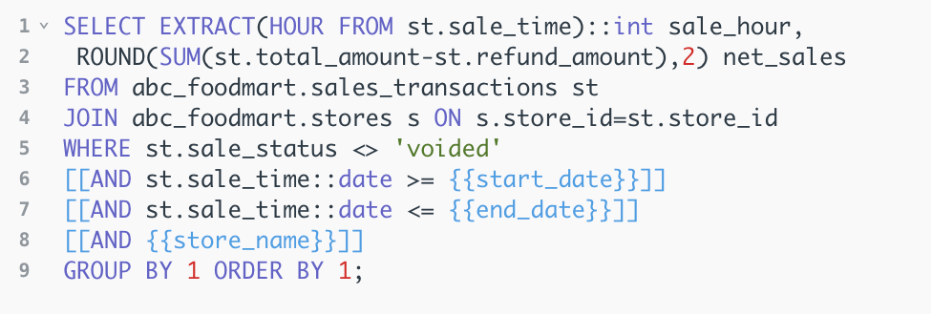
Supports staffing, cashier allocation, replenishment timing, and promotional planning around periods of higher demand.

6.3 Analysis 3 — Product and Category Performance – Appendix 3
Which products and categories contribute most to sales volume and revenue?
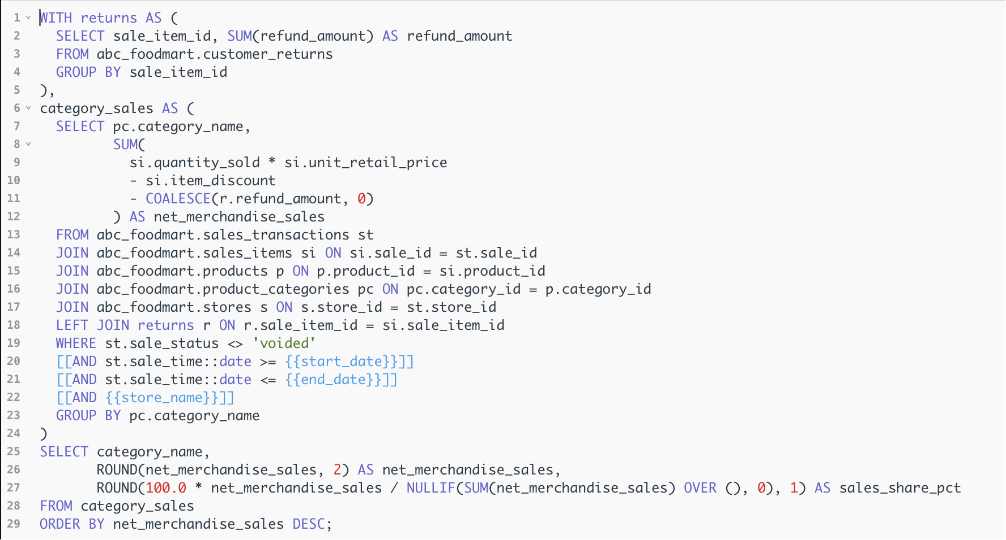
Helps management prioritize products and categories for inventory allocation and purchasing based on both volume and financial contribution.

6.4 Analysis 4 — Product Return Analysis – Appendix 4
Which products and categories have unusually high return rates?
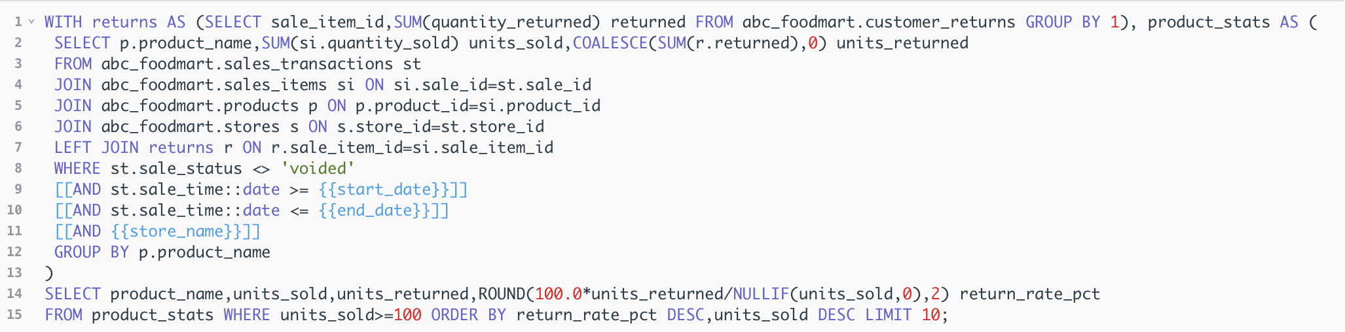Provides an exception-identification mechanism for products that may require further investigation into quality, storage, or store execution.

6.5 Analysis 5 — Reorder Priority Analysis – Appendix 5
Which products are closest to their reorder thresholds?
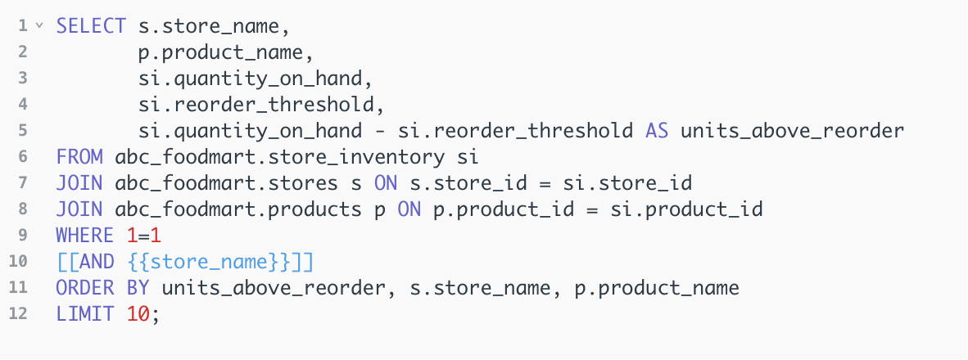
Converts inventory balances into actionable replenishment priorities and helps reduce future stockout risk.

6.6 Analysis 6 — Slow-Moving Inventory Analysis – Appendix 6
Which products may represent excess or slow-moving inventory? 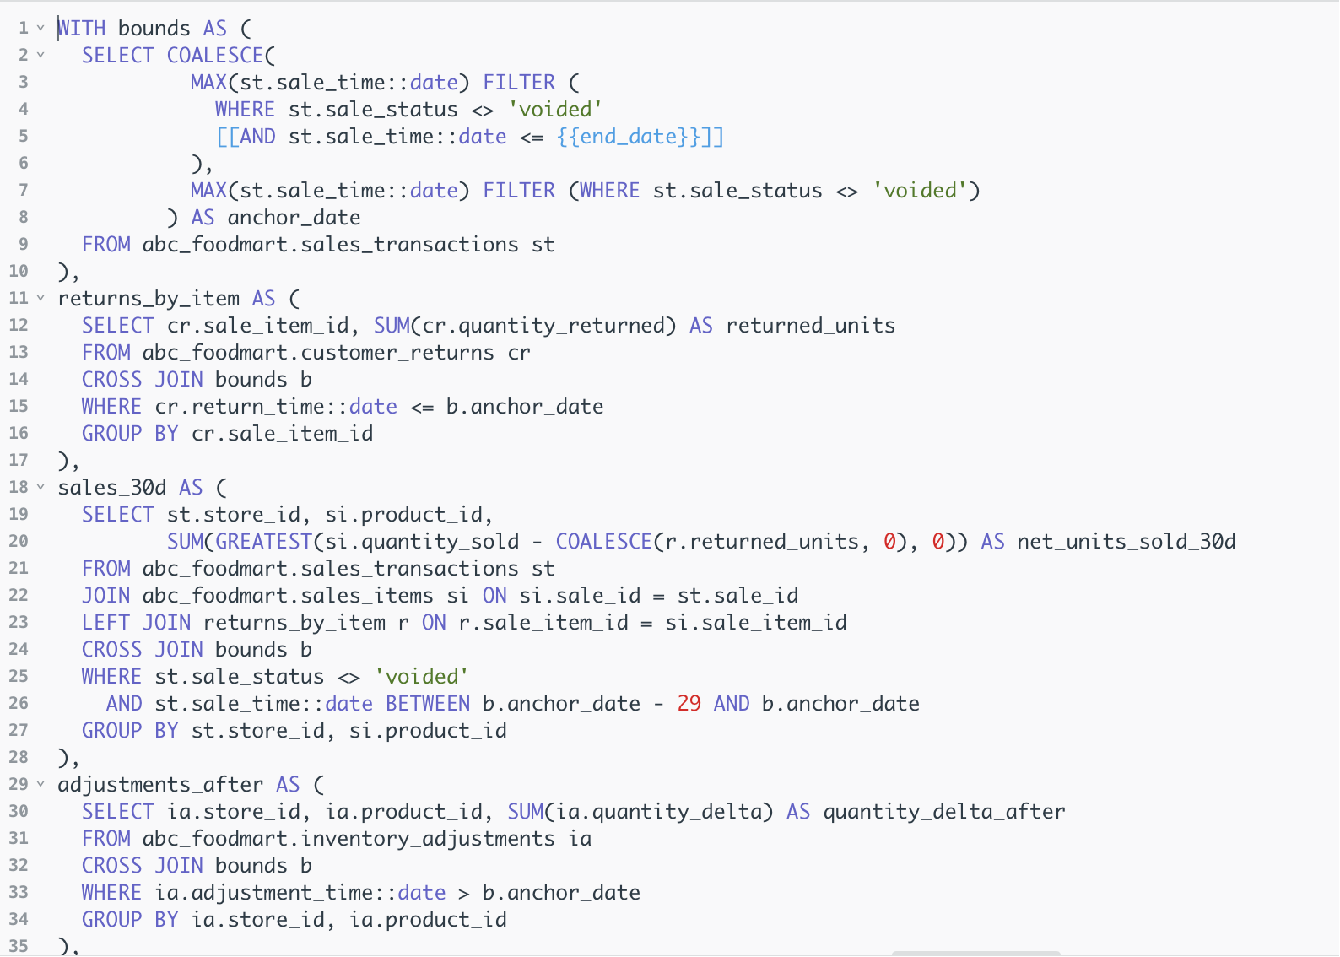
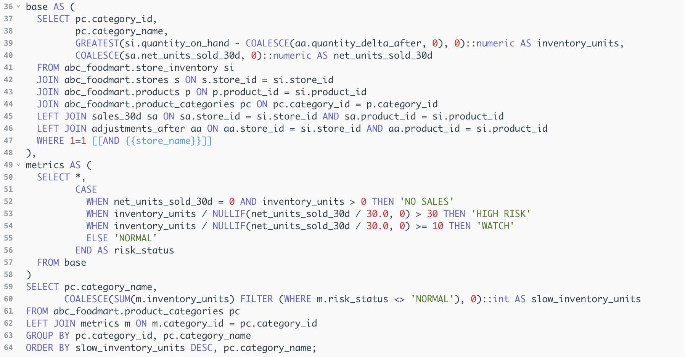
Slow-moving inventory is identified by comparing inventory levels with net sales during the most recent 30 days. Net Units Sold is calculated after accounting for returns, and Average Daily Net Sales is calculated over the 30-day period. The analysis then estimates how many days the current inventory would last at the recent sales rate. Products with no sales but positive inventory are classified as No Sales, those with more than 30 days of inventory as High Risk, those with 10–30 days as Watch, and the remaining products as Normal.
6.7 Analysis 7 — Inventory Loss Analysis – Appendix 7
Where are non-sales inventory losses occurring? 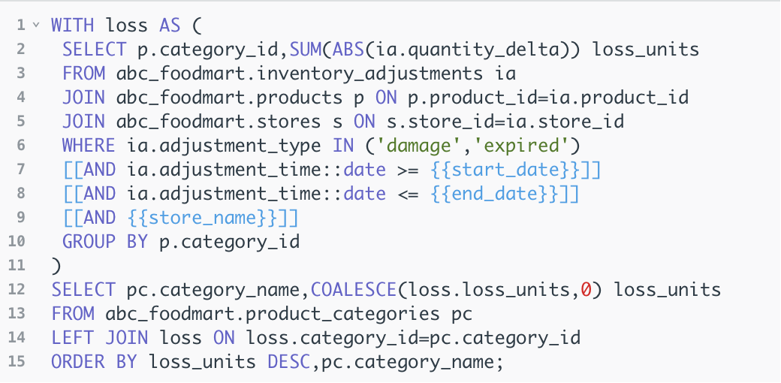Helps management distinguish normal stock movements from actual losses and focus investigation on categories with greater shrinkage or spoilage risk.
6.8 Analysis 8 — Labor Utilization Analysis – Appendix 8
How closely do actual labor hours match scheduled labor hours?
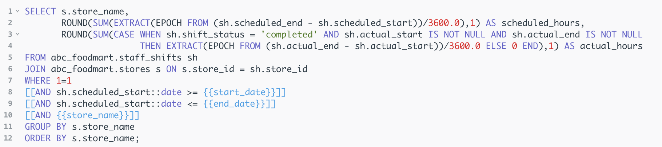
Helps managers evaluate whether staffing plans are being executed as expected and identify where labor resources are concentrated.

6.9 Analysis 9 — Attendance Exception Analysis – Appendix 9
Which employees show attendance exceptions requiring management attention?
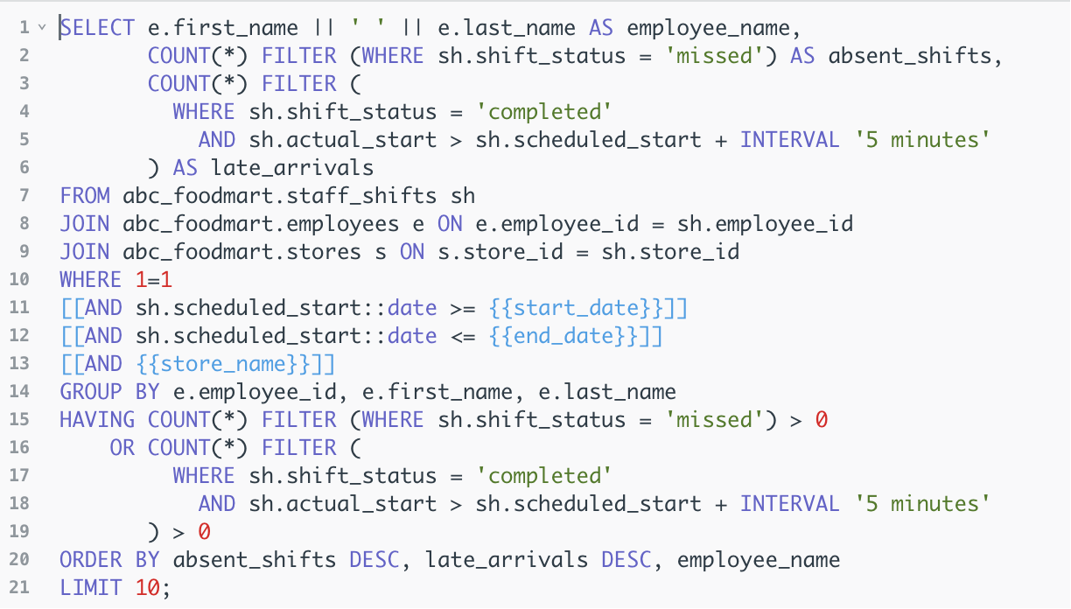Converts large volumes of shift records into exception-focused information so managers can prioritize cases requiring review.

6.10 Analysis 10 — Operating Expense Structure – Appendix 10
What are the major sources of operating costs at ABC Foodmart? 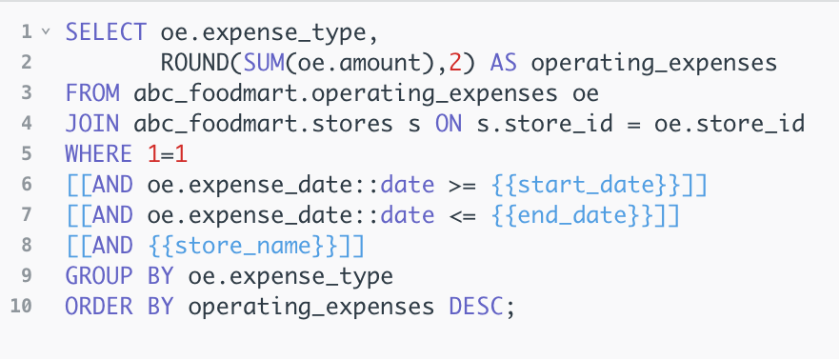
Shows that labor and rent dominate the cost structure, making labor utilization a particularly important area for cost-efficiency analysis.
6.11 Overall Business Insights
The ten analyses form a connected view of store operations rather than isolated performance measures. Sales timing can inform staffing decisions; product performance can guide replenishment; reorder and slow-moving inventory analyses identify opposite inventory risks; inventory-loss analysis highlights potential shrinkage or spoilage; and labor utilization directly connects staffing decisions with the largest component of operating expenses.
Together, these procedures demonstrate the value of the relational database by linking sales, products, inventory, employees, and expenses through shared store, product, employee, transaction, and date relationships. Metabase presents the SQL results as interactive KPIs, trends, rankings, and detail tables, allowing managers to move from overall performance indicators to specific operational issues requiring action.

7.1 User Interaction and System Architecture
The system provides different levels of interaction based on user roles. Analysts can directly access PostgreSQL using raw SQL or Python/R connectors, allowing them to run and modify the analytical procedures in Section 6 and perform detailed drill-down analysis. Using programming languages also makes repeated database operations more efficient and reproducible.
Managers and executives interact with the database primarily through Metabase. Analytical results are presented as KPIs, charts, rankings, and detailed tables, with store and date filters for interactive analysis. This allows non-technical users to review business performance and identify issues without writing SQL or directly accessing the underlying database.

7.2 Performance, Redundancy and Deployment

During the database design process, our strategy was to reduce data redundancy through 3NF and improve performance through indexing, query optimization, and potential future use of views. For dashboard queries that are executed repeatedly, regular views or materialized views could also be considered in the future to reduce repeated computation. It is important to note that these mechanisms were not actually implemented in this project and are better considered as future extensions once the system is deployed for real business operations.

For deployment, we recommend that ABC Foodmart use a cloud-based solution. ABC Foodmart is expanding from two stores to five locations, making cloud deployment more suitable for a multi-store environment. In addition, ABC Foodmart requires a real-time dashboard, which further increases the need for a cloud-based system, since the database and dashboard should not depend on someone manually refreshing or maintaining the data at all times.

7.3 Metabase Dashboards

The PostgreSQL database was connected to Metabase to provide an interactive reporting interface for managers and executives. The dashboard is organized into five business areas, with store and date filters allowing users to dynamically review different locations and periods.

The Store Overview provides a high-level view of business performance through key sales and operating KPIs, together with sales and expense trends. It allows managers to quickly assess overall store performance before investigating specific business areas.

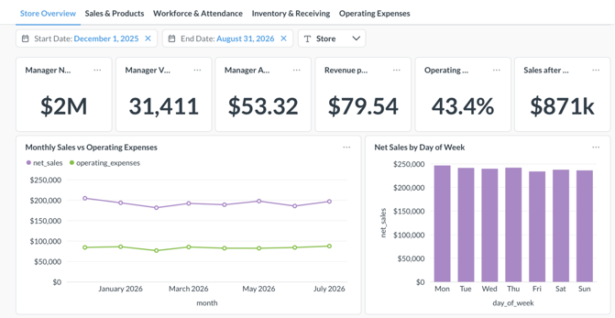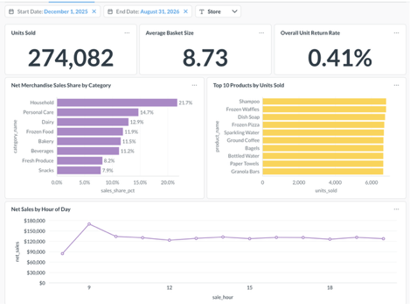

The Sales & Products dashboard presents sales volume, basket size, category contribution, product rankings, return performance, and sales timing. It helps managers identify major sales drivers, high-return products, and periods of stronger customer demand.

The Workforce & Attendance dashboard compares scheduled and actual labor hours and summarizes attendance performance and employee exceptions. It helps managers identify staffing gaps and employees or job roles requiring further attention.

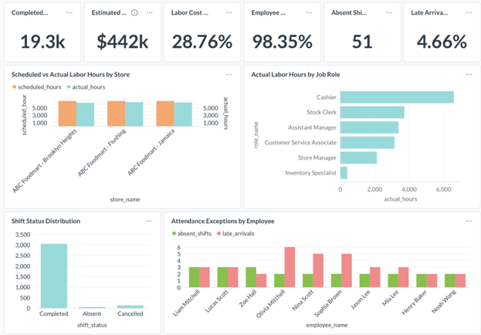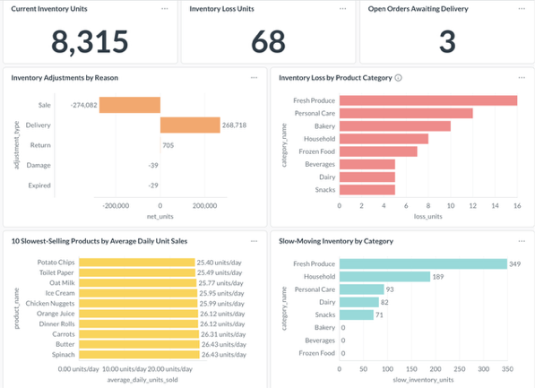

The Inventory & Receiving dashboard presents current inventory, inventory losses, outstanding orders, slow-moving stock, and reorder information. It supports replenishment decisions while also highlighting excess inventory and potential inventory losses.

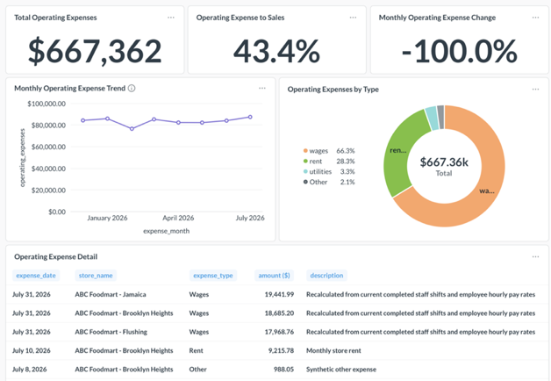
The Operating Expenses dashboard presents total expenses, the expense-to-sales ratio, monthly cost trends, and the distribution of expenses by type. It helps management identify major cost drivers and monitor changes in operating costs over time.
Overall, the dashboards convert the SQL analytical procedures into an accessible management interface. Non-technical users can monitor KPIs, apply store and date filters, identify exceptions, and drill down into detailed information. This improves the accessibility and efficiency of data-driven decision-making.

8. Conclusion
This project replaced ABC Foodmart’s fragmented records with a centralized PostgreSQL database and analytics system. The relational database improved data consistency, reduced redundancy, and supported analysis across sales, inventory, purchasing, workforce, and costs. The Python ETL pipeline standardized and validated data for reliable loading, while SQL analysis and Metabase dashboards provided insights into sales trends, inventory performance, staffing, attendance, and operating expenses. Together, these tools help management identify operational issues faster and make better decisions on inventory, staffing, purchasing, and store performance, while providing a scalable foundation for future expansion.

