# INLS 161 Participation - Create your own GIF (Workshop)

“Definition of GIF: Animated Looping Image”

On 17th of October 2016, at 6:00pm on the Undergraduate Library, I went to a tech workshop. The tech workshop is by skillfUL, and the name of the workshop is “Create Your Own GIF.” The class starts with two UL staff, Kim and Kelsey explaining how to pronounce the word “GIF”. They explained that in the future, the hard “G” will be used to pronounce GIF. Then, they put a definition of GIF in their Power Point slide.

|  |
| --- |
| People who pronounce GIF: |
| With a hard "G" | With a soft "G" |
| 70% | 30% |

Kim and Kelsey then explained how GIF is an important marketing tool, how it catches people’s eyes and is memorable. They suggested using Adobe Photoshop to do this.

Below are the steps to creating a simple GIF in Photoshop:

1. Open photoshop
2. (Open series of images - provided by workshop) Go to File > Scripts > Load File into Stacks
3. (Open timeline) Window > Timeline
4. (Edit timeline) Click down arrow in the center of “Timeline Panel” > Create Frame Animation
5. (Make frames stack horizontally) Timeline Menu > Make Frames from Layers
6. (In the Bottom Left of Timeline Panel - Set animation to loop) Once > Forever
7. (Save) File > Export > Save for Web

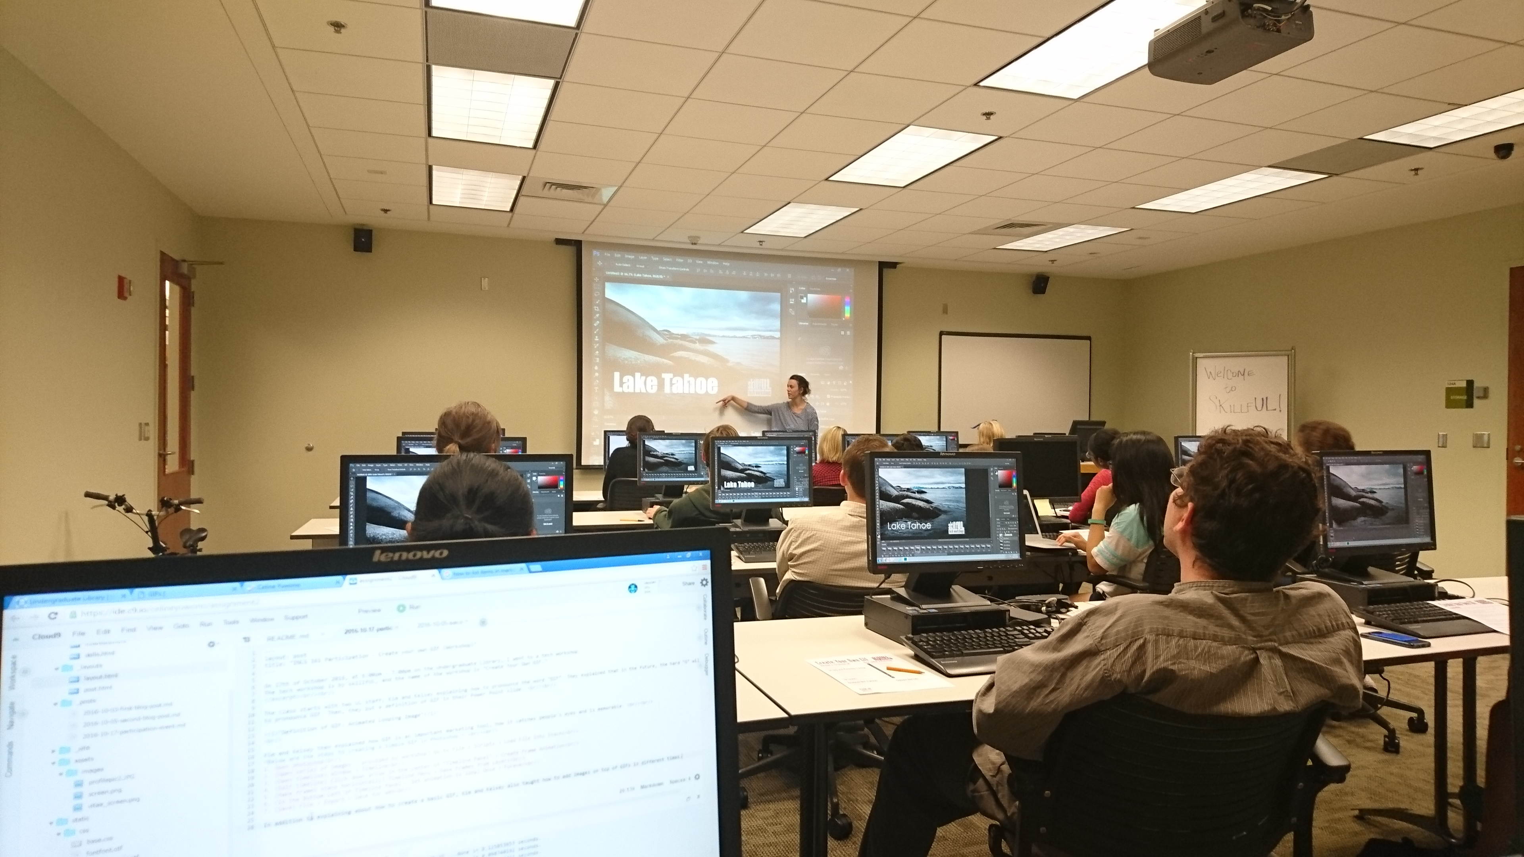

In addition to explaining about how to create a basic GIF, Kim and Kelsey also taught how to add images on top of GIFs in different times. Overall, I am a bit confused in Kim and Kelsey’s way of explaining, but I get it in the end and it was a good experience.