

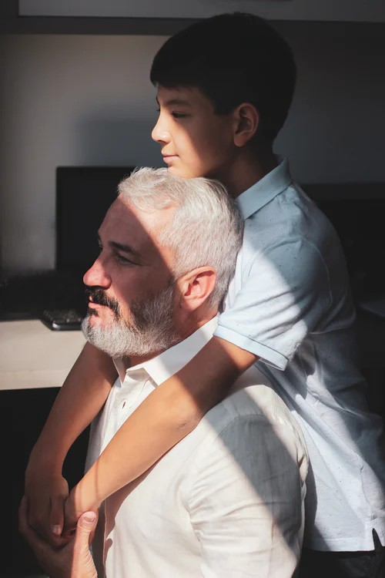Describing People

This is my father. He is 56 years old He lives in California and he is a sales consultant. He likes to run in the morning and he loves eating vegetables.

He doesn’t watch TV very often but he reads the newspaper. He doesn’t speak English but he speaks Italian.

I love my dad!

**It’s your turn! Write a short description of your mother, father, brother, sister or loved one.**