**Practice Worksheet**

**Meet your team leader**

**Instructions:**   
 **I. Look at the organizational chart. Put the employee names in the correct place according to their position. One new position is already included in the chart.**

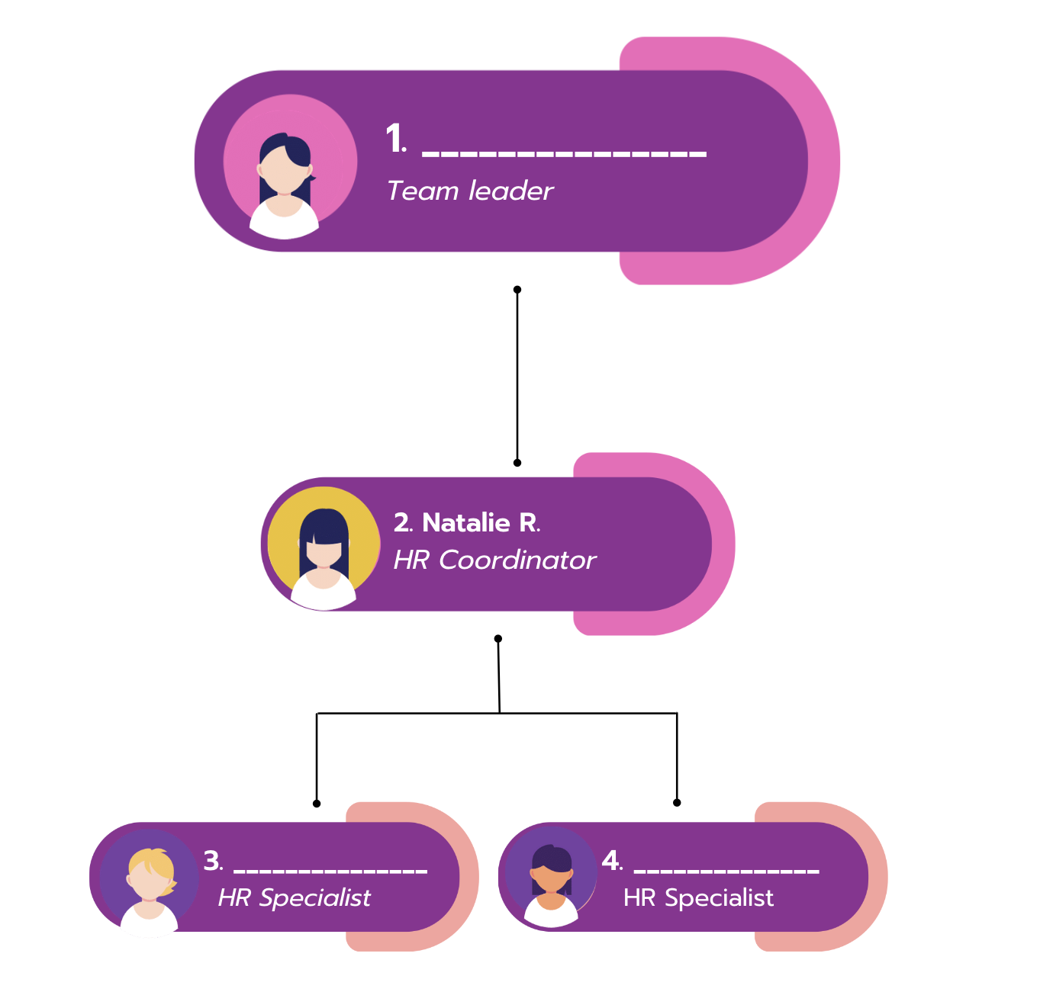



**Answer Key:**

1. Sandra
2. Natalie
3. Adam
4. Veronica